Multi-Tenant Authentication & Subscription Server
Technical Design Document
Built on Casdoor (Go) · OIDC/OAuth2 · WeChat Web QR + Phone OTP
Version 1.0
Date: 2026-05-20
Status: Approved design — ready for implementation

Table of Contents

1. Introduction & Scope
This document is the technical design for a self-hosted, multi-tenant authentication and authorization server. It serves multiple applications from a single central instance built by adopting Casdoor, an open-source, Go-based identity and access management (IAM) / single sign-on (SSO) platform. Users authenticate via WeChat Web QR (Open Platform) or phone one-time-password (OTP) over SMS through Casdoor's hosted login page. After login, applications receive signed JSON Web Tokens (JWTs) whose claims carry the user's plan, role, subscription status, and expiry, enabling each application to check subscription validity offline.

1.1 Goals
- One central identity provider serving multiple applications (multi-tenant).
- Login via WeChat Web QR and phone OTP (SMS via Twilio).
- User management through Casdoor's admin UI and API.
- Issue tokens whose claims let applications verify subscription expiration offline.
- Reproducible, version-controlled provisioning (infrastructure-as-code, not click-ops).

1.2 Non-Goals (v1)
- Payment-provider integration / billing-driven auto-renewal (API exposed for a future billing service).
- Instant sub-token-TTL revocation; offline verification accepts a bounded staleness window equal to the access-token TTL.
- WeChat surfaces other than Web QR (Official Account, Mini Program) — configurable later.
- High-availability / multi-node clustering (single-host Docker Compose for v1).

2. System Architecture
A single Casdoor instance is the central identity provider for all applications. Applications never store passwords or talk to WeChat / Twilio directly; they delegate login to Casdoor via the OIDC authorization code flow and verify the resulting JWTs offline using Casdoor's published public key (JWKS).
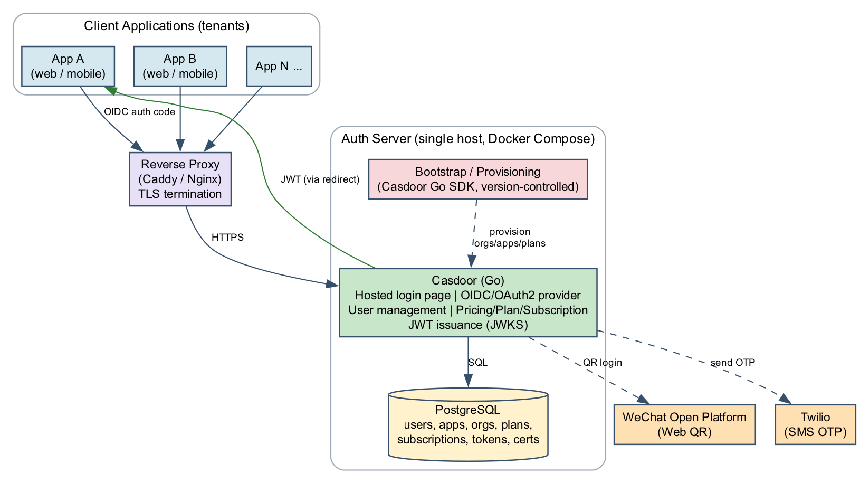
Figure 1. System architecture — clients delegate to Casdoor; apps verify JWTs offline.

2.1 Technology Stack
Concern | Choice | Rationale
Auth core / IdP | Casdoor (Go) | First-class WeChat & SMS-OTP, multi-tenant, OIDC/OAuth2 provider, built-in subscription engine
Datastore | PostgreSQL | Reliable, easy backup; Casdoor-supported via its ORM
Edge / TLS | Caddy or Nginx (reverse proxy) | TLS termination in front of Casdoor
Packaging | Docker Compose (single host) | Simple to stand up and operate for v1
Provisioning | Casdoor Go SDK / declarative config | Version-controlled, reproducible setup
WeChat login | WeChat Open Platform (Web QR) | Scan-to-login on the hosted page
SMS OTP | Twilio | Phone-number one-time passcode delivery
Token format | JWT-Custom (RS256) | Embeds subscription claims for offline verification

3. Module Design
The system is composed of Casdoor's configured modules (used as-is) plus a small amount of custom code that we own: the bootstrap/provisioning layer and a per-application verification helper. We extend Casdoor's source only if a required claim or flow cannot be configured.
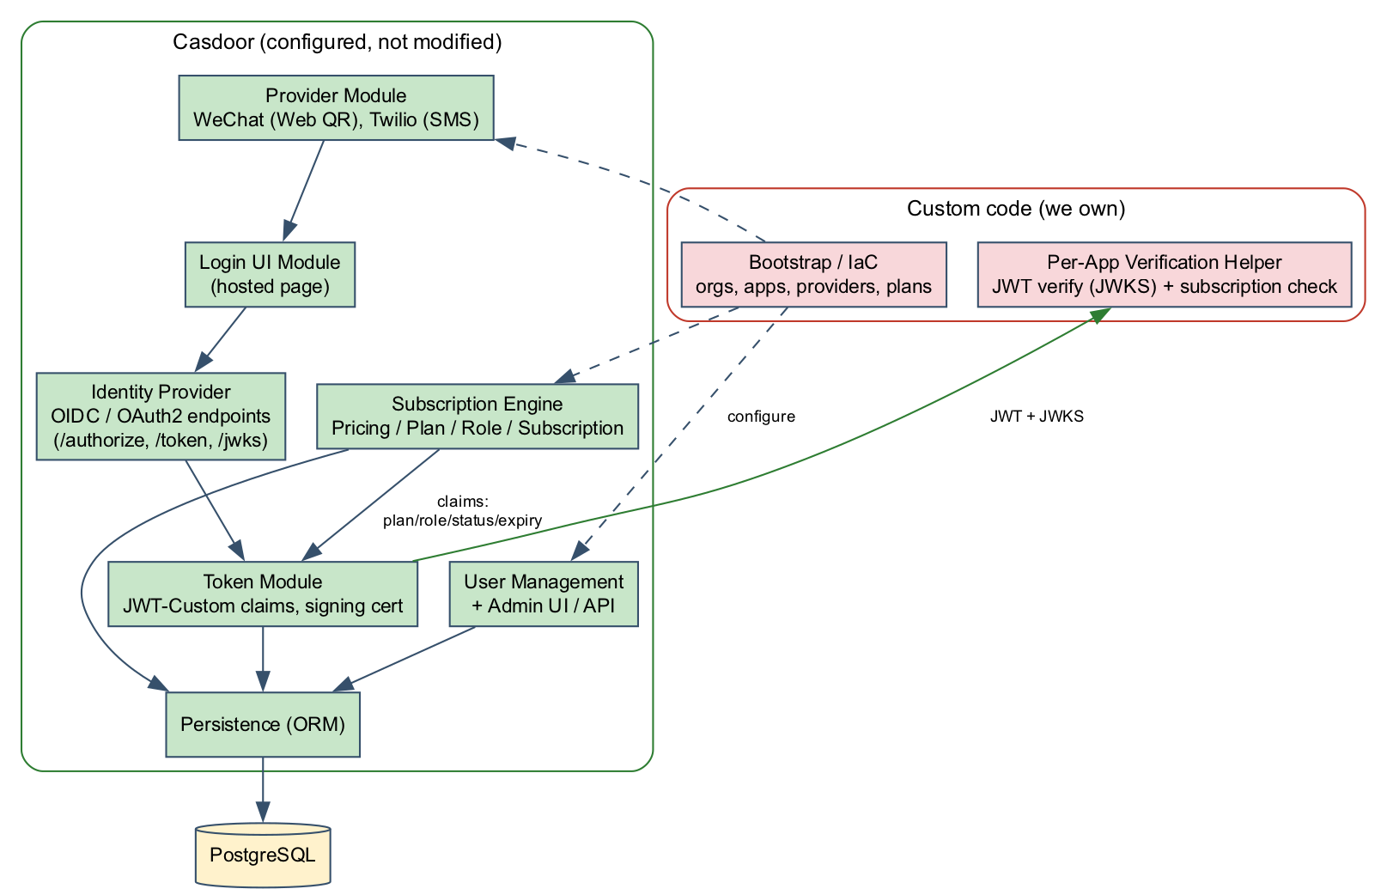
Figure 2. Module decomposition — green is configured Casdoor, red is custom code we own.

3.1 Module Responsibilities
Module | Responsibility | Ownership
Login UI | Hosted login page rendering WeChat QR and phone-OTP entry | Casdoor (config)
Identity Provider | OIDC/OAuth2 endpoints: /authorize, /token, /jwks, introspection | Casdoor (config)
Provider Module | WeChat Open Platform + Twilio SMS integrations | Casdoor (config)
User Management | User CRUD, account linking, admin UI/API | Casdoor (config)
Subscription Engine | Pricing / Plan / Role / Subscription state machine | Casdoor (config)
Token Module | JWT-Custom claim assembly, signing with cert | Casdoor (config)
Bootstrap / IaC | Provision orgs, apps, providers, plans reproducibly | Custom
Verification Helper | Per-app JWT verify (JWKS) + subscription check | Custom

4. Multi-Tenant Design
Casdoor's hierarchy maps directly onto our tenancy model. The Organization is the tenant boundary; it owns users, providers, and pricing/plans. An Application belongs to an organization and defines enabled login methods, redirect URLs, client credentials, and token/claim format. A User belongs to an organization and can be used across that organization's applications.
v1 topology: one Organization per Application, giving each application fully isolated users and subscription rules.
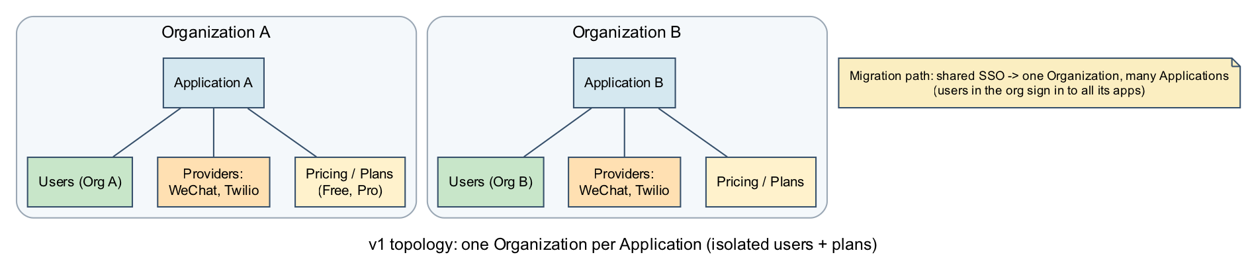
Figure 3. v1 tenancy: one Organization per Application, with a documented migration path to shared SSO.
Casdoor concept | Our meaning | Isolation
Organization | Tenant boundary (per application in v1) | Owns users, providers, plans
Application | App A, App B, ... | Own client ID/secret, redirect URIs, token config
User | End user of an application | Scoped to its organization
Provider | WeChat / Twilio credentials | Per organization
Pricing / Plan | Subscription tiers | Per application
Migration path: if shared SSO users across applications become desirable, move to a one-Organization, many-Applications topology so users in the org sign in to all its apps. This is a configuration change plus user-data migration, not a redesign.

5. Workflow Design

5.1 Login Flows
Both WeChat Web QR and phone OTP use the OIDC authorization code flow and terminate on Casdoor's hosted login page. The two methods resolve to a single identity when the same person uses both; the v1 linking rule is link-by-verified-phone.
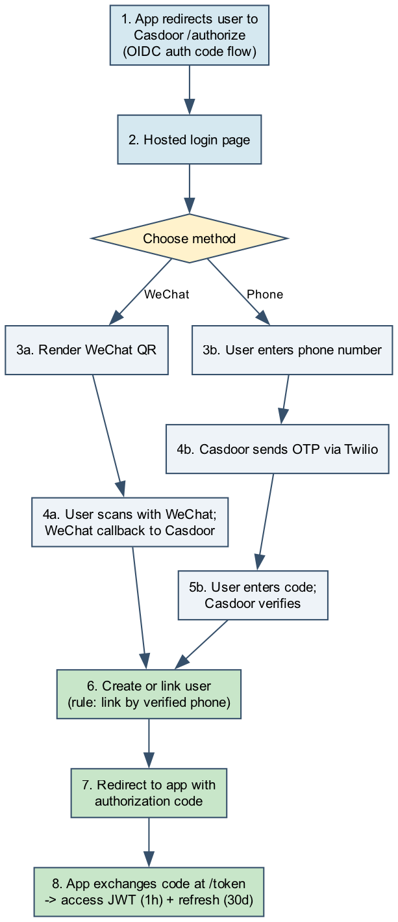
Figure 4. Login workflows for WeChat Web QR and phone OTP, ending in token issuance.

5.2 Token Validation, Refresh & Offline Subscription Check
On each protected request, the application verifies the JWT signature against Casdoor's JWKS (cached locally), checks expiry, and evaluates the subscription claims offline. When the short-lived access token expires, the app silently exchanges its refresh token for a new access token carrying fresh claims. The user stays signed in for the refresh-token lifetime (30 days) while subscription state is refreshed at most every access-token lifetime (1 hour).
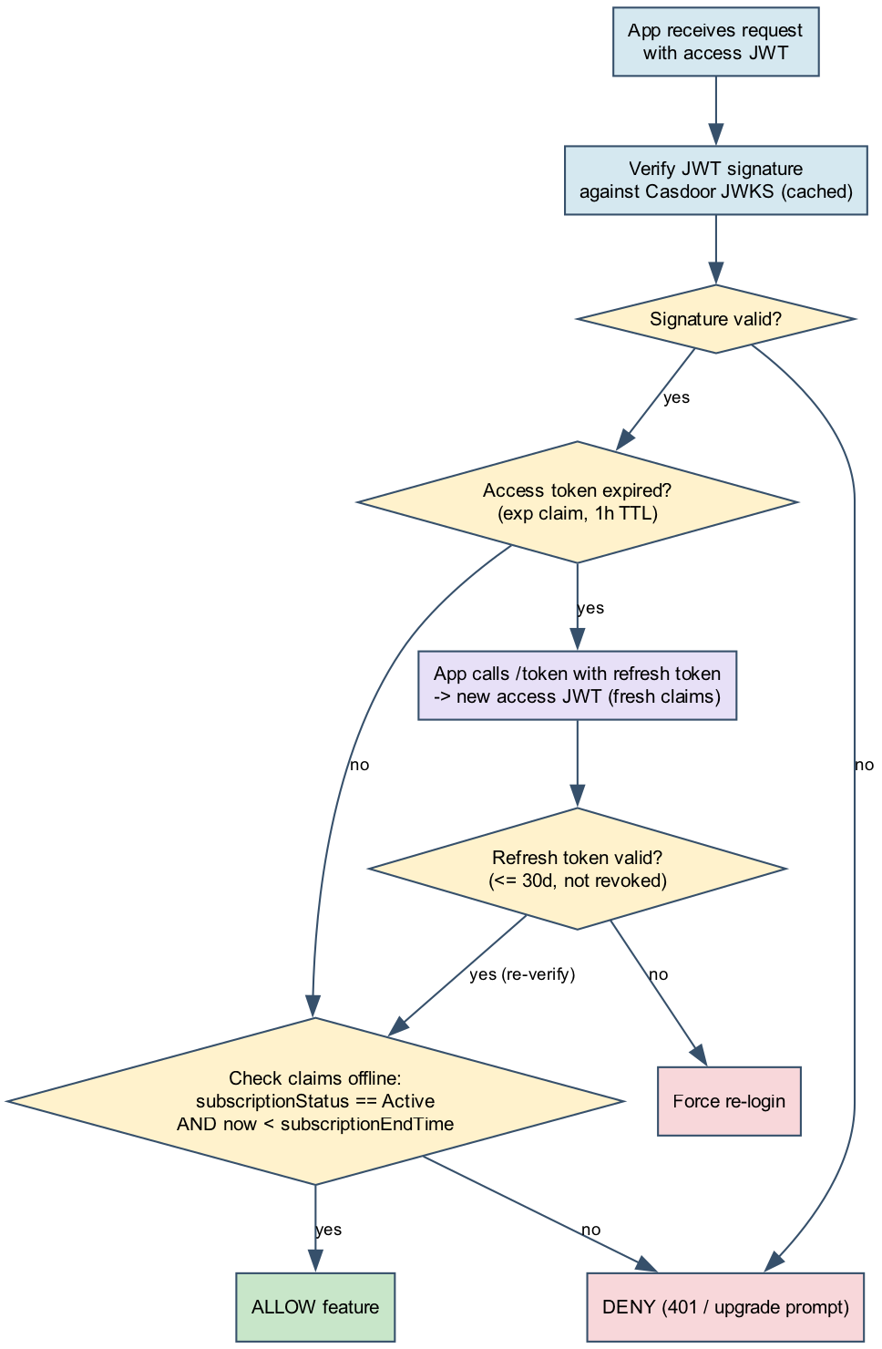
Figure 5. Offline JWT verification, refresh, and subscription gating.
Accepted trade-off: a user whose subscription expires or is cancelled mid-token retains access for up to the 1-hour access-token TTL. This is the cost of offline verification; an online check can be added at specific sensitive actions later if instant revocation is required.

6. Database Design
Casdoor persists all state in PostgreSQL via its ORM. The entities below are the subset relevant to this design. Primary keys in Casdoor are the composite (owner, name); owner is the organization for most tenant-scoped entities. The diagrams are split into identity/tenancy and subscription/token halves for legibility.
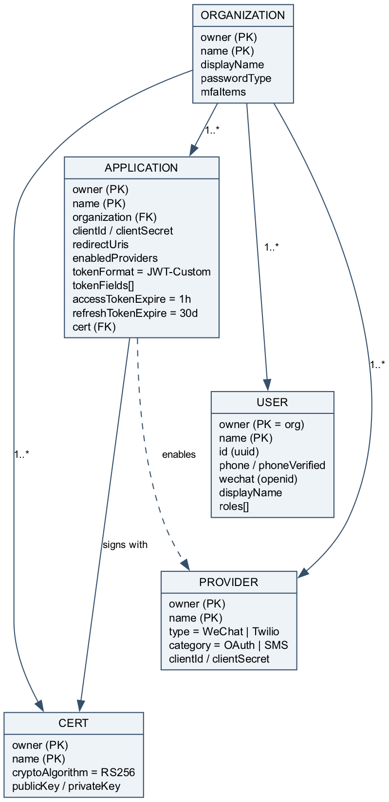
Figure 6a. Identity & tenancy entities.
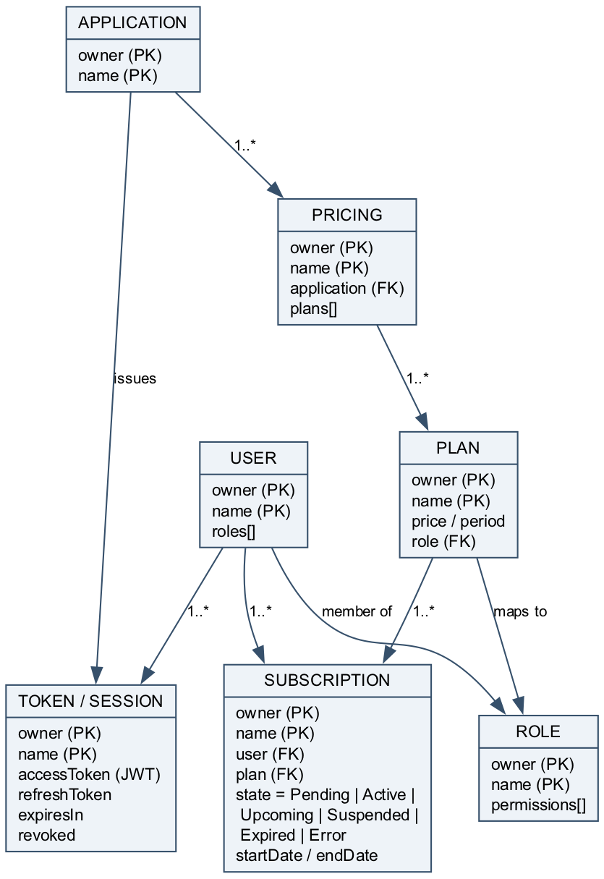
Figure 6b. Subscription & token entities.

6.1 Key Entities
APPLICATION — registration and token configuration:
Field | Type | Notes
owner, name | string (PK) | Composite primary key
organization | string (FK) | Tenant the app belongs to
clientId, clientSecret | string | OAuth2 client credentials
redirectUris | string[] | Allowed OIDC redirect targets
enabledProviders | string[] | WeChat, Twilio (SMS)
tokenFormat | enum | JWT-Custom
tokenFields | string[] | [Id, Name, DisplayName, Properties] -> subscription data emitted as nested 'properties' claim
accessTokenExpire | int (hours) | 1 hour (expireInHours)
refreshTokenExpire | int (min) | 30 days
cert | string (FK) | Signing certificate (RS256)

SUBSCRIPTION — ties a user to a plan with a lifecycle state:
Field | Type | Notes
owner, name | string (PK) | Composite primary key
user | string (FK) | Subscriber
plan | string (FK) | Selected plan (maps to a role)
state | enum | Pending | Active | Upcoming | Suspended | Expired | Error
startDate, endDate | datetime | Validity window; endDate drives subscriptionEndTime claim

PLAN & ROLE — entitlement mapping:
Field | Type | Notes
plan.name | string (PK) | e.g. free, pro, pro-annual
plan.price, period | number / enum | Pricing and billing period
plan.role | string (FK) | Role granted while subscription active
role.permissions | string[] | Permissions enforced via Casdoor enforce API

7. Protocol Details

7.1 OIDC / OAuth2 Authorization Code Flow
- App redirects the browser to GET /login/oauth/authorize with response_type=code, client_id, redirect_uri, scope, and state.
- User authenticates on the hosted login page (WeChat QR or phone OTP).
- Casdoor redirects back to redirect_uri with an authorization code and the original state.
- App exchanges the code at POST /api/login/oauth/access_token (code + client_id + client_secret) for an ID token, access token (JWT), and refresh token.
- App fetches and caches the signing public key from the JWKS endpoint to verify tokens offline.
- On access-token expiry, the app calls the token endpoint with grant_type=refresh_token to obtain a fresh access token.

7.2 Endpoints
Endpoint | Method | Purpose
/login/oauth/authorize | GET | Start authorization code flow
/api/login/oauth/access_token | POST | Exchange code or refresh token for tokens
/.well-known/openid-configuration | GET | OIDC discovery document
/.well-known/jwks.json | GET | Public signing keys for offline verification
/api/login/oauth/introspect | POST | Optional online token introspection
/api/logout | POST | End session / revoke

7.3 JWT Structure & Claims
Tokens use the JWT-Custom format signed with RS256. The header carries alg and kid; the signature is verified against the JWKS public key. The payload carries standard OIDC claims plus the custom subscription claims that drive offline gating.
Claim | Example | Meaning
sub | uuid | User identifier
iss | https://auth.example.com | Issuer (Casdoor)
aud | App A clientId | Audience / application
org | org-app-a | Tenant organization
iat / exp | epoch | Issued-at / expiry (1 hour after iat)
properties.plan | pro | Active plan name
properties.role | pro-role | Role backing the plan
properties.subscriptionStatus | Active | Pending | Active | Upcoming | Suspended | Expired | Error
properties.subscriptionEndTime | 2026-12-31T00:00:00Z | Expiry used for offline check (RFC3339)
Casdoor's JWT-Custom token fields select User struct fields, not arbitrary keys (verified on v1.812.0). The subscription data lives in the user's Properties and is emitted as a single nested "properties" claim by setting token fields to [Id, Name, DisplayName, Properties].
App-side gate: verify signature against the public key, then require properties.subscriptionStatus == "Active" AND now < properties.subscriptionEndTime.

8. Threading & Concurrency Design
Casdoor is a stateless Go service: each inbound HTTP request is served on its own goroutine by the underlying HTTP server, so request concurrency scales with available CPU and the goroutine scheduler rather than a fixed thread pool. Shared state lives in PostgreSQL, accessed through a bounded connection pool. The design keeps the auth server horizontally scalable later because no per-request state is held in process beyond caches.
Concern | Design / mitigation
Request concurrency | Goroutine-per-request (Go net/http). No shared mutable request state; CPU-bound crypto (RS256 signing) parallelizes across cores.
Database access | Bounded PostgreSQL connection pool (max-open / max-idle tuned). Transactions kept short; subscription state reads are single-row lookups.
JWKS / key handling | Signing key loaded once and cached in memory; apps cache JWKS client-side with periodic refresh to avoid per-request fetches.
OTP issuance | Per-phone rate limiting and short OTP TTL to bound SMS abuse and brute force; verification attempts are counted and throttled.
Refresh-token rotation | Refresh exchange is a short serialized DB transaction; a revoked/rotated token is rejected to prevent replay under concurrent refresh.
Subscription state writes | Lifecycle transitions (Active -> Expired, etc.) are atomic single-row updates; the next token issuance reads the committed state.
Idempotency | OAuth authorization codes are single-use and short-lived; concurrent code redemption is rejected after first use.
Caching staleness | Offline JWT verification accepts staleness bounded by the 1-hour access-token TTL by design (see 5.2).

9. Threat Model & Risk Analysis
The analysis below follows the STRIDE categories against the auth server's trust boundaries: the public edge (browser/app to proxy), the auth core, the datastore, and the external providers (WeChat, Twilio).

9.1 STRIDE Threats & Mitigations
Category | Threat / vector | Mitigation | Severity
Spoofing | Stolen access token replayed against an app | Short 1-hour access TTL; RS256 signature verification; TLS everywhere | High
Spoofing | OTP brute force / SIM-based phishing | Per-phone rate limits, short OTP TTL, attempt throttling | High
Tampering | Forged or altered JWT claims | Asymmetric RS256 signing; apps verify against JWKS; never trust unsigned claims | High
Repudiation | Disputed login / privilege change | Casdoor audit logs for auth and admin actions; retain logs | Medium
Info disclosure | Leak of client secrets / signing key / DB creds | Secrets via env/secret files (never committed); least-privilege DB user; cert rotation | High
Info disclosure | PII exposure (phone, WeChat openid) | TLS in transit; restrict admin access with MFA; encrypt backups | Medium
DoS | Authorization / token endpoint flooding | Rate limiting at reverse proxy; connection-pool bounds; stateless scale-out path | Medium
Elevation | Privilege gain via stale subscription claim | Bounded 1-hour staleness; online check for sensitive actions if needed | Medium
Elevation | Account-linking confusion across methods | Link only by verified phone; explicit linking rules | Medium

9.2 Risk Register
Risk | Likelihood | Impact | Mitigation / owner action
Signing key compromise | Low | Critical | Dedicated cert, restricted access, rotation plan, revoke + reissue procedure
Casdoor CVE / upstream bug | Medium | High | Pin versions, watch advisories, patch cadence, staging before prod
Single-host outage (no HA in v1) | Medium | High | Backups + documented restore; HA topology is a planned follow-up
SMS provider outage (Twilio) | Low | Medium | WeChat remains available; provider is pluggable; alerting on send failures
Subscription-claim staleness abuse | Low | Medium | Short TTL; add online check at high-value actions if warranted
Misconfiguration during provisioning | Medium | Medium | Version-controlled IaC bootstrap; integration tests assert config

10. Deployment & Operations
- Docker Compose on a single host running two services: casdoor and postgres, behind a reverse proxy (Caddy/Nginx) for TLS.
- Secrets (WeChat appid/secret, Twilio keys, JWT signing cert, DB credentials) supplied via environment or secret files; never committed to the repository.
- The JWT signing certificate is the root of trust: generate a dedicated cert and plan rotation.
- Regular PostgreSQL backups; encrypted at rest where possible.
- Admin accounts protected with MFA (Casdoor supports TOTP).

10.1 Testing Strategy
- Stand up the Compose stack, run the bootstrap layer, and assert an application can complete the OIDC login flow (WeChat/Twilio providers mocked/stubbed).
- Assert issued tokens carry correct subscription claims (plan, role, subscriptionStatus, subscriptionEndTime).
- Assert the verification helper accepts an active subscription and rejects an expired or suspended one.
- Assert refresh-token rotation works and a revoked refresh token is rejected.

11. Open Decisions (Defaulted)
Decision | Default chosen | Revisit when
Tenancy topology | One organization per application | Shared SSO across apps is needed
Access token TTL | 1 hour | Faster revocation or fewer refreshes desired
Refresh token TTL | 30 days | Different session-length policy required
Account-linking rule | Link by verified phone | Additional identity signals introduced

12. References
- Casdoor subscription: https://casdoor.org/docs/pricing/subscription/
- Casdoor plan/pricing: https://casdoor.org/docs/pricing/plan/
- Casdoor token formats (JWT-Custom): https://casdoor.org/docs/token/overview/
- Source spec: docs/superpowers/specs/2026-05-20-auth-server-design.md

