Thank you for taking patience to read this guide:) this is a personalized user interface mostly according to my interest. It may take much time to discover the buttons without attention (although there are tip texts added) so I pointed out the buttons for convenience. Please take some time to read and have fun!

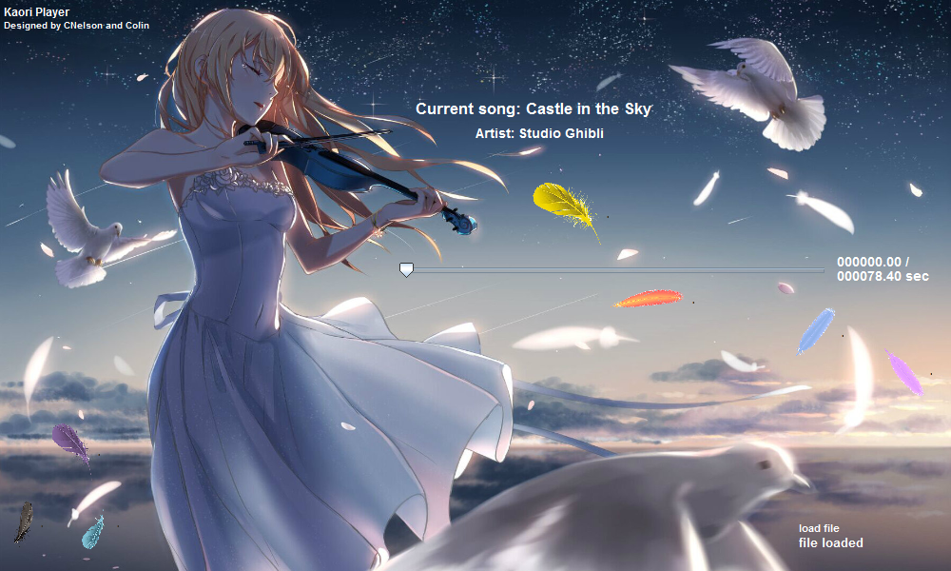

Status

Octave

Tempo

Reverse

Exit

Minimize

Load File

Play

Song info

When playing, the start button will change to pause and the stop button will show and the reverse and load button will hide.

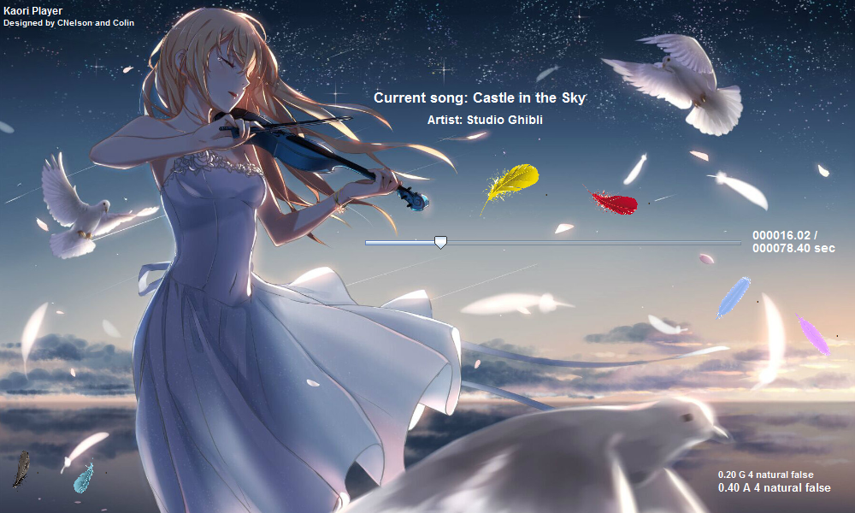

Stop

Pause

The octave button will show if we click the pink feather and will hide after we click other place. So as the tempo button which is the blue feather. We can adjust the tempo in two ways, either directly input the expected tempo into the textbox and click ok or use the slide to adjust the tempo from 0.1 to 1.9. With the reset button we can get the tempo back to 1.

By Gongyao