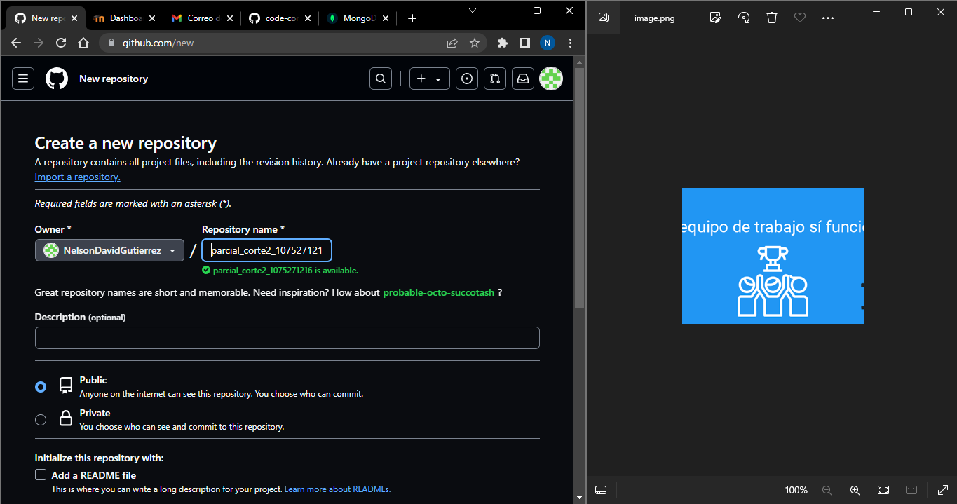

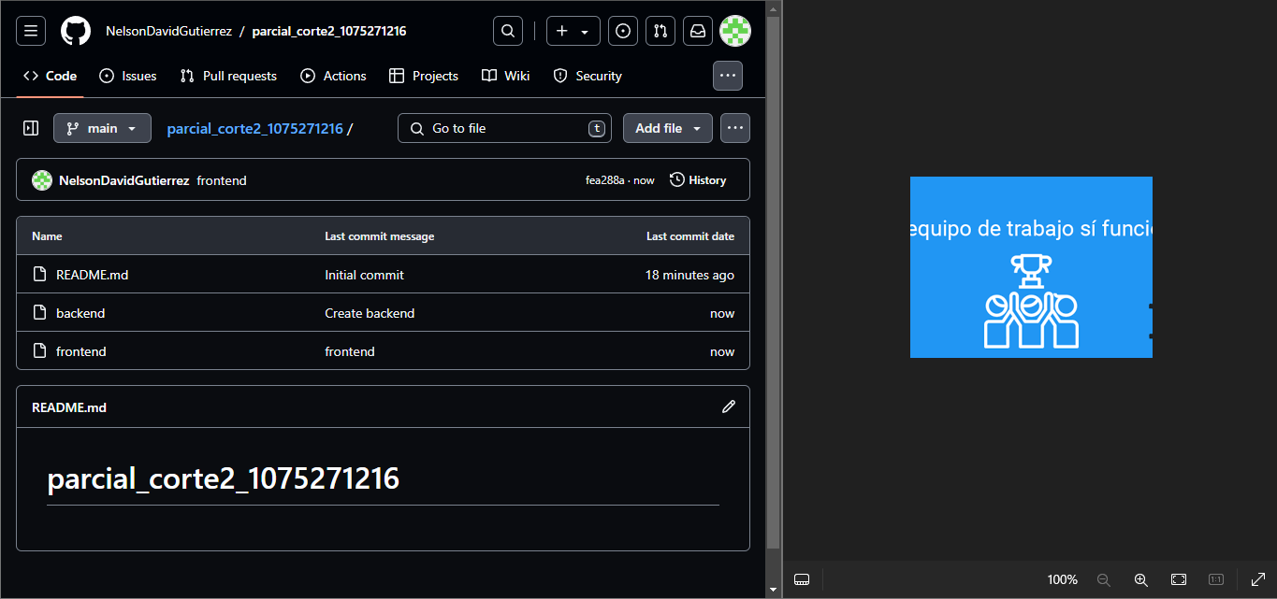

<https://github.com/NelsonDavidGutierrez/parcial_corte2_1075271216.git>