LOW VALUE CONTENT

Low Value Content Business Plan
Social media satire apparel launch and validation plan
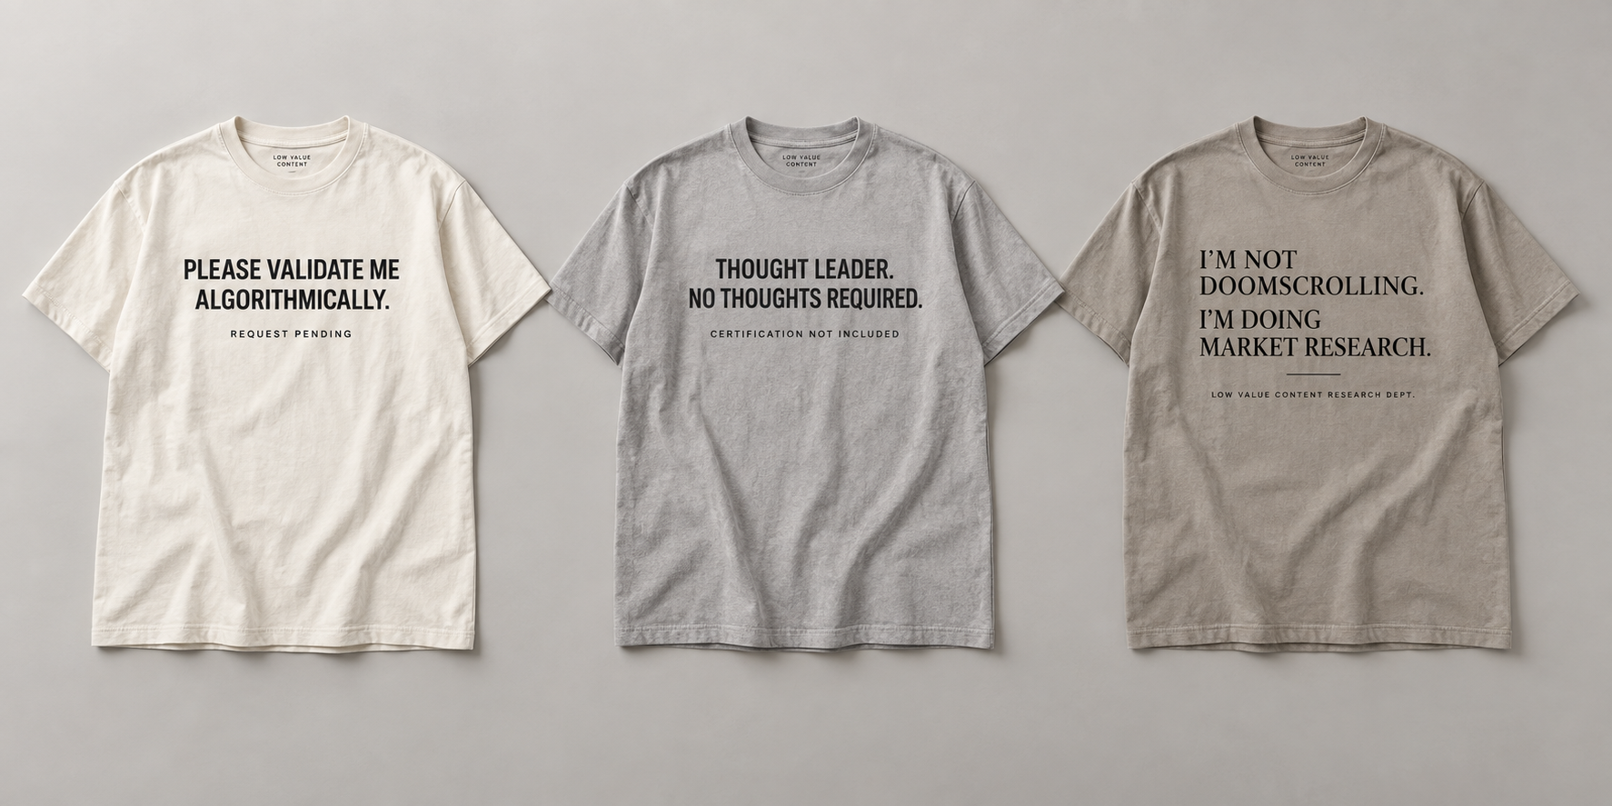
Prepared September 28 2026
Working business plan for founder review

Executive Summary
Low Value Content is a proposed direct to consumer apparel brand built around concise satire of social media, creator culture, workplace performance, algorithmic validation, doomscrolling, and artificial authenticity. The concept is easy to imitate at the product level. Its commercial case therefore depends on unusually strong writing, a consistent editorial design system, disciplined product quality, and an audience that returns for new releases.
Current marketplace evidence supports a low cost test. Etsy has active demand for adjacent creator, algorithm, doomscrolling, and LinkedIn humor shirts, including listings with hundreds or thousands of reviews. The same evidence also shows crowded competition and frequent discounting. A six design print on demand launch is justified; a large inventory purchase, custom mobile application, or fifty design production run is not yet justified.
The recommended first offer is a premium heavyweight Comfort Colors 1717 shirt at 32 dollars plus shipping, fulfilled through print on demand. Under the planning assumptions in this document, each Shopify order contributes about 18.98 dollars before monthly platform cost, advertising, refunds, samples, design labor, and income tax. The business remains attractive when customer acquisition stays below about 10 dollars. It becomes marginal when each sale requires 15 to 20 dollars in paid advertising.

Launch Decision
Decision area | Recommendation | Reason
Initial assortment | Six shirts | Tests the voice without diluting attention across fifty listings
Production | Print on demand | Avoids size and design inventory risk
Primary garment | Comfort Colors 1717 | Premium weight and finish support the intended positioning
Price | $32 plus shipping | Provides room for product cost and modest acquisition spending
Store | Mobile friendly web store | A native application adds cost without proven repeat usage
Expansion | Release winners in drops | Moves investment toward demonstrated demand

Conditions for Continued Investment
- At least 25 to 50 purchases from customers outside the founders personal network during the first four weeks.
- Two or more designs show demand so the result is not dependent on one accidental winner.
- Store conversion reaches roughly 2 percent or better after traffic quality is reviewed.
- Customer acquisition cost remains below 10 dollars and contribution after marketing remains above 8 to 10 dollars per shirt.
- Samples and customer feedback confirm that the garment and print feel justify premium pricing.

Company Concept

Brand Name
The working brand name is Low Value Content. The name functions as criticism of low quality online material and as self aware commentary on the shirt itself. A preliminary web search found no obvious exact apparel collision, and a WHOIS lookup on September 28 2026 returned no registration match for lowvaluecontent.com. Neither result constitutes trademark clearance, and domain availability can change immediately.

Positioning
The brand targets people who participate in online culture while remaining skeptical of its incentives. The humor should criticize platform behavior, corporate performance, creator economics, and compulsive consumption. It should not depend on attacking individual users or protected groups.
The proposed visual language uses neutral heavyweight garments, one color printing, editorial typography, restrained interface references, and small brand details. This system distinguishes the collection from novelty shirts that rely on loud clip art, generic templates, and isolated jokes.

Working Brand Promise
Low Value Content publishes wearable observations about online life. Each release should be specific enough to feel recognized, concise enough to read at a glance, and designed well enough to be worn after the joke is understood.

Product Principles
- The joke must work without a product description.
- The design must look intentional even when the viewer does not read every word.
- The shirt must feel like apparel rather than promotional merchandise.
- The collection must use a consistent voice without repeating the same joke structure.
- Platform names, logos, interface elements, and third party trade dress require additional review.

Initial Audience
Audience | Relevant tension | Likely message fit
Professionals and managers | Required participation in workplace posting and personal branding | Social Media Theater
Creators and marketers | Dependence on engagement systems they also criticize | Creator Economy and Algorithm Anxiety
Technology workers | Awareness of platform mechanics and automated content | Artificial Authenticity
Chronically online consumers | Humor about attention, notifications, and doomscrolling | Chronically Online
Gift buyers | Need for specific occupational or personality humor | Best selling individual statements

Market Assessment

Evidence of Adjacent Demand
The available evidence shows a market for adjacent products rather than proof of demand for this exact brand. Etsy reported 86.5 million active buyers, 5.6 million active sellers, and more than 100 million items for sale at the end of 2025. Apparel was among its six largest merchandise categories. Etsy also reported that custom or made to order merchandise represented about 30 percent of marketplace gross merchandise sales.
Marketplace searches show more than 1,000 content creator shirt results and roughly 491 algorithm shirt results. Visible examples commonly sell between about 17 and 35 dollars. Several listings have hundreds or thousands of reviews. Doomscrolling and LinkedIn satire listings also show triple digit review counts. These signals support a launch test, but they also reveal a saturated market with heavy discounting and weak barriers to entry.

Competitive Structure
Competitor type | Strength | Weakness | Response
Etsy POD sellers | Search traffic and low prices | Inconsistent identity and quality | Use a coherent brand and premium samples
Redbubble and marketplace artists | Large catalogs and easy discovery | Commodity presentation and limited customer relationship | Build owned email and website traffic
Corporate humor brands | Clear occupational audience | Often broad and generic | Stay specific to online behavior
Creator merchandise | Existing audience and trust | Usually attached to one personality | Build an editorial voice that supports many contributors
Fast copycat sellers | Rapid imitation and discounting | Weak originality and customer loyalty | Release often and protect core brand assets

Market Conclusion
Low Value Content has a plausible niche because the subject is culturally current, apparel purchases already occur around adjacent jokes, and print on demand keeps the test inexpensive. The opportunity is unsuitable for a large initial investment because competitors can copy short sayings and because customer acquisition costs can absorb most of the margin. The business should proceed as a measured brand experiment with explicit stop and scale criteria.

Differentiation Requirements
- A recognizable editorial voice across every release.
- Stronger garments and print quality than commodity novelty shirts.
- A consistent visual system that remains flexible across ten collections.
- Fast publication of new observations tied to online behavior without chasing every temporary meme.
- Owned customer relationships through the website and email rather than total marketplace dependence.

Product Portfolio

Ten Collections
Collection | Subject | Example
Social Media Theater | Posting, promotions, thought leadership, and public performance | Thought leader No thoughts required
Algorithm Anxiety | Engagement, recommendation systems, validation | Please validate me algorithmically
Creator Economy | Monetization, personal brands, content production | Content creator Meaning pending
Chronically Online | Doomscrolling, notifications, attention | I am not doomscrolling I am doing market research
Artificial Authenticity | AI content, edited vulnerability, simulated sincerity | Authenticity now available as a service
Future of Work | AI, automation, humanoid robots, and employment hype | Your replacement is currently rebooting
Productivity Theater | Meetings, hustle, efficiency, and visible busyness | Busy is my core competency
Performative Sustainability | Greenwashing, energy contradictions, and corporate virtue | Carbon neutral PowerPoint
Terms and Conditions | Subscriptions, privacy, apps, and digital ownership | Basic personality Premium features
Optimized Human | Wellness, self tracking, and compulsory self improvement | Mindfulness but competitively

Ten Featured Shirt Examples
The first six remain the recommended validation assortment. Four additional examples demonstrate how the design system extends into the newer collections without requiring all ten shirts to enter production at launch.
1. Please validate me algorithmically.
2. Thought leader. No thoughts required.
3. I am not doomscrolling. I am doing market research.
4. Content creator. Meaning pending.
5. My authentic self is currently being monetized.
6. I optimized this shirt for engagement.
7. Your replacement is currently rebooting.
8. Busy is my core competency.
9. Basic personality. Premium features.
10. Mindfulness, but competitively.
Concept mockups for the first three launch designs
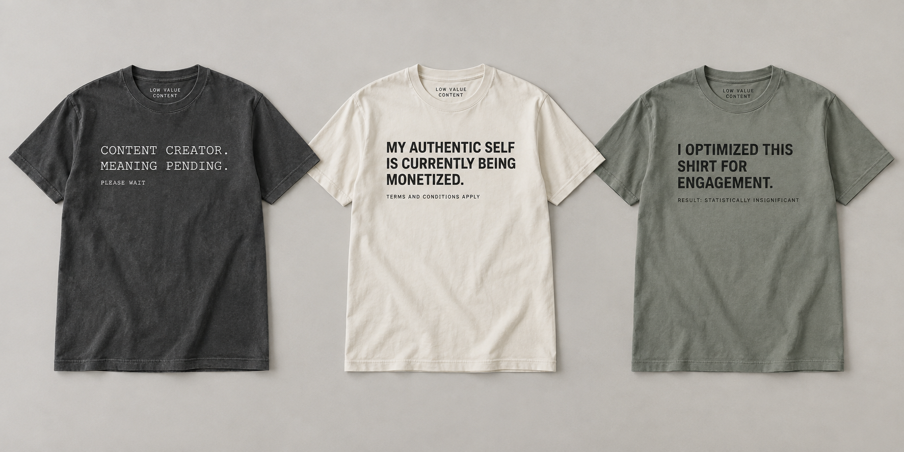
Concept mockups for the companion three launch designs
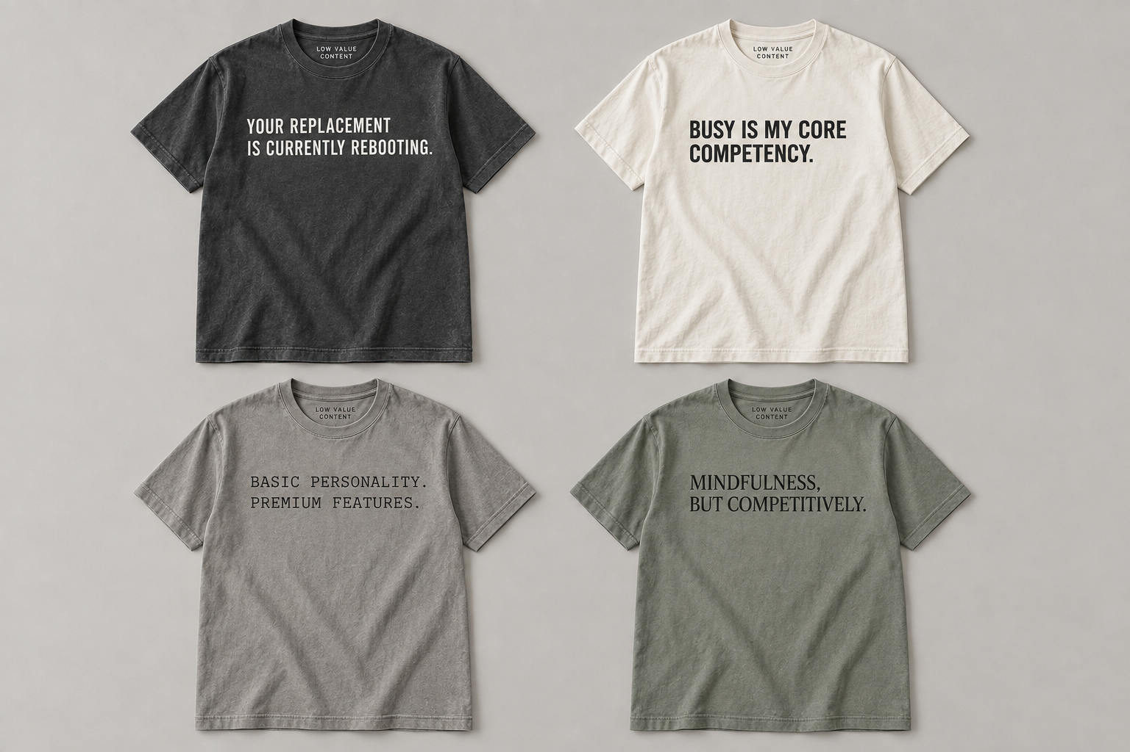
Four expansion examples from the extended collection matrix
The mockups illustrate the intended garment, color, and typography system. They are not production artwork. Final files require licensed fonts, outlined text, printer specific dimensions, color specifications, and sample approval.

Intellectual Property and Brand Protection

What the Business Can Protect
The strongest protectable asset is the Low Value Content brand as a source identifier for clothing and related goods. A federal intent to use trademark application may be filed before launch if a comprehensive clearance search supports the name. Registration requires later evidence of genuine commercial use.
Original human authored illustrations and sufficiently creative graphic compositions can receive copyright protection. The Copyright Office generally does not protect names, slogans, short phrases, ideas, familiar symbols, or basic typography. Individual shirt sayings will therefore be difficult to own exclusively even when the business creates them independently.

Required Protection Steps
1. Complete a comprehensive search for Low Value Content and confusingly similar marks across federal, state, business name, domain, social, and marketplace records.
2. Register the domain and relevant social handles, but delay a major public launch until name clearance is complete.
3. Use the brand on neck labels, hangtags, packaging, receipts, and storefront materials so it functions as a source identifier rather than only as decoration.
4. Use the trademark symbol while claiming the brand and reserve the registration symbol for a federally registered mark.
5. Keep dated drafts, source files, artist briefs, invoices, licenses, and publication records.
6. Require contractors to assign relevant artwork and usage rights in writing.
7. Register important human authored visual works when their commercial value justifies the cost.

Specific Risks
Risk | Why it matters | Control
Ornamental trademark refusal | Large front text may be viewed as decoration rather than branding | Use Low Value Content on labels, packaging, and consistent source identifying locations
Third party platform marks | Names, logos, colors, and interface trade dress may imply affiliation | Use commentary carefully and avoid copied logos or exact interface reproduction
Phrase collision | Short jokes may have prior commercial use | Search exact wording, variants, marketplaces, and trademark records before production
AI authorship limits | Purely generated artwork may lack copyright protection | Use substantial human selection, arrangement, drawing, and revision
Copycats | Successful sayings can be reproduced quickly | Compete through release cadence, customer relationship, garment quality, and brand recognition

Business Model and Operations

Recommended Sales Architecture
The first launch should use a mobile friendly website connected to a print on demand provider. A native iOS application should wait until repeat purchase behavior or product drops create a clear reason for installation and push notifications.
Stage | Store and fulfillment | Purpose
Validation | Printify Pop Up Store or Shopify with Printify | Launch quickly without inventory
Brand development | Shopify with Apliiq or a controlled POD provider | Improve labeling, packaging, analytics, and customer experience
Proven designs | Local screen printer plus stocked inventory | Improve unit cost and print consistency
Scale | Hybrid stocked winners and POD long tail | Preserve assortment while concentrating inventory on demand

Fulfillment Workflow
1. The customer selects the saying, garment color, and size.
2. The storefront accepts payment and sends the order to the POD provider.
3. The provider prints, packs, ships, and returns tracking information.
4. The storefront sends shipment updates and handles customer communication according to the providers service model.
5. Sales data identifies designs that qualify for bulk production.

Garment and Print Standards
- Primary blank: Comfort Colors 1717 or another verified heavyweight relaxed fit shirt.
- Initial printing: one color direct to garment for POD flexibility.
- Scaled printing: one or two color screen printing for proven designs.
- Initial palette: ivory, washed charcoal, stone, and muted gray green, subject to print testing.
- Every offered design and color combination must be sampled and washed at least three times before launch.

Quality Review
- Print alignment, opacity, edge quality, and placement.
- Collar shape, body length, shrinkage, and size consistency.
- Cracking, fading, or color migration after washing.
- Packaging, delivery time, and tracking quality.
- Correct neck branding and removal of unintended manufacturer labeling where promised.

Unit Economics

Planning Assumptions
Input | Assumption | Basis
Garment | Comfort Colors 1717 | Premium heavyweight positioning
POD production | $12.65 | Current Printify starting price
POD shipping | $3.99 | Current economy shipping starting price
Retail price | $32.00 | Premium but within visible adjacent market range
Shipping charged | $4.99 | Customer facing planning rate
Shopify processing | 2.9% plus $0.30 | Current Basic plan standard online rate
Shopify subscription | $39 monthly | Month to month Basic plan

Shopify POD Contribution
Line item | Per order
Shirt revenue | $32.00
Shipping collected | $4.99
Total collected | $36.99
Shirt and printing | ($12.65)
POD shipping | ($3.99)
Payment processing | ($1.37)
Contribution before overhead and marketing | $18.98

Monthly Platform Allocation
Monthly shirt sales | Shopify cost per shirt | Contribution after platform allocation
10 | $3.90 | $15.08
25 | $1.56 | $17.42
50 | $0.78 | $18.20
100 | $0.39 | $18.59

Etsy POD Contribution
Line item | Per order
Total collected | $36.99
Production and shipping | ($16.64)
Etsy transaction fee | ($2.40)
Estimated US payment processing | ($1.36)
Listing renewal | ($0.20)
Contribution before advertising | $16.39
Contribution after a 15% Offsite Ad fee | $10.84

Customer Acquisition Sensitivity
POD contribution | Acquisition cost | Remaining contribution
$18.98 | $0 | $18.98
$18.98 | $8 | $10.98
$18.98 | $15 | $3.98
$18.98 | $20 | ($1.02)

Bulk Production Economics
Published 2026 examples place a one color Comfort Colors shirt around 13 to 14 dollars at 24 units and near 11 dollars around 96 units. Exact quotes depend on garment color, sizes, ink colors, print locations, setup, freight, and turnaround. Each saying is normally a separate print run, so ordering fifty units across six designs does not receive the same economics as three hundred identical shirts.
Bulk production should begin only after sales identify repeatable winners. The principal financial benefit is a lower production cost. The principal financial risk is unsold inventory divided across designs, colors, and sizes.

Costs Excluded From Contribution
- Advertising, influencer compensation, affiliate commissions, and content production.
- Samples, photography, font licenses, design labor, and legal review.
- Refunds, replacements, chargebacks, and customer service time.
- Sales tax obligations, income tax, insurance, bookkeeping, and business registration.
- Discounts, bundles, free shipping differences, and costs for larger sizes or extra print locations.

Marketing and Sales Plan

Channel Priorities
Channel | Role | Initial approach
Owned website | Primary brand and conversion destination | Six products, clear fit and shipping information, email capture
Instagram and TikTok | Visual discovery and shareable satire | Short observations, design reveals, customer wear shots
LinkedIn | Contextual distribution for workplace satire | Use restrained posts that demonstrate the joke rather than imitate engagement bait
Etsy | Marketplace demand capture | List selected proven designs and protect margin from fee stacking
Email | Repeat purchase and product drop channel | Early access, voting, and release announcements
Creator partnerships | Credible access to aligned audiences | Gift or affiliate arrangements with clear disclosure

Launch Content
- A concise brand introduction that explains the target of the satire.
- One post for each launch saying showing the observation, design, and shirt.
- A comparison of the garment and print quality against ordinary novelty shirts.
- A customer vote on the next release from the remaining catalog.
- Behind the design material that shows human editing and authorship without overstating exclusivity.

QR Code Product Experience
A QR code on the upper back of every shirt can become a recognizable Low Value Content feature. The front should deliver a complete joke by itself. The QR code then rewards curiosity with a continuation, reveal, or small interaction before offering a restrained path to the store. This turns an observed shirt into a measurable discovery channel without making the garment feel like an advertisement.
Stage | Customer experience | Business role
Front of shirt | A complete, readable setup or joke | Earns attention without requiring a phone
Back prompt | A short invitation placed with the QR code | Creates a reason to scan
Joke page | An immediate continuation, reveal, animation, or deliberately low value result | Completes the interaction before selling
Store path | A discreet link to the featured shirt and broader collection | Converts interest without interrupting the joke

Recommended Implementation
- Assign each design a permanent URL on the owned domain, such as lowvaluecontent.com/q/doomscrolling, and place the printed short URL beneath the code as a fallback.
- Use a redirect controlled by Low Value Content so the destination can change after shirts have been printed without breaking the code.
- Show the joke continuation immediately. Do not require an app, account, email address, or extra permissions before the payoff.
- Track aggregate scans by design, campaign, and production batch while avoiding unnecessary personal data collection.
- Add the purchase link only after the continuation, with the scanned design preselected where practical.

Print and Quality Requirements
- Target an approximately 4 by 4 inch code on a relatively flat upper-back area, with strong contrast and a clear quiet zone around the code.
- Use a short destination URL so the generated pattern remains simple and tolerant of fabric texture, wrinkles, curvature, and normal print variation.
- Avoid seams, pockets, distressed treatments, gradients, ribbed fabric, and highly stretchable placements that can distort the modules.
- Test every garment color and print method while the shirt is flat, worn, wrinkled, stretched, and washed. Confirm scanning with several common phones and from realistic distances.
- Price the second print location before adoption. A back print can materially increase POD and bulk production cost, so the QR feature must be included in the unit economics and sample review.

Example Experience
Front: I am not doomscrolling. I am doing market research.
Back prompt: View the findings
Scan result: Finding 1: Everyone is pretending this counts as work. Finding 2: You just scanned someone's shirt.
A universal back prompt can also unify the catalog: This shirt contains additional low value content.

Pricing Tests
Offer | Purpose | Caution
$32 plus shipping | Baseline margin and transparent product price | Shipping may reduce checkout conversion
$36 delivered | Simpler message and free shipping expectation | Margin changes with destination
Two shirt bundle | Increase order value and distribute shipping cost | Discount must preserve contribution
Limited preorder | Measure demand before bulk printing | Communicate production and delivery dates clearly

Launch Roadmap
Phase | Timing | Work | Exit condition
Name and rights | Week 1 | Trademark clearance, domain, handles, contractor terms | Name approved for controlled use
Product preparation | Weeks 1 to 2 | Finalize six designs, choose fonts, order samples | All samples pass visual and wash review
Store preparation | Weeks 2 to 3 | Build product pages, policies, analytics, email capture | Test order completes successfully
Soft launch | Week 4 | Release to limited owned audience and collect feedback | No critical quality or fulfillment defects
Validation period | Weeks 5 to 8 | Organic distribution and limited paid tests | Meet or miss defined validation measures
Scale decision | End of week 8 | Select winners, revise pricing, request bulk quotes | Documented continue, revise, or stop decision

Validation Scorecard
Measure | Target | Interpretation
Non network purchases | 25 to 50 | Evidence that demand extends beyond friends and family
Store conversion | About 2% or better | Review traffic quality before judging the site
Customer acquisition cost | Below $10 | Preserves useful contribution on a $32 shirt
Contribution after marketing | $8 to $10 or more | Supports overhead and continued design work
Design distribution | At least two viable designs | Reduces dependence on one accidental hit
Quality defect rate | Below 3% | Signals whether the provider and artwork are reliable
Return and replacement requests | Below 5% | Tests sizing communication and print quality
Email opt in | Track baseline | Measures future release potential rather than one time sales only

Decision Rules
- Continue when several designs sell, contribution remains positive after acquisition, and product feedback supports premium pricing.
- Revise when customers like the writing but object to garment quality, fit, shipping, or price.
- Stop or pause when sales rely on personal contacts, acquisition exceeds contribution, or one design accounts for nearly all demand without repeat interest.
- Move a design to bulk printing only after its sales history supports a size and color forecast.

Risk Register
Risk | Likelihood | Impact | Mitigation
Crowded novelty apparel market | High | High | Narrow voice, premium product, six design test
Weak paid advertising economics | High | High | Cap tests, track contribution, emphasize organic and partnerships
Copied sayings and designs | High | Medium | Protect brand, retain source files, publish consistently
Trademark conflict | Medium | High | Complete clearance before major investment
POD quality variation | Medium | High | Sample every offered variant and control providers
Size and fit dissatisfaction | Medium | Medium | Publish exact garment measurements and fit photographs
Platform policy or account dependence | Medium | Medium | Maintain owned domain, customer list, and exportable assets
Humor becomes hostile or dated | Medium | Medium | Use editorial review and retire weak designs
Bulk inventory does not sell | Medium | High | Use POD until design level demand is demonstrated

Management Priorities
1. Clear the Low Value Content name and secure the domain before broader disclosure.
2. Select the six launch sayings and complete exact phrase, marketplace, and trademark screening.
3. Finalize licensed typography and one color production files.
4. Order samples from at least two POD configurations and select the provider from physical evidence.
5. Build the smallest store that supports a reliable purchase and fulfillment flow.
6. Launch with explicit validation measures and record the result before adding products or inventory.

Appendix A Complete Saying and Design Catalog
The following one hundred concepts are a creative working inventory. They have not received complete trademark, marketplace, or prior use clearance. Status labels indicate creative priority rather than legal approval.

Collection 1: Social Media Theater
No | Saying | Visual direction | Status
1 | Thought leader. No thoughts required. | Severe condensed type; tiny fake credential line below | Launch
2 | Building my personal brand instead of a personality. | Corporate sans serif inside a fake brand-guidelines grid | Launch
3 | This meeting could have been a LinkedIn post. | Calendar-invite layout with the duration crossed out | Develop
4 | I leveraged a walk into a journey. | Overwritten corporate announcement treatment | Launch
5 | Humblebragging at enterprise scale. | Small chest copy with oversized upward graph on back | Develop
6 | Delighted to announce I remain employed. | Faux celebratory announcement with restrained confetti | Launch
7 | Open to work. Closed to networking. | Status badge with contradictory toggle controls | Launch
8 | My career journey has terms and conditions. | Legal fine print flowing into a road icon | Develop
9 | Promoted by the power of posting constantly. | Achievement badge labeled MOST VISIBLE | Hold
10 | I endorsed myself for self-awareness. | Skill-endorsement bars, with self-awareness at 1% | Develop

Collection 2: Algorithm Anxiety
No | Saying | Visual direction | Status
11 | Please validate me algorithmically. | Centered institutional type with a tiny verification spinner | Launch
12 | I optimized this shirt for engagement. | A/B-test labels and fake conversion metrics | Launch
13 | The algorithm and I are taking some space. | Relationship-status form with “It’s complicated” selected | Launch
14 | Organic reach. Synthetic personality. | Two-column nutrition-label composition | Launch
15 | My self-worth is buffering. | Minimal progress wheel beneath the sentence | Launch
16 | Engagement may vary by personality. | Pharmaceutical-warning layout | Develop
17 | Recommended for reasons nobody can explain. | Recommendation card with an empty “Why this?” field | Launch
18 | I contain sponsored opinions. | Ingredient-label design with “paid partnership” microtype | Develop
19 | Currently underperforming the benchmark. | Analytics dashboard with one brutally flat line | Develop
20 | Please allow 3–5 business days for relevance. | Customer-service ticket typography | Launch

Collection 3: Creator Economy
No | Saying | Visual direction | Status
21 | Content creator. Meaning pending. | Bold headline with a blinking-cursor block | Launch
22 | My authentic self is currently being monetized. | Price tag attached to a fingerprint-like abstract mark | Launch
23 | I went viral and all I got was this dopamine imbalance. | Souvenir-shirt arc with a tiny unstable waveform | Launch
24 | Follow me for more reasons to unfollow me. | Repeating follow/unfollow buttons in a loop | Launch
25 | Everything is content if you disrespect the moment enough. | Documentary timecode over a simple family-photo frame | Launch
26 | Monetize the memory before it fades. | Sentimental script interrupted by a checkout button | Develop
27 | I turned my personality into a funnel. | Marketing funnel diagram ending in a tiny person icon | Launch
28 | Behind every candid moment is seventeen takes. | Film contact-sheet grid numbered 01–17 | Launch
29 | Creator-owned. Audience-dependent. | Ownership stamp with dependency clause beneath | Develop
30 | I make content for people avoiding their lives. | Quiet editorial serif; no graphic beyond a small pause icon | Launch

Collection 4: Chronically Online
No | Saying | Visual direction | Status
31 | I’m not doomscrolling. I’m doing market research. | Research-department seal around a thumb-swipe icon | Launch
32 | Offline is currently unavailable. | System-status message and empty signal bars | Launch
33 | I came. I saw. I refreshed. | Classical inscription treatment with refresh icon | Launch
34 | Screen time is still time. | Minimal clock whose hands form a phone outline | Develop
35 | Mentally in airplane mode. | Small chest status icon with large back statement | Launch
36 | My attention span has left the chat. | Chat transcript with a single departure notification | Launch
37 | Touch grass request timed out. | Terminal-style error box with retry button | Launch
38 | I have no new notifications and must now face myself. | Lock-screen layout with an ominously empty notification area | Launch
39 | Seen 2:14 AM. Regretted 2:15 AM. | Read-receipt timestamps in tiny blue-gray type | Launch
40 | Do not disturb unless it’s engagement. | Phone-focus-mode badge with exception enabled | Develop

Collection 5: Artificial Authenticity
No | Saying | Visual direction | Status
41 | Authenticity, now available as a service. | SaaS pricing table with “Human” as the premium tier | Launch
42 | Generated from a genuine human prompt. | Compliance label with a human-input percentage | Launch
43 | My vulnerability has been professionally edited. | Redline marks and tracked changes around “vulnerability” | Launch
44 | This opinion was trained on other opinions. | Model-card layout with vague source citations | Launch
45 | Please excuse the human-generated errors. | Quality-control stamp with HUMAN INSIDE | Launch
46 | Original thought temporarily unavailable. | Maintenance screen with estimated return: unknown | Launch
47 | Emotionally optimized for conversion. | Heart icon feeding into a checkout graph | Develop
48 | I automated being relatable. | Workflow nodes connecting “trauma” to “engagement” | Develop
49 | Real person. Artificial urgency. | Countdown timer frozen at 00:09 | Launch
50 | Your authenticity score could not be verified. | Failed verification panel with a tasteful warning triangle | Launch

Collection 6: Future of Work
No | Saying | Visual direction | Status
51 | Your replacement is currently rebooting. | Workplace warning notice with a frozen robot status bar | Launch
52 | Fully autonomous. Adult supervision required. | Industrial certification badge with a tiny chaperone icon | Launch
53 | It walked for twelve seconds. Valuation: eight billion. | Investor slide with a sharply rising graph beside a stumbling robot | Launch
54 | Human form. Printer reliability. | Technical silhouette with a paper-jam warning | Launch
55 | The future of labor needs a software update. | Update dialog over a factory shift schedule | Develop
56 | Optimized for choreographed demonstrations. | Stage marks and camera framing around a humanoid outline | Launch
57 | My coworker is a beta feature. | Employee badge labeled BETA beneath a robot portrait | Develop
58 | General purpose. Specifically unhelpful. | Product specification sheet with every capability unchecked | Launch
59 | Please do not startle the workforce. | Safety placard with human and robot figures | Develop
60 | The robot took my job and opened a support ticket. | Help desk ticket showing the robot as both requester and assignee | Launch

Collection 7: Productivity Theater
No | Saying | Visual direction | Status
61 | Busy is my core competency. | Performance review form with every box marked busy | Launch
62 | Deep work. Shallow results. | Deep descending diagram ending in a tiny empty output box | Launch
63 | I optimized the process until nothing got done. | Circular process map with no exit node | Launch
64 | My calendar is my personality. | Overbooked weekly grid shaped like a portrait | Launch
65 | Productivity is my favorite form of procrastination. | Completed checklist beside one untouched priority | Launch
66 | Available for a quick ninety minute call. | Calendar invitation with QUICK selected and duration highlighted | Launch
67 | Currently aligning on alignment. | Nested alignment guides that never meet | Launch
68 | Operationally excellent at looking busy. | Excellence award ribbon attached to a spinning cursor | Develop
69 | My deliverable is a status update about the deliverable. | Project tracker containing one endlessly nested task | Launch
70 | Let’s circle back until it goes away. | Circular arrows fading with every rotation | Launch

Collection 8: Performative Sustainability
No | Saying | Visual direction | Status
71 | Carbon neutral PowerPoint. | Corporate slide thumbnail with a leaf shaped pie chart | Launch
72 | Sustainable until it becomes inconvenient. | Green toggle switched off beside the word inconvenient | Launch
73 | Net zero by a date after I retire. | Long range corporate timeline disappearing over the horizon | Launch
74 | Reduce. Reuse. Overnight delivery. | Recycling arrows wrapped around a shipping box | Launch
75 | Climate conscious frequent flyer. | Airline status tag decorated with a tiny leaf | Develop
76 | This shirt offset its feelings. | Emotional emissions certificate with a stamped offset credit | Launch
77 | Renewable outrage. | Battery gauge repeatedly charged by an anger icon | Develop
78 | Saving the planet one branded water bottle at a time. | Conference giveaway bottle with an oversized sustainability seal | Develop
79 | Our values are printed on recycled paper. | Corporate values sheet beside a large disposal bin | Launch
80 | Clean energy. Messy incentives. | Tidy turbine icon connected to a tangled financial diagram | Develop

Collection 9: Terms and Conditions
No | Saying | Visual direction | Status
81 | Basic personality. Premium features. | Subscription comparison with personality traits behind a paywall | Launch
82 | Free trial of adulthood. | Trial countdown with no visible cancel button | Launch
83 | My privacy has ads. | Privacy settings panel interrupted by a sponsored banner | Launch
84 | Cancel anytime after calling us. | Cancellation button that redirects to a phone tree | Launch
85 | Your life is now a subscription. | Recurring billing receipt for ordinary daily activities | Launch
86 | Happiness available as an in app purchase. | Locked smile icon with a purchase price beneath it | Launch
87 | I have read and accepted nothing. | Checked agreement box above several pages of microtype | Launch
88 | Premium member of something I forgot about. | Membership card with the service name deliberately blurred | Launch
89 | My data is improving your experience. | Data pipeline flowing away from a confused user | Develop
90 | This feature is not available in your region. | Restriction dialog printed like an official travel stamp | Develop

Collection 10: Optimized Human
No | Saying | Visual direction | Status
91 | Mindfulness, but competitively. | Meditation timer displayed as a ranked leaderboard | Launch
92 | My self care has key performance indicators. | Wellness dashboard with quarterly targets | Launch
93 | I track my sleep instead of sleeping. | Sleep chart continuing through an awake status indicator | Launch
94 | Recovering from my recovery routine. | Circular recovery score that never reaches one hundred | Launch
95 | Emotionally available by appointment. | Booking calendar with one distant opening | Launch
96 | Grateful. Hydrated. Exhausted. | Three wellness checkboxes with the last one permanently selected | Launch
97 | Burnout, now with a morning routine. | Sunrise habit tracker fading into an empty battery | Launch
98 | I turned relaxation into another obligation. | Leisure checklist stamped OVERDUE | Launch
99 | My wellness app is worried about me. | Concerned notification from a cheerful health icon | Launch
100 | Optimizing my natural state. | Human silhouette covered in calibration marks and adjustment sliders | Develop

Appendix B Financial Model Notes

Contribution Formula
Contribution per order equals product revenue plus shipping revenue, less production, fulfillment shipping, payment processing, marketplace fees, refunds, discounts, and variable customer service costs. Monthly platform subscriptions and general operating expenses are deducted after unit contribution is calculated.

Break Even Formula
Monthly break even units equal fixed monthly operating cost divided by contribution per order. A 39 dollar Shopify subscription divided by 18.98 dollars of pre marketing contribution requires slightly more than two orders. This narrow calculation does not include design, legal, accounting, samples, advertising, or owner labor.

Inventory Formula
Inventory commitment equals the unit cost multiplied by the number of designs, colors, sizes, and units stocked. Six designs ordered at fifty units each create three hundred units of inventory even before a second color is added. Demand history should determine the size curve before bulk ordering.

Appendix C Sources and Research Notes
- United States Copyright Office Works Not Protected
- United States Copyright Office Artificial Intelligence Copyrightability Report
- United States Patent and Trademark Office Likelihood of Confusion
- United States Patent and Trademark Office Ornamental Refusal
- United States Patent and Trademark Office Intent to Use Applications
- Etsy 2025 Annual Report
- Etsy Seller Fees
- Etsy Content Creator Shirt Search
- Etsy Algorithm Shirt Search
- Etsy LinkedIn Shirt Search
- Printify Comfort Colors 1717
- Printify Bella Canvas Catalog
- Printify Shipping Options
- Printify Pop Up Store
- Shopify Pricing
- Apliiq Print on Demand
- Apple Developer Program Enrollment
- Apple App Review Guidelines
- Cloudflare Registrar
- RVA Threads Screen Printing Examples

Research Limitations
Marketplace result counts, visible prices, provider costs, domain status, policies, and fees can change. Search results do not prove total sales, current availability, trademark clearance, or legal permission. The financial model uses starting prices and stated assumptions; actual quotes and completed test orders should replace those assumptions before launch. This document consolidates work completed through September 28 2026. It is a planning document, not legal, tax, accounting, investment, or market validation advice. Proposed requirements and projections should not be represented as completed implementation or achieved performance.

