**Help Sub-System**

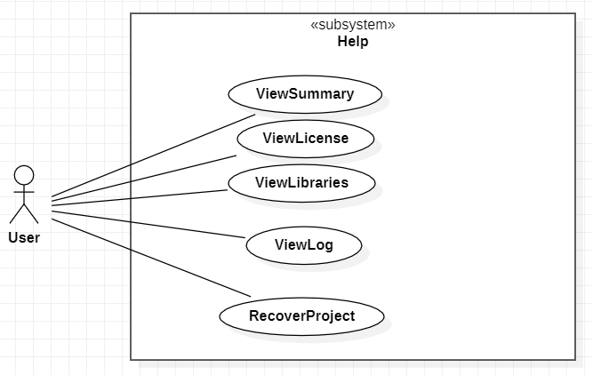

**Use case: ViewSummary**

ID: 1

Description: The System shows a little summary of the app.

Primary actors: User

Secondary actors: None

Main flow:

1. The use case starts when the user selects *“Summary”.*

2. The system shows a resume of the main information of the app.

**Use case: ViewLicense**

ID: 2

Description: System shows the license of the app.

Primary actors: User

Secondary actors: None

Main flow:

1. The use case starts when the user selects *“License”.*

2. The system shows the license info of the app.

3. The user selects *“Ok”.*

Alternative flows:

3. The user selects *“Cancel”.*

**Use case: ViewLibraries**

ID: 3

Description: The System shows some useful libraries of the app.

Primary actors: User

Secondary actors: None

Main flow:

1. The use case starts when the user selects *“Libraries”*.

2. The system shows the libraries info of the app.

3. The user selects *“Ok”.*

Alternative flows:

3. The user selects *“Cancel”.*

**Use case: ViewLog**

ID: 4

Description: The System shows the Log info about the last modifications of the user.

Primary actors: User

Secondary actors: None

Main flow:

1. The use case starts when the user selects *“View log”.*

2. The System shows log details, such as user directories, user classes, the date of the last modification of such class.

3. The user closes the text box.

Alternative flow:

None

**Use case: RecoverProject**

ID: 5

Description: To recover some useful data from project last versions.

Primary actors: User

Secondary actors: None

Main flow:

1. The use case starts when the user selects “Recover…”.

2. The System asks the user if he wants to restore.

3. The user confirm the recovery.

4. The System updates the project version.

Alternative flow 1:

2. The user jumps the version.

3. Go back to 2 of the Main flow.

Alternative flow 2:

(When there is only one last version of the Project, and the system updates automatically)

Point 2. and 3. of the “*main flow”* are jumped.

Alternative flow 3:

3. The user selects *“Cancel”.*