YOUR MISSION SHOULD YOU CHOOSE TO ACCEPT IT

You are the project manager tasked with testing robotic lab equipment. You must make sure that scientists can invent new medicines that will cure diseases without introducing intolerable side-effects. Your team is composed of humans and AI. Who does what? How can you verify the accuracy of your tests so that scientist get valid results from their lab equipment?

A GOVERNANCE MODEL

First, identify the tasks required to complete this project. Good news! There is a model you can use. This model comes from a governance model called, Combined Requirements Model, developed by the US Navy SPAWAR. Nick Stravos is the thought-leader behind this model. He explains it here:
https://www.omgwiki.org/dido/doku.php?id=dido:public:ra:xapend:xapend.j_gov_model

This goverance model includes five levels: wisdom, understanding, knowledge, information, and data. Take a look at the FDIC example: https://www.omgwiki.org/dido/doku.php?id=dido:public:ra:1.4_req:00_aboutreq:04_combexmpmdl

In order to address AI, I propose we add a sixth level: consciousness. Take a look at each level as it relates to your project.

Consciousness
Consciousness is our unique awareness of ourselves as human beings. The Covid-19 pandemic has heightened our awareness and shown us that we perceive our responsibility to safeguard ourselves and others differently. Without engaging in a debate about ethics, I propose a dramatic over-simplication. For purposes of our project, consciousness tells us to keep human beings safe. Safety-critical, robotic lab equipment must function properly in order for scientists to invent new medicines to cure diseases without introducing side-effects that can harm someone.

Wisdom
Wisdom comes from experience. In the USA, our collective experience has been codified in the Federal Code of Regulations (CFR).

Understanding
The collection of best practices identified over time by industry experts creates an understanding. CFR Title 21 empowers the Federal Drug Administration (FDA) to regulate Food and Drugs including lab equipment used for inventing medicines. https://en.wikipedia.org/wiki/Code_of_Federal_Regulations Thus, CFR Title 21 contains the best practices identified by industry experts. You can use them to jumpstart your project.

Knowledge
Knowledge defines the criteria under which electronic records and electronic signatures are considered trustworthy and reliable in accordance with a part of Title 21 called, 21 CFR Part 11

Information
Information includes collections of data that provide the proof needed to be certain that scientists followed the rules for their electronic signatures when they signed the results of their experiments

Data
Key data for 21 CFR Part 11 compliance includes the test results showing that the lab equipment performs as expected

SAMPLE TOOLKIT

More good news, I already designed a toolkit to accomplish 21 CFR Part 11 compliance. This toolkit included these documents:

• Software Risk Assessment
• Software Validation Plan
• Cybersecurity Policy and Procedure Recommendations for the GLP Laboratory
• User and Functional Requirements Specification
• System Design and Configuration Specification
• Test Plan
• Traceability Matrix to show how tests validated requirements
• Installation Qualification Protocol to test the environment and installation
• Operational Qualification protocol to test software functions
• Performance Qualification Protocol for performance testing
• Validation Summary Report
• FDA CFR Part 11 Assessment to demonstrate compliance with regulations
• Standard Operating Procedures for Analyst Software
• Standard Operating Procedures for GLP Lab Cybersecurity

Which of these tasks can be assigned to AI?
The first step in using AI is to identify what components of your project management can be automated. Here’s a simple project plan:

Step 1:
• Software Risk Assessment
• Software Validation Plan
• Cybersecurity Policy and Procedure Recommendations for the GLP Laboratory

Step 2:
• User and Functional Requirements Specification
• Begin the Test Plan
• Begin the Traceability Matrix to show how tests validated requirements

Step 3:
• System Design and Configuration Specification
• Update the Test Plan

Step 4:
• Finalize the Test Plan
• Finalize the Traceability Matrix to show how tests validated requirements

Step 5:
• Installation Qualification Protocol to test the environment and installation
• Operational Qualification protocol to test software functions
• Performance Qualification Protocol for performance testing

Step 6:
• FDA CFR Part 11 Assessment to demonstrate compliance with regulations
• Validation Summary Report
• QA review

Step 7:
• Standard Operating Procedures for Analyst Software
• Standard Operating Procedures for GLP Lab Cybersecurity
APPLYING THE GOVERNANCE MODEL

For each task on the project plan, identify where it falls in the governance model.

Step 1:
• Software Risk Assessment - Consciousness (what risks face human beings?)
• Software Validation Plan – Wisdom (what are best practices?)
• Cybersecurity Policy and Procedure Recommendations for the GLP Laboratory – Wisdom (what are best practices?)

Step 2:
• User and Functional Requirements Specification – Understanding (how does the lab equipment function)
• Begin the Test Plan - Understanding (how to test the lab equipment functions)
• Begin the Traceability Matrix to show how tests validated requirements – Data (proof that tests validate functions)

Step 3:
• System Design and Configuration Specification – Data (proof that the system does the functions)
• Update the Test Plan

Step 4:
• Finalize the Test Plan
• Finalize the Traceability Matrix to show how tests validated requirements

Step 5:
• Installation Qualification Protocol to test the environment and installation – Data
• Operational Qualification protocol to test software functions - Data
• Performance Qualification Protocol for performance testing - Data

Step 6:
• FDA CFR Part 11 Assessment to demonstrate compliance with regulations – Knowledge and Information
• Validation Summary Report – Information (proof that data supports compliance)
• QA review – Understanding (did the project accomplish its goal)

Step 7:
• Standard Operating Procedures for Analyst Software – Knowledge (criteria for continued compliance)
• Standard Operating Procedures for GLP Lab Cybersecurity – Knowledge (criteria for continued compliance)

WHICH TASKS CAN AI COMPLETE?

In 2021, AI is good at predicting outcomes given accurate, non-biased, historical data. AI can make rudimentary language translations. Robots can manuever in traffic. Can AI lead a project?

AI and Consciousness

Perhaps AI can use the governance model to decompose the project tasks. First, and most important, the primary goal of your project is to safeguard human life. As human beings, we are hard-wired for our survival. How would AI learn that human survival is important? In order to “think”, AI needs lots of data. Social media has lots of data that express human values. Could AI analyze millions of social media posts and reflect our collective values regarding human life?

Here’s a simple example showing how AI can read and analyze data. In this example, AI is reading posts published at LegiScan and creating word clouds showing popular themes. LegiScan is a website that publishes texts of bills introduced in federal and state legislatures. From February through June 2021, AI indicates that state legislatures have focused on these themes: person, school, identity, health, sports, and education. Here are some of the word clouds. Words in larger fonts are more popular.
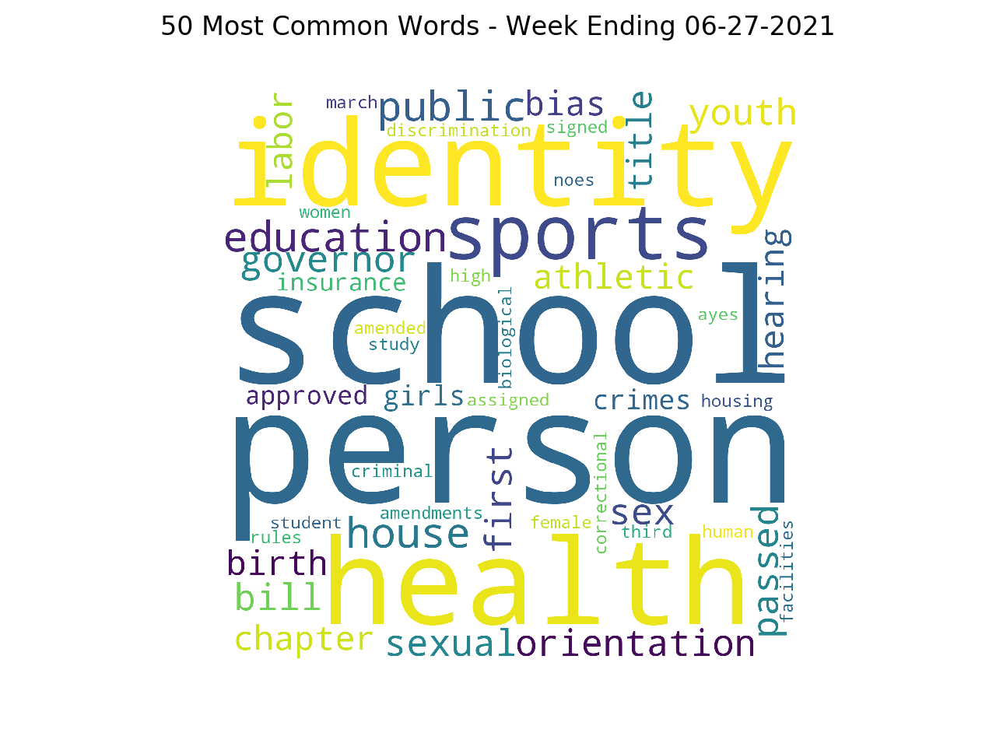
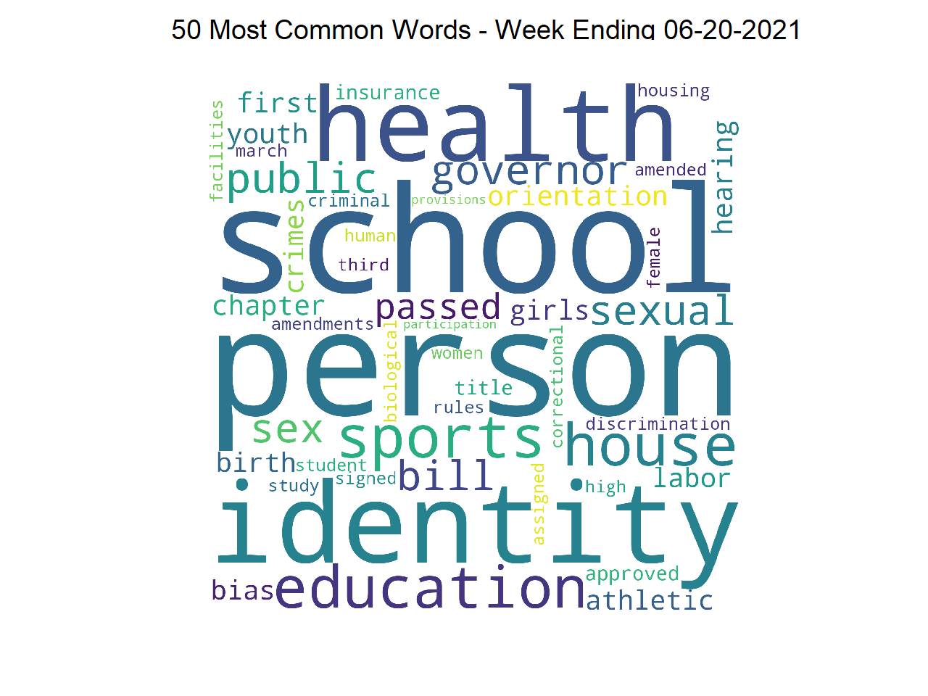

I verified that, as of June 2021, eight states in the USA have banned transgender girls from girl’s sports. Seventeen states have proposed bans. Eleven states have empowered transgender athletes. Putting aside any personal bias, we see that AI is reflecting the values of the legislatures in the USA.

What would AI reflect from analyzing social media? Take a look at Microsoft’s Twitterbot experiment:
https://robothot.ai/Course-AI_Teammember/08_twitter.htm

In my opinion, discussions about AI and consciousness are intriguing and important.

MOVING FROM INFORMATION TO UNDERSTANDING AND WISDOM

Consider governance. Governance is not a synonym for government or for regulations. Governance is the process that governments use to interpret and use regulations. Leaders use governance to define expectations, grant power, or verify performance. These three components are called: regulation, execution, and compliance. Goverance allows leaders to use data to create information. From this information leaders gain understanding. When this understanding is combined with experience, wisdom is achieved. Could AI use this governance process to achieve consciousness?

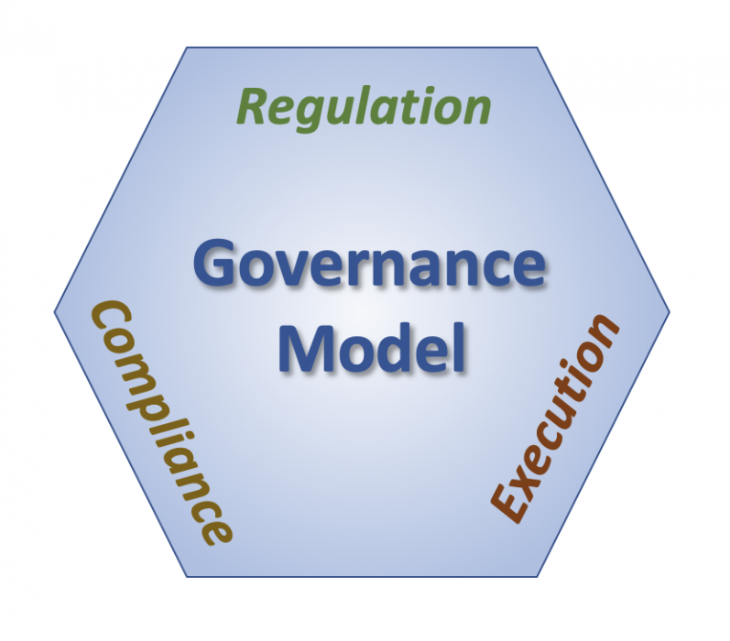
Good governance has these three components in equal and sometimes opposing aspects. Regulation indicates what needs to be done, execution is actually doing it, and compliance is making sure it is done correctly. In the USA, regulations are rules adopted by a public regulatory agency, usually, based on interpretations of statutes passed by a legislative body. USA regulations are written in English, a language that humans can read. They are difficult for AI to read.

Think of regulations as a collection of contracts. For example, IRS regulations require you to pay taxes if you earn money. Microsoft has undertaken a project to develop AI contracts using the Ethereum blockchain. For example, if you earn Bitcoin then taxes are paid automatically. However, in order to code such a contract, an attorney will need to learn a programming language similar to JavaScript. And legislatures will need to trust blockchain.

Compliance ensures that regulations are met through observation, measurement or testing. Good governance cleanly and effectively separates the responsibility for creating regulations from the enforcement of these regulations. For example, the IRS can audit your tax return. Some aspects of compliance are repetitive and can be automated. For example, AI may review all the tax returns and decide that the IRS should audit all tax returns for people who earn more than $200,000/year because these tax returns include the most reporting errors.

Execution is the aspect of governance charged with actually doing the tasks necessary to comply with the rules. Robots can and do perform many tasks for us.

1) Stavros, Robert W. and Albrant, Jeremiah; Engineering Governance, SPAWAR, October 9, 2007,
2) Adapted from Wikipedia: Governance; accessed 9 July 2007
3) Adapted from Wikipedia: Regulation, accessed 9 July 2007 https://en.wikipedia.org/wiki/Regulation ]]
dido/public/ra/xapend/xapend.j_gov_model.txt

AI and Wisdom, Understanding, Information, and Data

Finally let’s look at data. AI needs data in order to “think”. Biased data yields biased predictions. Missing data results in skewed results. How do you ensure that the data you are collecting is accurate and timely?

Selecting the proper AI algorithm is important so you know what type of data to collect. Decision trees, random forests, linear regression, logistic regression…

Testing the AI is critical to making sure it performs within normal bounds and yielding unbiased results.

Controlling raw data input is the key. Environment sensors can be more accurate that human data input. Apps are one good way to control data input. The culture of your team is also important. Is your team motivated to record accurate and timely data?

