Question 2：

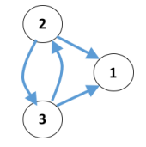

1. Adjacency matrix:

A:

|  |  |  |
| --- | --- | --- |
| 0 | 0 | 0 |
| 1 | 0 | 1 |
| 1 | 1 | 0 |

1. Answer:
   1. Authority scores: X, A*X = Y , X= A^T* Y, X= A^T *A *X

A^T *A:

|  |  |  |
| --- | --- | --- |
| 0 | 1 | 1 |
| 0 | 0 | 1 |
| 0 | 1 | 0 |

|  |  |  |
| --- | --- | --- |
| 0 | 0 | 0 |
| 1 | 0 | 1 |
| 1 | 1 | 0 |

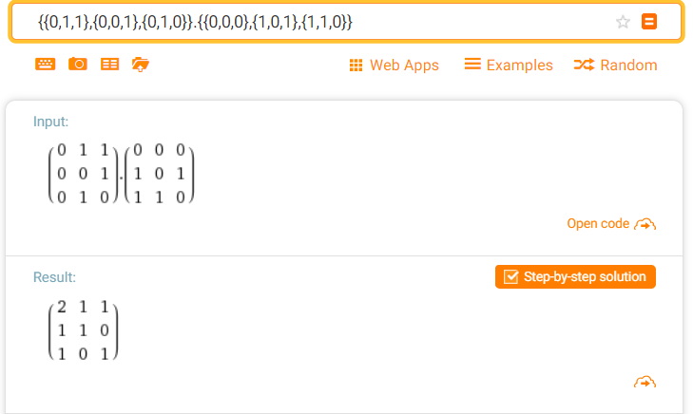

Find the eigenvectors the result metrics:

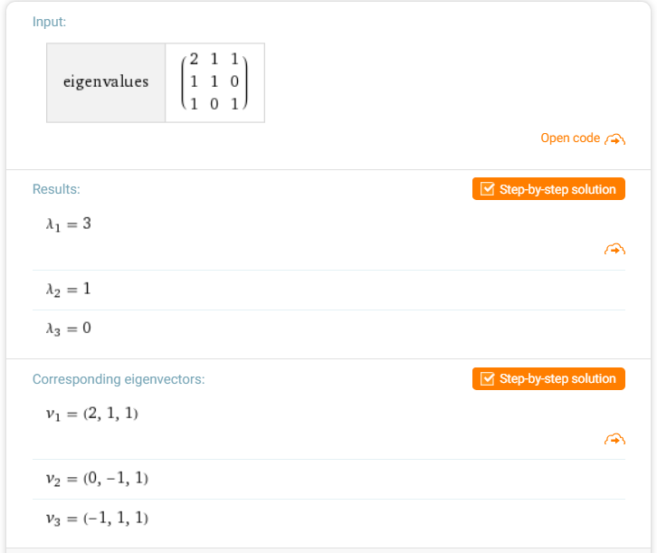

Normalized the v1(2,1,1)- Authority scores (2/,1/,1/1/)

* 1. Hub scores: Y, Y =A*X, Y= A*A^T*Y, find the metrics of A*A^T

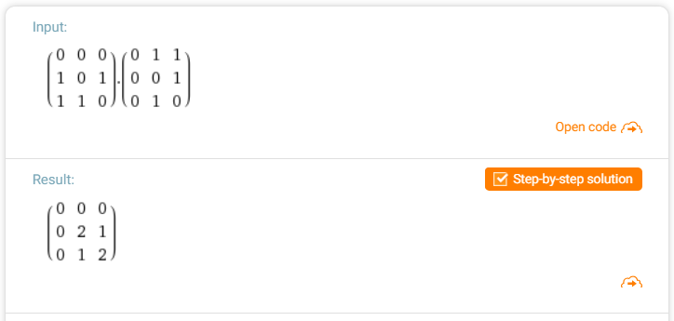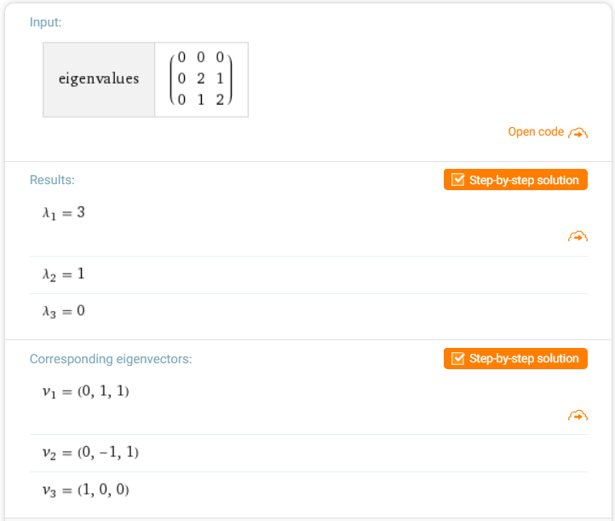

Normalized the v1 vector (0,1,1) --- Hub scores (0,1/, 1/)

* 1. Eigenvector centrality:

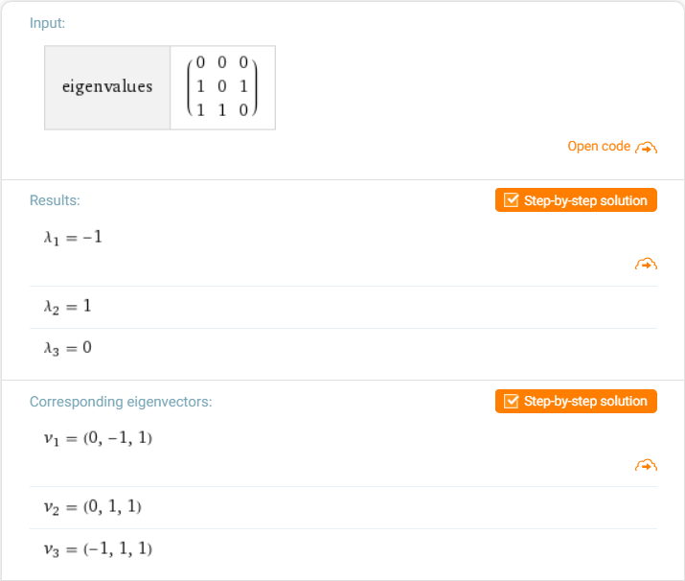

Normalized v2(0,1,1) ----eigenvector centrality: (0,1/ $\sqrt{2}$, 1/ $\sqrt{2}$))

1. The power method of iteration in **Centrality.py**

The results are blow: beta = 0.1, alpha= 0.1

Eigenvector_Centrality: [0. 0.70710678 0.70710678]

Katz_Centrality:[0.1 0.12222222 0.12222222]

PageRank Centrality: [0.11052632 0.10526316 0.10526316]

1. Let the beta = 0, alpha = 0.1

Eigenvector_Centrality: [0. 0.70710678 0.70710678]

Katz_Centrality: [0. 0. 0.]

PageRank Centrality: [0. 0. 0.]

Discuss：

Because the beta = 0 and without the stationary distribution value of beta, in the random walk with the weight of alpha = 0.1, the Node1 is the ‘dead end’ and it has no out-links. In this way, the random walk has nowhere to go to, so the node1 cause importance to ‘leak out’. Therefore, the values PageRank Centrality are all zero. In mathematics explanation, when the time of iteration become very larger, the result multiplied by alpha (0.1) after many iterations will become smaller and smaller, and become closed to zero. The iteration formulate is equivalent to $r{=\left(0.1\right)}^{n}×M^{n}×r_{0}$

In Katz Centrality, the power method only uses the parameter alpha. Because without the stationary distribution value of beta, the result multiplied by alpha (0.1) after many iterations will become smaller and smaller. So, in power method without beta parameter, the result is closed to zero.

The iteration formulate is equivalent to $r{=\left(0.1\right)}^{n}×M^{n}×r_{0}$

1. Remove the links from node2 to nodes 3

**Beta = 0.1 , alpha = 0.1**

remove_metrics = np.array([[0,0,0],[1,0,0],[1,1,0]])

remove_PageRank = np.array([[0,1,0.5],[0,0,0.5],[0,0,0]])

Eigenvector_Centrality: [0. 0. 0.]

Katz_Centrality:[0.1 0.11 0.121]

PageRank_Centrality: [0.1155 0.105 0.1 ]

Discuss:

The Katz Centrality and PageRank Centrality go well in this graph, but the Eigenvalue Centrality are all zero. In the power method, the eigenvector iterated after third times become zero so in this method the eigenvector become [0,0,0]. All-zero vector is the eigenvector of any corresponding size matrix. In addition, det(A-E*λ) =0 and the value of λ =0, the eigenvector = [0,0,x3], x3 can become any value(including zero)

A:,

|  |  |  |
| --- | --- | --- |
| 0 | 0 | 0 |
| 1 | 0 | 0 |
| 1 | 1 | 0 |