1.Create Your Own user ID from System Administrator Responsibility.  
 Assign the following responsibilities to your Oracle User ID

* **Vision Operation General Ledger.**
* **Vision Operation Inventory**.
* **Vision Operation Procurement**

To start off, we first log into Oracle Applications, then we navigate like this: System Administrator>Security>User>Define

Then putting in relevant info. First we use the naming convention given; xx_initial_form-name.

Which gives us xx_jc_users.

Then we add in the responsibilities listed. The third one doesn’t have a direct responsibility so I added in the closest responsibility I could find.

2. For your user ID password expiration day should be 60 days

Set

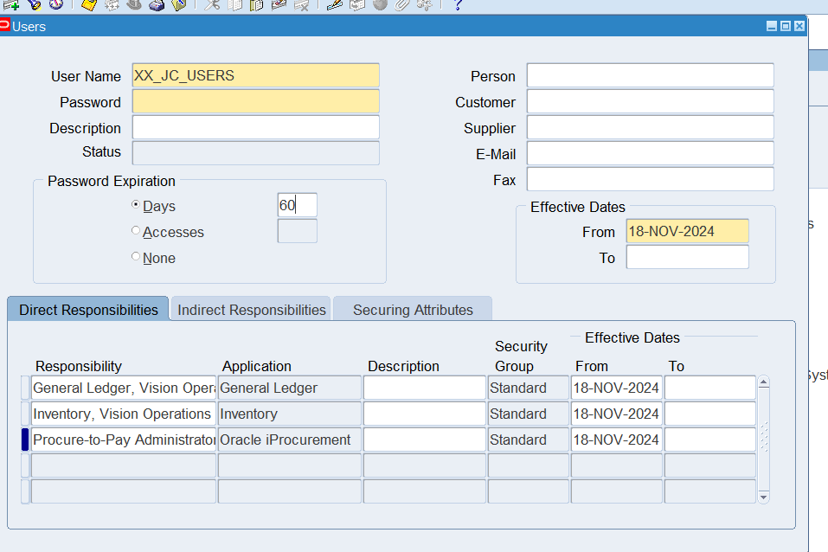

3. In **Vision Operation General Ledger** responsibility.

Form Accounting Setup Manager> Find the **Vision Operation [Primary Ledger]**

In this Ledger finds the **4C** Component, mentions the 4C name & take the screen shot as Evidence.

1. Find the Respective Calendar **Vision Operation [Primary Ledger].**

We take the path:

General Ledger>Setup>Accounting Setup Manager>Accounting Setups

Then we come to a website form where we search for our general ledger for vision operations

We click on “Update Accounting Options”

Which brings us to this, where we click “Update”.

Here we can see the: chart of accounts, currency, accounting calendar, and the accounting method (for the subledger in this instance.)

4.Find all the **Account Code Combinations.**

First the path: General Ledger>Setup>Accounts>Combinations

Then we click View>Find

5.Find all the Journals [**SOURCE: Payables].**

First the path: General Ledger>Journal>Enter

Then the ledger as General Ledger.

Then the source as Payables.

Which pulls up all of the journals in the general ledger from the payables business unit.

6. In Journal Header from record History find the respective **Data base Table name.**

Click on help and then record history.

Which brings this up.

7. Find the one Manual [Source] & one Payable [Source].

As per the previous step, we already have found the payable source journals, we just redo those steps to find the manual source journals.

8.How can you review posted journal entries in Oracle GL? Steps & screen shots

We Went over this some in the previous two steps, but now that we’re at that screen, click on review journal in the bottom left.

Which brings up this journal:

9. Find the **Chart of Accounts [COA]** Structure in General Ledger.

First the path: General Ledger>Setup>Financials>Key>Segments

Here we select the first chart of accounts that comes up. Then we click on segments in the bottom right.

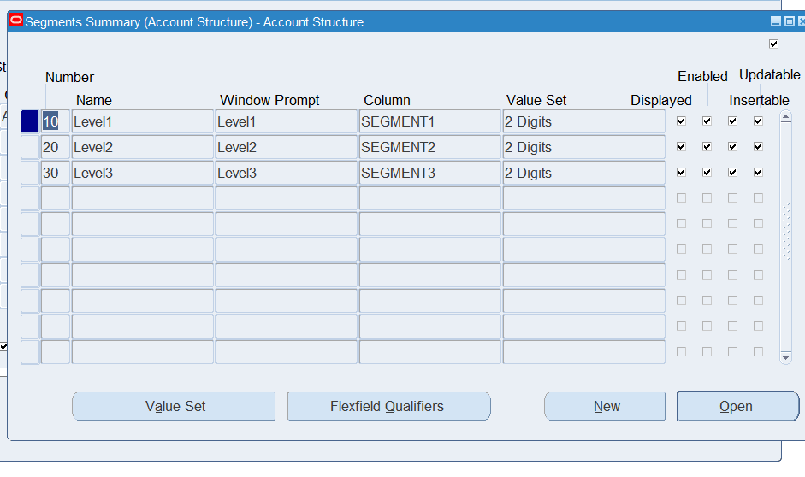

This brings up the segment structure.

10.How are you going to run one **Concurrent Request** from General Ledger (Navigation).

First we click on view, then on requests.

Then next to run a new request we click Submit a New Request in the bottom left.

Which brings up this:

Fill out the necessary forms and then submit.

11. In One Ledger Set what are all components common in all the Ledger?

This is the initial path:

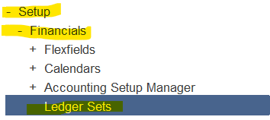

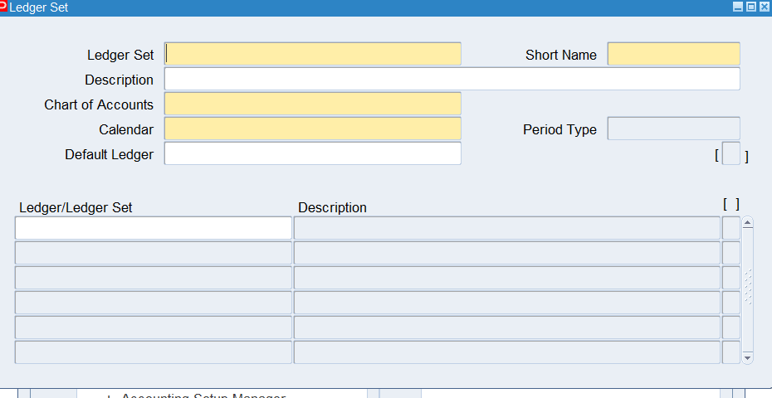

All components in yellow are required fields and thus common in the general ledger: Ledger Set, Short Name, Chart of Accounts, and Calendar.

12. Find how many types of accounts in Oracle GL [Account Code Combination]?

First the pathing: General Ledger>Setup>Financials>Accounts>Combinations

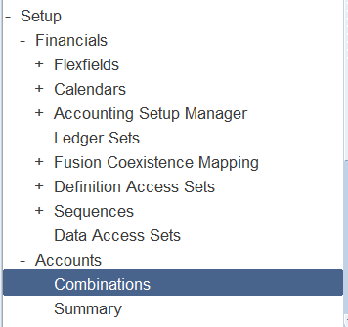

This brings us to the GL Accounts. Then view>find. Then click on types.

This shows all of the types: Assets, Expense, Liability, Owners’ equity/fund balance, and Revenue.

13. Check & show the Structure of Chart of Account segment structure.

This is the same as step 9, please refer to step 9, thanks.