Assignment for **Oracle E- Business Suite Inventory**

Date:15th Nov-2024

[Provide screenshots of each step (which performed in a live environment).  
As evidence all the activity screens shot needs to be attached]

1. What is the Oracle Inventory module?

The oracle inventory module is where the Inventory org level of the MOAC is located.

2.With you User id switch to: **Vision Operation Inventory**. Responsibility.

File>Switch Responsibility

Then put in the correct responsibility

Leading to this responsibility.

4.Take any Item & assign the same Item for all the **Inventory Org.**

**First the path: Inventory>Items>Master Items**

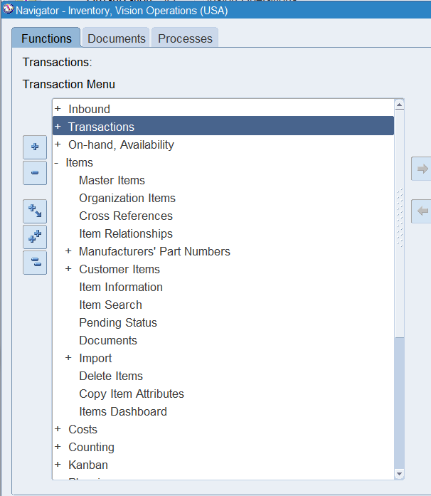

Then for any item:

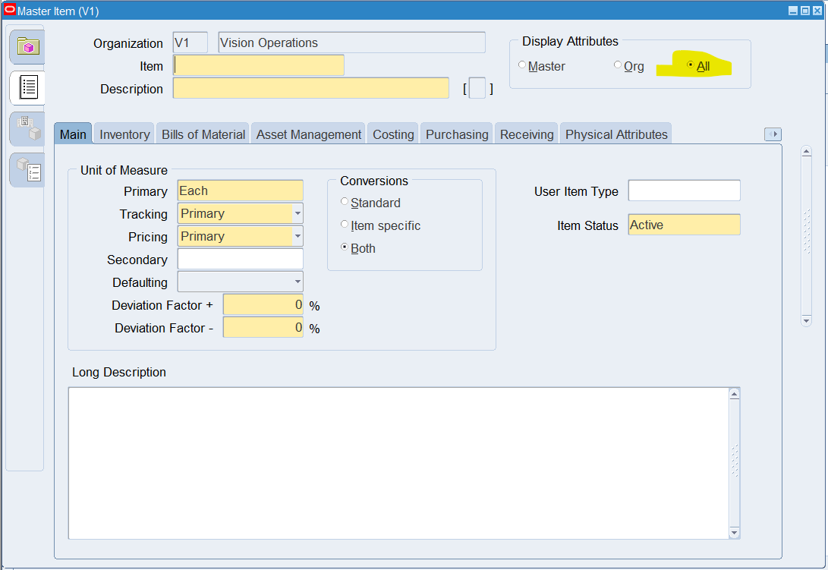

Click on All

5. And Un assign the same Item for all the **Inventory Org.**

To do 5, it’s the same path as 4, you just find the same item again, and then click on Org, which sets it to a single organization.

6**.** Any of the existing Item [VI Inventory org] Check the on-hand quantity.

First the path: Inventory>On-Hand Availability>On-Hand Quantity

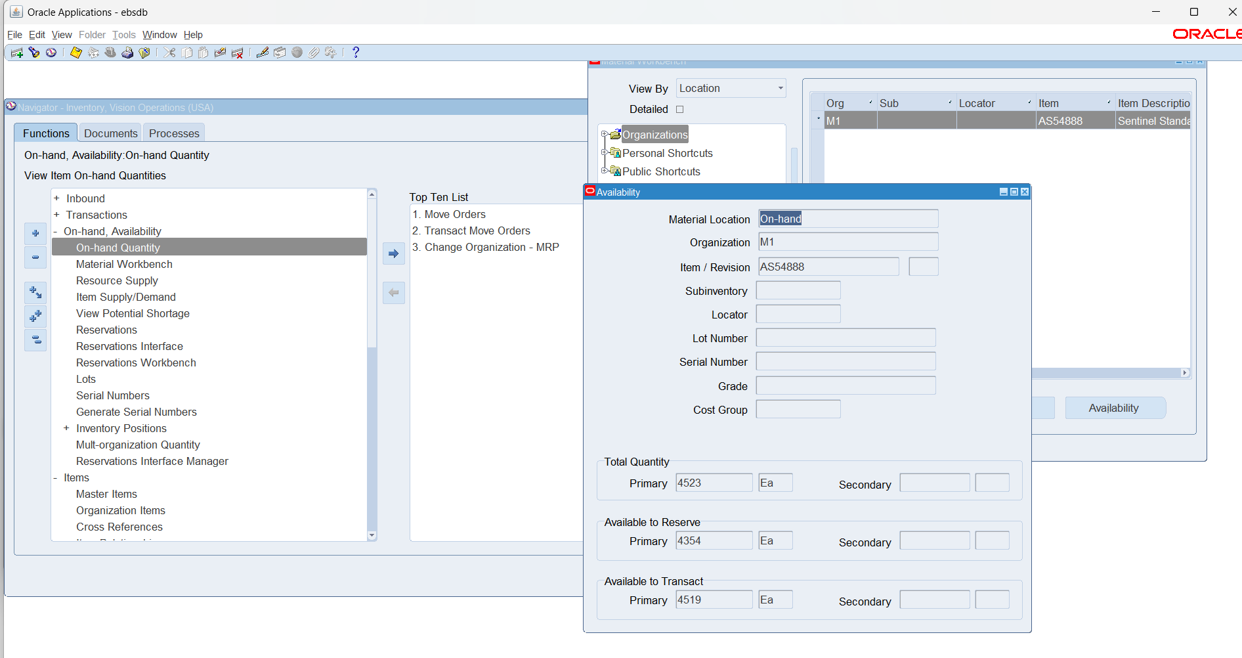

Then we do a couple of things to get here. In the immediately proceeding form we click on find tp get to here:

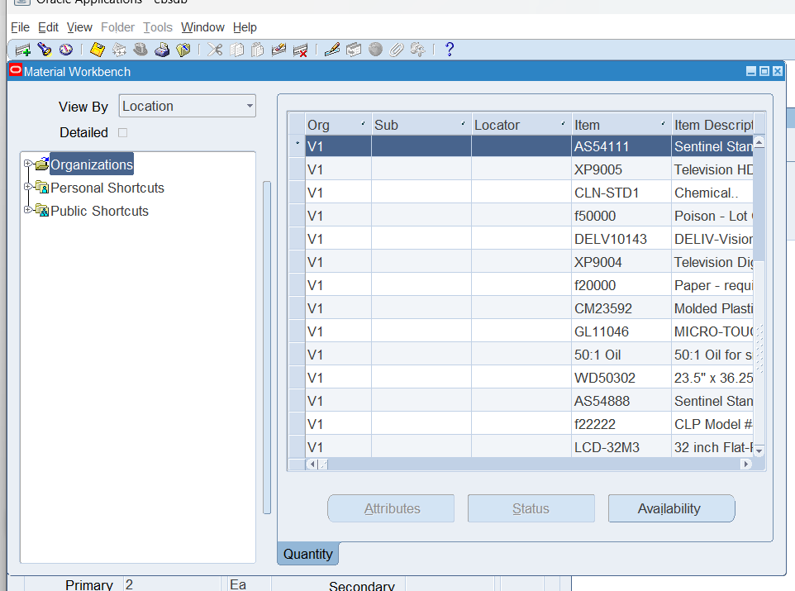

Then we click on an item and get to see the quantity in the next form:

7. Unit of Measure (UOM)... with Navigation show where UOM has been defined.

Inventory>Setup>Units of Measure> Units of measure

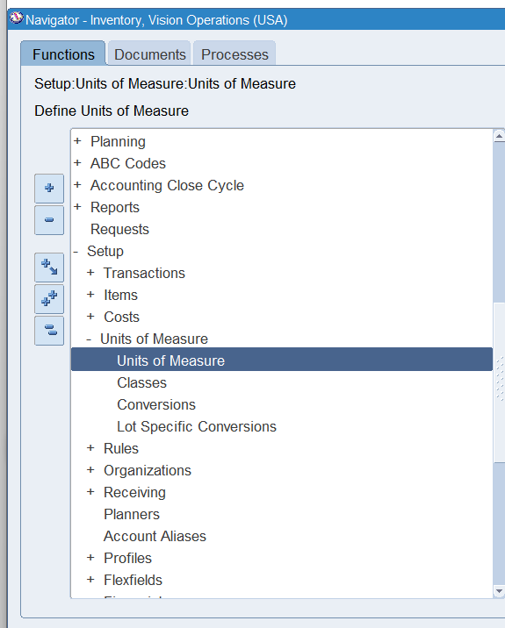

A new UOM can be created by clicking on the button in the top left immediately below “File”, then filling out the information, then saving the record.

8. How do you create a new inventory item?

Navigation: Inventory>Items>Master Items

Then fill out the form and click save

9. How to run Inventory Valuation Report?

First we do the navigation: Inventory>Reports>Cost>All

Then we get to this popup:

Single request works for us.

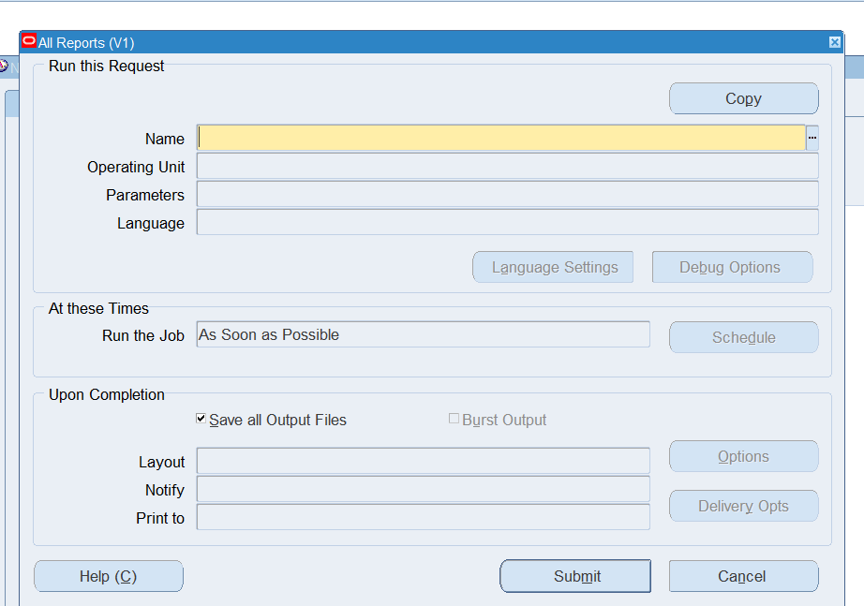

Then we click on the three dots on the right of the highlighted field

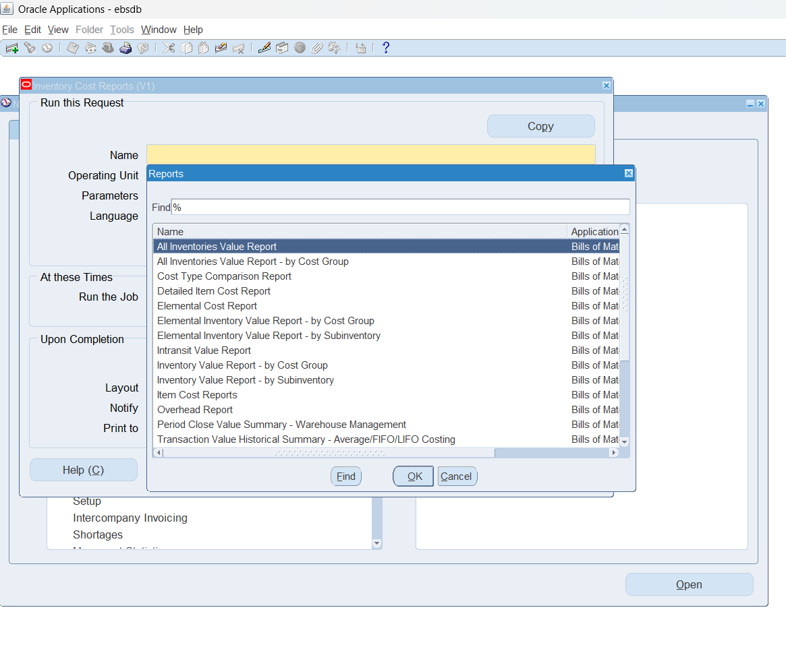

The we get to this menu, and the top answer is the one we click on

Accept necessary parameters. Click ok

Then submit, note down request is.

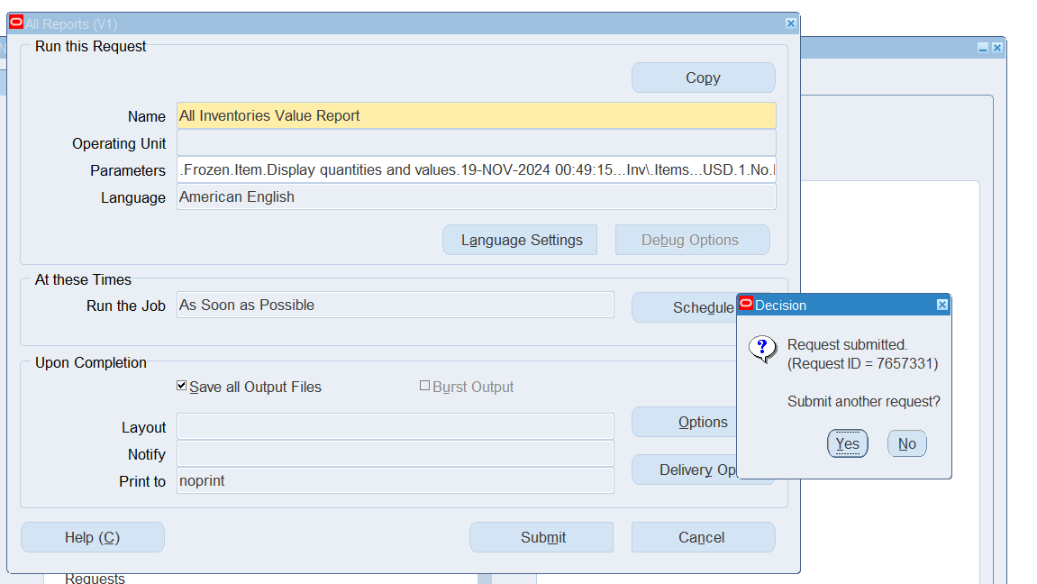

10.How to change Inventory Organization in the Current responsibility.

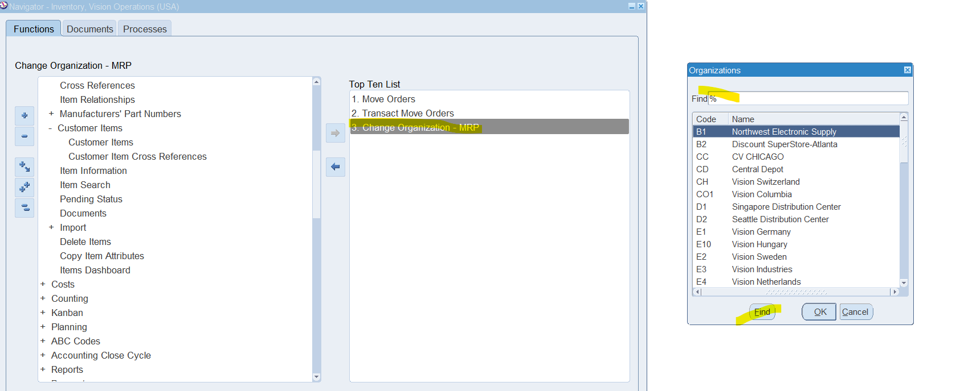

It’s on the righthand side in the Inventory for vision operations.

11. What is **Master Data** in Oracle Inventory?

Master data in oracle inventory is the item. Items are the most important data in the inventory org level, similar to a primary key in sql.

12.Show the existing ORG with navigation.

Inventory>Items>Organization Items

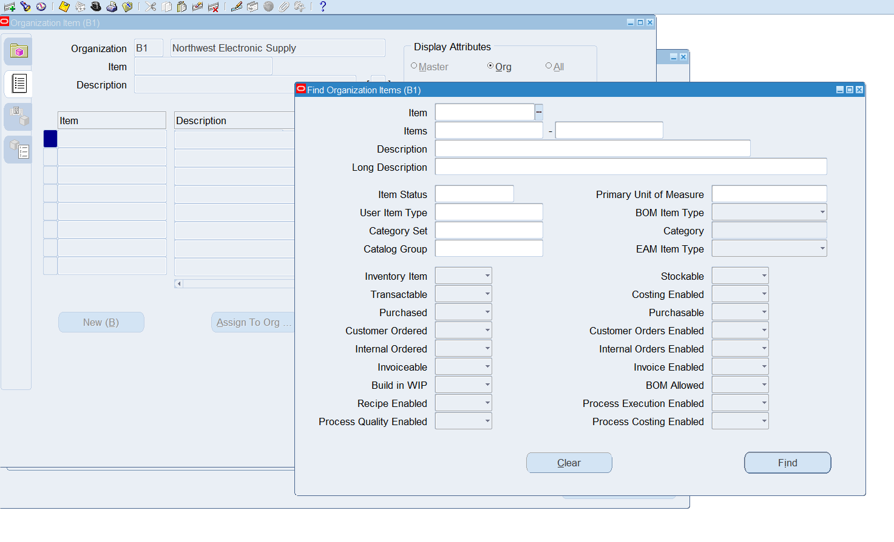

Then as shown here the default org that shows up is the one you’re currently in.

13: You can manage only finished goods in **Oracle Inventory**?

No (It continues downward idk how the formatting will look at the end)

You can see in various places materials, materials are not finished goods. Materials and other unfinished goods have to be managed in the inventory to allow for business processes to function…. No company that transformed materials could use Oracle otherwise.