1. Order Management Setup

•Define Order Management System Parameters

First the Navigation: Order Management Super User> Setup>System Parameters>Define

Which Brings us to this screen:

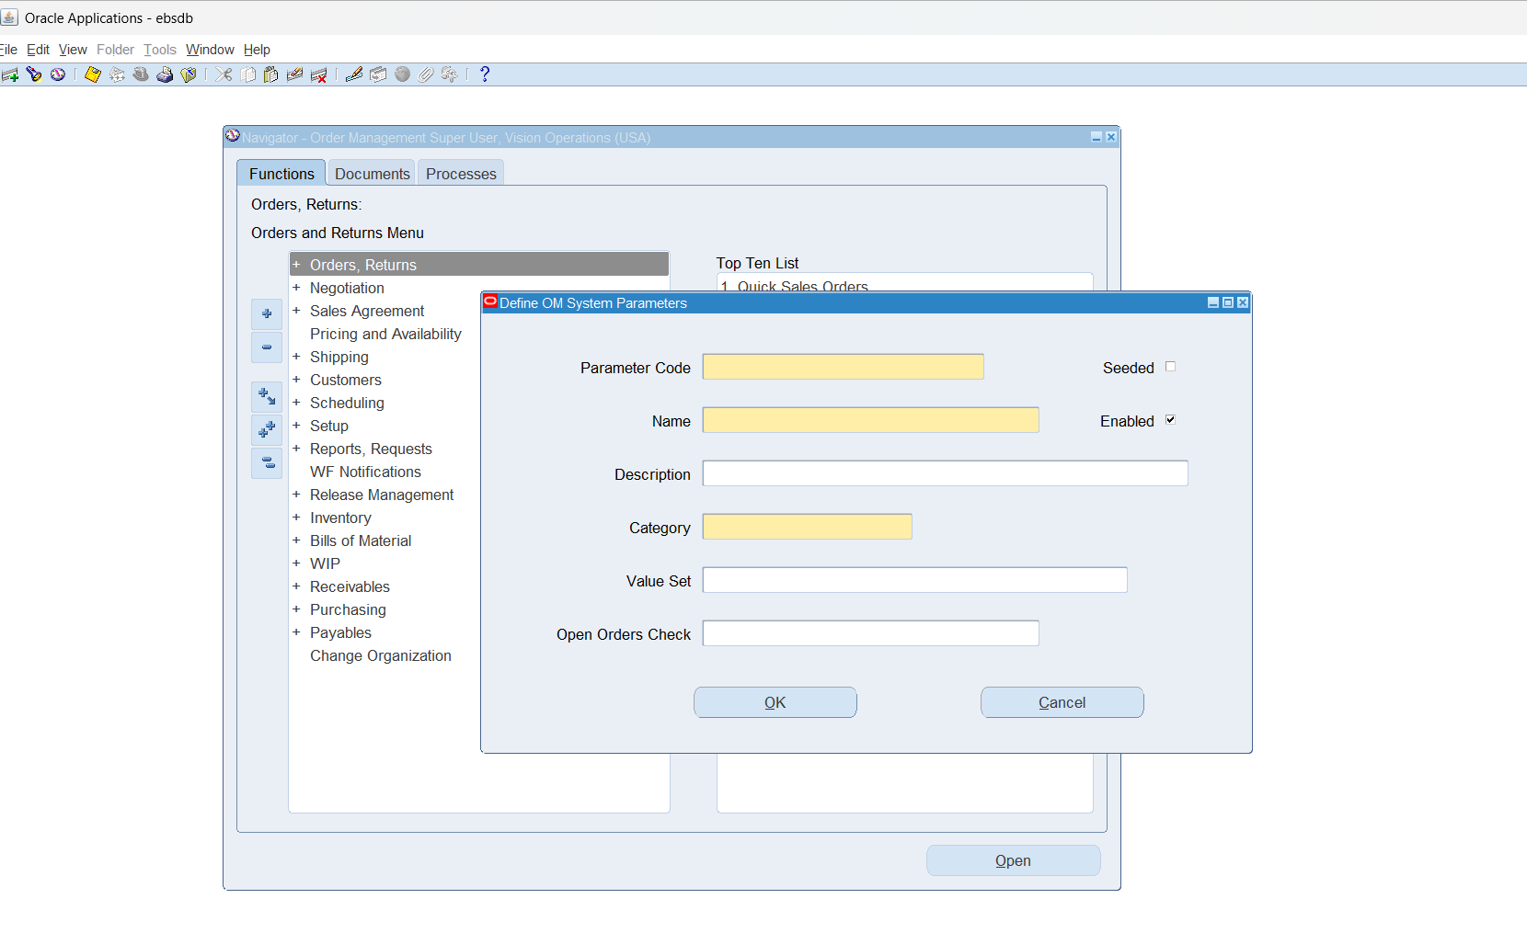

2. Customer Management [Customer Creation]

• Define and Maintain Customer Accounts and Contacts

First the Navigation: Order Management Super User>Customer>Standard

Gives us this:

Where we can create a user or look up a user.

•Setup Customer Shipping and Billing Information

Same as last part, click on create user, can modify the billing information:

•Manage Customer-Specific Pricing and Discounts

First the Navigation: Order Management Super User> Sales Agreement>Sales Agreements

3. Sales Order Creation and Entry

•Create Sales Orders Manually or Import from External Systems

First the Navigation: Order Management Super User> Sales Agreement> Sales Agreement Organizer

Click on new.

