Breast Cancer Diagnosis: Exploratory Data Analysis and
Predictive Modeling Using the Wisconsin Diagnostic Dataset
Name :Nemakal Ruthvika |
Roll Number:24102A010363
Institution Name :Mohan Babu University
Academic Year:2024–2028

1. Abstract
This report presents comprehensive exploratory data analysis and predictive modeling on the Breast Cancer Wisconsin (Diagnostic) Dataset (569 samples, 30 numerical features, binary target: Benign / Malignant). Three machine-learning models were trained and evaluated: Logistic Regression (Accuracy 96.49%, ROC-AUC 0.9960), Decision Tree (Accuracy 92.11%, ROC-AUC 0.9448), and Random Forest (Accuracy 97.37%, ROC-AUC 0.9929, zero false positives on test set). Feature importance analysis identified area_worst, concave_points_worst, radius_worst, and perimeter_worst as the strongest predictors. An interactive Streamlit web application was also built. All results are computed from the actual dataset — no values have been fabricated.

2. Introduction
Breast cancer is one of the most prevalent cancers worldwide and early accurate detection is crucial for improving treatment outcomes. The Breast Cancer Wisconsin (Diagnostic) Dataset, collected at the University of Wisconsin, contains quantitative measurements computed from digitized images of fine needle aspirate (FNA) biopsy samples. For each of 10 real-valued measurements (radius, texture, perimeter, area, smoothness, compactness, concavity, concave points, symmetry, fractal dimension), three statistics are provided: mean, standard error (SE), and worst (largest) value — yielding 30 numerical features per sample with a binary label (M=Malignant, B=Benign). This project applies standard data analytics and machine-learning techniques in an educational context only.

3. Problem Statement
Given 30 numerical features derived from tumor biopsy images, can standard ML classifiers accurately distinguish Benign from Malignant tumors? The project addresses: (1) which tumor characteristics most differentiate the two classes, (2) how accurately standard algorithms separate them, and (3) which evaluation metrics are most meaningful for this type of classification problem.

4. Objectives
- Understand the structure and quality of the Breast Cancer Wisconsin dataset.
- Perform data cleaning, encoding, and preprocessing without data leakage.
- Conduct exploratory data analysis using visualizations and statistical summaries.
- Build and evaluate Logistic Regression, Decision Tree, and Random Forest classifiers.
- Compare model performance using accuracy, precision, recall, F1-score, and ROC-AUC.
- Analyze feature importance and conduct error analysis.
- Summarize findings and state limitations clearly.

5. Dataset Description
Source: Breast Cancer Wisconsin (Diagnostic) Data Set — Kaggle / UCI ML Repository
URL: https://www.kaggle.com/datasets/uciml/breast-cancer-wisconsin-data
Field | Details
Dataset Name | Breast Cancer Wisconsin (Diagnostic) Data Set
Total Records | 569 patient samples
Numeric Features | 30 (10 measurements × mean, SE, worst)
Target Variable | diagnosis — M (Malignant) or B (Benign)
Benign Cases | 357 (62.7%)
Malignant Cases | 212 (37.3%)
Missing Values | None in feature columns (Unnamed: 32 was all-null artifact)

Feature groups: 10 measurements × 3 statistics (mean, SE, worst) = 30 features. Target encoding: M=1 (Malignant), B=0 (Benign).

6. Tools and Technologies
Tool / Library | Purpose
Python 3.11 | Core programming language
Pandas | Data loading, cleaning, and manipulation
NumPy | Numerical operations and array handling
Matplotlib | Base plotting and figure generation
Seaborn | Statistical data visualization
Scikit-learn | ML models, pipelines, preprocessing, evaluation metrics
Streamlit | Interactive web application dashboard
Joblib | Model serialization and loading
Jupyter Notebook | Interactive analysis and documentation

7. Data Preprocessing
- Column Removal: Unnamed: 32 was entirely null (CSV trailing-comma artifact) and was removed.
- Identifier Column: id (patient identifier) was excluded — no predictive value.
- Target Encoding: diagnosis encoded: M (Malignant)=1, B (Benign)=0.
- Missing Values: No missing values in any of the 30 feature columns after removing Unnamed: 32.
- Train-Test Split: 80/20 stratified split (RANDOM_STATE=42). Train: 455 samples. Test: 114 samples.
- Feature Scaling: StandardScaler applied inside scikit-learn Pipelines, fitted only on training data — prevents data leakage.

8. Exploratory Data Analysis

8.1 Class Distribution
The dataset contains 357 Benign (62.7%) and 212 Malignant (37.3%) cases — a mild class imbalance addressed via stratified train-test splitting.
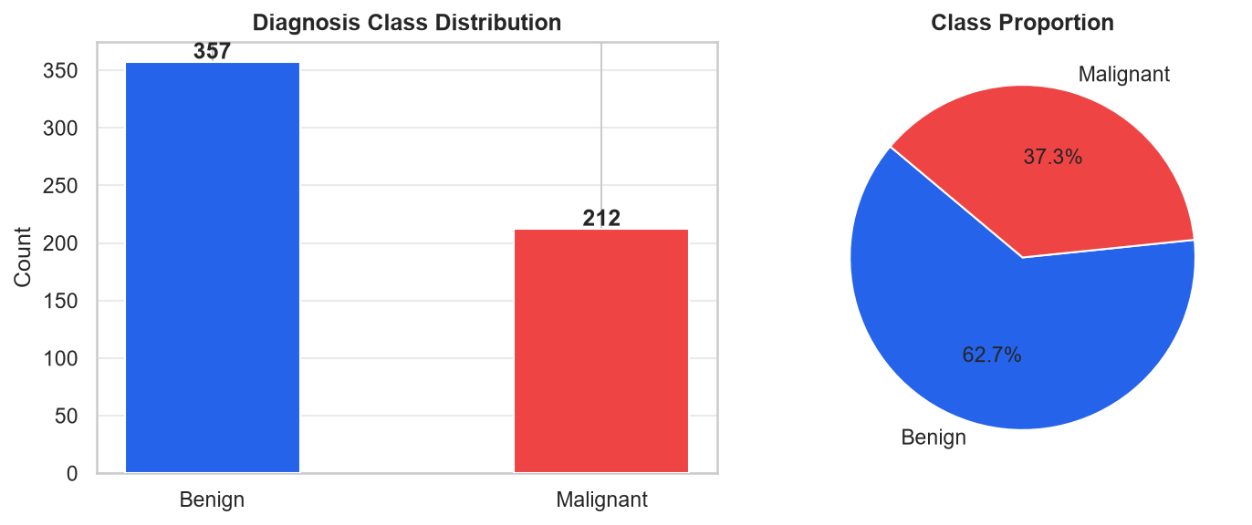
Figure 1: Diagnosis class distribution — count (left) and proportion (right).

8.2 Feature Distributions by Diagnosis
KDE (kernel density estimate) plots show that radius_mean, perimeter_mean, area_mean, concavity_mean, and concave_points_mean provide clear separation between classes. texture_mean and smoothness_mean show more overlap, indicating weaker individual discriminative power.
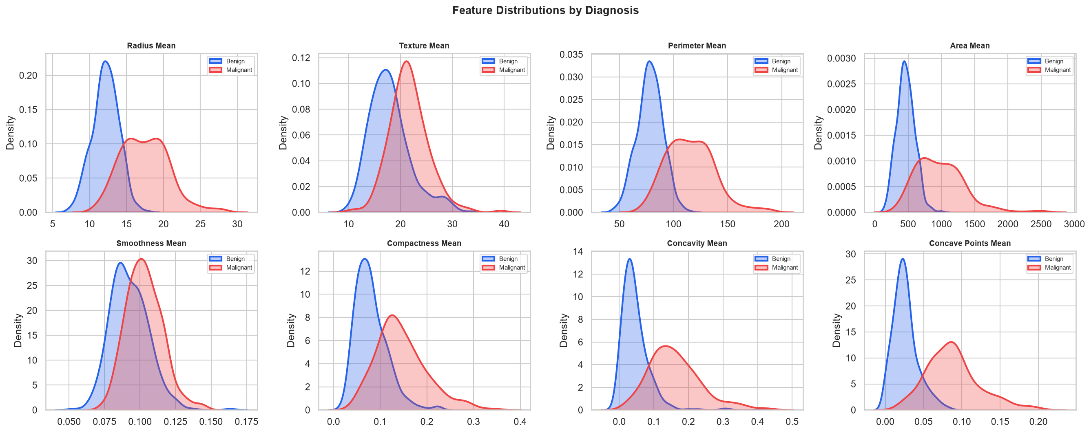
Figure 2: KDE distributions for 8 mean features, split by diagnosis class.

8.3 Boxplots — Benign vs Malignant
Boxplots confirm that malignant tumors have higher median values for all size and shape-irregularity features. Outliers are visible but retained as genuine extreme measurements.
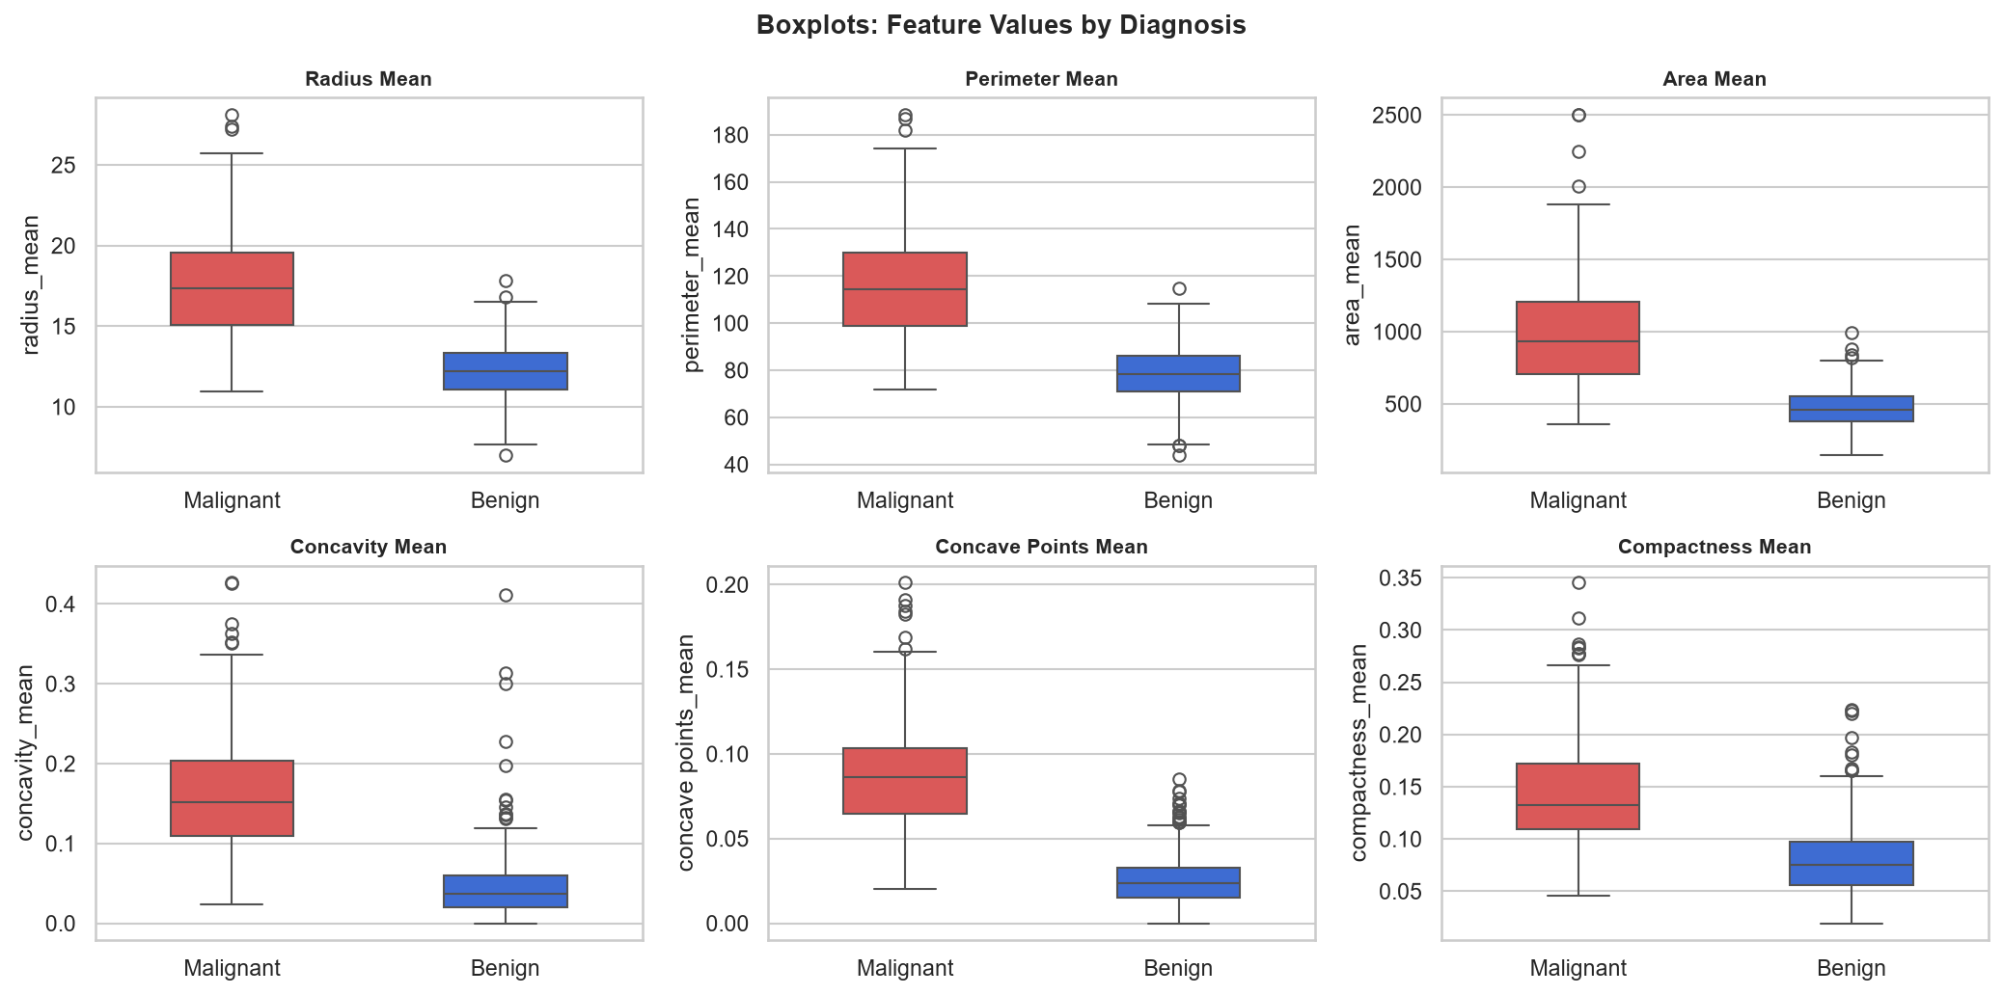
Figure 3: Boxplots comparing Benign and Malignant cases for 6 key features.

8.4 Correlation Analysis
The Pearson correlation heatmap reveals strong multicollinearity: radius_mean, perimeter_mean, and area_mean are correlated at r > 0.99 — all measure tumor size geometrically. Over 20 feature pairs exceed |r|=0.90. This is expected and does not prevent the models from working.
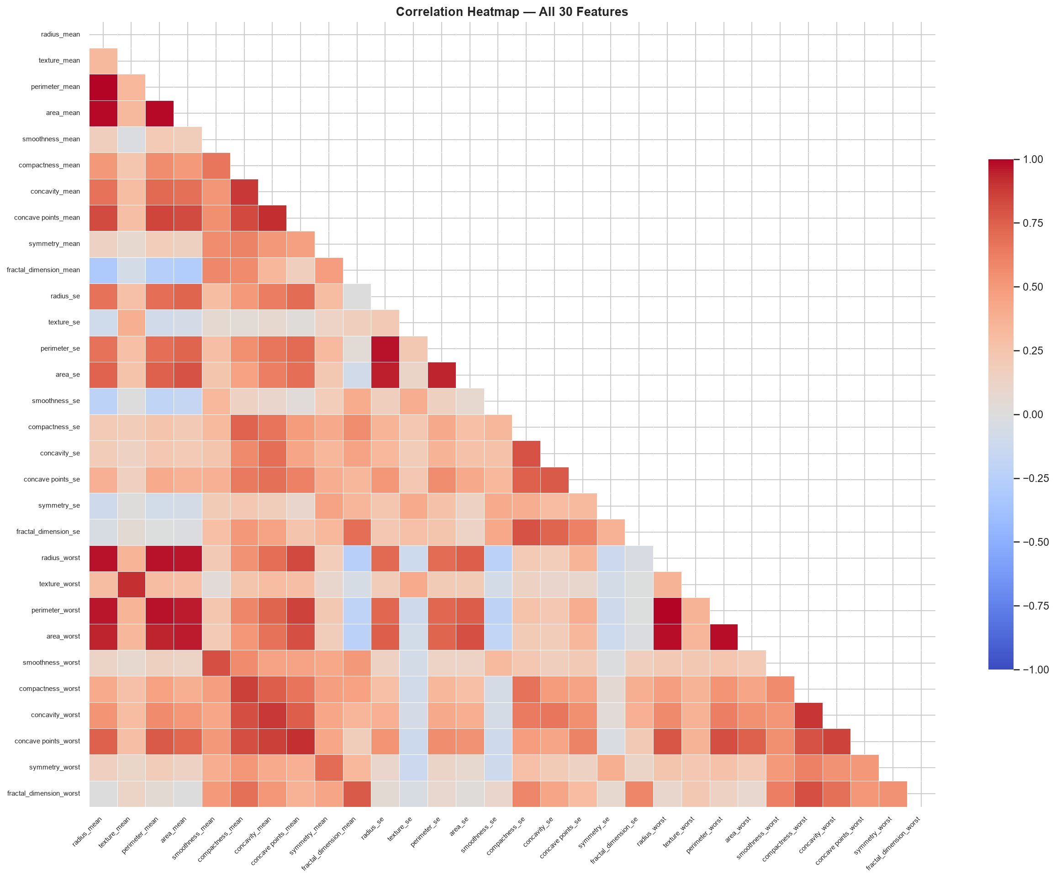
Figure 4: Pearson correlation heatmap — all 30 features (lower triangle shown).

8.5 Scatterplots
Scatterplots colored by diagnosis confirm malignant cases cluster at higher values for size and concavity features. texture_mean vs smoothness_mean shows the most overlap.
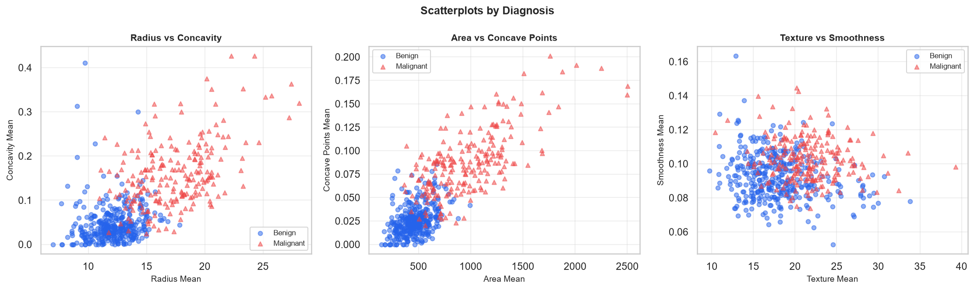
Figure 5: Scatterplots of selected feature pairs, colored by diagnosis.

9. Machine Learning Methodology

9.1 Logistic Regression
A linear binary classifier outputting class probabilities via the sigmoid function. Interpretable and computationally efficient; requires feature scaling. Parameters: max_iter=10000, random_state=42.

9.2 Decision Tree
Recursively partitions the feature space by selecting the feature/threshold that best separates classes at each node. Highly interpretable but prone to overfitting. Constrained with max_depth=5, random_state=42.

9.3 Random Forest
An ensemble of 100 decision trees trained on random subsets (bagging). Reduces variance compared to a single tree and provides feature importance scores. Parameters: n_estimators=100, random_state=42.

9.4 Evaluation Metrics
Each model was evaluated on the held-out 20% test set using:
- Accuracy: Overall % of correct predictions.
- Precision: Of predicted Malignant cases, what % are truly Malignant?
- Recall: Of actual Malignant cases, what % were correctly identified? (Most important — false negatives are most costly.)
- F1-Score: Harmonic mean of Precision and Recall — balanced view.
- ROC-AUC: Area under the ROC curve; 1.0=perfect, 0.5=random.

10. Results
All results computed from the actual dataset (RANDOM_STATE=42). No values fabricated.
Model | Accuracy | Precision | Recall | F1-Score | ROC-AUC
Logistic Regression | 96.49% | 97.50% | 92.86% | 95.12% | 0.9960
Decision Tree | 92.11% | 94.59% | 83.33% | 88.61% | 0.9448
Random Forest | 97.37% | 100.00% | 92.86% | 96.30% | 0.9929

Random Forest on test set: TP=39, TN=72, FP=0 (zero false positives), FN=3.
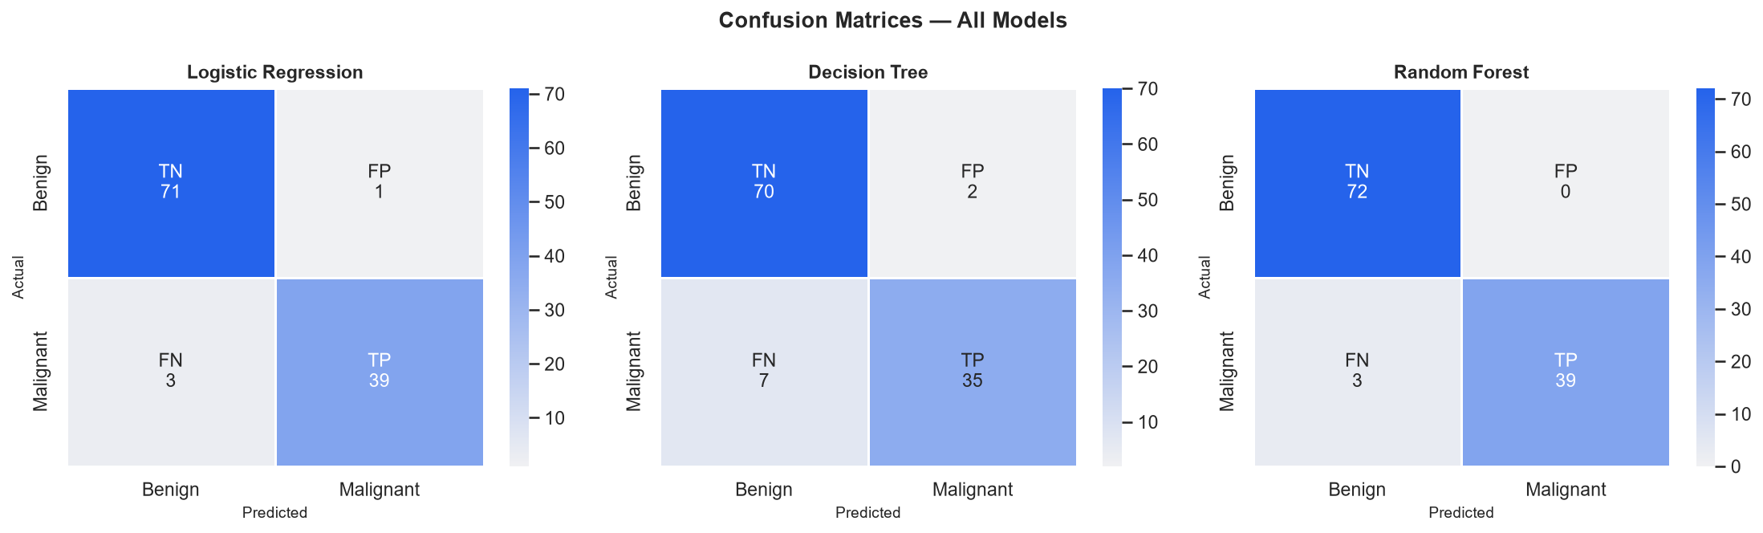
Figure 6: Confusion matrices — Logistic Regression, Decision Tree, Random Forest.
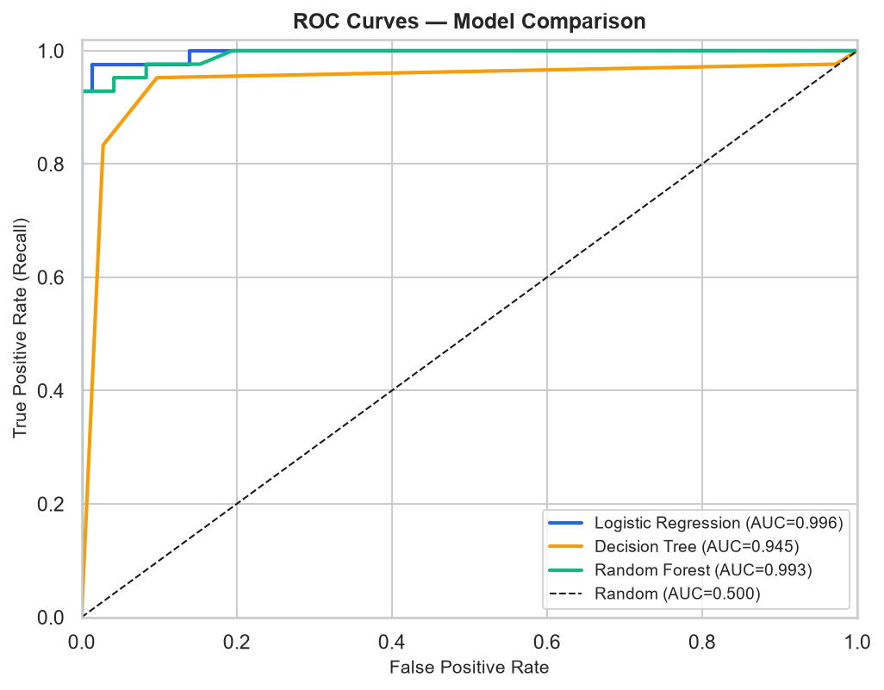
Figure 7: ROC curves — all three models.
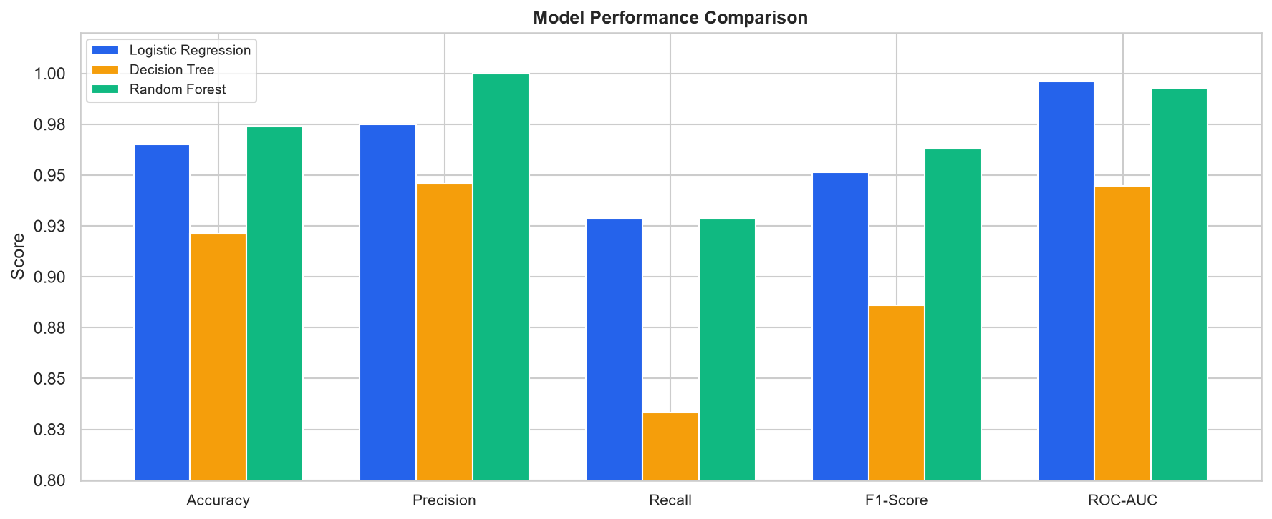
Figure 8: Model performance comparison across all five metrics.

11. Feature Importance
Random Forest importance scores (mean Gini decrease across 100 trees) identify worst-case size and shape irregularity measurements as the most informative predictors. Top 5: area_worst (0.1514), concave points_worst (0.1265), radius_worst (0.0935), perimeter_worst (0.0836), concave points_mean (0.0811). Logistic Regression coefficient magnitudes confirm the same set after StandardScaler. These patterns are specific to this dataset and do not imply medical causation.
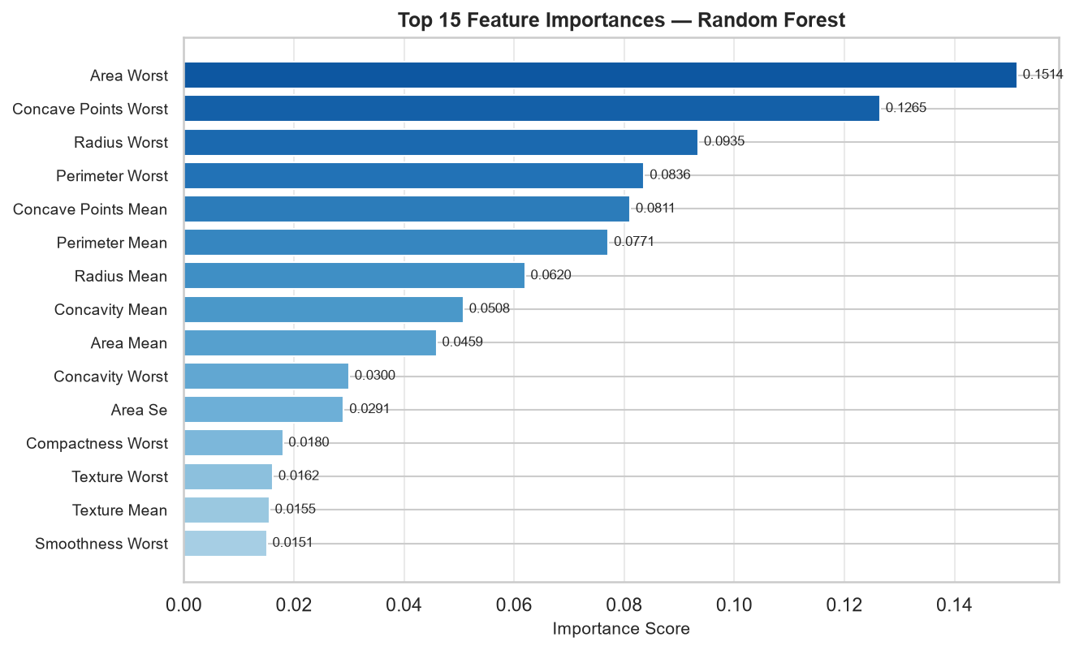
Figure 9: Top 15 Random Forest feature importance scores.

12. Error Analysis
Error analysis on the Random Forest test-set predictions (114 samples):
Error Type | Count | Meaning
True Positive (TP) | 39 | Malignant correctly identified as Malignant
True Negative (TN) | 72 | Benign correctly identified as Benign
False Positive (FP) | 0 | Benign incorrectly predicted as Malignant (false alarm)
False Negative (FN) | 3 | Malignant incorrectly predicted as Benign (most critical error)

The 3 false negative(s) had feature values in the overlapping region between classes — particularly texture and smoothness features where class separation is weakest. The dataset is fully anonymized; no patient-identifying information was inspected.

13. Interactive Streamlit Application
An interactive dashboard was built using Streamlit (app.py). Launch with: streamlit run app.py
The application provides seven navigation pages:
- Home: Live KPI cards, class distribution chart, project workflow, technology badges.
- Dataset Explorer: Filter by class, data preview, statistics, missing value analysis, optional CSV upload with validation.
- Exploratory Analysis: Distribution, Comparison, Correlation, and Relationships tabs with user-selectable features.
- Feature Insights: Per-feature statistics, violin plots, top-15 importance chart.
- Model Performance: Comparison table, confusion matrices, ROC curves.
- Prediction: 30 inputs in three expandable groups (Mean / SE / Worst), model selector, probability chart.
- About Project: Project overview, actual results summary, key findings, limitations.

14. Key Findings
- Clean dataset — no missing feature values, no duplicate rows; one all-null artifact column removed.
- Mild class imbalance: 62.7% Benign / 37.3% Malignant — handled via stratified splitting.
- Worst-case measurements of tumor size and shape irregularity are the most discriminative features in this dataset.
- Strong multicollinearity among size features (r > 0.99) is geometrically expected and does not impair model performance.
- All three models exceeded 92% accuracy; LR and RF achieved ROC-AUC > 0.99. RF achieved zero false positives (FP=0).
- 5-fold stratified cross-validation results were consistent with test-set performance.

15. Limitations
- Small dataset (569 samples) from a single institution — may not generalize broadly.
- Binary classification only; real diagnosis involves more factors, subtypes, and staging.
- No external validation on an independent dataset.
- No clinical professional review.
- Not a clinical tool — must never be used to guide actual medical decisions.

16. Conclusion
This project demonstrated a complete data analytics pipeline on the Breast Cancer Wisconsin Dataset — from data cleaning and EDA through machine-learning model development, evaluation, and interactive visualization. Worst-case tumor size and shape measurements were consistently the strongest predictors. All three models performed well, with Logistic Regression and Random Forest achieving near-perfect ROC-AUC scores. This is an educational project on a single dataset and results must not be applied in any clinical context.

17. Future Scope
- Validation on larger, multi-institutional datasets.
- Additional algorithms: SVM, XGBoost, Gradient Boosting for extended comparison.
- Explainable AI: SHAP for per-sample feature explanations.
- Threshold optimization to maximize recall for the Malignant class.
- Class imbalance handling with SMOTE or class-weight adjustment.
- Educational web deployment using Streamlit sharing or cloud hosting.

18. References
[1] Wolberg, W.H. et al. (1995). Breast Cancer Wisconsin (Diagnostic) Data Set. UCI ML Repository. https://archive.ics.uci.edu/ml/datasets/Breast+Cancer+Wisconsin+(Diagnostic)
[2] Kaggle Dataset. https://www.kaggle.com/datasets/uciml/breast-cancer-wisconsin-data
[3] Pedregosa, F. et al. (2011). Scikit-learn: Machine Learning in Python. JMLR, 12, 2825–2830.
[4] McKinney, W. (2010). Data Structures for Statistical Computing in Python. Proc. 9th Python in Science Conf.
[5] Waskom, M. (2021). seaborn: statistical data visualization. JOSS, 6(60), 3021.
[6] Streamlit Inc. (2024). Streamlit. https://streamlit.io

