1.0 System overview

ESP32 S3 N16R8 micro-controller
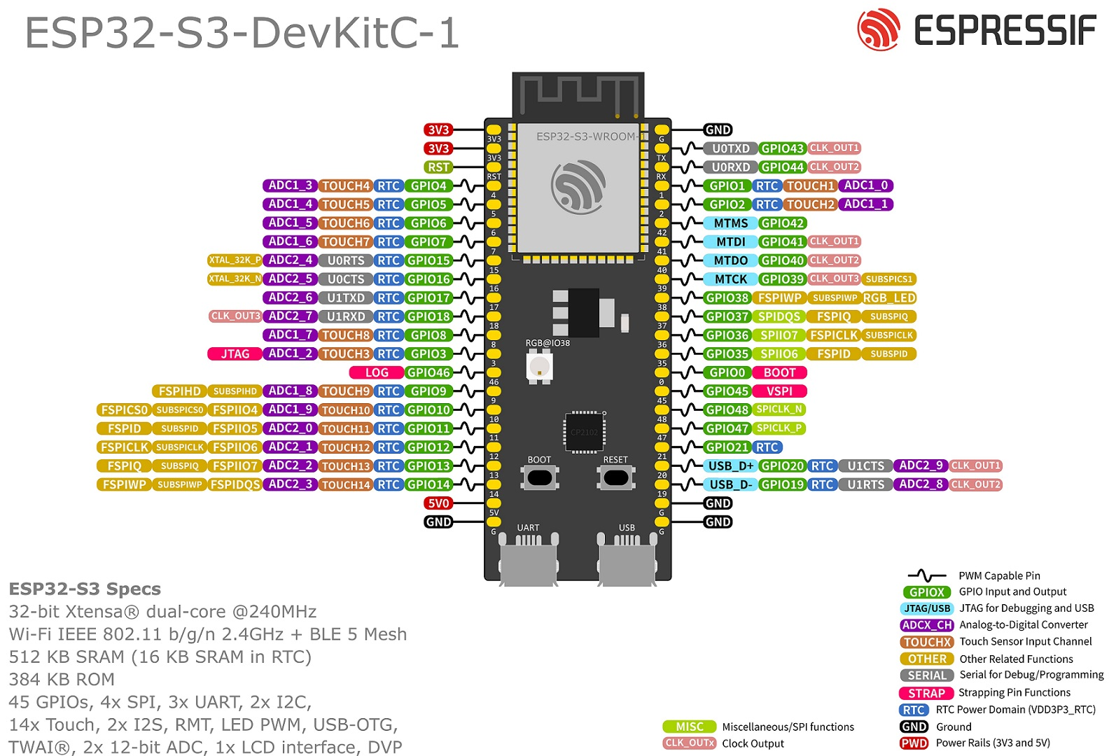
Breadboard
Jumper wires M-M and M-F connections
Output: Red LED → LED
Input: Flip switch → FS (input type INPUT_PULLUP)

1.1 General Requirements
- ESP32 represents slave module and it must only implement interaction with hardware.
- It communicates with master C++ application using TCP network protocol.
- All applicative requests are handled by master application.
- Slave module should run independently from master application.
- Upon startup master and slave are establishing connection
- LED is connected to GPIO 4 and FS is connected to GPIO 5

1.2 Hello World
- HelloWorld request represents a request to turn on LED on slave, and write HelloWorld on master console.
- IF
FS changes state 1 → 0
THEN
ESP32 send master request for HelloWorld

1.3 Good bye world
- GoodByeWorld request represents a request to turn off LED on slave, and write Good bye world on the master console.
- In addition, it also terminates master application.
- IF
FS changes state 0 → 1
THEN
ESP32 send master request for GoodByeWorld

