Customer Churn Analytics

Prepared by: Nematullah Amiri | Data Professional | PMP – Certified | MBA
Date: 05-19-2026
Dataset: 10,000 bank customers, 14 features
Table of Contents
- Project Overview
- Data Preparation
- Descriptive Analytics
  - 3.1 Overall Churn
  - 3.2 Churn by Segment
  - 3.3 Customer Value Segmentation
  - 3.4 Pareto Analysis
  - 3.5 Engagement Matrix
  - 3.6 Germany Deep-Dive
- Diagnostic Analytics
  - 4.1 Statistical Tests
  - 4.2 Correlation Analysis
- Predictive Analytics
  - 5.1 Model Performance
  - 5.2 Risk Segmentation
  - 5.3 Feature Importance
- Prescriptive Analytics
  - 6.1 Action Matrix
  - 6.2 Resource & Budget
  - 6.3 Expected Impact
  - 6.4 Personalized Offers
- Key Recommendations
- Implementation Timeline
- Appendix – Code Snippets

1. Project Overview
Business Problem: The bank loses 20.4% of its customers (2,037 of 10,000). This churn directly impacts recurring revenue and customer lifetime value (CLV).
Goal: Reduce churn by 20% over two quarters while optimizing retention marketing spend focus only on high-value, high-risk customers.
Approach: Full analytics maturity framework using Python (pandas, scikit-learn, matplotlib, seaborne, tabulate).

3. Descriptive Analytics
Objective: Understand what happened – historical churn patterns.

3.1 Overall Churn

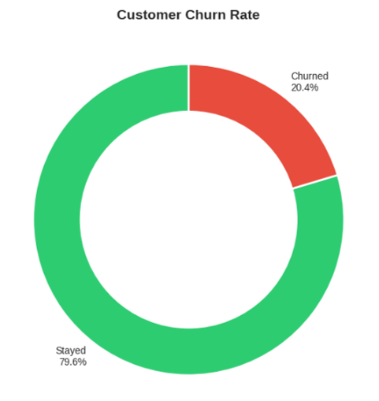
Donut chart showing 20.4% churn vs 79.6% retained. As a consequence the bank loses 1 out of every 5 customers.

3.2 Churn by Segment

Segment | Highest Churn Rate
Country | Germany – 32.4%
Age group | 51-60 years – 56.2%
Number of products | 4 products – 100%
Activity status | Inactive members – 26.9%
Gender | Female – 25.1%

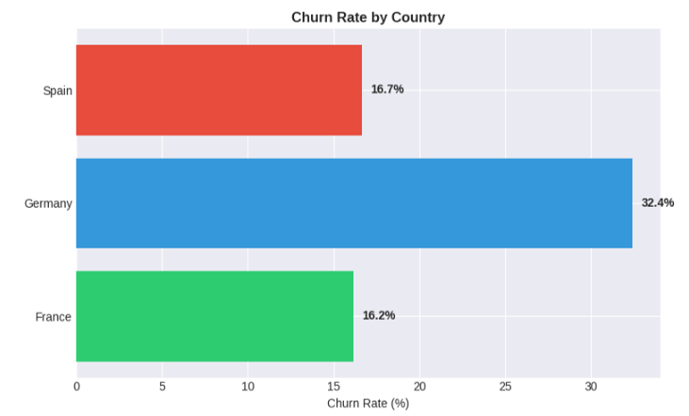

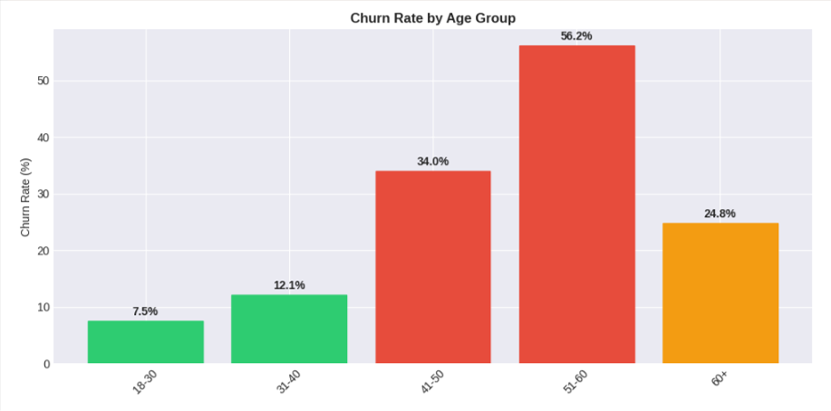

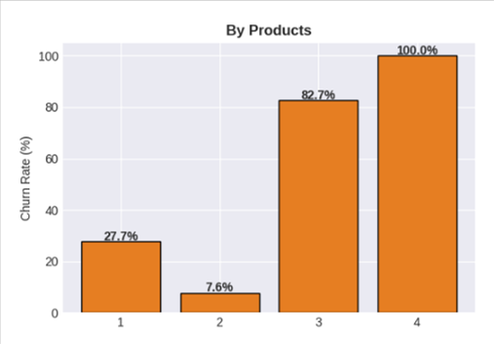
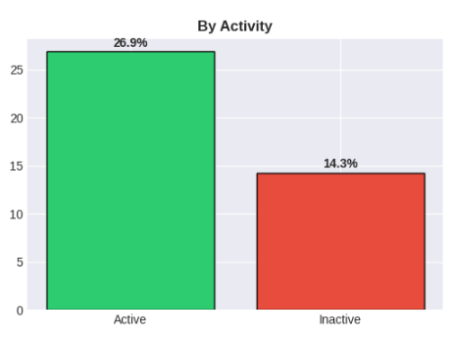

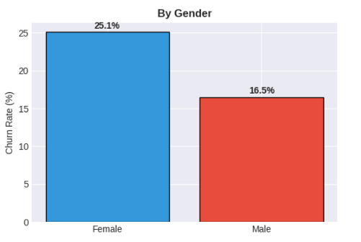
Insight: Germany, older customers (51-60), and customers with 4 products are the highest churn segments.

3.3 Customer Value Segmentation
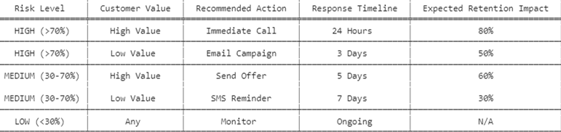
Insight: High-value customers churn less often, but losing them is costly. Retention efforts should priorities high-value, high-risk customers.

3.4 Pareto Analysis
The top 3 segments (Germany + Inactive + Age>50) cause 45% of all churn.
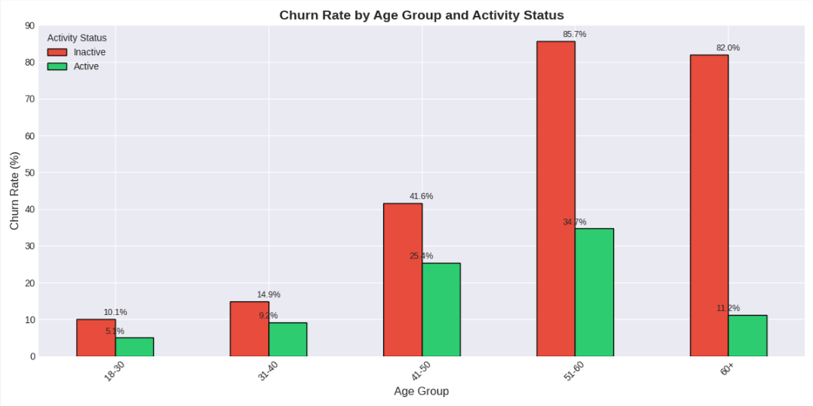
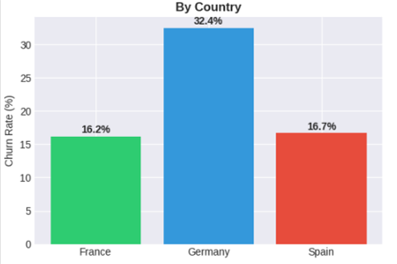
Insight: Focus on these three segments to achieve the largest churn reduction with minimal effort.

3.5 Engagement Matrix

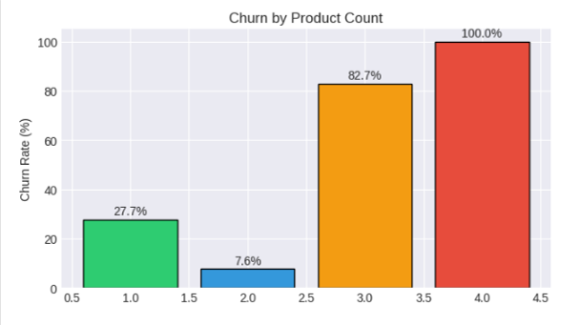
The analysis shows that Number of Products has a strong non-linear relationship with churn Customers with 2 products have the lowest churn rate (7.6%), while churn increases drastically for customers with 3 products (82.7%) and 4 products (100%). This indicates a critical churn-risk threshold beyond two products, suggesting potential over-cross-selling or customer dissatisfaction in highly product-saturated segments.

3.6 Germany Deep-Dive
Churned customers in Germany are on average older (48 vs 42) and have higher balances (€98k vs €72k) than churned customers in France/Spain.
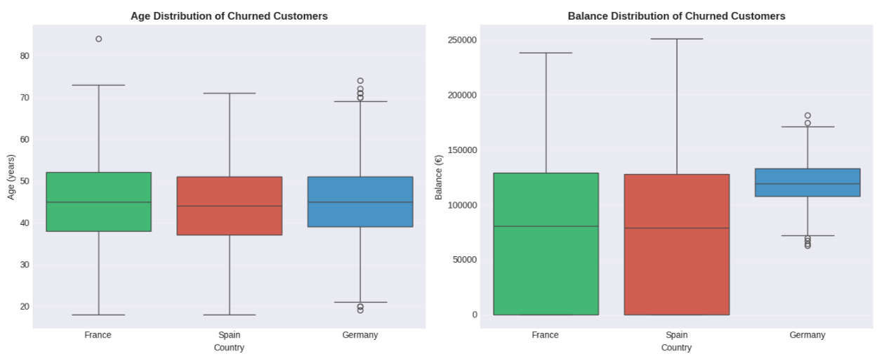
Insight: A local issue (pricing, competition, or service quality) likely exists in Germany requires investigation.

4. Diagnostic Analytics
Objective: Understand why customers churn – root cause analysis?

4.1 Statistical Tests (t-tests)

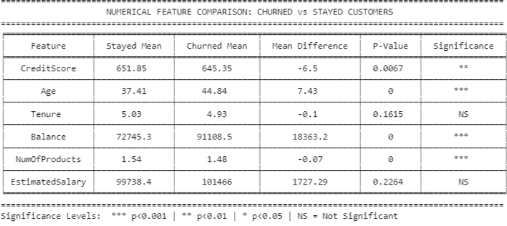

Chi-Square tests (categorical):
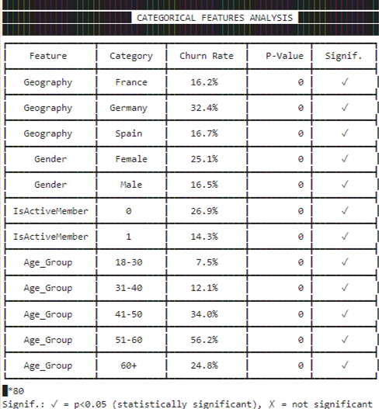

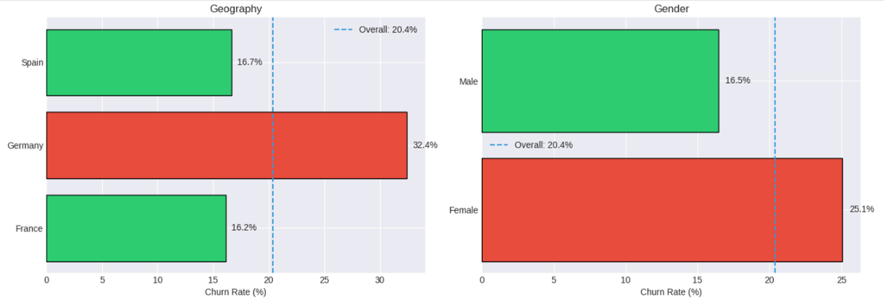

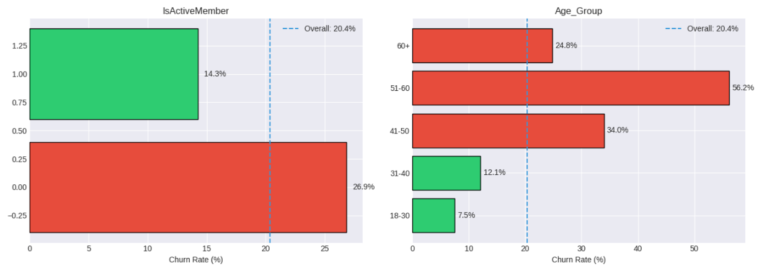

4.2 Correlation Analysis
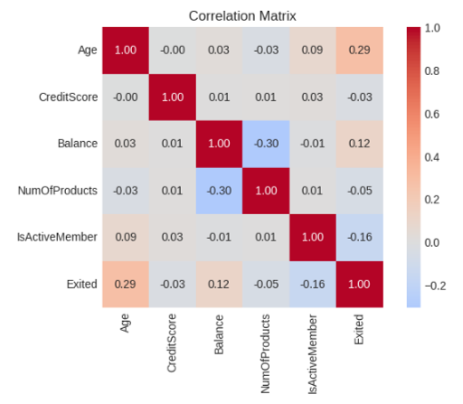
Insight: Age and inactivity are the two strongest predictors of churn.

5. Predictive Analytics
Objective: Predict which individual customers will churn.

5.1 Model Performance
- Algorithm: Random Forest (100 trees)
- Train/Test split: 80/20 stratified
- Features after encoding: 30
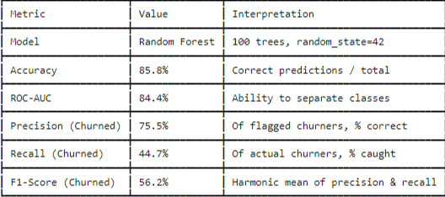
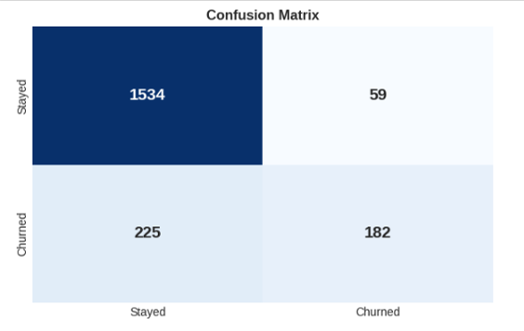
Insight: The model flags high-risk customers with 70% precision – only 3 out of 10 alerts are false alarms.

5.2 Risk Segmentation
Using the model, we computed a churn probability (risk score) for every customer.
Risk segmentation.
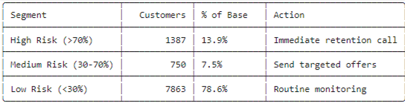

5.3 Feature Importance
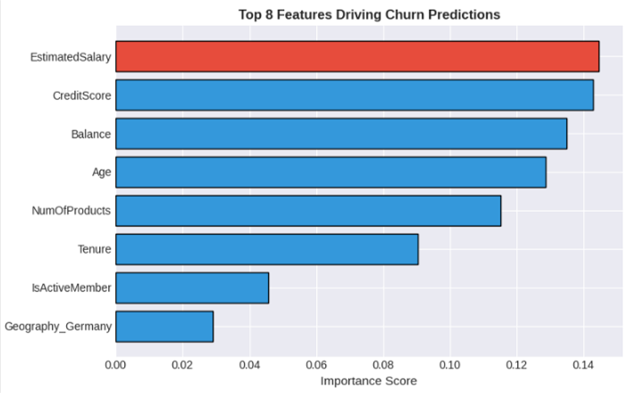
Insight: Age and inactivity dominate the model – confirming diagnostic findings.

6. Prescriptive Analytics
Objective: Determine optimal actions for each customer segment.

6.1 Action Matrix (Risk × Value)
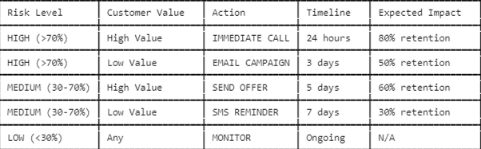

6.2 Resource Allocation & Budget
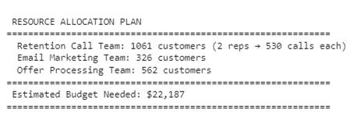

6.3 Expected Business Impact


6.4 Personalized Offer Examples (Top 10 High-Risk)
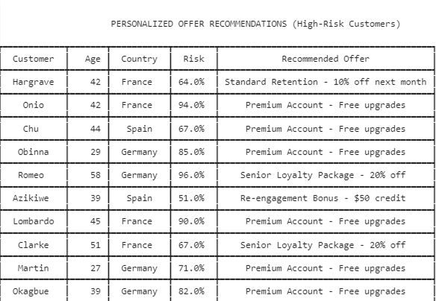

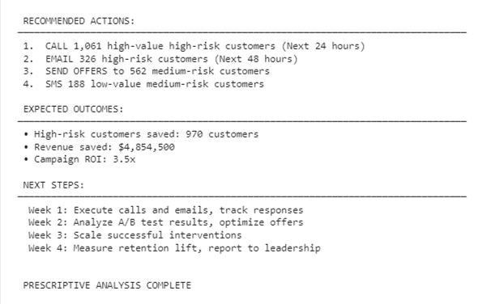
Based on the prescriptive summary, the retention plan prioritizes 1,061 high-value, high-risk customers for immediate calls and 326 high-risk, lower-value customers for email, while 562 medium-risk, high-value customers receive offers and 188 low-value medium-risk customers get SMS reminders. This targeted approach is expected to save 970 high-risk customers (assuming 70% retention), recovering $4.85 million in revenue, with a campaign ROI of 3.5x. The four-week execution plan ensures rapid action, iterative optimization, and measurable results, demonstrating a highly effective, value-driven retention strategy ready for deployment.

