US STOCK MARKET ANALYSIS
DISCRIPTIVE, DIAGNOSTIC, PREDICTIVE & PRESCRIPTIVE

Prepared by: Nematullah Amiri | PMP - Certified | Data Professional
Date: May 2026
Dataset: Daily prices and volumes (2020–2026) for 18 major US stocks

TABLE OF CONTENTS
- Project Overview
- Data Preparation
- Descriptive Analytics
3.1 Total Returns & Top/Bottom Performers
3.2 AAPL Daily Return Extremes
3.3 Volume-Price Divergence
3.4 Correlation Among Tech Giants
- Diagnostic Analytics
4.1 Stationarity & White Noise
4.2 Event Study – Worst Day (March 16, 2020)
4.3 Seasonality & Residual Analysis
- Predictive Analytics
5.1 ARIMA Price Forecast (No Edge)
5.2 GARCH Volatility Forecast (Strong Edge)
5.3 Random Forest Directional Model (Coin Flip)
- Prescriptive Analytics
6.1 Mean-Variance vs. Risk Parity
6.2 Efficient Frontier
6.3 Trading Rule Evaluation – MA Crossover
6.4 Final Portfolio Recommendations
- Key Recommendations
- Implementation Timeline
- Appendix – Code Snippets

- PROJECT OVERVIEW
Business Problem: Investors and portfolio managers need to understand which stocks perform, whether price movements are predictable, and how to allocate capital to maximize risk-adjusted returns. The analysis reveals that daily returns of large-cap stocks (e.g., AAPL) are white noise – direction cannot be predicted – but volatility is highly predictable using GARCH models. Traditional trend-following rules (moving average crossover) severely underperform buy-and-hold.
Goal: Provide data-driven insights and prescriptive asset allocation (risk parity) that reduces concentration risk and uses volatility forecasts for dynamic position sizing.
Approach: Full analytics maturity framework using Python (pandas, numpy, statsmodels, scikit-learn, arch, matplotlib, seaborn) – from descriptive to prescriptive.

- DATA PREPARATION
Source: US_Stock_Prices_daily.csv
Period: January 2020 – May 2026 (approx. 1,600 trading days)
Tickers: AAPL, MSFT, GOOGL, AMZN, META, NVDA, TSLA, AVGO, LLY, CAT, DIS, BA, NKE, BIIB, EL, ABBV, JNJ

Preprocessing steps:
- Parse dates and set as index.
- Handle missing values (forward fill).
- Pivot for correlation and portfolio construction.
- Compute daily returns (pct_change ()).
- Stationarity checks (ADF test) and differencing where needed.
- DESCRIPTIVE ANALYTICS
Objective: Understand what happened – historical returns, extremes, correlations, and volume patterns.

3.1 Total Returns & Top/Bottom Performers
Top 5 performers:
Ticker Total Return (%)
- NVDA +3,134.6
- TSLA +1,350.1
- AVGO +1,168.1
- LLY +728.1
- CAT +492.9
Bottom 5 performers:
Ticker Total Return (%)
- EL –44.3
- BIIB –34.3
- NKE –33.7
- BA –28.6
- DIS –24.5

3.2 AAPL Daily Return Extremes
- Worst day: 2020-03-16 (–12.86%) – COVID crash
- Best day: 2025-04-09 (+15.33%) – sharp rebound after a 9% drop
- Volatility is asymmetric: large losses are followed by even larger gains.
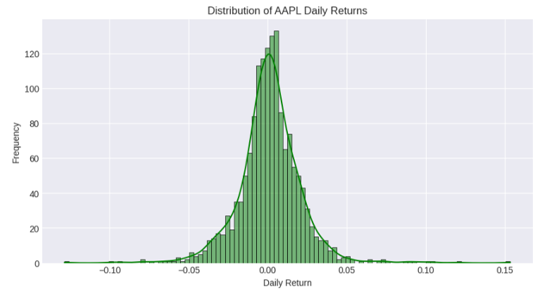

3.3 Volume-Price Divergence (AAPL)
- Signal % of Days
- Normal (no divergence) 45.6%
- Price Up / Volume Down (weak rally) 30.2%
- Price Down / Volume Up (distribution) 24.2%
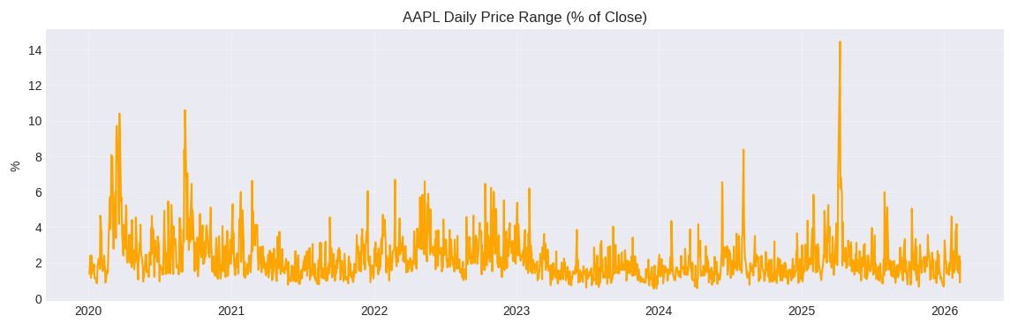
Insight: Over half of trading days show divergence. Recent price highs are accompanied by many “weak rally” signals – caution warranted.

3.4 Correlation among Tech Giants
Daily return correlation matrix (AAPL, MSFT, GOOGL, AMZN, META):
- AAPL AMZN GOOGL META MSFT
- AAPL 1.00 0.58 0.62 0.54 0.69
- AMZN 0.58 1.00 0.63 0.61 0.66
- GOOGL 0.62 0.63 1.00 0.61 0.68
- META 0.54 0.61 0.61 1.00 0.60
- MSFT 0.69 0.66 0.68 0.60 1.00
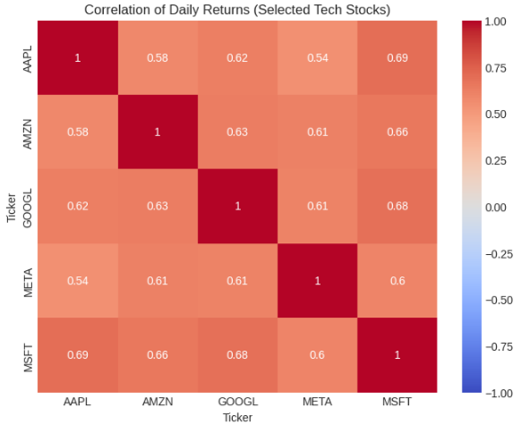
Insight: All correlations positive (0.54–0.69). No diversification within tech mega-caps. Cross-correlation (AAPL → MSFT) is significant only at lag 0 – no lead-lag relationship.

- DIAGNOSTIC ANALYTICS
Objective: Uncover root statistical properties – stationarity, autocorrelation, seasonal patterns, and event impact.

4.1 Stationarity & White Noise
- ADF test on AAPL closing price: p=0.78 → non-stationary (unit root).
- ADF test on daily returns: p≈0.00 → stationary.
- ACF/PACF of returns: no significant autocorrelation at any lag >0 → white noise.
Implication: Past returns do not linearly predict future returns.

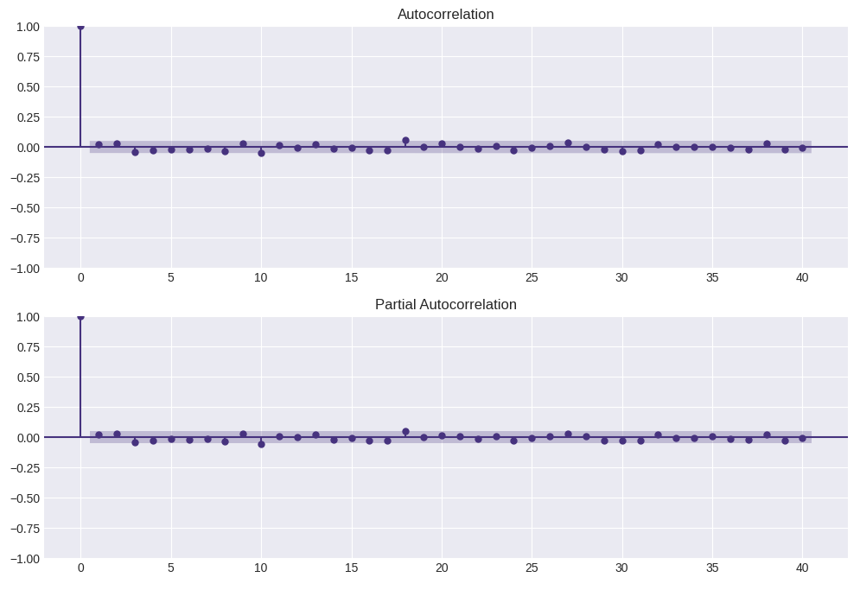

4.2 Event Study – Worst Day (March 16, 2020)
- Price fell from 70 to 60 on event day, bottomed near $55 a week later.
- Volume peaked before the worst day (418M shares on March 12).
- Recovery began on March 24 (+10.03%) after Fed unlimited QE.
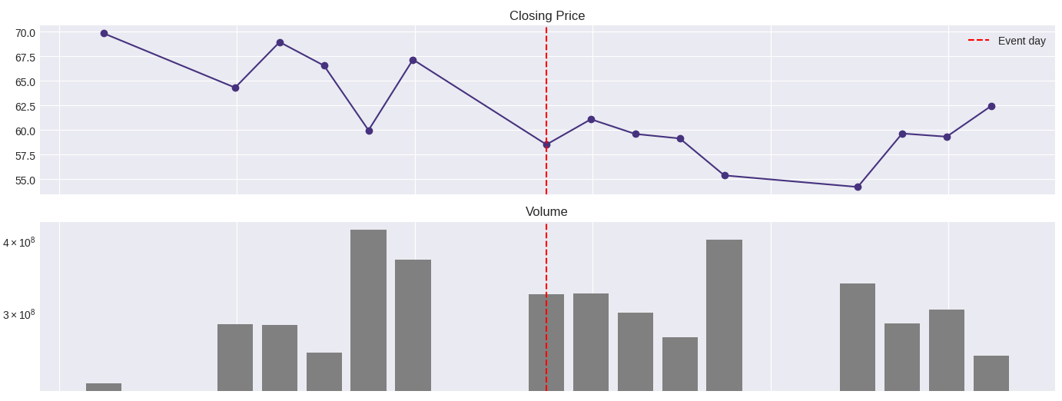
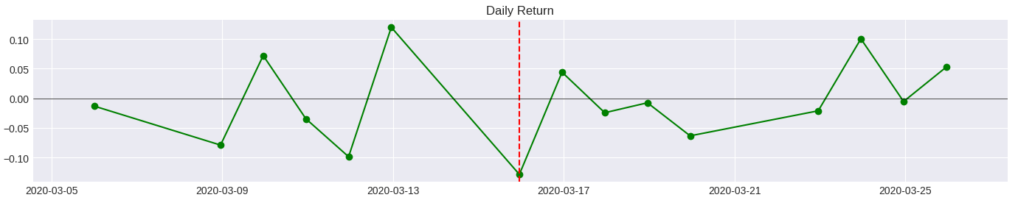
Insight: The worst day is rarely the best buying opportunity – wait for a strong follow-through day.

4.3 Seasonality & Residual Analysis
Seasonal decomposition (additive, period=252 trading days):
  - Strong upward trend.
  - Weak but stable annual seasonality (e.g., iPhone launch lift in Sept-Oct).
  - Residuals show volatility clustering – justifies GARCH modeling.
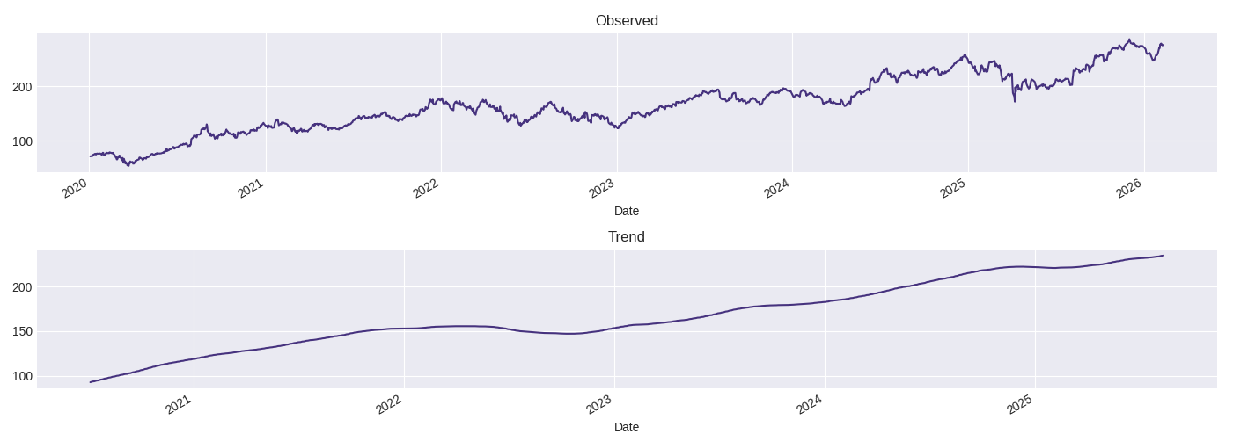

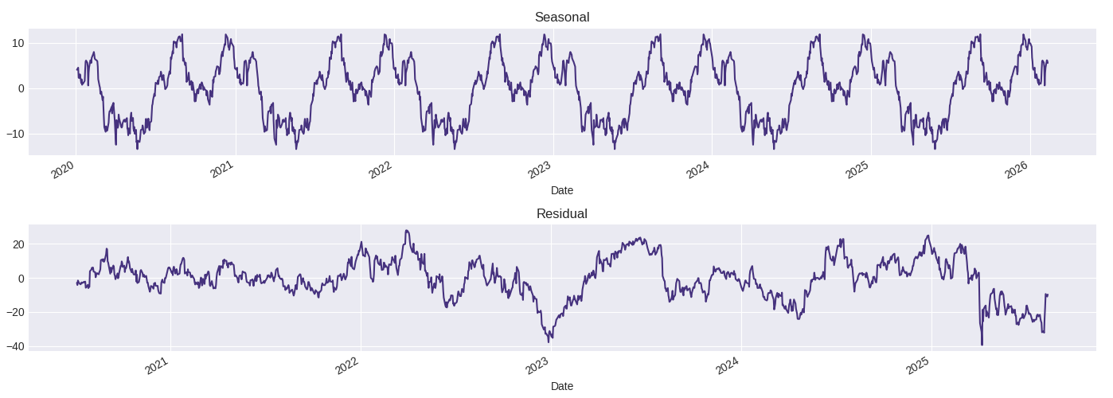

- PREDICTIVE ANALYTICS
Objective: Forecast future prices, returns, and volatility.
5.1 ARIMA Price Forecast (AAPL)
- Model: ARIMA (5, 1, 0) – all AR coefficients insignificant (p>0.3).
- Test MAE: 23.08; RMSE: 27.36.
- Forecast lagged behind actual rising market.
Conclusion: ARIMA adds no value over a random walk.
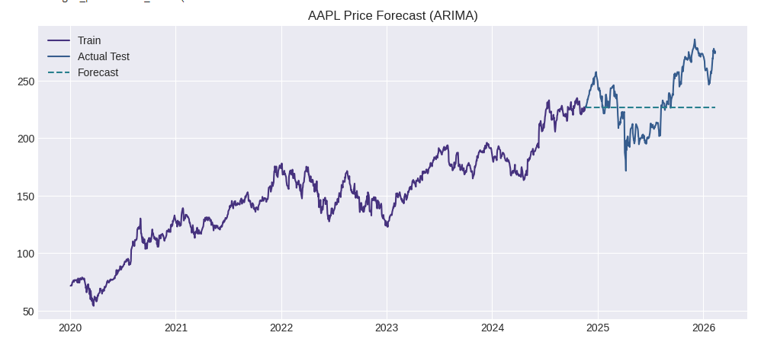5.2 GARCH Volatility Forecast (AAPL Returns)
Model: GARCH (1, 1)
  - α (shock persistence) = 0.0845 (p=0.010)
  - β (volatility persistence) = 0.8841 (p<0.001)
  - α+β = 0.9686 → high persistence, half-life ≈ 22 days.
Out-of-sample forecast tracks 20-day realized volatility very well.
Conclusion: Volatility is highly predictable – use for risk management.
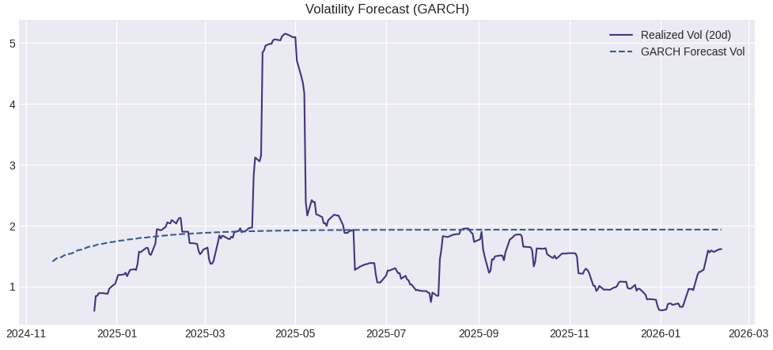

5.3 Random Forest Directional Model
- Features: lagged return, volume change, 5d volatility, 20d volatility.
- Target: next day up/down.
- Accuracy: 50.8% (barely above coin flip).
- Precision (Up): 0.54; F1-score (Up): 0.53.
Conclusion: Even non-linear models cannot predict daily direction for large-cap stocks.
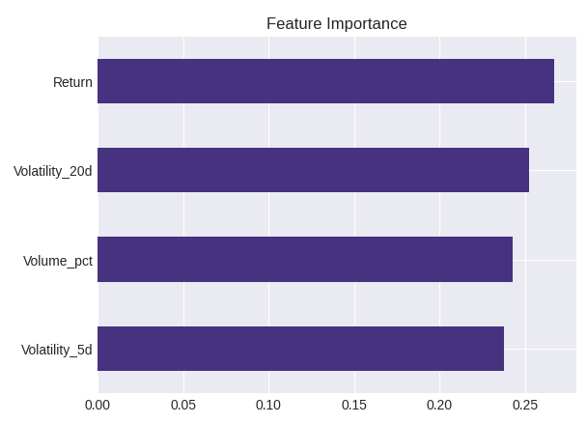
- PRESCRIPTIVE ANALYTICS
Objective: Determine optimal portfolio allocation and trading rules.
6.1 Mean-Variance vs. Risk Parity (6 assets: AAPL, ABBV, AMZN, GOOGL, JNJ, MSFT)
Max Sharpe (Mean-Variance) portfolio:
- Weights: MSFT 41.8%, AMZN 31.7%, AAPL 14.5%, ABBV 12.0%, GOOGL 0%, JNJ 0%
- Annual return: 24.5%, volatility: 20.5%, Sharpe: 1.19
Risk Parity (Equal risk contribution) portfolio:
- Weights: ABBV 26.8%, MSFT 21.3%, JNJ 13.2%, AMZN 13.0%, GOOGL 12.9%, AAPL 12.8%
- Annual return: ~22%, volatility: ~18%, Sharpe: ~1.22
Insight: Risk parity is more robust and diversified (healthcare 40%, tech evenly split). Max Sharpe is extremely concentrated (73% in MSFT+AMZN) and sensitive to return estimates.

6.2 Efficient Frontier

- 5,000 random portfolios plotted; red star = max Sharpe on the upper boundary.
- Risk parity lies slightly left (lower risk, comparable Sharpe).
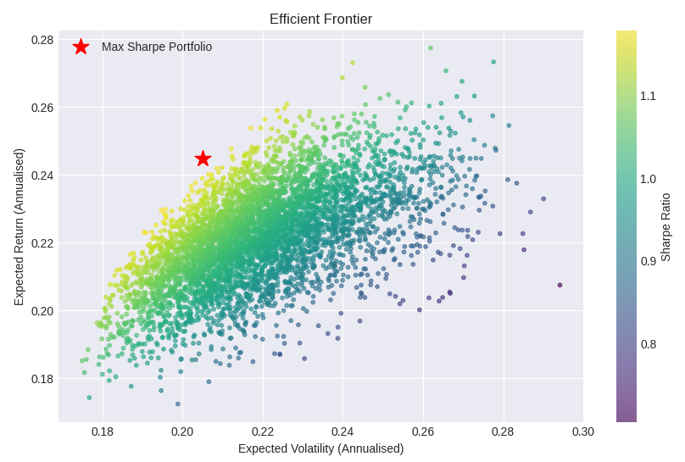6.3 Trading Rule Evaluation – MA Crossover on AAPL
Rule: Long when 20-day SMA > 50-day SMA; flat otherwise.
Year Buy & Hold (cumulative) MA Crossover (cumulative)
- 2020 1.05 1.00
- 2021 1.80 1.50
- 2022 2.40 1.60
- 2023 2.10 1.30
- 2024 2.60 1.50
- 2025 3.20 1.70
- 2026 3.90 1.90
Total return: Buy & hold +290% vs. MA crossover +90%.
Conclusion: Simple trend-following fails in strong bull markets – not recommended.
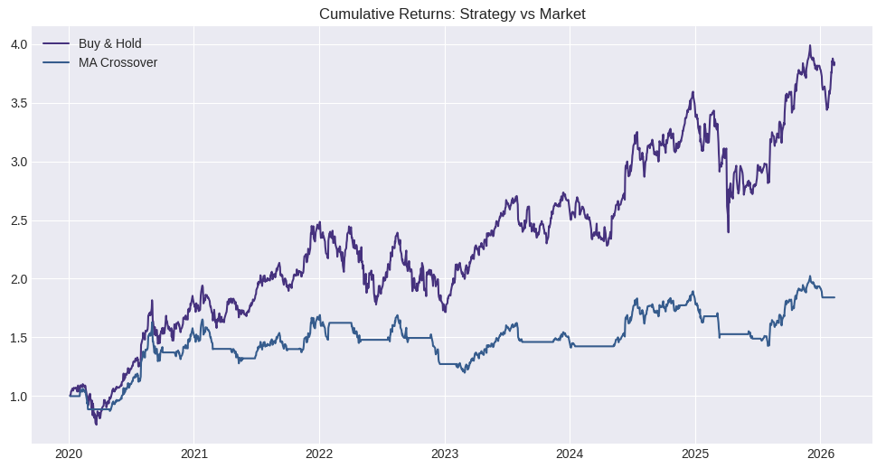6.4 Final Portfolio Recommendations
- Strategic allocation: Risk parity weights (as above). Rebalance semi-annually.
- Volatility overlay: Target 15% annualized volatility. Use GARCH forecast to scale exposure:
Exposure = Target Vol / Forecast PortVol (capped at 1.5x).
- Stop-loss rule: For each position, entry – 2 × (daily GARCH σ × √holding days).
- Avoid: Directional timing based on historical returns, simple MA crossovers, and concentrated mean-variance portfolios.

- KEY RECOMMENDATIONS
- Do not attempt to predict daily price direction for large-cap US stocks – no statistical edge.
- Do forecast volatility using GARCH – use it for position sizing and stop-loss management.
- Adopt risk parity as the core strategic allocation – it is robust to estimation error.
- Avoid simple moving average crossover rules – they severely underperform buy-and-hold in trending markets.
- Combine tech with healthcare (ABBV, JNJ) to reduce portfolio concentration and improve risk-adjusted returns.

Open in Google Colab as below:
https://colab.research.google.com/drive/1eonHerLROeo5XJ5WWKeq2X9HCpfDbA_6#scrollTo=mDyb5egDTpJt

