**DATA PREPARATION AND UNDERSTANDING THE GOAL OF THE PROJECT.**

This is a Coursera based realistic project scenario with a Model Car company’s database. The goal of the project is to create minimum two suggestions for reducing inventory to allow for closing of a storage facility. I used this preprepared script for creating the database on MySQL Workbench.

Here is the EER model of the dataset:

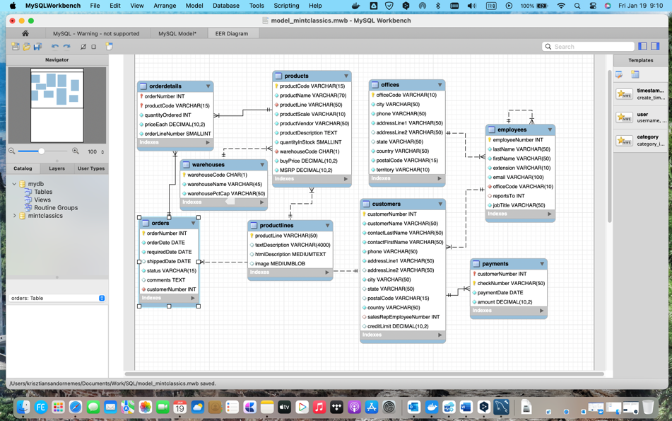

**ANALYSIS**

The analysis was carried out to answer some very important questions and to gain an understanding of the dataset.

**Warehouses**

1. To start with, I wanted to know the capacity and usage of the warehouses:

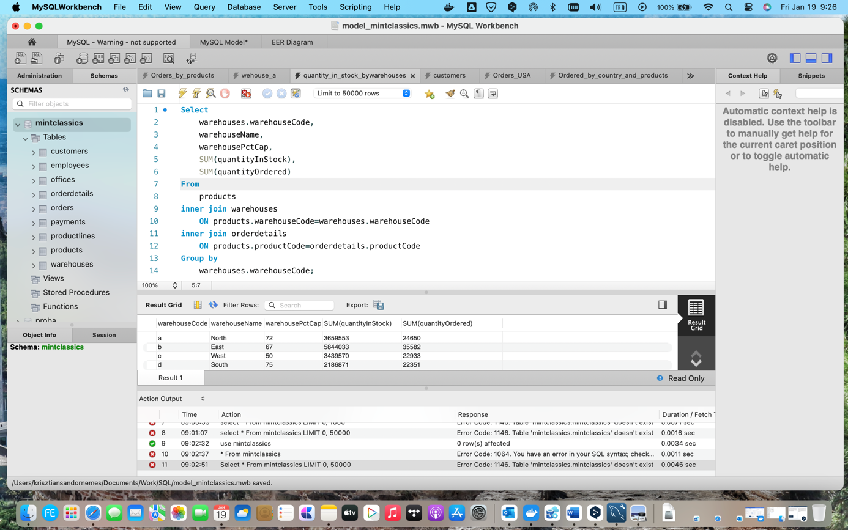

The company has four warehouses. Warehouse South (d) has the least amount of product and the fewest orders.

1. I wanted to know which products are ordered more frequently and how prices affect orders:

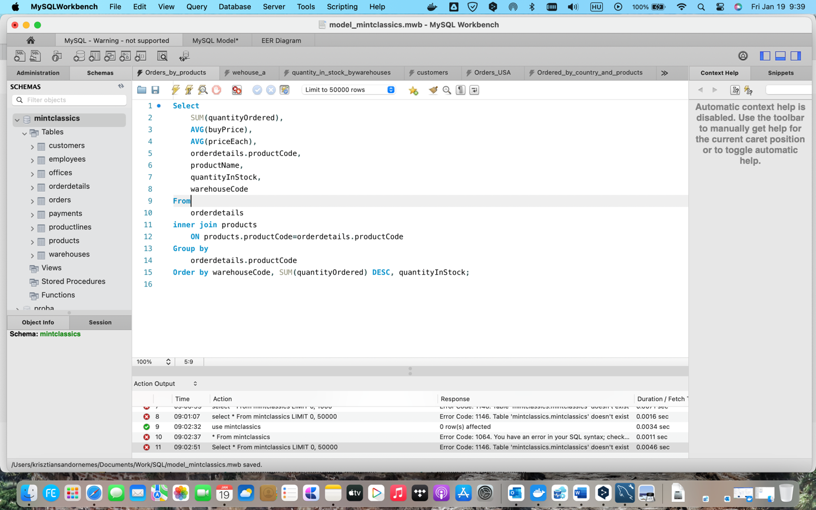

Here is a sample of the result of the query:

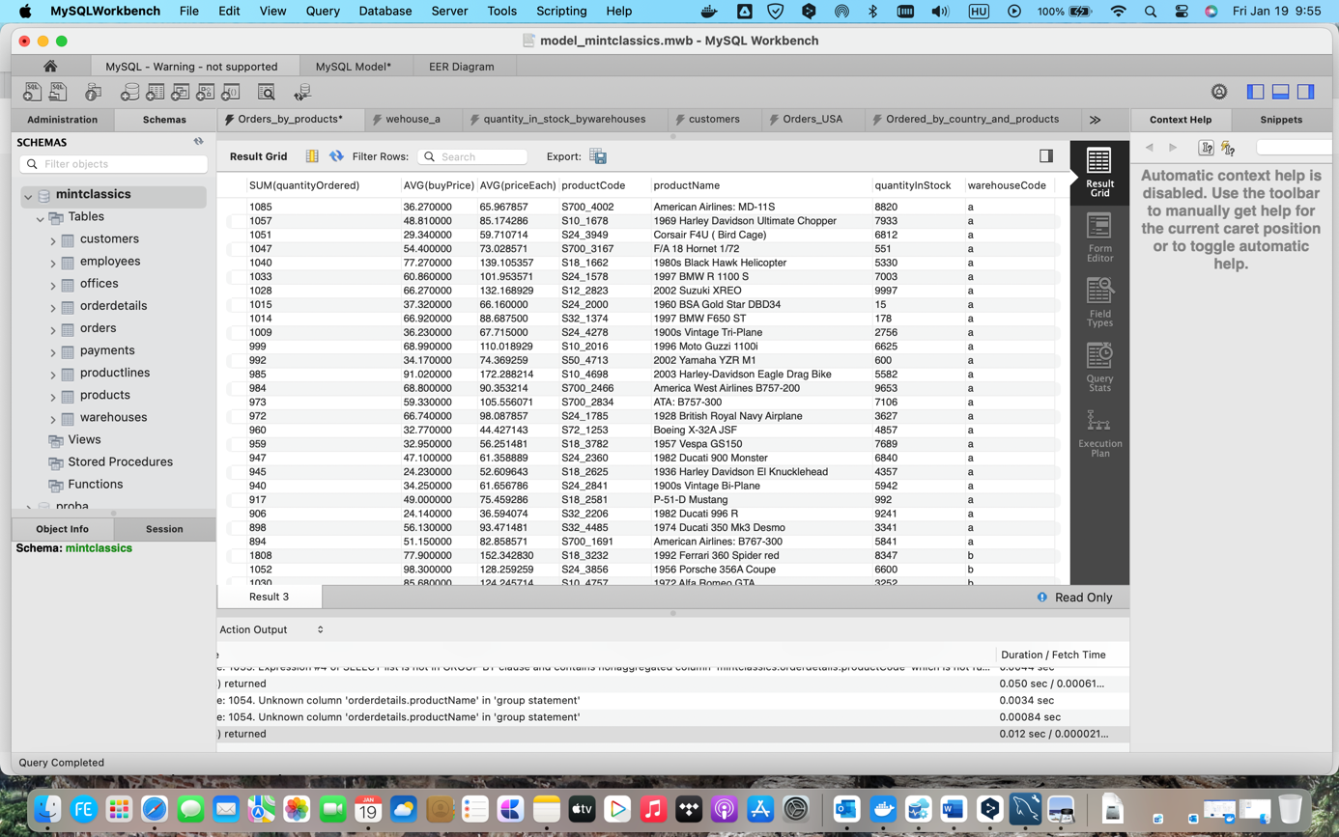

After the examination of the result, we can make some conclusion:

* There are also a large number of orders for both lower and higher priced products. Price does not significantly affect the number of orders.
* We have successfully identified which products are low in stock and which products we stock above average demand.

**Customer orders**

1. Firstly, I wanted to know where most orders were generated:

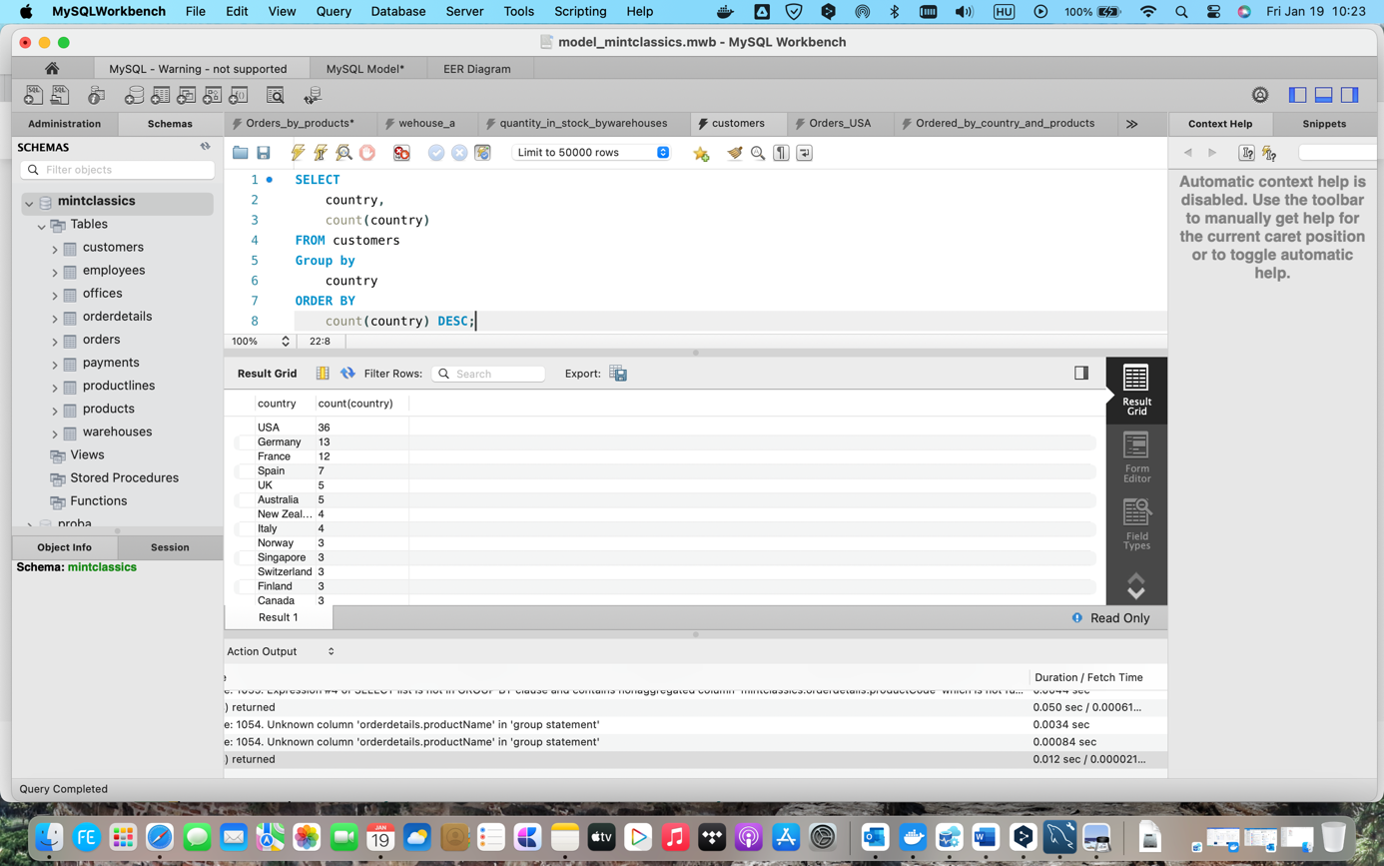

Most orders were placed in the USA.

1. Look into deeper a little bit:

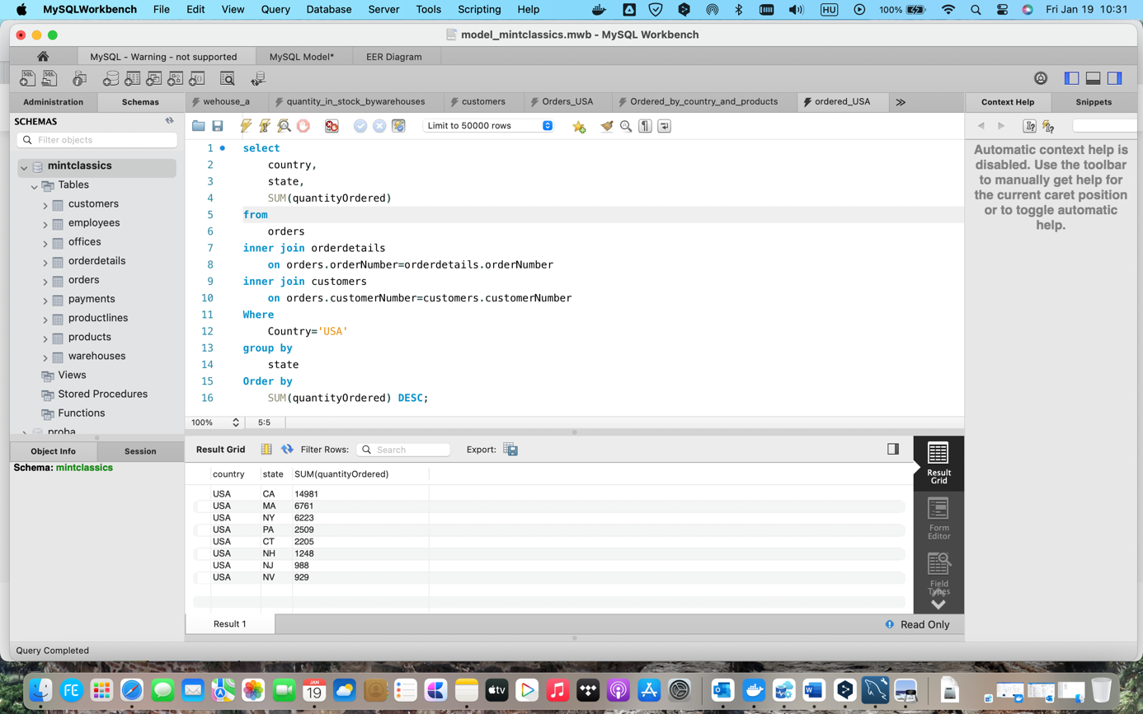

Based on the result, we can make some conclusion:

* The company's products are sold worldwide. However, the majority of orders come from the USA and Europe.
* The states on the east and west coasts of the USA have the highest number of the orders.

**Conclusions/Recommendations:**

1. In order to reduce the stock, the company should announce a discount campaign of the less or medium demanded product which have more in stock than the demand. However, some products quantities are very low in stock. So, the demand-based production is highly recommended.
2. By closing the South (d) warehouse and moving all products to the West and East warehouses, the company would be able to focus on the areas that generate the most orders.