HELIOS/roi_generator

ROI Generator is a GUI which transforms OnAcid/RTMC output (.mescroi files) into MES-friendly coordinate system, as well as visualizes the detected ROIs on the maximum projection images per each imaged layer.

**roi_generator** is a function defined in the HELIOS toolbox. All the necessary auxiliary functions are located in HELIOS. To run ROI Generator MatLab version 2019b or later is needed!

## **Installation**

**HELIOS directory can be found in the following path: ‘\vr_gramophone\VR_Andy\HELIOS’. If your MatLab client does not have access to HELIOS, add it to the MatLab path:**

1. **Click on ‘Home’, then ‘Add Path’.**

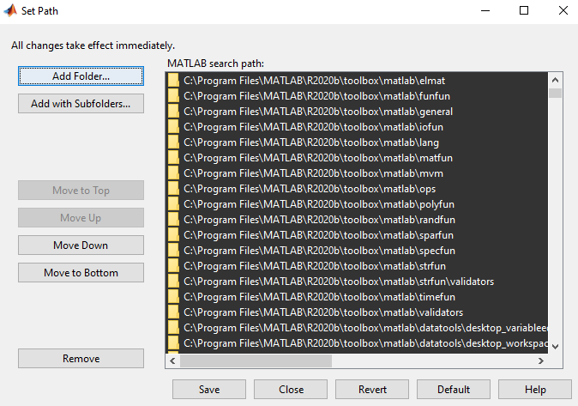

1. **In the MatLab window that appears, click on ‘Add Folder…’, then in the new window navigate inside HELIOS directory and select any directory that does not start with ‘@’ (e.g. ‘external’). Click on ‘Select Folder’.**

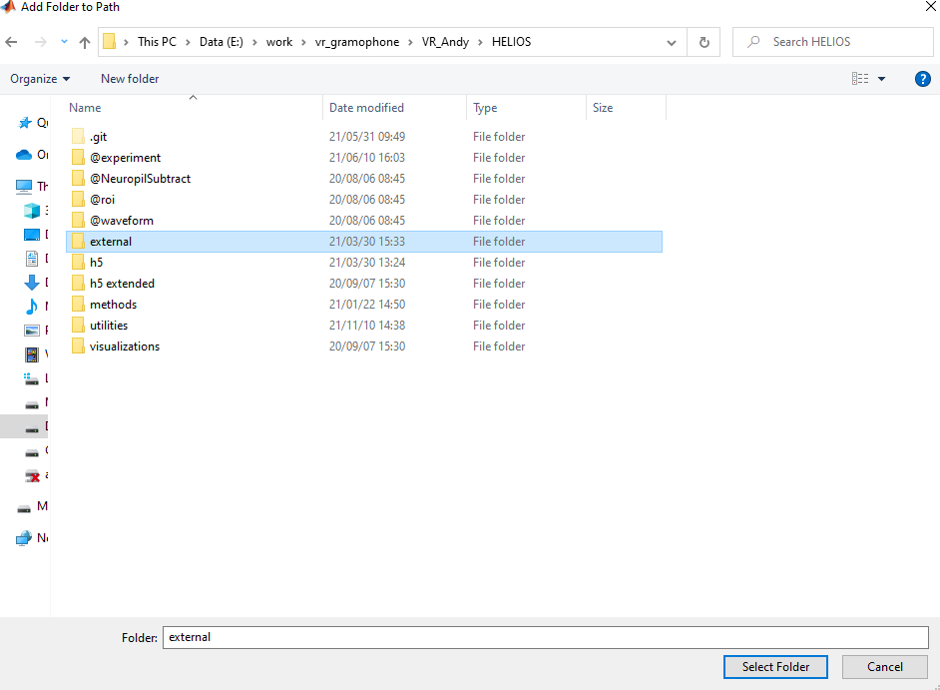

1. **Repeat the process for all the other directories inside HELIOS that do not start with ‘@’.**
2. **MatLab will list these directories at the top of the list in the “MATLAB search path:” panel. Select all the new paths/directories that you added and click on ‘Move to Bottom’. This ensures that HELIOS won’t conflict with native MatLab functions.**
3. **Click on ‘Save’.**
4. **HELIOS now should be installed in your MatLab client.**

**Alternatively, (instead of steps 2-3) in the ‘Set Path’ window you can click on ‘Add with Subfolders…’, then select the HELIOS directory itself (inside VR_Andy directory). All the directories inside HELIOS will be added to the MatLab path.**

## **Prerequisites**

To run roi_generator you need to have access to all the necessary files needed for the program.  
A priori, the user has to perform OnAcid/RTMC analysis on the measurement file (.mesc format). If the OnAcid/RTMC finished successfully, then both the data file and the exported .mescroi files will be suitable for ROI Generator.

**ROI Generator requires three separate components to run successfully.**

1. The data file (format .mesc).
2. A directory with all the .mescroi files that were produced by OnAcid/RTMC.
3. zcoord.txt file in the same directory as in (2).

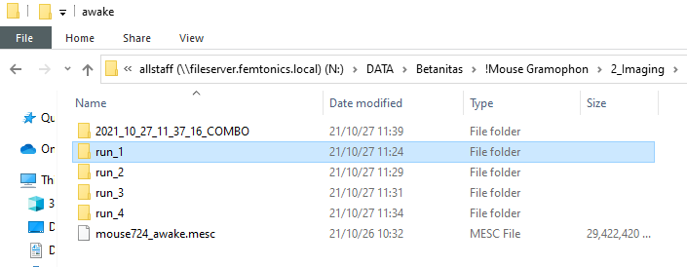

**2**

**1**

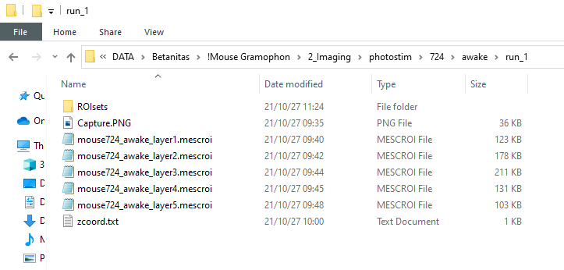

**3**

**2**

**If you have a multi-layer recording, make sure that .mescroi files are present for all the layers in the recording and they are in the same directory!**

**zcoord.txt file has to be created/added manually by the user (pay attention to keep all letters lowercase) and inside it there must be only one line:**

**zcoord = [layer1_depth, layer2_depth…];**

**The parts in bold red are compulsory, the numbers between the squared brackets have to represent the values of the layer imaging depths (layer1_depth, layer2_depth etc.).   
  
This is needed due to non-trivial access to layers’ depths in .mesc file, and gives user flexibility to specify the correct relative coordinates in case during the measurement only absolute values were stored. You can look up the depth values per layer in MESC software by opening the data file and scrolling through the layers in one measurement unit.**

**The depth values have to be written out from left to right from the first to the last layer, each value separated by a comma.**

**An example of a proper 5-layer measurement zcoord.txt file is shown below:**

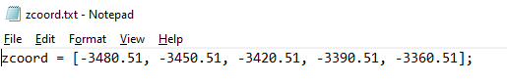

**zcoord.txt file should be stored in the same directory as the .mescroi files.**

**If all three components are prepared, ROI Generator can successfully perform the estimates.**

## **Running it**

In your MatLab console window run the following command: **roi_generator**.

You should get the following GUI appear.

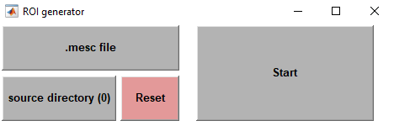

Steps to proceed:

1. Specify the data file that was used in OnAcid/RTMC analysis. Click on the **.mesc file** button, navigate and find the .mesc file, and click ‘Open’. The **.mesc file** button should change its color to blue.
2. Click on the **source directory** button. In the new window navigate and select the directory which contains the .mescroi files as well and the zcoord.txt file. Click ‘Select Folder’. The button should change the color to blue and the number in the parentheses should change from 0 to 1.
3. (Optional) Repeat the step 2 for every directory which contains .mescroi files and the zcoord.txt file in case you have run OnAcid/RTMC multiple times (e.g. varying OnAcid/RTMC parameters). In case of multiple directories selected, the conversion process will run once for each directory and finally will combine the results into separate directory (see next chapter).
4. (Optional) If you made a mistake in file/directory selection use the **Reset** button to clear your selections and start the selection process from the beginning.
5. Click **Start** to begin the conversion process.

During the conversion process multiple reporting lines will be printed on the MatLab console window. Their intent is to allow keeping track of conversion process.

If more than one source directory has been selected, the number in the parenthesis on the button “source directory” will indicate how many source directories are still left to be processed.

**When the conversion process is finished you will receive a message box with a message “ROI Generator finished the task!**”

## **Output**

During the conversion process, ROI Generator will create a directory “ROISets” inside each source directory specified. Inside ROISets directory, the output directory of ROI Generator will be created. The name of the directory consists of the date and time stamp of the moment when the directory was created (e.g 2021_11_2_15_44_59). This ensures that every new ROI Generator run stores the results in unique directory and does not overwrite previous results, even if the source data used is identical.

All conversion results are stored in this output directory. Inside it you will find the following:

* **Log.txt** file – a logging file where every step of conversion is stored. In case of program crash, log file can help identify during which stage the crash occurred.
* **Contours_x.fig** file – MatLab image file, with the maximum projection of the layer x and the ROI contours detected by OnAcid/RTM. Drag and drop it to your MatLab console window to show it.
* The following **.mescroi** files:
  + - **<filename>_layerx_contours** – the ROI contour coordinates. Can be loaded in MESC to visualize. These are slightly different from the original .mescroi files produced by OnAcid/RTMC due to conversion process, however they encompass the same areas in the data.
    - **<filename>_layerx_centroids** – the ROI contours’ mass center coordinates, given as corners of a square around the mass center. Can be loaded in MESC to visualize. Originally MESC does not allow one point visualization on the images, so this representation is a workaround that allows visualization of mass centers.
    - **<filename>_layerx_centers** – the ROI contour’s mass center coordinates (one point). Cannot be visualized in MESC.
  + **<filename>_layerx_centers.xlsx** – the ROI contour’s mass center coordinates transformed to be applicable in MES imaging format. These are the files that the user will want to use in most cases.
  + **R_x.mat** files – pre- and postprocessing coordinates of ROIs for the layer x stored in a MatLab structure format.
  + **R_all.mat** – all R_x.mat data stored in one structure.
  + **PROJ.mat** – MatLab structure file containing maximum projection images for all the layers.

## **Workflow**

ROI Generator’s primary goal is to give access to the OnAcid/RTMC-detected ROI coordinates in a user-friendly format. Due to different coordinate systems used in MES and MESC software, the coordinates in original .mescroi files cannot be directly loaded into MES point manager system. ROI Generator provides means to get this access.  
  
After the measurement is finished and the data is stored in .mesc format, run the OnAcid/RTMC analysis with your desired parameter set.

For better results, repeat OnAcid/RTMC analysis on the same dataset with different parameter sets (vary SNR, CNN and ROI Size parameters for best results) and store the outputs in separate directories. It is advised to save a snapshot of what parameter values were used during each run.

Create a zcoord.txt file in every OnAcid/RTMC output directory, and fill it in with correct z-coord values for each layer (see Prerequisites for the precise format needed).

Launch ROI Generator (call roi_generator in MatLab console window), specify the data file, all the OnAcid/RTMC output directories (one by one) and click on START.

After some time a message box will inform you that the conversion is finished. You will find results inside each OnAcid/RTMC output directory that you provided to the GUI.

If you specified more than one source directory, a special directory with a prefix ‘COMBO’ will be created.

COMBO directory contains combined results of all the source files you provided. However, ROIs per layer will not be shown if they spatially overlap. The first directory specified will be treated as a base (all its ROIs will be kept) and every subsequent addition of ROIs for the same layer will exclude spatially overlapping cases.

Inspect visually how the detected contours look like by loading the .fig files in your MatLab.

You can also load the “_contours.mescroi” files in MESC software on the data file to visualize these contours for a more interactive access.

If you are happy with the results,