**PRACTICAL - 3**

**AIM: To install Windows Server 2016 network operating system.**

## **Step 1: Download Windows Server 2016 ISO**

## Go to the official Microsoft Windows Server 2016 download site.

## Choose the appropriate version (Standard Evaluation with Desktop Experience).

## Download the **ISO file** to your system.

## **Step 2: Open VirtualBox**

* Launch **Oracle VirtualBox** on your computer.
* Click on the "**New**" button to start creating a new Virtual Machine (VM).
* A dialog box will appear where you need to enter VM details.

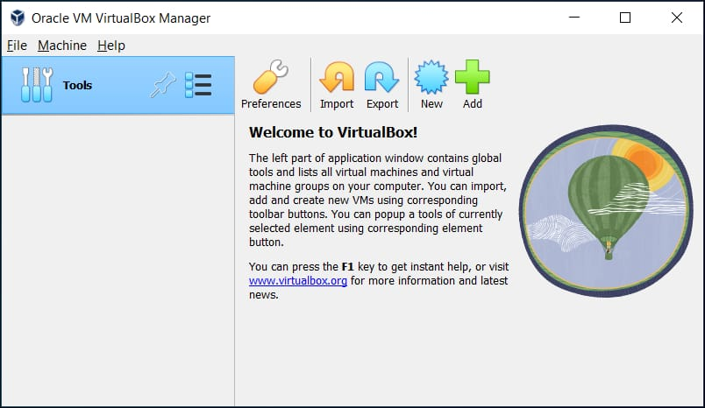

## **Step 3: Configure VM Settings and Windows Server ISO**

* **Name the VM**: Enter a meaningful name (e.g.,WindowsServer2016).
* **Select Type**: Choose **Microsoft Windows**.
* **Select ISO**: Browse and select the **Windows Server 2016 ISO** you downloaded.
* **Select Version**: Choose **Windows Server 2016 (64-bit)**.
* Click **Next** to proceed.

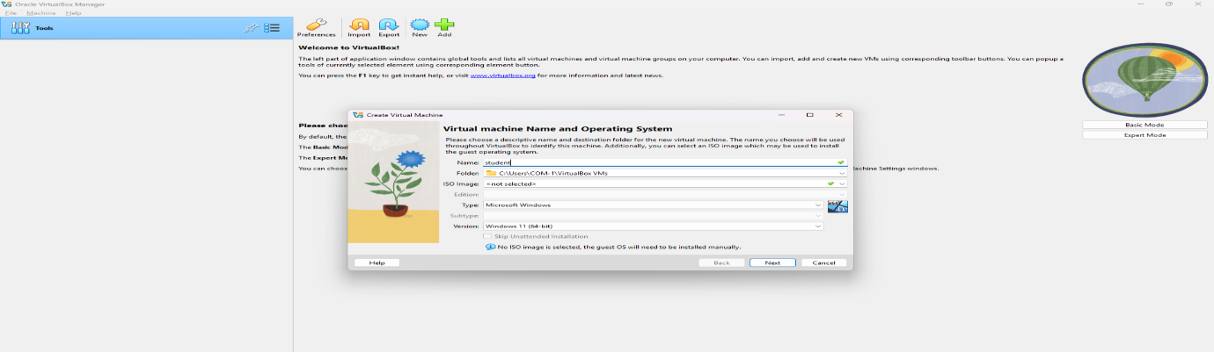

**Step 4: Allocate Memory (RAM)**

* Set RAM (min 2GB), CPUs (min 2), and disk space (40GB+), check the box labelled Create a virtual hard disk now in the Hard disk section. Last, click one next.
* Assign at least **2GB (2048MB)** of RAM (recommended: **4GB or more** for better performance).
* Click **Next** to proceed.

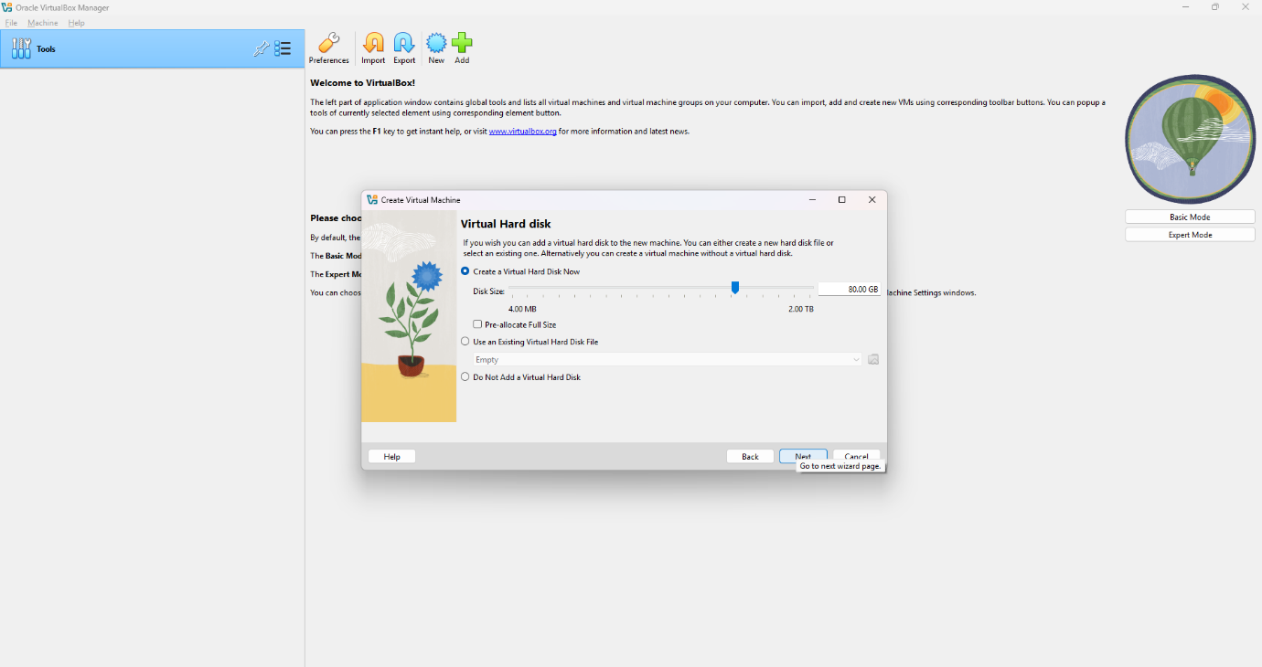

## **Step 5: Start Installation**

* Click **Install Now** to begin the installation process.

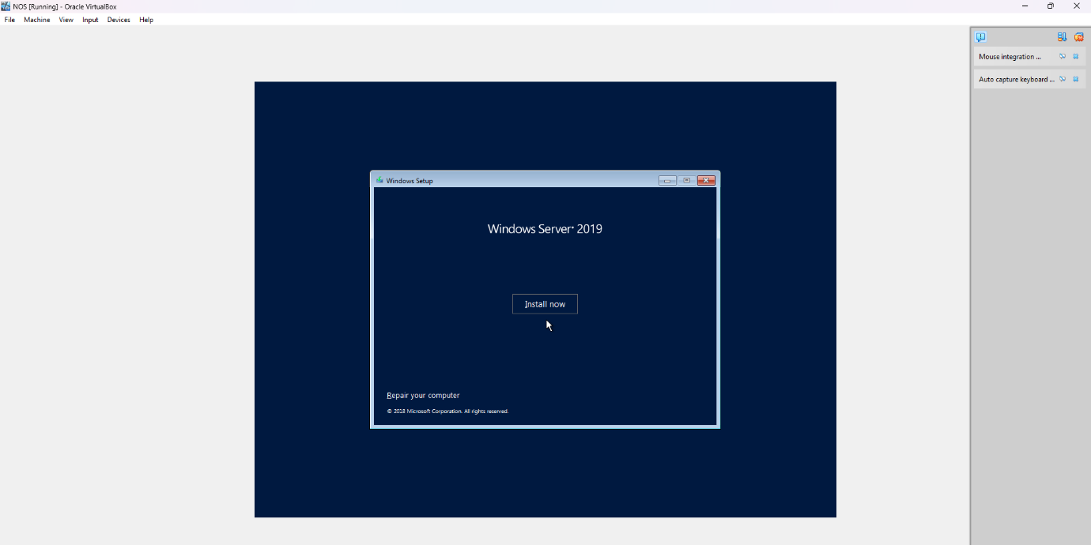

## **Step 6: Select OS**

## Choose **Windows Server 2016 Standard Evaluation (with Desktop Experience)**.

## Click **Next**.

## **w**

## **Step 7: Follow the setup, accept terms**

* Read the license agreement.
* Check the **"I accept the license terms"** box.
* Click **Next**.

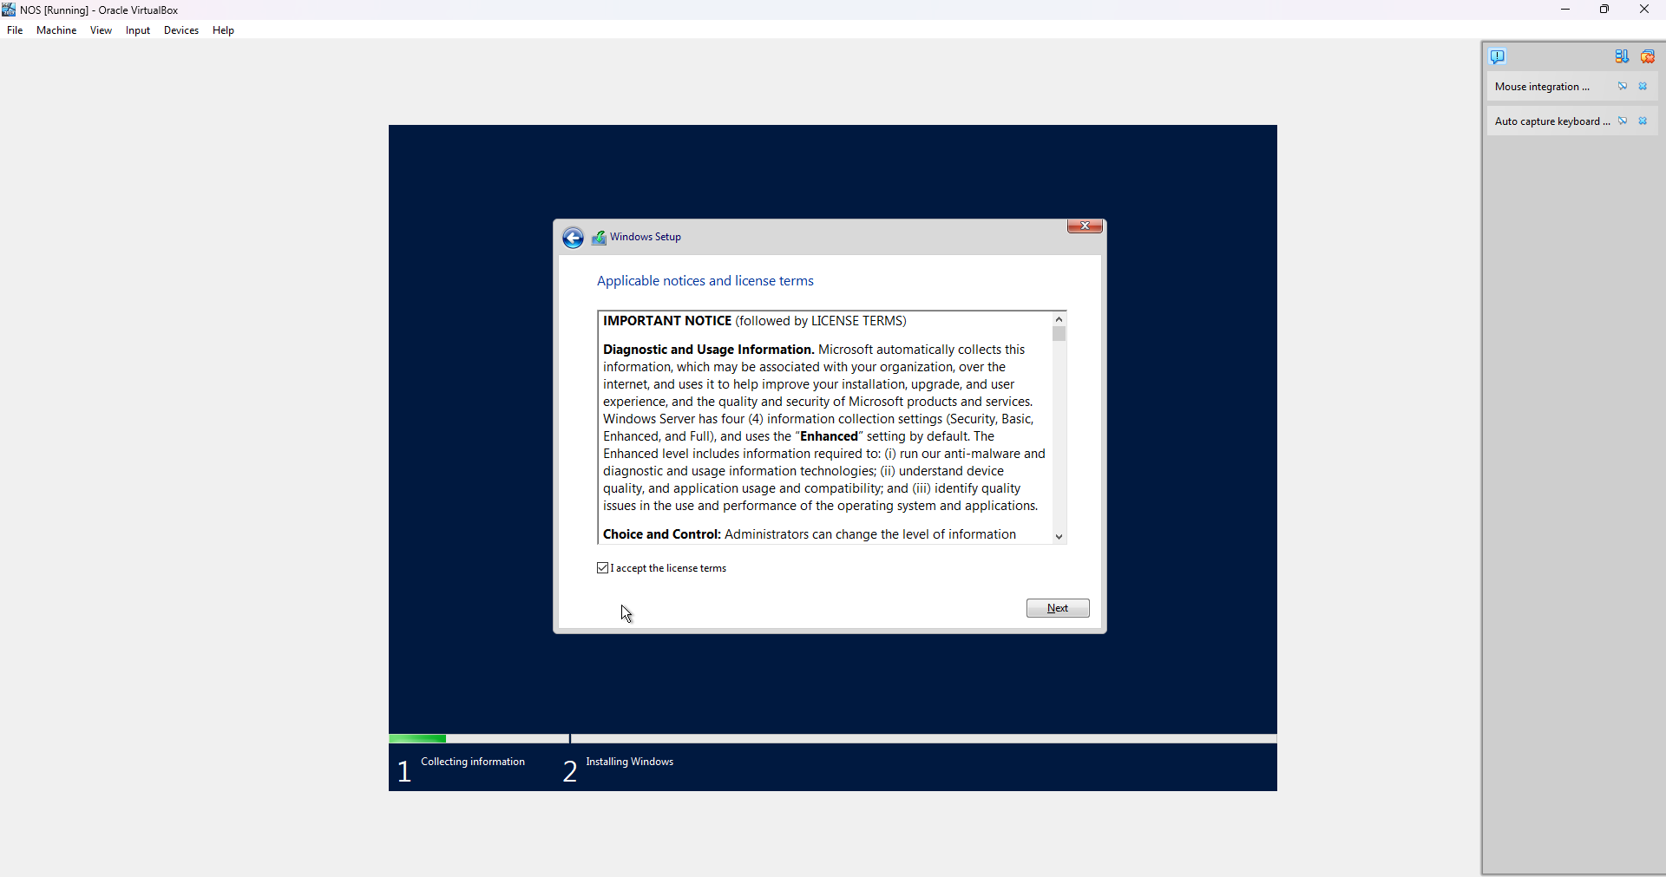

## **Step 8: Wait for Installation to Complete**

## The installation will take several minutes.

## Your VM will restart automatically.

## Follow any on-screen instructions.

## **Step 9: Finish Setup**

* Create a user and Enter a secure password and confirm it.
* Windows Server is ready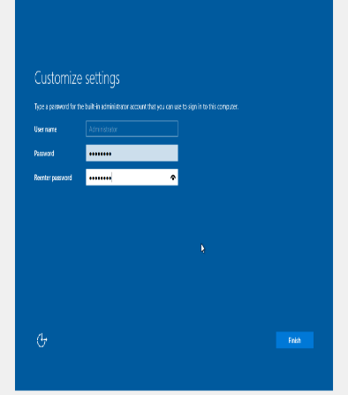.

**Step 10: Login to Windows Server**

* Press **Ctrl + Alt + Del** (VirtualBox shortcut: Right Ctrl + Del).
* Enter the Administrator password.
* Click **Sign in**.

