**Table Of contents**

1. Introduction 1
2. Functional Requirements 2
3. Data Flow Diagram 4
4. Entity Relationship (ER) Diagram 6
5. Usecase Diagram 7
6. Class Diagram 8
7. Sequence Diagram 9
8. Activity Diagram 10

# **Introduction**

This project is a comprehensive **Online Payment Platform** that streamlines secure financial transactions between users, offering seamless integration of features like two-factor authentication (2FA), bank account management, coupon redemption, and administrative oversight. Designed with user experience and security in mind, the system ensures efficient handling of payments and related activities in a structured and traceable manner.

The system starts by allowing users to register and enable 2FA to enhance security. Upon login, authentication is managed through a dedicated login session with security checks to handle login attempts. Users can manage their profiles, add or remove bank accounts, and securely initiate transactions. Each payment undergoes validation before being processed, ensuring that only legitimate transactions are confirmed and recorded.

Additionally, users can redeem bonus coupons during transactions, which are validated before being applied. The platform provides access to balance inquiries and transaction histories, giving users full visibility and control over their financial activities. Feedback mechanisms are also included to collect user suggestions and concerns for continuous improvement.

From an administrative perspective, the platform supports report generation, transaction monitoring, and fraud detection. Admins can also manage user accounts, ensuring compliance with policies and taking necessary actions in case of suspicious activity. Overall, this project encapsulates a well-rounded digital payment ecosystem with robust user interaction and strong backend management.

# **Functional Requirements**

**R1. Registration**

* Users can register with their name, email, and password.
* Verification is required for account registration.

**R2. Login**

* Users can log in using email and password with OTP.
* "Forgot Password" allows password reset.

**R3. Add/Remove Account**

* Users can add a bank account with verification.
* Users can link UPI ID with bank accounts.
* Users can remove bank accounts with verification.

**R4. Payment**

* Users can pay by scanning a QR code.
* Users can also pay using mobile number / UPI ID.
* Payment requires entering UPI PIN.

**R5. Extra Features**

* Users can check bank balance for a limited time duration.
* Users can download their past transactions in the form of PDF by applying filters.

**R6. Bonus**

* Users can earn & redeem bonus points and promo codes.
* Bonus details are visible in the user dashboard.
* Bonuses can be earned for a limited time span.

**R7. Update Profile**

* Users can edit name, email, phone number, and password.
* Profile update requires verification.

**R8. Security**

* Users must have OTP for authentication.
* Users must be able to enable/disable security features.
* Users must receive status updates.

**R9. Feedback & Customer Support**

* Users must be able to submit feedback and complaints.
* Users must be able to contact support via multiple channels.

**R10. Admin Panel (for Admins)**

* Admins must be able to manage user accounts.
* Admins must be able to monitor and flag frauds.
* Admins must generate reports on transactions, refunds, and security issues.

# **Data Flow Diagram**

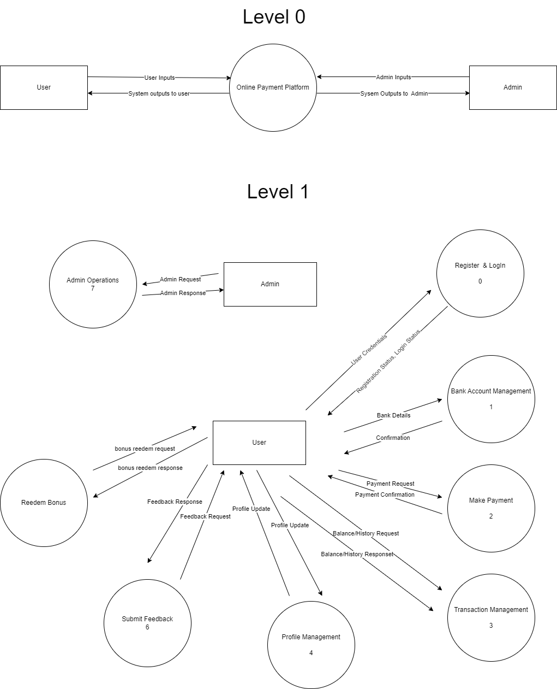

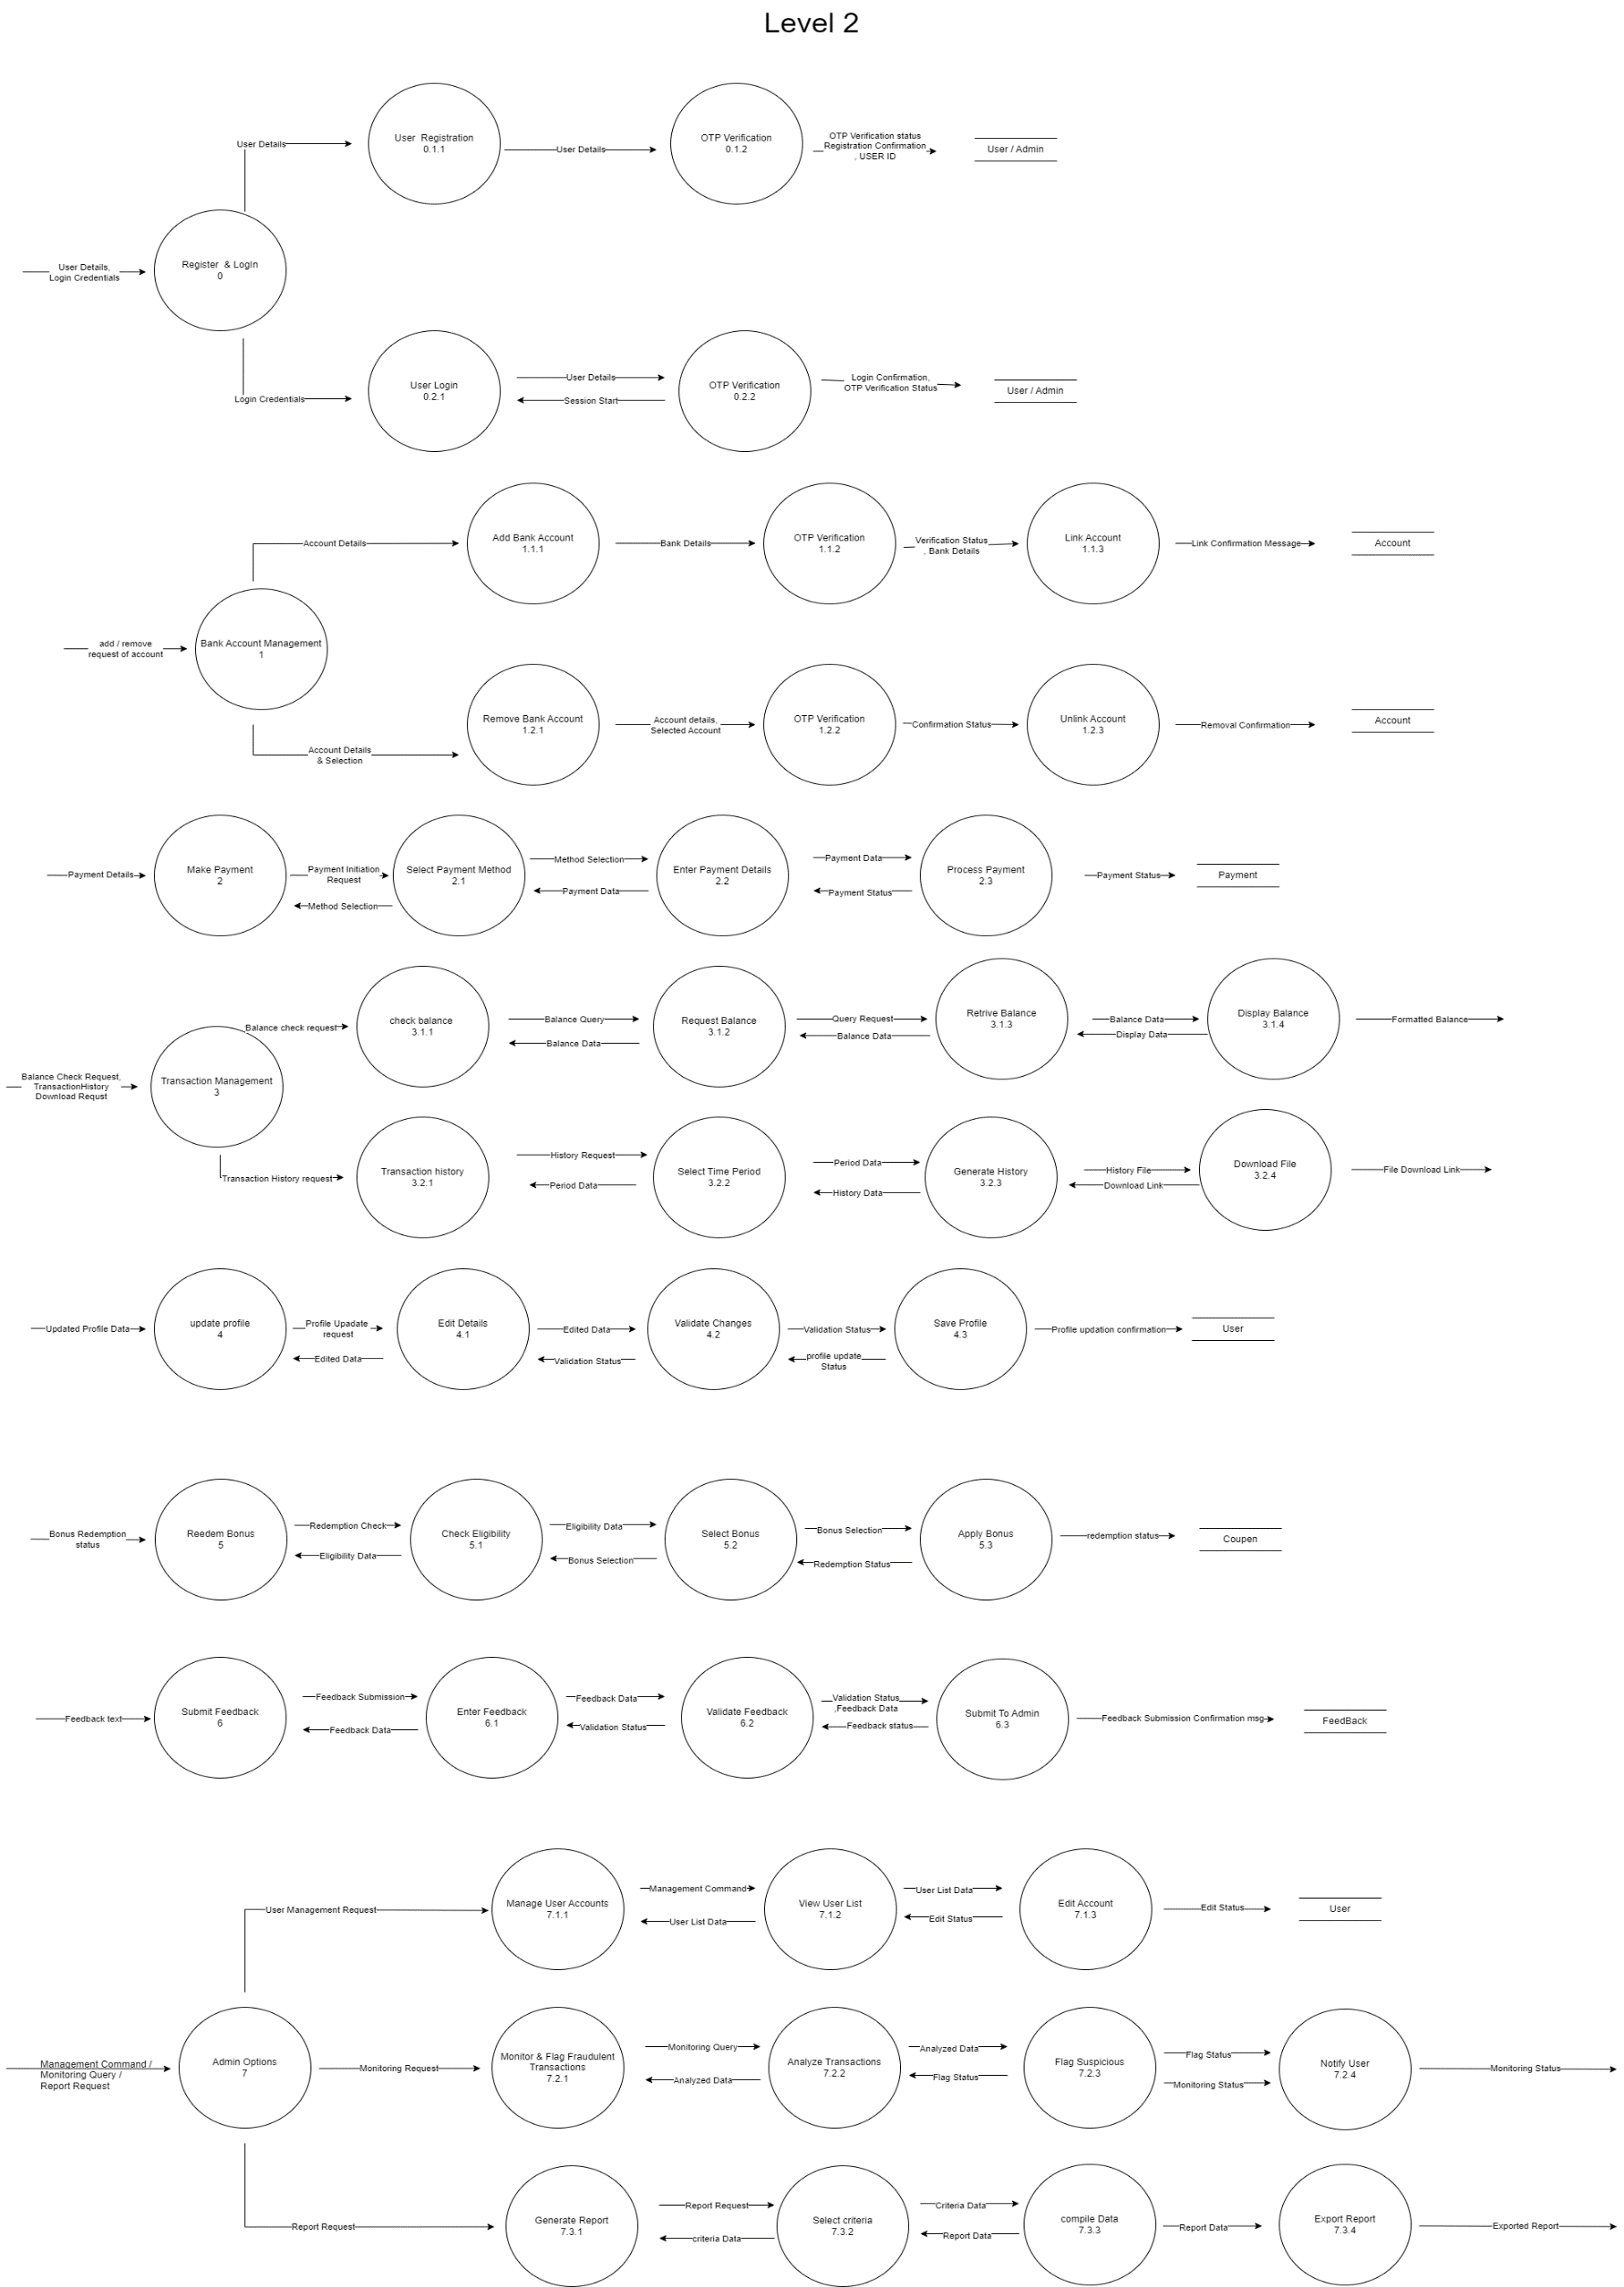

# **Entity Relationship (ER) Diagram**

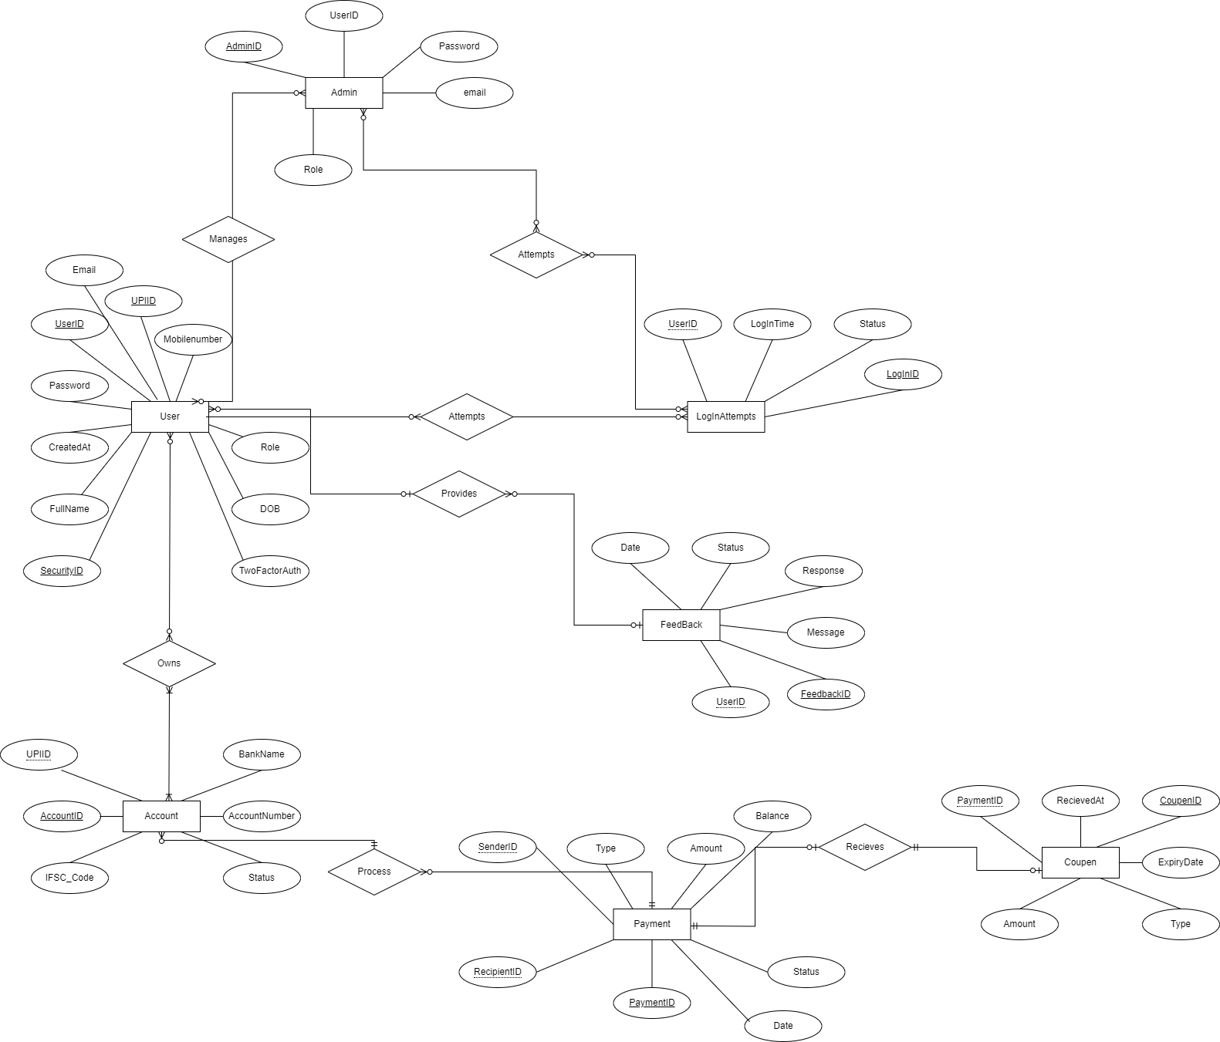

# **Usecase Diagram**

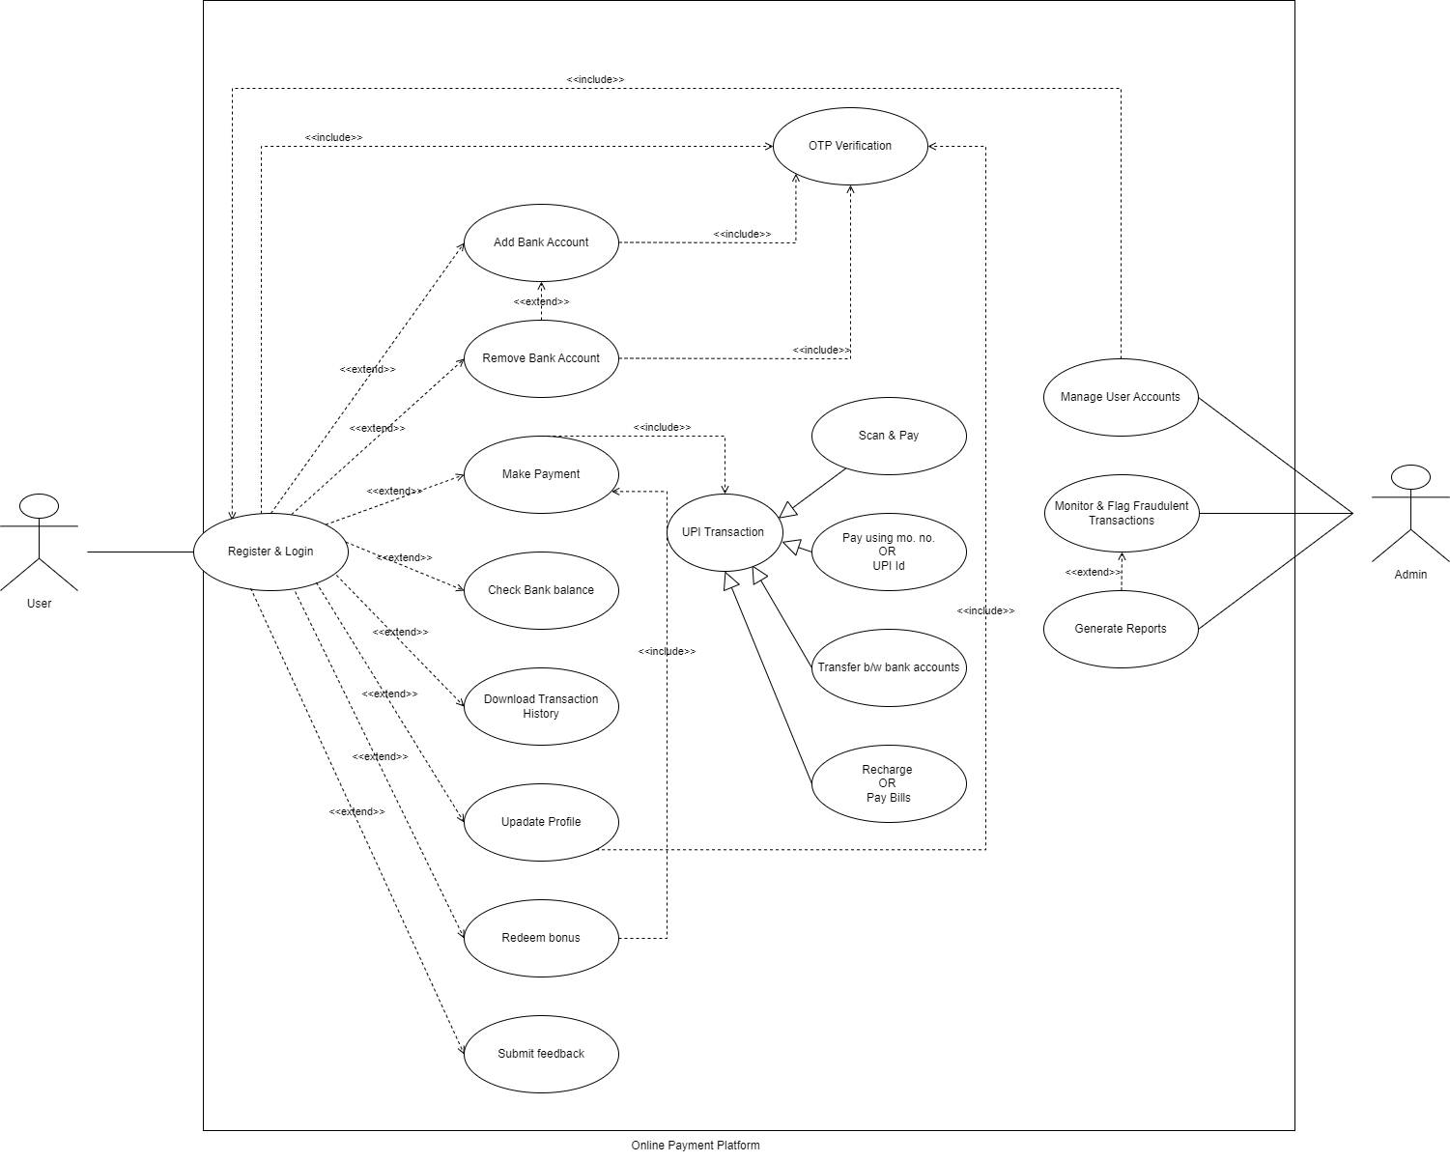

# **Class Diagram**

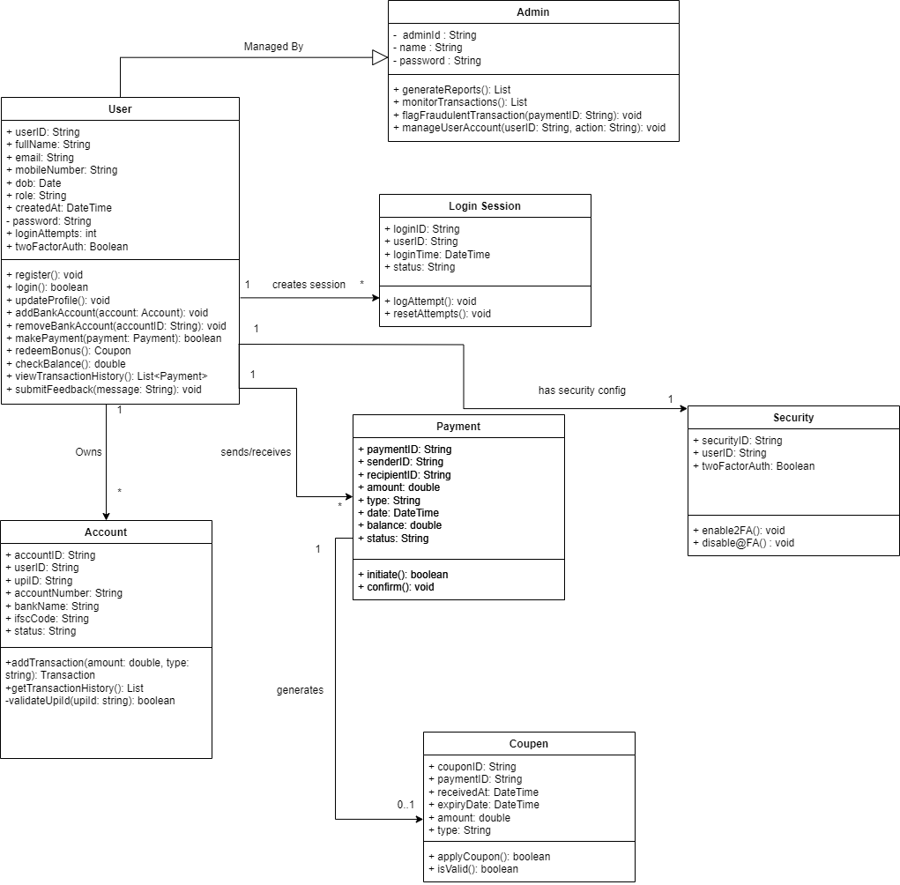

# **Sequence Diagram**

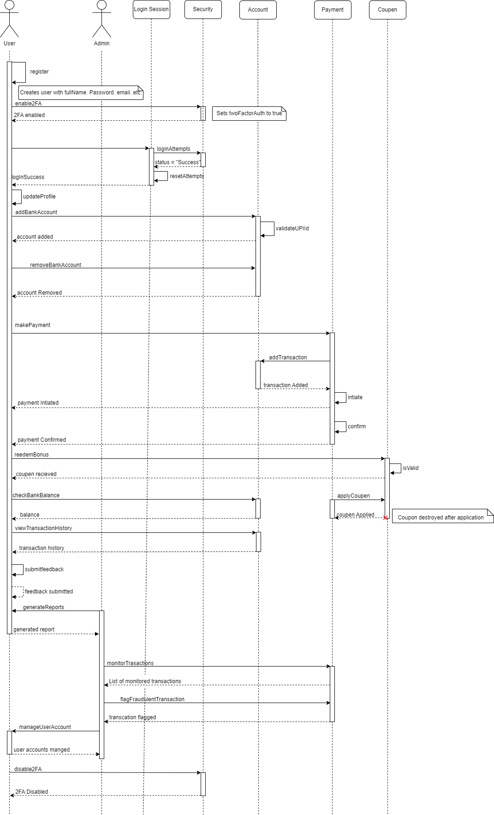

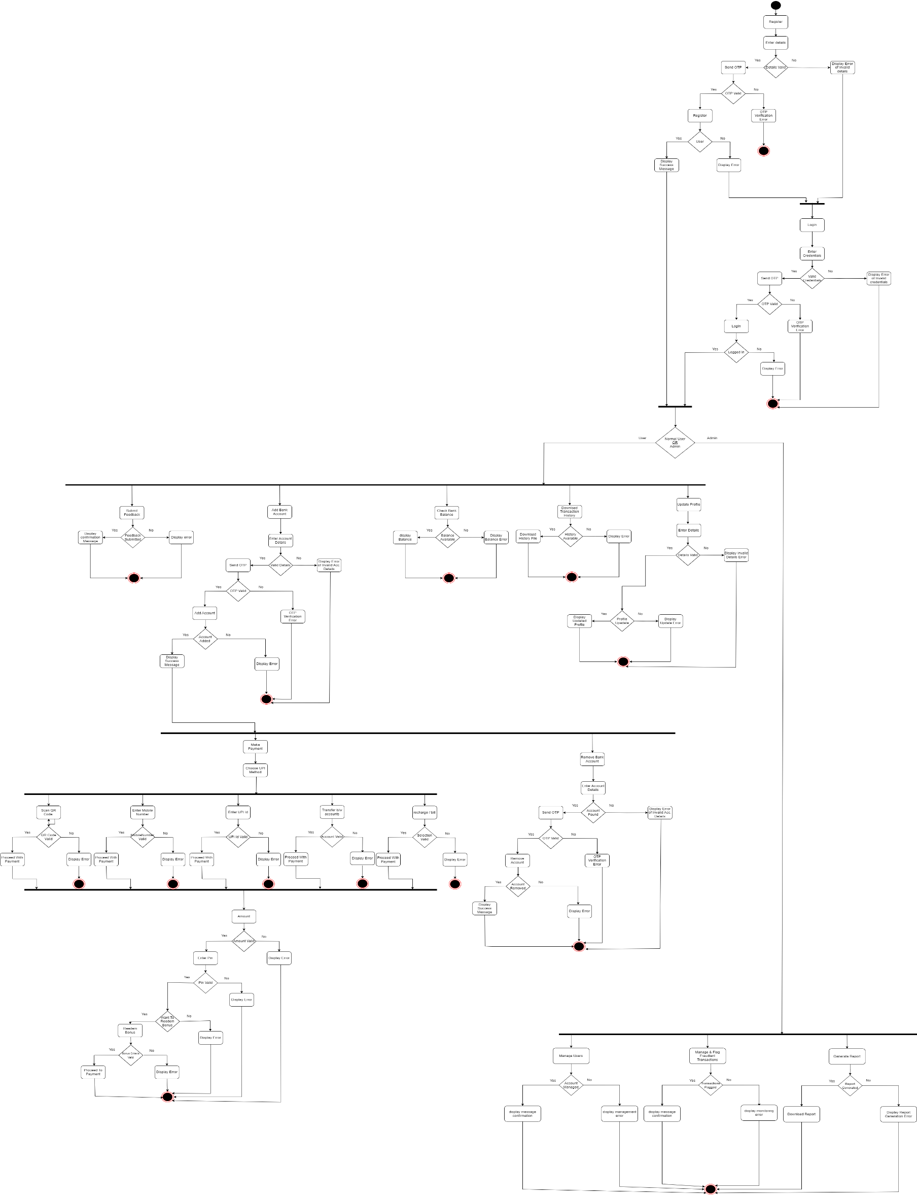

# **Activity Diagram**