**CH.1 : Software Development Process Models**

**WHAT IS SOFTWARE ?**

**Definition :**

Software is collection or set of computer programs, procedures, rules or associated documents

it includes audio, video, images etc.

**WHAT IS SOFTWARE ENGINEERING ?**

**Definition :**

1. Software engineering is an engineering approach that covers various stages from planning to maintenance stage
2. SE is an engineering discipline that delivers high quality s/w at agreed cost &in planed schedule.

**SOFTWARE APPLICATION DOMAIN**

Area of software that it can operate easily

**TYPES OF SOFTWARE**

mainly 2 types : Application Software

System Software

**APPLICATION SOFTWARE :**

--> User requirement

--> Designed to fulfil user requirements

--> Ex., MS Excel, Browser

**SYSTEM SOFTWARE :**

--> interface b/w software & hardware

--> Designed to manage control of hardware and software

--> Ex., OS, Drivers

**CHARACTERISTICS OF GOOD SOFTWARE :**

1.Maintainability

2.Budget friendly

3.Reliability

4.Readability

5.Reusability

6.Modularity

7.Functionality

8.Portability

9.Proper Documentation

10.Correctness

**SPECIAL CHARACTERISTICS OF SOFTWARE :**

**1.Software doesn't wear out**

any hardware after long use it can be damaged but in case of software it can't be damages , through maintenance it can be updatable

it can't be affected by "environmental effects"

**2. Software is engineered not manufactured**

Hardware can't be modifiable but software can modifiable for use later on

**3. Reusability of component**

Once software created it should be scalable , it should have ability to reuse its components

**4. Software is flexible for custom built**

Software is manufactured from gathering user requirements and for fulfil requirements

**PROGRAM V/S SOFTWARE**

1. small in size 1.large in size

2. single developer 2. team of developer

3. may not be structured 3. well structured

4. may not be scalable 4. can be scalable

5. no or less documentation 5. well documented

6. may not be maintainable 6. maintainable

**SOFTWARE ENGINEERING LAYERED APPROACH :**

**Four Layers**

**1. Quality**

it is first layer of layered approach

software mainly focuses on quality

it checks weather output satisfies user's requirement or not

every organization should focus on its software quality

**2. Process**

it is second layer of layered approach

it is heart of software engineering

main idea behind add process in layered approach is to delivery good software in timely manner

**3. Method**

it is third layer of layered approach

it describes 'how to build' and in which method software should be developed

**4. Tools**

it is fourth and last layer of layered approach

it executes process in proper layer

it supports of its above layer

**WHY SOFTWARE ENGINEERING ?**

1. To develop high quality software product

2. To develop large problems

3. To achieve skill of problem solving

4. To construct project with agreed cost

5. To deliver product with timely manner

6. To become good programmer / developer

**UMBRELLA ACTIVITIES**

**TRICK :**  "Please Follow Simple Rules During Real Software"

1. P – Project Tracking & Control

2. F – Formal Technical Review

3. S – Software Quality Assurance (SQA)

4. R – Risk Management

5. D – Document Preparation & Production

6. R – Reusability Management

7. S – Software Configuration Management (SCM)

**GENERIC PROCESS FRAMEWORK**

1. Communication

2. Planning

3. Modelling

4. Construct

5. Deployment

**SOFTWARE DEVELOPMENT LIFE CYCLE**

1. Birth/Dead

2. Development

3. Maturity

4. Maintenance

1. Planning

2. Analysis (SRS,Size estimation etc)

3. Designing

4. Coding/ Implementation

5. Testing

6. Maintenance

**CLASSICAL WATERFALL MODEL**

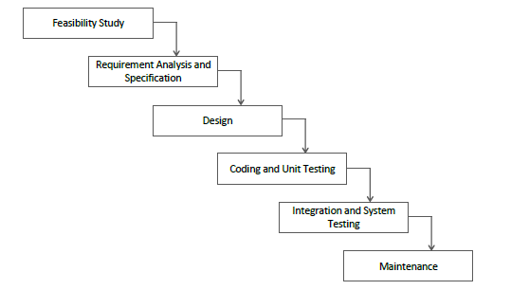

**1.Feasibility Study**

analysis of project weather it is feasible or not

feasible means budget, team management, time duration etc.

**2. Requirement Analysis & Specification**

SRS

**3. Design**

Different diagrams of software

**4. Coding & Unit Testing**

Actual Implementation of product

**5. System Testing & Integration**

Combine small units

Various type of testing like black box testing, Whitebox testing, alpha, beta testing etc...

**6. Maintenance**

Maintain the product

maximum effort (60%)

**Advantages :**

Base Model, Easy to Implement, Simple, Small Project

**Disadvantages :**

No Feedback, High-risk, 60% effort in maintenance, No Experiment, No Parallelism (Team can't work parallelly)

**ITERATIVE WATERFALL MODEL**

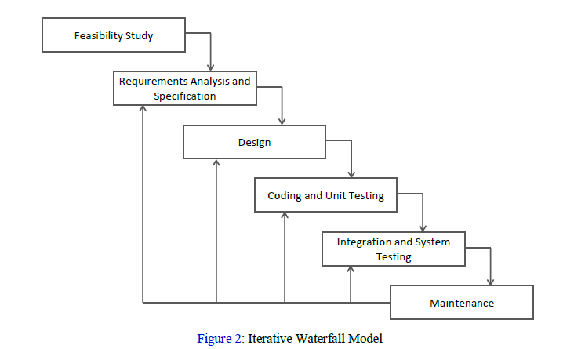

Modified version of classical waterfall model

Difference b/w classical & iterative is feedback

No feedback in Feasibility study

**Advantages :**

Base Model, Easy to Implement, Simple, Small Project, Feedback

**Disadvantages** :

High-risk, 60% effort in maintenance, No Experiment, No Parallelism (Team can't work parallelly), Not Efficient, Less customer interaction

**INCREMENTAL MODEL**

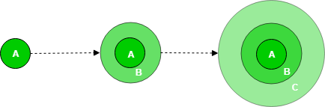

Specially for large project

module by module development

ex.,College : Faculties, Students, HODs, Attendance are the modules of College management system

**1.Requirements (SRS)**

**2. Design&Delopment --> Testing --> Maintenance //for each & every model**

**Advantages :**

MaximumCustomerInteraction, ForLargeProducts, BenificialForEarlyReleaseDemand, FlexibleToChange

**Disadvantages :**

NeedsGoodPlanning, SometimesComplexToDivideModules

**PROTOTYPE MODEL**

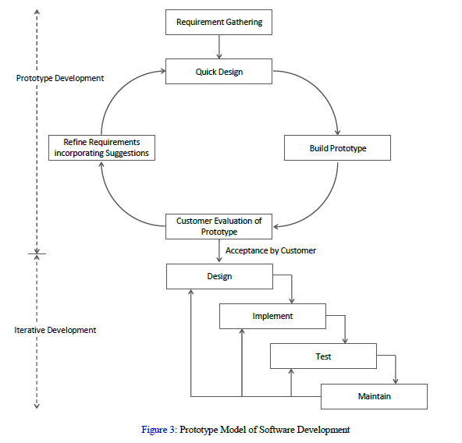

Make replica before actual product

User can give feedback

If user's requirements are not clear then this model is worst

1. Requirement Gathering

2. Quick design

3. Refine Requirements

4. Customer Evolution

if customer accepts then

4.1. Design

4.2. Implement

4.3. Test

4.4. Maintain

if no then repeat 1,2,3....

**Advantages :**

GoodForTechnicalAndRequirementRisks, MoreChancesOfUserSatisfaction, FlexibleForDesign&Development,

**Disadvantages :**

CostlyForDevelopment, SometimesWastingOfTime,

if user not satified with initial prototype then it can be lost interaction

**SPIRAL MODEL**

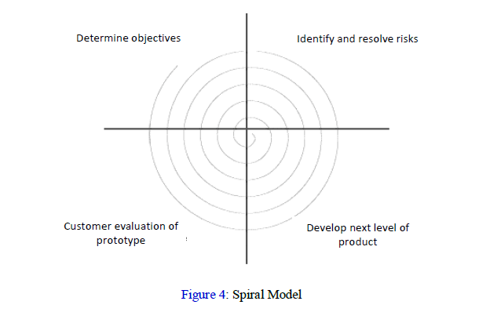

Best for risk management

1. Objective determination & identify alternative solutions

2. Identify & resolve risks

3. Develop next version of product

4. Review & plan for next phase

if user not satisfied then it continues like loops

for large products

used when risk is in every phase

radius of spiral is equal to cost

angular dimension shows progress(if 180 then half complete,360 then one spiral is completed likewise...)

Meta model because it uses multimodal like.. Iterative , prototype

**Advantages :**

Risk Handling, ForLargeProducts, Flexible, MoreCustomerSatisfaction

**Disadvantages :**

Complex, Costly, MuchMoreRiskAnalysis, Time-consuming

**AGILE DEVELOPMENT MODEL**

Latest model in compare of non-agile models

quick & Efficient

for large models

1. Divide product into small chunks (Iteration)

2. Release

3. Feedback

4. Enhance

5. Re-release

**Types :**

- Scrum

- XP

**Advantages :**

Frequent Delivery, FaceToFaceCommunication, LessTimeConsuming

**Disadvantages :**

Less Documentation, RegularMaintananceRequired

**SCRUM MODEL**

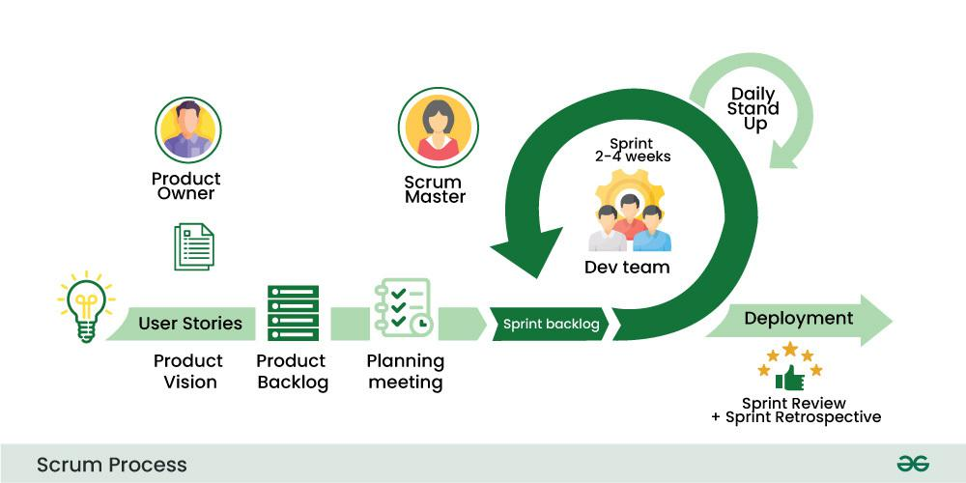

Most popular agile methodology

Lightweight (not complex), iterative (step by step), incremental framework

Scrum breakdowns the development phases into stages or cycles called as "SPIRINTS"

Time boundary is here

One spirint at a time

Team has scrum master and product owner with constant communication on daily basis

Widely Used

Daily Scrum : daily meeting of duration 10 to 15 minutes

Backlog : Form where all details of product is mentioned

Scrum master : monitor of team that communicates with client

Product Owner : Client

**Advantages :**

Freedom, High-quality, LowRiskProduct, LessTimeConsuming, Customer Satisfaction, Reviewing

**Disadvantages :**

MoreEfficientForSmallTeam (not for large teams), NoChangesInTheSpirint

**eXTREME PROGRAMMING (XP) MODEL**

Suggest quick release

bugs can be detect easily

can be monitoring that how product works

**Advantages :**

Well Performance, LessDocumentationNeeded

**Disadvantages :**

Time consuming, High Cost