训练自己的数据集进行目标检测

          1、在工程下新建一个文件夹VOCdevkit，目录结构为VOCdevkit/VOC2007/,在下面就是新建几个默认名字的文件夹           Annotation，ImageSet（该目录还有三个文件需要建立），JPEGImages(把你所有的图片都复制到该目录里面，如下图），SegmentationClass，SegmentationObject。

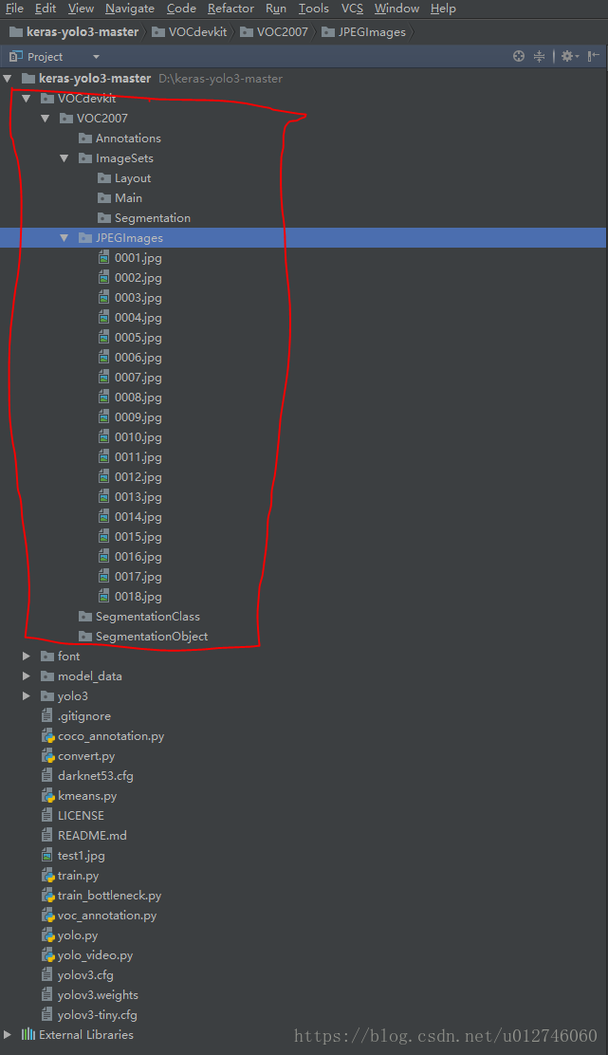

           2、生成Annotation下的文件，安装工具labelImg。安装过程可参照：

<https://blog.csdn.net/u012746060/article/details/81016993>，结果如下图：

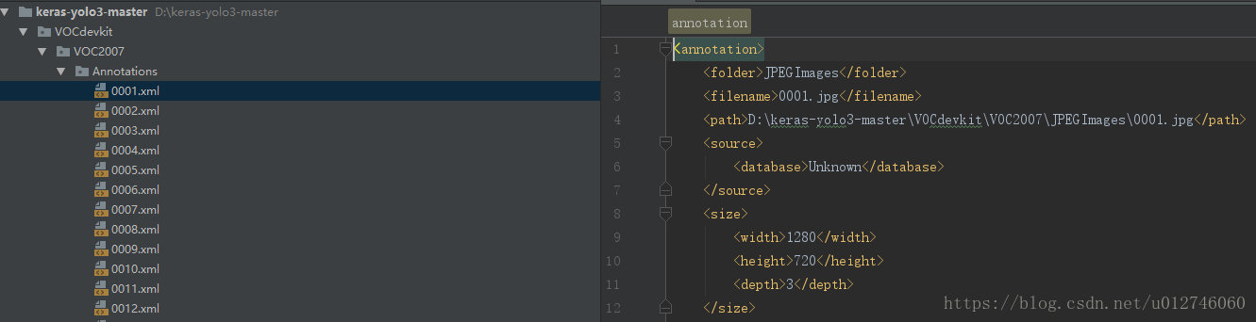

            3、生成ImageSet/Main/4个文件。在VOC2007下新建一个python文件，复制如下代码

import os
import random
trainval_percent = 0.2
train_percent = 0.8
xmlfilepath = 'Annotations'
txtsavepath = 'ImageSets\Main'
total_xml = os.listdir(xmlfilepath)
num = len(total_xml)
list = range(num)
tv = int(num * trainval_percent)
tr = int(tv * train_percent)
trainval = random.sample(list, tv)
train = random.sample(trainval, tr)
ftrainval = open('ImageSets/Main/trainval.txt', 'w')
ftest = open('ImageSets/Main/test.txt', 'w')
ftrain = open('ImageSets/Main/train.txt', 'w')
fval = open('ImageSets/Main/val.txt', 'w')
for i in list:
name = total_xml[i][:-4] + '\n'
if i in trainval:
ftrainval.write(name)
if i in train:
ftest.write(name)
else:
fval.write(name)
else:
ftrain.write(name)
ftrainval.close()
ftrain.close()
fval.close()
ftest.close()

                 运行代码之后，生成如下文件，VOC2007数据集制作完成。

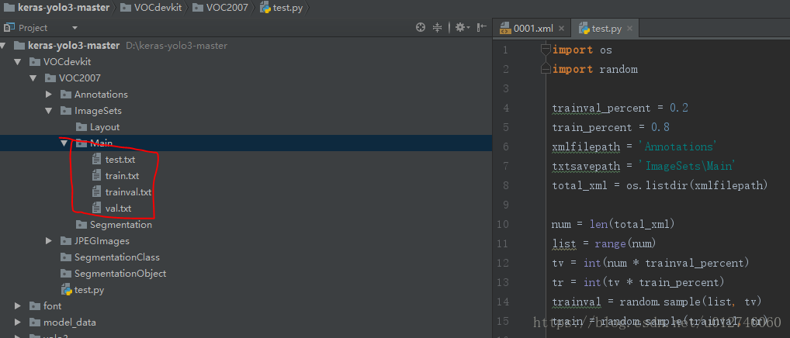

                4、生成yolo3所需的train.txt,val.txt,test.txt

                  生成的数据集不能供yolov3直接使用。需要运行voc_annotation.py ，classes以检测两个类为例（车和人腿），在voc_annotation.py需改你的数据集为：

C6BBC14FC0AC4E5FAC280B6399814204.png

                运行之后，生成如下三个文件：

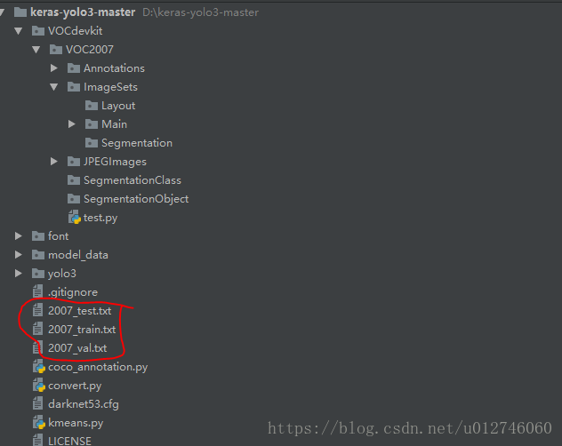

                5、修改参数文件yolo3.cfg

                 打开yolo3.cfg文件。搜索yolo(共出现三次)，每次按下图都要修改

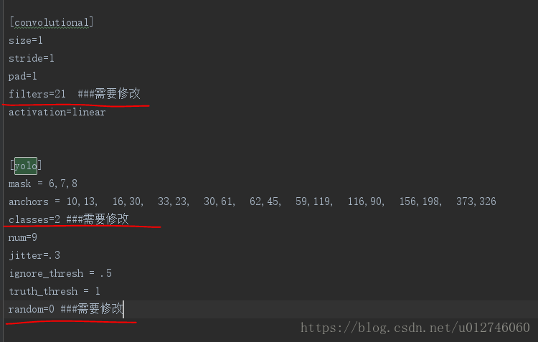

                  filter：3*（5+len（classes））

                  classes:你要训练的类别数（我这里是训练两类）

                  random：原来是1，显存小改为0

                 6、修改model_data下的voc_classes.txt为自己训练的类别

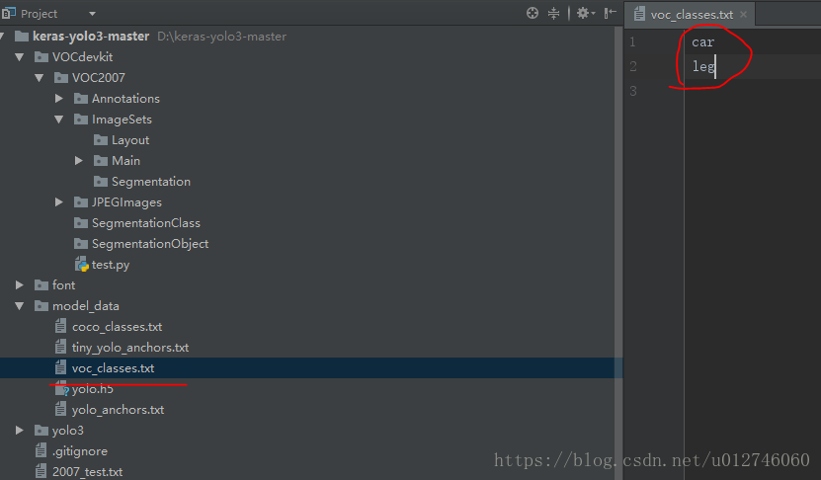

                7、 修改train.py代码（用下面代码直接替换原来的代码）

"""
Retrain the YOLO model for your own dataset.
"""
import numpy as np
import keras.backend as K
from keras.layers import Input, Lambda
from keras.models import Model
from keras.callbacks import TensorBoard, ModelCheckpoint, EarlyStopping
from yolo3.model import preprocess_true_boxes, yolo_body, tiny_yolo_body, yolo_loss
from yolo3.utils import get_random_data
def _main():
annotation_path = '2007_train.txt'
log_dir = 'logs/000/'
classes_path = 'model_data/voc_classes.txt'
anchors_path = 'model_data/yolo_anchors.txt'
class_names = get_classes(classes_path)
anchors = get_anchors(anchors_path)
input_shape = (416,416) # multiple of 32, hw
model = create_model(input_shape, anchors, len(class_names) )
train(model, annotation_path, input_shape, anchors, len(class_names), log_dir=log_dir)
def train(model, annotation_path, input_shape, anchors, num_classes, log_dir='logs/'):
model.compile(optimizer='adam', loss={
'yolo_loss': lambda y_true, y_pred: y_pred})
logging = TensorBoard(log_dir=log_dir)
checkpoint = ModelCheckpoint(log_dir + "ep{epoch:03d}-loss{loss:.3f}-val_loss{val_loss:.3f}.h5",
monitor='val_loss', save_weights_only=True, save_best_only=True, period=1)
batch_size = 10
val_split = 0.1
with open(annotation_path) as f:
lines = f.readlines()
np.random.shuffle(lines)
num_val = int(len(lines)*val_split)
num_train = len(lines) - num_val
print('Train on {} samples, val on {} samples, with batch size {}.'.format(num_train, num_val, batch_size))
model.fit_generator(data_generator_wrap(lines[:num_train], batch_size, input_shape, anchors, num_classes),
steps_per_epoch=max(1, num_train//batch_size),
validation_data=data_generator_wrap(lines[num_train:], batch_size, input_shape, anchors, num_classes),
validation_steps=max(1, num_val//batch_size),
epochs=500,
initial_epoch=0)
model.save_weights(log_dir + 'trained_weights.h5')
def get_classes(classes_path):
with open(classes_path) as f:
class_names = f.readlines()
class_names = [c.strip() for c in class_names]
return class_names
def get_anchors(anchors_path):
with open(anchors_path) as f:
anchors = f.readline()
anchors = [float(x) for x in anchors.split(',')]
return np.array(anchors).reshape(-1, 2)
def create_model(input_shape, anchors, num_classes, load_pretrained=False, freeze_body=False,
weights_path='model_data/yolo_weights.h5'):
K.clear_session() # get a new session
image_input = Input(shape=(None, None, 3))
h, w = input_shape
num_anchors = len(anchors)
y_true = [Input(shape=(h//{0:32, 1:16, 2:8}[l], w//{0:32, 1:16, 2:8}[l], \
num_anchors//3, num_classes+5)) for l in range(3)]
model_body = yolo_body(image_input, num_anchors//3, num_classes)
print('Create YOLOv3 model with {} anchors and {} classes.'.format(num_anchors, num_classes))
if load_pretrained:
model_body.load_weights(weights_path, by_name=True, skip_mismatch=True)
print('Load weights {}.'.format(weights_path))
if freeze_body:
# Do not freeze 3 output layers.
num = len(model_body.layers)-7
for i in range(num): model_body.layers[i].trainable = False
print('Freeze the first {} layers of total {} layers.'.format(num, len(model_body.layers)))
model_loss = Lambda(yolo_loss, output_shape=(1,), name='yolo_loss',
arguments={'anchors': anchors, 'num_classes': num_classes, 'ignore_thresh': 0.5})(
[*model_body.output, *y_true])
model = Model([model_body.input, *y_true], model_loss)
return model
def data_generator(annotation_lines, batch_size, input_shape, anchors, num_classes):
n = len(annotation_lines)
np.random.shuffle(annotation_lines)
i = 0
while True:
image_data = []
box_data = []
for b in range(batch_size):
i %= n
image, box = get_random_data(annotation_lines[i], input_shape, random=True)
image_data.append(image)
box_data.append(box)
i += 1
image_data = np.array(image_data)
box_data = np.array(box_data)
y_true = preprocess_true_boxes(box_data, input_shape, anchors, num_classes)
yield [image_data, *y_true], np.zeros(batch_size)
def data_generator_wrap(annotation_lines, batch_size, input_shape, anchors, num_classes):
n = len(annotation_lines)
if n==0 or batch_size<=0:returnNone
returndata_generator(annotation_lines, batch_size, input_shape, anchors, num_classes)
if__name__ == '__main__':
_main()

                   替换完成后，**千万千万值得注意的是**，因为程序中有logs/000/目录，你需要创建这样一个目录，这个目录的作用就是存放自己的数据集训练得到的模型。不然程序运行到最后会因为找不到该路径而发生错误。生成的模型trained_weights.h5如下：

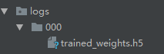

               8、修改yolo.py文件，如下将self这三行修改为各自对应的路径。

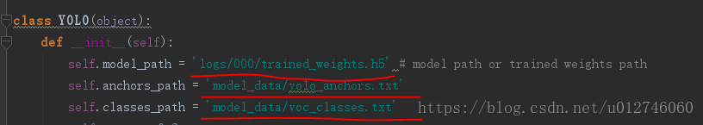

                   运行python yolo.py,输入自己要检测的类的图片即可查看训练效果了。

