# Department of Computing

# EE353: Computer Networks

# Class: BESE-13-B

**NAME: Ibrahim Qaiser**

**CMS ID: 405459**

**Lab 2:** **Wireshark – HTTP (Hypertext Transfer Protocol)**

# Lab 2: Wireshark – HTTP (Hypertext Transfer Protocol)

**Exercise 01:** The Basic HTTP GET/response interaction

* 1. **Which version of HTTP is the browser running 1.0 or 1.1? Which HTTP version is the server running?**

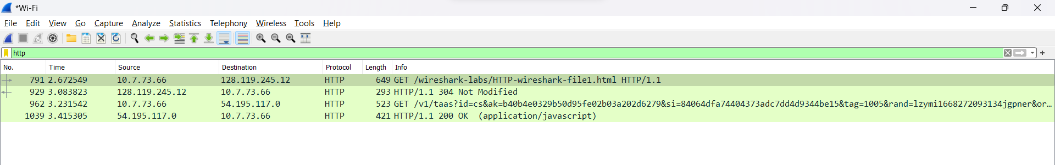

**The version of HTTP on server and browser is 1.1.**

* 1. **What is the status code returned from the server to your browser?**



**The status code returned from server is 200.**

* 1. **When was the HTML file that you are retrieving last modified at the server?**

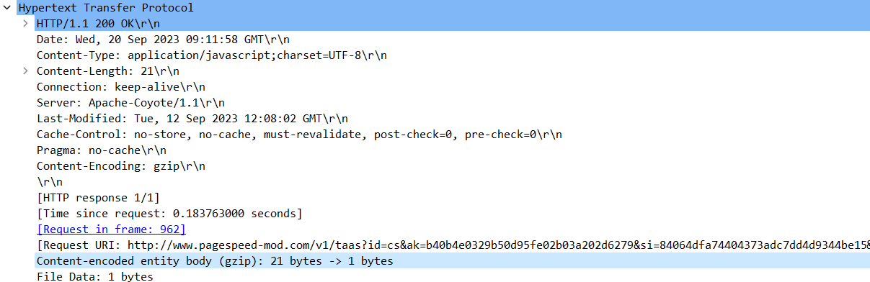

**The last modified file was expected to be done on 12-sept, 2023 at 12:08:02.**

* 1. **How many bytes of content are being returned to your browser?**

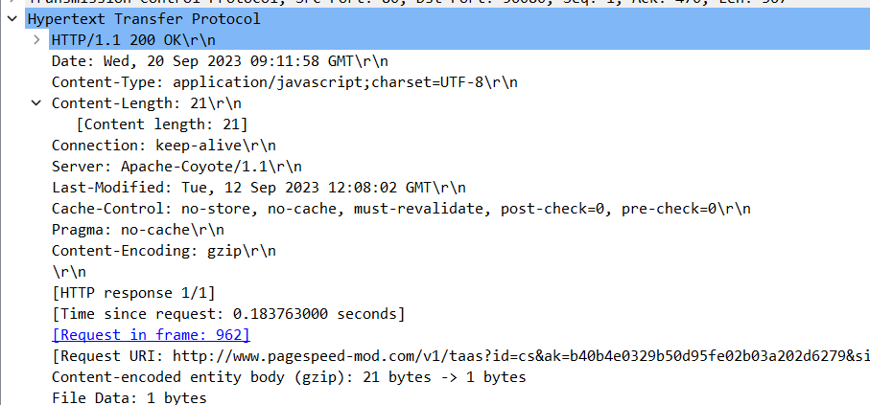

**21 bytes are my main content-length being returned to my browser.**

**Exercise 02:** The HTTP CONDITIONAL GET/response interaction

* 1. **Inspect the contents of the first and 2nd HTTP GET requests from the browser to the server. Do you see “IF-MODIFIED-SINCE” and “IF-NONE-MATCH” lines in these HTTP GET message? Why?**

The If-Modified-Since header is used to specify the time at which the browser last received the requested resource. Since our file is already loaded in cache so we got last modified to same time and date. The If-None-Match header is used to specify the entity tag that the server issued with the requested resource when it was last received. Again, the case is same just like if last modified case.

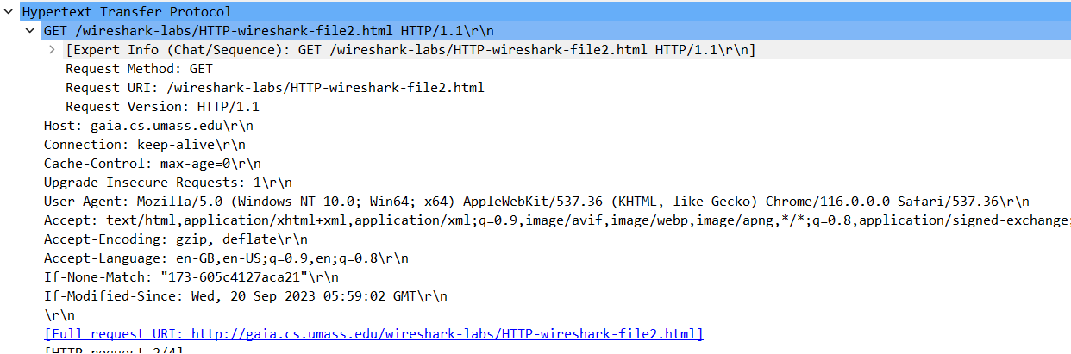

* 1. **What is the difference in first and second response received? What is the last modified time in the first response message?**

**The main difference between first response and second response is just that in first attempt, file contents are downloaded and then displayed but in second attempt, file was already present in cache memory so we got status code of 304.**



* 1. **What is the HTTP status code and phrase returned from the server in response to the first and second HTTP GET? Did the server explicitly return the contents of the file? Explain.**

**From first response, we got status code of 200 for successfully downloading the file and displaying on browser but on second request, we first got 304 status code since contents are already available and ready to display on browser.**



* 1. **Empty your browser cache again and open the webpage** <http://gaia.cs.umass.edu/wireshark-labs/HTTP-wireshark-file2.html> **and capture the GET and OK response messages. How many total objects does the server return?**

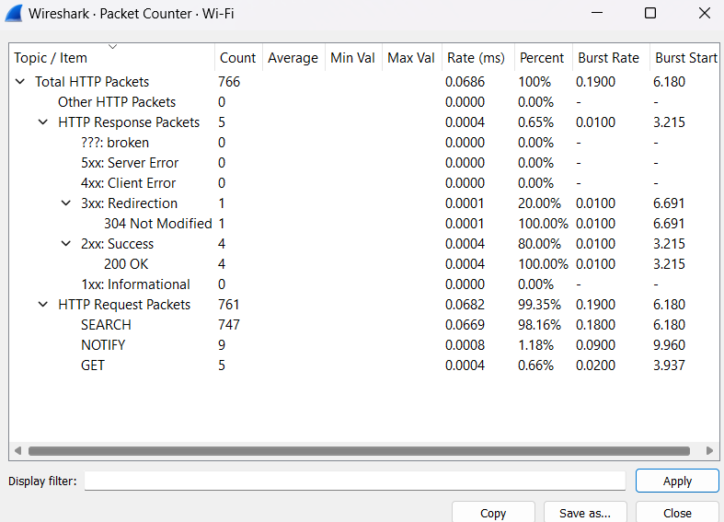

**Here we obtained 5 embedded objects in case of given site.**

**But for** [**www.seecs.edu.pk**](http://www.seecs.edu.pk)**, I only got 1 object in return.**

* 1. **What is the page load time (PLT) for the interaction in 2.4?**

**Page load time is the time it takes to download and display the entire content of a web page in the browser window (measured in seconds).**

**The time taken by** <http://gaia.cs.umass.edu/wireshark-labs/HTTP-wireshark-file2.html> **was 849 ms in total.**

**The time taken by** [**www.seecs.edu.pk**](http://www.seecs.edu.pk) **was 2.4 sec in total.**