# Department of Computing

# EE353: Computer Networks

# Class: BESE-13B

**Name: Ibrahim Qaiser**

**CMS: 405459**

**Lab 07: Wireless Access point Configuration**

**Lab Task:**

Follow the given tutorial in the below YouTube link

<https://www.youtube.com/watch?v=EbfWDCWraB8&t=30s>

Create a Wireless Network and configure wireless access point in your topology. Attach at least 5 wireless end devices to the access point.

Firstly configuring the router and then assigning IP address to PC:

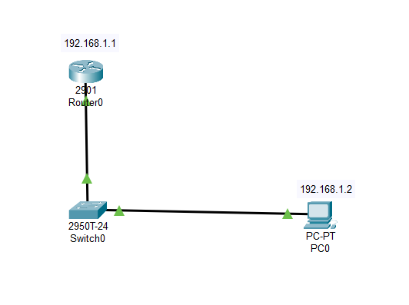

Then by attaching the access point through which our wireless devices should connect.

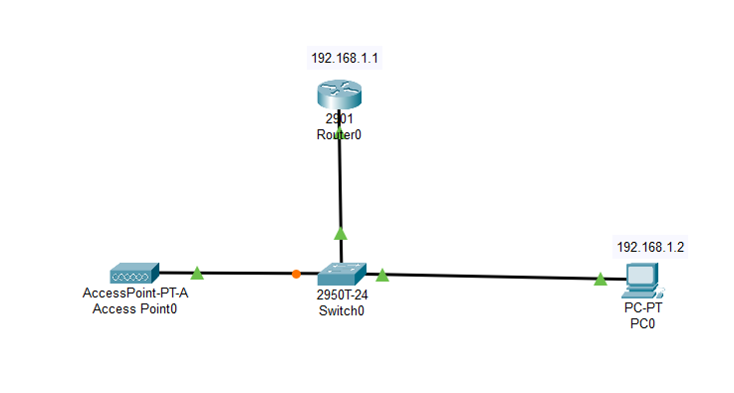

Here by attaching the PCs and firstly removing their wired ports to then attaching the wireless port.

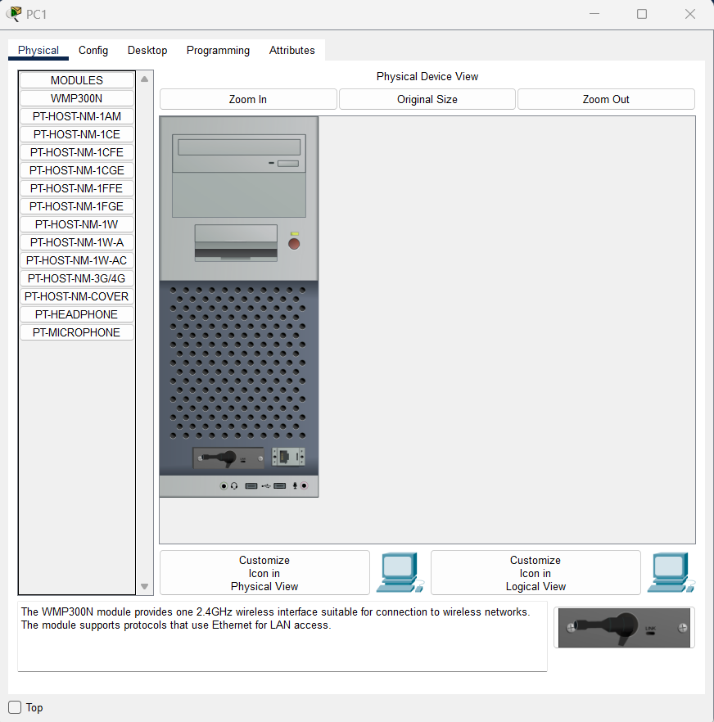

Following is the current wireless network required:

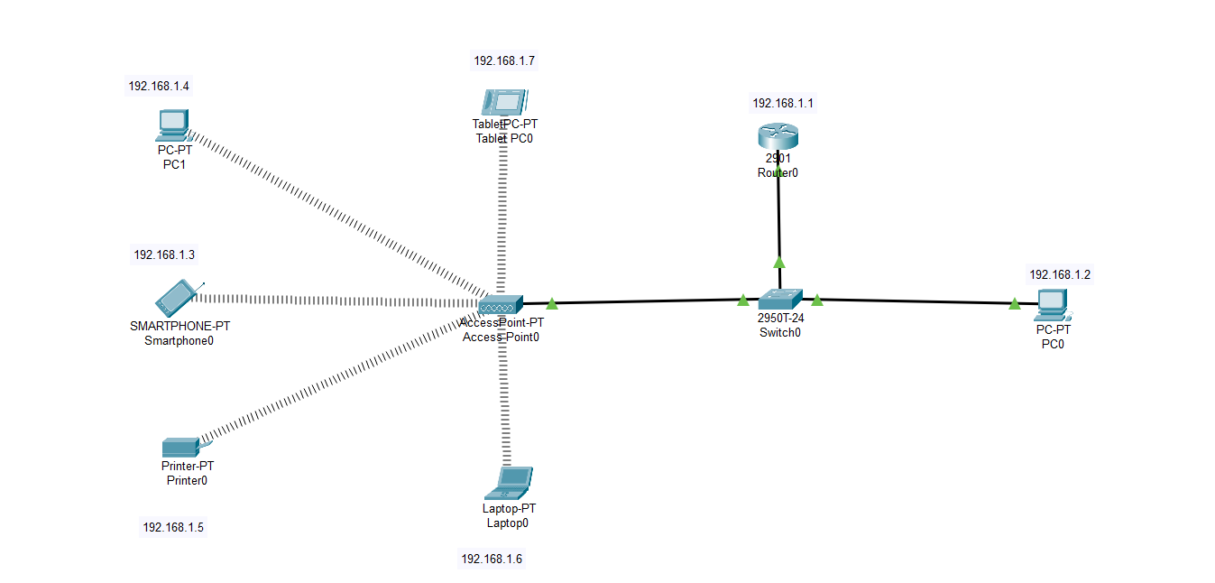

After assigning IP addresses and replacing the wired ports of PC and laptop and printer, we have successfully established the wireless connection and even confirmed this working by pinging from wired PC to wireless devices.

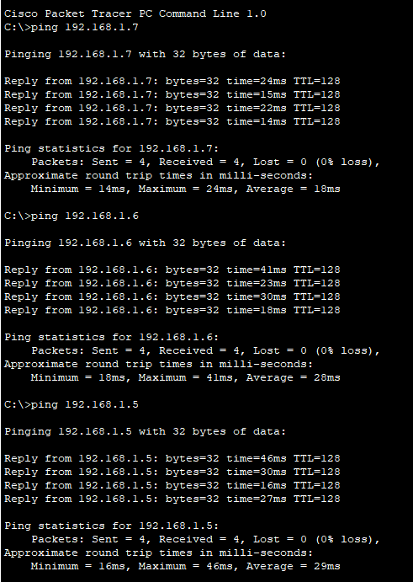

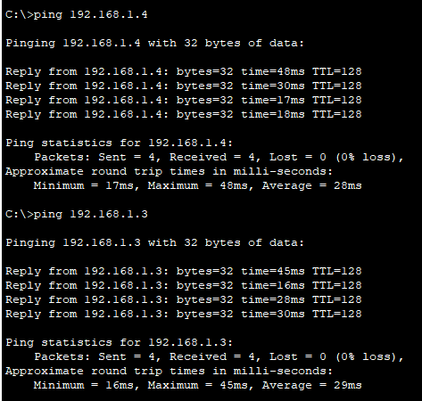

**Deliverables**

Zip and Upload all .pkt files

**Grade Criteria**

This lab is graded. Min marks: 0. Max marks: 10.

**TASK 2**

**Now for VOIP configuration:**

Here firstly we took 2811 router since the telephonic service is only available on this router and then attaching the switch and then connecting the two telephones.

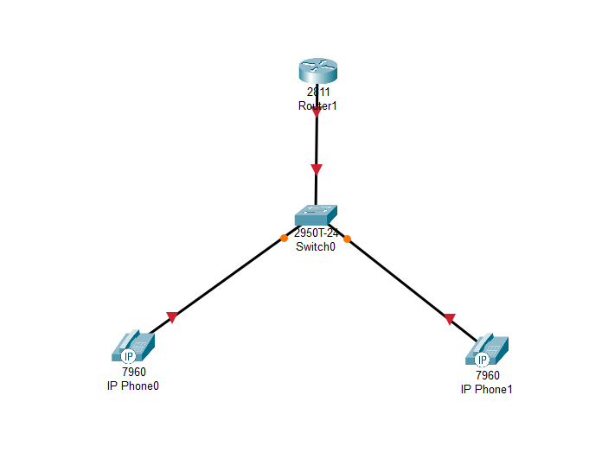

Now configuring the router and then even configuring the telephonic service for it.

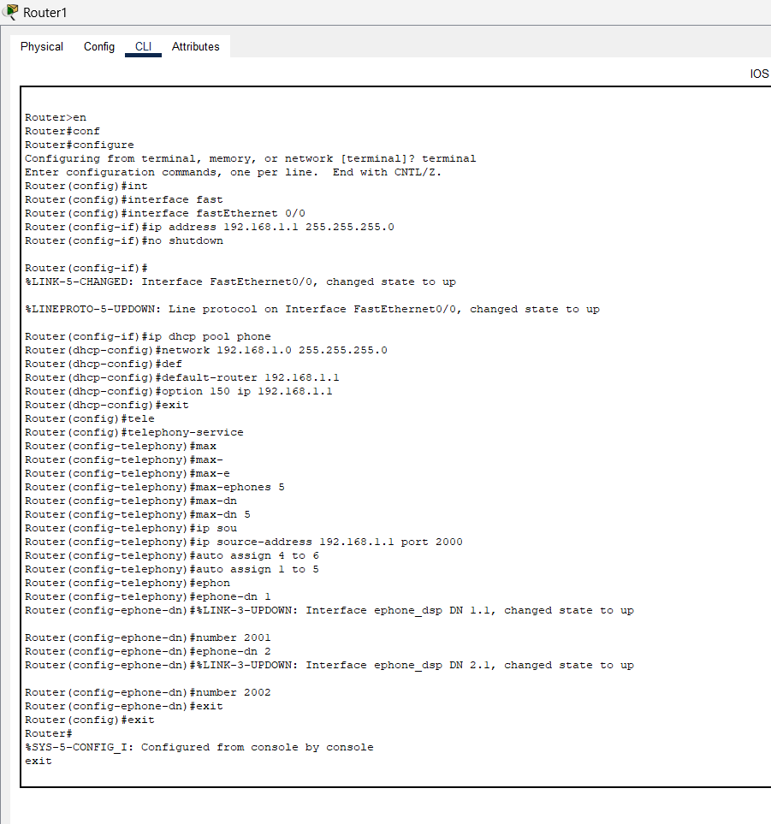

Now configuring the switch,

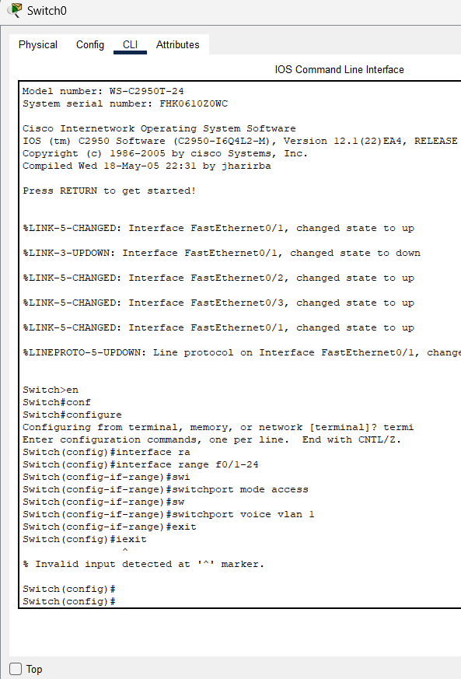

And now finally after sometime both phones are automatically assigned Ips and then after making successful connection calls our work is completed.

