Newbot Chatbot Working Scenarios

Scenarios for the chatbot to interact with the user. The user will use the chatbot to look for his desired list of movies. When the chatbot is not sure of the user’s intention, it will ask things to clarify what the user needs, building the query to TMDB.

# **First time user scenario**

**>** Hello. What is your name? (Will later change for FB Messenger to automatically get user’s name)

**User:** *writes*

**>** Welcome {name}! You can ask me to search for any movie you want. Either type some words to search, or a genre of movies, or you can just pick one of the lists below.

*quickreplies [“Now Playing Movies”, “Top Rated Movies”, “Upcoming Movies”, “Popular Movies”]*

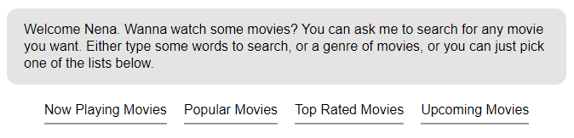

# **When a user comes back after a while (requires data store)**

**User:** Hello/Hi/Hey/Good Morning/Good Afternoon

**>** Hello {name}. Welcome back! How can I help you?

# **Intention Uncertain**

(When the bot cannot match the user text to a specific intention)  
**Note:** when too many intentions match, the bot will pick the newest (NLP issue)

**>** I'm not sure what you want {name}, can you ask again?

# **User chooses one of the choices listed**

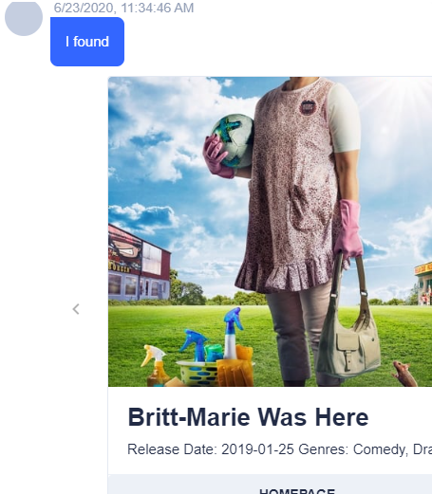The bot just fetches the list.

Figure 2: What we should be seeing instead

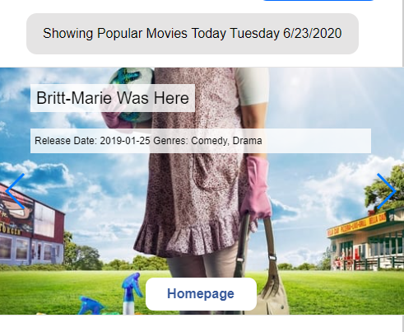

Figure 1: What we see on localhost right now

# **User text with clear intention**

**User:** star wars

**>** (fetches all movies containing the phrase ‘star wars’)

…

**User:** wars

**>** (fetches all movies containing the word ‘war’)

# **Asking questions to build the query**

**User: (Intention) movies**

**>** What movies to search for?

**>** Here are some lists. Pick one of those or just ask me about what you want.

*quickreplies [“Now Playing”, “Top Rated”, “Upcoming”, “Popular”]*

**User:** Either clicks on one of those or types sth else

…

**User: (Intention) genres**

**>** What genre of movies? *quickreplies [<all genres>]*

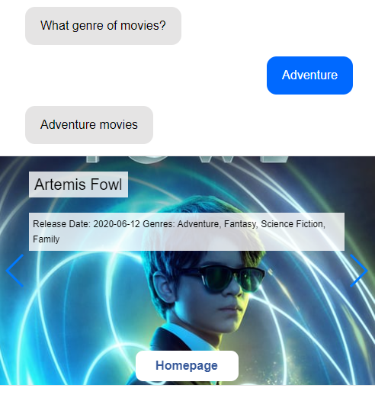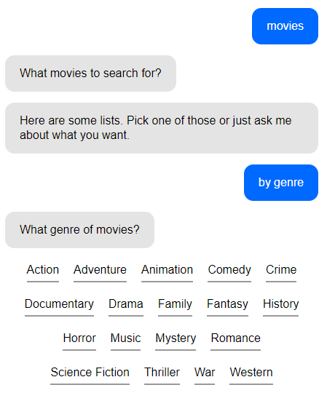

**Sort results (by popularity, release date etc.)**

**NOTE:** no errors thrown, but the sort_by keyword doesn’t seem to work on all types of queries

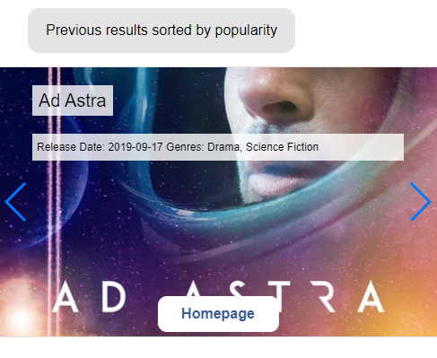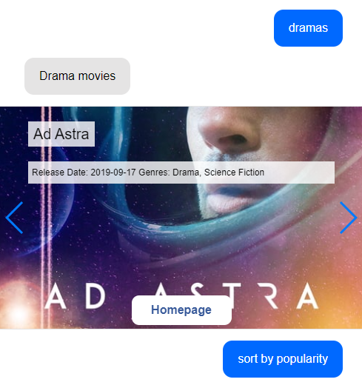

# **More Features Implemented (but not matched fully to scenarios)**

## Display picture (or video) of the day (from NASA’s API)

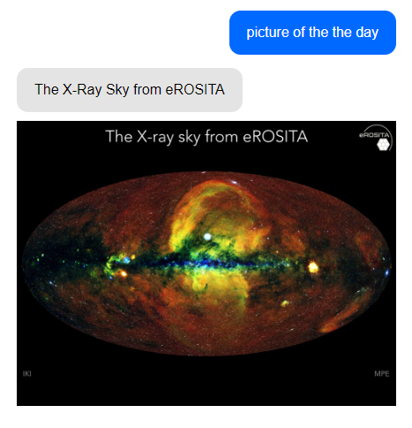

## Date picking

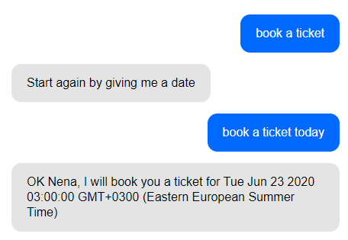

# To be finished…

* Understanding of mistakes: (NLP related) spelling mistakes/typos can match to intentions
* Doubt management: (NLP related) if confused between several intentions, offer choices to clarify