
DAYANANDA SAGAR COLLEGE OF ENGINEERING
(An Autonomous Institute affiliated to Visvesvaraya Technological University (VTU), Belagavi,
Approved by AICTE and UGC, Accredited by NAAC with ‘A’ grade & ISO 9001 – 2015 Certified Institution)
Shavige Malleshwara Hills, Kumaraswamy Layout, Bengaluru-560 111, India

DEPARTMENT OF ARTIFICIAL INTELLGENCE & MACHINE LEARNING

Alternate Assessment Tool

Course Title: INTERNET OF THINGS AND 5G
Course Code: 22AI642
Semester: VI

Submitted by

Nenad Matada – 1DS23AI039

Under the Guidance of
Dr Aruna M G
Professor
Department of Artificial Intellgence & Machine Learning
DSCE, Bengaluru

Visvesvaraya Technological University
Jnanasangama, Belagavi-590018, Karnataka, India
2025-206

Table of Contents

Activity 1: TinkerCAD Aurdino 1
Activity 2: Wokwi ESP32 8
Activity 3: Wokwi STM 14
Activity 4: Wokwi RaspberryPi Pico simulator 20
Activity 5: TinyML simulation in Wokwi 26

Activity 1: TinkerCAD Aurdino
Problem Statement | The Smart Fire Alarm System addresses the need for early detection of fire hazards to prevent damage and ensure safety. Conventional fire detection methods may not provide immediate alerts or real-time monitoring, leading to delayed responses. Hence, an automated system is required to quickly detect fire or high temperature conditions and trigger instant alerts.
AAT MARKS | Design (5) | Execution (5) | Result (5) | Innovation/ Extra Features (5) | Total
TOOLS USED | • TinkerCAD  • Arduino Uno  • Breadboard  • MQ-2 Gas Sensor
MAP SDG | • 3.9: Reduce deaths and illnesses caused by hazardous conditions such as fire and smoke exposure.  • 11.5: Reduce the number of deaths and economic losses caused by disasters, including fire accidents.  • 11.B: Improve disaster risk management and early warning systems in communities.  • 9.1: Develop reliable and resilient infrastructure, including safety systems for buildings.
MAP COURSE OUTCOME of IOT | CO Mapping Justification  CO1 Yes Demonstrates perception layer of IoT architecture using temperature/fire sensor to detect heat or flame, microcontroller processes the data, and buzzer/alerts act as output  CO2 Yes Uses Arduino C programming, sensor data acquisition, analog/digital signal processing, and communication protocols for alert generation  CO3 No Data analytics is not applied as the system focuses on real-time detection and alerting rather than data storage or analysis  CO4 Yes Integrates fire/temperature sensor (sensing) and buzzer/alarm system (actuation) to implement a complete sense-process-act IoT system
MAP PROGRAM OUTCOME | PO Mapping Justification  PO1 Yes Applied knowledge of electronics (temperature/fire sensors), basic science, and programming for detecting fire conditions  PO2 Yes Identified and analysed the real-world problem of delayed fire detection and need for faster response systems  PO3 Yes Designed an automated smart fire alarm system to provide early detection and instant alerts  PO5 Yes Used modern tools such as Arduino IDE and simulation platforms for system design and implementation  PO6 Yes Addresses societal safety by preventing fire hazards, reducing damage, and protecting lives
MAP PROGRAM SPECIFIC OUTCOME(PSO) of DEPARTMENT | PSO Mapping Justification  PSO 1 Yes Demonstrates programming and problem-solving by implementing sensor-based fire detection logic with threshold conditions and alert mechanisms  PSO 2 Yes Identifies and solves the real-world problem of fire hazard detection by developing an automated system for early warning and safety  PSO 3 Yes Utilizes simulation tools like Tinkercad or embedded platforms to design, test, and deploy the smart fire alarm system
URL Link | https://www.tinkercad.com/things/bbOAvitsXTa/editel?returnTo=%2Fdashboard%2Fdesigns%2Fall&sharecode=oxsgethJIDLGoJnZIKj434W-CTJOj6mu2lid9TU9oM8
SYSTEM DIAGRAM / UML / SEQUENCE DIGRAM/ 3D Model | 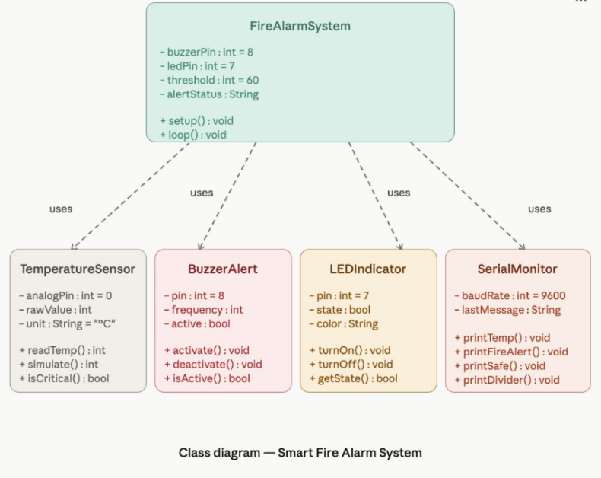
COURSE COORDINATOR | Dr ARUNA M G

Details
Abstract :
The Smart Fire Alarm System is an IoT-based safety project developed using Arduino UNO. It detects fire or high temperature conditions using a sensor and immediately triggers an alert system. When fire is detected, a buzzer sounds and an LED glows to indicate danger. The system also displays an alert message in the serial monitor. This project helps in early fire detection and improves safety measures.
Use Case:
This system can be used in homes, offices, industries, and public places to detect fire accidents at an early stage. It helps in alerting people quickly, reducing damage and ensuring safety.
Introduction:
Fire accidents can cause serious damage to life and property. Early detection is important to prevent such disasters. Traditional fire detection systems can be expensive, but this Smart Fire Alarm System provides a simple and cost-effective solution using Arduino and sensors. It continuously monitors conditions and gives immediate alerts when fire is detected.
Objective:
- To design a fire detection and alert system
- To detect fire or high temperature using sensors
- To activate buzzer and LED as warning signals
- To improve safety and reduce risk of fire hazards
General procedure
- Connect the fire sensor (or temperature sensor) to Arduino UNO
- Connect LED and buzzer to output pins
- Provide power supply to the circuit
- Upload the program (code) to Arduino
- Start the simulation
- Observe alerts when fire is detected
Step to Execute:
- Open Tinkercad simulation platform
- Place Arduino UNO, sensor, LED, and buzzer
- Connect all components properly (VCC, GND, signal pins)
- Write or paste the code in the editor
- Click on “Start Simulation”
- Open Serial Monitor
- Simulate fire condition and observe LED, buzzer, and alert message
Source Code
int buzzer = 8;
int led = 7;
void setup() {
Serial.begin(9600);
randomSeed(analogRead(0));
pinMode(buzzer, OUTPUT);
pinMode(led, OUTPUT);
}
void loop() {
int temperature = random(20, 100);
Serial.print("Temperature: ");
Serial.print(temperature);
Serial.println(" °C");
if (temperature > 60) {
Serial.println("🔥 FIRE DETECTED!");
digitalWrite(buzzer, HIGH);
digitalWrite(led, HIGH);
} else {
Serial.println("✅ Safe");
digitalWrite(buzzer, LOW);
digitalWrite(led, LOW);
}
Serial.println("-------------------");
delay(1000);
}
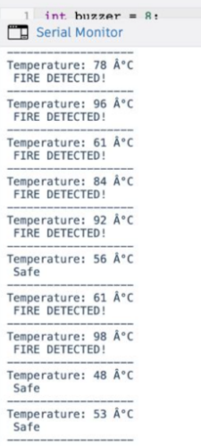
Output:

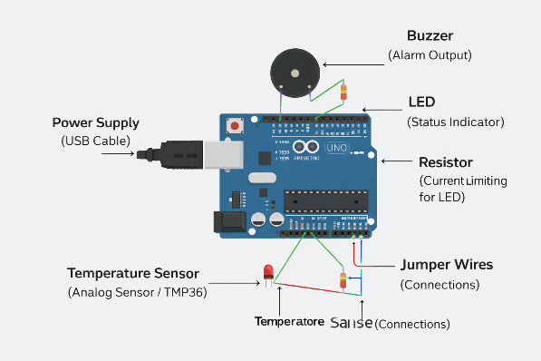
Photos/ Screenshot/Snapshot :

Outcome:
The Smart Fire Alarm System successfully detects fire conditions and triggers alerts using a buzzer and LED. It also displays warning messages in the serial monitor. This demonstrates how IoT can be used to enhance safety and prevent fire-related accidents.

Activity 2: Wokwi ESP32
Problem Statement | The Smart Temperature Monitoring System addresses the need for continuous and real-time tracking of temperature to prevent unsafe environmental conditions. Traditional monitoring methods lack instant alerts and remote accessibility, making it difficult to respond quickly to temperature fluctuations. Therefore, an automated IoT-based solution is required to monitor temperature.
AAT MARKS | Design (5) | Execution (5) | Result (5) | Innovation/ Extra Features (5) | Total
TOOLS USED | • Wokwi  • ESP32  • DHT22 sensor  • 16x2 LCD display
MAP SDG | • 3.9: Reduce illnesses caused by exposure to unsafe environmental conditions such as extreme temperatures.  • 9.1: Develop reliable and resilient infrastructure through real-time monitoring systems.  • 11.6: Reduce environmental impact by improving monitoring and management of indoor conditions.  • 13.1: Strengthen resilience and adaptive capacity to climate-related risks and temperature variations.
MAP COURSE OUTCOME of IOT/ BFE | CO Mapping Justification  CO1 Yes Demonstrates perception layer of IoT architecture using a temperature sensor to continuously sense environmental data, which is processed by a microcontroller and displayed or used for alerts  CO2 Yes Implements Arduino C programming, sensor interfacing, analog-to-digital conversion, and communication protocols for real-time monitoring  CO3 No Data analytics is not included as the system focuses on real-time temperature monitoring without historical data processing or analysis  CO4 Yes Utilizes temperature sensor (sensing) and display/alert mechanisms (actuation) to form a complete sense-process-act IoT system
MAP PROGRAM OUTCOME | PO Mapping Justification  PO1 Yes Applied knowledge of electronics (temperature sensors), IoT concepts, and programming for real-time data monitoring  PO2 Yes Identified and analyzed the issue of lack of continuous monitoring and delayed response in traditional temperature tracking systems  PO3 Yes Designed an IoT-based smart temperature monitoring system with real-time tracking and alert mechanisms  PO5 Yes Used modern tools such as Arduino IDE, IoT platforms, and simulation tools for implementation and testing  PO6 Yes Addresses societal needs by ensuring safety in environments like homes, industries, and storage systems where temperature control is critical
MAP PROGRAM SPECIFIC OUTCOME(PSO) of DEPARTMENT | PSO Mapping Justification  PSO 1 Yes Demonstrates programming and problem-solving by implementing real-time temperature sensing, data processing, and alert generation using embedded systems  PSO 2 Yes Addresses the real-world problem of monitoring environmental conditions by providing continuous and automated temperature tracking  PSO 3 Yes Utilizes IoT platforms and simulation tools to monitor, visualize, and test temperature data with remote accessibility.
URL Link | https://wokwi.com/projects/460845442125174785
SYSTEM DIAGRAM / UML / SEQUENCE DIGRAM/ 3D Model | 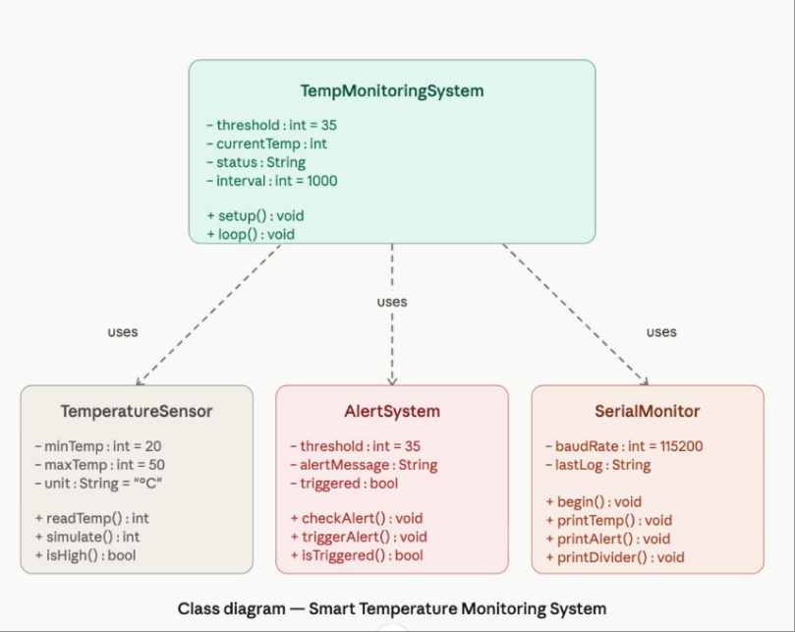
COURSE COORDINATOR | Dr ARUNA M G

Details
Abstract :
The Smart Temperature Monitoring System is an IoT-based project developed using ESP32. It monitors temperature values and displays them in the serial monitor. When the temperature exceeds a predefined threshold, the system generates an alert message. This helps in maintaining safe environmental conditions and enables real-time monitoring.
Use Case:
This system can be used in smart homes, industries, and server rooms to monitor temperature continuously. It helps in preventing overheating and ensures proper environmental control.
Introduction:
Temperature monitoring is important in many applications such as homes, industries, and electronic systems. Manual monitoring is not efficient, especially in critical environments. This project uses ESP32 and simulated sensor data to continuously check temperature and provide alerts when the value exceeds safe limits, making the system reliable and efficient.
Objective:
- To monitor temperature using ESP32
- To display temperature values in real time
- To generate alerts when temperature exceeds threshold
- To improve safety and automation
General procedure
- Set up ESP32 in the simulation platform (Wokwi)
- Initialize serial communication
- Generate or read temperature values
- Compare temperature with threshold value
- Display results in serial monitor
- Trigger alert message if temperature is high
Step to Execute:
- Open Wokwi simulation platform
- Add ESP32 to the workspace
- Write or paste the code in the editor
- Start the simulation
- Open Serial Monitor
- Observe temperature values and alerts
- Verify alert condition when temperature exceeds limit
Source Code

void setup() {
Serial.begin(115200);
}

void loop() {
int temp = random(20, 50); // simulate temperature

Serial.print("Temperature: ");
Serial.print(temp);
Serial.println(" °C");

if(temp > 35){
Serial.println(" High Temperature Alert!");
} else {
Serial.println(" Normal");
}

Serial.println("------------------");
delay(1000);
}

Output:

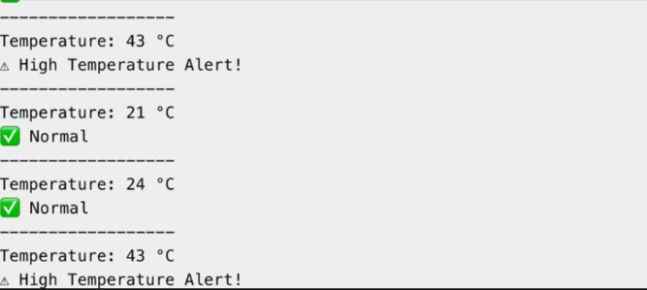

Photos/ Screenshot/Snapshot :
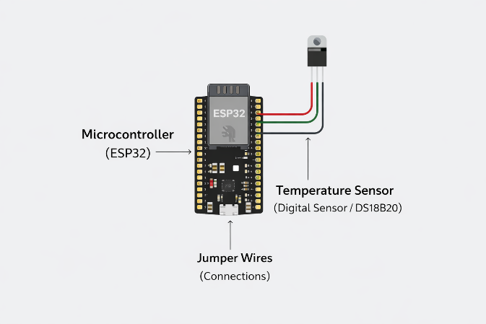

Outcome:
The Smart Temperature Monitoring System successfully displays temperature values and generates alerts when the temperature exceeds the set threshold. This demonstrates real-time monitoring and alert functionality using IoT concepts.

Activity 3: Wokwi STM
Problem Statement | Efficient water management is a major challenge in agriculture. Traditional irrigation methods often lead to overwatering or underwatering, which affects crop yield and wastes resources.
AAT MARKS | Design (5) | Execution (5) | Result (5) | Innovation/ Extra Features (5) | Total
TOOLS USED | • Wokwi  • STM32 Nucleo C031C6  • Soil Moisture Sensor Module  • Water Pump (DC Mini Pump)
MAP SDG | • 2.4: Ensure sustainable food production and improve agricultural productivity through efficient water use.  • 6.4: Increase water-use efficiency and ensure sustainable withdrawal of freshwater resources.  • 12.2: Achieve sustainable management and efficient use of natural resources.  • 13.1: Strengthen resilience to climate-related impacts affecting water availability in agriculture.
MAP COURSE OUTCOME of IOT/ BFE | CO Mapping Justification  CO1 Yes Demonstrates perception layer of IoT architecture using soil moisture and/or environmental sensors to monitor field conditions, with microcontroller processing the sensed data  CO2 Yes Uses Arduino C programming, sensor interfacing, and analog/digital data acquisition for monitoring and control of irrigation parameters  CO3 No Data analytics is not applied as the system focuses on real-time monitoring and irrigation control rather than historical analysis or prediction  CO4 Yes Integrates soil moisture sensing (input) and water pump/valve control (output) to implement a complete sense-process-act IoT-based irrigation system
MAP PROGRAM OUTCOME | PO Mapping Justification  PO1 Yes Applied knowledge of sensors, basic electronics, and control systems for monitoring soil moisture and irrigation control  PO2 Yes Identified and analyzed the real-world problem of inefficient water usage in agriculture leading to overwatering and underwatering  PO3 Yes Designed an efficient irrigation solution to optimize water usage and improve crop yield through automated control  PO5 Yes Used modern engineering tools such as microcontroller platforms and simulation/software tools for system development  PO6 Yes Addresses environmental and societal concerns by conserving water resources and supporting sustainable agriculture practices
MAP PROGRAM SPECIFIC OUTCOME(PSO) of DEPARTMENT | PSO Mapping Justification  PSO 1 Yes Demonstrates programming and problem-solving by implementing sensor-based control logic for automated irrigation based on soil or environmental conditions  PSO 2 Yes Addresses the real-world problem of inefficient water usage in agriculture by enabling smart irrigation to prevent overwatering and underwatering  PSO 3 Yes Utilizes embedded/IoT simulation platforms to design, test, and validate an automated irrigation system for efficient water management
URL Link | https://wokwi.com/projects/460846540843282433
SYSTEM DIAGRAM / UML / SEQUENCE DIGRAM/ 3D Model | 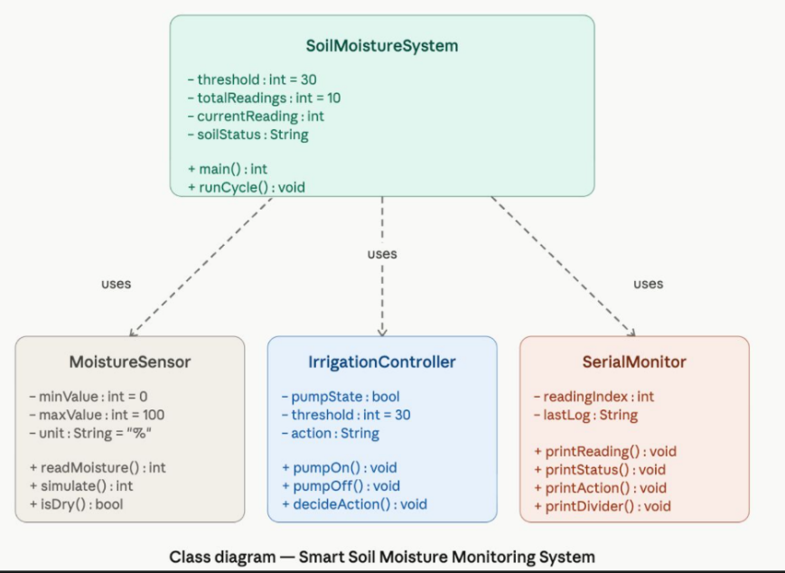
COURSE COORDINATOR | Dr ARUNA M G

Details
Abstract :
This project presents a Smart Soil Moisture Monitoring System using STM32. It monitors soil moisture levels and determines whether the soil is dry or wet. Based on the moisture value, the system suggests whether irrigation is required. This helps in efficient water usage and improves agricultural productivity.
Use Case:
Smart agriculture systems integrate automated irrigation, greenhouse monitoring, and data-driven tools to improve farming efficiency. These technologies help optimize water usage, monitor crop conditions in real time, and enhance overall productivity. By leveraging automation and analytics, farmers can make smarter decisions and maximize yields.
Introduction:
Water is a critical resource in agriculture, and its efficient use is essential for sustainable farming. Traditional irrigation methods lack precision and often lead to wastage. This project uses a moisture monitoring approach to analyze soil conditions and provide irrigation recommendations. It demonstrates how embedded systems can be used to enhance agricultural efficiency.

Objective:
- To monitor soil moisture levels
- To classify soil as dry or wet
- To suggest irrigation actions
- To promote efficient water usage
General procedure
- Initialize STM32 system
- Generate or read soil moisture values
- Compare moisture value with threshold
- Determine soil condition (dry/wet)
- Display appropriate message
- Suggest irrigation action
Step to Execute:
- Set up STM32 simulation environment
- Write or paste the C code
- Compile and run the program
- Observe generated moisture values
- Check soil status (Dry/Wet)
- Verify suggested action (Pump ON/OFF)
Source Code
#include <stdio.h>
#include <stdlib.h>
#include <time.h>

int main() {
srand(time(0));
for(int i = 1; i <= 10; i++) {
int moisture = rand() % 100;
printf("\nReading %d\n", i);
printf("Moisture Level: %d%%\n", moisture);
if(moisture < 30) {
printf("Status: Soil is DRY \n");
printf("Action: Turn ON Water Pump\n");
} else {
printf("Status: Soil is WET \n");
printf("Action: No Water Needed\n");
}
printf("-----------------------------\n");
}
return 0;
}\
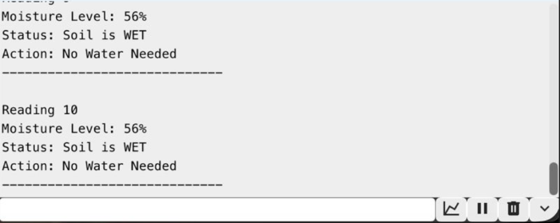
Output:

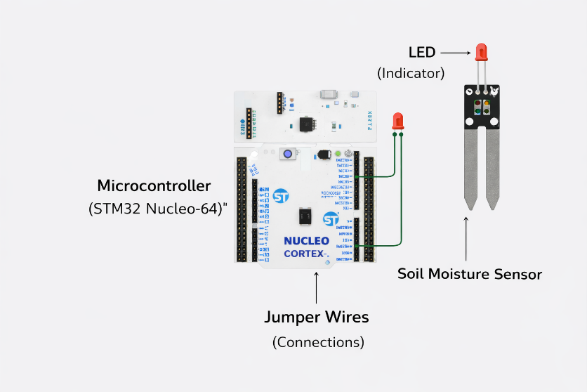
Photos/ Screenshot/Snapshot :

Outcome:
The Smart Soil Moisture Monitoring System successfully determines soil condition and suggests irrigation actions based on moisture levels. This demonstrates efficient water management and the application of embedded systems in smart agriculture.

Activity 4: Wokwi RaspberryPi Pico simulator
Problem Statement | Manual control of lighting systems can lead to energy wastage, especially when lights are left ON during daytime. There is a need for an automated system that can detect ambient light conditions and control lighting accordingly to improve energy efficiency.
AAT MARKS | Design (5) | Execution (5) | Result (5) | Innovation/ Extra Features (5) | Total
TOOLS USED | • Wokwi  • Arduino Uno  • LDR (Light Dependent Resistor)  • LED
MAP SDG | • 7.3: Improve energy efficiency by reducing unnecessary power consumption in lighting systems.  • 12.2: Achieve sustainable management and efficient use of energy resources.  • 11.6: Reduce environmental impact by minimizing energy wastage in buildings and public spaces.  • 13.3: Improve awareness and practices related to energy conservation and climate change mitigation.
MAP COURSE OUTCOME of IOT/ BFE | CO Mapping Justification  CO1 Yes Demonstrates perception layer of IoT architecture using LDR/ambient light sensor to detect light intensity, which is processed by a microcontroller to determine lighting conditions  CO2 Yes Uses Arduino C programming, sensor interfacing, and analog-to-digital conversion to read light intensity and control output devices based on conditions  CO3 No Data analytics is not included as the system operates in real-time for automatic lighting control without storing or analyzing historical data  CO4 Yes Integrates light sensor (sensing) and relay/LED lighting system (actuation) to form a complete sense-process-act IoT automation system
MAP PROGRAM OUTCOME | PO Mapping Justification  PO1 Yes Applied knowledge of light sensors (LDR), basic electronics, and control systems for automatic lighting control  PO2 Yes Identified and analyzed the issue of energy wastage due to manual lighting control and lack of ambient light awareness  PO3 Yes Designed an automated smart lighting system that adjusts based on ambient light conditions to improve efficiency  PO5 Yes Used modern engineering tools such as microcontroller programming (Arduino IDE) and simulation platforms for implementation  PO6 Yes Addresses energy conservation and environmental sustainability by reducing unnecessary electricity consumption
MAP PROGRAM SPECIFIC OUTCOME(PSO) of DEPARTMENT | PSO Mapping Justification  PSO 1 Yes Demonstrates programming and problem-solving by implementing sensor-based logic to automatically control lighting based on ambient light conditions  PSO 2 Yes Addresses the real-world problem of energy wastage by designing an automated lighting control system that improves energy efficiency  PSO 3 Yes Utilizes embedded/IoT tools or simulation platforms to design, test, and validate an automatic light control system
URL Link | https://wokwi.com/projects/460850902742046721
SYSTEM DIAGRAM / UML / SEQUENCE DIGRAM/ 3D Model | 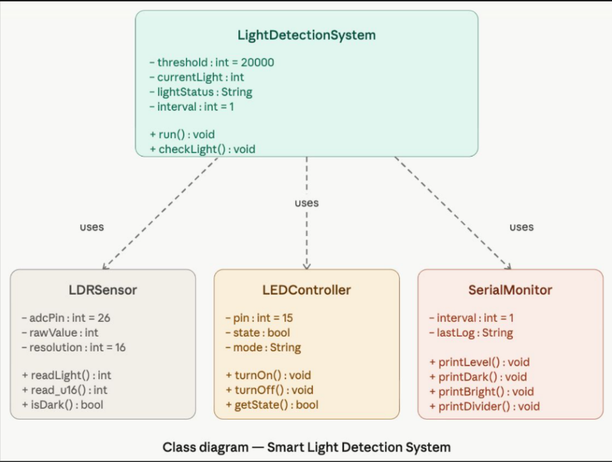
COURSE COORDINATOR | Dr ARUNA M G

Details
Abstract :
This project presents a Smart Light Detection System using an LDR sensor and microcontroller. The system monitors ambient light levels and automatically controls an LED. When it is dark, the LED turns ON, and when it is bright, the LED turns OFF. This system helps in reducing energy consumption and supports automation.
Use Case:
Automatic street lighting and smart home lighting systems use sensors and automation to adjust brightness based on activity and ambient conditions. These energy-saving applications reduce power consumption while maintaining safety and convenience. Outdoor lighting automation further enhances efficiency by ensuring lights operate only when needed.

Introduction:
Energy conservation is an important aspect of modern technology. Manual control of lighting systems often leads to inefficiency. This project uses an LDR sensor to detect light intensity and automatically control lighting. It demonstrates how IoT and embedded systems can be used to create smart and energy-efficient solutions.
Objective:
- To detect ambient light intensity
- To control LED based on light conditions
- To automate lighting system
- To reduce energy consumption
General procedure
- Connect LDR sensor to microcontroller ADC pin
- Connect LED to output pin
- Read light intensity values from LDR
- Compare with threshold value
- Determine light/dark condition
- Turn LED ON or OFF accordingly
Step to Execute:
- Open Wokwi simulation platform
- Add microcontroller, LDR, and LED
- Connect all components properly
- Paste the MicroPython code
- Start simulation
- Change light intensity (LDR input)
- Observe LED behavior and serial output
Source Code
from machine import ADC, Pin
import time
ldr = ADC(26)
led = Pin(15, Pin.OUT)
while True:
light = ldr.read_u16()
print("Light Level:", light)
if light < 20000:
print("🌙 Dark - Light ON")
led.value(1)
else:
print("☀ Bright - Light OFF")
led.value(0)
print("----------------------")
time.sleep(1)
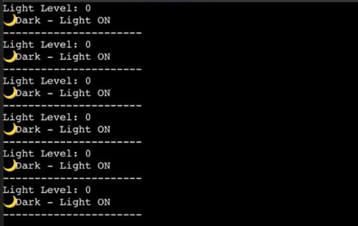
Output:

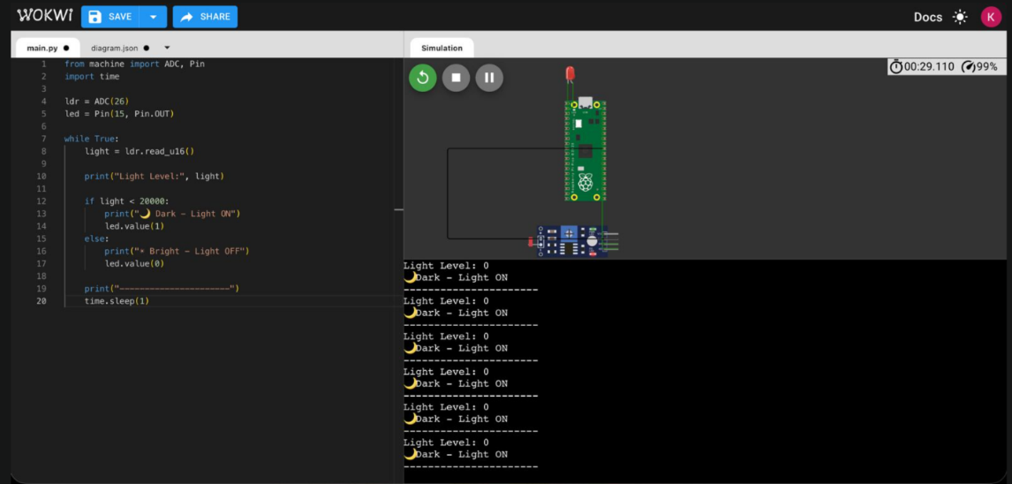
Photos/ Screenshot/Snapshot :

Outcome:
The Smart Light Detection System successfully detects ambient light levels and controls the LED accordingly. It demonstrates an efficient and automated lighting solution using IoT concepts.

Activity 5: TinyML simulation in Wokwi
Problem Statement | In smart environments, there is a need for simple and efficient human-machine interaction methods. Traditional switches require physical contact, which may not always be convenient.
AAT MARKS | Design (5) | Execution (5) | Result (5) | Innovation/ Extra Features (5) | Total
TOOLS USED | • Wokwi  • ESP32 DevKit V1  • Microphone Sound Sensor Module  • LED
MAP SDG | • 9.1: Develop reliable and innovative infrastructure through advanced human-machine interaction systems.  • 9.5: Enhance technological capabilities and promote innovation in user interface systems.  • 11.7: Provide inclusive and accessible environments through touchless control systems.  • 3.9: Reduce health risks by minimizing physical contact with shared surfaces.
MAP COURSE OUTCOME of IOT | CO Mapping Justification  CO1 Yes Demonstrates perception layer of IoT architecture using input sensors (such as IR sensors, touch sensors, or gesture modules) to detect user actions, which are processed by a microcontroller  CO2 Yes Uses Arduino C programming, sensor interfacing, and digital input processing to enable contactless control of devices through programmed logic  CO3 No Data analytics is not involved as the system focuses on real-time interaction and control rather than data storage or analysis  CO4 Yes Integrates input sensing (gesture/touch/IR detection) and output actuation (switching relays, lights, or appliances) to implement a complete sense-process-act IoT system
MAP PROGRAM OUTCOME | PO Mapping Justification  PO1 Yes Applied knowledge of sensors and embedded systems for developing touchless or automated control mechanisms  PO2 Yes Identified and analyzed the limitation of traditional physical switches in modern smart environments  PO3 Yes Designed a convenient human-machine interaction system to enable contactless or automated control  PO5 Yes Used modern engineering tools such as microcontrollers and simulation/software platforms for system development  PO6 Yes Improves user convenience and accessibility, supporting safer and more hygienic interaction in smart environments
MAP PROGRAM SPECIFIC OUTCOME(PSO) of DEPARTMENT | PSO Mapping Justification  PSO 1 Yes Demonstrates programming and problem-solving by implementing sensor-based or input-driven control logic for touchless human–machine interaction  PSO 2 Yes Addresses the real-world need for convenient and contactless control in smart environments by reducing dependence on physical switches  PSO 3 Yes Utilizes embedded systems or IoT simulation tools to design, test, and validate a smart interaction-based control system
URL Link | https://wokwi.com/projects/460938409570791425
SYSTEM DIAGRAM / UML / SEQUENCE DIGRAM/ 3D Model | 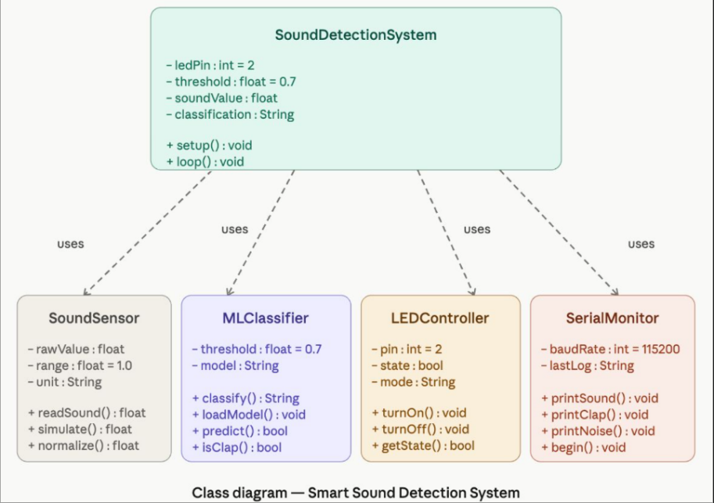
COURSE COORDINATOR | Dr ARUNA M G

Details
Abstract :
This project presents a Smart Sound Detection System that distinguishes between clap sounds and background noise. It uses simulated or real audio data to classify sound signals. Based on the detection, the system can trigger actions such as turning devices ON or OFF.
Use Case:
Smart home automation with clap-based control and touchless switches enables intuitive, hands-free operation of devices for greater convenience and hygiene. Assistive technology systems enhance accessibility for users with disabilities.
Introduction:
Human interaction with devices is evolving towards more natural and touchless methods. Sound-based control is one such approach. This project uses sound intensity or classification techniques to distinguish between clap and noise. By identifying specific sound patterns, the system can trigger actions, making it useful for smart environments.
Objective:
- To detect sound signals
- To classify clap and noise
- To implement simple AI or threshold-based logic
- To enable touchless control systems
General procedure
- Collect sound data (clap and noise)
- Train classification model (optional using Edge Impulse)
- Deploy model to microcontroller
- Read sound input (sensor/simulated)
- Analyze sound intensity or pattern
- Display classification result
Step to Execute:
- Create project in Edge Impulse (optional)
- Upload audio samples (clap and noise)
- Train audio classification model
- Deploy model as Arduino library
- Open Wokwi and select ESP32
- Paste code and run simulation
- Observe output in Serial Monitor
Source Code
#define LED_PIN 2
void setup() {
Serial.begin(115200);
pinMode(LED_PIN, OUTPUT);
}
void loop() {
float sound = random(0, 1000) / 1000.0;
Serial.print("Sound: ");
Serial.print(sound);
Serial.print(" -> ");
if (sound > 0.7) {
Serial.println("Clap Detected!");
digitalWrite(LED_PIN, HIGH);
} else {
Serial.println("Noise");
digitalWrite(LED_PIN, LOW);
}
delay(1000);
}
ML Training
import tensorflow as tf
import numpy as np

X = np.array([[0.1],[0.2],[0.3],[0.8],[0.9],[1.0]])
y = np.array([0,0,0,1,1,1]) # 0 = Noise, 1 = Clap

model = tf.keras.Sequential([
tf.keras.layers.Dense(8, activation='relu', input_shape=(1,)),
tf.keras.layers.Dense(1, activation='sigmoid')
])
model.compile(optimizer='adam', loss='binary_crossentropy', metrics=['accuracy'])

model.fit(X, y, epochs=100)
model.save("clap_model.h5")

Output:
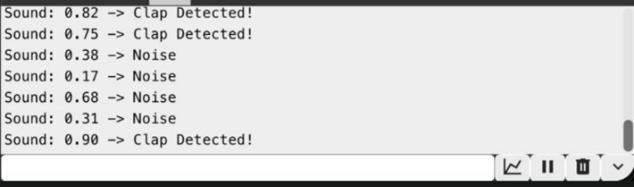

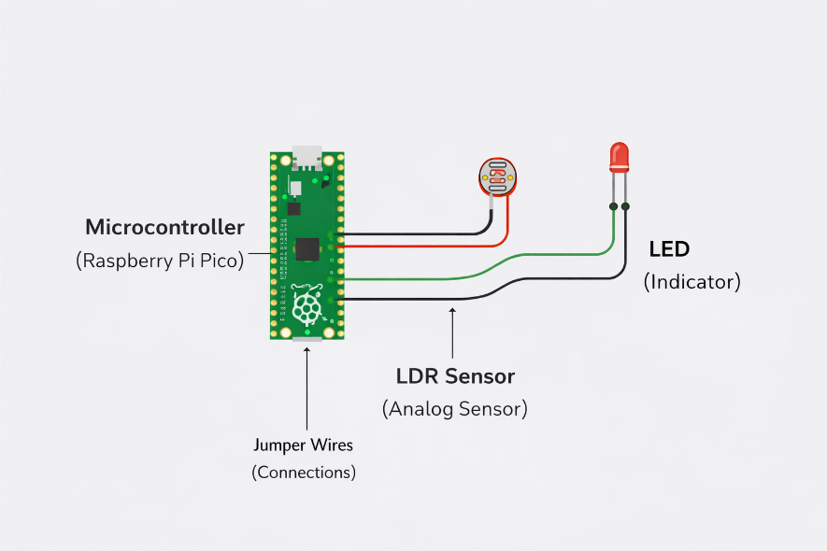
Photos/ Screenshot/Snapshot :

Outcome:
The Smart Sound Detection System successfully distinguishes between clap and background noise. It demonstrates the use of IoT and basic AI for touchless control and smart automation.

Dr . Vindhya P Malagi
Head of the Department
Artificial Intelligence & Machine Learning
Dayananda Sagar College of Engineering
Bangalore-560111

Dr . Aruna M G
Course Coordinator

