Unified Travel Commerce Platform

Final Architecture Document + UI/UX Architecture
Enterprise blueprint for OTA, Tour Operator, Charter, B2B, CRM, Mail, Marketing, AI and B2C Website
Prepared for Olympic TravelAI
Version 1.0 • March 2026

1. Executive Summary
UTCP is designed as a unified travel commerce and operations platform that replaces fragmented tools for booking, tour operating, charter management, B2B distribution, CRM, communication, marketing, SEO publishing and AI-assisted workflows.
The architecture supports three business models in the same system: dynamic OTA-style travel, fixed and hybrid tour-operator programs, and charter/series operations with seat and hotel inventory control.
Strategic principle: everything that can be handled deterministically by code, rules, calculations or indexed retrieval should stay outside the LLM path. AI is introduced only where semantic interpretation, generation, summarization or natural-language interaction create real business value.

2. Business Scope and Platform Goals
- Support dynamic search, offers, repricing and booking for hotel, flight, transfer, activity and hybrid packages.
- Create and manage tour-operator programs with departures, itineraries, pricing, rooming, manifests and guide operations.
- Manage charter seasons, flight series, seat pools, hotel allotments, 7/10/14-night packages and hybrid fixed/API pricing.
- Provide a central reservation dossier with linked finance, documents, operational flags, rooming and communication.
- Expose a B2C website powered by the same master data, offers, SEO content and publishing workflows.
- Provide B2B agency distribution with credit control, statements, documents, support and optional API access.
- Centralize mail, communication quality monitoring, CRM timelines, campaigns, AI assistance and token governance.

3. High-Level System Map
The platform is organized into 17 logical domains with a clear responsibility boundary in the data model, API layer and event model.
Domain | Primary Responsibility | Approx. Tables
Identity & Access | Users, roles, permissions, sessions, security | 20
CRM & Accounts | Contacts, agencies, suppliers, consents, preferences | 35
Product Master | Destinations, hotels, room types, boards, amenities | 35
Contracting & Rates | Contracts, seasons, rates, promotions, allotments | 70
Search & Offers | Search requests, offers, price breakdowns, repricing | 30
Booking Core | Bookings, items, passengers, supplier reservations | 35
Reservation Operations | Workspace, flags, dispatches, operational lists | 30
Finance & Settlement | Payments, receivables, payables, refunds, statements | 45
Rooming & Capacity | Rooming, occupancy, manifests, capacity snapshots | 35
Tour Operator Programs | Programs, departures, itinerary, guides, publishing | 35
Charter & Series | Seasons, flights, seat inventory, hybrid packages | 35
B2B Distribution | Agency users, statements, restrictions, support, API | 25
Mail & Communication | Mailboxes, threads, quality review, tasks | 40
Marketing Automation | Campaigns, segments, deliveries, automations | 35
AI Governance & Usage | Sessions, budgets, routes, approvals, usage logs | 20
Website / CMS / SEO | Pages, SEO metadata, publications, AI SEO | 30
Audit / Monitoring / Control | Queue, logs, feature flags, incidents, health | 25

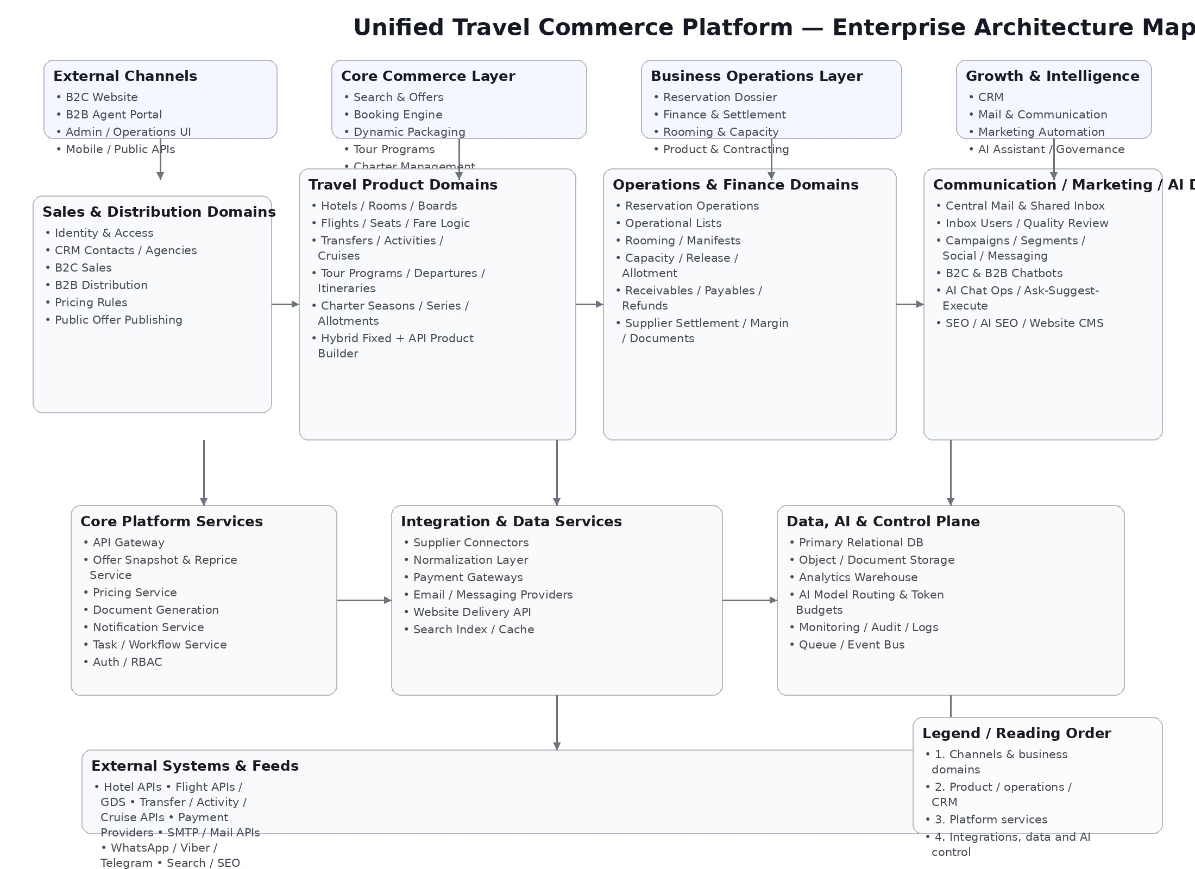
Figure 1. Enterprise architecture map.

4. Architecture Layers

4.1 Presentation Layer
- B2C website powered by publication snapshots and public APIs.
- B2B agent portal with pricing, credit, statements, bookings and support.
- Internal admin and operations UI for reservation teams, finance, contracting, marketing and management.
- Chatbot interfaces for B2C and B2B users, plus internal AI command center.

4.2 Application Layer
- Core domain services for booking, finance, product, charter, tour, mail, marketing and AI governance.
- Public, customer, B2B, admin and system API boundaries.
- Read models and publication services for website and reporting.
- Workflow orchestration through synchronous commands and asynchronous events/jobs.

4.3 Infrastructure Layer
- Primary PostgreSQL database with domain schemas.
- Redis for cache, sessions, idempotency and fast state.
- Search index for retrieval, website and internal fuzzy search.
- Object storage for vouchers, invoices, attachments, media and exports.

5. Data, API and Event Architecture
The relational model is domain-based and designed for approximately 580 business tables plus reporting views, materialized projections, queue tables and analytics facts.
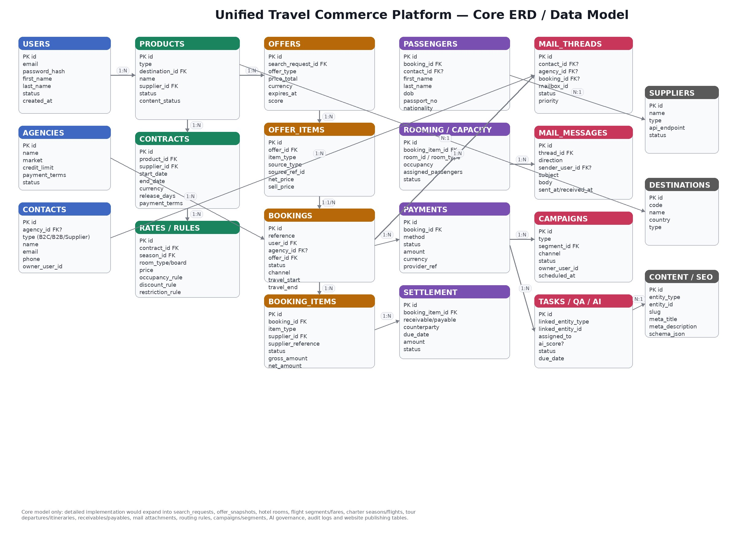
Figure 2. Core ERD and main relational groupings.

5.1 Data Layer Principles
- Schema separation by domain: iam, crm, product, contracting, search, booking, ops, finance, rooming, tour, charter, b2b, communication, marketing, ai, cms, control, reporting, integration.
- Transactional outbox for critical domain events.
- Monthly or daily partitioning for logs, mail, AI usage, campaign recipients, payments and audit trails.
- Materialized views for booking finance summaries, departure readiness, charter load factors and mail quality KPIs.

5.2 API Boundaries
- Public Website API for content, search and published offers.
- B2C Customer API for profile, bookings, payments, documents and chatbot.
- B2B Partner API for agency profile, credit, search, bookings, statements and support.
- Internal Admin API for contracts, bookings, finance, rooming, communication, marketing, AI and CMS.
- System / Integration API for supplier connectors, webhooks, imports, exports and publishing.

5.3 Event and Queue Model
- Standard envelope with event_id, event_name, version, producer, aggregate, correlation_id and payload.
- Priority queues split into critical.booking, ops.dispatch, finance.async, mail.async, marketing.async, ai.async, website.publish and monitoring.system.
- Retry policies differ for transient errors, business errors and delayed confirmations.
- Dead-letter handling and replay are mandatory for booking, finance and communication pipelines.

6. Implementation Blueprint
Delivery should proceed in controlled phases with data quality, pricing and booking correctness ahead of AI and advanced automation.
Phase | Focus | Key Deliverables | Duration
1 | Foundation & Core Data | IAM, CRM, Product Master, Contracting, base admin, object storage, queue skeleton | 8–12 weeks
2 | Core Commerce & Reservation | Search, offers, booking core, reservation dossier basic, public search API | 10–14 weeks
3 | Operations & Finance | Receivables, payables, rooming basic, manifests, operational lists, finance docs | 12–16 weeks
4 | Tour Operator & Charter | Programs, departures, itinerary, charter seasons, seat control, hybrid builder | 14–18 weeks
5 | Communication, B2B & Publishing | B2B portal, central mail, Inbox Users basic, CMS/SEO, website publication | 12–16 weeks
6 | Marketing, AI & Optimization | Campaigns, chatbots, AI governance, token budgets, AI SEO and quality scoring | 12–18 weeks

6.1 Recommended Team
- 1 Solution Architect / Tech Lead
- 1 Product Lead and 1 Delivery Manager
- 4–6 backend developers
- 2–4 frontend developers
- 2 QA engineers
- 1 DevOps engineer
- 1 UX/Product designer
- 1 data/AI engineer from phase 5 onward or shared part-time

7. UI/UX Architecture
The UI is designed as a calm, premium, enterprise travel workspace: high information density where needed, but always with clear hierarchy, whitespace and consistent action placement.

7.1 UX Principles
- One source of truth: reservation, finance, communication and documents are linked through the same dossier and timeline.
- Operational speed: sticky side panels, quick actions, bulk actions and read-optimized summary cards are first-class patterns.
- Progressive disclosure: critical state is visible immediately; detail appears in drawers, tabs or secondary panels.
- Deterministic-first AI: AI surfaces guidance and summaries but never obscures deterministic business state.

7.2 Main Workspaces
- Reservation Dossier
- Finance Workspace
- Operational Lists
- Rooming & Capacity
- Shared Inbox / Inbox Users
- B2B Dashboard
- Marketing Workspace
- AI Command Center
- Tour Operator Program Management
- Charter / Series Management
- Product & Contracting
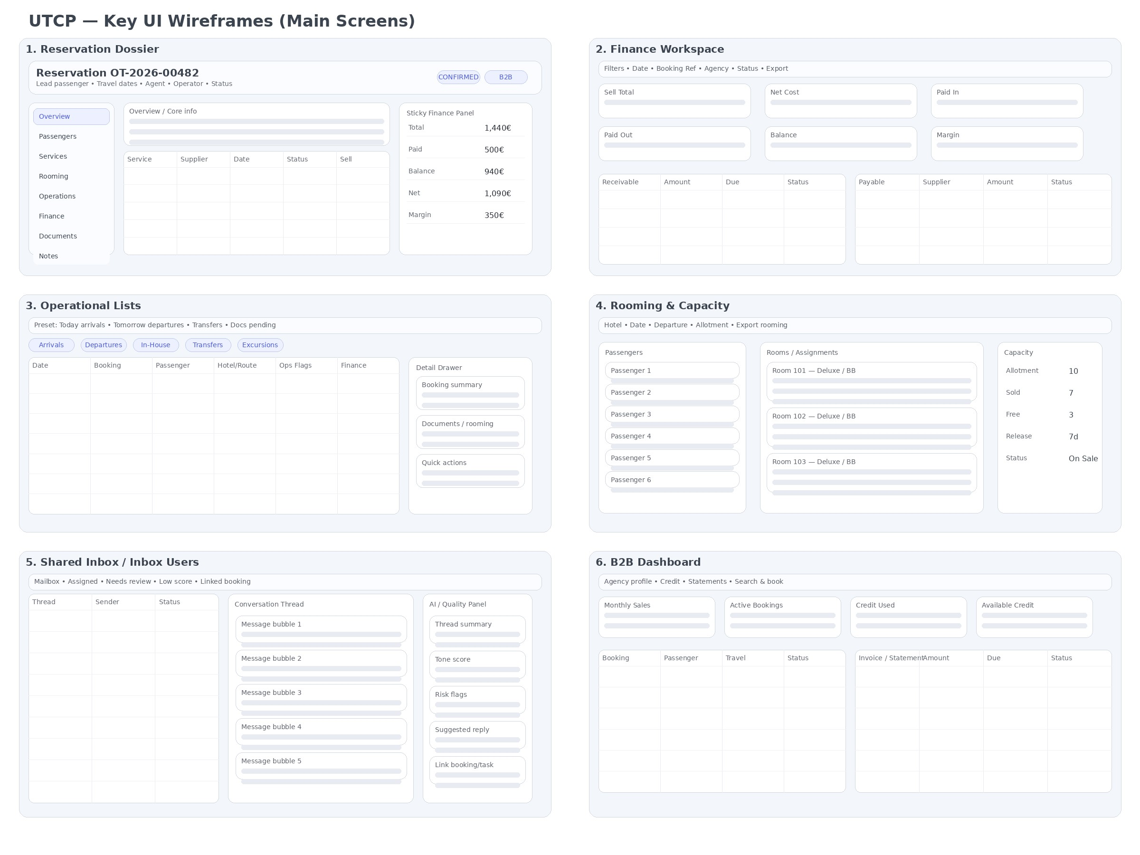
Figure 3. Core UI wireframes.
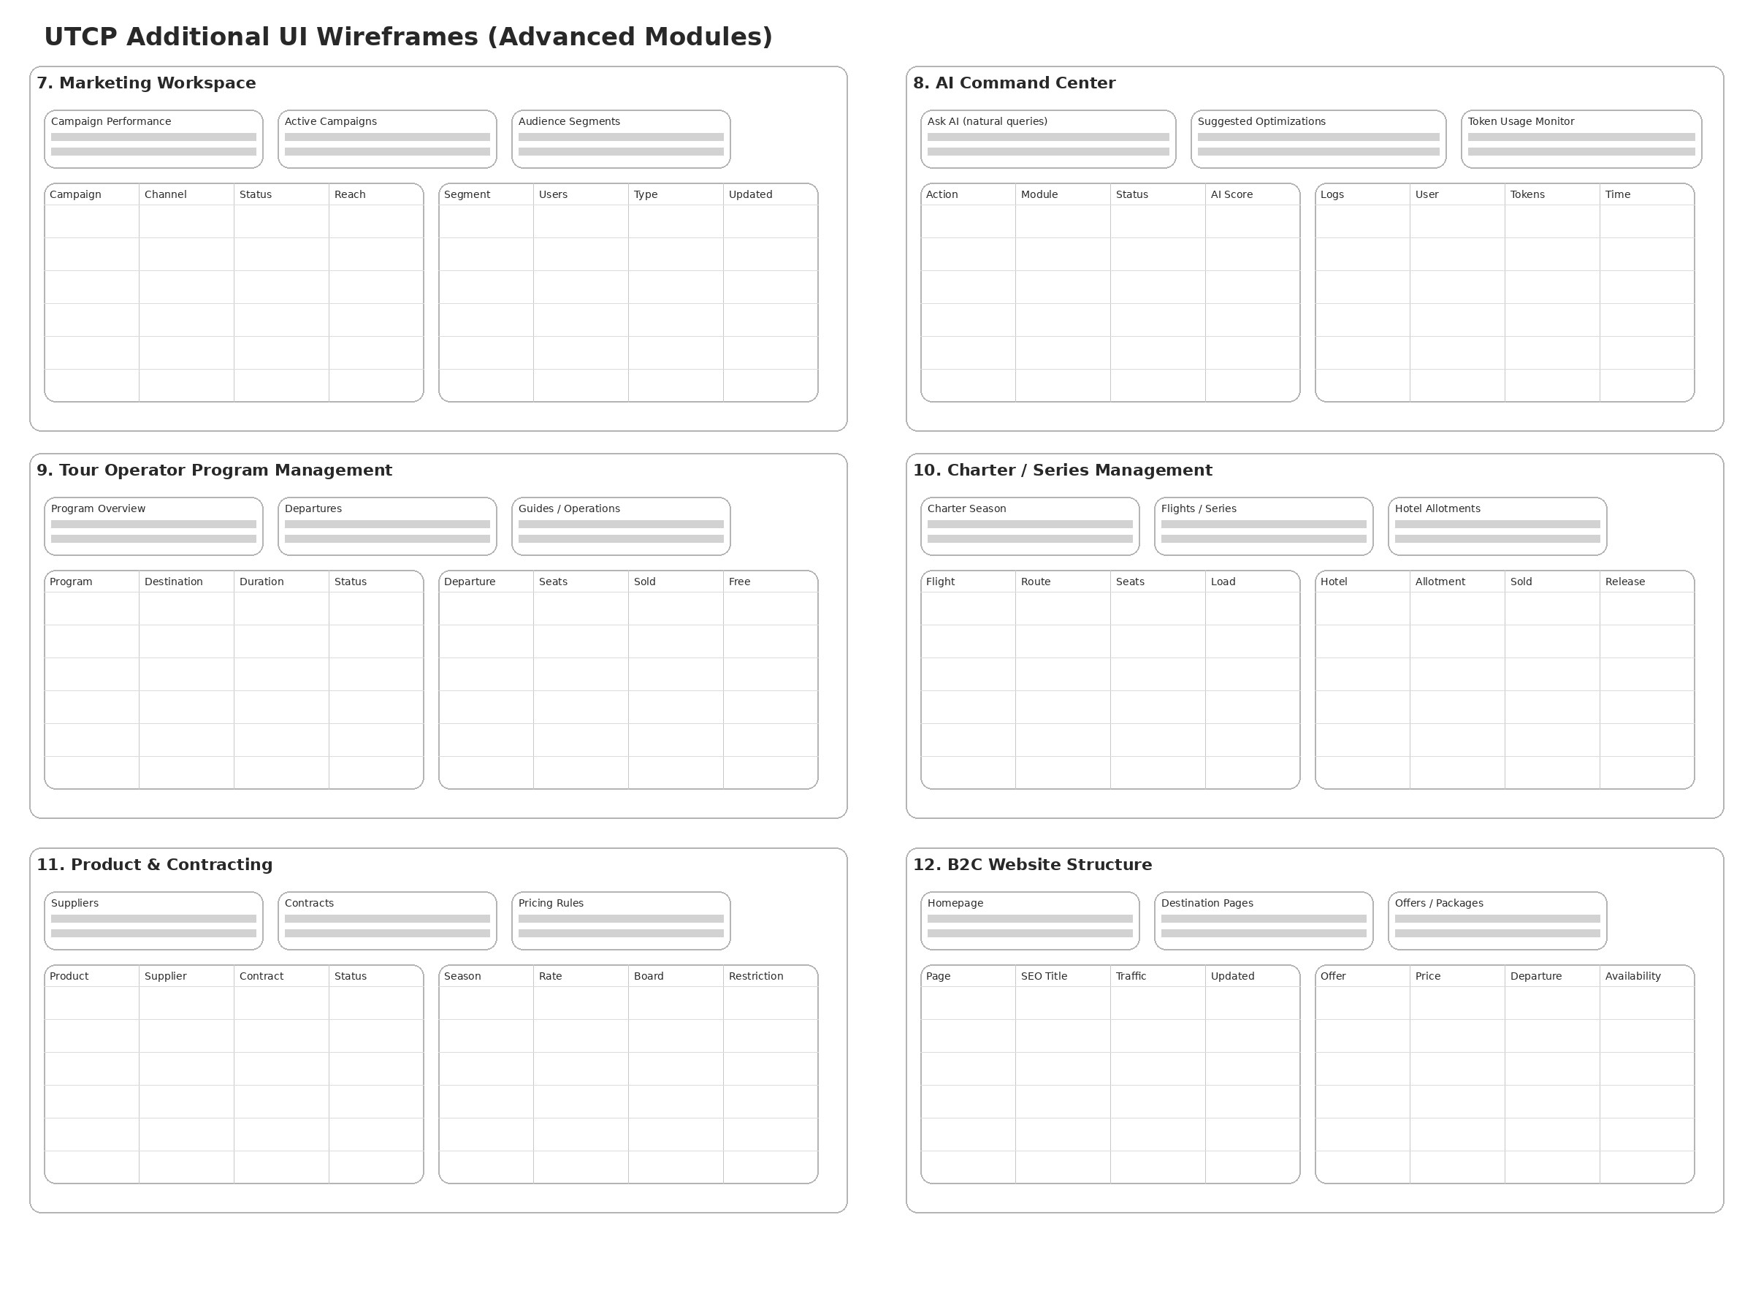
Figure 4. Additional UI wireframes.

8. B2C Website and SEO Architecture
The B2C website is a presentation layer fed by platform-controlled publication snapshots, public APIs and SEO metadata. This removes duplicate entry and keeps content aligned with live product and offer state.
Website Area | Driven By | Purpose
Homepage | Published campaigns, destination blocks, top charter/tour/public offer snapshots | Entry point and promotional routing
Destination Pages | destination_content, SEO metadata, linked offers and articles | Organic acquisition and conversion routing
Hotel Pages | hotel_content, amenity highlights, dynamic or hybrid offer links | Hotel detail and offer entry
Tour Pages | tour_content, departures, itinerary, FAQ, publication state | Group travel merchandising and conversion
Charter Pages | charter_content, season snapshots, durations, hotels, price-from blocks | Series package sales
Landing Pages | campaigns, SEO targets, dynamic offer widgets | Commercial and SEO performance
Blog / Guides | articles, FAQs, internal linking, schema markup | Top-of-funnel acquisition and AI search discoverability

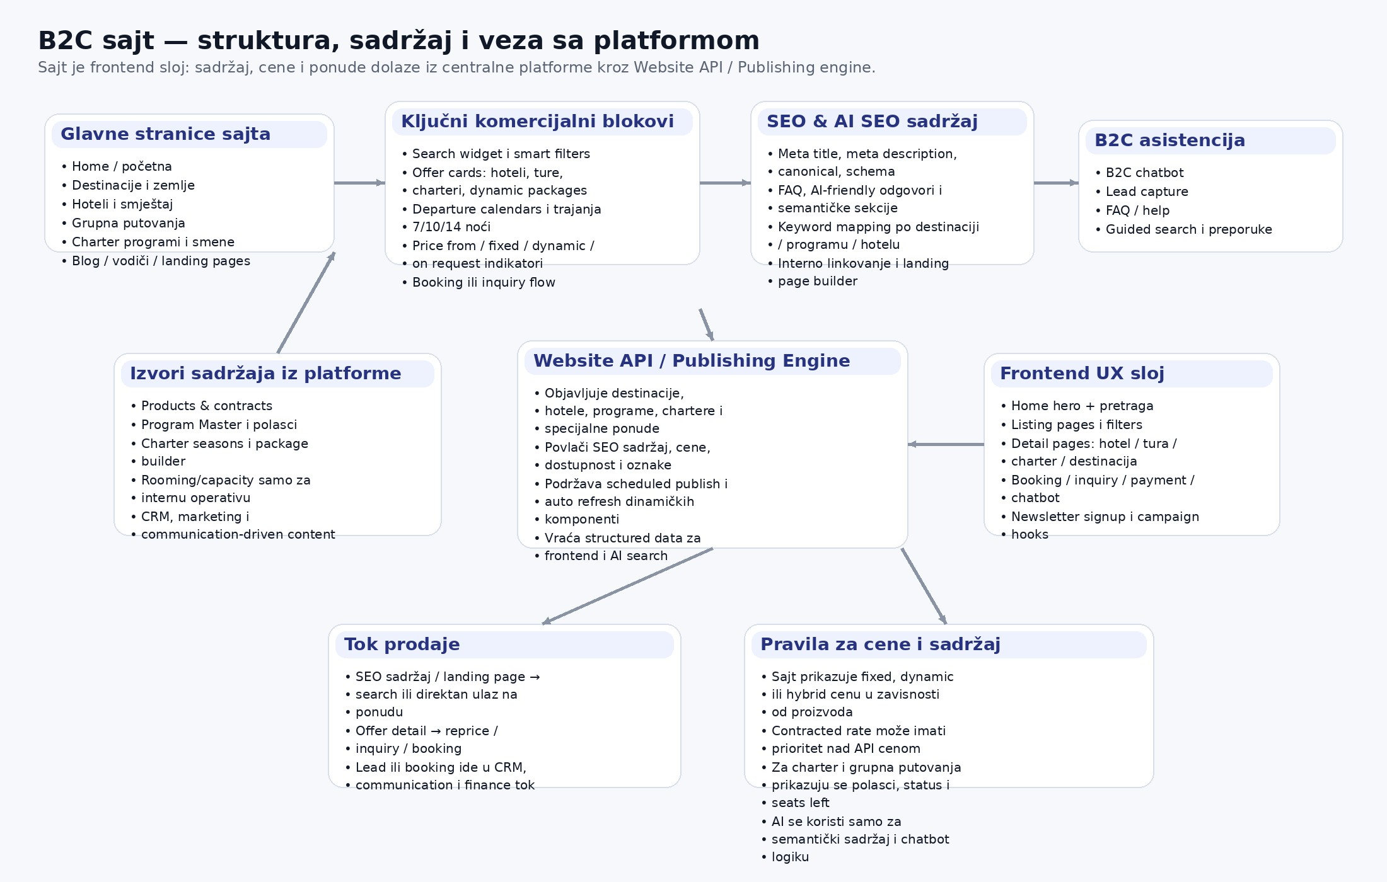
Figure 5. B2C website map powered by platform content and commerce services.

8.1 SEO and AI-SEO
- Entity-level SEO metadata for destinations, hotels, tours, charters, articles and landing pages.
- Structured data for FAQ, offer, product, breadcrumb, article and organization pages.
- AI-generated SEO suggestions treated as drafts, not auto-published content.
- Keyword target mapping and internal linking controlled from CMS/SEO layer.

9. AI Operating Model and Token Governance
AI is introduced as a governed assistant layer, not as a replacement for deterministic business logic.
Tier | Approach | Typical Use
Tier 1 | No AI | Pricing calculations, occupancy validation, credit checks, status transitions, exact filtering
Tier 2 | Light AI | Classification, short summaries, limited routing decisions
Tier 3 | Medium AI | Drafting replies, chatbot explanation, campaign copy, quality scoring
Tier 4 | High-cost AI | Deep summarization, complex multi-step reasoning, long-form generation

- Budgets can be defined per module, team, user, chatbot session or campaign.
- Execute-mode AI requires policy checks, permissions and optional approval workflow.
- Prompt templates, model routes and usage logs are versioned and auditable.

10. Risks and Critical Success Factors
Risk | Impact | Mitigation
Supplier API inconsistency | Search, repricing and booking failures | Adapter layer, fallback logic, connector monitoring, replay-safe workflows
Pricing complexity | Wrong sell price or margin erosion | Rule simulation tools, contract validation, deterministic calculators, approval for overrides
Finance correctness | Settlement errors and trust loss | Strong reconciliation, auditable ledgers, staged go-live, strict test coverage
Scope explosion | Delays and unstable releases | Phase gates, domain owners, locked phase scope, MVP discipline
Communication fragmentation | Lost thread context and quality issues | Central inbox, booking links, Inbox Users, quality review workflow
Uncontrolled AI cost | Unexpected spend and unsafe actions | Budget controls, route policies, cache, deterministic-first routing

10.1 Recommended Next Actions
- Approve this architecture baseline and freeze phase-1 scope.
- Translate domains into service ownership, backlog epics and acceptance criteria.
- Select first supplier connectors and define connector contract tests.
- Prepare migration strategy for CRM, products, contracts and active bookings.
- Create production-ready design-system specification from the validated wireframes.

11. Final Recommendation
UTCP should be treated as a long-lived enterprise program, not a one-off site or booking build. The strongest implementation path is to deliver the platform in phases, with contracts, pricing, search, bookings, finance and operational correctness forming the backbone. Once those layers are stable, communication, B2B, publishing, marketing and AI can be added in a controlled way on top of trusted data and well-defined workflow boundaries.
Build the operating system first; then let the website, B2B portal, campaigns and AI run on top of it.

