Software Architecture Document (SAD)
UTCP - Unified Travel Commerce Platform
Final enterprise documentation package

- Enterprise architecture for travel commerce, tour operator, charter, B2B, regulatory, treasury and AI domains
- Development, infrastructure, security and reliability blueprint
- Version: Final drafting package

1. Purpose and Scope
This Software Architecture Document defines the target architecture for UTCP, a modular enterprise platform that unifies reservation management, commerce, finance, operations, B2B distribution, compliance, treasury and AI-assisted workflows for a travel company.

2. Architectural Principles
- Domain-driven modular architecture
- API-first and versioned service boundaries
- Event-driven integration for asynchronous workflows
- Security by design and least-privilege access
- Operational resilience with backup, failover and observability
- Extensibility through adapters, feature flags and stable contracts

3. System Context
UTCP serves five primary interaction layers: B2C website, B2B portal, admin/backoffice, AI conversational interfaces, and external partner/regulatory integrations.
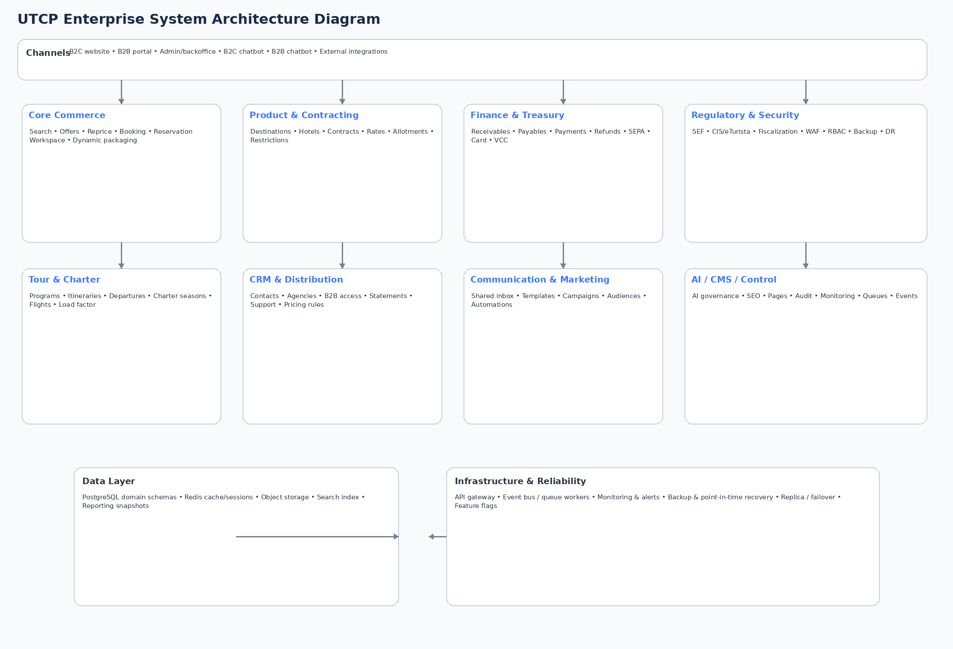
Figure 1. Enterprise system architecture overview.

4. Domain Architecture
Domain | Responsibility
Identity & Access | Users, roles, MFA, sessions, API clients
CRM & Accounts | Contacts, agencies, suppliers, profiles, preferences
Product & Contracting | Destinations, hotels, rooms, rates, allotments, restrictions
Search / Offers / Booking | Search requests, offers, repricing, bookings, supplier reservations
Finance & Treasury | Receivables, payables, settlements, SEPA, card and VCC supplier payments
Operations & Rooming | Reservation workspaces, rooming, manifests, dispatches, capacity
Tour / Charter | Programs, departures, charter flights, seats, load factor
Communication / Marketing / AI | Inbox, quality review, campaigns, AI routing and budgets
CMS / Regulatory / Control | Website publishing, SEF, CIS, fiscalization, monitoring, audit

5. Data Architecture
UTCP uses PostgreSQL as the system of record, organized into domain schemas. Redis is used for cache, session and idempotency needs. Search indexing and object storage complement the transactional layer.
- Estimated total production model: 500+ tables
- Foundation schemas: iam, crm, product, contracting, search, booking, ops, finance, rooming, tour, charter, b2b, communication, marketing, ai, cms, regulatory, treasury, control, integration, reporting
- Large-volume tables are candidates for time-based partitioning
- Read models and reporting snapshots support dashboards and exports

6. API Architecture
The platform exposes versioned REST APIs across public, customer, B2B, admin and system namespaces.
Namespace | Purpose | Examples
/api/v1/public | B2C content and discovery | search, offers, pages, articles
/api/v1/customer | Authenticated traveler actions | profile, bookings, payments, documents
/api/v1/b2b | Agency and subagent workflows | search, bookings, statements, support
/api/v1/admin | Backoffice operations | contracts, reservations, finance, rooming
/api/v1/system | Internal/system integrations | webhooks, publishing, imports, supplier connectors

7. Event and Async Architecture
Transactional outbox and event-driven processing are used for non-blocking side effects and integrations.
- Representative events: booking.booking.created, finance.payment.received, regulatory.sef.sent, communication.mail.sent
- Queue classes: critical.booking, finance.async, ops.dispatch, marketing.async, ai.async, website.publish
- Dead-letter handling, retry backoff and idempotent consumers are mandatory

8. Security Architecture
- WAF, DDoS protection and rate limiting at the edge
- JWT/API key authentication and RBAC authorization
- MFA for privileged roles
- Encryption in transit and at rest
- Sensitive field masking and audit logging
- Malware scanning for uploaded content

9. Regulatory and Treasury Architecture
- SEF / e-Fakture integration for invoice transmission and status sync
- CIS / eTurista integration for regulatory trip/traveler reporting
- Fiscalization integration for advance and final fiscal receipts
- Supplier treasury flows through SEPA transfers, card payments and VCC issuance

10. Infrastructure and Deployment
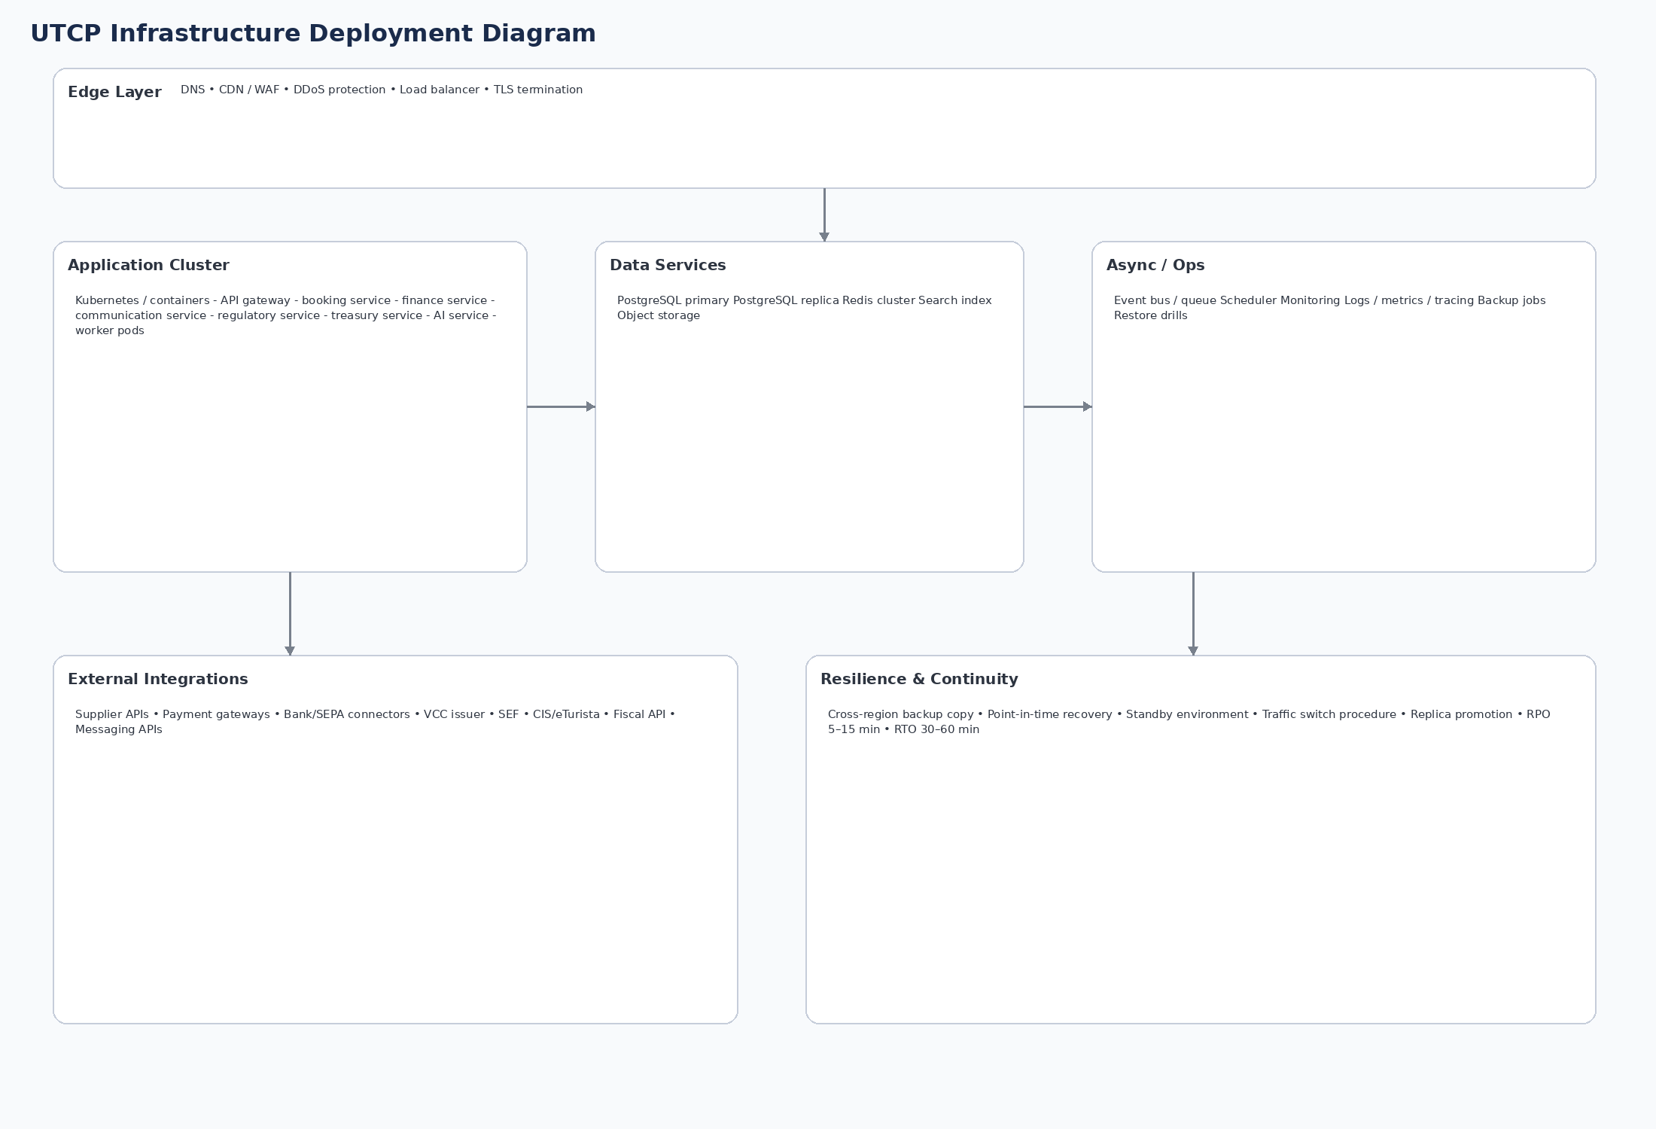
Figure 2. Infrastructure deployment and resilience overview.
- Kubernetes/container platform for app services and workers
- PostgreSQL primary + replica topology
- Redis cluster, search index, object storage
- Monitoring, logging, alerting and backup services
- Standby/failover procedure with target RPO 5-15 min and RTO 30-60 min

11. Development and Operational Standards
- Versioned schema migrations by domain and release
- Contract tests for APIs and integrations
- Golden E2E workflows for booking, finance, rooming and regulatory scenarios
- Feature flags for controlled rollouts
- Observability baked into each domain and worker

