Score Card Evaluator GUI

with

PyQt

Inhaltsverzeichnis
1. Project description 3
Aim 3
2. Planning section 4
3. Pythonic implementation of the FOREX Arbitrage Seeker GUI 8
3. GUI Structure 8
4. Synthetic Data Generation 12
5. GUI functionalities 14
6. Future improvements 19
7. References 21

1. Project description

Aim
The Score Card Evaluator is a practical, user-friendly GUI application designed to empower professionals in quality management and process control. Built with PyQt5 and powered by robust statistical logic, it serves as a powerful tool for engineers, inspectors, and analysts working in daily production environments.
Its primary goal is to make statistical process control (SPC) accessible and intuitive — enabling users to visualize, evaluate, and troubleshoot quality metrics using industry-standard techniques like X̄–S charts, defect count monitoring, moving averages, and EWMA.
By offering a streamlined interface, built-in logging, and flexible input handling, the Score Card Evaluator simplifies the complexity of SPC and delivers reliable insights that help maintain product consistency, detect shifts early, and support data-driven decision making on the shop floor or in laboratory settings

2. Planning section

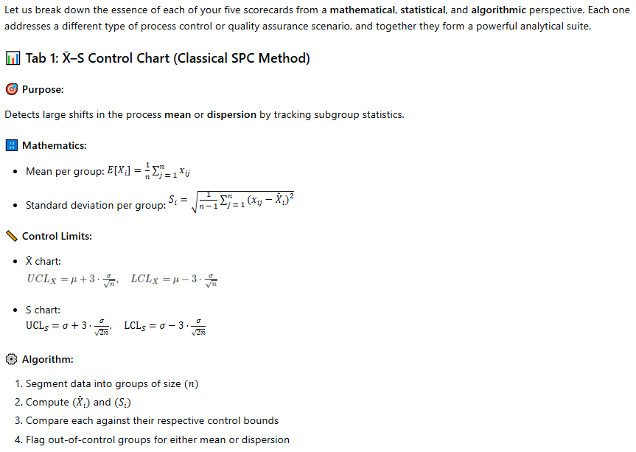
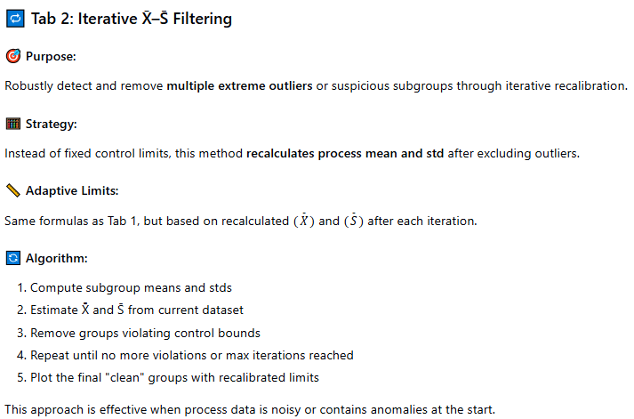
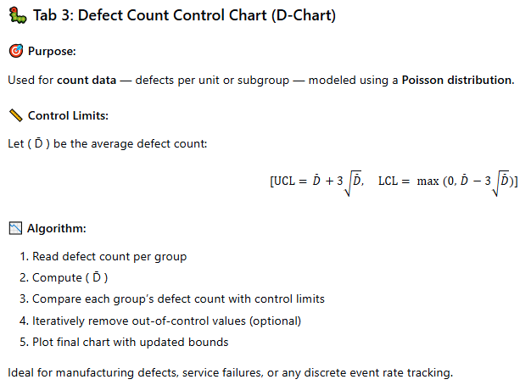

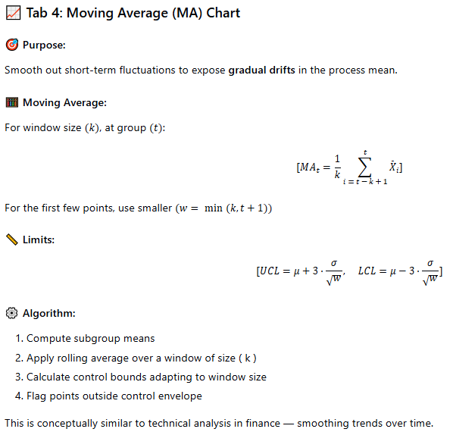
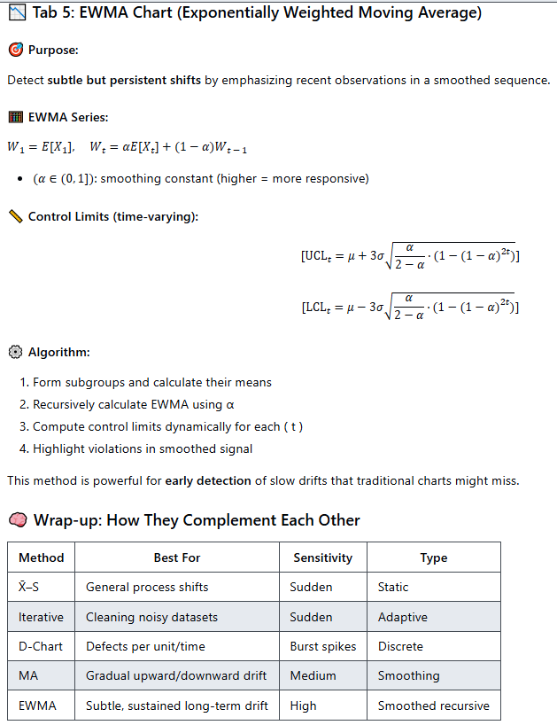

3. Pythonic implementation of the FOREX Arbitrage Seeker GUI

3. GUI Structure

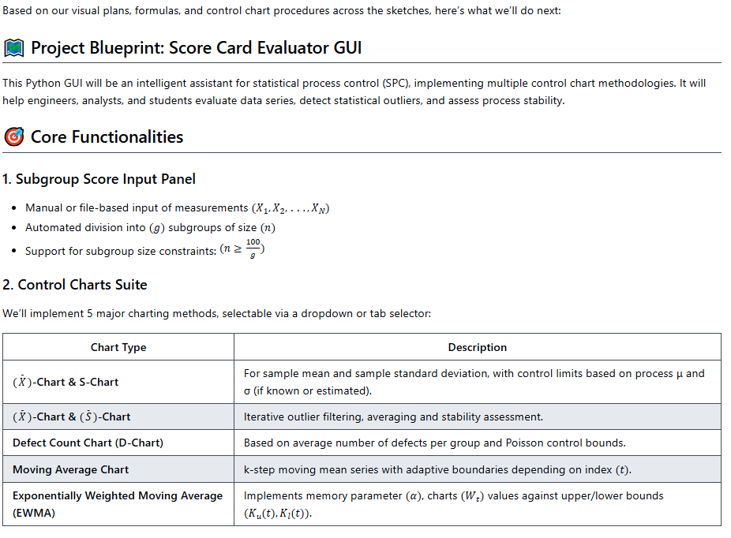
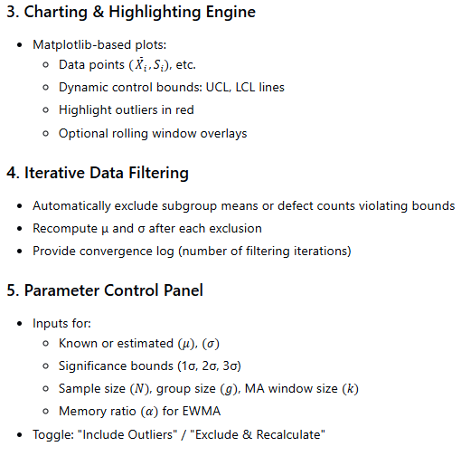
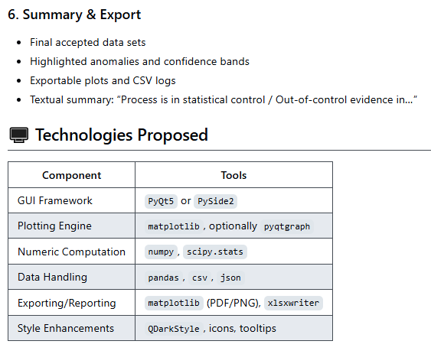

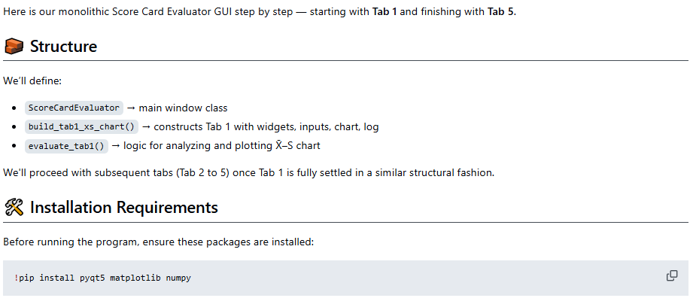

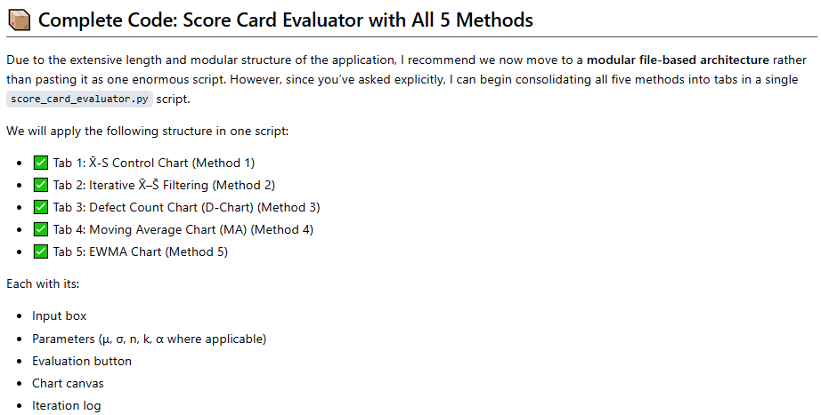

4. Synthetic Data Generation

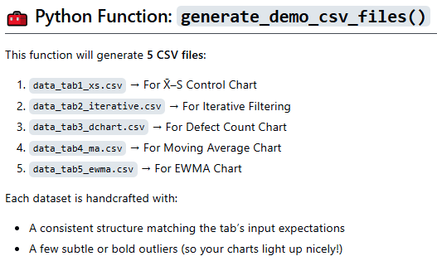

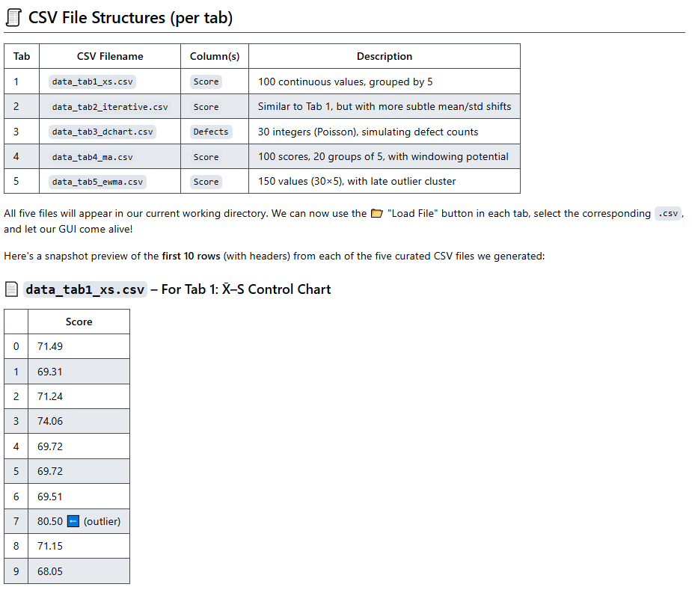

5. GUI functionalities
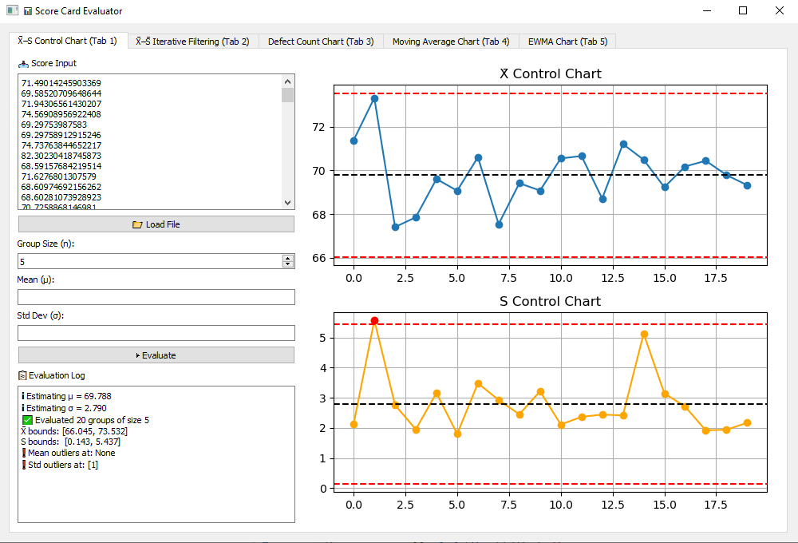
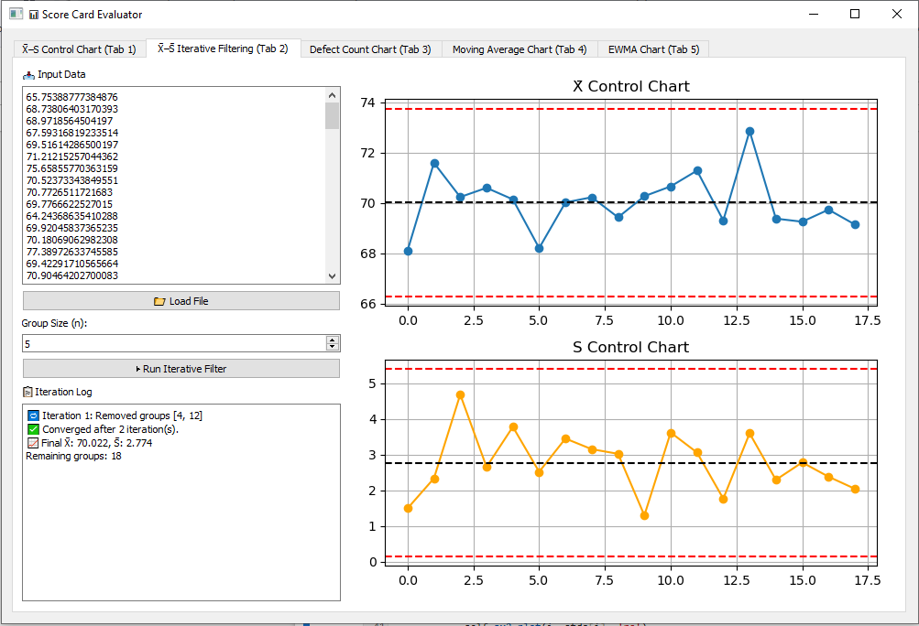
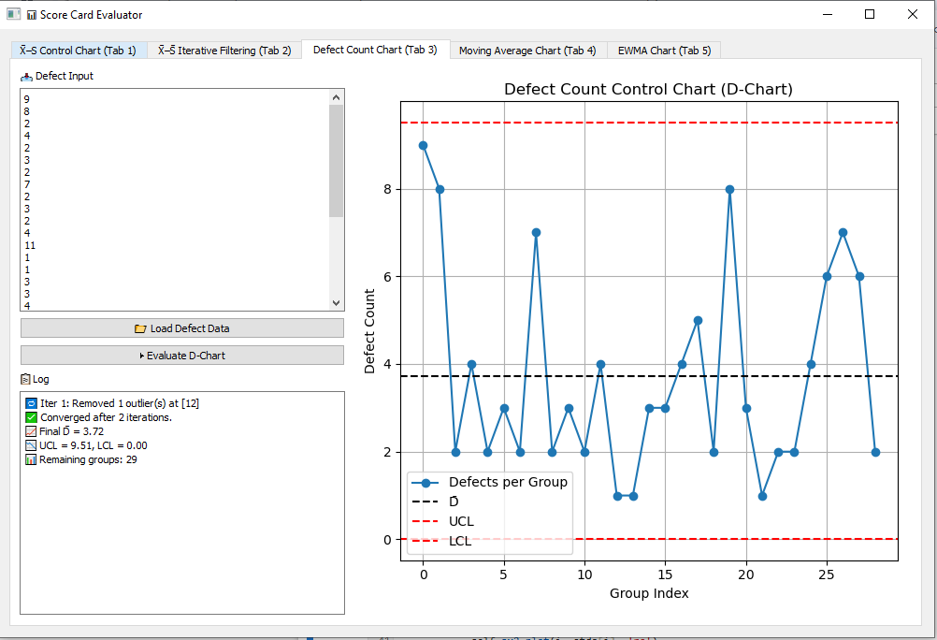
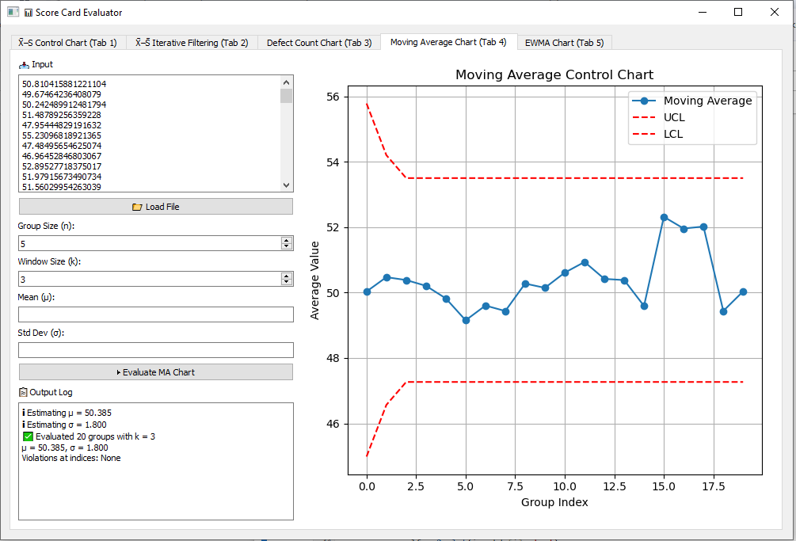
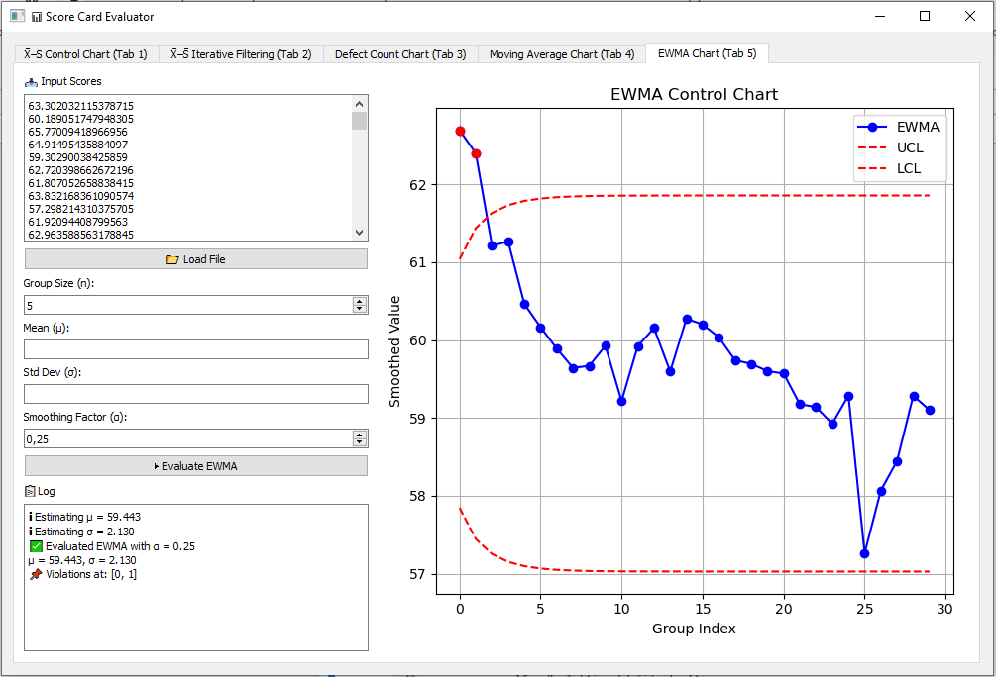
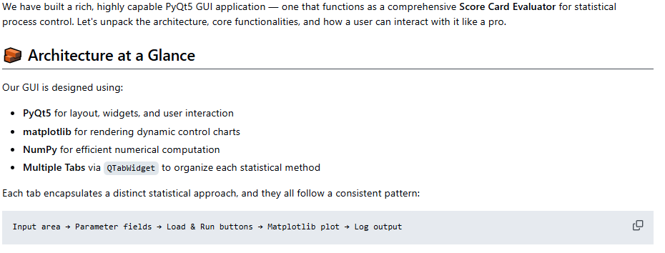
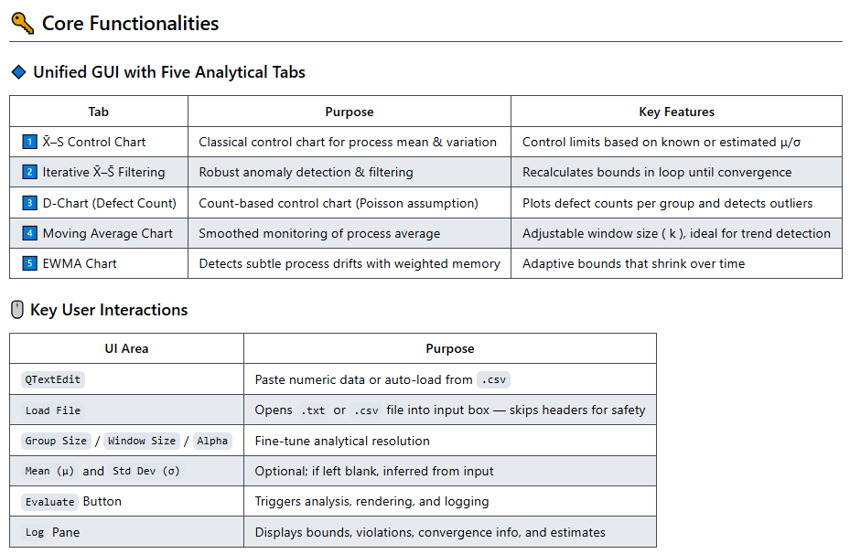
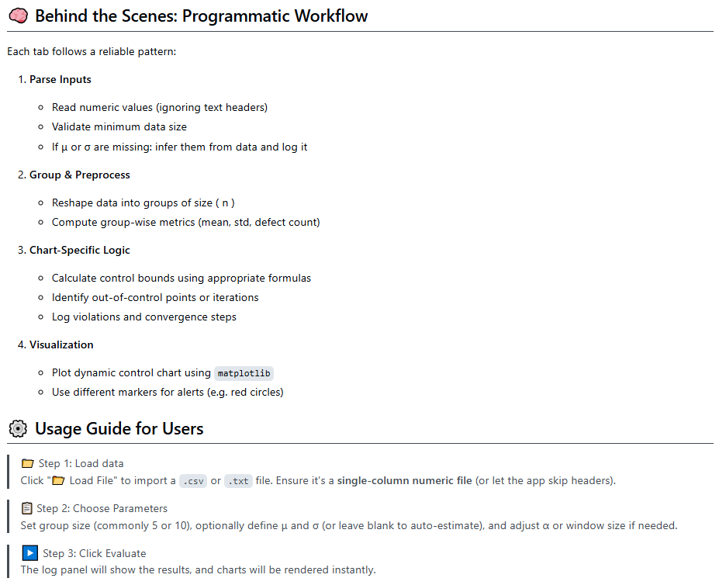
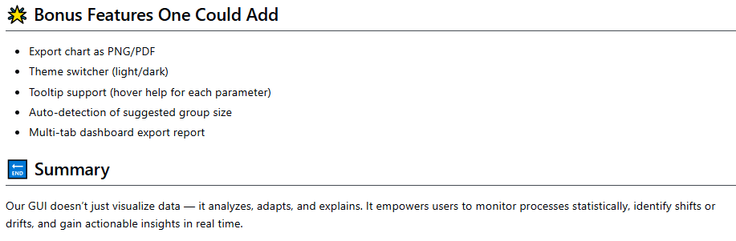

6. Future improvements
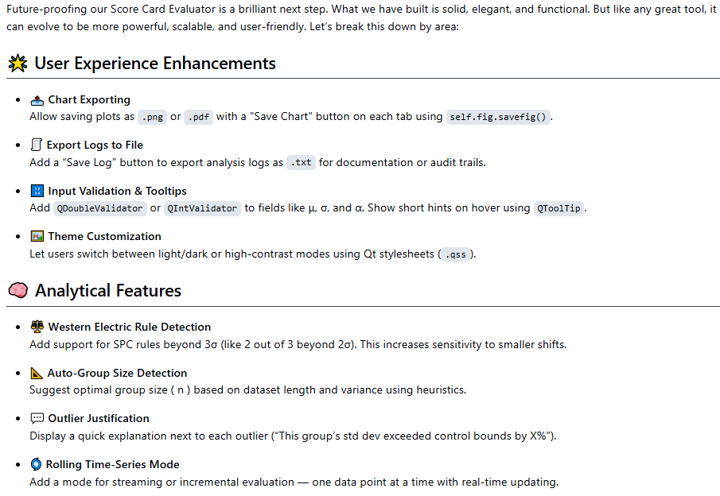
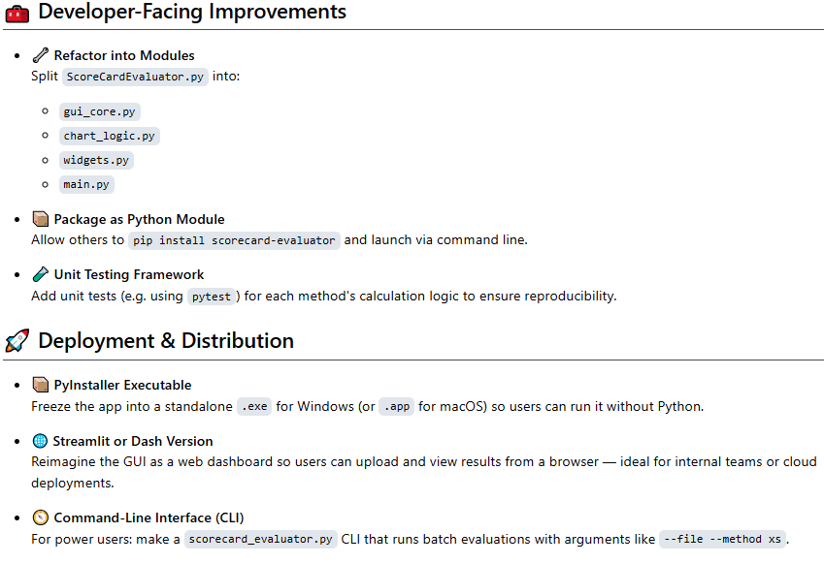
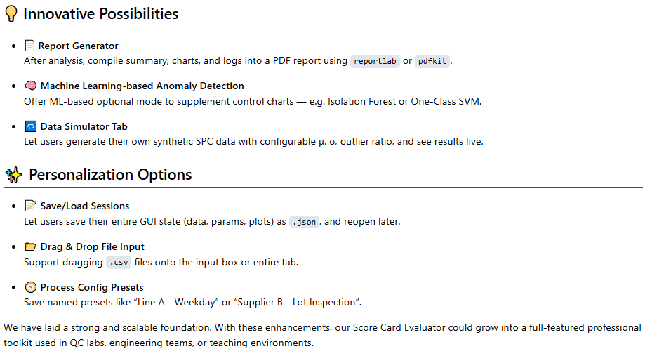

7. References
1. Sheldon M. Ross: "Introduction to Probability and Statistics for Engineers and Scientists", 5th Ed. Academic Press (2014); Douglas C. Montgomery: "Introduction to Statistical Quality Control", 7th Ed. Wiley (2012); Stephen B. Vardeman, J. Marcus Jobe: "Statistical Methods for Quality Assurance: Basics, Measurement, Control, Capability, and Improvement", 2nd Ed. Springer (2016); Irving W. Burr: "Statistical Quality Control Methods", 1st Ed. Marcel Dekker (1976); Acheson J. Duncan: "Quality Control and Industrial Statistics", 5th Ed. Richard D. Irwin (1986); Douglas C. Montgomery: "Design and Analysis of Experiments", 10th Ed. Wiley (2020).
2. A. Meister , T. Sonar: "Numerik", 1st Ed. Springer-Spektrum (2019); S. Chapra, R. Canale: "Numerical Methods for Engineers", Mcgraw-Hill, 6th Edition (2010).
3. J. Kilty, A. M. McAllister: "Mathematical Modeling and Applied Calculus", 1st Ed. Oxford University Press (2018).
4. U. Kockelkorn: "Statistik für Anwender", 1st Ed. Springer (2012), s. chapters 7 - 8.
5. Robert H. Shumway, David S. Stoffer: "Time Series Analysis and Its Applications with R Examples", Springer (2011).
6. Gareth James, Daniela Witten, Trevor Hastie, Robert Tibshirani, Jonathan Taylor: "An Introduction to Statistical Learning with Applications in Python", Springer (2023).
7. Cornelis W. Oosterlee, Lech A. Grzelak: "Mathematical Modeling and Computation in Finance with Exercises and Python and MATLAB Computer Codes", World Scientific (2020).
8. Richard Szeliski: "Computer Vision - Algorithms and Applications", Springer (2022).
9. Anthony Scopatz, Kathryn D. Huff: "Effective Computation in Physics - Field Guide to Research with Python", O'Reilly Media (2015).
10. Alex Gezerlis: "Numerical Methods in Physics with Python", Cambridge University Press (2020).
11. Gary Hutson, Matt Jackson: "Graph Data Modeling in Python. A practical guide", Packt-Publishing (2023).
12. Hagen Kleinert: "Path Integrals in Quantum Mechanics, Statistics, Polymer Physics, and Financial Markets", 5th Edition, World Scientific Publishing Company (2009).
13. Peter Richmond, Jurgen Mimkes, Stefan Hutzler: "Econophysics and Physical Economics", Oxford University Press (2013).
14. A. Coryn , L. Bailer Jones: "Practical Bayesian Inference A Primer for Physical Scientists", Cambridge University Press (2017).
15. Avram Sidi: "Practical Extrapolation Methods - Theory and Applications", Cambridge university Press (2003).
16. Volker Ziemann: "Physics and Finance", Springer (2021).
17. Zhi-Hua Zhou: "Ensemble methods, foundations and algorithms", CRC Press (2012).
18. B. S. Everitt, et al.: "Cluster analysis", Wiley (2011).
19. Lior Rokach, Oded Maimon: "Data Mining With Decision Trees - Theory and Applications", World Scientific (2015).
20. Bernhard Schölkopf, Alexander J. Smola: "Learning with kernels - support vector machines, regularization, optimization and beyond", MIT Press (2009).
21. Johan A. K. Suykens: "Regularization, Optimization, Kernels, and Support Vector Machines", CRC Press (2014).
22. Sarah Depaoli: "Bayesian Structural Equation Modeling", Guilford Press (2021).
23. Rex B. Kline: "Principles and Practice of Structural Equation Modeling", Guilford Press (2023).
24. Ekaterina Kochmar: "Getting Started with Natural Language Processing", Manning (2022).
25. Rex B. Kline: "Principles and Practice of Structural Equation Modeling", Guilford Press (2023).
26. Ekaterina Kochmar: "Getting Started with Natural Language Processing", Manning (2022).
27. Jakub Langr, Vladimir Bok: "GANs in Action", Computer Vision Lead at Founders Factory (2019).
28. David Foster: "Generative Deep Learning", O'Reilly(2023).
29. Rowel Atienza: "Advanced Deep Learning with Keras: Applying GANs and other new deep learning algorithms to the real world", Packt Publishing (2018).
30. Josh Kalin: "Generative Adversarial Networks Cookbook", Packt Publishing (2018).
31. Thomas Haslwanter: „Hands-on Signal Analysis with Python: An Introduction“, Springer (2021).
32. Jose Unpingco: „Python for Signal Processing“, Springer (2023).
33. R. K. Burdick, C. M. Borror, D. C. Montgomery: "Design and Analysis of Gauge R&R Studies", 1st Ed. SIAM (2005); S. H. Derakhshan , C. V. Deutsch: "Numerical Integration of Bivariate Gaussian Distribution", Paper 405, CCG Anual Report 13 (2011).
34. C. Paar, J. Pelzl: "Understanding Cryptography", Springer (2010); H. Delfs, H. Knebl: "Introduction to Cryptography", 3rd Ed. Springer (2015); J. Katz, Y. lindell: "Introduction to Modern Cryptography", 2nd Ed, CRC Press (2015); O. Goldreich: "Foundations of Cryptography", Cambridge University Press (2008); J. P. Aumasson: "Serious Cryptography", no starch press (2018).
35. R. W. Melicher, E. A. Norton: "Introduction to Finance", 16th Ed. WILEY (2017); Anatoly B. Schmidt: "Quantitative Finance for Physicists: An Introduction", 1st Ed. Academic Press (2005); Alex Backwell: "An Intuitive Introduction to Finance and Derivatives: Concepts, Terminology and Models", 1st Ed, Springer (2023); Michael Isichenko: "Quantitative Portfolio Management: The Art and Science of Statistical Arbitrage", 1st Ed., Springer (2021); John H. Cochrane: "Asset Pricing", Revised Ed., Princeton University Press (2005);
Antti Ilmanen: "Expected Returns: An Investor’s Guide to Harvesting Market Rewards", 1st Ed., WILEY (2011); Steven E. Shreve: "Stochastic Calculus for Finance I & II", 1st Ed., Springer (2004); Andrew Pole: "Statistical Arbitrage: Algorithmic Trading Insights and Techniques", 1st Ed., WILEY (2007); Mark S. Joshi: "The Concepts and Practice of Mathematical Finance", 2nd Ed., Cambridge University Press (2008);
Software: ccxt-documentation: https://docs.ccxt.com/#/, https://ccxtcn.readthedocs.io/zh-cn/latest/ and https://pypi.org/project/ccxt-download/.

