Invoice and Tax

Tracker GUI with

Pythonic functional modeling

Inhaltsverzeichnis
1. Project description 3
Aim 3
🎯 Primary Aim 3
2. GUI and algorithmic concepts 4
3. GUI design and its interaction flow 7
4. Heatmap coloring scheme 15
5. Modularized Pythonic implementation (Tax-Invoice-GUI) 17
6. Results and conclusions 18
7. User Manual 20
8. References 24

1. Project description

Aim
The Invoice and Tax Tracker + Fraud Detector project was conceived as a modular, auditable framework for managing financial documents in environments where compliance, transparency, and fraud prevention are paramount. In today’s business landscape, organizations face increasing pressure to ensure that their financial reporting is not only accurate but also defensible under regulatory scrutiny. This project addresses that need by combining robust document parsing, anomaly detection, visualization, and reporting into a single, user-friendly application.
At its core, the system ingests invoices in PDF format and transforms them into structured, machine-readable data. The parsing engine leverages PyMuPDF for text extraction, regex rules for field identification, and OCR fallbacks to capture tampered or hidden values. This hybrid approach ensures resilience against common manipulation techniques, such as altering only the graphical layer of a PDF while leaving the text layer intact. By normalizing amounts and preserving raw text, the parser provides both clean data for downstream analysis and a transparent audit trail for validation.
Once parsed, invoices are passed through the fraud detection module. This component applies a series of plausibility and consistency checks designed to surface anomalies that may indicate fraud or error. Rules include verifying the presence of mandatory fields, checking whether totals are realistic, comparing paid amounts against total prices, detecting suspicious formatting, and validating VAT calculations. The module also compares text-layer values against OCR results to catch discrepancies introduced by tampering. Each anomaly is reported in plain language, making the system’s findings explainable and defensible to auditors, executives, and regulators alike.
The graphical user interface, built with PyQt5, orchestrates the workflow and presents results in an accessible manner. Users can import invoices, toggle fraud detection, run batch or single-document analyses, and view anomalies in both textual and visual formats. A fraud heatmap translates anomaly reports into intuitive color-coded grids, allowing users to quickly identify which fields are problematic and how severe the issues are. Debug Mode provides transparency by exposing raw parsed data and anomaly lists, reinforcing the system’s commitment to auditability.
Beyond detection, the project emphasizes reporting and compliance. The exporter module enables users to save parsed results to CSV and generate tax summaries that distinguish between valid and flagged invoices. This functionality supports both operational workflows and regulatory reporting requirements. To facilitate demos and training, a test generator creates synthetic invoices with configurable ratios of clean and tampered cases, ensuring that the system can be validated under controlled conditions.
The overarching aim of the project is to demonstrate how advanced analytics and physics-inspired rigor can be embedded into consulting-ready tools that balance technical depth with business clarity. By foregrounding transparency, explainability, and reproducibility, the system provides a defensible framework for fraud detection and tax tracking. It is designed not only to catch anomalies but also to communicate them clearly, bridging the gap between technical analysis and executive decision-making. In doing so, the project showcases how modular AI/ML components can be integrated into client-facing environments to deliver measurable business impact while maintaining compliance and trust
(see References 1 - 3 below).

🎯 Primary Aim
Structure and implement a PyQt5-powered GUI for detecting fraudulent content in invoices and tax forms with built-in logic to route the problem to regex and OCR parsers prior to subjecting such parsed output to fraud detection modules, both from a UX and reporting (compliance) architecture perspective.

2. GUI and algorithmic concepts
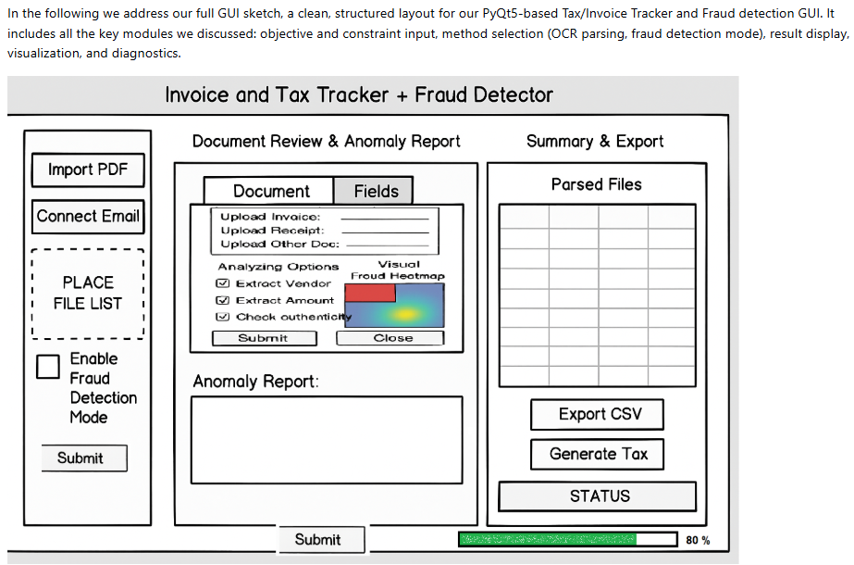
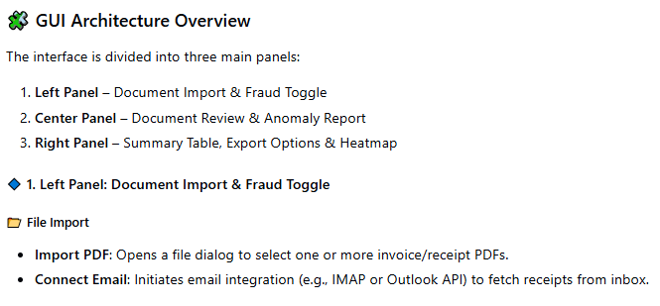

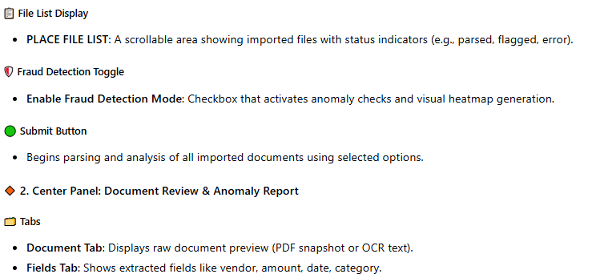
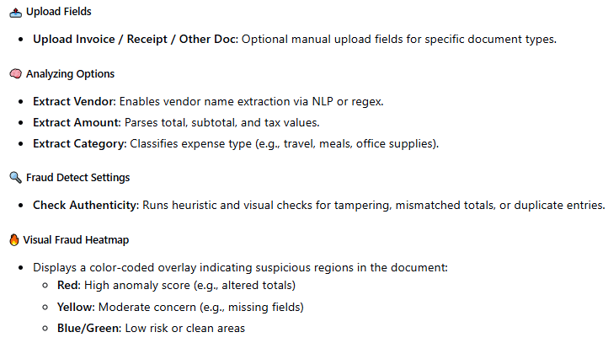

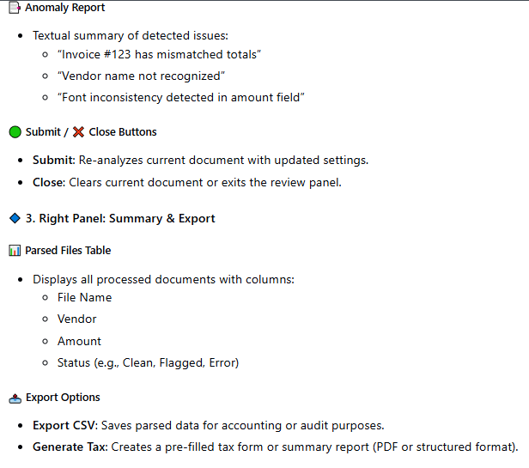

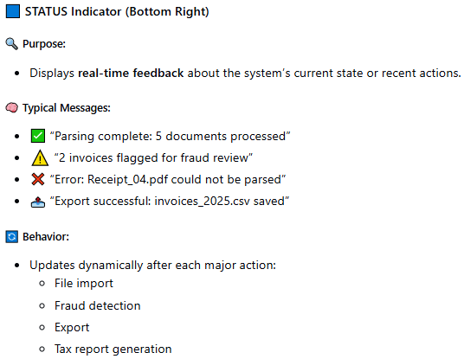

3. GUI design and its interaction flow
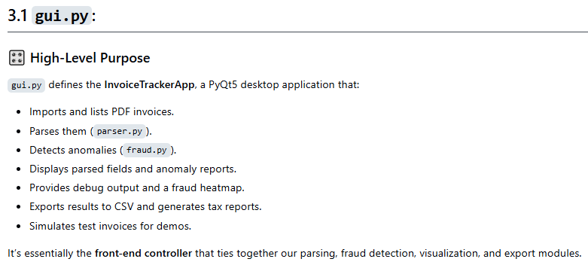
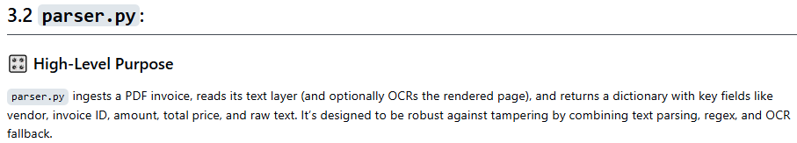
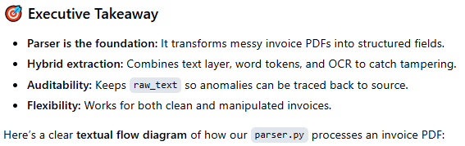

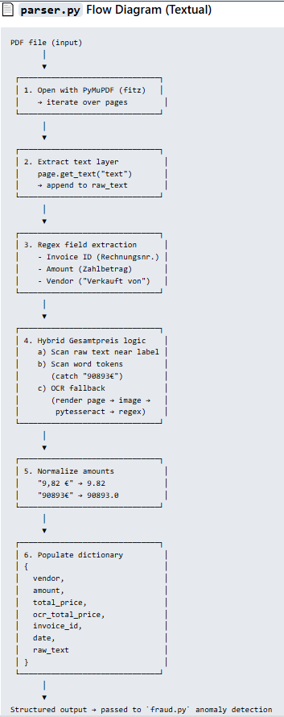

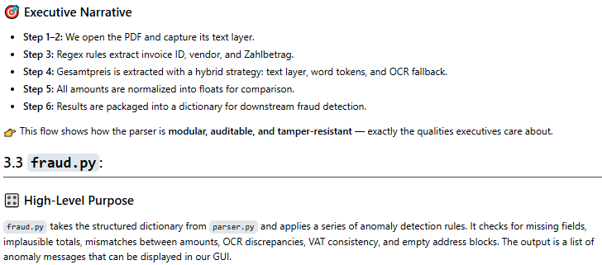
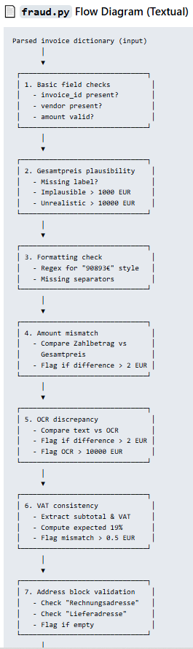

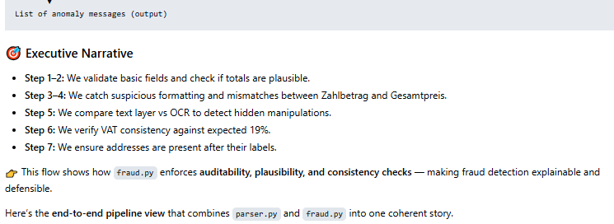
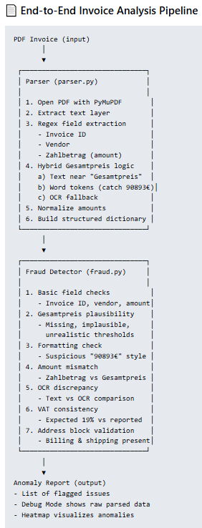

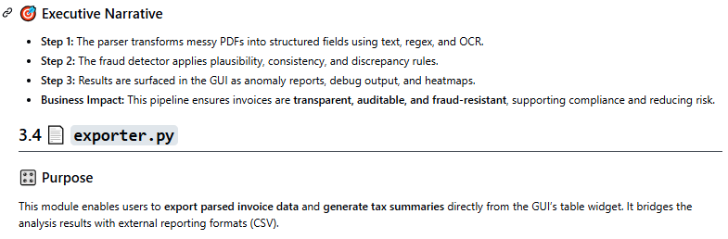
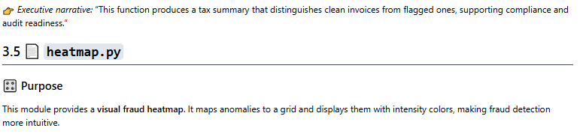
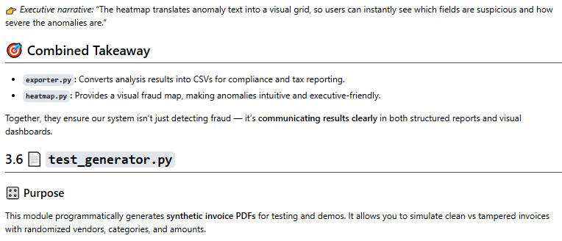

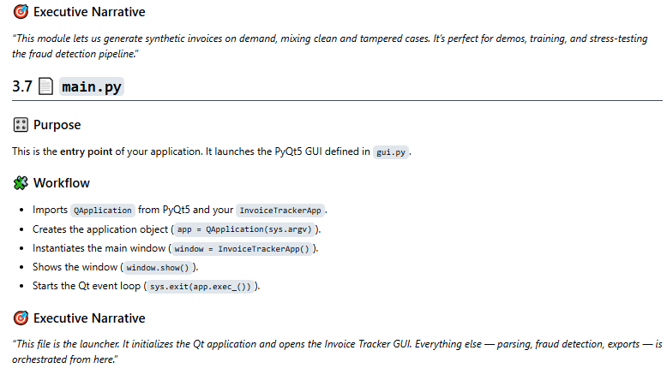
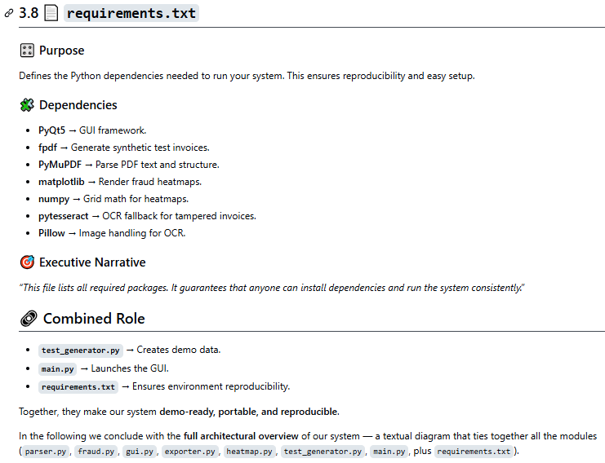
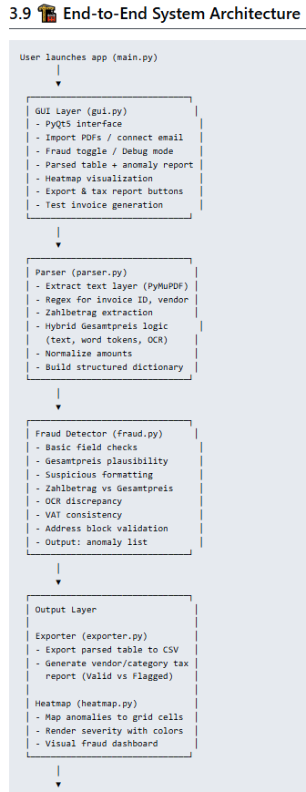

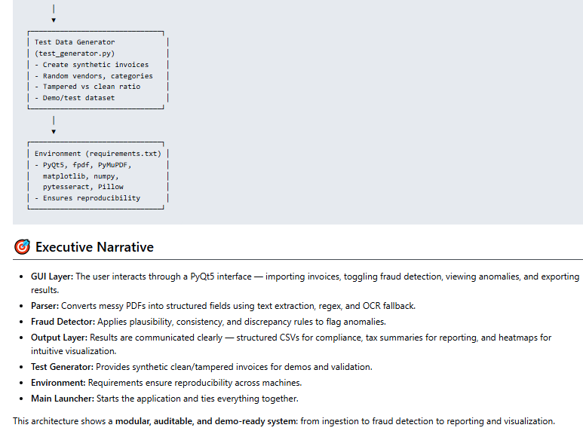

4. Heatmap coloring scheme
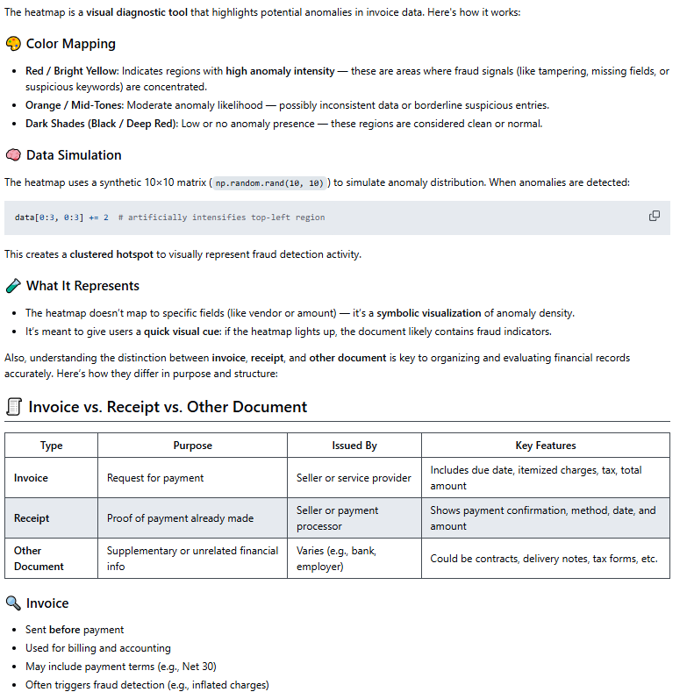

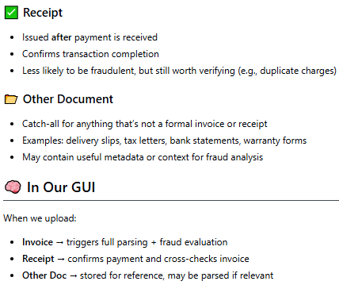

5. Modularized Pythonic implementation (Tax-Invoice-GUI)
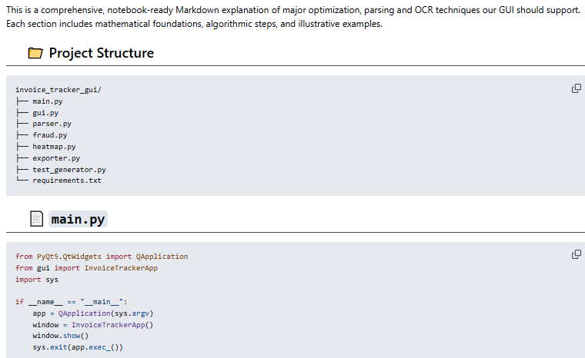

The full Pythonic code can be accessed via
https://github.com/NenadBalaneskovic/ExternalProjects/blob/main/Invoice_TaxTracker_GUI/Invoice_TaxTracker_GUI.md (sections 2.1 – 2.6 therein).

6. Results and conclusions
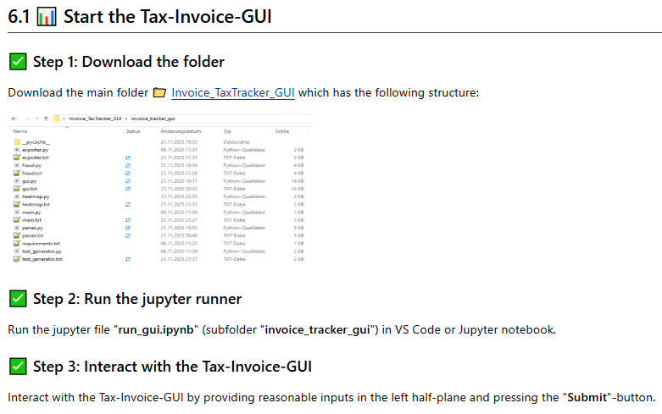
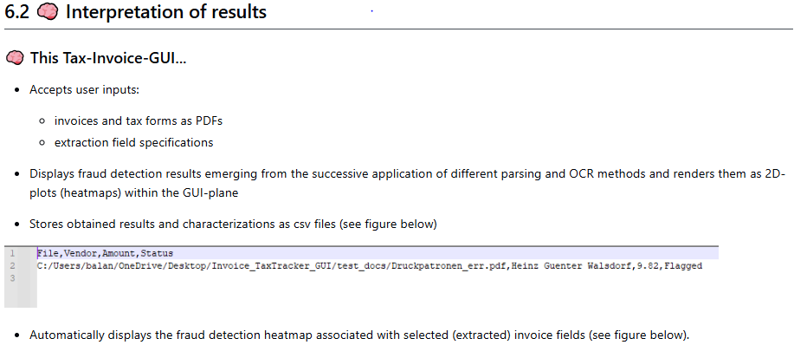

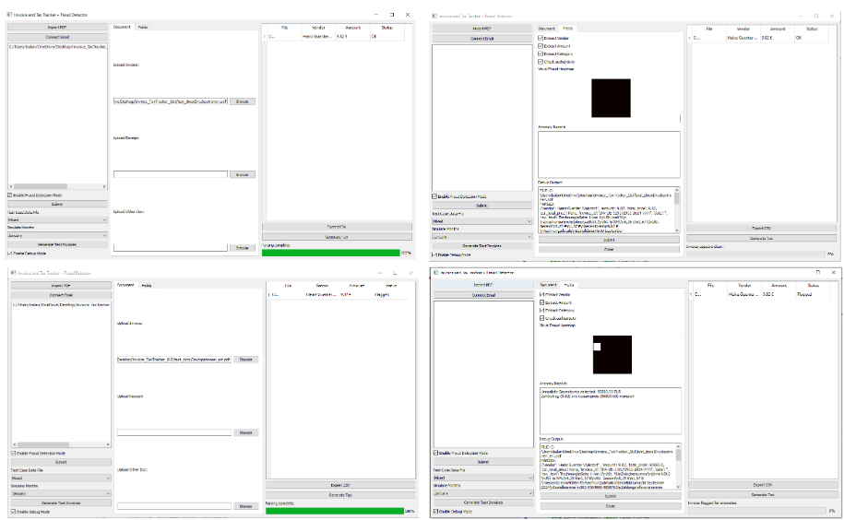
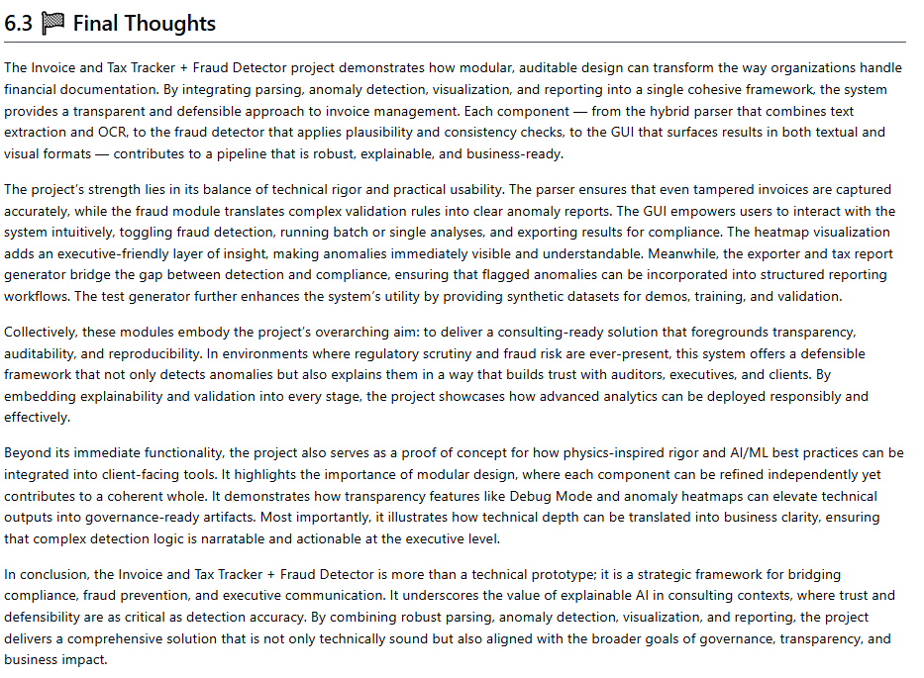

7. User Manual

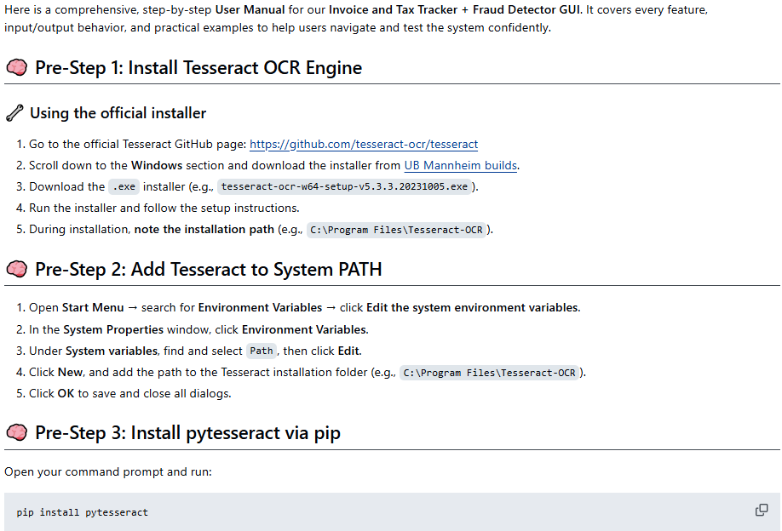
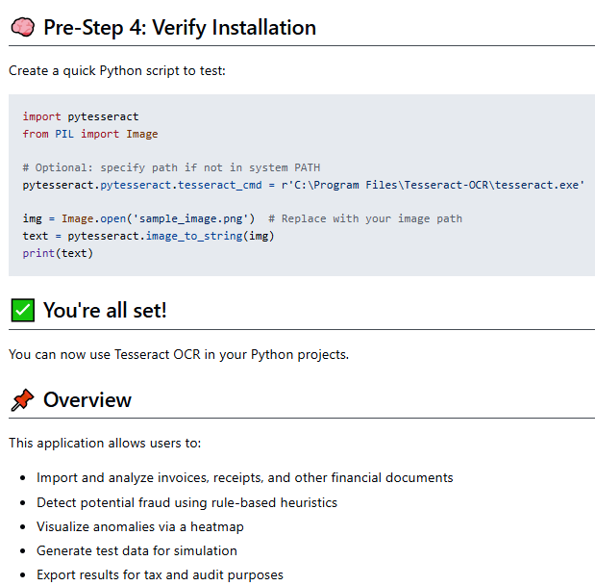

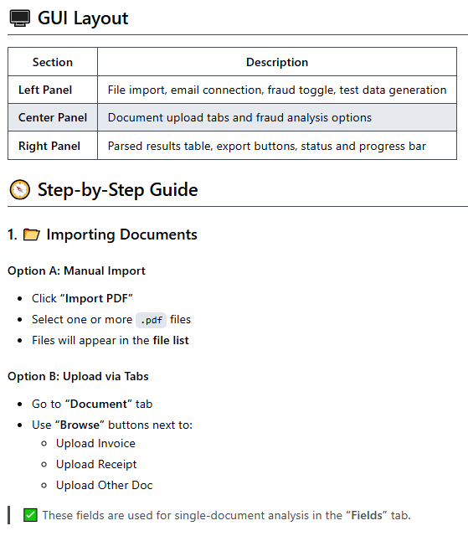

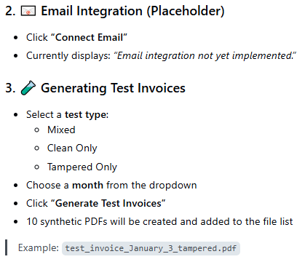

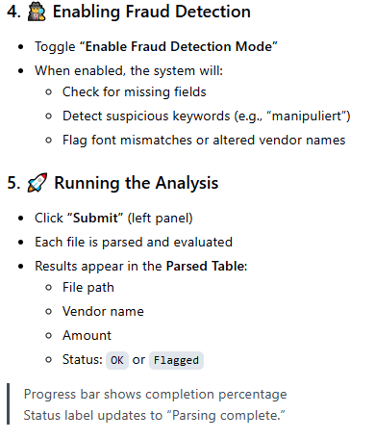

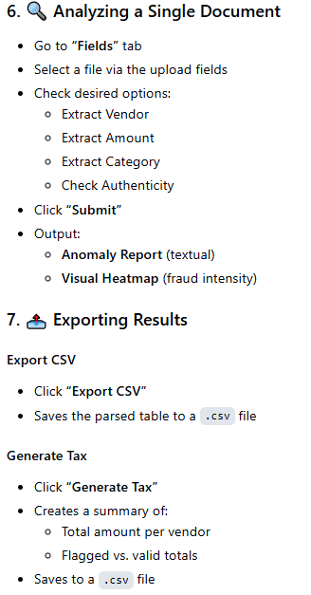

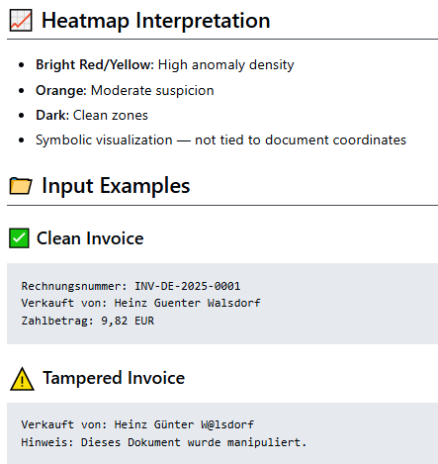

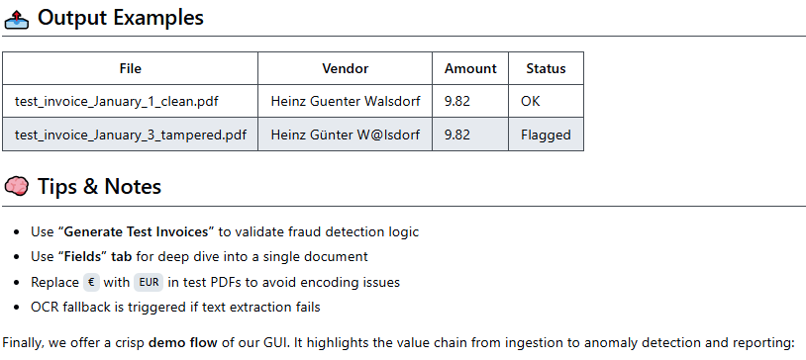

8. References
1. (Py-)tesseract package: https://github.com/tesseract-ocr/tesseract, https://pypi.org/project/pytesseract/, https://builtin.com/data-science/python-ocr, https://www.analyticsvidhya.com/blog/2024/04/ocr-libraries-in-python/ and UB Mannheim builds.
2. A. Meister , T. Sonar: "Numerik", 1st Ed. Springer-Spektrum (2019); S. Chapra, R. Canale: "Numerical Methods for Engineers", Mcgraw-Hill, 6th Edition (2010).
3. J. Kilty, A. M. McAllister: "Mathematical Modeling and Applied Calculus", 1st Ed. Oxford University Press (2018).
4. U. Kockelkorn: "Statistik für Anwender", 1st Ed. Springer (2012), s. chapters 7 - 8.
5. Robert H. Shumway, David S. Stoffer: "Time Series Analysis and Its Applications with R Examples", Springer (2011).
6. Gareth James, Daniela Witten, Trevor Hastie, Robert Tibshirani, Jonathan Taylor: "An Introduction to Statistical Learning with Applications in Python", Springer (2023).
7. Cornelis W. Oosterlee, Lech A. Grzelak: "Mathematical Modeling and Computation in Finance with Exercises and Python and MATLAB Computer Codes", World Scientific (2020).
8. Richard Szeliski: "Computer Vision - Algorithms and Applications", Springer (2022).
9. Anthony Scopatz, Kathryn D. Huff: "Effective Computation in Physics - Field Guide to Research with Python", O'Reilly Media (2015).
10. Alex Gezerlis: "Numerical Methods in Physics with Python", Cambridge University Press (2020).
11. Gary Hutson, Matt Jackson: "Graph Data Modeling in Python. A practical guide", Packt-Publishing (2023).
12. Hagen Kleinert: "Path Integrals in Quantum Mechanics, Statistics, Polymer Physics, and Financial Markets", 5th Edition, World Scientific Publishing Company (2009).
13. Peter Richmond, Jurgen Mimkes, Stefan Hutzler: "Econophysics and Physical Economics", Oxford University Press (2013).
14. A. Coryn , L. Bailer Jones: "Practical Bayesian Inference A Primer for Physical Scientists", Cambridge University Press (2017).
15. Avram Sidi: "Practical Extrapolation Methods - Theory and Applications", Cambridge university Press (2003).
16. Volker Ziemann: "Physics and Finance", Springer (2021).
17. Zhi-Hua Zhou: "Ensemble methods, foundations and algorithms", CRC Press (2012).
18. B. S. Everitt, et al.: "Cluster analysis", Wiley (2011).
19. Lior Rokach, Oded Maimon: "Data Mining With Decision Trees - Theory and Applications", World Scientific (2015).
20. Bernhard Schölkopf, Alexander J. Smola: "Learning with kernels - support vector machines, regularization, optimization and beyond", MIT Press (2009).
21. Johan A. K. Suykens: "Regularization, Optimization, Kernels, and Support Vector Machines", CRC Press (2014).
22. Sarah Depaoli: "Bayesian Structural Equation Modeling", Guilford Press (2021).
23. Rex B. Kline: "Principles and Practice of Structural Equation Modeling", Guilford Press (2023).
24. Ekaterina Kochmar: "Getting Started with Natural Language Processing", Manning (2022).
25. Rex B. Kline: "Principles and Practice of Structural Equation Modeling", Guilford Press (2023).
26. Ekaterina Kochmar: "Getting Started with Natural Language Processing", Manning (2022).
27. Jakub Langr, Vladimir Bok: "GANs in Action", Computer Vision Lead at Founders Factory (2019).
28. David Foster: "Generative Deep Learning", O'Reilly(2023).
29. Rowel Atienza: "Advanced Deep Learning with Keras: Applying GANs and other new deep learning algorithms to the real world", Packt Publishing (2018).
30. Josh Kalin: "Generative Adversarial Networks Cookbook", Packt Publishing (2018).
31. Thomas Haslwanter: „Hands-on Signal Analysis with Python: An Introduction“, Springer (2021).
32. Jose Unpingco: „Python for Signal Processing“, Springer (2023).
33. R. K. Burdick, C. M. Borror, D. C. Montgomery: "Design and Analysis of Gauge R&R Studies", 1st Ed. SIAM (2005); S. H. Derakhshan , C. V. Deutsch: "Numerical Integration of Bivariate Gaussian Distribution", Paper 405, CCG Anual Report 13 (2011).
34. C. Paar, J. Pelzl: "Understanding Cryptography", Springer (2010); H. Delfs, H. Knebl: "Introduction to Cryptography", 3rd Ed. Springer (2015); J. Katz, Y. lindell: "Introduction to Modern Cryptography", 2nd Ed, CRC Press (2015); O. Goldreich: "Foundations of Cryptography", Cambridge University Press (2008); J. P. Aumasson: "Serious Cryptography", no starch press (2018).
35. Kaggle-link: competition-documentation: https://www.kaggle.com/competitions/drw-crypto-market-prediction. R. Nystrom: „Game Programming Patterns“, 1st Ed. genever benning (2014); A. A. Stepanov, D. E. Rose: „From Mathematics to Generic Programming“, 1st Ed. Addison-Wesley (2015);
36. J. Berk, P. DeMarzo: „Corporate Finance“, 6th Ed., Pearson (2023); R. W. Melicher, E. A. Norton: "Introduction to Finance", 16th Ed. WILEY (2017); Anatoly B. Schmidt: "Quantitative Finance for Physicists: An Introduction", 1st Ed. Academic Press (2005); Alex Backwell: "An Intuitive Introduction to Finance and Derivatives: Concepts, Terminology and Models", 1st Ed, Springer (2023); Michael Isichenko: "Quantitative Portfolio Management: The Art and Science of Statistical Arbitrage", 1st Ed., Springer (2021); John H. Cochrane: "Asset Pricing", Revised Ed., Princeton University Press (2005); Antti Ilmanen: "Expected Returns: An Investor’s Guide to Harvesting Market Rewards", 1st Ed., WILEY (2011); Steven E. Shreve: "Stochastic Calculus for Finance I & II", 1st Ed., Springer (2004); Andrew Pole: "Statistical Arbitrage: Algorithmic Trading Insights and Techniques", 1st Ed., WILEY (2007); Mark S. Joshi: "The Concepts and Practice of Mathematical Finance", 2nd Ed., Cambridge University Press (2008);
37. E. Parzen: "Stochastic Processes", 3rd Ed. Dover Publications (2015); S. Aloorravi: "Metaprogramming with Python", 1st Ed. Packt (2022); B. Klein, P. Klein: "Funktionale Programmierung mit Python", Hanser (2025); K. Webel, D. Wied: "Stochastische Prozesse", 2. Auflage Springer (2016); L. Held: "Methoden der statistischen Inferenz", 1. Auflage Spektrum (2008); E. Cinlar: "Stochastic Processes", Dover (2013); N. Bäuerle, U. Rieder: "Finanzmathematik in diskreter Zeit", Springer-Spektrum (2017); M. Albrecht, R. Maurer: "Investment- und Risikomanagement", 3. Auflage, Schäffer Poeschel (2008); N. H. Bingham, R. Kiesel: "Risk Neutral Valuation: Pricing and Hedging of Financial Derivatives", 2. Auflage Springer (2004); T. Björk: "Arbitrage Theory in Continuous Time", 3rd Ed. Oxford University Press (2009); N. J. Cutland, A. Roux: "Derivative Pricing in Discrete Time", Springer (2013); F. Delbaen, W. Schachermayer: "The Mathematics of Arbitrage", Springer (2006); R. J. Elliott, P. E. Kopp: "Mathematics of Financial Markets", 2nd Ed. Springer (2005); H. Föllmer, A. Scheid: "A Stochastic Finance: An Introduction in Discrete Time", 3rd Ed. de Gruyter (2011); J. C. Hull: "Options, Futures and Other Derivatives", 8th Ed. Pearson (2011); J. Kremer: "Einführung in die diskrete Finanzmathematik", Springer (2005); D. Lamberton, B. Lapeyre: "Introduction to Stochastic Calculus Applied to Finance", Chapman & Hall (2007); D. G. Luenberger: "Investment Science", Oxford University Press (1998); S. R. Pliska: "Introduction to Mathematical Finance: Discrete Time Models", Blackwell (2000); A. N. Shiryaev: "Essentials of Stochastic Finance", World Scientific (2001); S. E. Shreve: "Stochastic Calculus for Finance I: The Binomial Asset Pricing Model", Springer (2004); J. Kremer: "Portfoliotheorie, Risikomanagement und die Bewertung von Derivaten", Springer (2011); L. Rüschendorf: "Mathematical Risk Analysis", Springer (2013).
38. A. Becker: "Kalman Filter - From the Ground Up", 1st Ed. private publication (2023); K. Triantafyllopoulos: "Bayesian Inference of State Space Models", 1st Ed. Springer (2021); P. Zarchan, H. Musoff: "Fundamentals of Kalman Filtering: A Practical Approach", 3rd Ed. AIAA (2009); A. Sidi: "Vector Extrapolation Methods with Applications", 1st Ed. SIAM (2019); C. Brezinski, M. R. Zaglia: "Extrapolation Methods - Theory and Practice", 2nd Ed. North-Holland (2002); C. Gardiner, P. Zoller: "Quantum Noise: A Handbook of Markovian and Non-Markovian Quantum Stochastic Methods with Applications to Quantum Optics", 3rd Ed. Springer (2004); K. Kendre: "Machine Learning for Quantum Noise Reduction", https://arxiv.org/abs/2509.16242 (2025); D. C. Marinescu, G. M. Marinescu: "Classical and Quantum Information", 1sr Ed. Academic Press (2012); Liao, H et al.: "Machine Learning for Practical Quantum Error Mitigation", arXiv:2309.17368v2 (2024), https://arxiv.org/pdf/2309.17368; Streamlit: https://streamlit.io/; Mitiq-package: https://quantum-journal.org/papers/q-2022-08-11-774/, https://arxiv.org/abs/2009.04417; Extrapolation packages: https://pypi.org/project/extrapolation/
39. A. Koop, H. Moock: "Lineare Optimierung - Eine anwendungsorientierte Einführung in Operations Research", 1st Ed. Spektrum (2008); G, B, Dantzig, M. N. Thalpa: "Linear Programming 1: Introduction", 1st Ed. Springer (1997) & "Linear Programming 2: Theory and Extensions", 1st Ed. Springer (2003); H. S. Kasana, K. D. Kumar: "Introductory Operations Research, Theory and Applications", 1st Ed. Springer (2004); D. G. Luenberger: "Linear and Nonlinear Programming", 2nd Ed. Kluwer (2004); R. J. Boucherie, A. Braaksma, H. Tijms: "Operations Research - Introduction to Models and Methods", 1st Ed. World Scientific (2022); A. J. King, S. W. Wallace: "Modeling with Stochastic Programming", 2nd Ed. Springer (2024); J. O. Royset, R. J.-B. Wets: "An Optimization Primer", 1st Ed. Springer (2021); cvxpy package: https://www.cvxpy.org/, https://pypi.org/project/cvxpy/; py-packages for operations research: https://wiki.python.org/moin/PythonForOperationsResearch

