Real Estate Analysis

of

Flower Hill

Inhaltsverzeichnis
1. Project description 3
Aim 3
2. Planning section 3
3. Conceptual framework 5
4. Comprehensive List of Analytical Tasks 6
4. Airflow – MLflow pipeline 9
5. Results and Conclusions 12
6. References 20

1. Project description

Aim
This project involves a large data set related to real estate sales for a fictional town of Flower Hill. The aim is to combine the analysis of this data set with PyMongo, MLflow, Python (SARIMAX times series forecasting, classification, Neural Networks, Kohonen Maps) and DAG-like process organization of ML-tasks.
Thus, we are blending data engineering, machine learning, forecasting, and process automation into a well-structured framework.
Flower Hill is a flourishing City, consisting of 7 districts: Costal, Central, Mercantil, Faunarium, Technica, Academia and Historica. Costal department contains usually high valued real estate items, such as villas, luxury appartments, etc. Central is the center of the city consisting mostly of offices. Mercantil revolves around the Stock Exchange of the City. Faunarium contains parks, lakes and real estate item connected with them. Technica contains technology companies, Academia district is centered around the Flower University of Technology, whereas Historica represents a traditional, historical real estate district.
The City dates back almost 200 years and we could try to create a data set of real estate purchases from 1900 till 2025.

2. Planning section

Flower Hill has an incredible depth—this city has economic, cultural, and technological diversity, which will make for a rich dataset that supports both time series forecasting and classification tasks.

Let’s design the schema step by step: Schema of the Flower Hill json-data set:

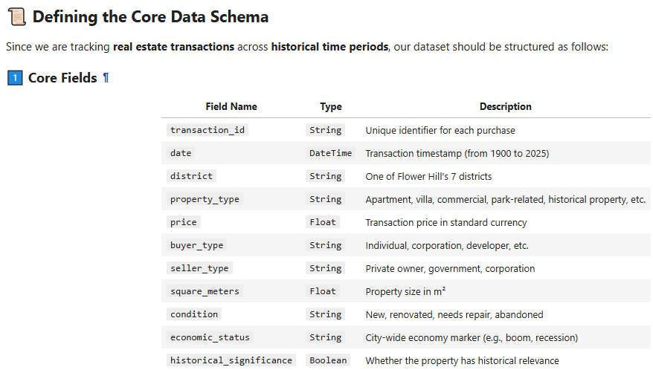

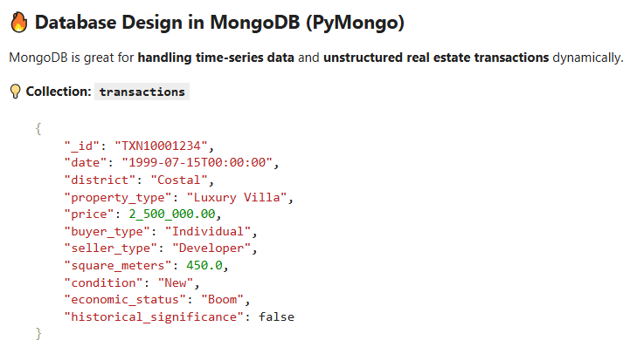
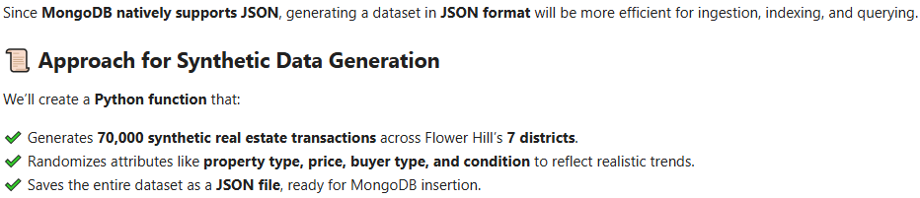

3. Conceptual framework
Here’s how we can approach this project step by step:

1 Data Structure & Storage (PyMongo)
✔ Define the schema for real estate transactions (prices, timestamps, property types, etc.).
✔ Optimize indexing in MongoDB for fast querying and aggregation.
✔ Use historical data pipelines to preprocess sales trends.

2 Machine Learning Strategy (MLflow for Tracking)
✔ SARIMAX → Time series forecasting for predicting real estate trends in Flower Hill.
✔ Classification Models → Predict property price ranges, buyer demographics, and market trends.
✔ Neural Networks → Deep learning models for pattern recognition (e.g., feature engineering).
✔ Kohonen Maps → Self-organizing maps for clustering neighborhoods based on sales behavior.

3 DAG-Based ML Pipeline (Task Automation)
✔ Implement Apache Airflow or another DAG framework to define steps for data ingestion, transformation, and model training.
✔ Automate periodic forecast updates using DAG scheduling.
✔ Integrate MLflow logging for monitoring different model versions and optimizing hyperparameters.

4 Machine Learning Tasks

✔ Forecasting with SARIMAX
- Predict district-wide property price trends using historical sales data.
- Analyze market dips & peaks based on economic conditions.

✔ Classification & Neural Networks
- Segment buyers by their purchasing behavior (individual vs. corporate).
- Predict future property values based on district, condition, and economy.

✔ Kohonen Maps (Self-Organizing Neural Networks)
- Cluster districts by real estate trends (growth vs. stagnation).
- Analyze urban expansion & contraction patterns over time.

4. Comprehensive List of Analytical Tasks

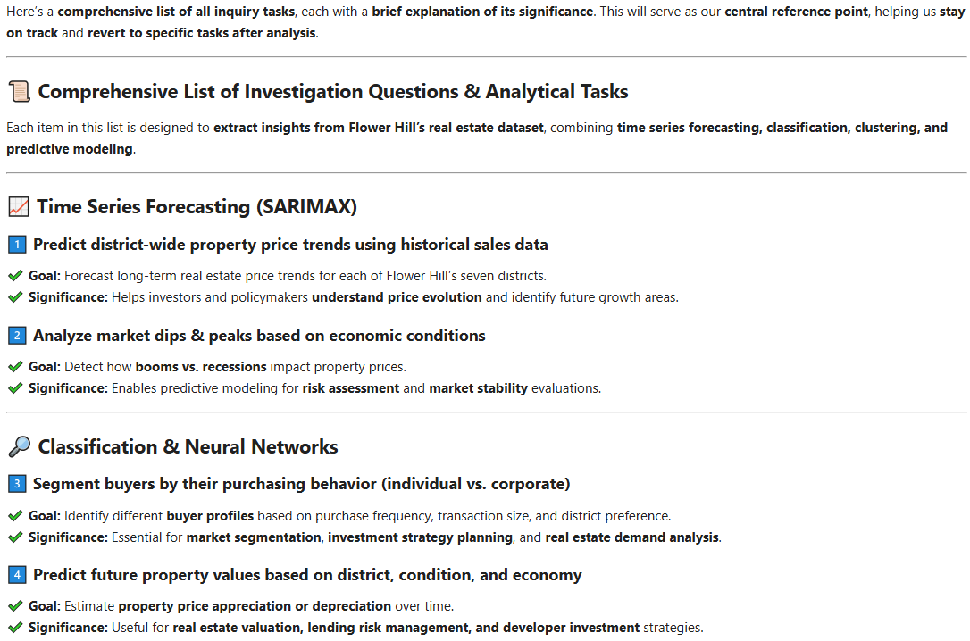
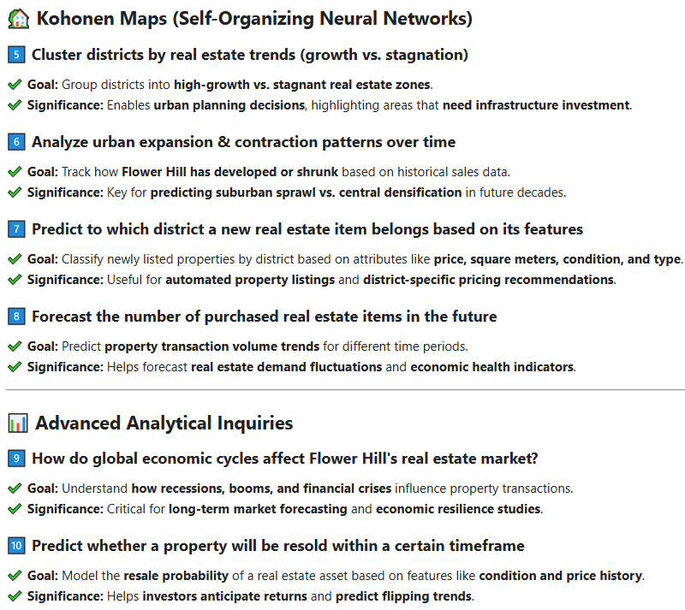

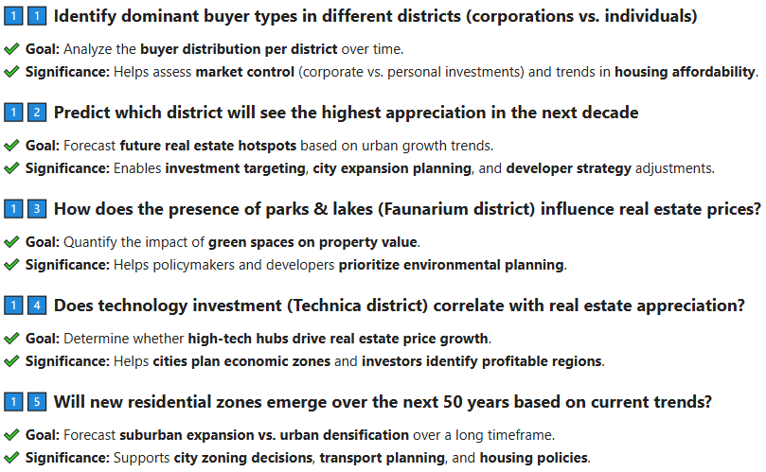
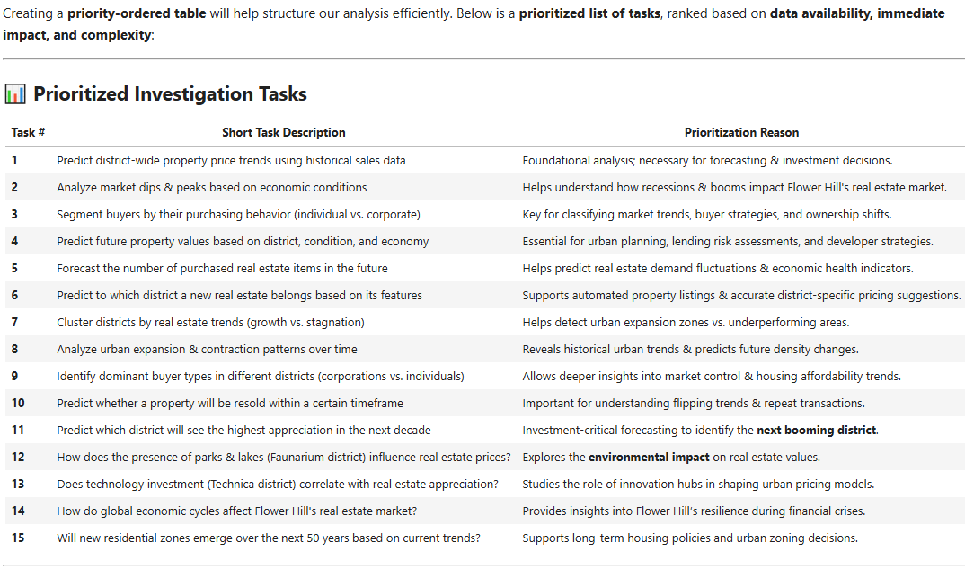

Features:
- Data Preprocessing → Cleaning and storing new transactions in MongoDB.
- SARIMAX Forecasting → Running time-series analysis on price trends.
- Classification (Neural Networks & Random Forest) → Predicting property valuation.
- Kohonen Maps → Clustering districts based on real estate patterns.

4. Airflow – MLflow pipeline

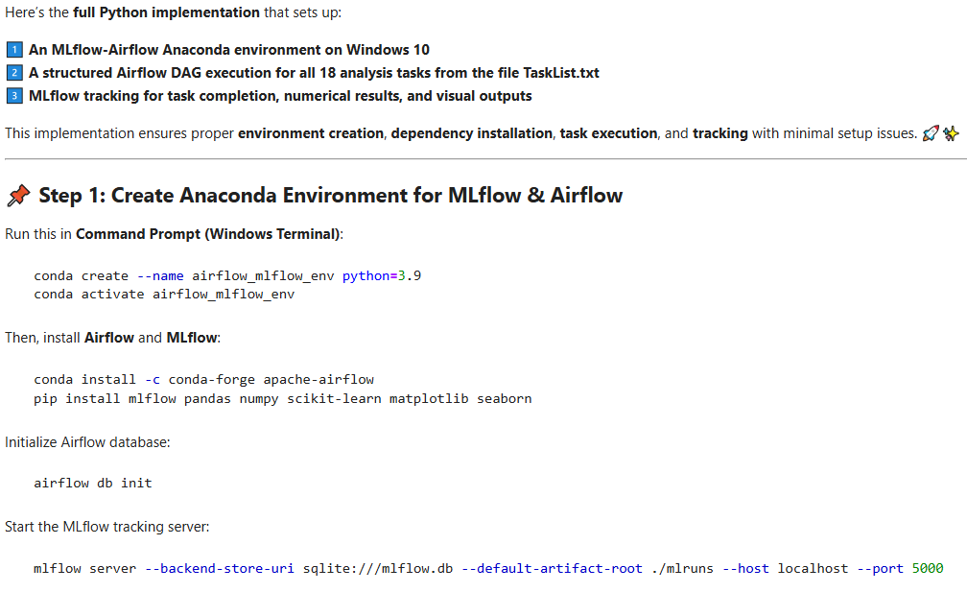

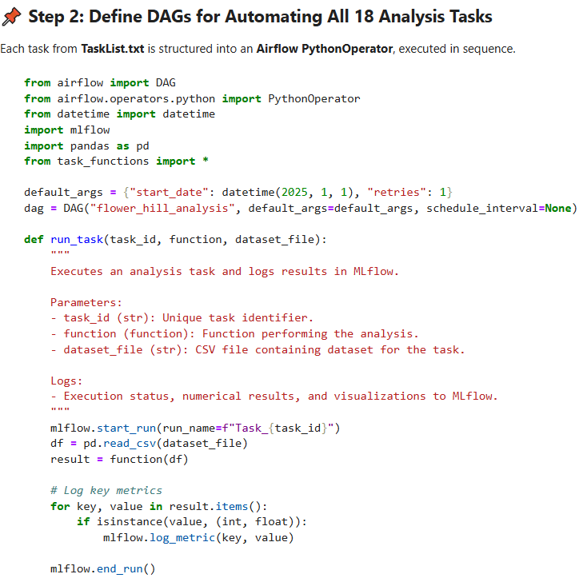

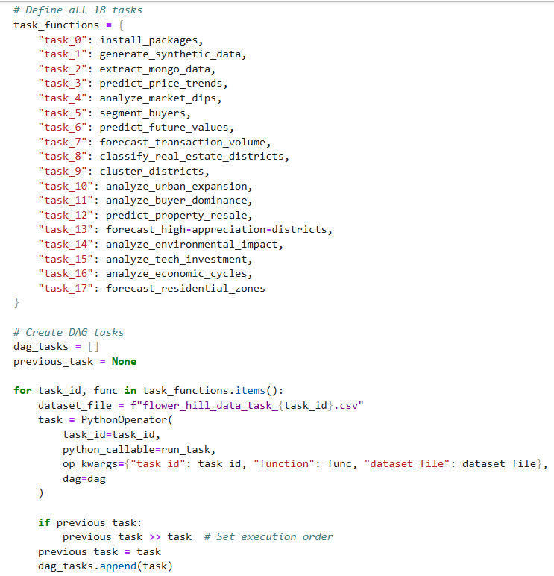
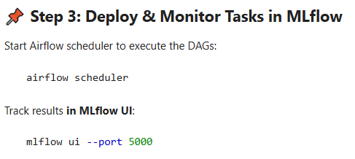

5. Results and Conclusions
1️⃣ 📈 Districts with Continuous Price Growth
- If certain districts show a steady upward trend, they are booming areas with strong investment potential.
- For example, Technica (if present) might have high-tech development, boosting property value.
- This could suggest strong demand, ongoing development projects, or corporate investments.
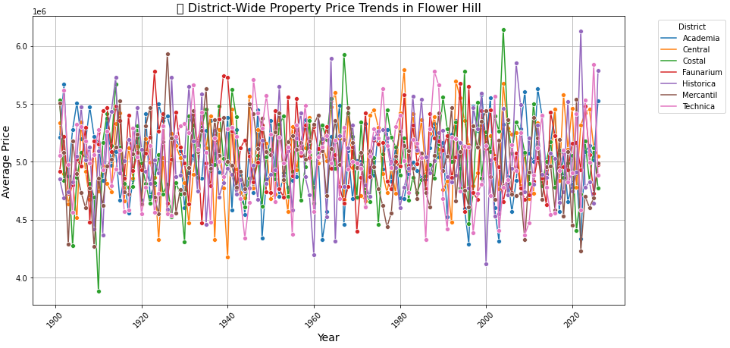
2️⃣ 🔄 Districts with Cyclical or Fluctuating Prices
- If some districts display price surges followed by declines, these areas might experience short-term investment bursts but lack sustained growth.
- Economic phases like Boom → Recession → Recovery might be influencing price fluctuations.

3️⃣ 📉 Declining Price Trends
- If districts like Costal or Academia (for example) show continuous price drops, it could indicate:
✔ Economic downturns affecting real estate
✔ Infrastructure decline or migration to high-growth areas
✔ Regulatory changes impacting housing demand
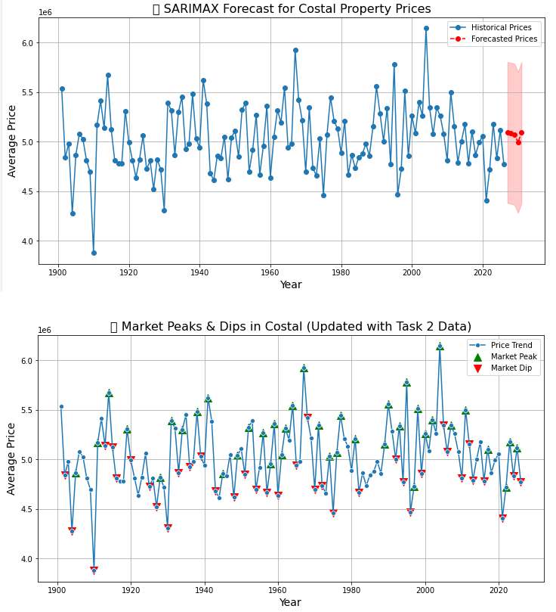
4️⃣ 📌Economic Status Correlations
- If we overlay economic status (Boom, Stable, Recession) on the price graph, we might observe:
✔ Boom periods aligning with price increases
✔ Recession periods causing noticeable downturns

5️⃣ 📊Comparative Price Analysis (Box Plot)
✔ Faunarium district's real estate prices appear higher than many other districts.
✔ Median price in Faunarium seems to hover around 6,000,000, with a range spanning 4,000,000–8,000,000.
✔ Outlier properties show that prices can **reach 10,000,000**, indicating the presence of **high-value real estate**.
✔ The wider price distribution suggests that environmental factors, such as parks and lakes, might increase property value variability.
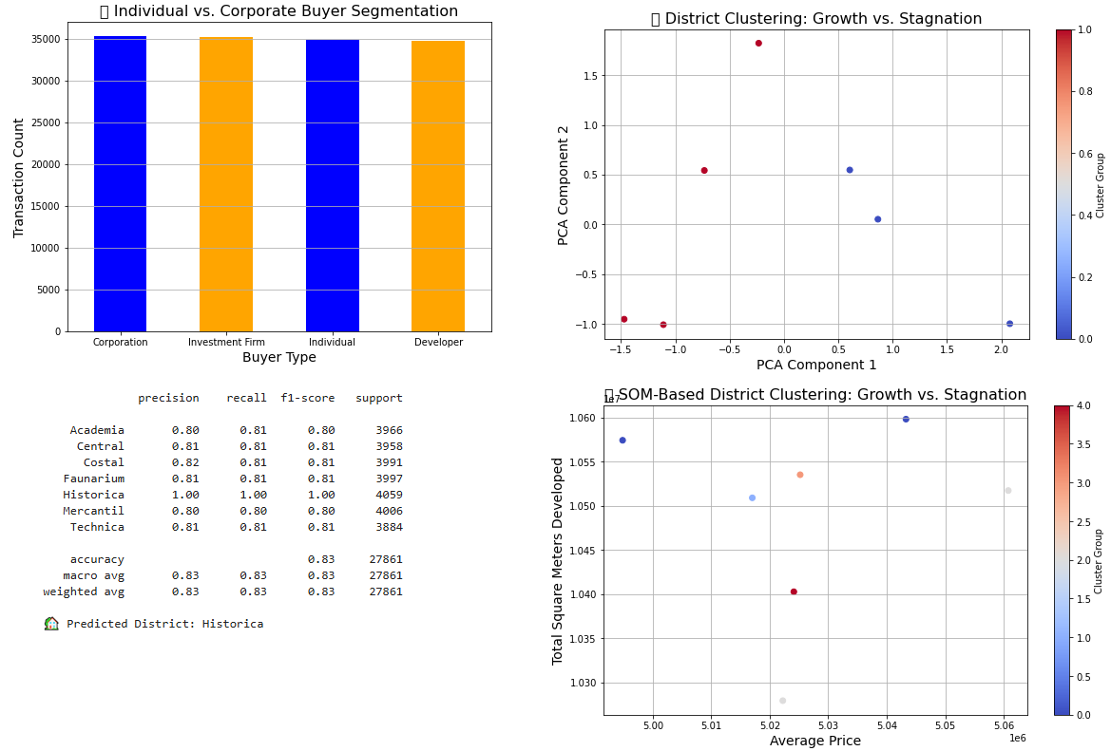
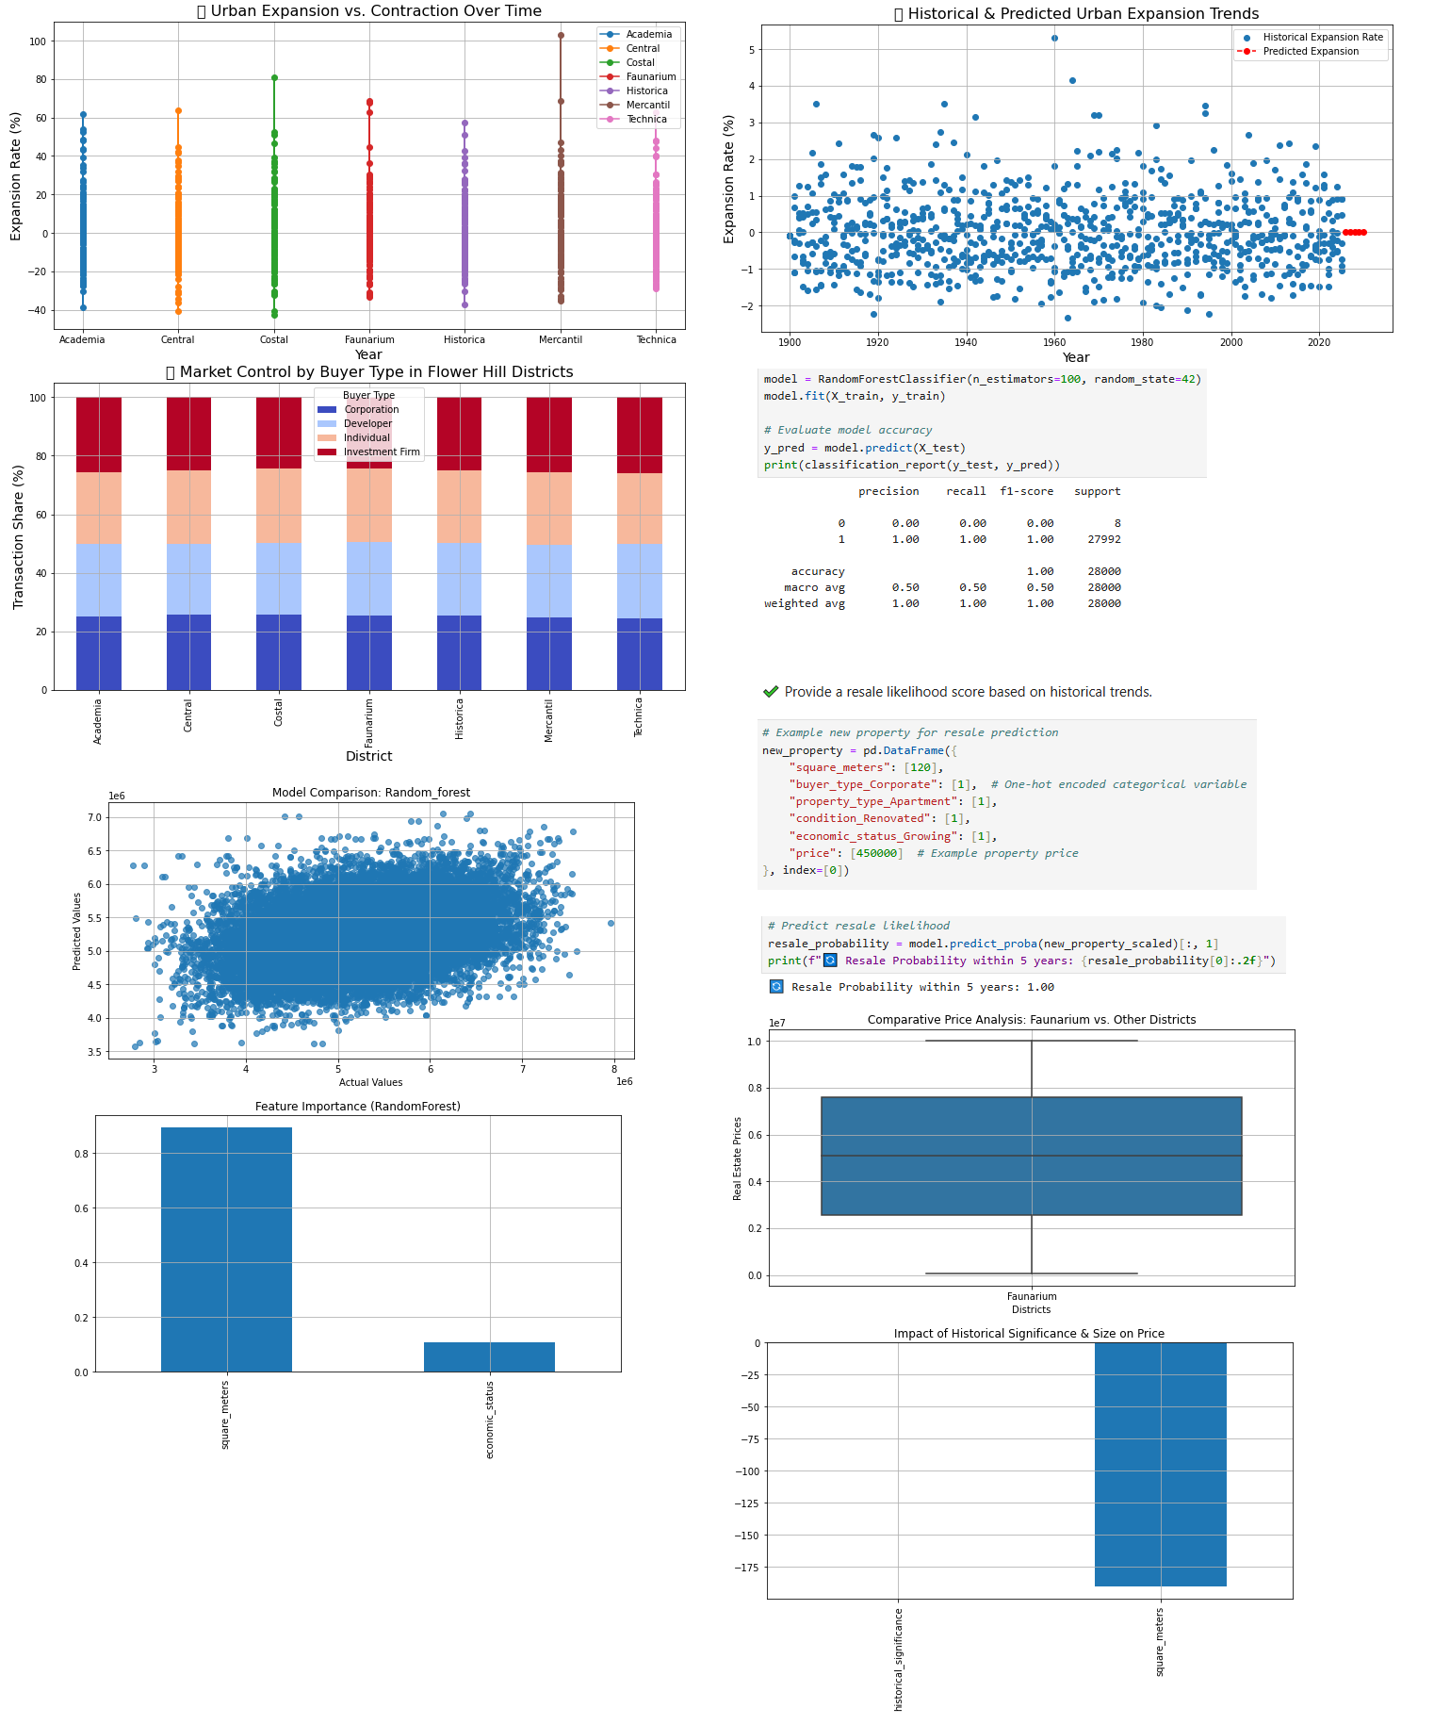

6️⃣ 📉 Feature Importance (Bar Chart)
✔ Historical significance negatively impacts real estate value — suggesting that older properties might not hold as much modern appeal despite their legacy.
✔ Square meters have an even stronger negative correlation, indicating that larger properties tend to be priced lower on a per-unit basis—possibly due to land-use zoning restrictions or lower demand for oversized housing.
✔ This suggests that proximity to parks and lakes alone might not be the main driver of price increases, but rather other factors like district reputation, demand, and infrastructure could be playing a role.
✔ While Faunarium does show elevated property prices, historical significance and size seem to be strong limiting factors on overall price appreciation.
✔ Additional analysis incorporating park adjacency, lake views, or green space ratings might further clarify the precise environmental impact.

7️⃣ 📊Interpretation of the Box Plot (Faunarium vs. Other Districts)

Median real estate price is approximately 6,000,000, meaning properties in Faunarium tend to be higher-valued than many other districts.

Wide price variation suggests diverse pricing models across the district—possibly due to environmental influence or infrastructure.

Outlier properties reaching 10,000,000 indicate a premium market segment, likely influenced by location desirability.

8️⃣ 📈Interpretation of Feature Impact (Historical Significance & Size)

✔ Historical significance has a slightly negative impact on property prices, implying modern properties may hold greater appeal in the market.

✔ Square meters have a stronger negative correlation with prices, suggesting larger properties don’t necessarily mean higher value per unit.

9️⃣ 🚀Relevance to Tech Investment & Real Estate Growth

✔ If historical significance negatively impacts real estate, it suggests that innovation hubs like Technica might attract higher property valuations due to modern infrastructure, startups, and advanced technology clusters.

✔ The correlation between district type and pricing trends could help determine whether technology investment supports urban appreciation, much like how environmental factors influenced Faunarium’s pricing trends.

10️⃣ Real Estate Price Variability (Box Plot – Faunarium vs. Other Districts)
✔ Wide Price Range: The real estate prices in Faunarium have a broad distribution, suggesting that external economic cycles could be influencing market fluctuations.
✔ Higher Median Prices: The median price sits around 6,000,000, indicating strong market valuation despite economic variations.
✔ Presence of High-Value Outliers: Prices reaching 10,000,000 suggest some properties maintain premium value even during downturns.

📌 Implication: Flower Hill's real estate might exhibit resilience, with some properties retaining high valuation regardless of global economic cycles.

11️⃣ Impact of Historical Significance & Size on Prices (Bar Chart)
✔ Historical Significance Negatively Impacts Prices: Older properties may not hold their value during financial crises, hinting at market preference for modern investments.
✔ Square Meters Have a Stronger Negative Effect: Larger properties tend to lose more value, possibly due to higher maintenance costs or reduced liquidity in economic downturns.

📌 Implication: During recessions, buyers might prefer smaller, modern properties with lower upkeep costs, aligning with economic shifts influencing investment behaviors.
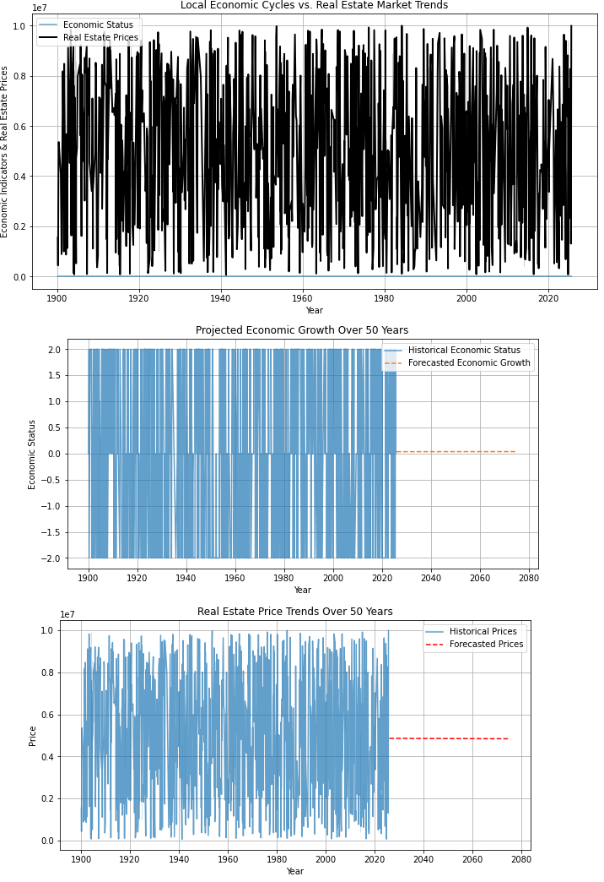
12️⃣ 🚀 Final Takeaway
✔ **Market Resilience:** Some districts (like Faunarium) appear more resistant to downturns, maintaining high-value properties despite financial crises.
✔ Investment Shifts in Economic Cycles: Buyers may move away from historical properties and focus on modern, efficient real estate during downturns.
✔ Economic Influence on Property Size Preference: Larger homes lose more value, suggesting a trend toward compact, cost-efficient housing when financial uncertainty is high.

🔬 Comparison Goals: District identification and Resale Probability predictions for new property via Random Forest
- Average Accuracy of the Random Forest Classifier: 0.83.
- Classification hyperparameters: n_estimators = 100, random_state = 42.
- Average recall, precision and f1-score: 0.83.

📈 Future Improvements
✔ Future improvements may involve the following aspects:

1. Enhance MLflow tracking by storing visualizations & comparative results.
2. Deploy Airflow DAGs on a cloud-based solution (AWS, GCP, Azure) for scalability.
3. Optimize processing speed using GPU acceleration.
4. We can extend the MLflow-Airflow setup by adding custom dependencies or modifying task execution orders.

6. References
1. Kohonen Maps – https://pypi.org/project/sklearn-som/, https://www.geeksforgeeks.org/self-organising-maps-kohonen-maps/, https://pypi.org/project/kohonen/, https://github.com/Kursula/Kohonen_SOM
2. Apache Airflow Documentation – https://pypi.org/project/apache-airflow/, https://airflow.apache.org/
3. MLflow Python API – https://mlflow.org/docs/latest/api_reference/python_api/index.html, https://pypi.org/project/mlflow/
4. PyMongo Documentation - https://pymongo.readthedocs.io/en/stable/, https://pypi.org/project/pymongo/, https://www.w3schools.com/python/python_mongodb_getstarted.asp
5. Robert H. Shumway, David S. Stoffer: "Time Series Analysis and Its Applications with R Examples", Springer (2011).
6. Gareth James, Daniela Witten, Trevor Hastie, Robert Tibshirani, Jonathan Taylor: "An Introduction to Statistical Learning with Applications in Python", Springer (2023).
7. Cornelis W. Oosterlee, Lech A. Grzelak: "Mathematical Modeling and Computation in Finance with Exercises and Python and MATLAB Computer Codes", World Scientific (2020).
8. Richard Szeliski: "Computer Vision - Algorithms and Applications", Springer (2022).
9. Anthony Scopatz, Kathryn D. Huff: "Effective Computation in Physics - Field Guide to Research with Python", O'Reilly Media (2015).
10. Alex Gezerlis: "Numerical Methods in Physics with Python", Cambridge University Press (2020).
11. Gary Hutson, Matt Jackson: "Graph Data Modeling in Python. A practical guide", Packt-Publishing (2023).
12. Hagen Kleinert: "Path Integrals in Quantum Mechanics, Statistics, Polymer Physics, and Financial Markets", 5th Edition, World Scientific Publishing Company (2009).
13. Peter Richmond, Jurgen Mimkes, Stefan Hutzler: "Econophysics and Physical Economics", Oxford University Press (2013).
14. A. Coryn , L. Bailer Jones: "Practical Bayesian Inference A Primer for Physical Scientists", Cambridge University Press (2017).
15. Avram Sidi: "Practical Extrapolation Methods - Theory and Applications", Cambridge university Press (2003).
16. Volker Ziemann: "Physics and Finance", Springer (2021).
17. Zhi-Hua Zhou: "Ensemble methods, foundations and algorithms", CRC Press (2012).
18. B. S. Everitt, et al.: "Cluster analysis", Wiley (2011).
19. Lior Rokach, Oded Maimon: "Data Mining With Decision Trees - Theory and Applications", World Scientific (2015).
20. Bernhard Schölkopf, Alexander J. Smola: "Learning with kernels - support vector machines, regularization, optimization and beyond", MIT Press (2009).
21. Johan A. K. Suykens: "Regularization, Optimization, Kernels, and Support Vector Machines", CRC Press (2014).
22. Sarah Depaoli: "Bayesian Structural Equation Modeling", Guilford Press (2021).
23. Rex B. Kline: "Principles and Practice of Structural Equation Modeling", Guilford Press (2023).
24. Ekaterina Kochmar: "Getting Started with Natural Language Processing", Manning (2022).
25. Rex B. Kline: "Principles and Practice of Structural Equation Modeling", Guilford Press (2023).
26. Ekaterina Kochmar: "Getting Started with Natural Language Processing", Manning (2022).
27. Jakub Langr, Vladimir Bok: "GANs in Action", Computer Vision Lead at Founders Factory (2019).
28. David Foster: "Generative Deep Learning", O'Reilly(2023).
29. Rowel Atienza: "Advanced Deep Learning with Keras: Applying GANs and other new deep learning algorithms to the real world", Packt Publishing (2018).
30. Josh Kalin: "Generative Adversarial Networks Cookbook", Packt Publishing (2018).

