Linear Programming (LP)

Optimization GUI with

Pythonic functional modeling

Inhaltsverzeichnis
1. Project description 3
Aim 3
🎯 Primary Aim 3
2. GUI and algorithmic concepts 4
3. GUI design and its interaction flow 6
4. Pythonic concepts behind the LP-GUI 8
5. Modularized Pythonic implementation (LP-GUI) 11
6. Results and conclusions 13
7. User Manual 15
8. References 19

1. Project description

Aim
This project presents a unified computational framework for solving linear optimization problems through a multi-method graphical interface. By integrating classical simplex algorithms, dual formulations, parametric linear programming, integer-constrained solvers, and interior-point techniques such as the Dikin method, the system enables robust exploration of feasible regions and optimality paths across diverse problem structures. The central aim is to democratize access to advanced linear programming strategies while offering real-time visualization and interpretability. Leveraging simplex-based pivoting for vertex traversal, parametric solvers for dynamic constraint sensitivity, and integer programming for discrete decision modeling, the framework accommodates both continuous and combinatorial optimization scenarios. The inclusion of the Dikin method introduces a smooth, interior-point trajectory that complements boundary-based approaches, offering insights into curvature and convergence behavior within feasible polyhedra. This methodological synthesis is encapsulated in a Python-powered GUI that dynamically adapts to user-defined variable types, constraint structures, and solver preferences. The interface supports interactive input parsing, automatic method detection, and 2D geometric rendering of feasible regions, constraint boundaries, and optimization paths. Designed for both educational and applied contexts, the system fosters intuitive understanding of linear optimization mechanics while maintaining algorithmic rigor. The resulting application serves as a modular launchpad for future extensions into nonlinear programming, multi-objective optimization, and hybrid solver orchestration. By bridging algorithmic depth with visual clarity, this project opens new avenues for accessible, interpretable, and customizable optimization workflows (see References 1 - 3 below).

🎯 Primary Aim
Structure and implement a PyQt5-powered GUI for linear optimization with built-in logic to route the problem to simplex, dual simplex, Dikin method, parametric linear programming (LP), or integer LP depending on the input, both from a UX and functional architecture perspective.

2. GUI and algorithmic concepts
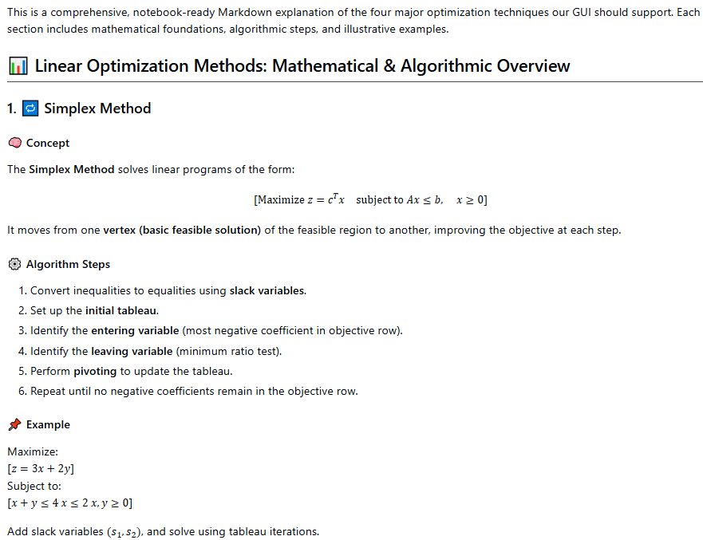

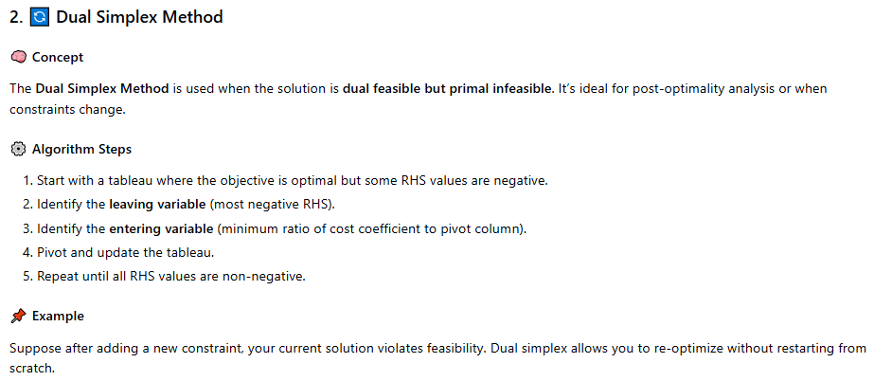

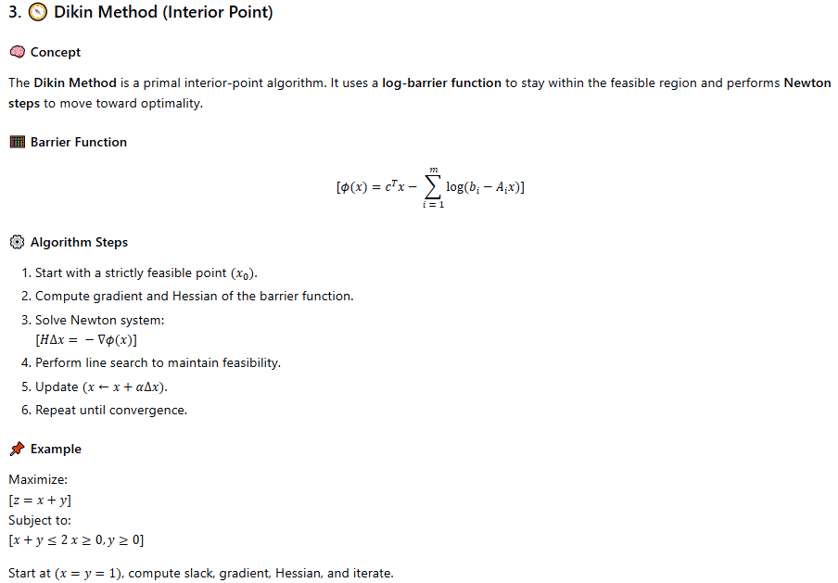
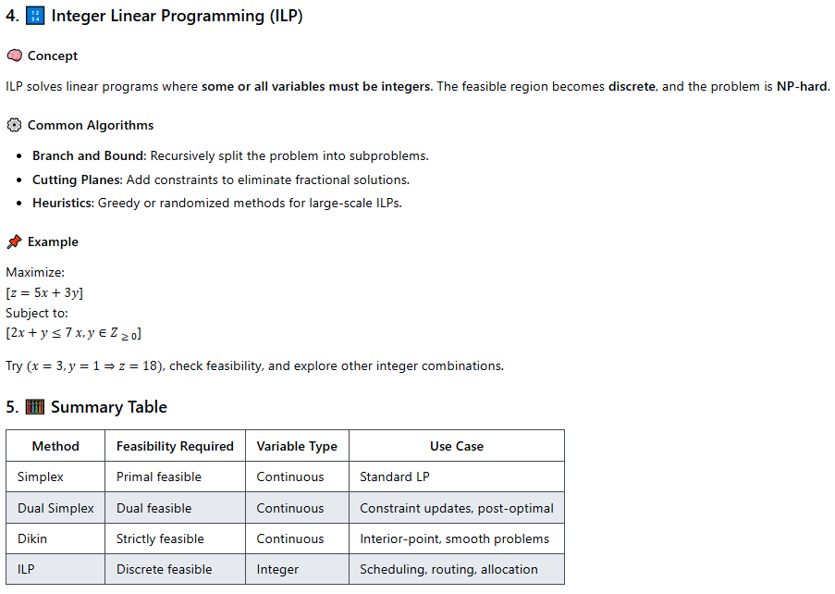

3. GUI design and its interaction flow
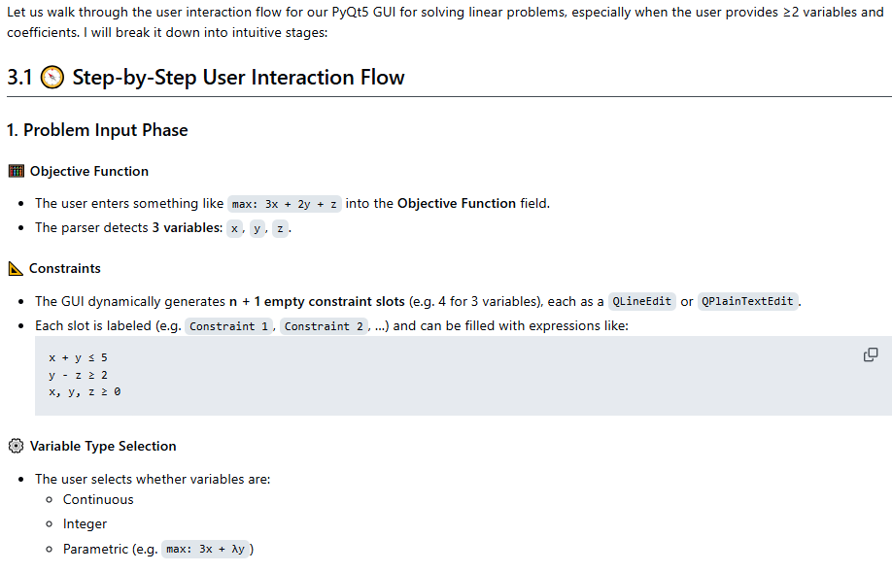
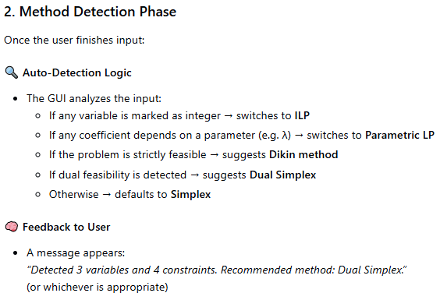

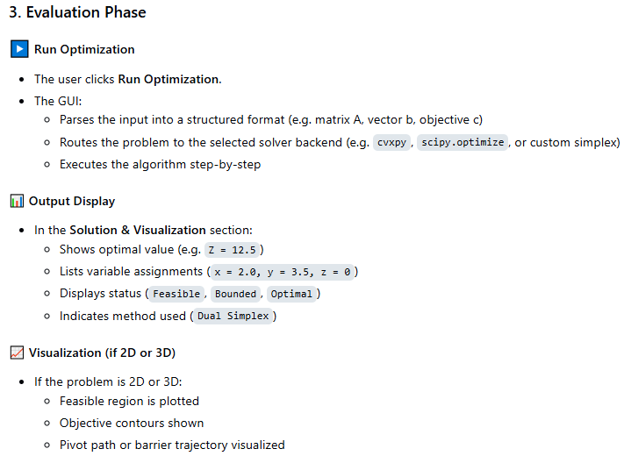
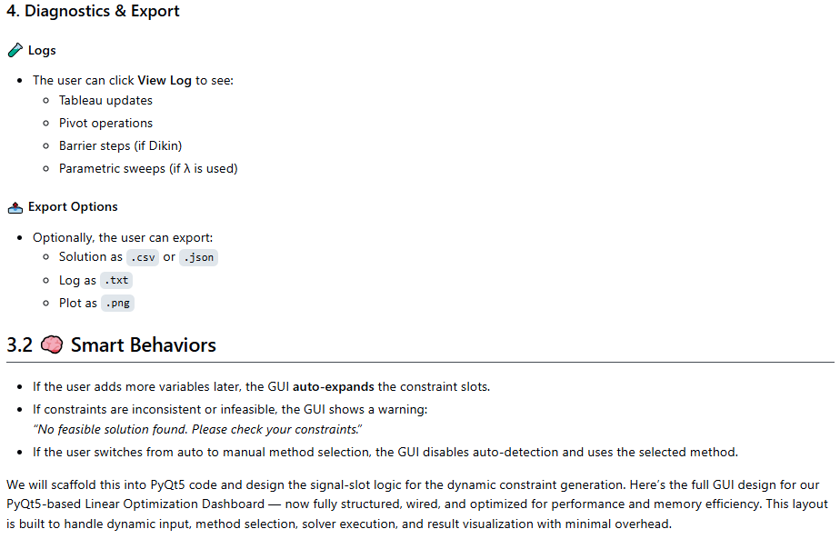

4. Pythonic concepts behind the LP-GUI

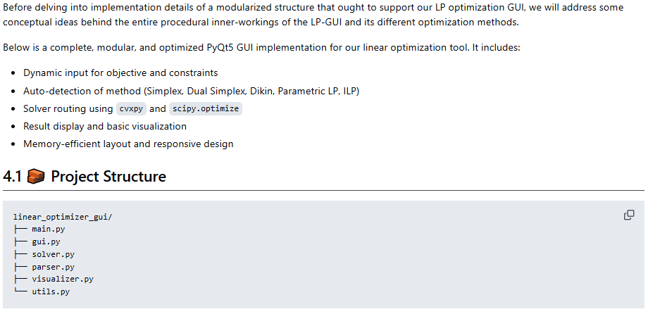
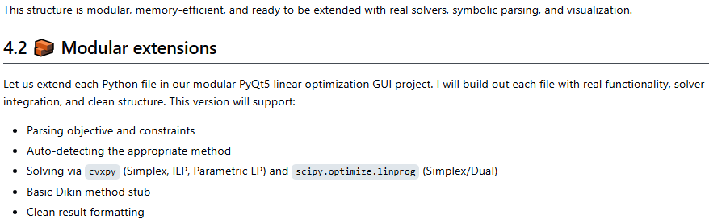
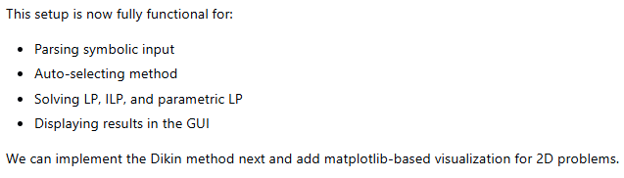

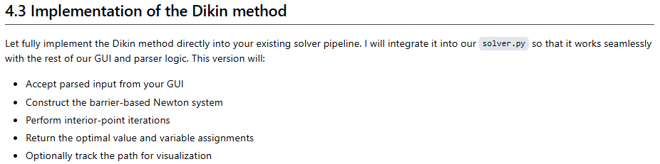
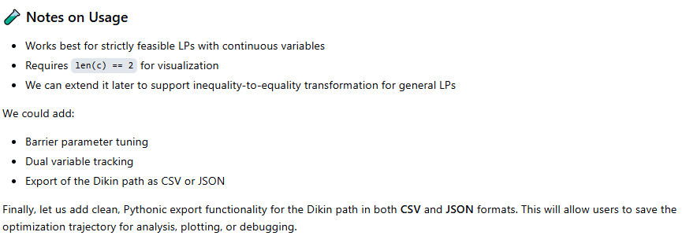
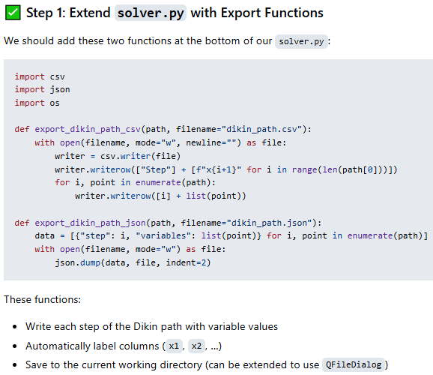
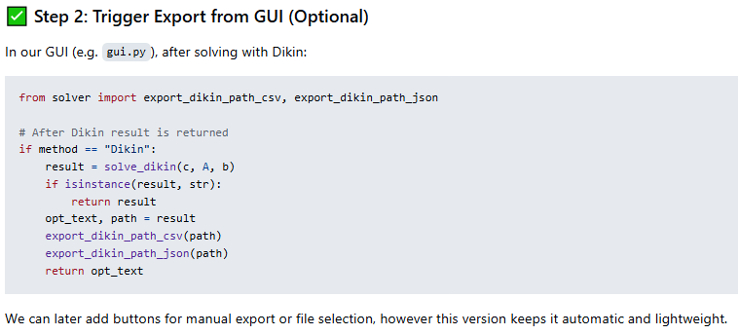
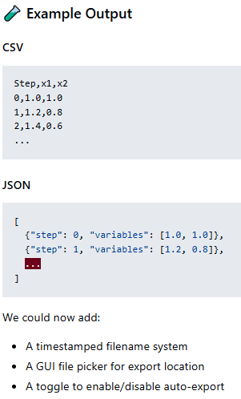

5. Modularized Pythonic implementation (LP-GUI)
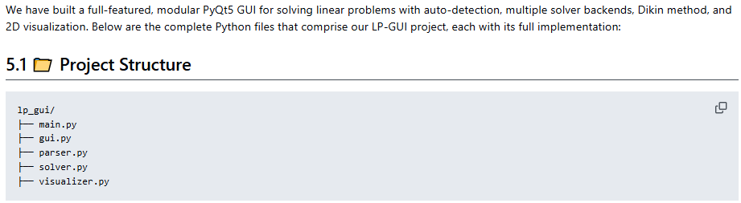
The full Pythonic code can be accessed via https://github.com/NenadBalaneskovic/ExternalProjects/blob/main/LinearProgramming_GUI/LinearProgramming_GUI.md (sections 5.2 – 5.6 therein).

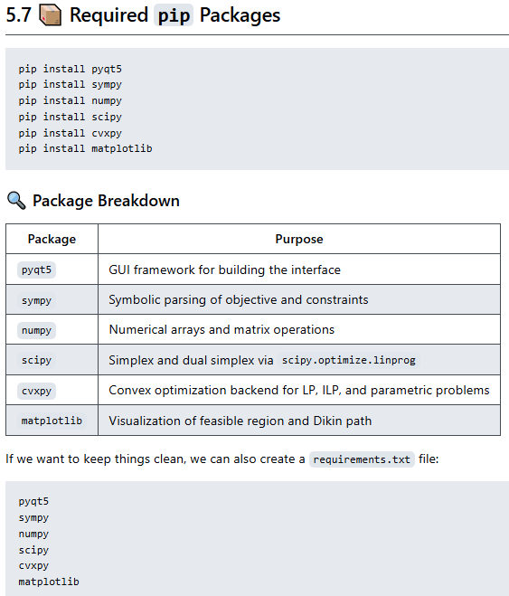

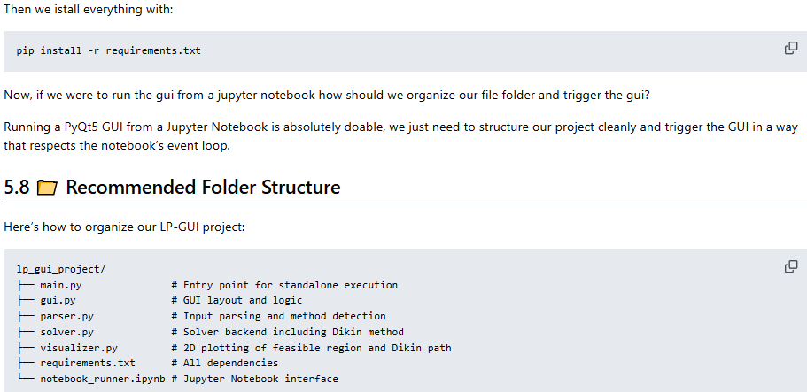
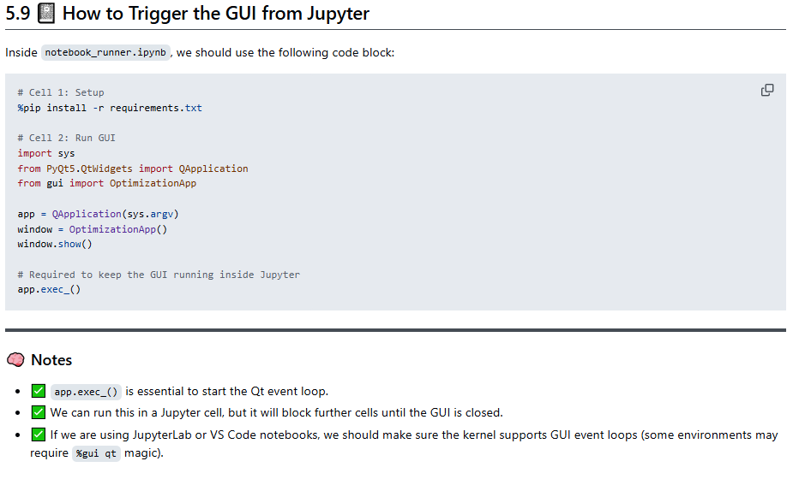
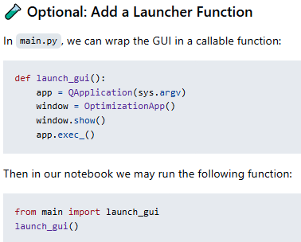

6. Results and conclusions
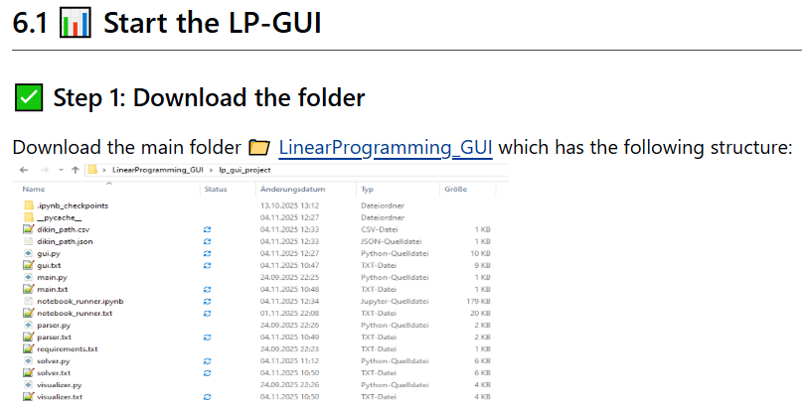
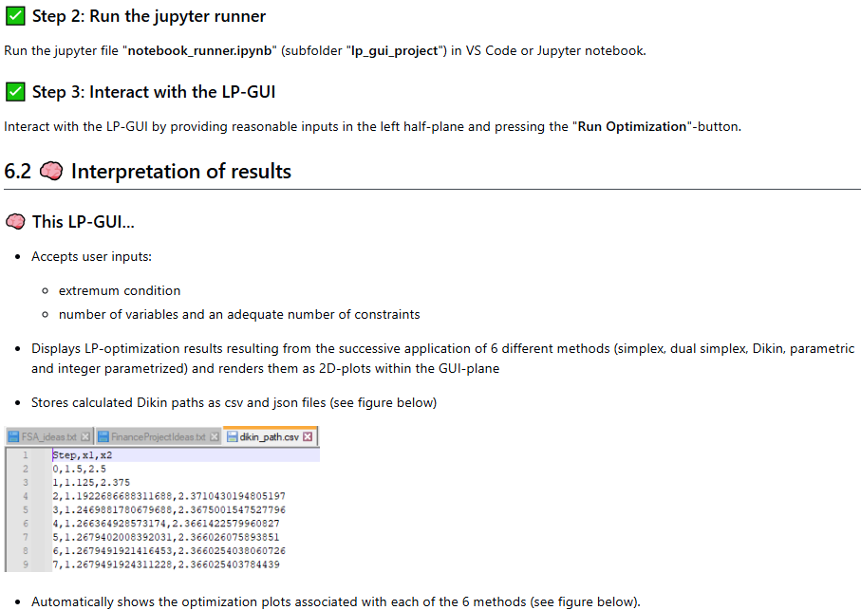

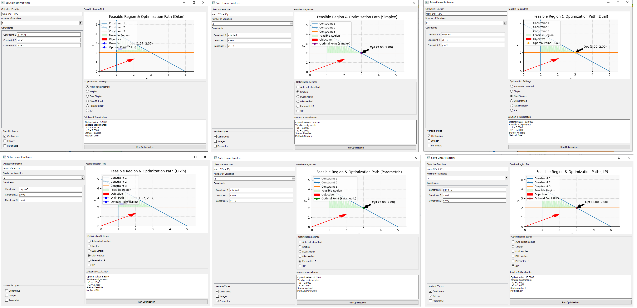
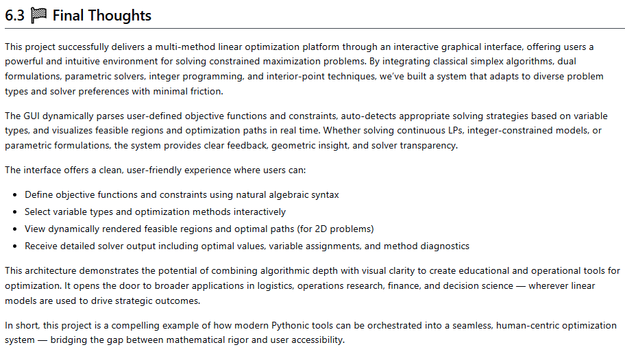

7. User Manual
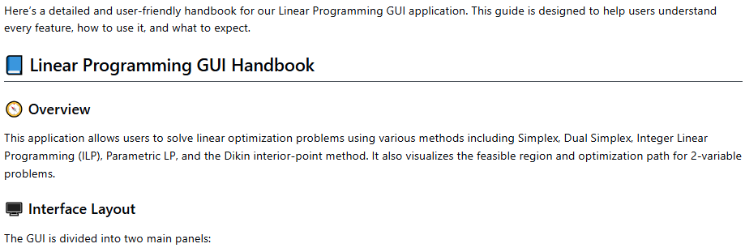
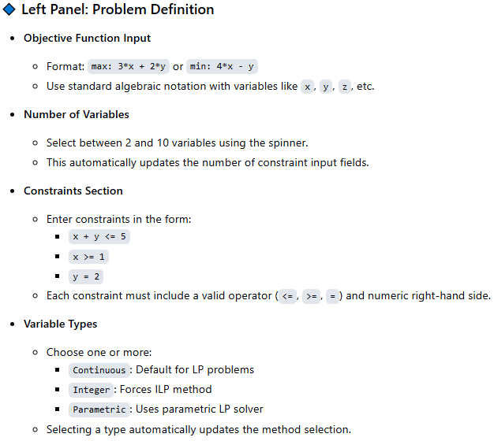

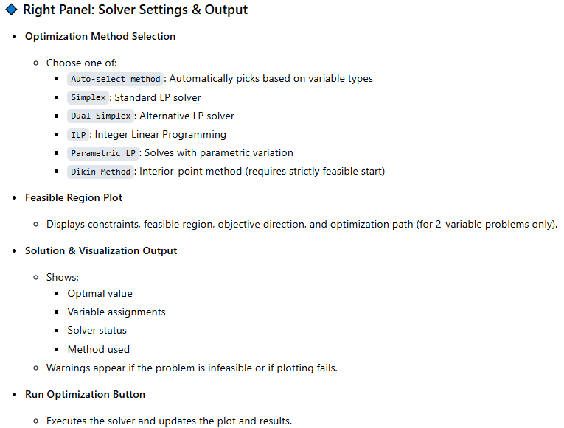

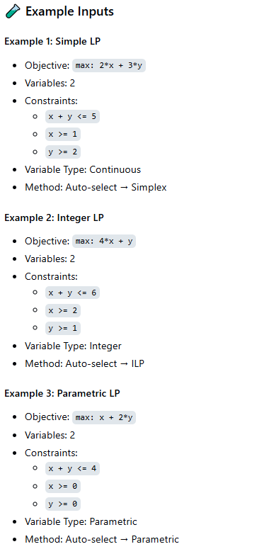

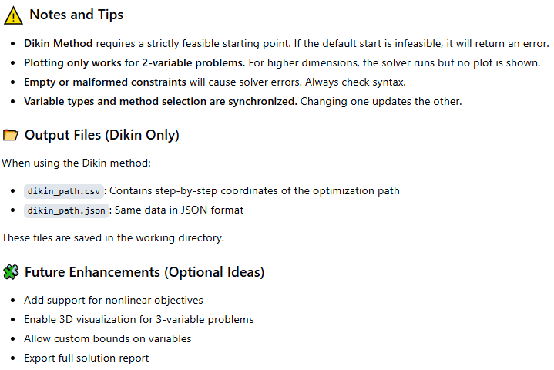

8. References
1. A. Koop, H. Moock: "Lineare Optimierung - Eine anwendungsorientierte Einführung in Operations Research", 1st Ed. Spektrum (2008); G, B, Dantzig, M. N. Thalpa: "Linear Programming 1: Introduction", 1st Ed. Springer (1997) & "Linear Programming 2: Theory and Extensions", 1st Ed. Springer (2003); H. S. Kasana, K. D. Kumar: "Introductory Operations Research, Theory and Applications", 1st Ed. Springer (2004); D. G. Luenberger: "Linear and Nonlinear Programming", 2nd Ed. Kluwer (2004); R. J. Boucherie, A. Braaksma, H. Tijms: "Operations Research - Introduction to Models and Methods", 1st Ed. World Scientific (2022); A. J. King, S. W. Wallace: "Modeling with Stochastic Programming", 2nd Ed. Springer (2024); J. O. Royset, R. J.-B. Wets: "An Optimization Primer", 1st Ed. Springer (2021); cvxpy package: https://www.cvxpy.org/, https://pypi.org/project/cvxpy/; py-packages for operations research: https://wiki.python.org/moin/PythonForOperationsResearch
2. A. Meister , T. Sonar: "Numerik", 1st Ed. Springer-Spektrum (2019); S. Chapra, R. Canale: "Numerical Methods for Engineers", Mcgraw-Hill, 6th Edition (2010).
3. J. Kilty, A. M. McAllister: "Mathematical Modeling and Applied Calculus", 1st Ed. Oxford University Press (2018).
4. U. Kockelkorn: "Statistik für Anwender", 1st Ed. Springer (2012), s. chapters 7 - 8.
5. Robert H. Shumway, David S. Stoffer: "Time Series Analysis and Its Applications with R Examples", Springer (2011).
6. Gareth James, Daniela Witten, Trevor Hastie, Robert Tibshirani, Jonathan Taylor: "An Introduction to Statistical Learning with Applications in Python", Springer (2023).
7. Cornelis W. Oosterlee, Lech A. Grzelak: "Mathematical Modeling and Computation in Finance with Exercises and Python and MATLAB Computer Codes", World Scientific (2020).
8. Richard Szeliski: "Computer Vision - Algorithms and Applications", Springer (2022).
9. Anthony Scopatz, Kathryn D. Huff: "Effective Computation in Physics - Field Guide to Research with Python", O'Reilly Media (2015).
10. Alex Gezerlis: "Numerical Methods in Physics with Python", Cambridge University Press (2020).
11. Gary Hutson, Matt Jackson: "Graph Data Modeling in Python. A practical guide", Packt-Publishing (2023).
12. Hagen Kleinert: "Path Integrals in Quantum Mechanics, Statistics, Polymer Physics, and Financial Markets", 5th Edition, World Scientific Publishing Company (2009).
13. Peter Richmond, Jurgen Mimkes, Stefan Hutzler: "Econophysics and Physical Economics", Oxford University Press (2013).
14. A. Coryn , L. Bailer Jones: "Practical Bayesian Inference A Primer for Physical Scientists", Cambridge University Press (2017).
15. Avram Sidi: "Practical Extrapolation Methods - Theory and Applications", Cambridge university Press (2003).
16. Volker Ziemann: "Physics and Finance", Springer (2021).
17. Zhi-Hua Zhou: "Ensemble methods, foundations and algorithms", CRC Press (2012).
18. B. S. Everitt, et al.: "Cluster analysis", Wiley (2011).
19. Lior Rokach, Oded Maimon: "Data Mining With Decision Trees - Theory and Applications", World Scientific (2015).
20. Bernhard Schölkopf, Alexander J. Smola: "Learning with kernels - support vector machines, regularization, optimization and beyond", MIT Press (2009).
21. Johan A. K. Suykens: "Regularization, Optimization, Kernels, and Support Vector Machines", CRC Press (2014).
22. Sarah Depaoli: "Bayesian Structural Equation Modeling", Guilford Press (2021).
23. Rex B. Kline: "Principles and Practice of Structural Equation Modeling", Guilford Press (2023).
24. Ekaterina Kochmar: "Getting Started with Natural Language Processing", Manning (2022).
25. Rex B. Kline: "Principles and Practice of Structural Equation Modeling", Guilford Press (2023).
26. Ekaterina Kochmar: "Getting Started with Natural Language Processing", Manning (2022).
27. Jakub Langr, Vladimir Bok: "GANs in Action", Computer Vision Lead at Founders Factory (2019).
28. David Foster: "Generative Deep Learning", O'Reilly(2023).
29. Rowel Atienza: "Advanced Deep Learning with Keras: Applying GANs and other new deep learning algorithms to the real world", Packt Publishing (2018).
30. Josh Kalin: "Generative Adversarial Networks Cookbook", Packt Publishing (2018).
31. Thomas Haslwanter: „Hands-on Signal Analysis with Python: An Introduction“, Springer (2021).
32. Jose Unpingco: „Python for Signal Processing“, Springer (2023).
33. R. K. Burdick, C. M. Borror, D. C. Montgomery: "Design and Analysis of Gauge R&R Studies", 1st Ed. SIAM (2005); S. H. Derakhshan , C. V. Deutsch: "Numerical Integration of Bivariate Gaussian Distribution", Paper 405, CCG Anual Report 13 (2011).
34. C. Paar, J. Pelzl: "Understanding Cryptography", Springer (2010); H. Delfs, H. Knebl: "Introduction to Cryptography", 3rd Ed. Springer (2015); J. Katz, Y. lindell: "Introduction to Modern Cryptography", 2nd Ed, CRC Press (2015); O. Goldreich: "Foundations of Cryptography", Cambridge University Press (2008); J. P. Aumasson: "Serious Cryptography", no starch press (2018).
35. Kaggle-link: competition-documentation: https://www.kaggle.com/competitions/drw-crypto-market-prediction. R. Nystrom: „Game Programming Patterns“, 1st Ed. genever benning (2014); A. A. Stepanov, D. E. Rose: „From Mathematics to Generic Programming“, 1st Ed. Addison-Wesley (2015);
36. J. Berk, P. DeMarzo: „Corporate Finance“, 6th Ed., Pearson (2023); R. W. Melicher, E. A. Norton: "Introduction to Finance", 16th Ed. WILEY (2017); Anatoly B. Schmidt: "Quantitative Finance for Physicists: An Introduction", 1st Ed. Academic Press (2005); Alex Backwell: "An Intuitive Introduction to Finance and Derivatives: Concepts, Terminology and Models", 1st Ed, Springer (2023); Michael Isichenko: "Quantitative Portfolio Management: The Art and Science of Statistical Arbitrage", 1st Ed., Springer (2021); John H. Cochrane: "Asset Pricing", Revised Ed., Princeton University Press (2005); Antti Ilmanen: "Expected Returns: An Investor’s Guide to Harvesting Market Rewards", 1st Ed., WILEY (2011); Steven E. Shreve: "Stochastic Calculus for Finance I & II", 1st Ed., Springer (2004); Andrew Pole: "Statistical Arbitrage: Algorithmic Trading Insights and Techniques", 1st Ed., WILEY (2007); Mark S. Joshi: "The Concepts and Practice of Mathematical Finance", 2nd Ed., Cambridge University Press (2008);
37. E. Parzen: "Stochastic Processes", 3rd Ed. Dover Publications (2015); S. Aloorravi: "Metaprogramming with Python", 1st Ed. Packt (2022); B. Klein, P. Klein: "Funktionale Programmierung mit Python", Hanser (2025); K. Webel, D. Wied: "Stochastische Prozesse", 2. Auflage Springer (2016); L. Held: "Methoden der statistischen Inferenz", 1. Auflage Spektrum (2008); E. Cinlar: "Stochastic Processes", Dover (2013); N. Bäuerle, U. Rieder: "Finanzmathematik in diskreter Zeit", Springer-Spektrum (2017); M. Albrecht, R. Maurer: "Investment- und Risikomanagement", 3. Auflage, Schäffer Poeschel (2008); N. H. Bingham, R. Kiesel: "Risk Neutral Valuation: Pricing and Hedging of Financial Derivatives", 2. Auflage Springer (2004); T. Björk: "Arbitrage Theory in Continuous Time", 3rd Ed. Oxford University Press (2009); N. J. Cutland, A. Roux: "Derivative Pricing in Discrete Time", Springer (2013); F. Delbaen, W. Schachermayer: "The Mathematics of Arbitrage", Springer (2006); R. J. Elliott, P. E. Kopp: "Mathematics of Financial Markets", 2nd Ed. Springer (2005); H. Föllmer, A. Scheid: "A Stochastic Finance: An Introduction in Discrete Time", 3rd Ed. de Gruyter (2011); J. C. Hull: "Options, Futures and Other Derivatives", 8th Ed. Pearson (2011); J. Kremer: "Einführung in die diskrete Finanzmathematik", Springer (2005); D. Lamberton, B. Lapeyre: "Introduction to Stochastic Calculus Applied to Finance", Chapman & Hall (2007); D. G. Luenberger: "Investment Science", Oxford University Press (1998); S. R. Pliska: "Introduction to Mathematical Finance: Discrete Time Models", Blackwell (2000); A. N. Shiryaev: "Essentials of Stochastic Finance", World Scientific (2001); S. E. Shreve: "Stochastic Calculus for Finance I: The Binomial Asset Pricing Model", Springer (2004); J. Kremer: "Portfoliotheorie, Risikomanagement und die Bewertung von Derivaten", Springer (2011); L. Rüschendorf: "Mathematical Risk Analysis", Springer (2013).
38. A. Becker: "Kalman Filter - From the Ground Up", 1st Ed. private publication (2023); K. Triantafyllopoulos: "Bayesian Inference of State Space Models", 1st Ed. Springer (2021); P. Zarchan, H. Musoff: "Fundamentals of Kalman Filtering: A Practical Approach", 3rd Ed. AIAA (2009); A. Sidi: "Vector Extrapolation Methods with Applications", 1st Ed. SIAM (2019); C. Brezinski, M. R. Zaglia: "Extrapolation Methods - Theory and Practice", 2nd Ed. North-Holland (2002); C. Gardiner, P. Zoller: "Quantum Noise: A Handbook of Markovian and Non-Markovian Quantum Stochastic Methods with Applications to Quantum Optics", 3rd Ed. Springer (2004); K. Kendre: "Machine Learning for Quantum Noise Reduction", https://arxiv.org/abs/2509.16242 (2025); D. C. Marinescu, G. M. Marinescu: "Classical and Quantum Information", 1sr Ed. Academic Press (2012); Liao, H et al.: "Machine Learning for Practical Quantum Error Mitigation", arXiv:2309.17368v2 (2024), https://arxiv.org/pdf/2309.17368; Streamlit: https://streamlit.io/; Mitiq-package: https://quantum-journal.org/papers/q-2022-08-11-774/, https://arxiv.org/abs/2009.04417; Extrapolation packages: https://pypi.org/project/extrapolation/

