LLM-GAN Reconstruction

of

Chessboard Images

Inhaltsverzeichnis
1. Project description 3
Aim 3
2. Planning section 3
3. Standard OpenCV Implementation 5
4. GAN-implementation 6
4. Potential improvements 14
5. Conclusions 15
6. References 16

1. Project description

Aim
This project aims to compare traditional OpenCV-based methods for chessboard image reconstruction with
Generative Adversarial Network (GAN)-driven approaches. The goal is to evaluate the effectiveness of deep learning
in reconstructing secluded or obscured chessboard sections more accurately than conventional techniques.
The goal of this project is to experiment with and understand the inner workings of Python's LLM and GAN functionalities in conjunction with OpenCV with respect to reconstruction attempts of partially secluded fronat images of chessboard patterns.

2. Planning section

Before implementing the GAN-induced image reconstruction we want to address its core principles.

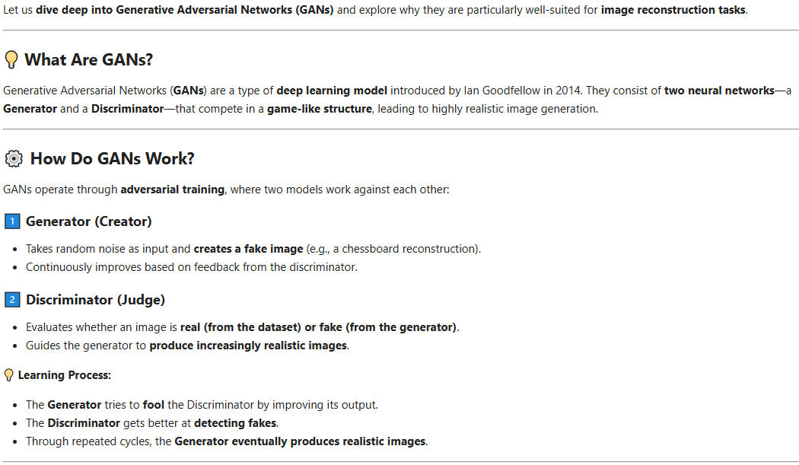

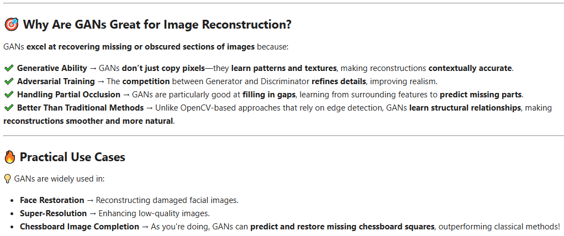
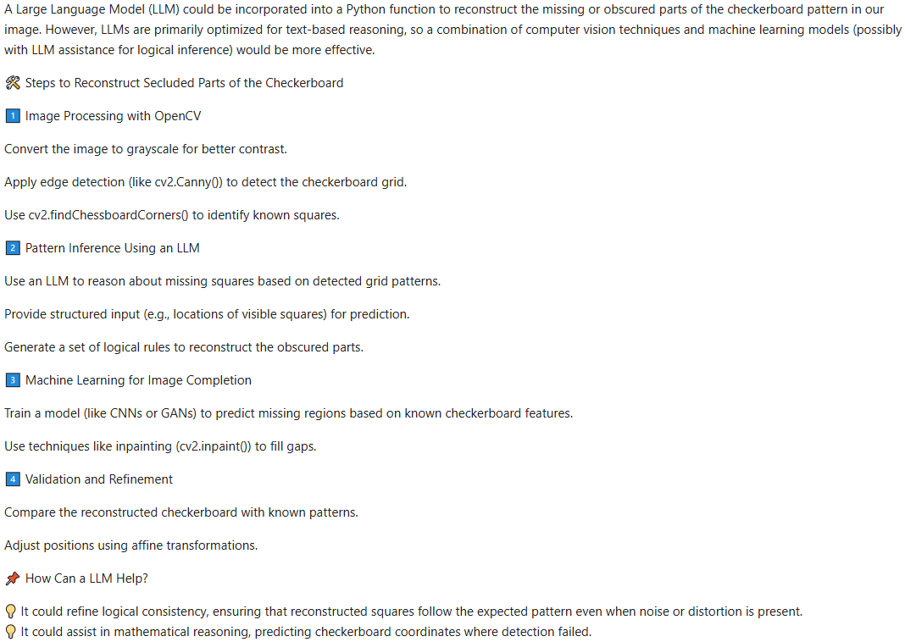

3. Standard OpenCV Implementation
We implement a well-commented Python function „reconstruct_chessboard(image_path)“ that uses OpenCV to detect and reconstruct secluded parts of a chessboard in an image. This function leverages image processing techniques like edge detection, corner detection, and inpainting to infer missing or obscured squares.

Example usage:
image_path = "pos50.png" # Replace with an appropriate chessboard image path
reconstructed = reconstruct_chessboard(image_path)

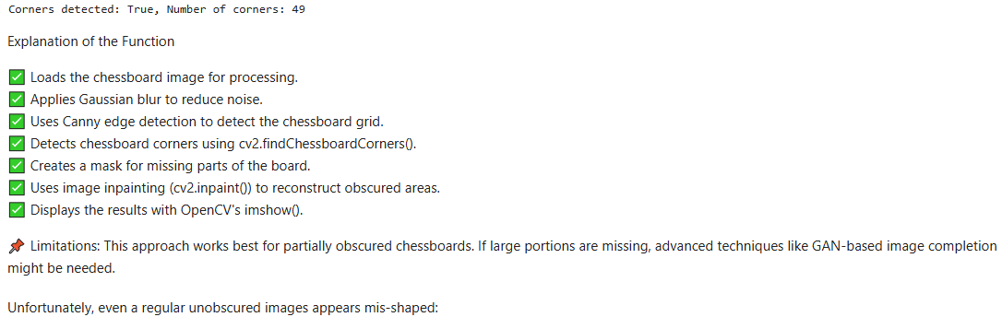
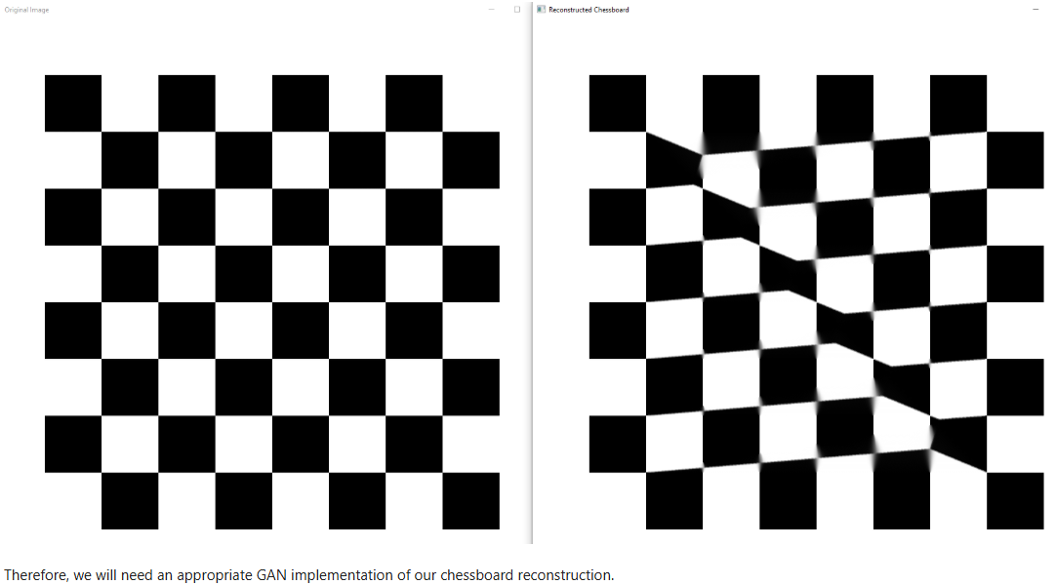

4. GAN-implementation

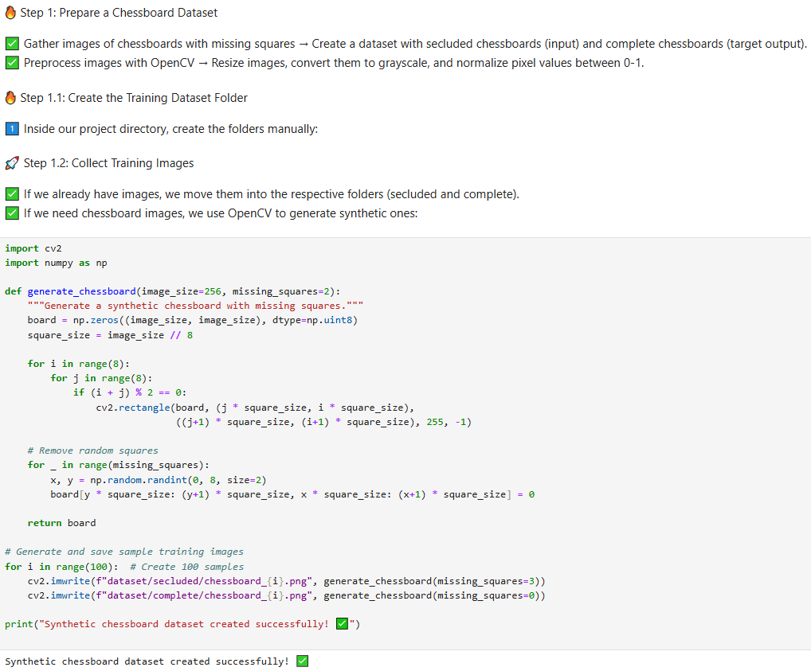

The following function „preprocess_image“ prepares the generated chessboard images for a GAN training session:
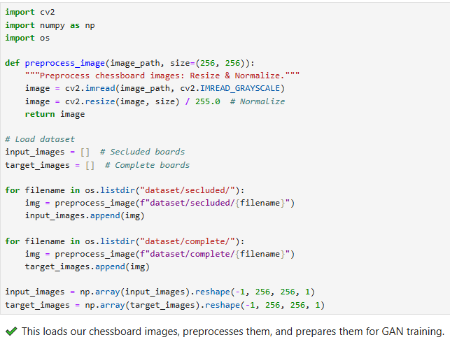
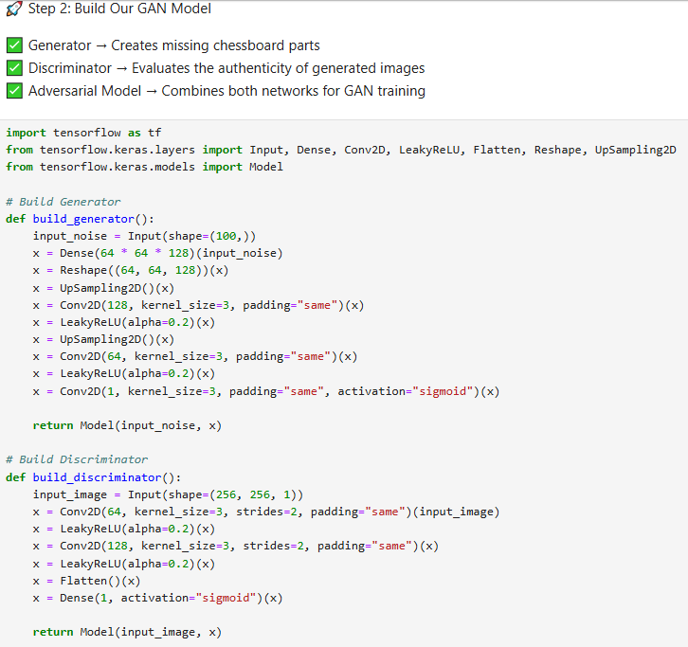
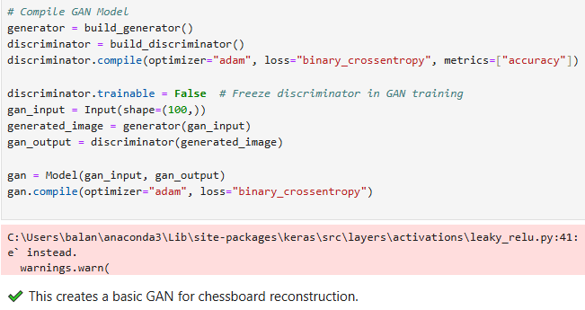
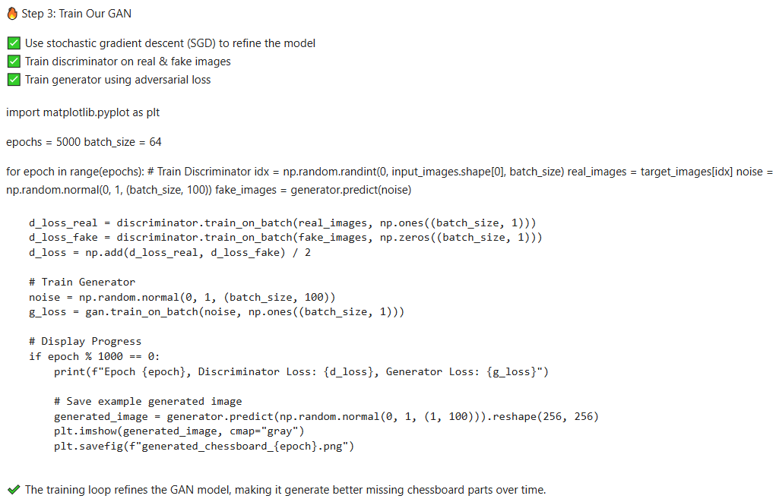
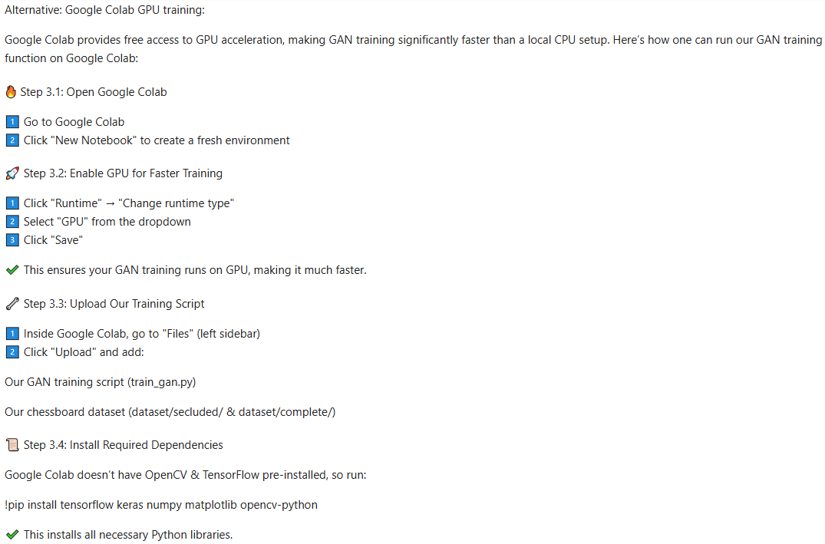

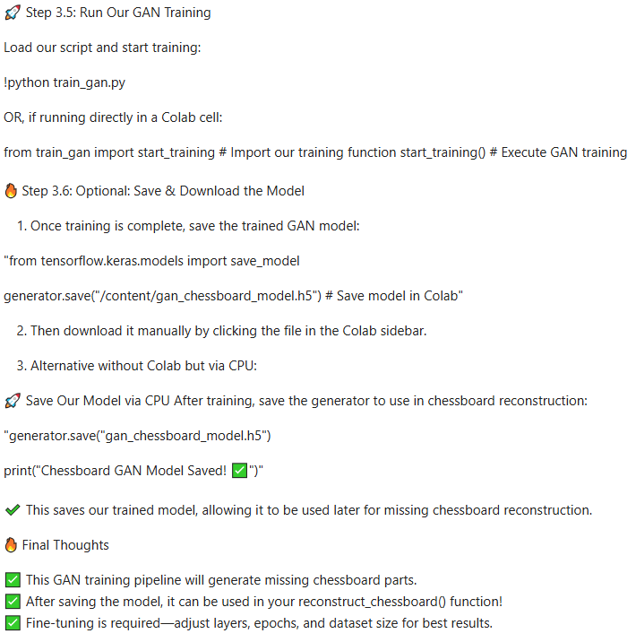

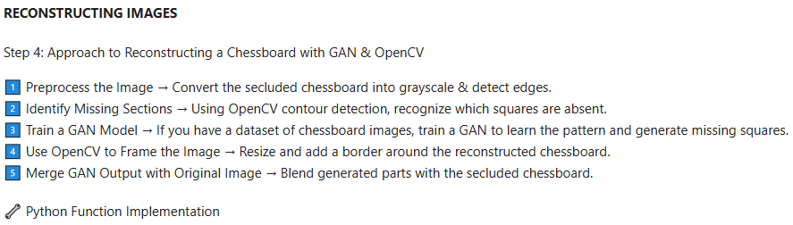
Here is a starting point for our GAN-extended function „reconstruct_chessboard“. It detects missing squares, resizes, and frames the chessboard. The GAN integration would require a trained model, which is accomplished via Google Colab.
The function „reconstruct_chessboard“ is invoked as follows:

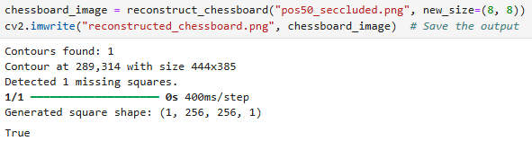
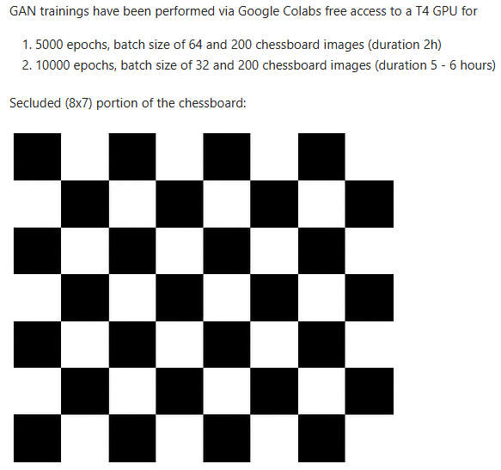
After 10000 epochs for batch sizes 32 the GAN model was capable of draving an (8x8) rectangular boundary around the originally secluded (8x7) portion of the chessboard and reconstructing its rectangles (the last 8th row is the missing corrected chessboard portion):

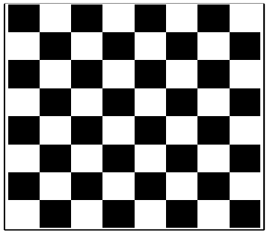

4. Potential improvements

Since our GAN now successfully reconstructs frontal chessboard images, the next challenge is handling tilted, distorted, and partially obscured boards. Here are some improvements and techniques to make your GAN more robust:

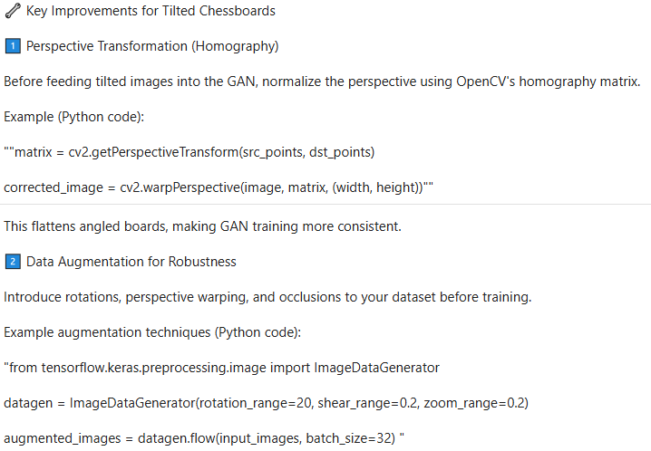
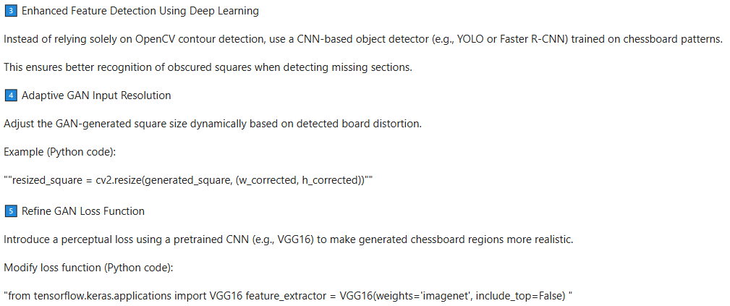

5. Conclusions

✔ GAN trainings have been performed via Google Colabs free access to a T4 GPU for
-- 1. 5000 epochs, batch size of 64 and 200 chessboard images (duration 2h),
-- 2. 10000 epochs, batch size of 32 and 200 chessboard images (duration 5 - 6 hours).
✔ After 10000 epochs for batch sizes 32 the GAN model was capable of draving an (8x8) rectangular boundary around the originally secluded (8x7) portion of the chessboard and reconstructing its rectangles (the last 8th row is the missing corrected chessboard portion).

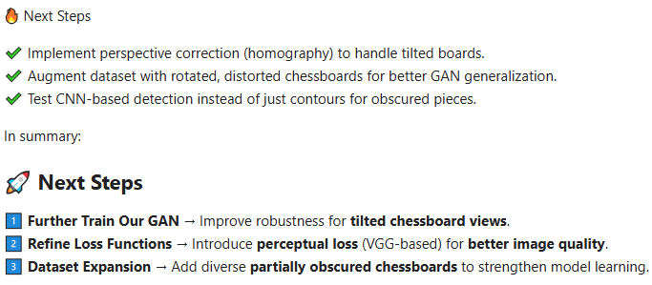

6. References
1. Generative Adversarial Networks – https://realpython.com/generative-adversarial-networks/, https://www.tensorflow.org/tutorials/generative/dcgan
2. pygan Documentation – https://pypi.org/project/pygan/
3. GAN with pytorch – https://medium.com/the-research-nest/how-to-program-a-simple-gan-559ad707e201
4. GAN in Python – https://www.codemotion.com/magazine/ai-ml/deep-learning/how-to-build-a-gan-in-python/
5. Robert H. Shumway, David S. Stoffer: "Time Series Analysis and Its Applications with R Examples", Springer (2011).
6. Gareth James, Daniela Witten, Trevor Hastie, Robert Tibshirani, Jonathan Taylor: "An Introduction to Statistical Learning with Applications in Python", Springer (2023).
7. Cornelis W. Oosterlee, Lech A. Grzelak: "Mathematical Modeling and Computation in Finance with Exercises and Python and MATLAB Computer Codes", World Scientific (2020).
8. Richard Szeliski: "Computer Vision - Algorithms and Applications", Springer (2022).
9. Anthony Scopatz, Kathryn D. Huff: "Effective Computation in Physics - Field Guide to Research with Python", O'Reilly Media (2015).
10. Alex Gezerlis: "Numerical Methods in Physics with Python", Cambridge University Press (2020).
11. Gary Hutson, Matt Jackson: "Graph Data Modeling in Python. A practical guide", Packt-Publishing (2023).
12. Hagen Kleinert: "Path Integrals in Quantum Mechanics, Statistics, Polymer Physics, and Financial Markets", 5th Edition, World Scientific Publishing Company (2009).
13. Peter Richmond, Jurgen Mimkes, Stefan Hutzler: "Econophysics and Physical Economics", Oxford University Press (2013).
14. A. Coryn , L. Bailer Jones: "Practical Bayesian Inference A Primer for Physical Scientists", Cambridge University Press (2017).
15. Avram Sidi: "Practical Extrapolation Methods - Theory and Applications", Cambridge university Press (2003).
16. Volker Ziemann: "Physics and Finance", Springer (2021).
17. Zhi-Hua Zhou: "Ensemble methods, foundations and algorithms", CRC Press (2012).
18. B. S. Everitt, et al.: "Cluster analysis", Wiley (2011).
19. Lior Rokach, Oded Maimon: "Data Mining With Decision Trees - Theory and Applications", World Scientific (2015).
20. Bernhard Schölkopf, Alexander J. Smola: "Learning with kernels - support vector machines, regularization, optimization and beyond", MIT Press (2009).
21. Johan A. K. Suykens: "Regularization, Optimization, Kernels, and Support Vector Machines", CRC Press (2014).
22. Sarah Depaoli: "Bayesian Structural Equation Modeling", Guilford Press (2021).
23. Rex B. Kline: "Principles and Practice of Structural Equation Modeling", Guilford Press (2023).
24. Ekaterina Kochmar: "Getting Started with Natural Language Processing", Manning (2022).
25. Rex B. Kline: "Principles and Practice of Structural Equation Modeling", Guilford Press (2023).
26. Ekaterina Kochmar: "Getting Started with Natural Language Processing", Manning (2022).
27. Jakub Langr, Vladimir Bok: "GANs in Action", Computer Vision Lead at Founders Factory (2019).
28. David Foster: "Generative Deep Learning", O'Reilly(2023).
29. Rowel Atienza: "Advanced Deep Learning with Keras: Applying GANs and other new deep learning algorithms to the real world", Packt Publishing (2018).
30. Josh Kalin: "Generative Adversarial Networks Cookbook", Packt Publishing (2018).

