Weather Aggregator

Flask App with

Pythonic LLM stacking

Inhaltsverzeichnis
1. Project description 3
Aim 3
🎯 Primary Aim 3
2. GUI and algorithmic concepts 5
3. App design and its interaction flow 7
4. Run instructions and Mermaid diagrams 9
5. Modularized Pythonic implementation 13
6. Results and conclusions 14
7. User Manual 17
8. References 21

1. Project description

Aim
The Weather Aggregator Flask App is conceived as a modular demonstration platform that integrates modern machine learning methodologies with practical data aggregation in the domain of weather forecasting. At its core, the project seeks to provide a transparent, auditable environment in which different predictive models can be compared, combined, and evaluated. By leveraging Flask as the lightweight web framework, the application offers an accessible interface for both technical and non-technical stakeholders, enabling forecasts to be generated, visualized, and stored with ease. This design choice reflects a broader ambition: to bridge the gap between advanced ensemble learning research and executive-ready reporting tools.
The central aim of the project is to test and characterize stacked surrogate models—meta-learners that combine the outputs of diverse base predictors. In practice, this involves running multiple forecasting algorithms, such as SARIMAX, Kalman filters, Random Forests, Gradient Boosting, CNNs, LSTMs, and Autoencoders, on the same weather dataset. Each of these models captures different statistical or structural aspects of the data. The surrogate model, typically implemented as a ridge regression or similar linear meta-learner, then integrates these heterogeneous predictions into a single ensemble forecast. This stacked approach allows the system to exploit complementary strengths while mitigating individual weaknesses, producing results that are more robust and generalizable.
A distinctive feature of the project is its emphasis on explainability and governance. Rather than treating ensemble learning as a black box, the app is designed to characterize the results of different learning strategies—both linear regression models (LRM) and more complex large language models (LLM) adapted for surrogate tasks. By storing forecasts alongside confidence bands, user inputs, and metadata, the system creates a traceable record that can be audited and analyzed. This ensures that the outputs are not only accurate but also narratable: stakeholders can understand how predictions were formed, which base models contributed most, and how uncertainty was quantified.
The use of stacked surrogate models in this context serves two purposes. First, it provides a rigorous testbed for evaluating ensemble learning techniques under real-world conditions, where data may be noisy, incomplete, or non-stationary. Second, it demonstrates how surrogate modeling can be operationalized within a consulting-ready application. By embedding these techniques in a Flask app with a clear user interface, the project shows how advanced machine learning can be packaged into tools that are both technically sound and organizationally impactful.
Beyond its immediate technical objectives, the Weather Aggregator Flask App also functions as a narrative asset. It illustrates how modular architectures, reproducible workflows, and governance-compliant reporting can be combined to deliver value in enterprise settings. The project highlights the importance of transparency in ensemble learning, the role of surrogate models in characterizing complex outputs, and the potential of lightweight web applications to democratize access to advanced analytics. In doing so, it positions itself not merely as a forecasting tool, but as a demonstrator of best practices in explainable AI, ensemble modeling, and consulting-oriented system design.
(see References 1 - 3 below).

🎯 Primary Aim
The motivation behind the Weather Aggregator Flask App arises from the growing need to evaluate and operationalize ensemble learning strategies in domains where predictive accuracy, transparency, and reproducibility are paramount. Weather forecasting provides an ideal testbed: it is inherently complex, data-rich, and subject to uncertainty. Traditional single-model approaches often struggle to capture the full variability of meteorological data, while ensemble methods promise improved robustness by combining diverse perspectives. Yet, ensemble learning itself introduces challenges of interpretability, governance, and deployment. This project is motivated by the desire to confront those challenges directly, creating a demonstrator that not only aggregates forecasts but also characterizes how stacked surrogate models perform in practice.
A central motivation is the pursuit of explainability. In both academic research and consulting environments, stakeholders increasingly demand that machine learning outputs be narratable and auditable. Black-box ensembles may deliver strong predictive performance, but without clear insight into how results are formed, they risk eroding trust. By designing a system that explicitly logs base model outputs, surrogate model predictions, and confidence intervals, the Weather Aggregator Flask App ensures that every forecast can be traced back to its components. This transparency supports governance requirements and provides a foundation for executive-ready reporting.
Another motivation is methodological experimentation. The project aims to test stacked surrogate models that integrate both linear regression models (LRM) and large language models (LLM) adapted for surrogate tasks. This dual focus reflects the evolving landscape of machine learning: linear models remain valuable for their simplicity and interpretability, while LLMs offer powerful representational capacity. By comparing and combining these approaches, the app provides insights into how different surrogate strategies characterize ensemble outputs. This experimentation is not purely academic; it is designed to inform consulting practice by identifying which methods yield the most reliable and narratable results under real-world conditions.
The objectives of the project can be grouped into four categories. First, technical objectives: to implement a modular architecture that supports multiple base models, a meta-learner, and a datastore for forecasts and user inputs. Second, analytical objectives: to evaluate the performance of stacked surrogate models, quantify uncertainty through confidence bands, and generate summary statistics that characterize ensemble behavior. Third, reporting objectives: to produce executive-ready artifacts, including web pages and PDF reports, that present forecasts in a clear, auditable format. Fourth, strategic objectives: to demonstrate how explainability-first ensemble modeling can be embedded in lightweight applications, thereby bridging the gap between research prototypes and consulting deliverables.
Together, these motivations and objectives position the Weather Aggregator Flask App as more than a technical exercise. It is a narrative tool that illustrates best practices in ensemble learning, surrogate modeling, and explainable AI. By focusing on transparency, reproducibility, and governance, the project aligns with the needs of organizations that must balance innovation with accountability. Ultimately, the app serves as both a testbed for methodological exploration and a demonstrator of how advanced machine learning can be packaged into consulting-ready solutions that inspire confidence and drive impact.

2. GUI and algorithmic concepts

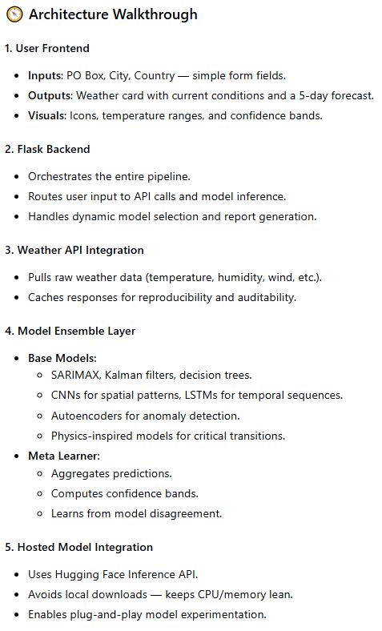

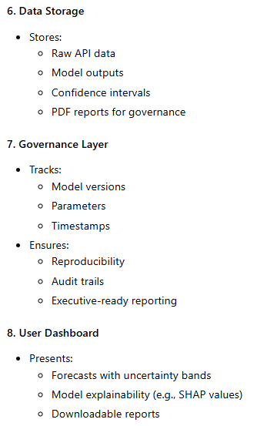

3. App design and its interaction flow
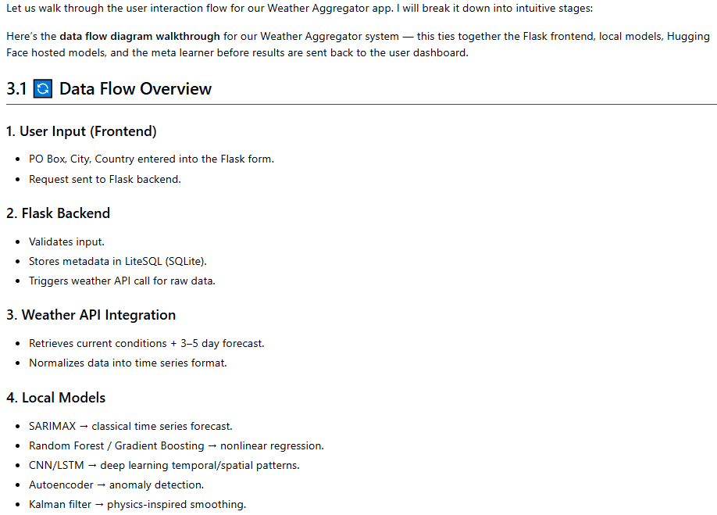
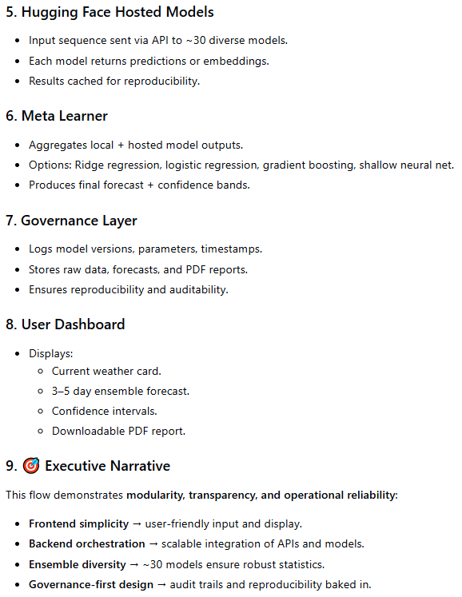

4. Run instructions and Mermaid diagrams
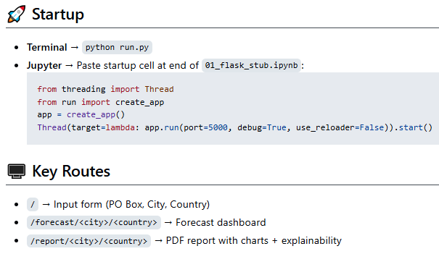
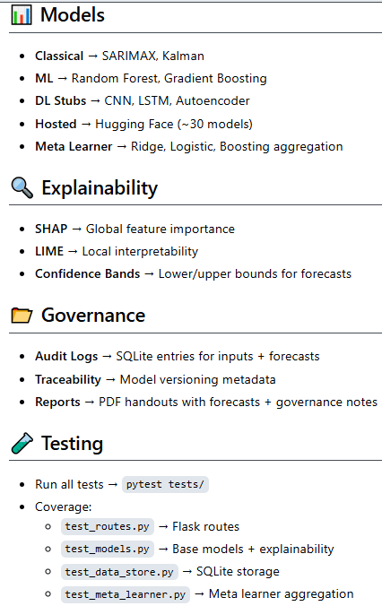

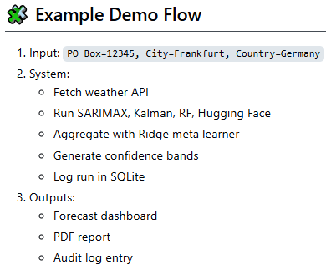

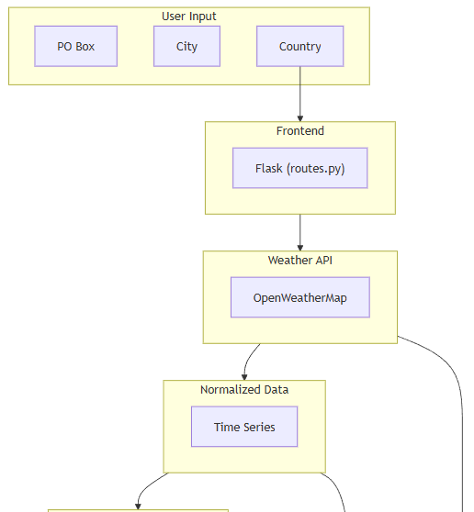

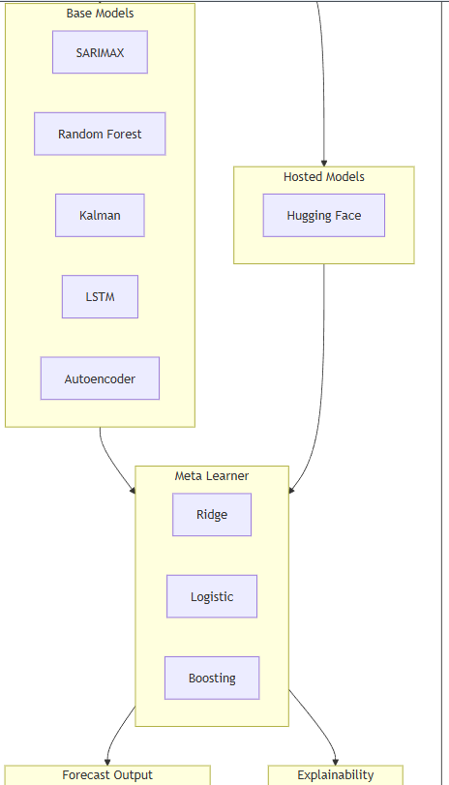

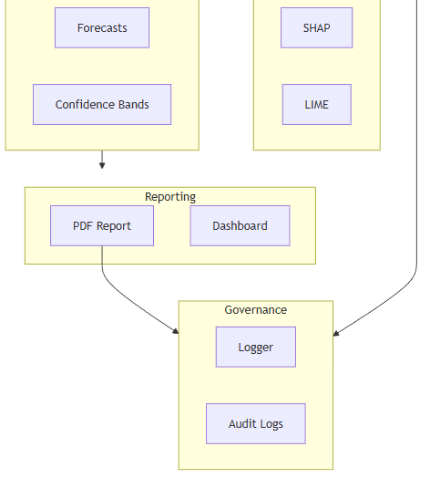

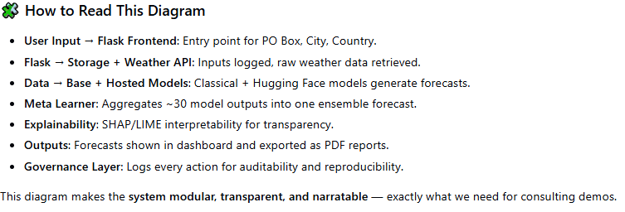
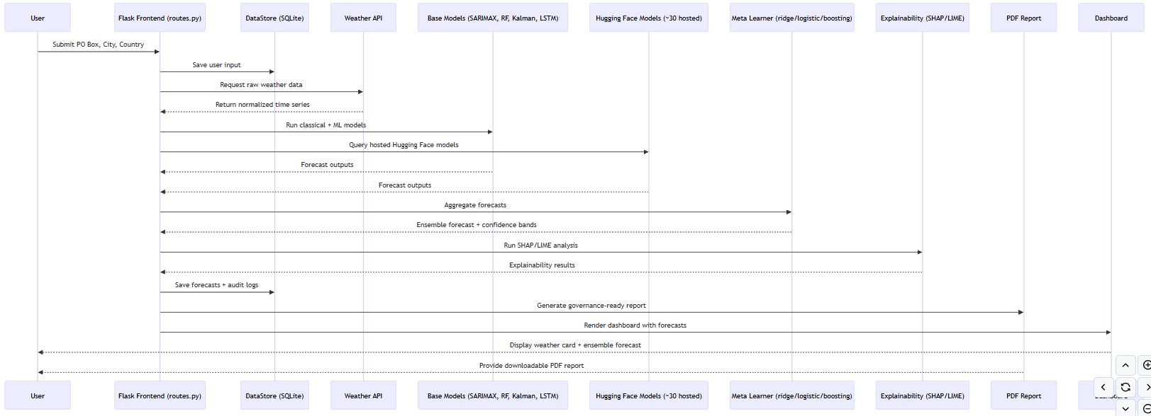
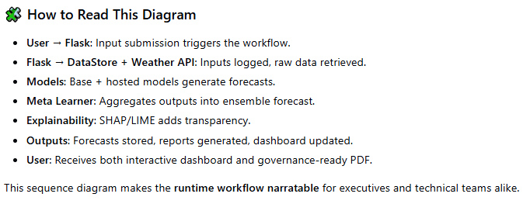

5. Modularized Pythonic implementation
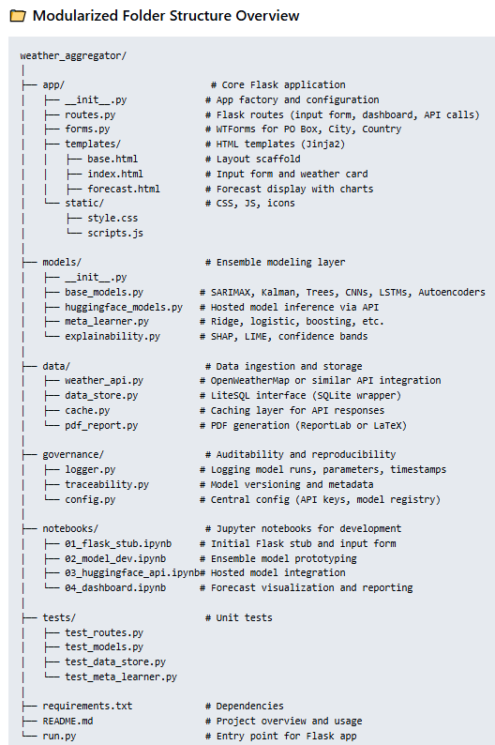
The full Pythonic code can be accessed via https://github.com/NenadBalaneskovic/ExternalProjects/blob/main/Weather_Aggregator_FlaskApp/Weather_Aggregator_FlaskApp.md (sections 2.1 – 2.10 therein).

6. Results and conclusions
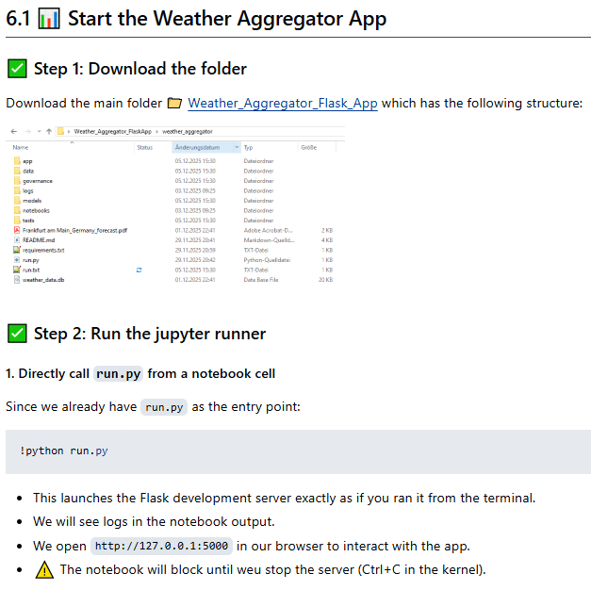

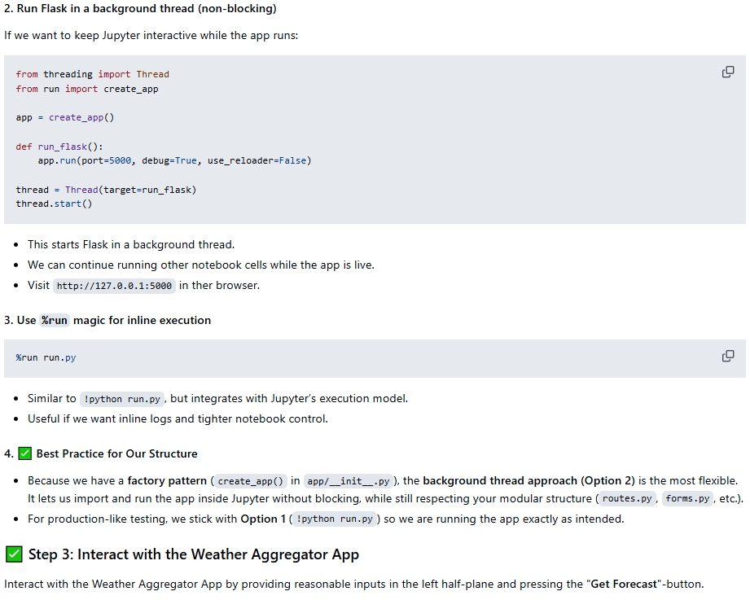
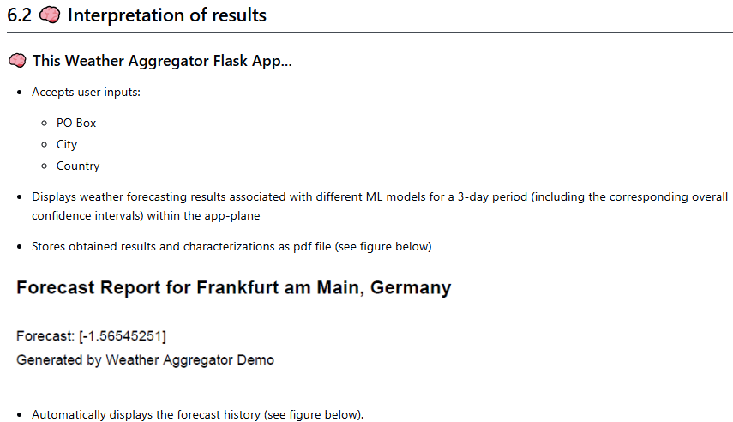
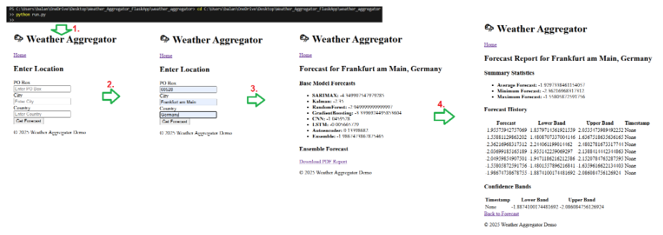
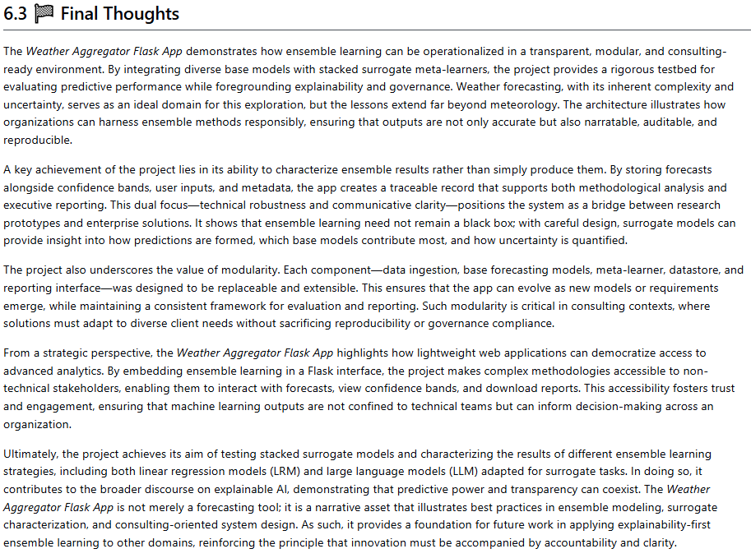

7. User Manual

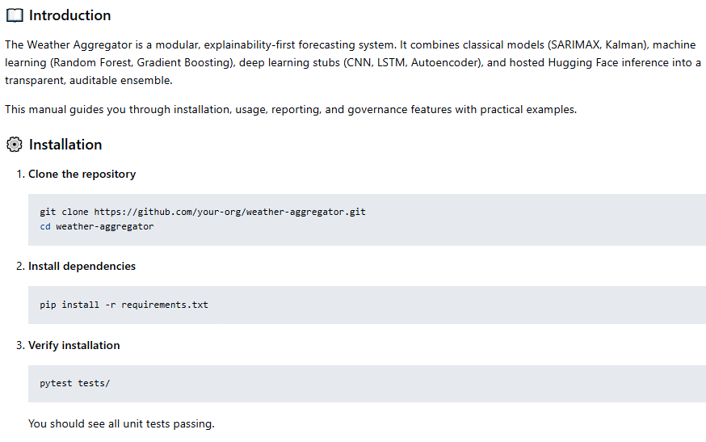
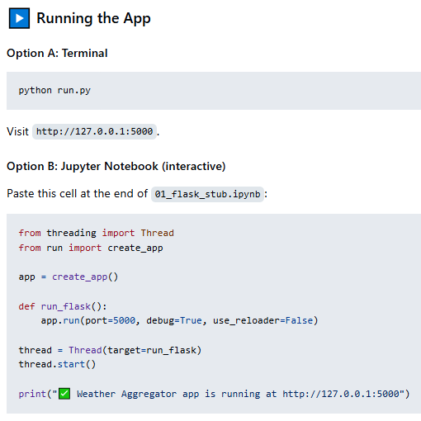

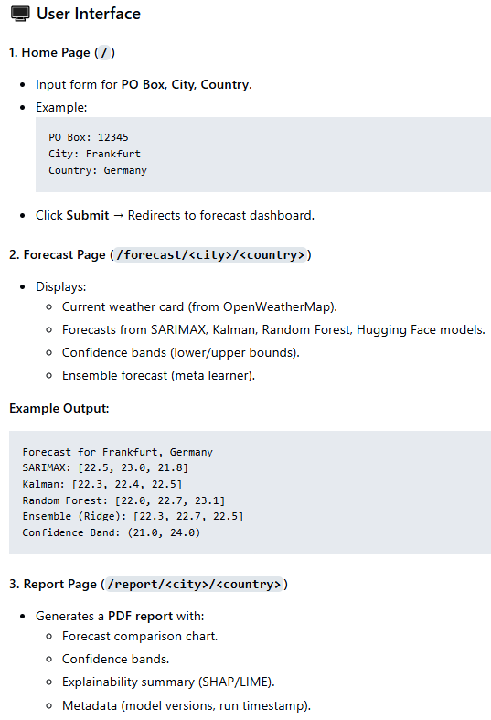
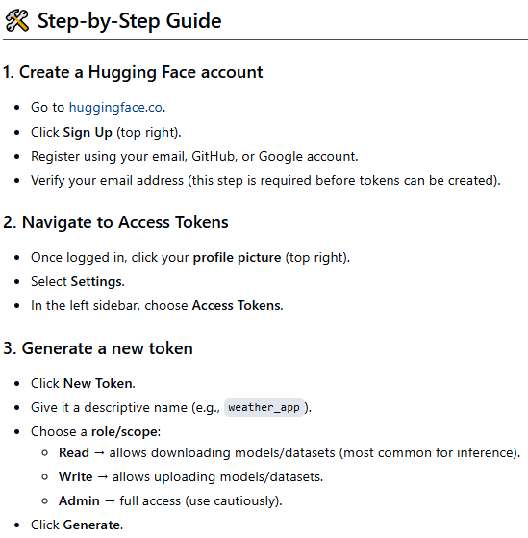
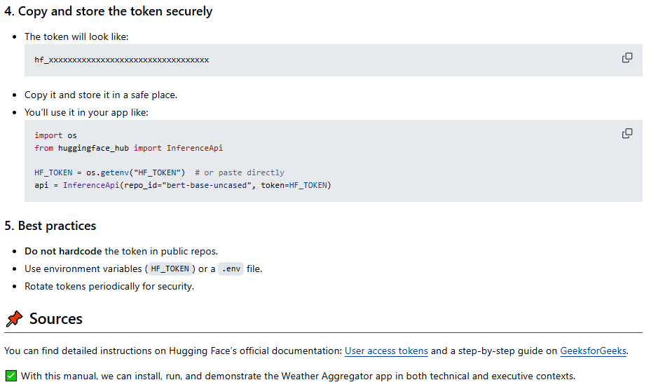

8. References
1. Chip Huyen, AI Engineering: Building Applications with Foundation Models, 1st Edition, O’Reilly Media, 2025; Michael Lanham, AI Agents in Action, 1st Edition, Manning Publications, 2025; Melanie Mitchell, Artificial Intelligence: A Guide for Thinking Humans, 1st Edition, Pelican Books, 2019; Brian Christian & Tom Griffiths, Algorithms to Live By: The Computer Science of Human Decisions, 1st Edition, Henry Holt and Company, 2016; Ray Kurzweil, The Singularity Is Nearer: When We Merge with AI, 1st Edition, Viking, 2024; OpenWeatherMap: https://openweathermap.org/, HuggingFace: https://huggingface.co/, LLM vs LRM: https://www.aryaxai.com/article/llm-vs-lrm-vs-lam-understanding-the-future-of-language-based-ai-systems, https://magazine.sebastianraschka.com/p/understanding-reasoning-llms
2. A. Meister , T. Sonar: "Numerik", 1st Ed. Springer-Spektrum (2019); S. Chapra, R. Canale: "Numerical Methods for Engineers", Mcgraw-Hill, 6th Edition (2010).
3. J. Kilty, A. M. McAllister: "Mathematical Modeling and Applied Calculus", 1st Ed. Oxford University Press (2018).
4. U. Kockelkorn: "Statistik für Anwender", 1st Ed. Springer (2012), s. chapters 7 - 8.
5. Robert H. Shumway, David S. Stoffer: "Time Series Analysis and Its Applications with R Examples", Springer (2011).
6. Gareth James, Daniela Witten, Trevor Hastie, Robert Tibshirani, Jonathan Taylor: "An Introduction to Statistical Learning with Applications in Python", Springer (2023).
7. Cornelis W. Oosterlee, Lech A. Grzelak: "Mathematical Modeling and Computation in Finance with Exercises and Python and MATLAB Computer Codes", World Scientific (2020).
8. Richard Szeliski: "Computer Vision - Algorithms and Applications", Springer (2022).
9. Anthony Scopatz, Kathryn D. Huff: "Effective Computation in Physics - Field Guide to Research with Python", O'Reilly Media (2015).
10. Alex Gezerlis: "Numerical Methods in Physics with Python", Cambridge University Press (2020).
11. Gary Hutson, Matt Jackson: "Graph Data Modeling in Python. A practical guide", Packt-Publishing (2023).
12. Hagen Kleinert: "Path Integrals in Quantum Mechanics, Statistics, Polymer Physics, and Financial Markets", 5th Edition, World Scientific Publishing Company (2009).
13. Peter Richmond, Jurgen Mimkes, Stefan Hutzler: "Econophysics and Physical Economics", Oxford University Press (2013).
14. A. Coryn , L. Bailer Jones: "Practical Bayesian Inference A Primer for Physical Scientists", Cambridge University Press (2017).
15. Avram Sidi: "Practical Extrapolation Methods - Theory and Applications", Cambridge university Press (2003).
16. Volker Ziemann: "Physics and Finance", Springer (2021).
17. Zhi-Hua Zhou: "Ensemble methods, foundations and algorithms", CRC Press (2012).
18. B. S. Everitt, et al.: "Cluster analysis", Wiley (2011).
19. Lior Rokach, Oded Maimon: "Data Mining With Decision Trees - Theory and Applications", World Scientific (2015).
20. Bernhard Schölkopf, Alexander J. Smola: "Learning with kernels - support vector machines, regularization, optimization and beyond", MIT Press (2009).
21. Johan A. K. Suykens: "Regularization, Optimization, Kernels, and Support Vector Machines", CRC Press (2014).
22. Sarah Depaoli: "Bayesian Structural Equation Modeling", Guilford Press (2021).
23. Rex B. Kline: "Principles and Practice of Structural Equation Modeling", Guilford Press (2023).
24. Ekaterina Kochmar: "Getting Started with Natural Language Processing", Manning (2022).
25. Rex B. Kline: "Principles and Practice of Structural Equation Modeling", Guilford Press (2023).
26. Ekaterina Kochmar: "Getting Started with Natural Language Processing", Manning (2022).
27. Jakub Langr, Vladimir Bok: "GANs in Action", Computer Vision Lead at Founders Factory (2019).
28. David Foster: "Generative Deep Learning", O'Reilly(2023).
29. Rowel Atienza: "Advanced Deep Learning with Keras: Applying GANs and other new deep learning algorithms to the real world", Packt Publishing (2018).
30. Josh Kalin: "Generative Adversarial Networks Cookbook", Packt Publishing (2018).
31. Thomas Haslwanter: „Hands-on Signal Analysis with Python: An Introduction“, Springer (2021).
32. Jose Unpingco: „Python for Signal Processing“, Springer (2023).
33. R. K. Burdick, C. M. Borror, D. C. Montgomery: "Design and Analysis of Gauge R&R Studies", 1st Ed. SIAM (2005); S. H. Derakhshan , C. V. Deutsch: "Numerical Integration of Bivariate Gaussian Distribution", Paper 405, CCG Anual Report 13 (2011).
34. C. Paar, J. Pelzl: "Understanding Cryptography", Springer (2010); H. Delfs, H. Knebl: "Introduction to Cryptography", 3rd Ed. Springer (2015); J. Katz, Y. lindell: "Introduction to Modern Cryptography", 2nd Ed, CRC Press (2015); O. Goldreich: "Foundations of Cryptography", Cambridge University Press (2008); J. P. Aumasson: "Serious Cryptography", no starch press (2018).
35. Kaggle-link: competition-documentation: https://www.kaggle.com/competitions/drw-crypto-market-prediction. R. Nystrom: „Game Programming Patterns“, 1st Ed. genever benning (2014); A. A. Stepanov, D. E. Rose: „From Mathematics to Generic Programming“, 1st Ed. Addison-Wesley (2015);
36. J. Berk, P. DeMarzo: „Corporate Finance“, 6th Ed., Pearson (2023); R. W. Melicher, E. A. Norton: "Introduction to Finance", 16th Ed. WILEY (2017); Anatoly B. Schmidt: "Quantitative Finance for Physicists: An Introduction", 1st Ed. Academic Press (2005); Alex Backwell: "An Intuitive Introduction to Finance and Derivatives: Concepts, Terminology and Models", 1st Ed, Springer (2023); Michael Isichenko: "Quantitative Portfolio Management: The Art and Science of Statistical Arbitrage", 1st Ed., Springer (2021); John H. Cochrane: "Asset Pricing", Revised Ed., Princeton University Press (2005); Antti Ilmanen: "Expected Returns: An Investor’s Guide to Harvesting Market Rewards", 1st Ed., WILEY (2011); Steven E. Shreve: "Stochastic Calculus for Finance I & II", 1st Ed., Springer (2004); Andrew Pole: "Statistical Arbitrage: Algorithmic Trading Insights and Techniques", 1st Ed., WILEY (2007); Mark S. Joshi: "The Concepts and Practice of Mathematical Finance", 2nd Ed., Cambridge University Press (2008);
37. E. Parzen: "Stochastic Processes", 3rd Ed. Dover Publications (2015); S. Aloorravi: "Metaprogramming with Python", 1st Ed. Packt (2022); B. Klein, P. Klein: "Funktionale Programmierung mit Python", Hanser (2025); K. Webel, D. Wied: "Stochastische Prozesse", 2. Auflage Springer (2016); L. Held: "Methoden der statistischen Inferenz", 1. Auflage Spektrum (2008); E. Cinlar: "Stochastic Processes", Dover (2013); N. Bäuerle, U. Rieder: "Finanzmathematik in diskreter Zeit", Springer-Spektrum (2017); M. Albrecht, R. Maurer: "Investment- und Risikomanagement", 3. Auflage, Schäffer Poeschel (2008); N. H. Bingham, R. Kiesel: "Risk Neutral Valuation: Pricing and Hedging of Financial Derivatives", 2. Auflage Springer (2004); T. Björk: "Arbitrage Theory in Continuous Time", 3rd Ed. Oxford University Press (2009); N. J. Cutland, A. Roux: "Derivative Pricing in Discrete Time", Springer (2013); F. Delbaen, W. Schachermayer: "The Mathematics of Arbitrage", Springer (2006); R. J. Elliott, P. E. Kopp: "Mathematics of Financial Markets", 2nd Ed. Springer (2005); H. Föllmer, A. Scheid: "A Stochastic Finance: An Introduction in Discrete Time", 3rd Ed. de Gruyter (2011); J. C. Hull: "Options, Futures and Other Derivatives", 8th Ed. Pearson (2011); J. Kremer: "Einführung in die diskrete Finanzmathematik", Springer (2005); D. Lamberton, B. Lapeyre: "Introduction to Stochastic Calculus Applied to Finance", Chapman & Hall (2007); D. G. Luenberger: "Investment Science", Oxford University Press (1998); S. R. Pliska: "Introduction to Mathematical Finance: Discrete Time Models", Blackwell (2000); A. N. Shiryaev: "Essentials of Stochastic Finance", World Scientific (2001); S. E. Shreve: "Stochastic Calculus for Finance I: The Binomial Asset Pricing Model", Springer (2004); J. Kremer: "Portfoliotheorie, Risikomanagement und die Bewertung von Derivaten", Springer (2011); L. Rüschendorf: "Mathematical Risk Analysis", Springer (2013).
38. A. Becker: "Kalman Filter - From the Ground Up", 1st Ed. private publication (2023); K. Triantafyllopoulos: "Bayesian Inference of State Space Models", 1st Ed. Springer (2021); P. Zarchan, H. Musoff: "Fundamentals of Kalman Filtering: A Practical Approach", 3rd Ed. AIAA (2009); A. Sidi: "Vector Extrapolation Methods with Applications", 1st Ed. SIAM (2019); C. Brezinski, M. R. Zaglia: "Extrapolation Methods - Theory and Practice", 2nd Ed. North-Holland (2002); C. Gardiner, P. Zoller: "Quantum Noise: A Handbook of Markovian and Non-Markovian Quantum Stochastic Methods with Applications to Quantum Optics", 3rd Ed. Springer (2004); K. Kendre: "Machine Learning for Quantum Noise Reduction", https://arxiv.org/abs/2509.16242 (2025); D. C. Marinescu, G. M. Marinescu: "Classical and Quantum Information", 1sr Ed. Academic Press (2012); Liao, H et al.: "Machine Learning for Practical Quantum Error Mitigation", arXiv:2309.17368v2 (2024), https://arxiv.org/pdf/2309.17368; Streamlit: https://streamlit.io/; Mitiq-package: https://quantum-journal.org/papers/q-2022-08-11-774/, https://arxiv.org/abs/2009.04417; Extrapolation packages: https://pypi.org/project/extrapolation/
39. A. Koop, H. Moock: "Lineare Optimierung - Eine anwendungsorientierte Einführung in Operations Research", 1st Ed. Spektrum (2008); G, B, Dantzig, M. N. Thalpa: "Linear Programming 1: Introduction", 1st Ed. Springer (1997) & "Linear Programming 2: Theory and Extensions", 1st Ed. Springer (2003); H. S. Kasana, K. D. Kumar: "Introductory Operations Research, Theory and Applications", 1st Ed. Springer (2004); D. G. Luenberger: "Linear and Nonlinear Programming", 2nd Ed. Kluwer (2004); R. J. Boucherie, A. Braaksma, H. Tijms: "Operations Research - Introduction to Models and Methods", 1st Ed. World Scientific (2022); A. J. King, S. W. Wallace: "Modeling with Stochastic Programming", 2nd Ed. Springer (2024); J. O. Royset, R. J.-B. Wets: "An Optimization Primer", 1st Ed. Springer (2021); cvxpy package: https://www.cvxpy.org/, https://pypi.org/project/cvxpy/; py-packages for operations research: https://wiki.python.org/moin/PythonForOperationsResearch
40. (Py-)tesseract package: https://github.com/tesseract-ocr/tesseract, https://pypi.org/project/pytesseract/, https://builtin.com/data-science/python-ocr, https://www.analyticsvidhya.com/blog/2024/04/ocr-libraries-in-python/ and UB Mannheim builds.

