SARIMAX-Akima Forecasting

of

Stock Price Time Trends

Inhaltsverzeichnis
1. Data set description 3
Content 3
2. Akima interpolation of stock prices 4
2.1 Remarks on Akima interpolation 5
2.2 Sources 5
3. Adaptive Pythonic Trend Detection with Akima Interpolation 6
3.1 Interpretation of graphed stock price trends 8
3.2 On Akima trend forecasting via the theory of critical phenomena 9
3.3 Further ideas and refinements 10
4. Forecasting of Akima interpolated stock prices via SARIMAX 10
4.1 Advantages of SARIMAX Forecasting 10
4.2 Resources 13
5. Batching function 14
6. SARIMAX with batching 17
7. Conclusions 18

1. Data set description

Content
This is a ficticious data set „stock_prices.csv“ of stock prices from January 1st 2025 until July 31st 2025 with the following csv structure:
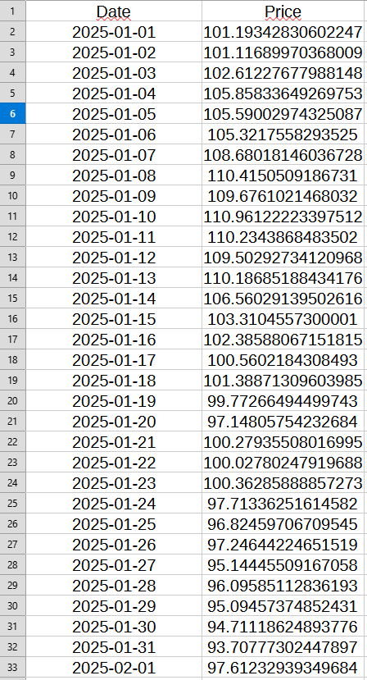

The data set contains two columns:
1) „Date“: Date information formatted as „YYY-MM-DD“;
2) „Price“: Closing price of a stock for the particular trading day (float).
The data set has been generated by means of the following python function:

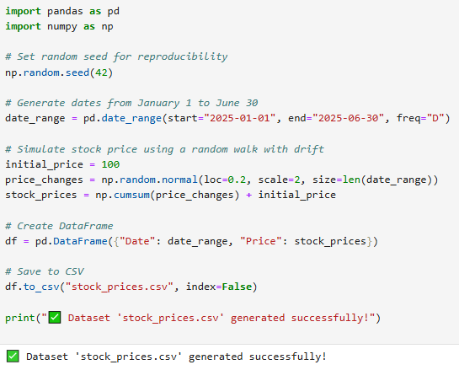

2. Akima interpolation of stock prices
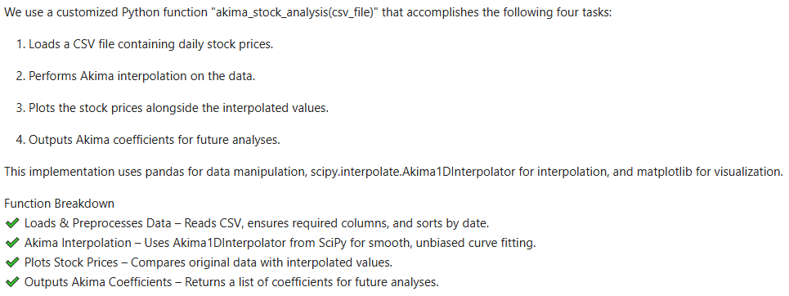
The function is triggered as follows:
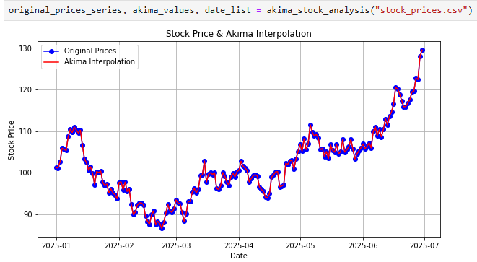

2.1 Remarks on Akima interpolation

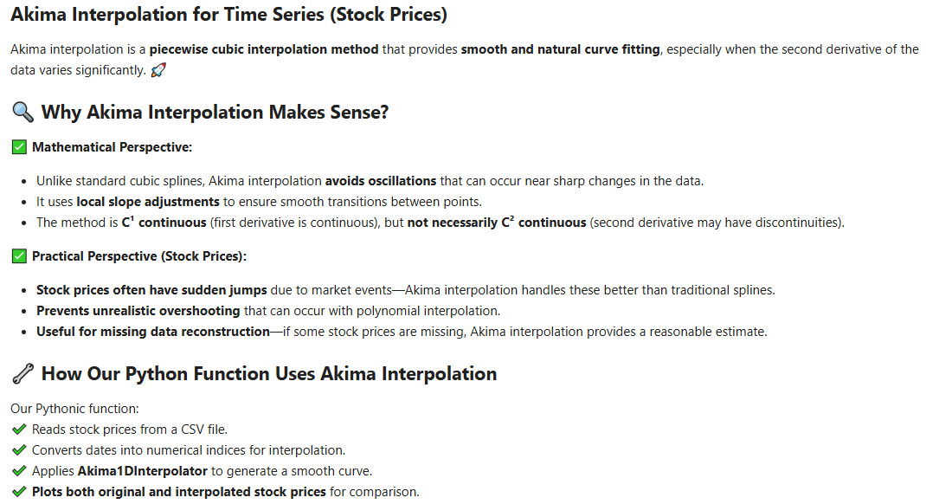

2.2 Sources

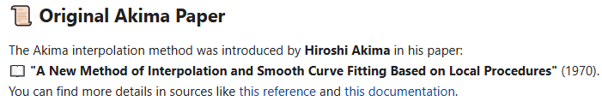

3. Adaptive Pythonic Trend Detection with Akima Interpolation

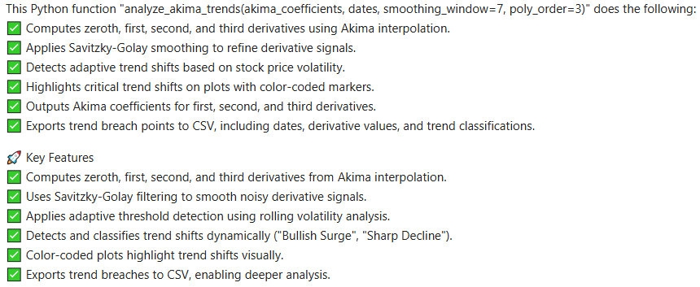

The function is triggered as follows:

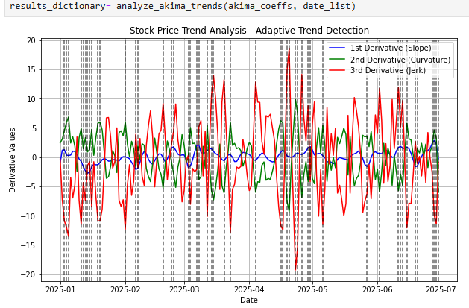
This graph corresponds to the following csv file structure „critical_trends.csv“ generated as a result of the above pythonic function, containing calculated values of first and second derivative with respect to specific dates of an Akima interpolated stock price curve, as well as the trend type characterisation emerging from these two parameters:

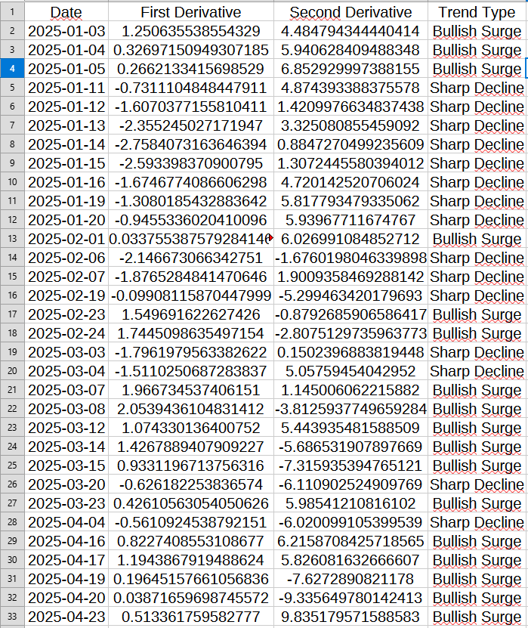

3.1 Interpretation of graphed stock price trends

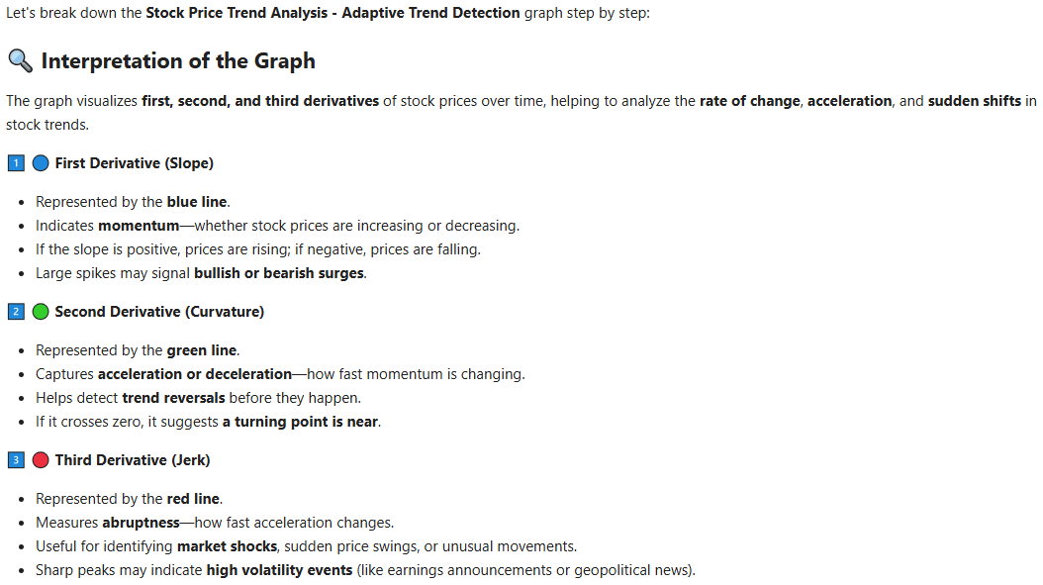
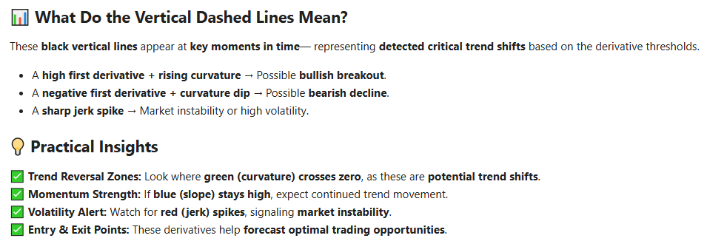

3.2 On Akima trend forecasting via the theory of critical phenomena

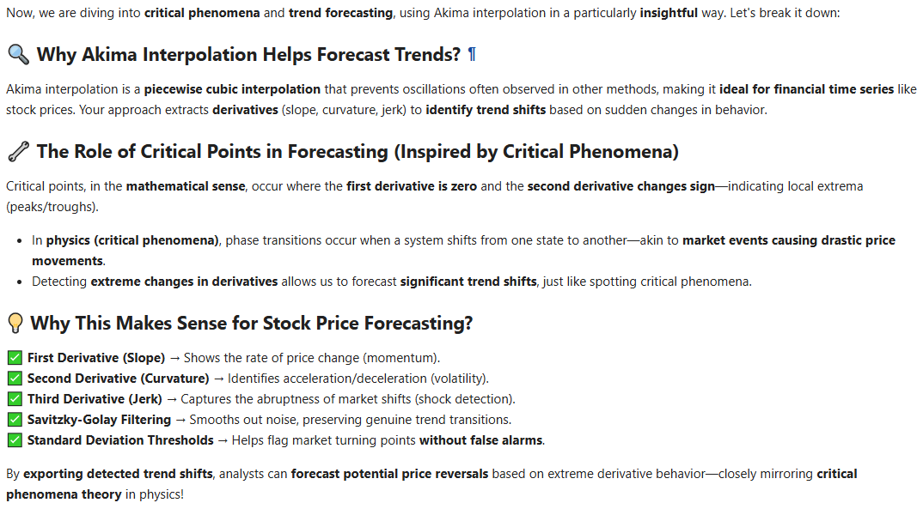

3.3 Further ideas and refinements

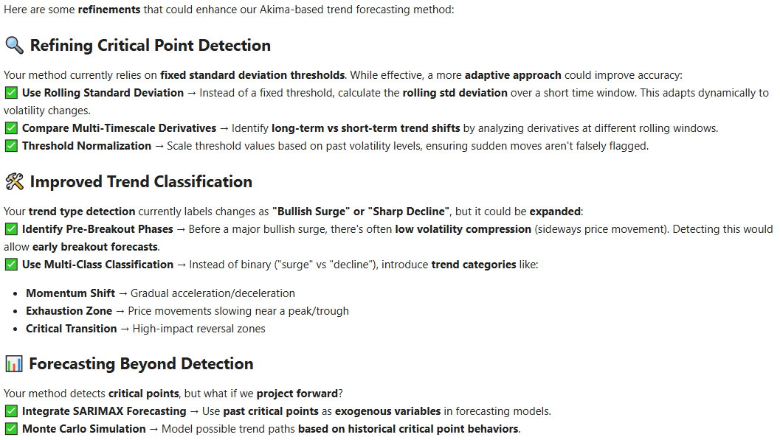

4. Forecasting of Akima interpolated stock prices via SARIMAX

4.1 Advantages of SARIMAX Forecasting

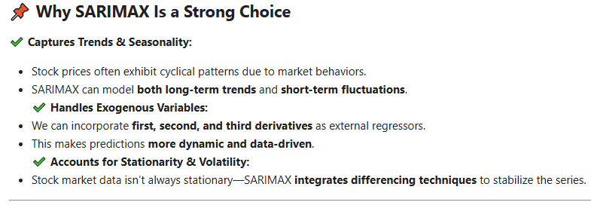
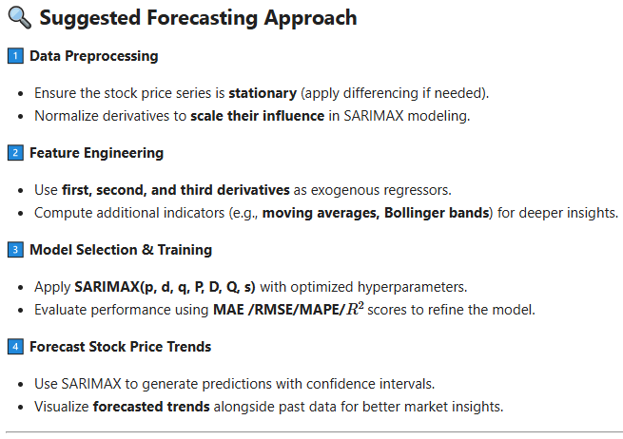
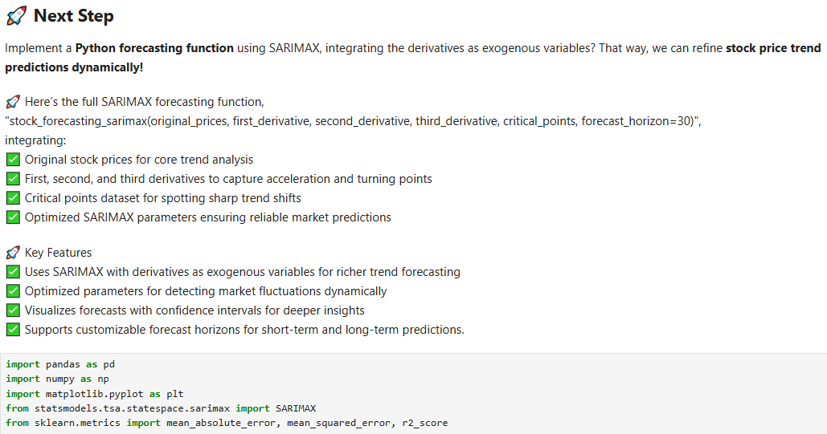
The function is triggered as follows:

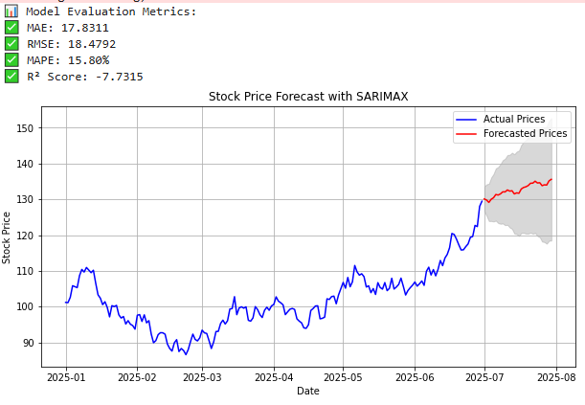

Apparently, Akima interpolated SARIMAX forecasting does manage to reconstruct the appropriate volatility range of unknown time series trends, as the following visual comparison suggests:

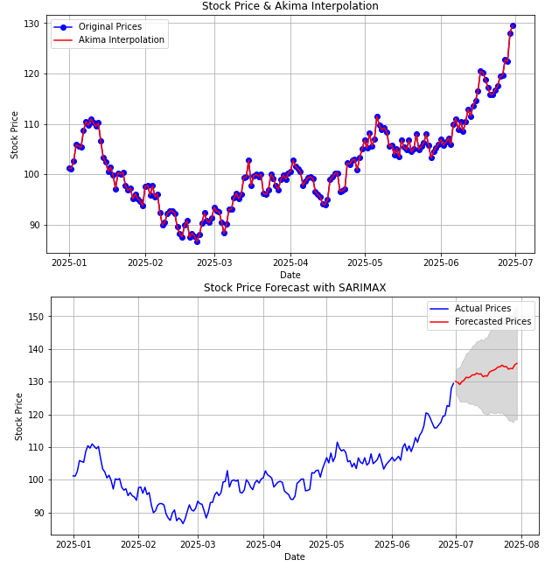

4.2 Resources

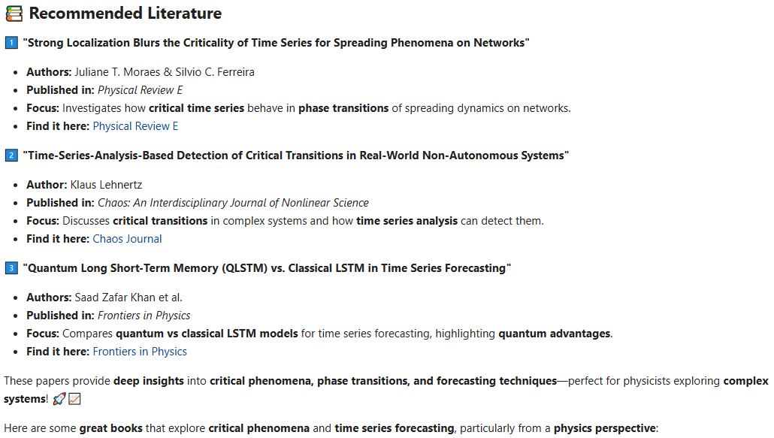
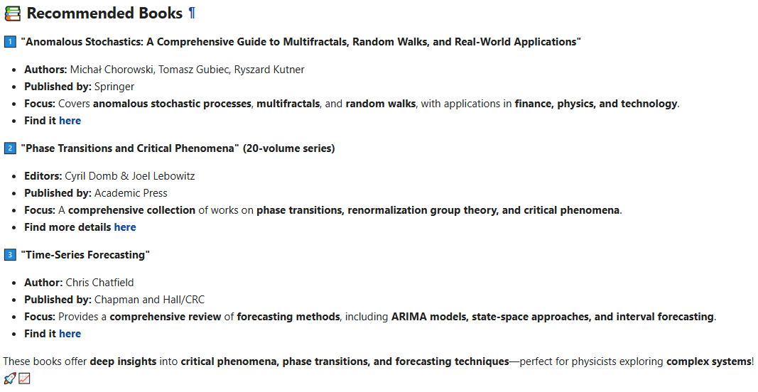

5. Batching function

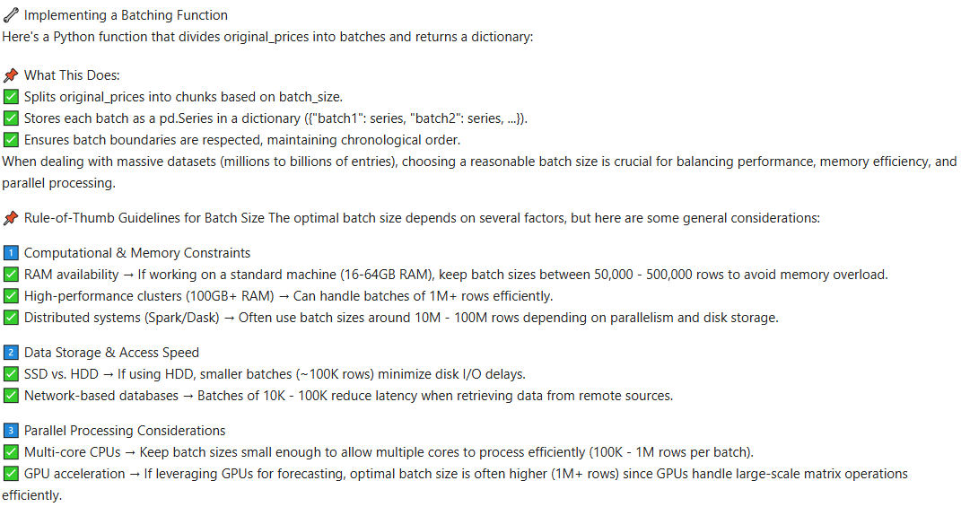
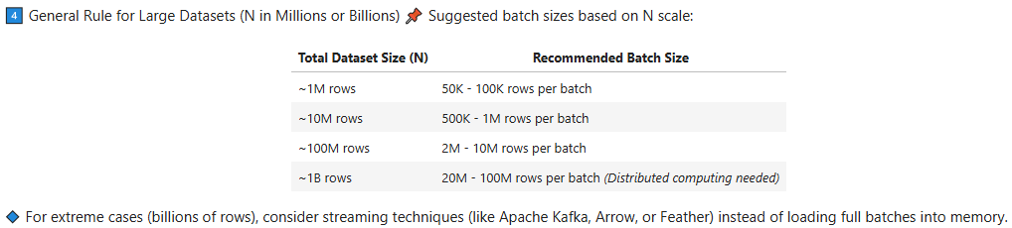
The following pythonic function implements this batching procedure:

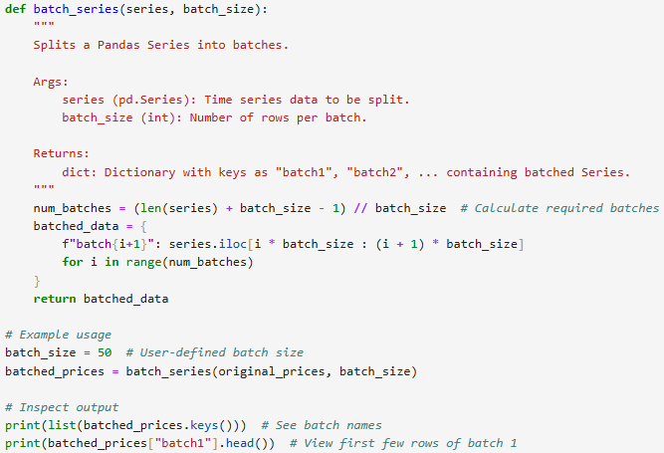
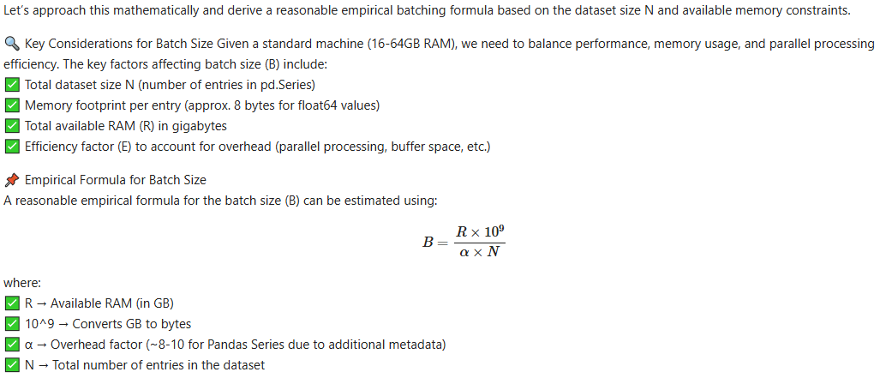
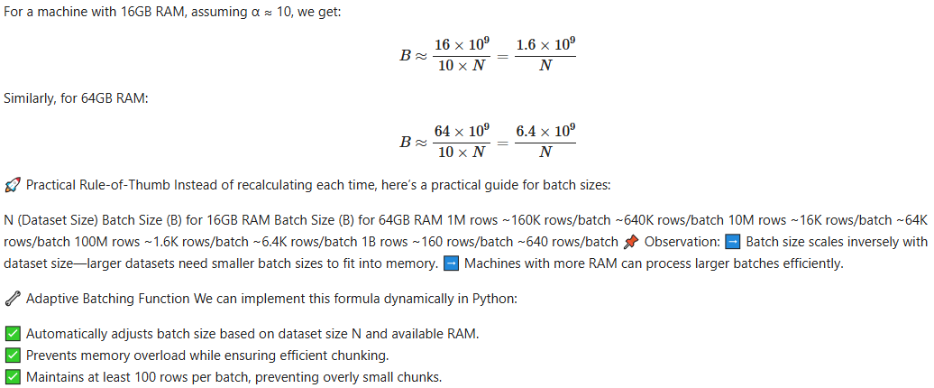
The following pythonic function implements the adaptive batching procedure:
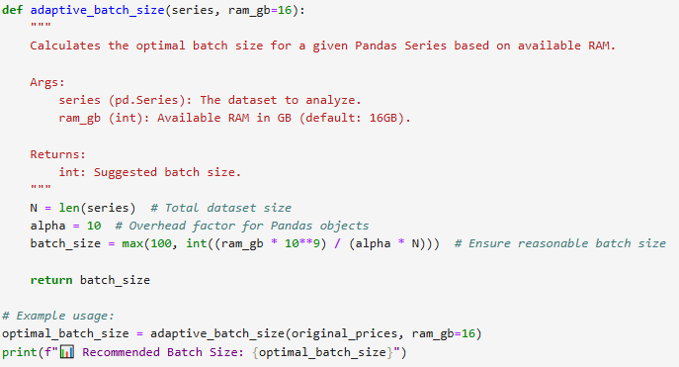

6. SARIMAX with batching
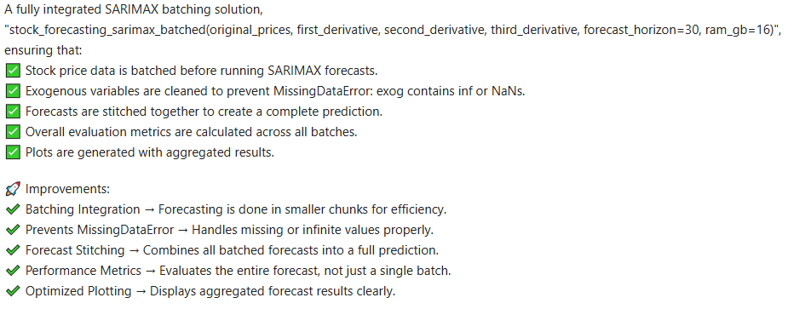
This function is triggered as follows:
„forecast_df = stock_forecasting_sarimax_batched(original_prices_series, first_derivative_series, second_derivative_series, third_derivative_series, ram_gb=16)“:

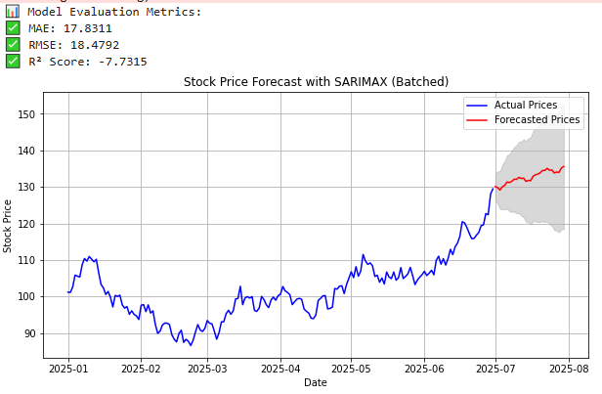
This reproduces the non-batched forecasts.

7. Conclusions

Non-batched execution time: 2.13 seconds
Batched execution time: 2.18 seconds.

