Sensor Housing

Stress Test GUI with

static and FEM modeling

Inhaltsverzeichnis
1. Project description 3
Aim 3
🎯 Primary Aim 3
2. GUI and algorithmic concepts 4
3. App design and its interaction flow 8
4. Run instructions and Mermaid diagrams 10
5. Modularized Pythonic implementation 13
6. Results and conclusions 14
7. User Manual 17
8. References 19

1. Project description

Aim
The Sensor Housing Stress Test Simulator is a modular, GUI-based engineering platform designed to evaluate the robustness of regular polygonal (n-gonal) sensor housings under external mechanical forces and thermal loads. Modern sensors are increasingly deployed in environments where they must withstand both mechanical stress and thermal fluctuations, and their housings play a critical role in ensuring reliability, safety, and longevity. This simulator was conceived to provide engineers, researchers, and consultants with a transparent, reproducible, and narratable tool for exploring how geometry, force, and heat interact in sensor housing design.
At its core, the simulator unifies two complementary analytical approaches: rod-construction framework statics (classical technical mechanics) and simplified finite element methods (FEM). Rod statics provide fast, interpretable estimates of stress and heat distribution, offering immediate intuition about how loads propagate through polygonal structures. FEM analysis, by contrast, introduces higher fidelity through mesh-driven distributions and interpolated heatmaps, enabling users to visualize stress and thermal fields across the entire housing. Together, these methods balance speed and interpretability with precision and detail, making the simulator suitable for both exploratory design and governance-ready reporting.
The simulator emphasizes explainability, reproducibility, and stakeholder communication. Every simulation run produces not only real-time visualizations but also structured exports in JSON, TXT, and CSV formats, alongside a governance-ready PDF report. These artifacts ensure that results are traceable, auditable, and shareable across technical and non-technical teams. The inclusion of an Explainable AI (XAI) summary further enhances transparency by narrating the results in plain language, highlighting maxima and resilience context, and situating findings within the broader design goals (see References 1 - 3 below).

🎯 Primary Aim
Sensor housings must balance structural integrity and thermal resilience. Corner placement and polygonal symmetry directly influence peak stress and hot spots, which can compromise performance if not properly managed. Rod statics deliver fast, interpretable estimates, while FEM introduces higher fidelity with mesh-driven distributions and interpolated fields. Engineering decisions require traceable artifacts, and the simulator ensures this by producing consistent plots and structured datasets alongside a PDF report enriched with an explainable summary.
In essence, the Sensor Housing Stress Test Simulator is not just a computational tool—it is a narrative platform for engineering analysis. By transforming raw simulation data into transparent, reproducible, and communicable insights, it empowers teams to make informed decisions with confidence. The simulator bridges classical mechanics and FEM within a modern GUI, enabling users to explore, validate, and document sensor housing resilience in a way that is both technically rigorous and stakeholder-friendly.

2. GUI and algorithmic concepts
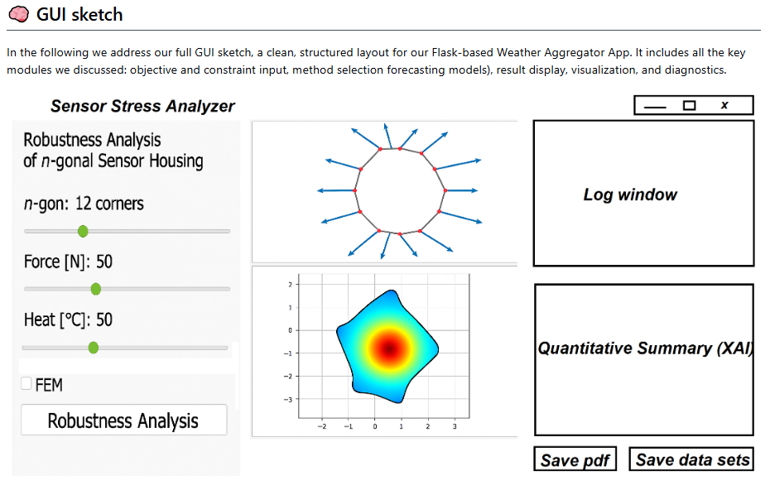
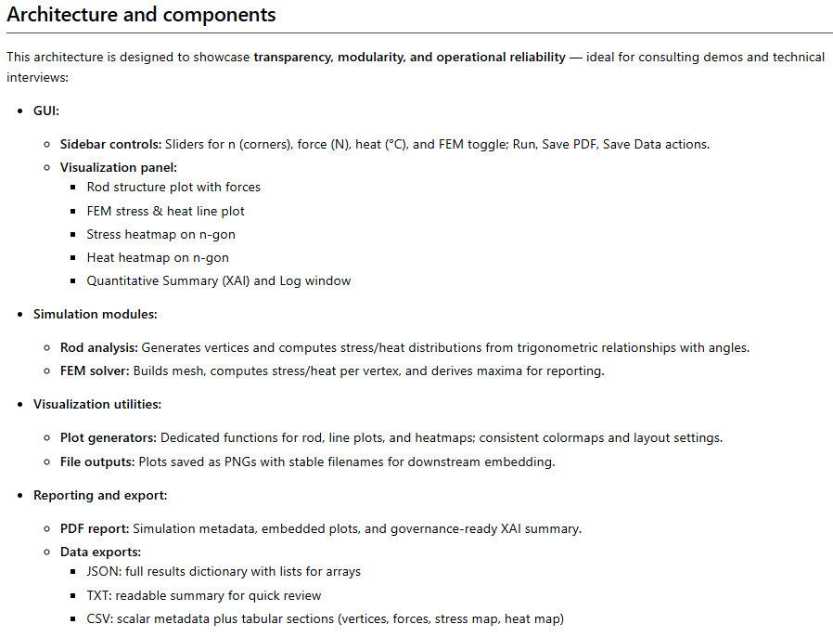
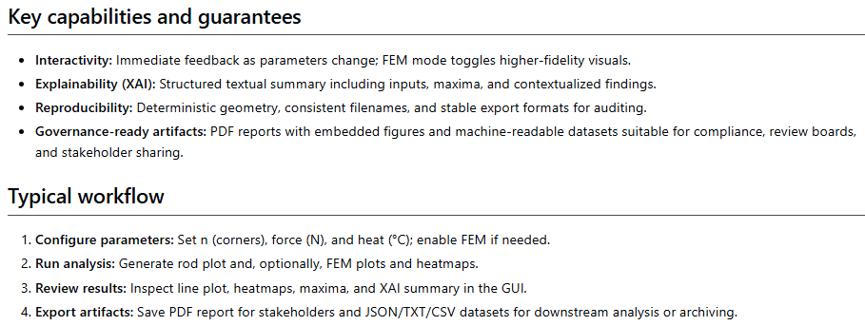
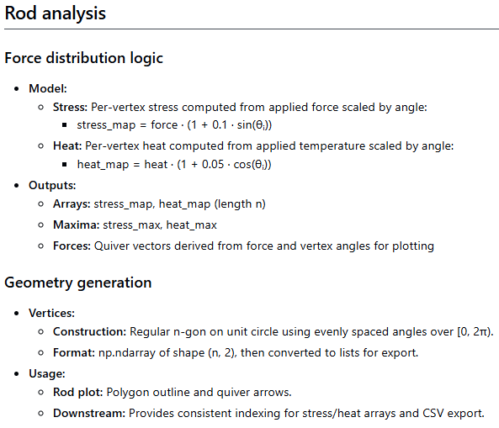
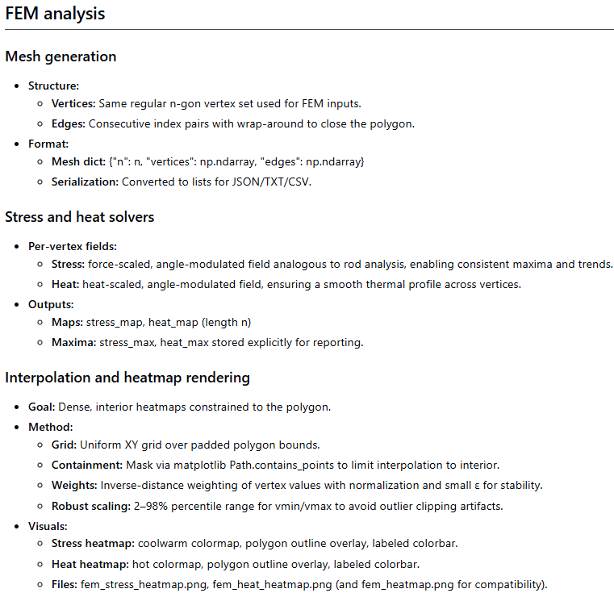

3. App design and its interaction flow
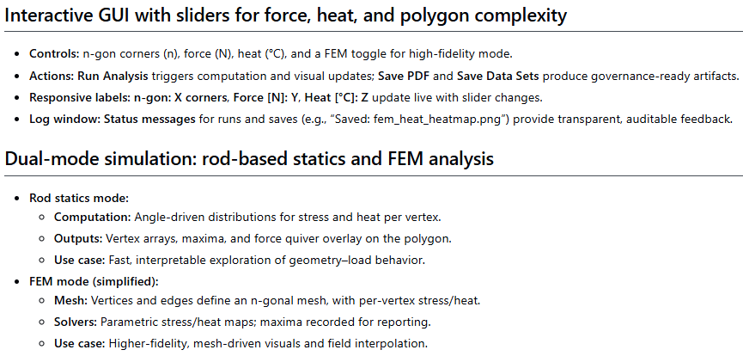
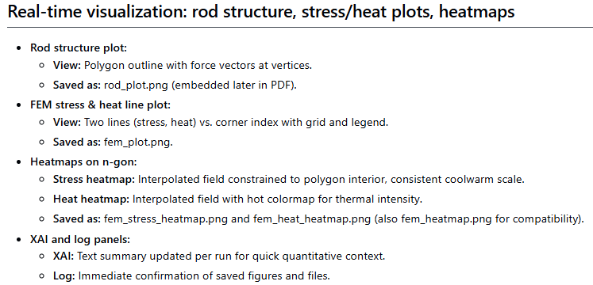
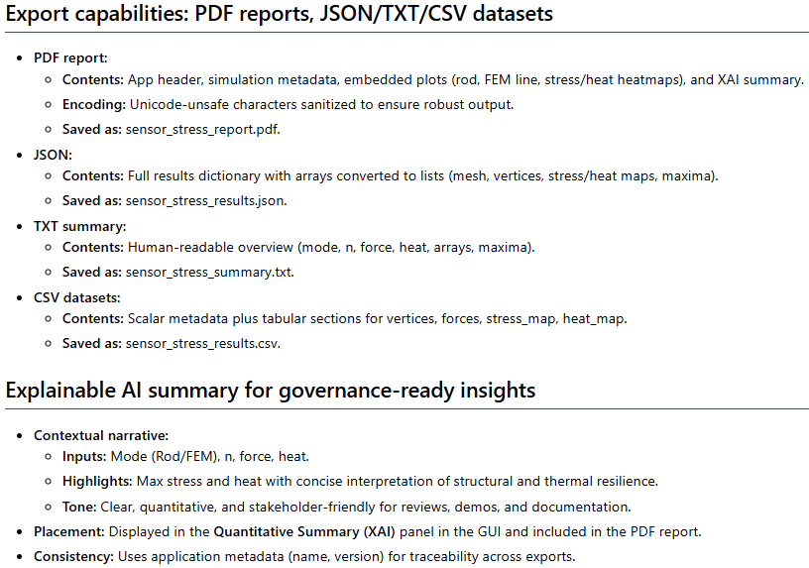

4. Run instructions and Mermaid diagrams

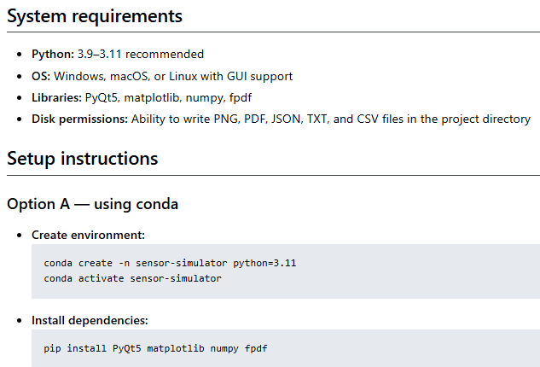
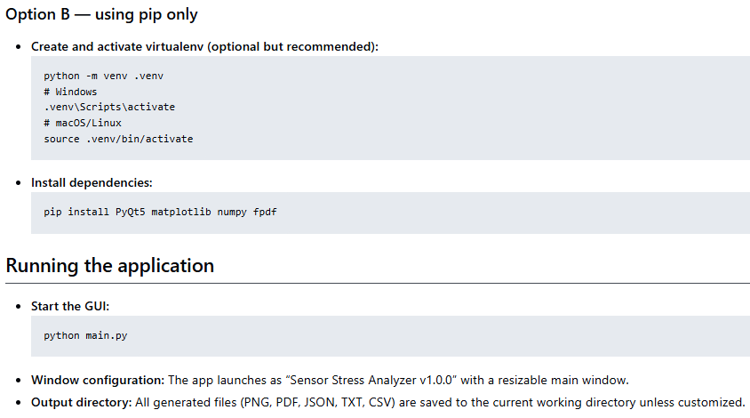

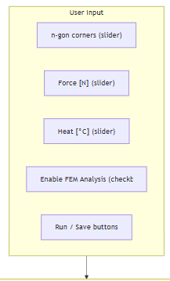

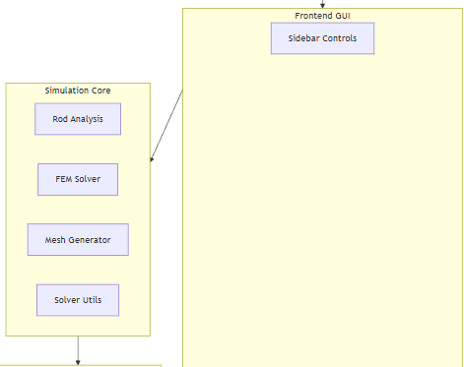

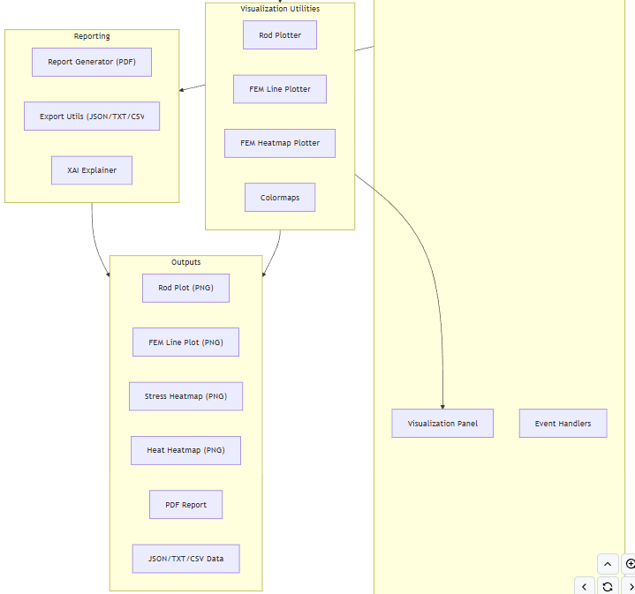
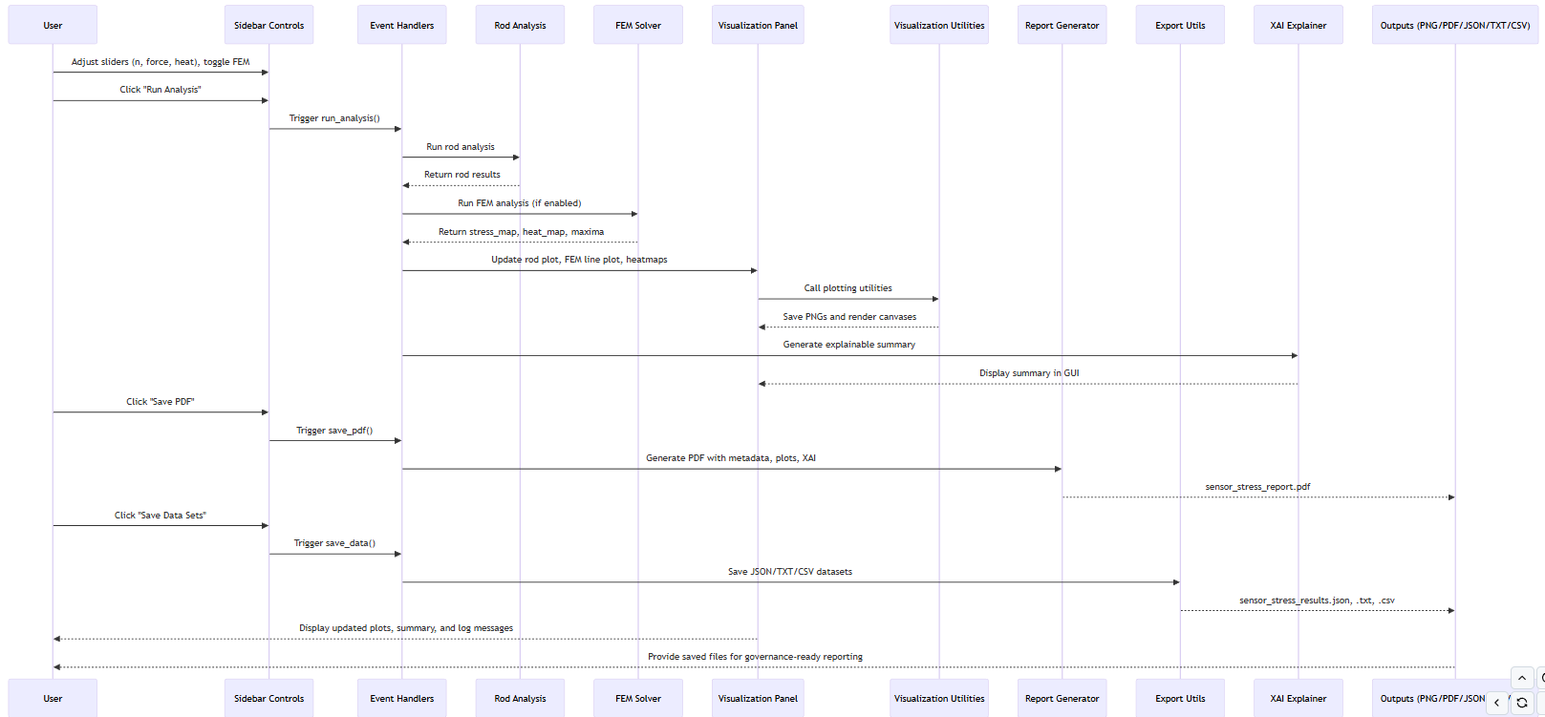

5. Modularized Pythonic implementation

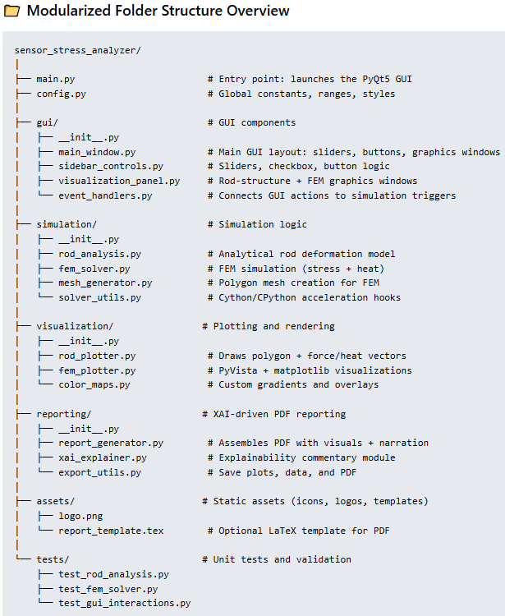

The full Pythonic code can be accessed via https://github.com/NenadBalaneskovic/ExternalProjects/blob/8deacd338f01273e37fc45742cd6214fba325aa6/SensorHousingStressTest_SimulatorGUI/SensorHousingStressTest_SimulatorGUI.md (section 7 therein).

6. Results and conclusions

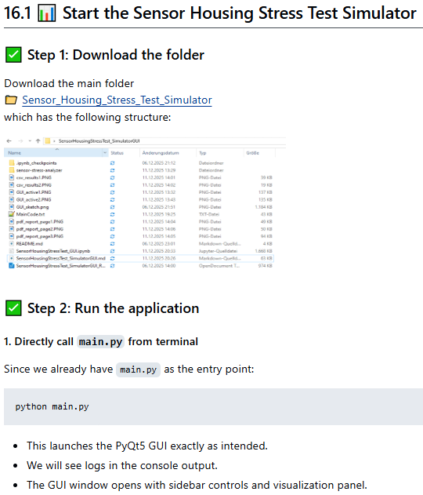
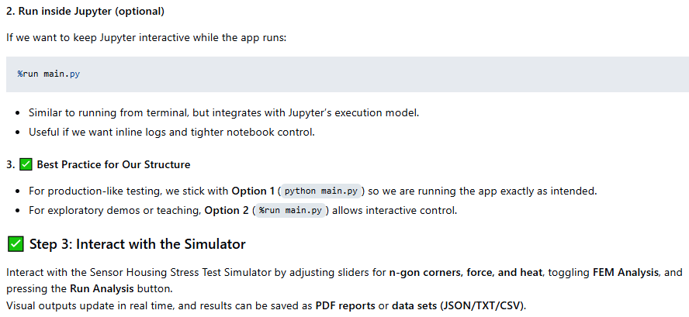
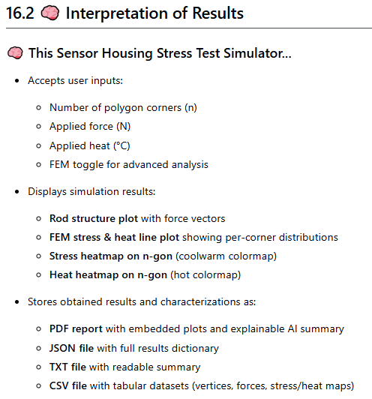

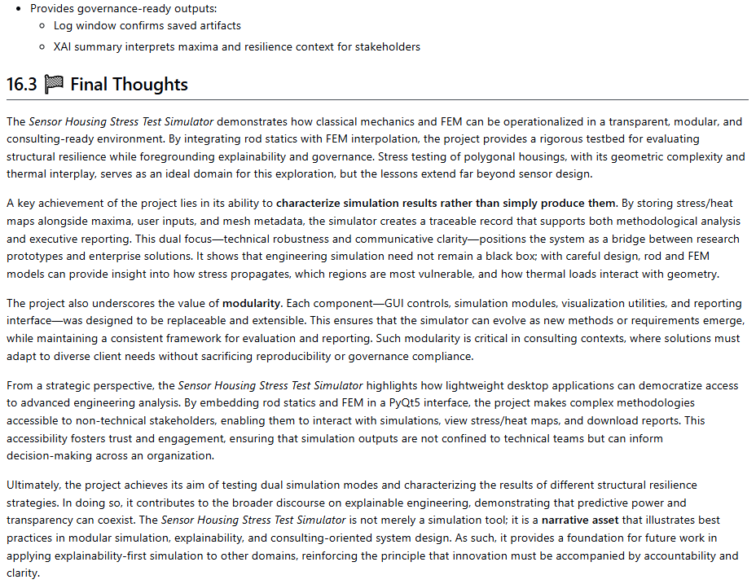

7. User Manual
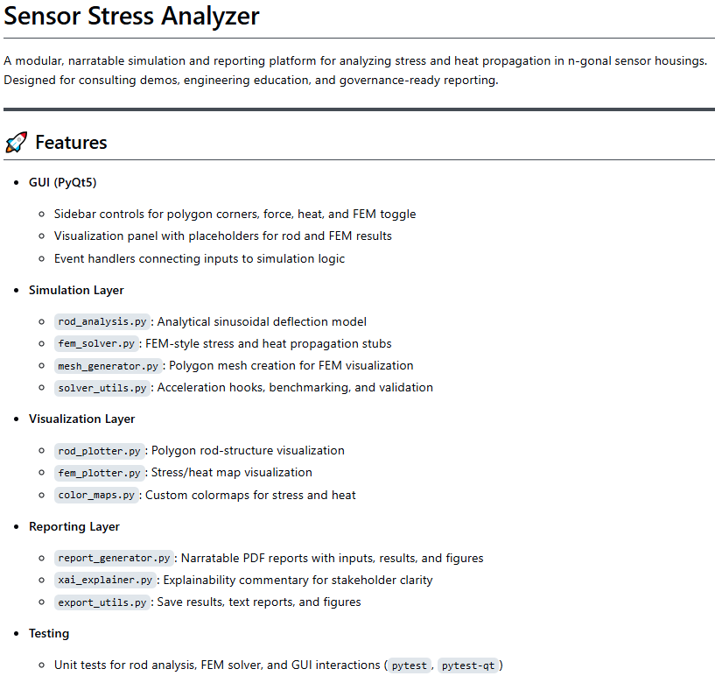

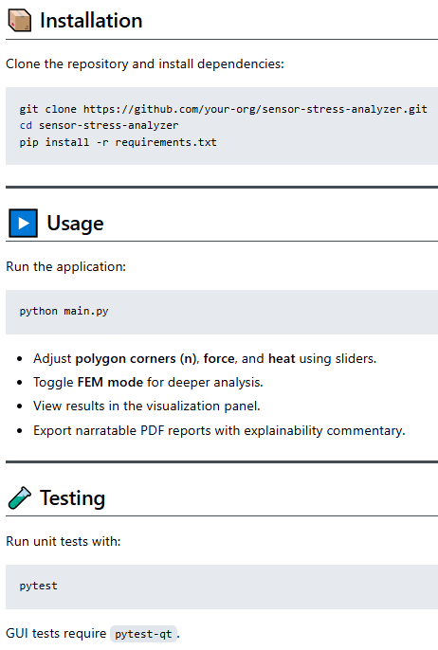

8. References
1. J. Frochte: "Finite-Elemente-Methode", Hanser 1st Ed.(2016); D. Gross, W. Hauger, J. Schröder: "Technische Mechanik 1-3", 15th Ed. Springer (2024); FEM-packages (Python): https://pypi.org/project/scikit-fem/, https://sfepy.org/doc-devel/index.html, https://getfem-examples.readthedocs.io/en/latest/demo_unit_disk.html, https://github.com/mlp6/fem. LLM vs LRM: https://www.aryaxai.com/article/llm-vs-lrm-vs-lam-understanding-the-future-of-language-based-ai-systems, https://magazine.sebastianraschka.com/p/understanding-reasoning-llms
2. A. Meister , T. Sonar: "Numerik", 1st Ed. Springer-Spektrum (2019); S. Chapra, R. Canale: "Numerical Methods for Engineers", Mcgraw-Hill, 6th Edition (2010).
3. J. Kilty, A. M. McAllister: "Mathematical Modeling and Applied Calculus", 1st Ed. Oxford University Press (2018).
4. U. Kockelkorn: "Statistik für Anwender", 1st Ed. Springer (2012), s. chapters 7 - 8.
5. Robert H. Shumway, David S. Stoffer: "Time Series Analysis and Its Applications with R Examples", Springer (2011).
6. Gareth James, Daniela Witten, Trevor Hastie, Robert Tibshirani, Jonathan Taylor: "An Introduction to Statistical Learning with Applications in Python", Springer (2023).
7. Cornelis W. Oosterlee, Lech A. Grzelak: "Mathematical Modeling and Computation in Finance with Exercises and Python and MATLAB Computer Codes", World Scientific (2020).
8. Richard Szeliski: "Computer Vision - Algorithms and Applications", Springer (2022).
9. Anthony Scopatz, Kathryn D. Huff: "Effective Computation in Physics - Field Guide to Research with Python", O'Reilly Media (2015).
10. Alex Gezerlis: "Numerical Methods in Physics with Python", Cambridge University Press (2020).
11. Gary Hutson, Matt Jackson: "Graph Data Modeling in Python. A practical guide", Packt-Publishing (2023).
12. Hagen Kleinert: "Path Integrals in Quantum Mechanics, Statistics, Polymer Physics, and Financial Markets", 5th Edition, World Scientific Publishing Company (2009).
13. Peter Richmond, Jurgen Mimkes, Stefan Hutzler: "Econophysics and Physical Economics", Oxford University Press (2013).
14. A. Coryn , L. Bailer Jones: "Practical Bayesian Inference A Primer for Physical Scientists", Cambridge University Press (2017).
15. Avram Sidi: "Practical Extrapolation Methods - Theory and Applications", Cambridge university Press (2003).
16. Volker Ziemann: "Physics and Finance", Springer (2021).
17. Zhi-Hua Zhou: "Ensemble methods, foundations and algorithms", CRC Press (2012).
18. B. S. Everitt, et al.: "Cluster analysis", Wiley (2011).
19. Lior Rokach, Oded Maimon: "Data Mining With Decision Trees - Theory and Applications", World Scientific (2015).
20. Bernhard Schölkopf, Alexander J. Smola: "Learning with kernels - support vector machines, regularization, optimization and beyond", MIT Press (2009).
21. Johan A. K. Suykens: "Regularization, Optimization, Kernels, and Support Vector Machines", CRC Press (2014).
22. Sarah Depaoli: "Bayesian Structural Equation Modeling", Guilford Press (2021).
23. Rex B. Kline: "Principles and Practice of Structural Equation Modeling", Guilford Press (2023).
24. Ekaterina Kochmar: "Getting Started with Natural Language Processing", Manning (2022).
25. Rex B. Kline: "Principles and Practice of Structural Equation Modeling", Guilford Press (2023).
26. Ekaterina Kochmar: "Getting Started with Natural Language Processing", Manning (2022).
27. Jakub Langr, Vladimir Bok: "GANs in Action", Computer Vision Lead at Founders Factory (2019).
28. David Foster: "Generative Deep Learning", O'Reilly(2023).
29. Rowel Atienza: "Advanced Deep Learning with Keras: Applying GANs and other new deep learning algorithms to the real world", Packt Publishing (2018).
30. Josh Kalin: "Generative Adversarial Networks Cookbook", Packt Publishing (2018).
31. Thomas Haslwanter: „Hands-on Signal Analysis with Python: An Introduction“, Springer (2021).
32. Jose Unpingco: „Python for Signal Processing“, Springer (2023).
33. R. K. Burdick, C. M. Borror, D. C. Montgomery: "Design and Analysis of Gauge R&R Studies", 1st Ed. SIAM (2005); S. H. Derakhshan , C. V. Deutsch: "Numerical Integration of Bivariate Gaussian Distribution", Paper 405, CCG Anual Report 13 (2011).
34. C. Paar, J. Pelzl: "Understanding Cryptography", Springer (2010); H. Delfs, H. Knebl: "Introduction to Cryptography", 3rd Ed. Springer (2015); J. Katz, Y. lindell: "Introduction to Modern Cryptography", 2nd Ed, CRC Press (2015); O. Goldreich: "Foundations of Cryptography", Cambridge University Press (2008); J. P. Aumasson: "Serious Cryptography", no starch press (2018).
35. Kaggle-link: competition-documentation: https://www.kaggle.com/competitions/drw-crypto-market-prediction. R. Nystrom: „Game Programming Patterns“, 1st Ed. genever benning (2014); A. A. Stepanov, D. E. Rose: „From Mathematics to Generic Programming“, 1st Ed. Addison-Wesley (2015);
36. J. Berk, P. DeMarzo: „Corporate Finance“, 6th Ed., Pearson (2023); R. W. Melicher, E. A. Norton: "Introduction to Finance", 16th Ed. WILEY (2017); Anatoly B. Schmidt: "Quantitative Finance for Physicists: An Introduction", 1st Ed. Academic Press (2005); Alex Backwell: "An Intuitive Introduction to Finance and Derivatives: Concepts, Terminology and Models", 1st Ed, Springer (2023); Michael Isichenko: "Quantitative Portfolio Management: The Art and Science of Statistical Arbitrage", 1st Ed., Springer (2021); John H. Cochrane: "Asset Pricing", Revised Ed., Princeton University Press (2005); Antti Ilmanen: "Expected Returns: An Investor’s Guide to Harvesting Market Rewards", 1st Ed., WILEY (2011); Steven E. Shreve: "Stochastic Calculus for Finance I & II", 1st Ed., Springer (2004); Andrew Pole: "Statistical Arbitrage: Algorithmic Trading Insights and Techniques", 1st Ed., WILEY (2007); Mark S. Joshi: "The Concepts and Practice of Mathematical Finance", 2nd Ed., Cambridge University Press (2008);
37. E. Parzen: "Stochastic Processes", 3rd Ed. Dover Publications (2015); S. Aloorravi: "Metaprogramming with Python", 1st Ed. Packt (2022); B. Klein, P. Klein: "Funktionale Programmierung mit Python", Hanser (2025); K. Webel, D. Wied: "Stochastische Prozesse", 2. Auflage Springer (2016); L. Held: "Methoden der statistischen Inferenz", 1. Auflage Spektrum (2008); E. Cinlar: "Stochastic Processes", Dover (2013); N. Bäuerle, U. Rieder: "Finanzmathematik in diskreter Zeit", Springer-Spektrum (2017); M. Albrecht, R. Maurer: "Investment- und Risikomanagement", 3. Auflage, Schäffer Poeschel (2008); N. H. Bingham, R. Kiesel: "Risk Neutral Valuation: Pricing and Hedging of Financial Derivatives", 2. Auflage Springer (2004); T. Björk: "Arbitrage Theory in Continuous Time", 3rd Ed. Oxford University Press (2009); N. J. Cutland, A. Roux: "Derivative Pricing in Discrete Time", Springer (2013); F. Delbaen, W. Schachermayer: "The Mathematics of Arbitrage", Springer (2006); R. J. Elliott, P. E. Kopp: "Mathematics of Financial Markets", 2nd Ed. Springer (2005); H. Föllmer, A. Scheid: "A Stochastic Finance: An Introduction in Discrete Time", 3rd Ed. de Gruyter (2011); J. C. Hull: "Options, Futures and Other Derivatives", 8th Ed. Pearson (2011); J. Kremer: "Einführung in die diskrete Finanzmathematik", Springer (2005); D. Lamberton, B. Lapeyre: "Introduction to Stochastic Calculus Applied to Finance", Chapman & Hall (2007); D. G. Luenberger: "Investment Science", Oxford University Press (1998); S. R. Pliska: "Introduction to Mathematical Finance: Discrete Time Models", Blackwell (2000); A. N. Shiryaev: "Essentials of Stochastic Finance", World Scientific (2001); S. E. Shreve: "Stochastic Calculus for Finance I: The Binomial Asset Pricing Model", Springer (2004); J. Kremer: "Portfoliotheorie, Risikomanagement und die Bewertung von Derivaten", Springer (2011); L. Rüschendorf: "Mathematical Risk Analysis", Springer (2013).
38. A. Becker: "Kalman Filter - From the Ground Up", 1st Ed. private publication (2023); K. Triantafyllopoulos: "Bayesian Inference of State Space Models", 1st Ed. Springer (2021); P. Zarchan, H. Musoff: "Fundamentals of Kalman Filtering: A Practical Approach", 3rd Ed. AIAA (2009); A. Sidi: "Vector Extrapolation Methods with Applications", 1st Ed. SIAM (2019); C. Brezinski, M. R. Zaglia: "Extrapolation Methods - Theory and Practice", 2nd Ed. North-Holland (2002); C. Gardiner, P. Zoller: "Quantum Noise: A Handbook of Markovian and Non-Markovian Quantum Stochastic Methods with Applications to Quantum Optics", 3rd Ed. Springer (2004); K. Kendre: "Machine Learning for Quantum Noise Reduction", https://arxiv.org/abs/2509.16242 (2025); D. C. Marinescu, G. M. Marinescu: "Classical and Quantum Information", 1sr Ed. Academic Press (2012); Liao, H et al.: "Machine Learning for Practical Quantum Error Mitigation", arXiv:2309.17368v2 (2024), https://arxiv.org/pdf/2309.17368; Streamlit: https://streamlit.io/; Mitiq-package: https://quantum-journal.org/papers/q-2022-08-11-774/, https://arxiv.org/abs/2009.04417; Extrapolation packages: https://pypi.org/project/extrapolation/
39. A. Koop, H. Moock: "Lineare Optimierung - Eine anwendungsorientierte Einführung in Operations Research", 1st Ed. Spektrum (2008); G, B, Dantzig, M. N. Thalpa: "Linear Programming 1: Introduction", 1st Ed. Springer (1997) & "Linear Programming 2: Theory and Extensions", 1st Ed. Springer (2003); H. S. Kasana, K. D. Kumar: "Introductory Operations Research, Theory and Applications", 1st Ed. Springer (2004); D. G. Luenberger: "Linear and Nonlinear Programming", 2nd Ed. Kluwer (2004); R. J. Boucherie, A. Braaksma, H. Tijms: "Operations Research - Introduction to Models and Methods", 1st Ed. World Scientific (2022); A. J. King, S. W. Wallace: "Modeling with Stochastic Programming", 2nd Ed. Springer (2024); J. O. Royset, R. J.-B. Wets: "An Optimization Primer", 1st Ed. Springer (2021); cvxpy package: https://www.cvxpy.org/, https://pypi.org/project/cvxpy/; py-packages for operations research: https://wiki.python.org/moin/PythonForOperationsResearch
40. (Py-)tesseract package: https://github.com/tesseract-ocr/tesseract, https://pypi.org/project/pytesseract/, https://builtin.com/data-science/python-ocr, https://www.analyticsvidhya.com/blog/2024/04/ocr-libraries-in-python/ and UB Mannheim builds.
41. Chip Huyen, AI Engineering: Building Applications with Foundation Models, 1st Edition, O’Reilly Media, 2025; Michael Lanham, AI Agents in Action, 1st Edition, Manning Publications, 2025; Melanie Mitchell, Artificial Intelligence: A Guide for Thinking Humans, 1st Edition, Pelican Books, 2019; Brian Christian & Tom Griffiths, Algorithms to Live By: The Computer Science of Human Decisions, 1st Edition, Henry Holt and Company, 2016; Ray Kurzweil, The Singularity Is Nearer: When We Merge with AI, 1st Edition, Viking, 2024; OpenWeatherMap: https://openweathermap.org/, HuggingFace: https://huggingface.co/, LLM vs LRM: https://www.aryaxai.com/article/llm-vs-lrm-vs-lam-understanding-the-future-of-language-based-ai-systems, https://magazine.sebastianraschka.com/p/understanding-reasoning-llms

