Meta Multi-Asset Analysis

with

Pythonic functional modeling

Inhaltsverzeichnis
1. Project description 3
Aim 3
🎯 Primary Aim 3
2. GUI and algorithmic concepts 4
3. Main code (conceptual explanation) 9
4. Modularized Pythonic implementation 18
5. Results and conclusions 20
6. References 26

1. Project description

Aim
Meta and functional programming paradigms offer significant flexibility in designing robust and flexible GUIs via PyQt5 capable of automatically adapting their widget structure to continuously changing data set schemas. Especially in the course of multi asset management tasks such flexibilities promise higher efficiencies in simultaneously evaluating numerous portfolio structures comprised of diverse asset classes. Therefore, multi asset management may be regarded as an adequate playground for testing highly adaptable GUI designs and their UX performance (see References 1 - 3 below).

🎯 Primary Aim
1. Design a data analysis (pythonic) project regarding portfolio, risk and volatility analysis used within the framework of a multi-asset management company.
2. Generate a large synthetic data set and design a pyqt gui which uses modern physical and statistical methods and accomodates its widget structure to feature changes within a csv data set by means of functional and meta programming paradigms.

2. GUI and algorithmic concepts

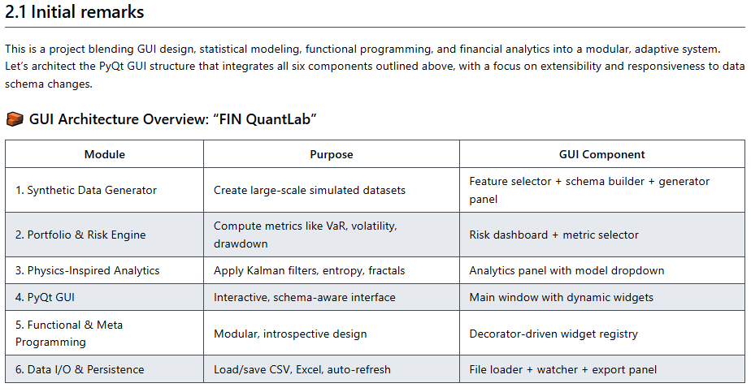
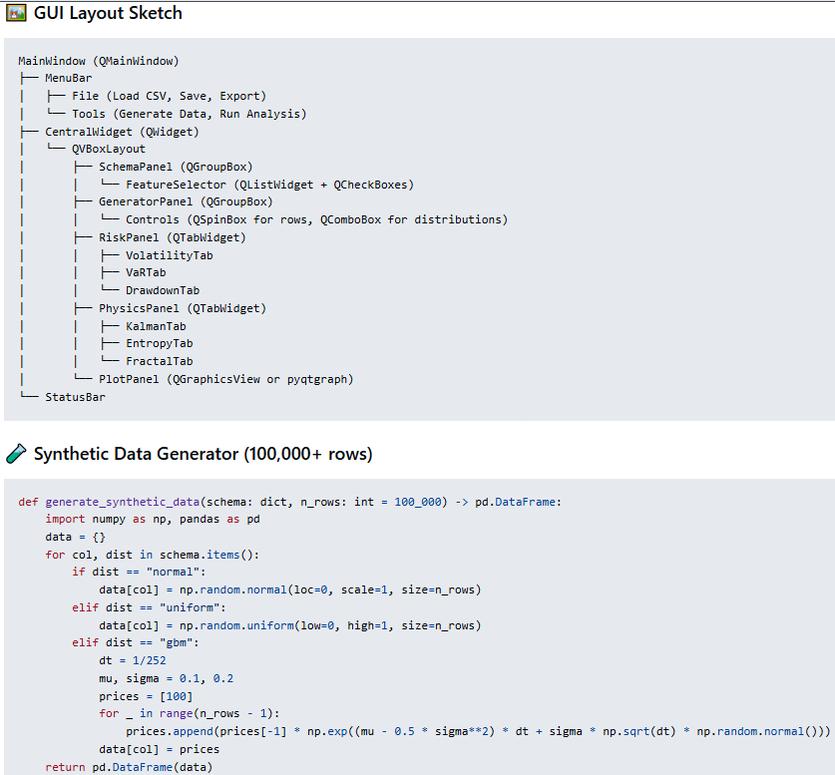

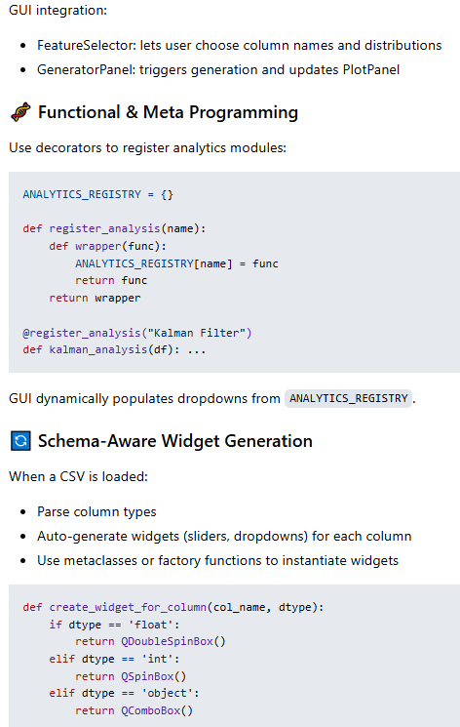

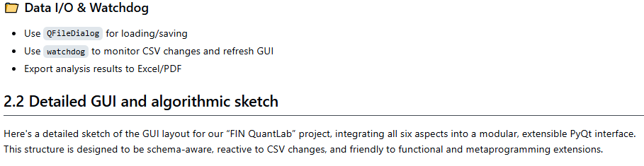
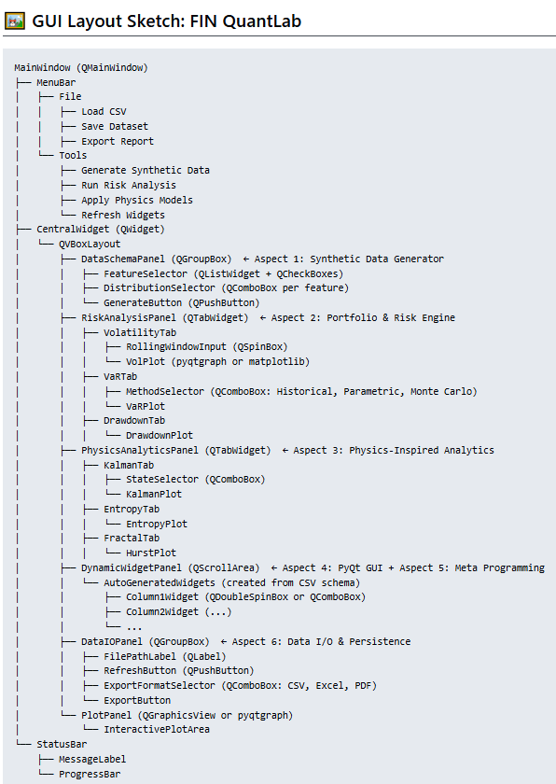
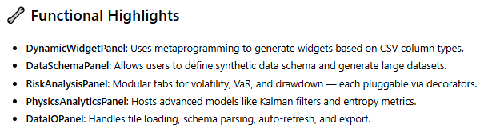

3. Main code (conceptual explanation)

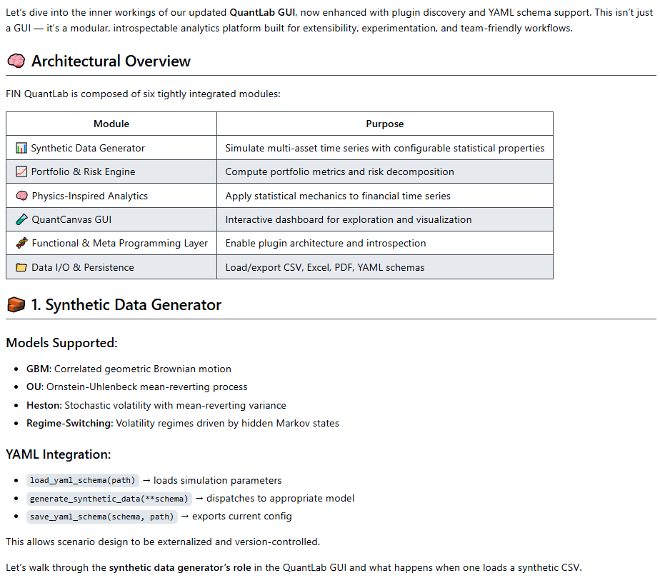
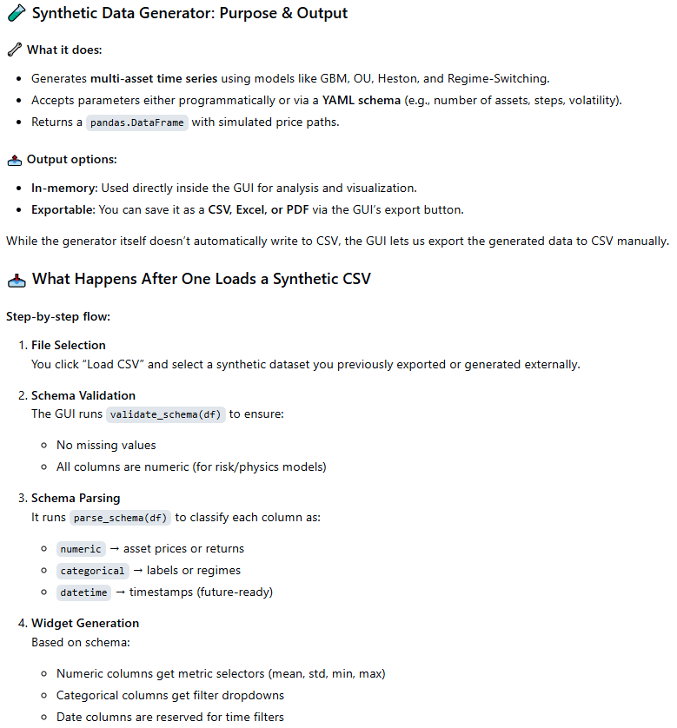

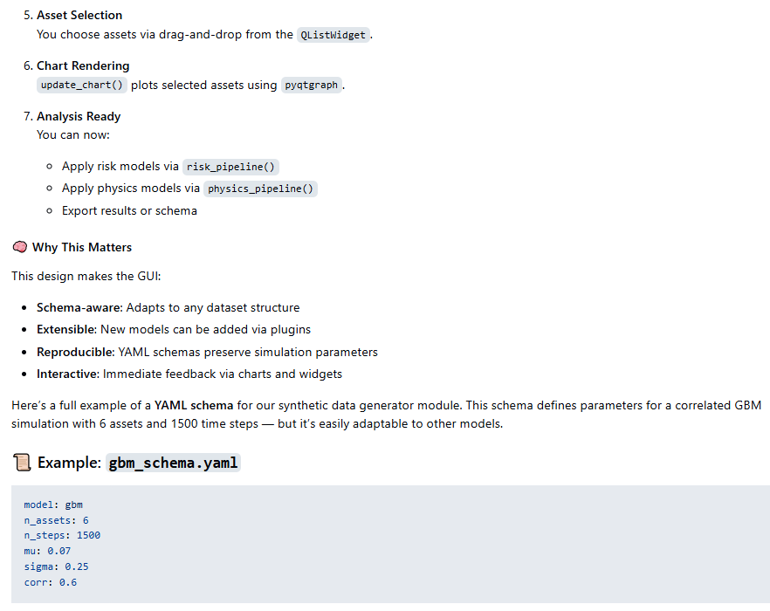
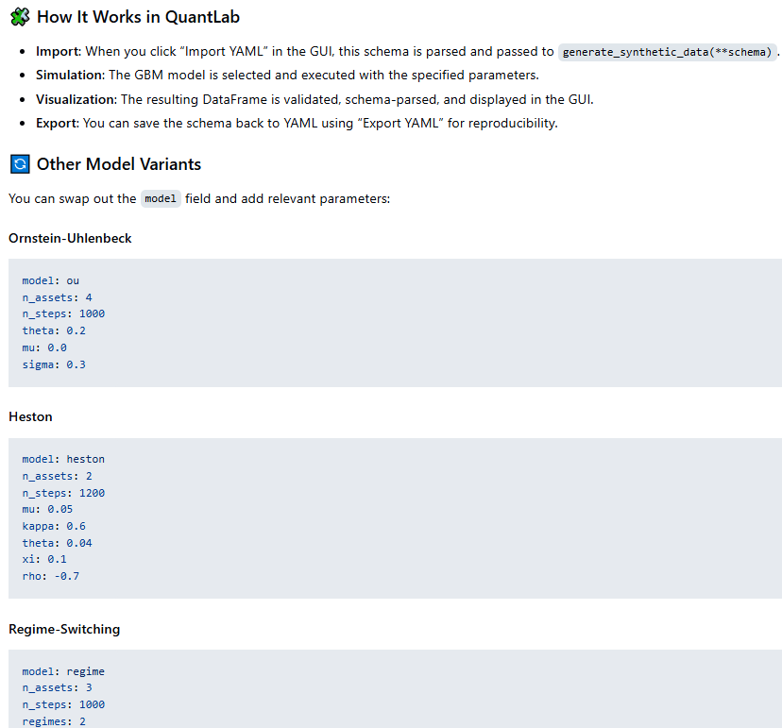
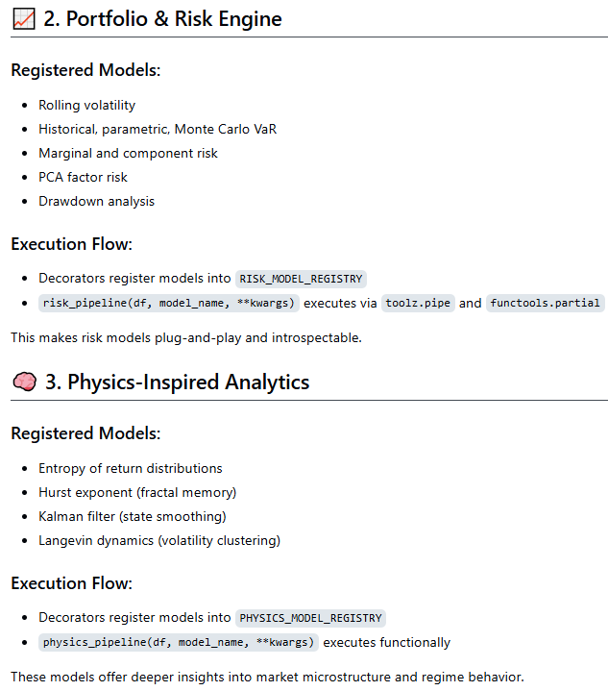

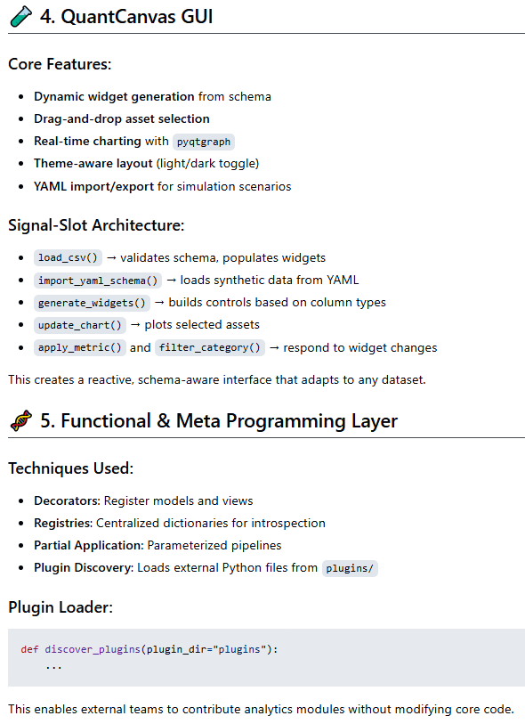

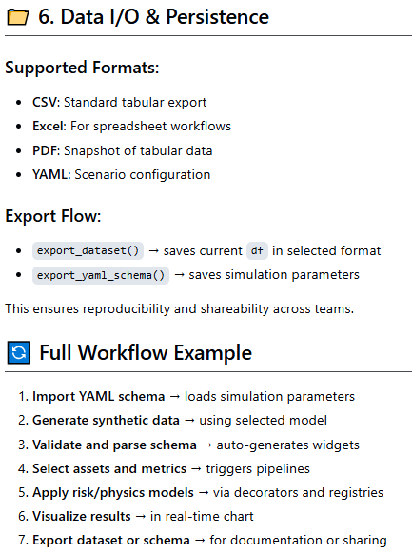

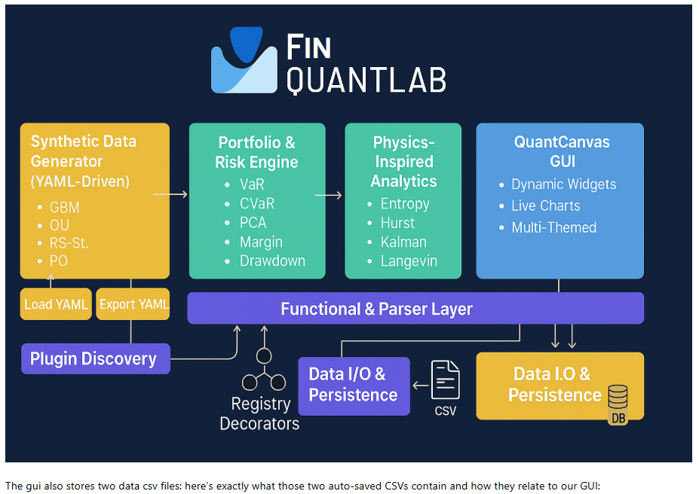
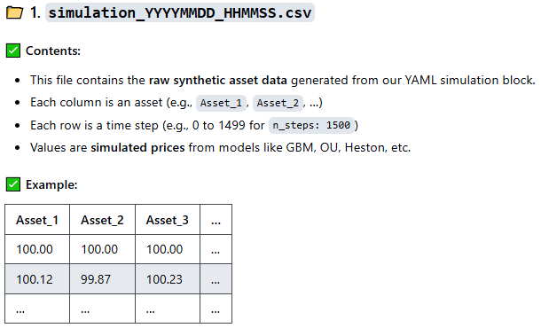

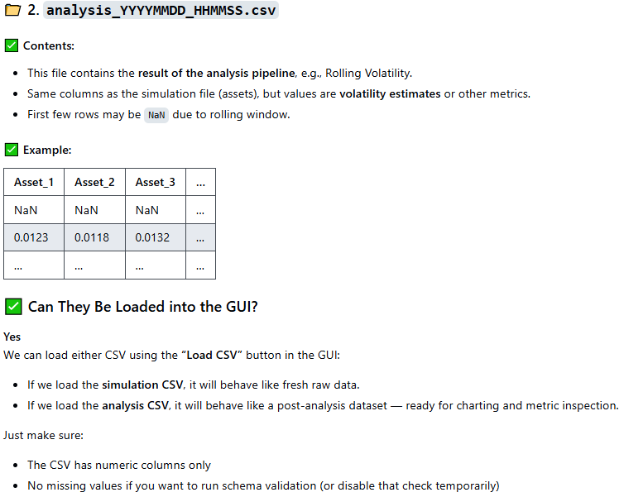

4. Modularized Pythonic implementation

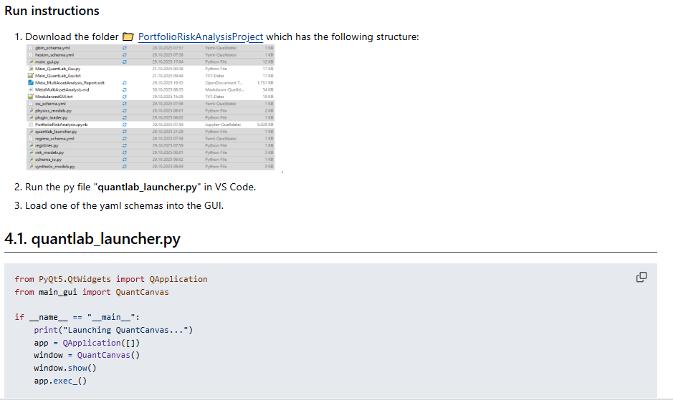

5. Results and conclusions

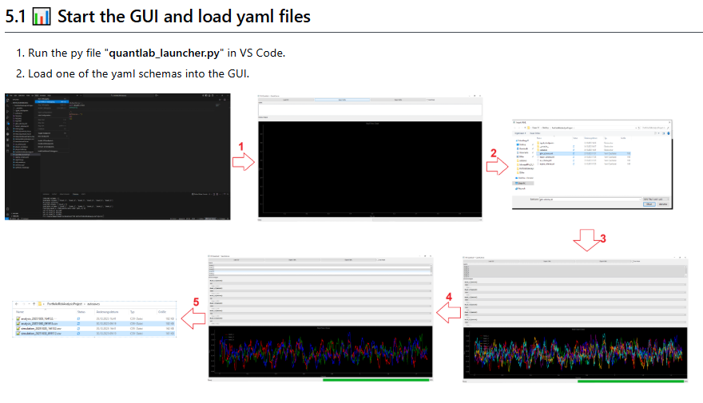
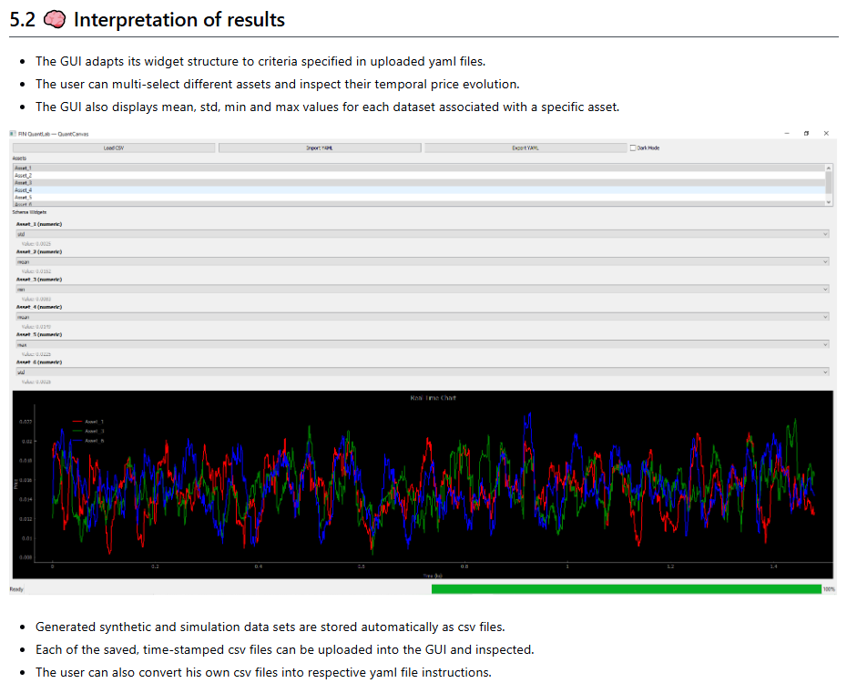
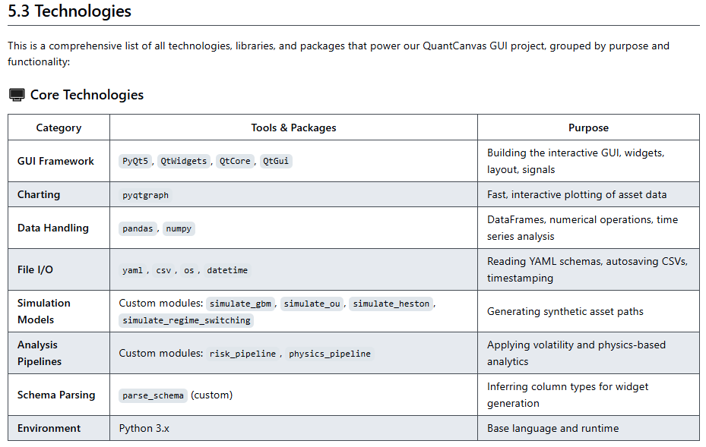
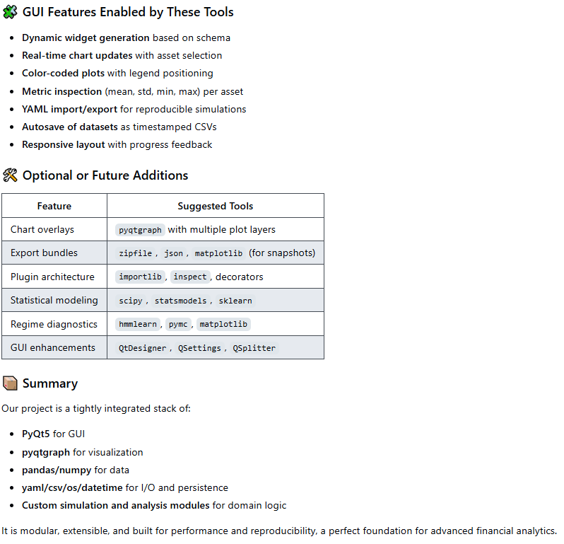
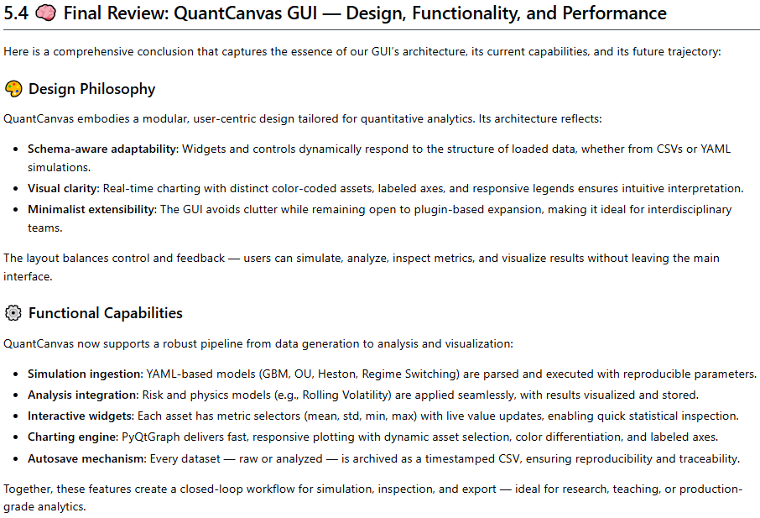
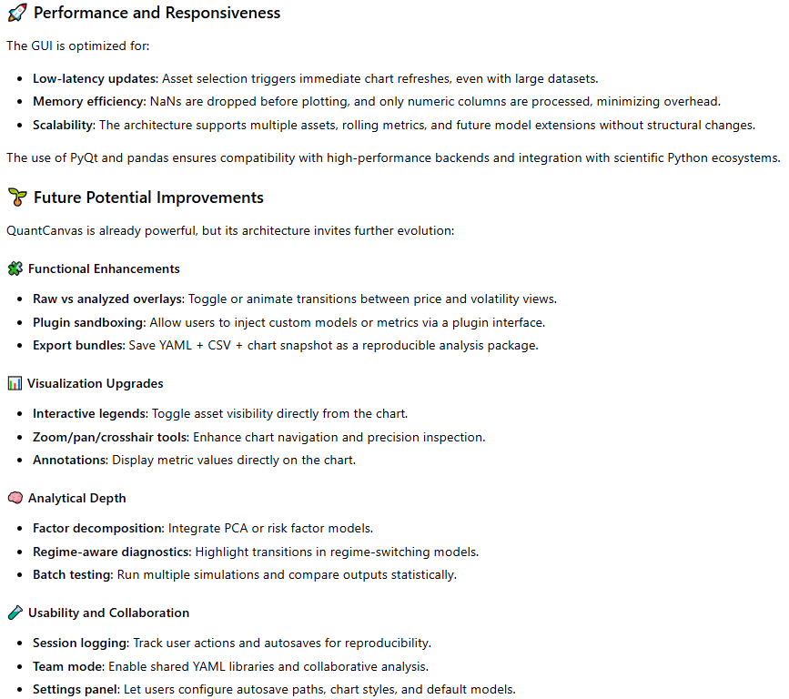
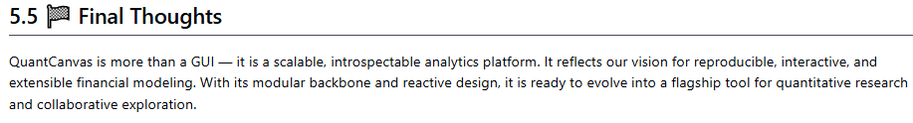

6. References
1. E. Parzen: "Stochastic Processes", 3rd Ed. Dover Publications (2015); S. Aloorravi: "Metaprogramming with Python", 1st Ed. Packt (2022); B. Klein, P. Klein: "Funktionale Programmierung mit Python", Hanser (2025); K. Webel, D. Wied: "Stochastische Prozesse", 2. Auflage Springer (2016); L. Held: "Methoden der statistischen Inferenz", 1. Auflage Spektrum (2008); E. Cinlar: "Stochastic Processes", Dover (2013); N. Bäuerle, U. Rieder: "Finanzmathematik in diskreter Zeit", Springer-Spektrum (2017); M. Albrecht, R. Maurer: "Investment- und Risikomanagement", 3. Auflage, Schäffer Poeschel (2008); N. H. Bingham, R. Kiesel: "Risk Neutral Valuation: Pricing and Hedging of Financial Derivatives", 2. Auflage Springer (2004); T. Björk: "Arbitrage Theory in Continuous Time", 3rd Ed. Oxford University Press (2009); N. J. Cutland, A. Roux: "Derivative Pricing in Discrete Time", Springer (2013); F. Delbaen, W. Schachermayer: "The Mathematics of Arbitrage", Springer (2006); R. J. Elliott, P. E. Kopp: "Mathematics of Financial Markets", 2nd Ed. Springer (2005); H. Föllmer, A. Scheid: "A Stochastic Finance: An Introduction in Discrete Time", 3rd Ed. de Gruyter (2011); J. C. Hull: "Options, Futures and Other Derivatives", 8th Ed. Pearson (2011); J. Kremer: "Einführung in die diskrete Finanzmathematik", Springer (2005); D. Lamberton, B. Lapeyre: "Introduction to Stochastic Calculus Applied to Finance", Chapman & Hall (2007); D. G. Luenberger: "Investment Science", Oxford University Press (1998); S. R. Pliska: "Introduction to Mathematical Finance: Discrete Time Models", Blackwell (2000); A. N. Shiryaev: "Essentials of Stochastic Finance", World Scientific (2001); S. E. Shreve: "Stochastic Calculus for Finance I: The Binomial Asset Pricing Model", Springer (2004); J. Kremer: "Portfoliotheorie, Risikomanagement und die Bewertung von Derivaten", Springer (2011); L. Rüschendorf: "Mathematical Risk Analysis", Springer (2013).
2. A. Meister , T. Sonar: "Numerik", 1st Ed. Springer-Spektrum (2019); S. Chapra, R. Canale: "Numerical Methods for Engineers", Mcgraw-Hill, 6th Edition (2010).
3. J. Kilty, A. M. McAllister: "Mathematical Modeling and Applied Calculus", 1st Ed. Oxford University Press (2018).
4. U. Kockelkorn: "Statistik für Anwender", 1st Ed. Springer (2012), s. chapters 7 - 8.
5. Robert H. Shumway, David S. Stoffer: "Time Series Analysis and Its Applications with R Examples", Springer (2011).
6. Gareth James, Daniela Witten, Trevor Hastie, Robert Tibshirani, Jonathan Taylor: "An Introduction to Statistical Learning with Applications in Python", Springer (2023).
7. Cornelis W. Oosterlee, Lech A. Grzelak: "Mathematical Modeling and Computation in Finance with Exercises and Python and MATLAB Computer Codes", World Scientific (2020).
8. Richard Szeliski: "Computer Vision - Algorithms and Applications", Springer (2022).
9. Anthony Scopatz, Kathryn D. Huff: "Effective Computation in Physics - Field Guide to Research with Python", O'Reilly Media (2015).
10. Alex Gezerlis: "Numerical Methods in Physics with Python", Cambridge University Press (2020).
11. Gary Hutson, Matt Jackson: "Graph Data Modeling in Python. A practical guide", Packt-Publishing (2023).
12. Hagen Kleinert: "Path Integrals in Quantum Mechanics, Statistics, Polymer Physics, and Financial Markets", 5th Edition, World Scientific Publishing Company (2009).
13. Peter Richmond, Jurgen Mimkes, Stefan Hutzler: "Econophysics and Physical Economics", Oxford University Press (2013).
14. A. Coryn , L. Bailer Jones: "Practical Bayesian Inference A Primer for Physical Scientists", Cambridge University Press (2017).
15. Avram Sidi: "Practical Extrapolation Methods - Theory and Applications", Cambridge university Press (2003).
16. Volker Ziemann: "Physics and Finance", Springer (2021).
17. Zhi-Hua Zhou: "Ensemble methods, foundations and algorithms", CRC Press (2012).
18. B. S. Everitt, et al.: "Cluster analysis", Wiley (2011).
19. Lior Rokach, Oded Maimon: "Data Mining With Decision Trees - Theory and Applications", World Scientific (2015).
20. Bernhard Schölkopf, Alexander J. Smola: "Learning with kernels - support vector machines, regularization, optimization and beyond", MIT Press (2009).
21. Johan A. K. Suykens: "Regularization, Optimization, Kernels, and Support Vector Machines", CRC Press (2014).
22. Sarah Depaoli: "Bayesian Structural Equation Modeling", Guilford Press (2021).
23. Rex B. Kline: "Principles and Practice of Structural Equation Modeling", Guilford Press (2023).
24. Ekaterina Kochmar: "Getting Started with Natural Language Processing", Manning (2022).
25. Rex B. Kline: "Principles and Practice of Structural Equation Modeling", Guilford Press (2023).
26. Ekaterina Kochmar: "Getting Started with Natural Language Processing", Manning (2022).
27. Jakub Langr, Vladimir Bok: "GANs in Action", Computer Vision Lead at Founders Factory (2019).
28. David Foster: "Generative Deep Learning", O'Reilly(2023).
29. Rowel Atienza: "Advanced Deep Learning with Keras: Applying GANs and other new deep learning algorithms to the real world", Packt Publishing (2018).
30. Josh Kalin: "Generative Adversarial Networks Cookbook", Packt Publishing (2018).
31. Thomas Haslwanter: „Hands-on Signal Analysis with Python: An Introduction“, Springer (2021).
32. Jose Unpingco: „Python for Signal Processing“, Springer (2023).
33. R. K. Burdick, C. M. Borror, D. C. Montgomery: "Design and Analysis of Gauge R&R Studies", 1st Ed. SIAM (2005); S. H. Derakhshan , C. V. Deutsch: "Numerical Integration of Bivariate Gaussian Distribution", Paper 405, CCG Anual Report 13 (2011).
34. C. Paar, J. Pelzl: "Understanding Cryptography", Springer (2010); H. Delfs, H. Knebl: "Introduction to Cryptography", 3rd Ed. Springer (2015); J. Katz, Y. lindell: "Introduction to Modern Cryptography", 2nd Ed, CRC Press (2015); O. Goldreich: "Foundations of Cryptography", Cambridge University Press (2008); J. P. Aumasson: "Serious Cryptography", no starch press (2018).
35. Kaggle-link: competition-documentation: https://www.kaggle.com/competitions/drw-crypto-market-prediction. R. Nystrom: „Game Programming Patterns“, 1st Ed. genever benning (2014); A. A. Stepanov, D. E. Rose: „From Mathematics to Generic Programming“, 1st Ed. Addison-Wesley (2015);
36. J. Berk, P. DeMarzo: „Corporate Finance“, 6th Ed., Pearson (2023); R. W. Melicher, E. A. Norton: "Introduction to Finance", 16th Ed. WILEY (2017); Anatoly B. Schmidt: "Quantitative Finance for Physicists: An Introduction", 1st Ed. Academic Press (2005); Alex Backwell: "An Intuitive Introduction to Finance and Derivatives: Concepts, Terminology and Models", 1st Ed, Springer (2023); Michael Isichenko: "Quantitative Portfolio Management: The Art and Science of Statistical Arbitrage", 1st Ed., Springer (2021); John H. Cochrane: "Asset Pricing", Revised Ed., Princeton University Press (2005); Antti Ilmanen: "Expected Returns: An Investor’s Guide to Harvesting Market Rewards", 1st Ed., WILEY (2011); Steven E. Shreve: "Stochastic Calculus for Finance I & II", 1st Ed., Springer (2004); Andrew Pole: "Statistical Arbitrage: Algorithmic Trading Insights and Techniques", 1st Ed., WILEY (2007); Mark S. Joshi: "The Concepts and Practice of Mathematical Finance", 2nd Ed., Cambridge University Press (2008);

