SARIMAX Forecasting

of a

Boarder Crossing Data Set

Inhaltsverzeichnis
1. Data set description 3
Context 3
Content 3
2. Data preprocessing 5
3. SARIMAX evaluation 9

1. Data set description

Context
The Bureau of Transportation Statistics (BTS) Border Crossing Data provide summary statistics for inbound crossings at the U.S.-Canada and the U.S.-Mexico border at the port level. Data are available for trucks, trains, containers, buses, personal vehicles, passengers, and pedestrians. Border crossing data are collected at ports of entry by U.S. Customs and Border Protection (CBP). The data reflect the number of vehicles, containers, passengers or pedestrians entering the United States. CBP does not collect comparable data on outbound crossings. Users seeking data on outbound counts may therefore want to review data from individual bridge operators, border state governments, or the Mexican and Canadian governments.
The data set is accessible at: https://www.kaggle.com/datasets/akhilv11/border-crossing-entry-data.

Content
COVERAGE: Incoming vehicle, container, passenger, and pedestrian counts at U.S.-Mexico and U.S.-Canada land border ports.
DEFINITIONS:
1. Bus Crossings: Number of arriving buses at a particular port, whether or not they are carrying passengers.
2. Container: A Container is defined as any conveyance entering the U.S. used for commercial purposes, either full or empty. Includes containers moving in-bond for the port initiating the bonded movements.
3. Types of Containers: The following are examples of a Container: Stakebed truck, truck with a car carrier, van, pickup truck/car, flatbed truck, piggyback truck with two linked trailers/containers = 2 containers, straight truck, bobtail truck, railcar, rail flatbed car stacked with four containers = 4 containers (on each rail car if there is multiple box containers count each container and the flatbed car.), and tri-level boxcar with multiple containers inside = 3 containers
4. Passengers Crossing In Buses: Number of persons arriving by bus requiring U.S. Customs and Border Protection (CBP) processing.
5. Passengers Crossing In Privately Owned Vehicles: Persons entering the United States at a particular port by private automobiles, pick-up trucks, motorcycles, recreational vehicles, taxis, ambulances, hearses, tractors, snowmobiles and other motorized private ground vehicles.
6. Passengers Crossing In Trains: Number of passengers and crew arriving by train and requiring CBP processing.
7. Pedestrian Crossings: The number of persons arriving on foot or by certain conveyance (such as bicycles, mopeds, or wheel chairs) requiring CBP processing.
8. Privately Owned Vehicle Crossings: Number of privately owned vehicles (POVs) arriving at a particular port. Includes pick-up trucks, motorcycles, recreational vehicles, taxis, snowmobiles, ambulances, hearses, and other motorized private ground vehicles.
9. Rail Container Crossings (loaded and empty): A container is any conveyance entering the U.S. used for commercial purposes, full or empty. In this case, it is the number of full or empty rail containers arriving at a port. This series includes containers moving as inbound shipments.
10. Train Crossings: Number of arriving trains at a particular port.
11. Truck Container Crossings (loaded and empty): A container is any conveyance entering the U.S. used for commercial purposes, full or empty. In this case, it is the number of full or empty truck containers arriving at a port. This series includes containers moving as inbound shipments.
12. Truck Crossings: Number of arriving trucks; does not include privately owned pick-up trucks.
Notes
Canada:
The ports of entry at Noyes, Minnesota and Whitetail, Montana closed in June 2006 and January 2013, respectively.
1. Incoming Trucks, Incoming PVs, PV Passengers, Incoming Buses, Bus Passengers, and Incoming Pedestrians
o Bar Harbor and Portland, Maine (ferry crossing) - Ferries arrived from May to September. The Bar Harbor, Maine to Yarmouth, Nova Scotia ferry is no longer in operation.
o Anacortes and Friday Harbor - The international ferries that connect Anacortes and Friday Harbor, Washington with Sidney, British Columbia do not run in February. Truck Containers (Loaded) and Truck Containers (Unloaded)
o Passenger vehicle and passengers in personal vehicles data for Cape Vincent, New York (ferry) are available beginning in 2007. The ferry between Wolfe Island (Canada) and Cape Vincent does not operate in the winter.
2. Incoming Train Passengers
o Includes both passengers and crew.
o Starting with November 2017, Maine officials restrict international bridge traffic to passenger vehicles only.
Mexico:
Data for the port of Calexico are reported as a combined total with Calexico East.
1. Incoming Trucks:
o Data represent the number of truck crossings, not the number of unique vehicles, and include both loaded and unloaded trucks.
2. Incoming Train Passengers:
o Includes train crew. BTS is not aware of any passenger service currently operating across the U.S.-Mexico Border.
o CBP has indicated to BTS that since 2009 train crew are being exchanged at the Texas-Mexico border, and thus do not enter the United States.

2. Data preprocessing
Main question: Forecast the monthly number of boarder crossings between USA and Canada.

STEP1: We extract via DuckDB the relevant portion of the data set by means of the following list of SQL queries:

query1 = """
CREATE TABLE IF NOT EXISTS AllData AS
SELECT * FROM read_csv('Border_Crossing_Entry_Data.csv')
"""
# Select the first 7 columns of the AllData table and store them into a new table "RelevantData"
query2 = """
CREATE TABLE IF NOT EXISTS RelevantData AS
SELECT #1, #2, #3, #4, #5, #6, #7
FROM AllData
"""
# Select the first 7 columns of the "RelevantData" table and store them into a new table "US_Canada_Data"
query3 = """
CREATE TABLE IF NOT EXISTS US_Canada_Data AS
SELECT #1, #2, #3, #4, #5, #6, #7
FROM RelevantData
WHERE Border = 'US-Canada Border'
"""
# Select the first 7 columns of the "RelevantData" table and store them into a new table "US_Mexico_Data"
query4 = """
CREATE TABLE IF NOT EXISTS US_Mexico_Data AS
SELECT #1, #2, #3, #4, #5, #6, #7
FROM RelevantData
WHERE Border = 'US-Mexico Border'
"""
# Describe the schema of the US_Canada_Data table
query5 = "DESCRIBE US_Canada_Data"
# Convert a string date column to date format with a CTE
query6 = """
CREATE TABLE IF NOT EXISTS US_Canada_Data_Altered AS
SELECT
*,
strptime(concat('01 ', Date), '%d %b %Y') AS converted_date
FROM
US_Canada_Data
"""
# Select the entire altered table US_Canada_Data_Altered
query7 = "SELECT * FROM US_Canada_Data_Altered"
# Describe the altered table US_Canada_Data_Altered
query8 = "DESCRIBE US_Canada_Data_Altered"
# Order the table US_Canada_Data_Altered based on the converted_date
# column in ascending manner
query9 = """
SELECT *
FROM US_Canada_Data_Altered
ORDER BY converted_date ASC
"""
# Ctreate a US_Canada_AggregatedData table
query10 = """
-- Step 1: Drop the table if it exists
DROP TABLE IF EXISTS US_Canada_AggregatedData;
-- Step 2: Create the new table and populate it with aggregated data
CREATE TABLE IF NOT EXISTS US_Canada_AggregatedData AS
SELECT
converted_date,
AVG(Value) AS avg_value_month,
SUM(Value) AS total_value_month
FROM
US_Canada_Data_Altered
GROUP BY
converted_date
ORDER BY
converted_date ASC;
"""
# select the aggregated table:
query11 = """
SELECT *
FROM US_Canada_AggregatedData
"""
These queries lead to the following table structure:
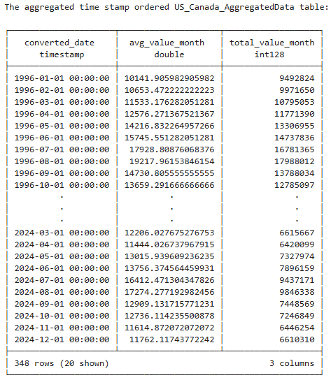

We convert the SQL table into a data frame via
„US_Canada_Data_Aggregated_df = db.sql("SELECT * FROM US_Canada_AggregatedData").df()“,
leading to:
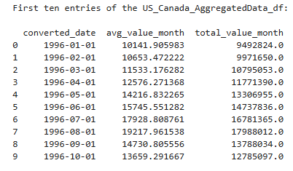

STEP 2: We create an aggregate dictionare from the extracted pandas DataFrame containing averaged numbers of boarder crossings for each month between January 1996 and December 2024 via:
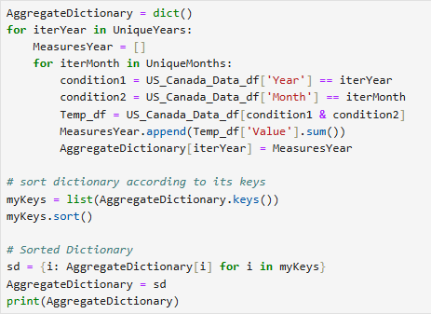

This leads us to the following Data Frame structure:
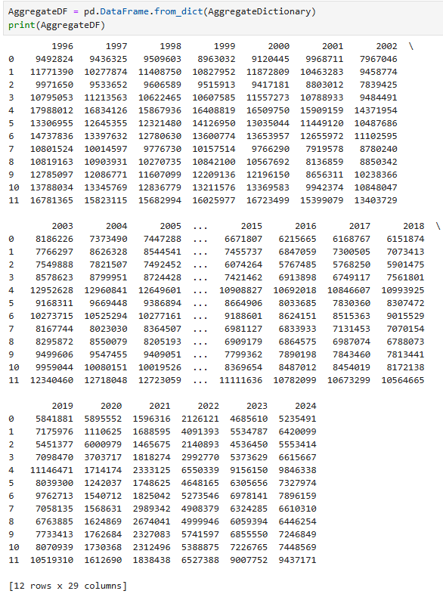
c

STEP 3: We perform an 80-20 train-test split of the aggregated DataFrame via:
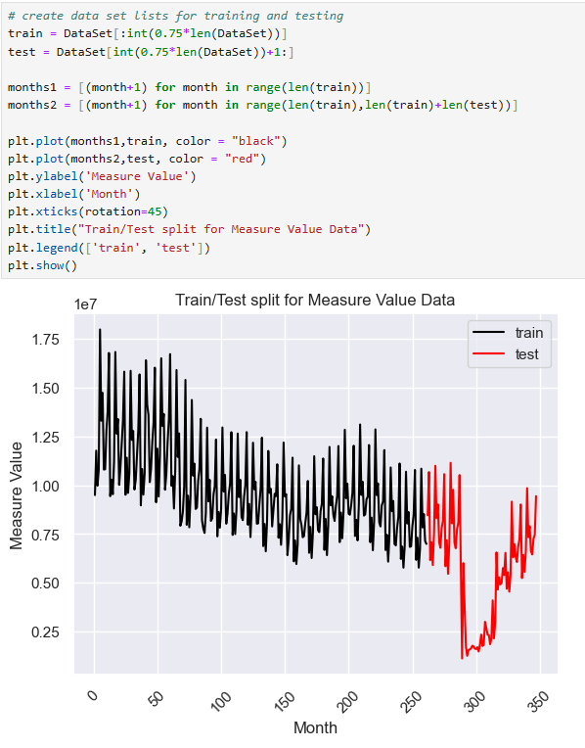

The test portion of the data set present a Covid-induced time anomaly in boarder crossings. This implies that we may have to expect our algorithm to perform suboptimally, however this split allows us to test the customized and automated forecasting performance of the cross-validated SARIMAX model under more „strained“ conditions.

3. SARIMAX evaluation
We trigger a customized Python function „SARIMAX_grid_search“ and obtain the following optimal SARIMAX parameters (seasonality s is set to 12) via
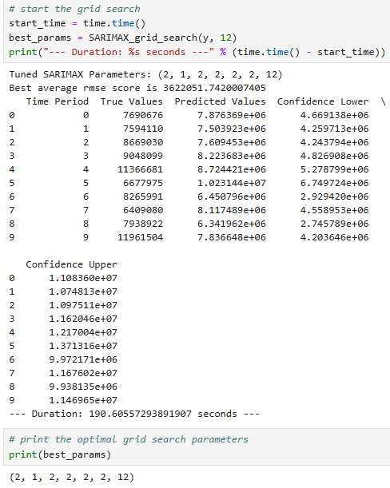

The average RMSE score indicates a lot of room for improvement, however due to the pronounced time series anomaly of the test portion within the extracted DataFrame it may be regarded as a solid „first guess“, as indicated by the corresponding forecast plot:
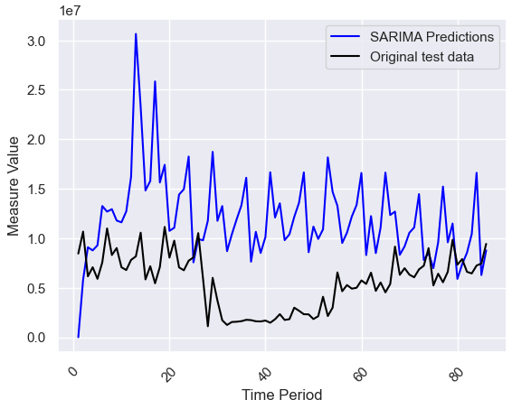

In the above plot „Measure Value“ denotes an aggregated number of monthly boarder crossings, whereas „Time Period“ refers to the number of months passed since the last training month.
Now we perform an automated cross-validated SARIMAX grid search by means of the Pythonic function „AutomatedSarimaxGridSearch“ and obtain the following results:
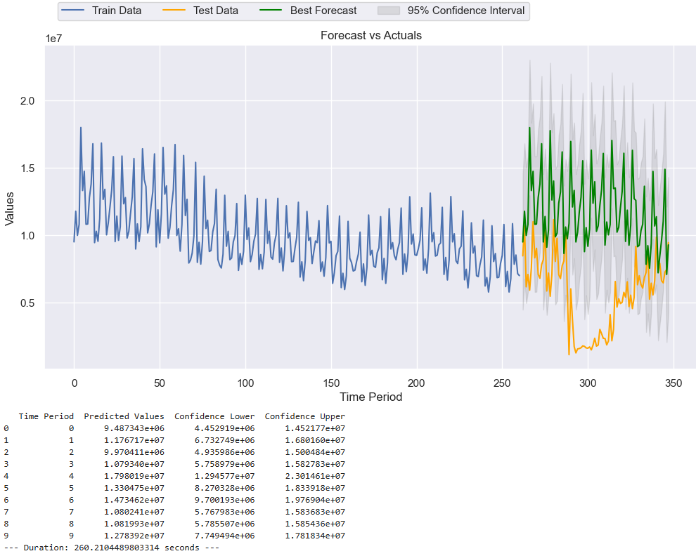
The ideal SARIMAX parameter set amounts to
`p=4.0`, `d=1.0`, `q=2.0`, `P=2.0`, `D=2.0`,`Q=2.0`,`s=12`
and leads to Mean Absolute Percentage Error (MAPE) of about 0.06 which indicates a significant forecasting improvement compared to the previous customized SARIMAX grid search.
Apparently, Pythonic SARIMAX modeling allows for robust and reliable trend predictions even in cases of highly anomalous time series trend patterns.

