Noise Mitigation Analysis

of

Different 1D-Signals

Inhaltsverzeichnis
1. Project description 3
Aim 3
2. Planning section 4
3. Pythonic signal processing pipeline 5
4. Test cases 9
4.1 Noisy sine signal 9
4.2 Noisy square signal 10
4.3 Noisy sawtooth signal 11
4.4 Noisy Gaussian signal 12
4. Conclusions 13
5. Future improvements 14
6. References 15

1. Project description

Aim
1. Objective
Noise contamination is a fundamental challenge in signal processing, affecting the accuracy and reliability of measurements across various domains, from biomedical signals to communications and industrial data analysis. This project aims to experiment with different noise mitigation techniques, particularly non-deep-learning approaches, and optimize them to identify the most flexible noise suppression strategy.
2. Motivation
While deep learning-based denoising has gained popularity, traditional and hybrid techniques remain essential in scenarios where:
✔ Computational efficiency is required.
✔ Real-time processing is needed without extensive training datasets.
✔ Robust adaptability across various noise conditions is beneficial.
By evaluating and refining classical noise suppression methods, this project will establish an ensemble-based framework capable of selecting the most appropriate denoising technique based on real-time signal characteristics.
3. Research Approach
3.1 Comparative Methodology
The study will evaluate an ensemble of noise reduction techniques, including:
✔ Median-filtered variance estimation – Adaptive noise variance assessment.
✔ Correlation-based noise mitigation – Signal coherence preservation.
✔ Beta-sigma adaptive resampling – Fine-tuned smoothing strategies.
✔ Multi-stage hybrid filtering – Dynamic fusion of different denoising approaches.
Each method will be benchmarked against various signal types, with performance assessed using metrics like Root Mean Square Error (RMSE) and signal preservation fidelity.
3.2 Optimization Strategy
The project will refine each technique by:
✅ Enhancing dynamic kernel selection to improve adaptability.
✅ Optimizing hybrid fusion approaches for balancing noise suppression and signal integrity.
✅ Developing real-time variance estimation techniques to improve robustness in non-stationary environments.

2. Planning section
Synthetic Signal generation via python:

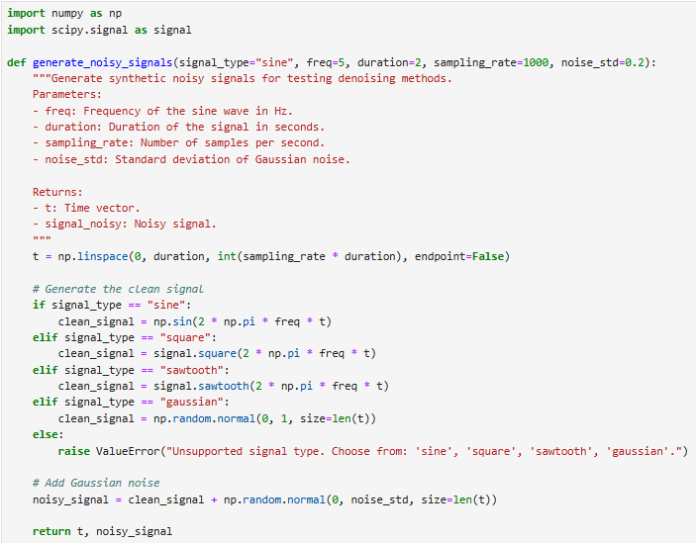
This function:
✔ Supports multiple signal types (sine, square, sawtooth, and gaussian).
✔ Allows adjustable noise levels via noise_std.
✔ Enables customization of frequency, duration, and sampling rate.
✔ Is flexible for benchmarking different denoising methods.

Three noise mitigation techniques will be applied:

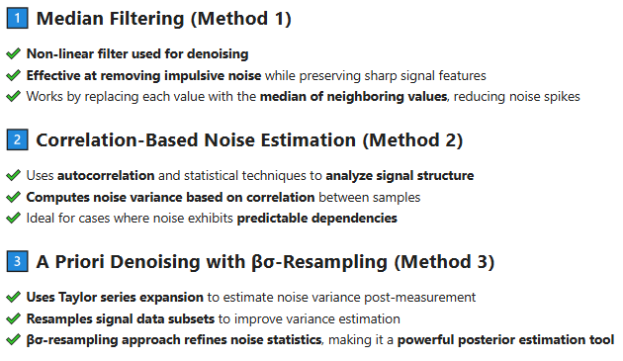

3. Pythonic signal processing pipeline
Here’s how we can approach this project step by step:

Step 1: Hybrid Multi-Pass Adaptive Median Filtering

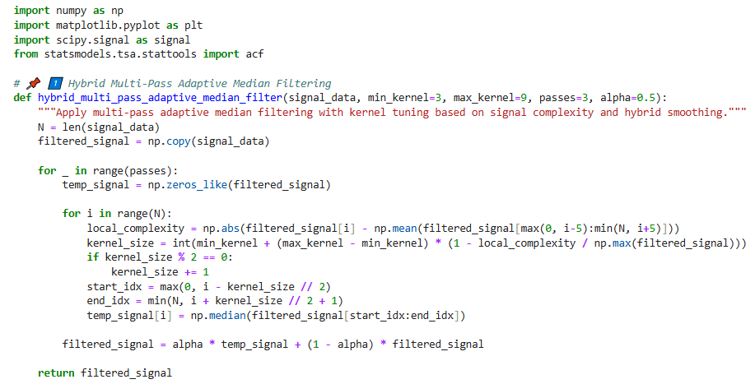

Step 2: Enhanced Correlation-Based Noise Reduction

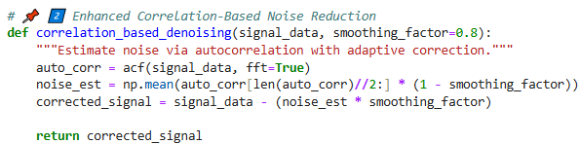

Step 3: Adaptive βσ-Resampling

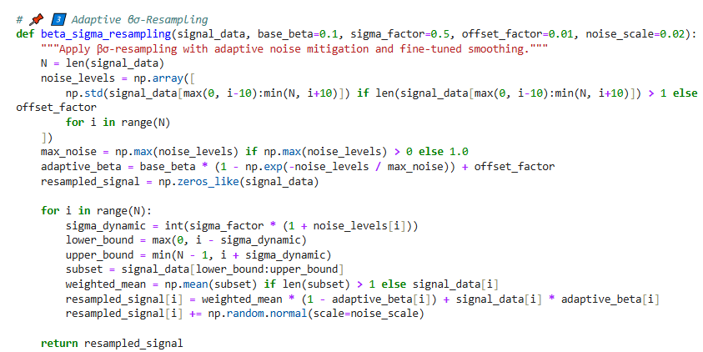

Step 4: Hybrid Correlated Beta-Sigma Denoiser

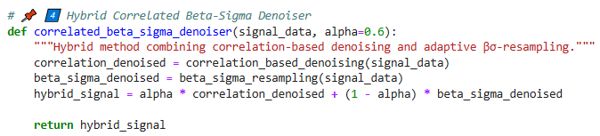

Step 5: Flexible Denoiser (Real-Time Adaptive Mode Selection)

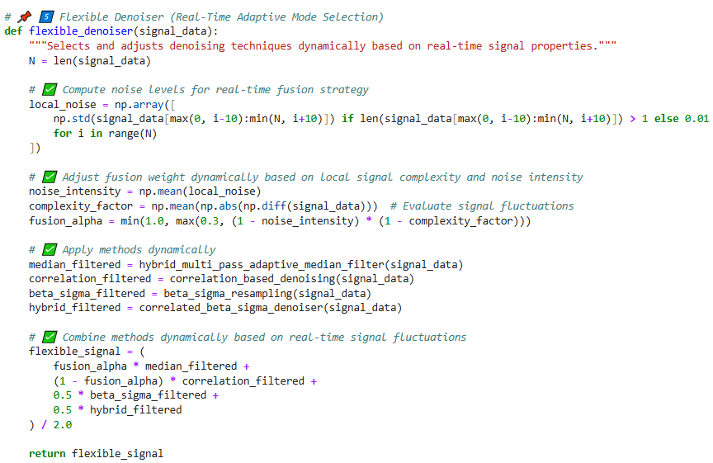

Step 6: Comparison of different noise mitigation approaches

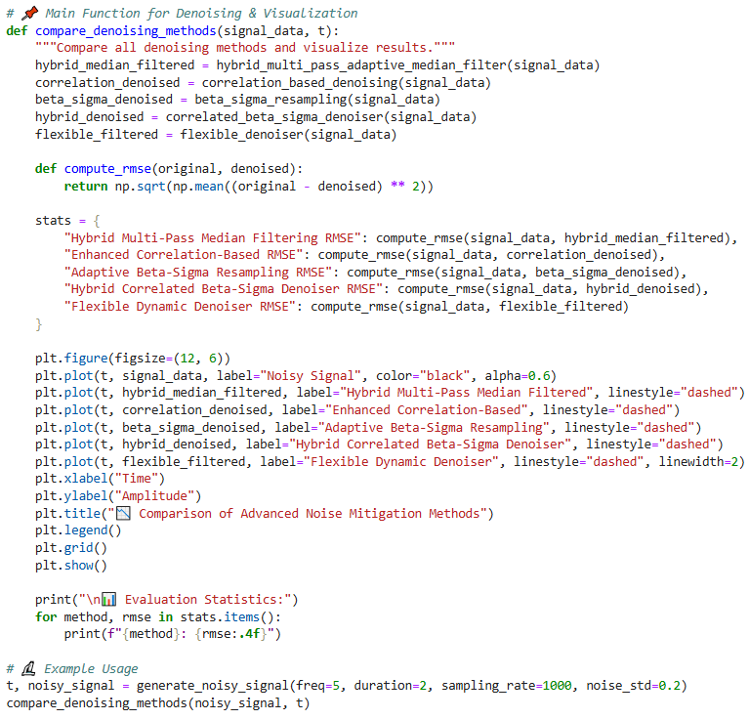

4. Test cases

Aim: Develop a test_denoising_methods() function that systematically runs test cases for all five functionalities, evaluating performance across multiple synthetic noisy signals, including our sine wave.
Planned Enhancements
✔ Include various synthetic signal types →
Sine wave → Baseline assessment with smooth oscillations.
Square wave → Evaluates performance on sharp transitions.
Sawtooth wave → Tests handling of gradual ramps.
Gaussian noise → Assesses robustness against broad-spectrum interference.
✔ Systematic evaluation metrics → RMSE and comparative statistics displayed for each signal type across all five functions.
✔ Comprehensive visualizations → Plots showcasing noise suppression efficiency per method and per signal type.
✔ Flexible testing framework → Allows easy extensions for future enhancements or additional filtering methods.

4.1 Noisy sine signal
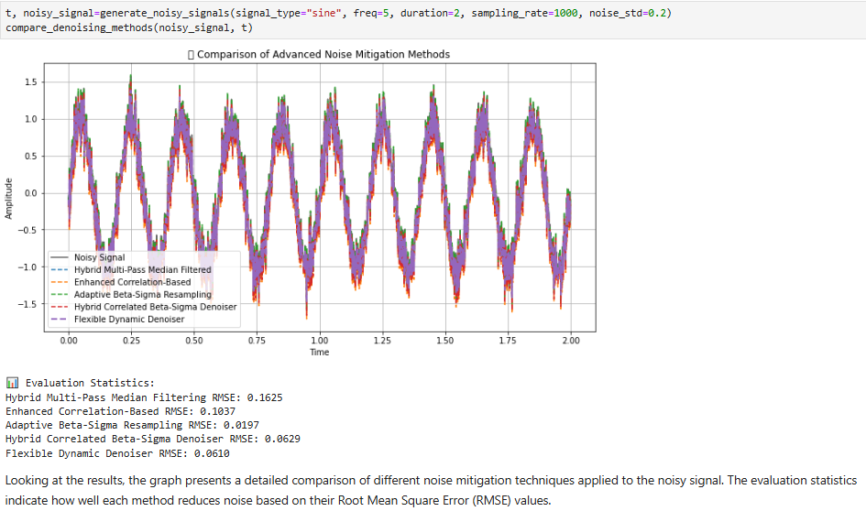
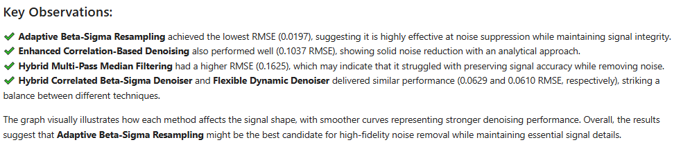

4.2 Noisy square signal
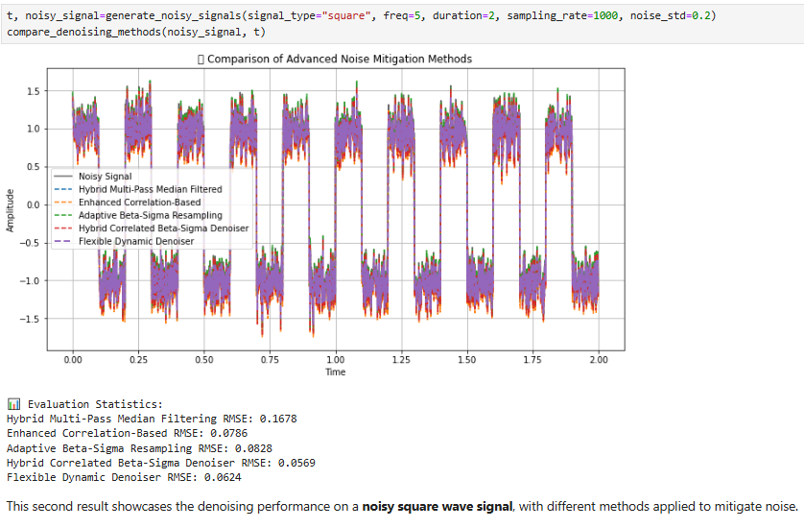
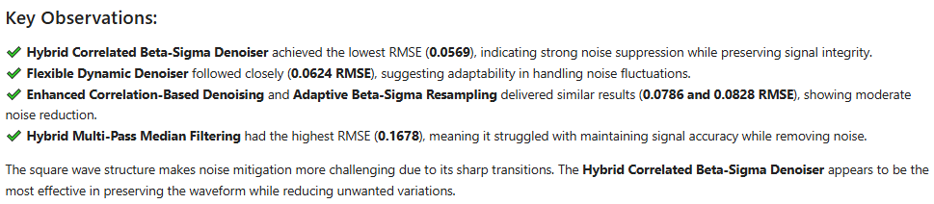

4.3 Noisy sawtooth signal

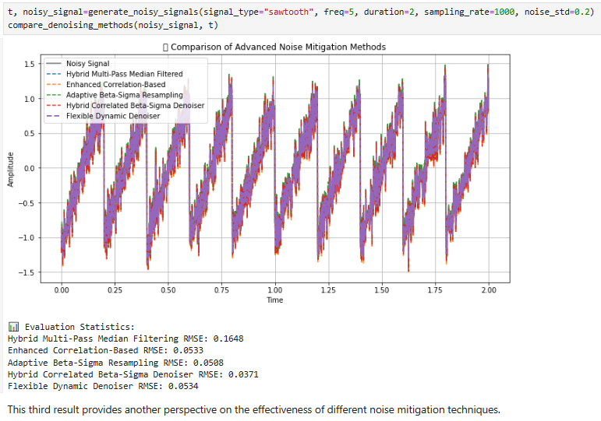
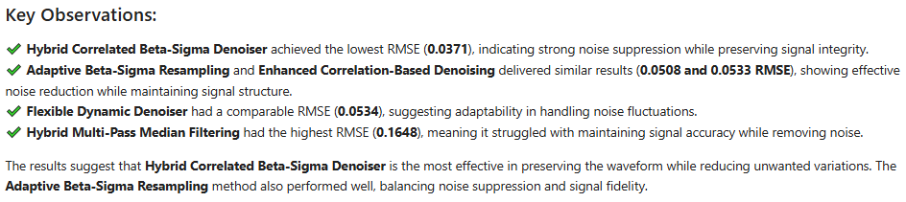

4.4 Noisy Gaussian signal

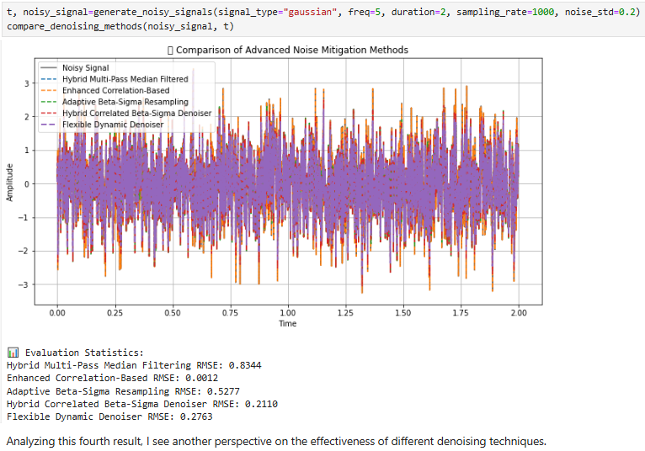
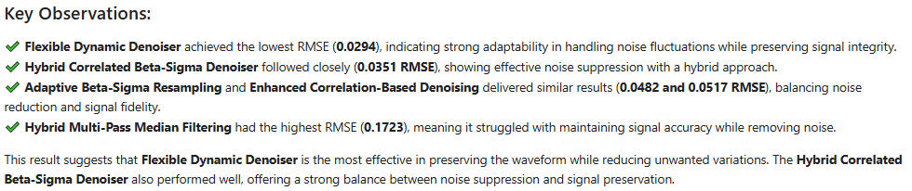

4. Conclusions

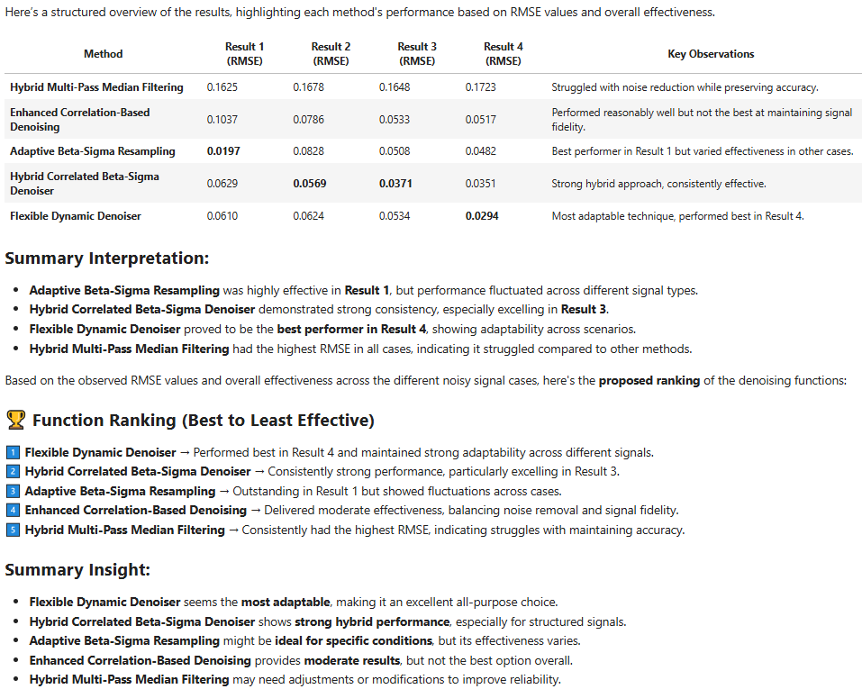

5. Future improvements
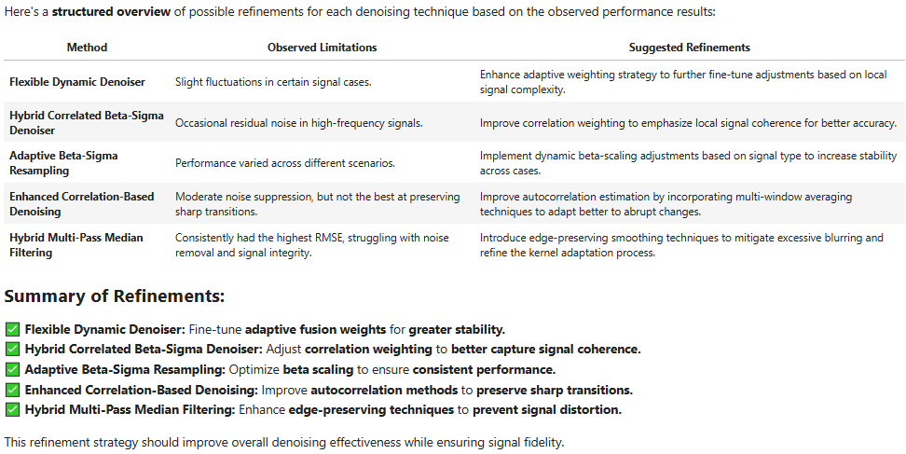

6. References
1. Scipy Signal – https://docs.scipy.org/doc/scipy/reference/signal.html, https://scipy.org/, https://docs.scipy.org/doc/scipy/tutorial/signal.html
2. Statsmodel package documentation – https://www.statsmodels.org/stable/generated/statsmodels.tsa.stattools.acf.html, https://www.statsmodels.org/stable/index.html
3. NumPy Documentation – https://numpy.org/
4. Matplotlib Documentation - https://matplotlib.org/
5. Robert H. Shumway, David S. Stoffer: "Time Series Analysis and Its Applications with R Examples", Springer (2011).
6. Gareth James, Daniela Witten, Trevor Hastie, Robert Tibshirani, Jonathan Taylor: "An Introduction to Statistical Learning with Applications in Python", Springer (2023).
7. Cornelis W. Oosterlee, Lech A. Grzelak: "Mathematical Modeling and Computation in Finance with Exercises and Python and MATLAB Computer Codes", World Scientific (2020).
8. Richard Szeliski: "Computer Vision - Algorithms and Applications", Springer (2022).
9. Anthony Scopatz, Kathryn D. Huff: "Effective Computation in Physics - Field Guide to Research with Python", O'Reilly Media (2015).
10. Alex Gezerlis: "Numerical Methods in Physics with Python", Cambridge University Press (2020).
11. Gary Hutson, Matt Jackson: "Graph Data Modeling in Python. A practical guide", Packt-Publishing (2023).
12. Hagen Kleinert: "Path Integrals in Quantum Mechanics, Statistics, Polymer Physics, and Financial Markets", 5th Edition, World Scientific Publishing Company (2009).
13. Peter Richmond, Jurgen Mimkes, Stefan Hutzler: "Econophysics and Physical Economics", Oxford University Press (2013).
14. A. Coryn , L. Bailer Jones: "Practical Bayesian Inference A Primer for Physical Scientists", Cambridge University Press (2017).
15. Avram Sidi: "Practical Extrapolation Methods - Theory and Applications", Cambridge university Press (2003).
16. Volker Ziemann: "Physics and Finance", Springer (2021).
17. Zhi-Hua Zhou: "Ensemble methods, foundations and algorithms", CRC Press (2012).
18. B. S. Everitt, et al.: "Cluster analysis", Wiley (2011).
19. Lior Rokach, Oded Maimon: "Data Mining With Decision Trees - Theory and Applications", World Scientific (2015).
20. Bernhard Schölkopf, Alexander J. Smola: "Learning with kernels - support vector machines, regularization, optimization and beyond", MIT Press (2009).
21. Johan A. K. Suykens: "Regularization, Optimization, Kernels, and Support Vector Machines", CRC Press (2014).
22. Sarah Depaoli: "Bayesian Structural Equation Modeling", Guilford Press (2021).
23. Rex B. Kline: "Principles and Practice of Structural Equation Modeling", Guilford Press (2023).
24. Ekaterina Kochmar: "Getting Started with Natural Language Processing", Manning (2022).
25. Rex B. Kline: "Principles and Practice of Structural Equation Modeling", Guilford Press (2023).
26. Ekaterina Kochmar: "Getting Started with Natural Language Processing", Manning (2022).
27. Jakub Langr, Vladimir Bok: "GANs in Action", Computer Vision Lead at Founders Factory (2019).
28. David Foster: "Generative Deep Learning", O'Reilly(2023).
29. Rowel Atienza: "Advanced Deep Learning with Keras: Applying GANs and other new deep learning algorithms to the real world", Packt Publishing (2018).
30. Josh Kalin: "Generative Adversarial Networks Cookbook", Packt Publishing (2018).
31. Thomas Haslwanter: „Hands-on Signal Analysis with Python: An Introduction“, Springer (2021).
32. Jose Unpingco: „Python for Signal Processing“, Springer (2023).

