Sentiment Analysis

of

News Headlines

Inhaltsverzeichnis
1. Project description 3
Aim 3
2. Planning section 3
2. Implementation 6
3. Results 7
4. Potential improvements 8
5. Conclusions 9
6. References 10

1. Project description

Aim
This project analyzes sentiments of news headlines contained within the Groundnews website by means of a customized Pythonic GUI (https://ground.news/):
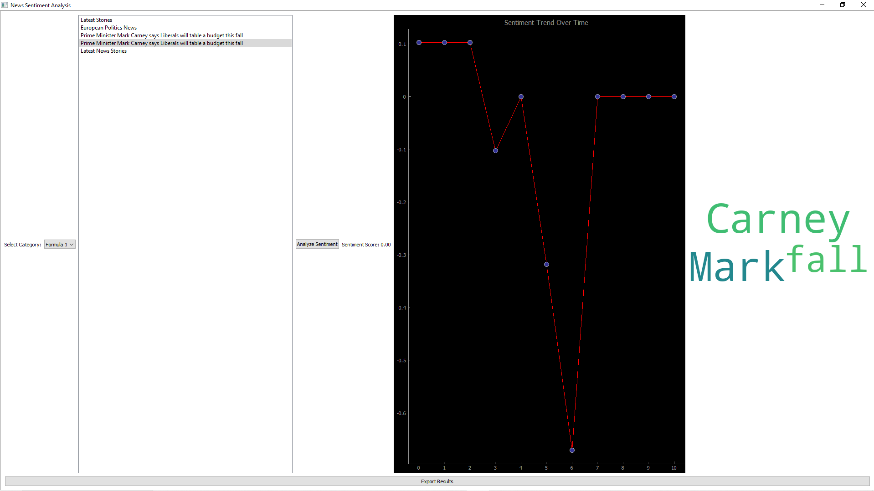
The News Sentiment Analysis GUI is a PyQt5-based application designed to analyze sentiment trends of news headlines fetched from Ground News.
By leveraging natural language processing (NLP) tools like NLTK and SpaCy, alongside web scraping via BeautifulSoup, the project aims to provide valuable insights into Python’s NLP capabilities and real-world text analysis.
The goal of this project is to experiment with and understand the inner workings of Python's NLTK and SpaCy libraries in conjunction with web scraping using BeautifulSoup. Through sentiment analysis of real-time headlines, the tool demonstrates how different NLP techniques can be used to quantify public sentiment, keyword extraction, and trend visualization in an interactive interface.

2. Planning section

Before implementing the GUI we want to address its core frontend and backend structure.

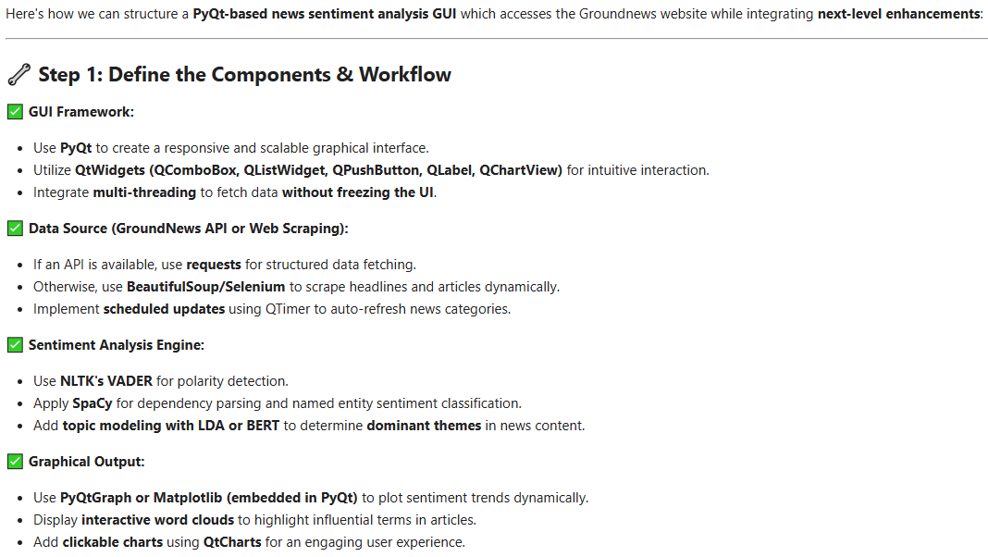
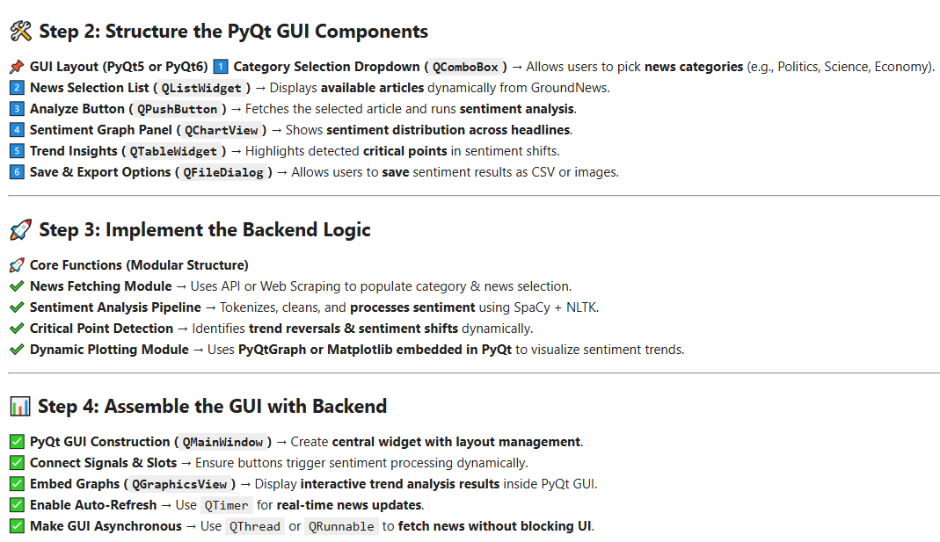

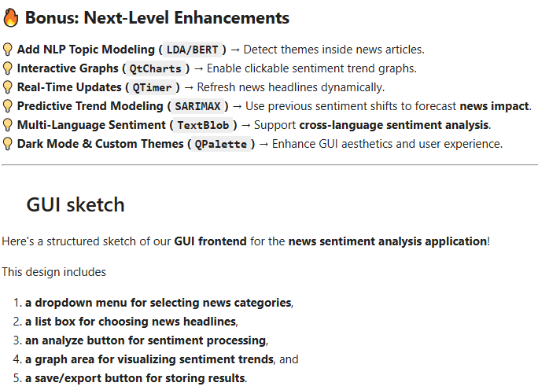
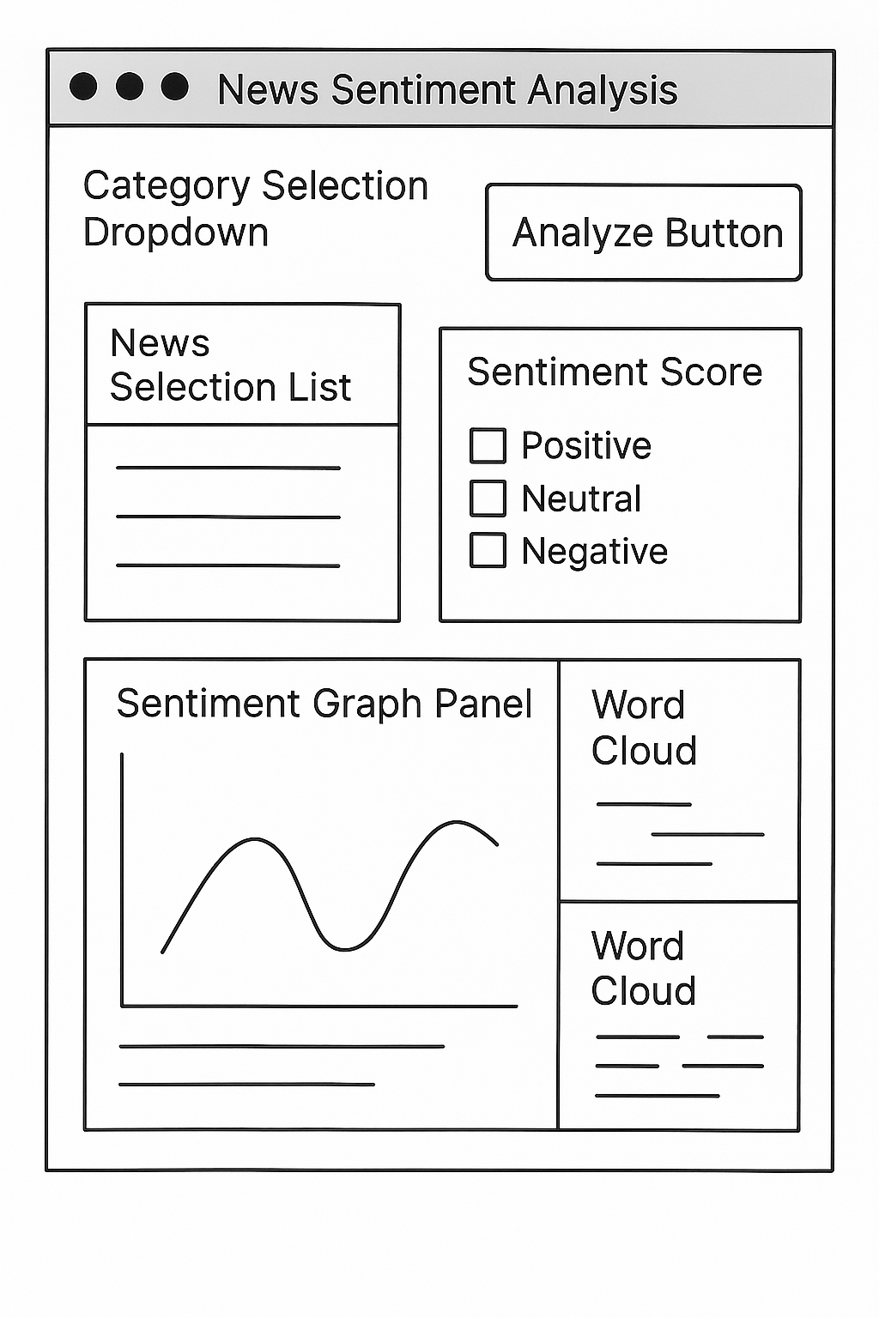

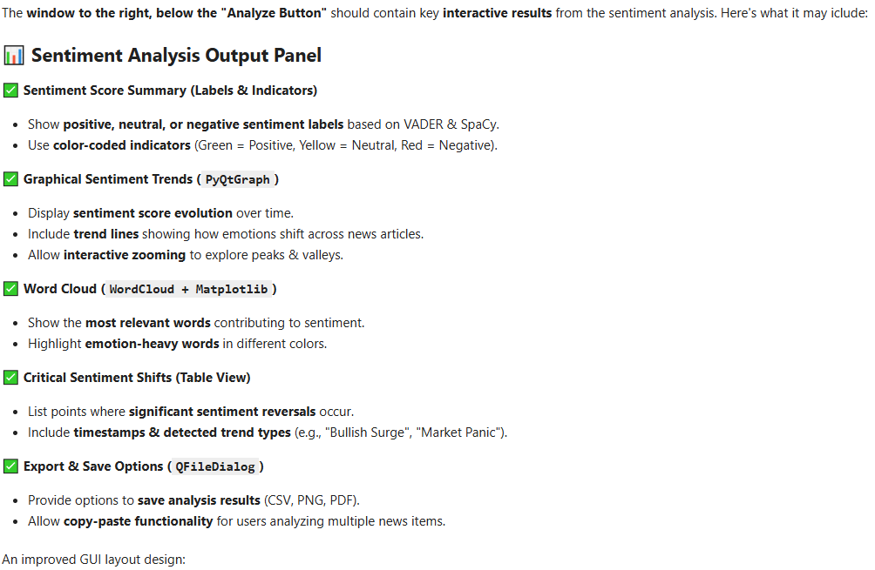
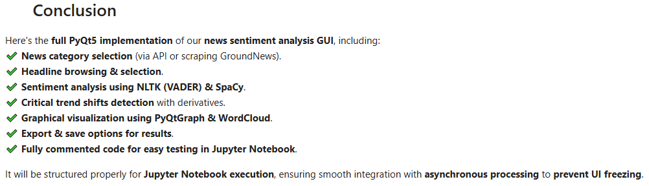

2. Implementation

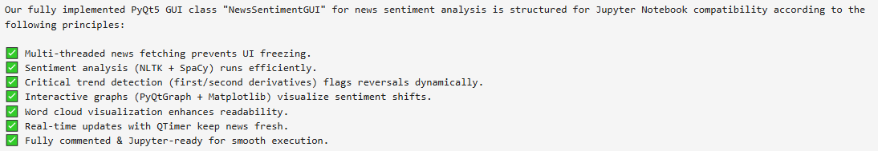

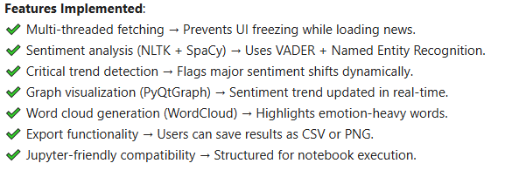

3. Results

The Sentiment analysis GUI offers the following functionality:

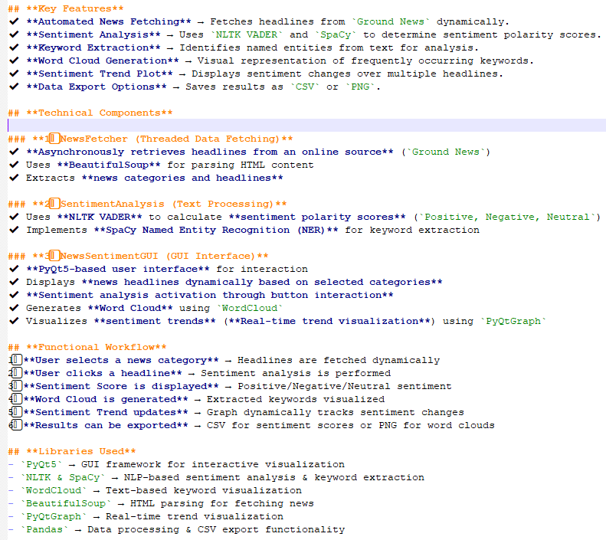

The csv file containing the latest sentiment result has the following structure:
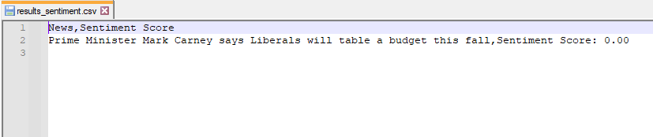
The corresponding associated word cloud, stored as a png file, has the following form:



4. Potential improvements

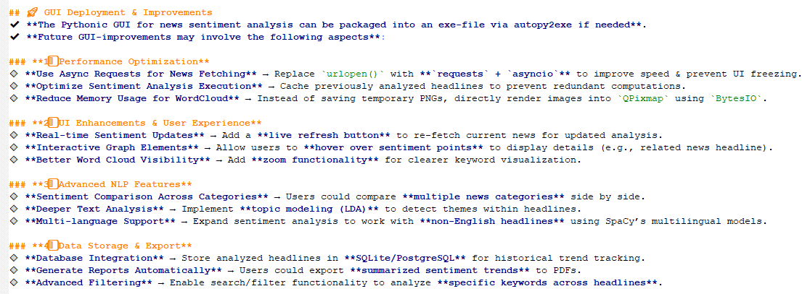

5. Conclusions

The News Sentiment Analysis GUI provides an intuitive and data-driven approach to analyzing news sentiment in real-time.
By integrating advanced NLP techniques, graphical visualization, and dynamic data retrieval, it serves as a powerful tool for extracting emotional insights from online news.
The News Sentiment Analysis GUI serves as a hands-on exploration into Python's NLP capabilities using NLTK and SpaCy, combined with web scraping via BeautifulSoup.
By analyzing real-world news headlines, the project demonstrates how machine learning and NLP techniques can quantify sentiment and extract meaningful insights from textual data in an interactive framework.

6. References
1. Ground News Website – https://ground.news/
2. NLTK Documentation – https://www.nltk.org/
3. SpaCy Documentation – https://pypi.org/project/spacy/, https://spacy.io/
4. Beautiful Soup & WordCloud Documentation – https://pypi.org/project/beautifulsoup4/, https://www.crummy.com/software/BeautifulSoup/bs4/doc/, https://pypi.org/project/wordcloud/, https://amueller.github.io/word_cloud/
5. Robert H. Shumway, David S. Stoffer: "Time Series Analysis and Its Applications with R Examples", Springer (2011).
6. Gareth James, Daniela Witten, Trevor Hastie, Robert Tibshirani, Jonathan Taylor: "An Introduction to Statistical Learning with Applications in Python", Springer (2023).
7. Cornelis W. Oosterlee, Lech A. Grzelak: "Mathematical Modeling and Computation in Finance with Exercises and Python and MATLAB Computer Codes", World Scientific (2020).
8. Richard Szeliski: "Computer Vision - Algorithms and Applications", Springer (2022).
9. Anthony Scopatz, Kathryn D. Huff: "Effective Computation in Physics - Field Guide to Research with Python", O'Reilly Media (2015).
10. Alex Gezerlis: "Numerical Methods in Physics with Python", Cambridge University Press (2020).
11. Gary Hutson, Matt Jackson: "Graph Data Modeling in Python. A practical guide", Packt-Publishing (2023).
12. Hagen Kleinert: "Path Integrals in Quantum Mechanics, Statistics, Polymer Physics, and Financial Markets", 5th Edition, World Scientific Publishing Company (2009).
13. Peter Richmond, Jurgen Mimkes, Stefan Hutzler: "Econophysics and Physical Economics", Oxford University Press (2013).
14. A. Coryn , L. Bailer Jones: "Practical Bayesian Inference A Primer for Physical Scientists", Cambridge University Press (2017).
15. Avram Sidi: "Practical Extrapolation Methods - Theory and Applications", Cambridge university Press (2003).
16. Volker Ziemann: "Physics and Finance", Springer (2021).
17. Zhi-Hua Zhou: "Ensemble methods, foundations and algorithms", CRC Press (2012).
18. B. S. Everitt, et al.: "Cluster analysis", Wiley (2011).
19. Lior Rokach, Oded Maimon: "Data Mining With Decision Trees - Theory and Applications", World Scientific (2015).
20. Bernhard Schölkopf, Alexander J. Smola: "Learning with kernels - support vector machines, regularization, optimization and beyond", MIT Press (2009).
21. Johan A. K. Suykens: "Regularization, Optimization, Kernels, and Support Vector Machines", CRC Press (2014).
22. Sarah Depaoli: "Bayesian Structural Equation Modeling", Guilford Press (2021).
23. Rex B. Kline: "Principles and Practice of Structural Equation Modeling", Guilford Press (2023).
24. Ekaterina Kochmar: "Getting Started with Natural Language Processing", Manning (2022).

