A Crypto-Pipeline

with

Dagster

Inhaltsverzeichnis
1. Project description 3
Aim 3
2. Planning section 4
2.1 Structure of the encryption pipeline 4
2.2 Elaboration on pythonic implementation details 5
3. Pythonic Crypto pipeline implementation 8
3.1 Packages to be installed 8
3.2 Generate private and public keys 8
3.3 Encryption pipeline 9
3.4 Decryption pipeline 12
4. Dagster Pipeline structure 14
4.1 Project Structure 15
4.2 Define Dagster Ops (ops.py) 15
4.3 Define Dagster Jobs (jobs.py) 15
4.4 Entry Point (CLI or UI) 16
4.5 Structure of pythonic crypto-files 16
5. Pipeline execution via dagster 17
5.1 Package installation 17
5.2 Generate appropriate folder structure 18
5.3 Generate public and private keys 18
5.4 Execute the Dagster UI 19
5.5 Open the Dagster UI and run jobs 19
6. Resume 21
6.1 The DAG view of the Crypto pipeline 21
6.2 Op Breakdown 21
6.3 How Dagster improves procedures 22
6.4 Summary 22
7. References 24

1. Project description

Aim
The purpose of a Dagster Encryption Pipeline is to test and showcase dagsters DAG-chaining capabilities, resulting in a self-contained encryption-decryption pipeline which, 1) connects different encryption methods of a plain text prior to, 2) decrypting (and thus reversing the performed chain of encryption operations performed on an) encrypted message.
This project aims at designing a encryption-decryption pipeline via Dagsterr's website that would support users in generating robustly encrpted messages from a well-defined plain text input

2. Planning section

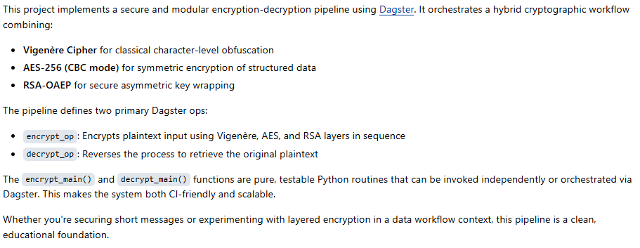

2.1 Structure of the encryption pipeline

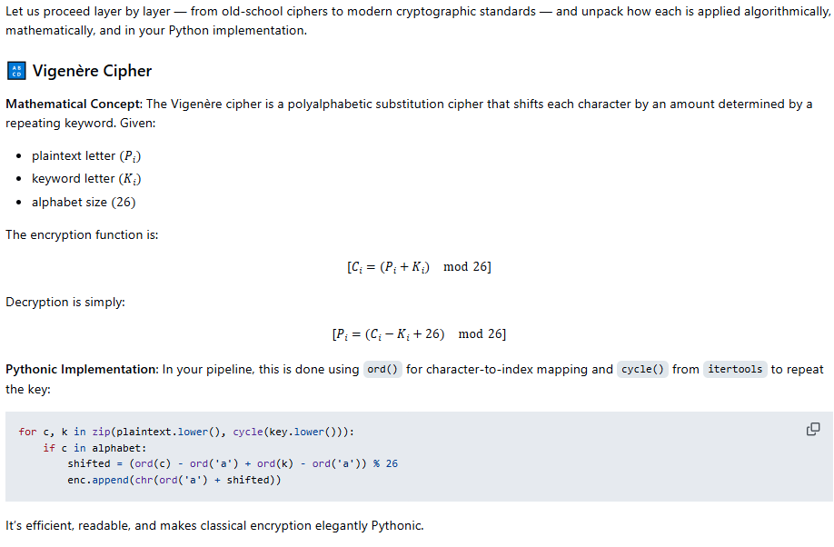
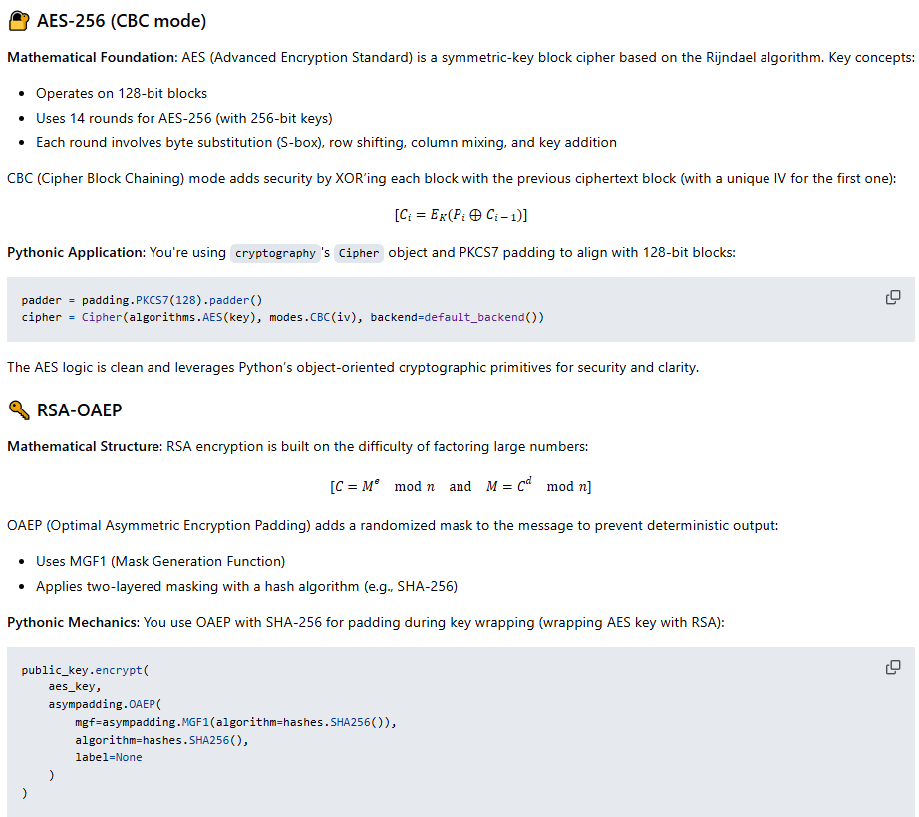
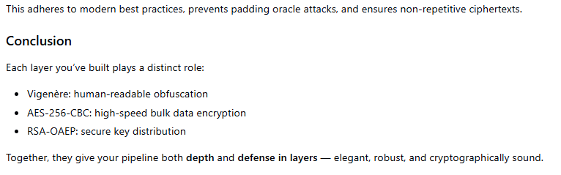

2.2 Elaboration on pythonic implementation details

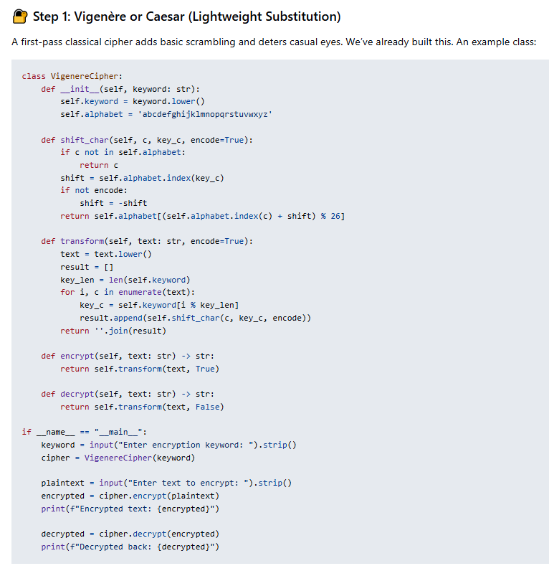
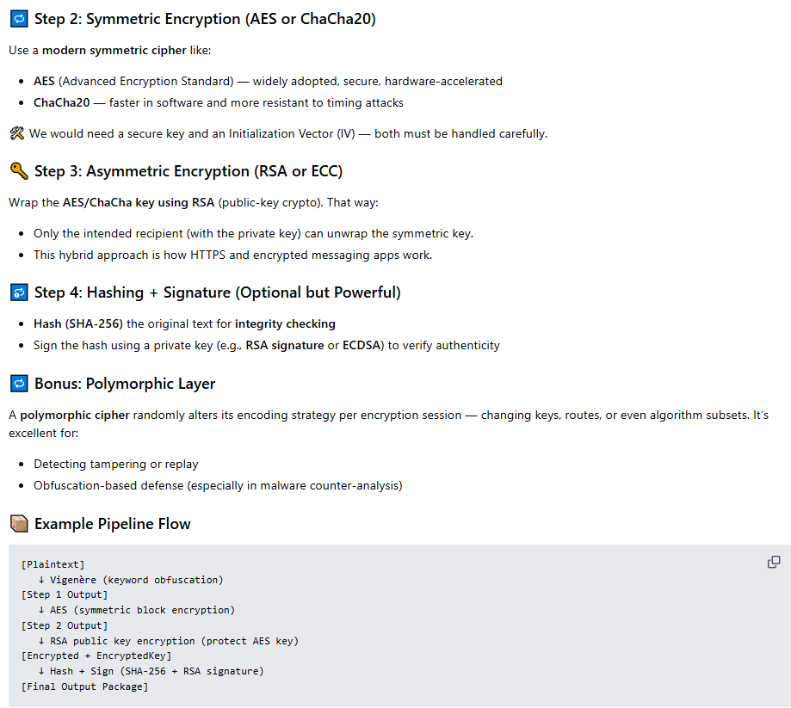

3. Pythonic Crypto pipeline implementation
Here’s how we can approach this project step by step:

3.1 Packages to be installed

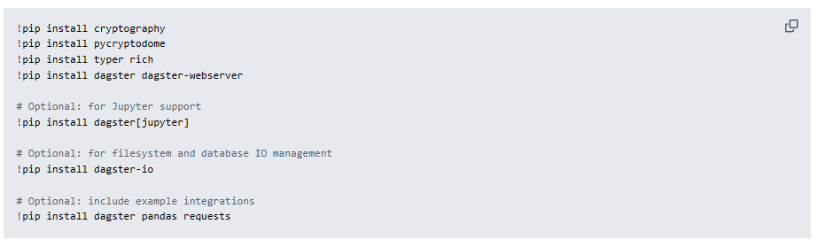

3.2 Generate private and public keys

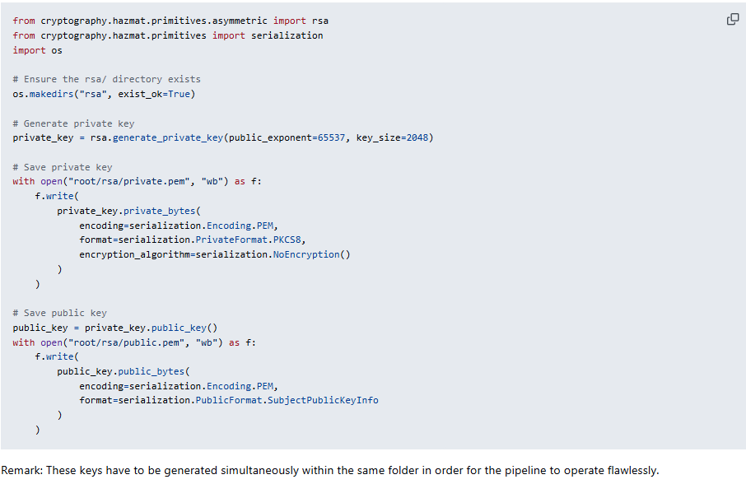

3.3 Encryption pipeline

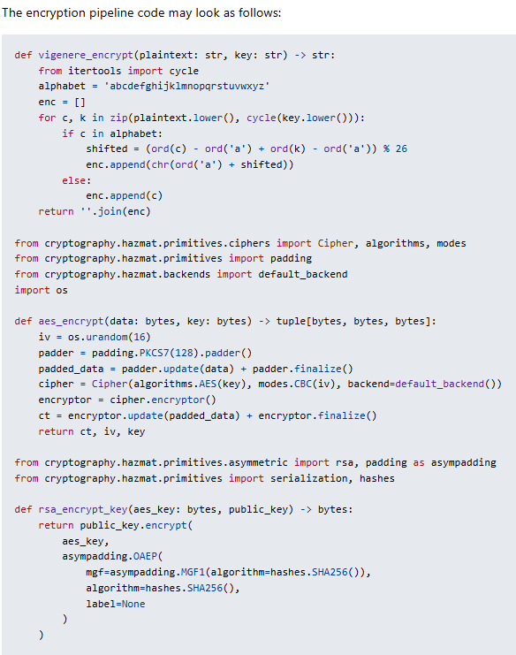

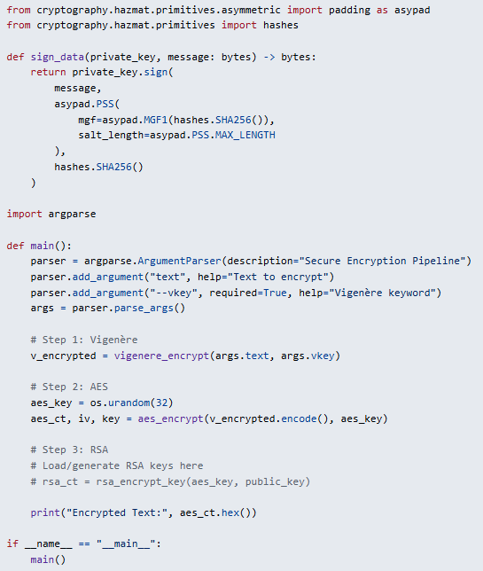

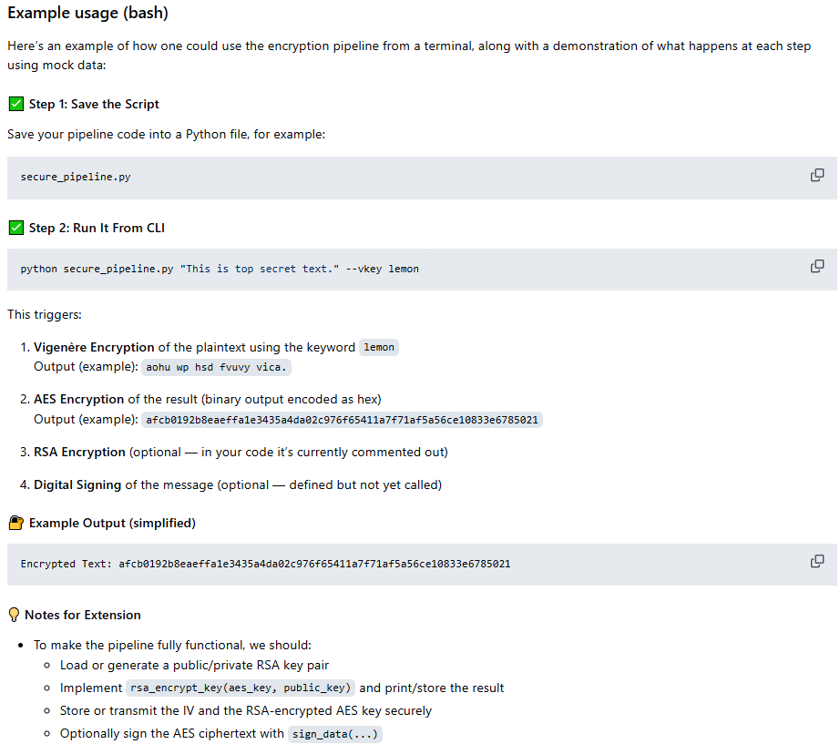

3.4 Decryption pipeline

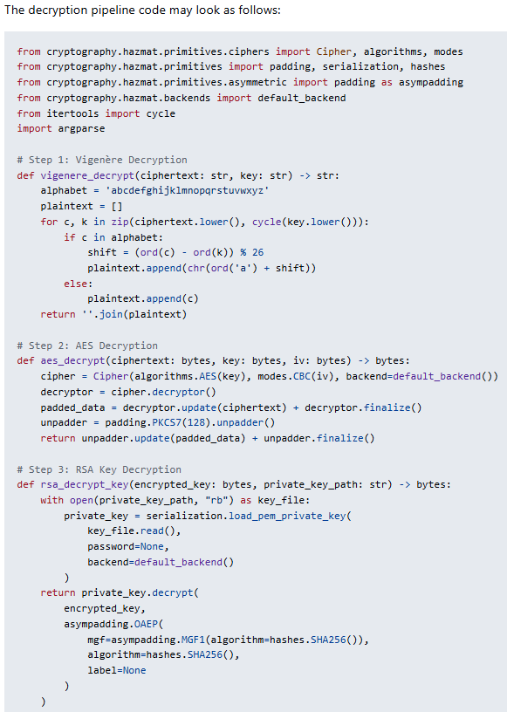
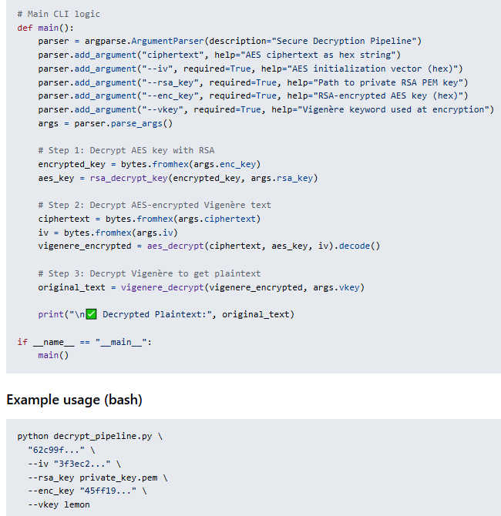

4. Dagster Pipeline structure

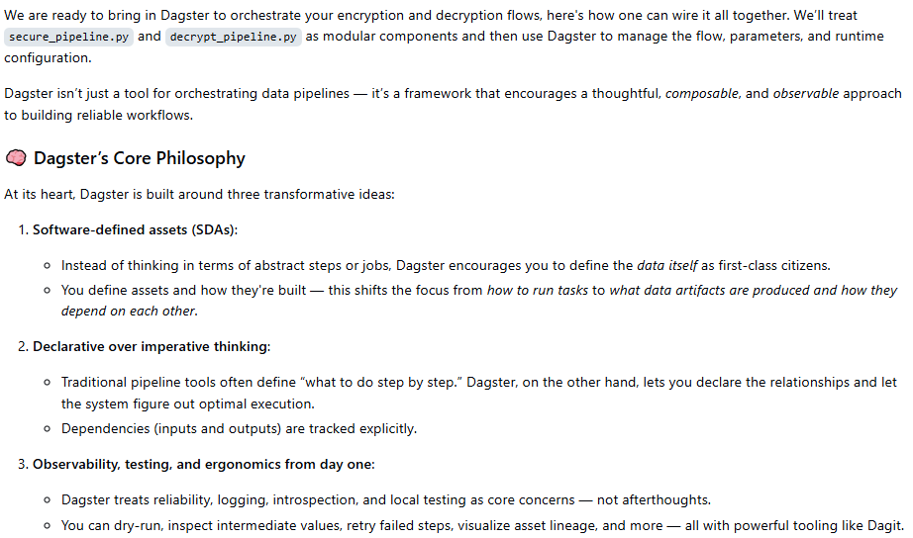
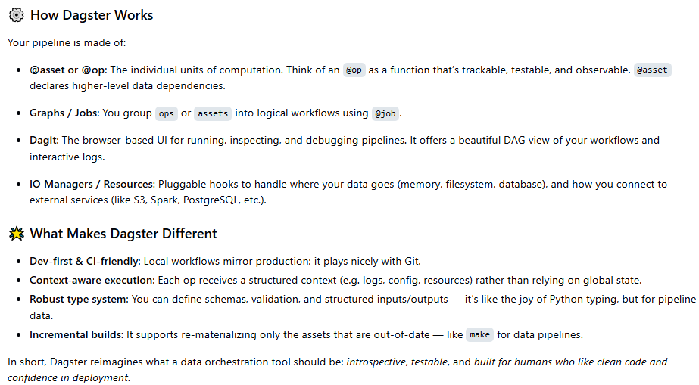

4.1 Project Structure

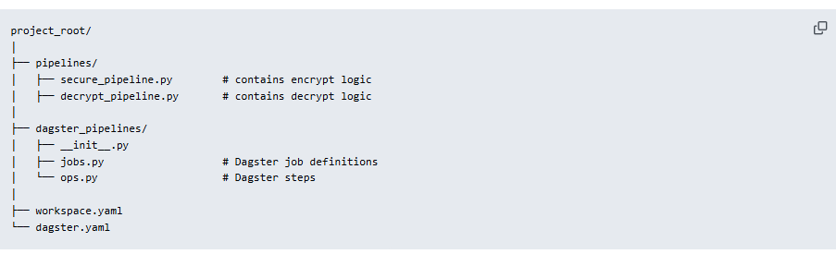

4.2 Define Dagster Ops (ops.py)
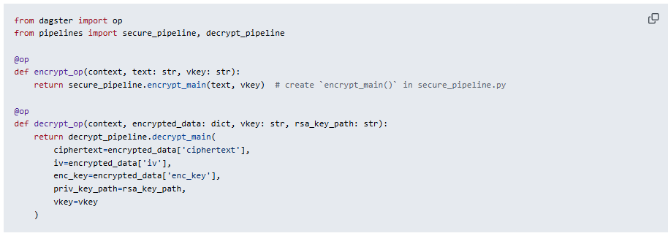

4.3 Define Dagster Jobs (jobs.py)

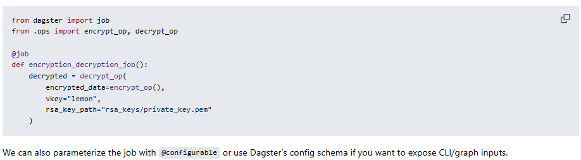

4.4 Entry Point (CLI or UI)
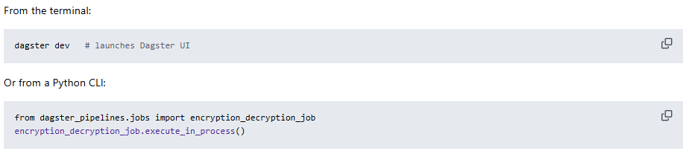

4.5 Structure of pythonic crypto-files

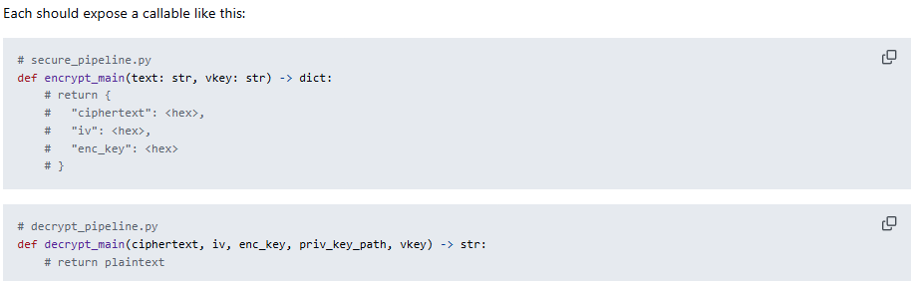
This turns our CLI tools into reusable data pipeline steps. Add logging, tests, or run schedules and we on our way to production-grade cryptography orchestration.

5. Pipeline execution via dagster

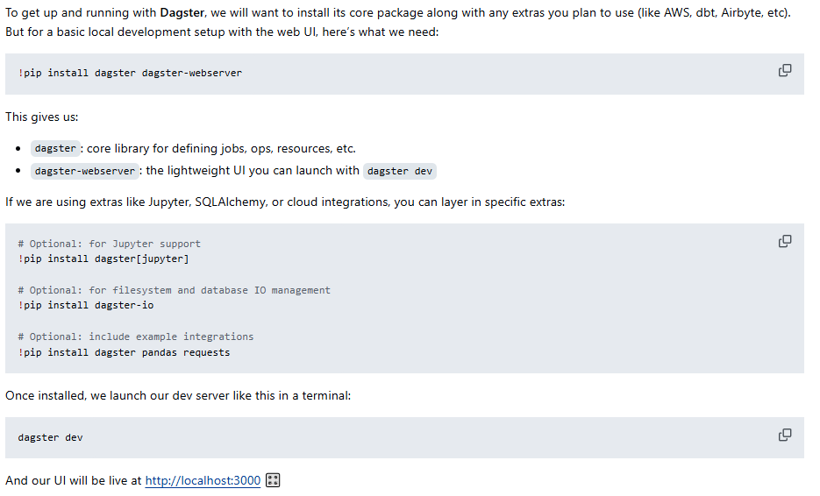

5.1 Package installation

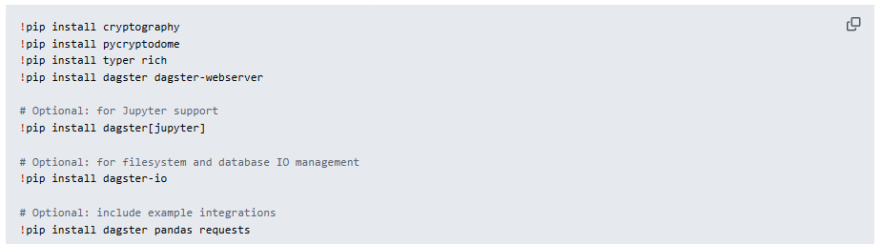

5.2 Generate appropriate folder structure

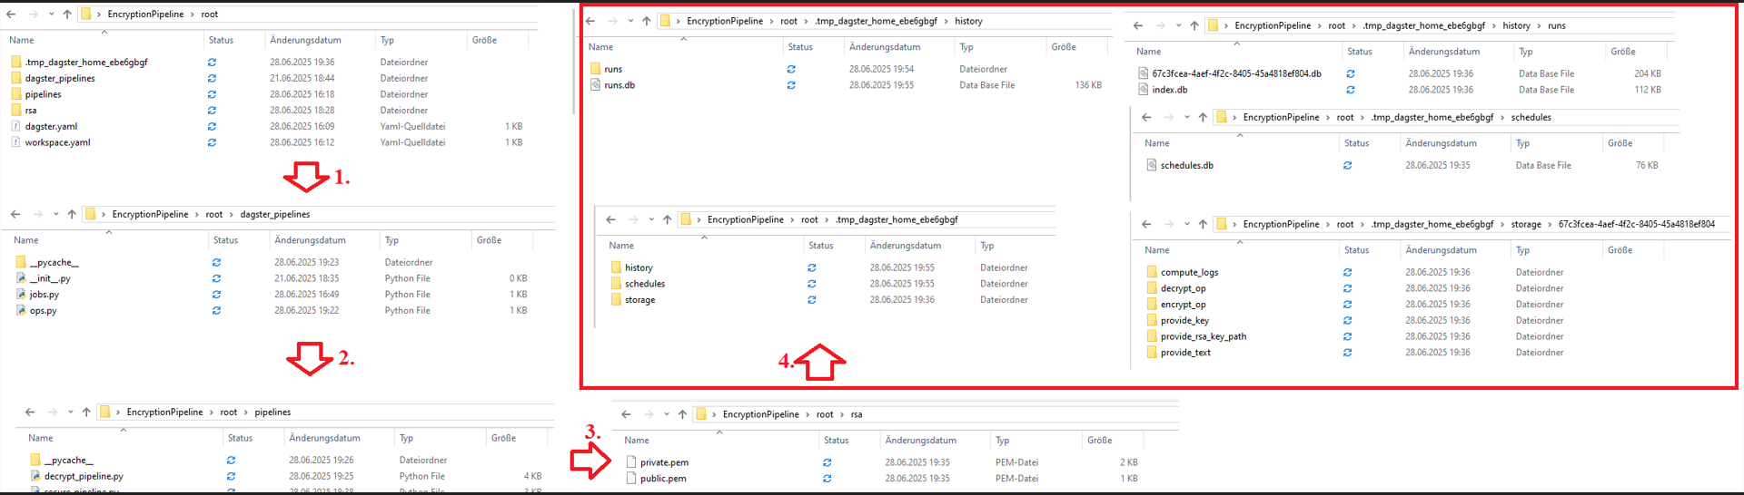

5.3 Generate public and private keys
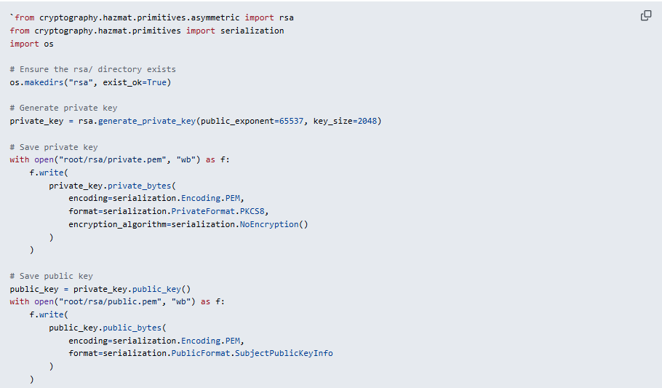

5.4 Execute the Dagster UI
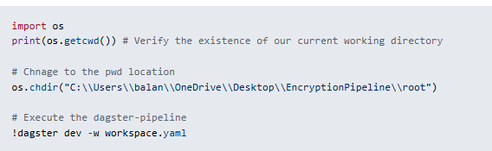

5.5 Open the Dagster UI and run jobs
Our UI will be live at http://localhost:3000 🎛️

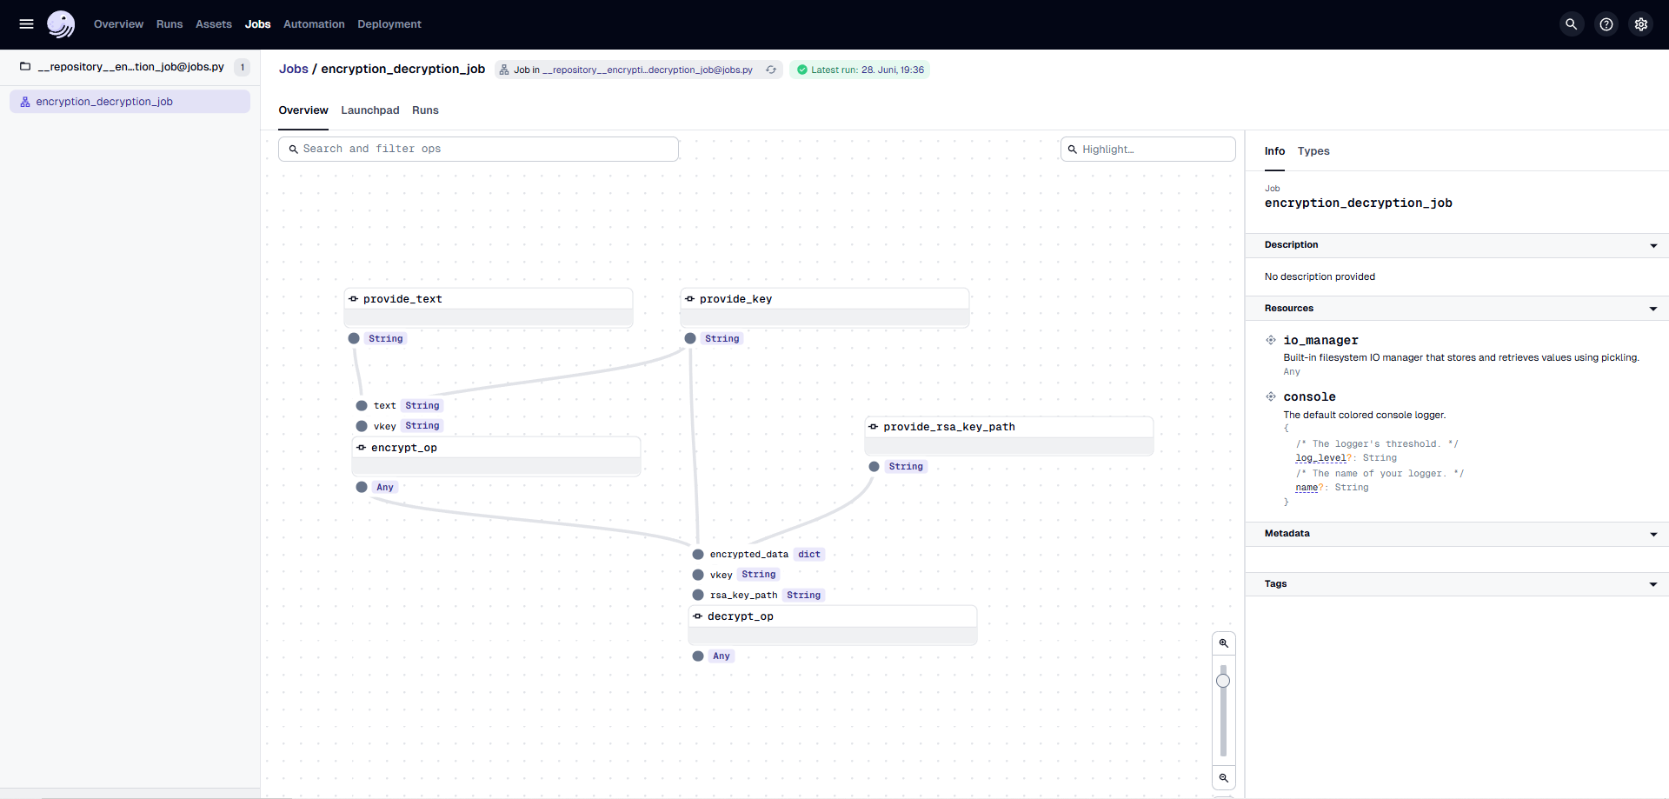
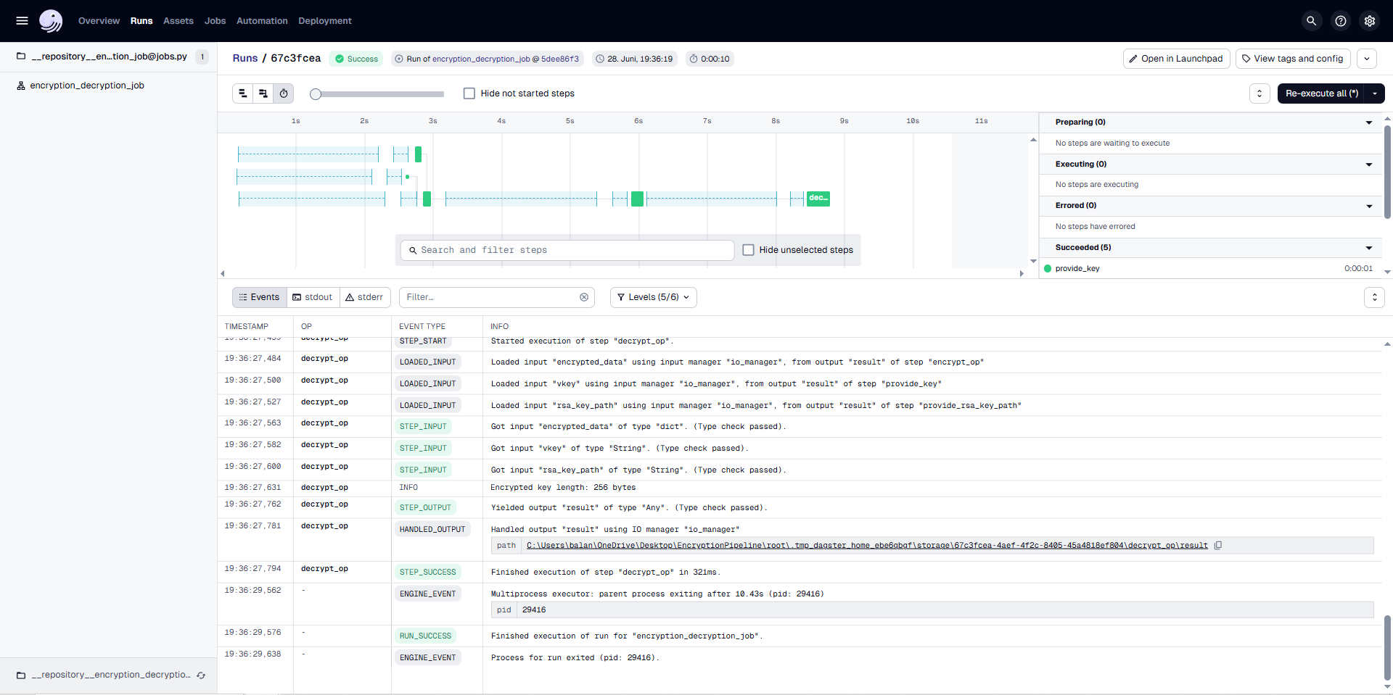

6. Resume

6.1 The DAG view of the Crypto pipeline
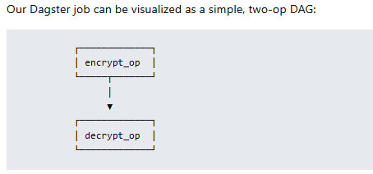

6.2 Op Breakdown
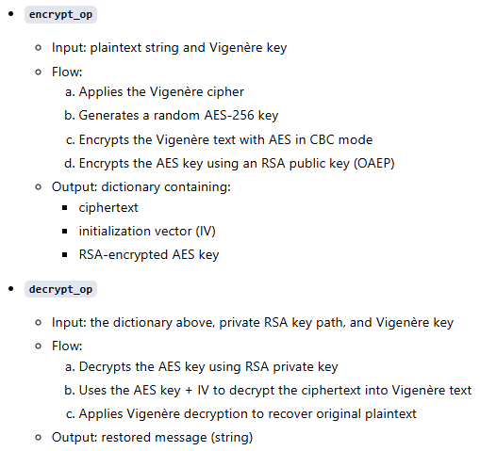

6.3 How Dagster improves procedures
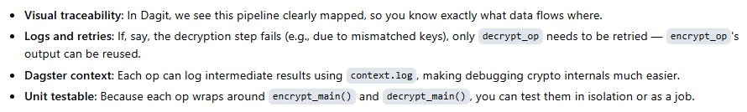

6.4 Summary
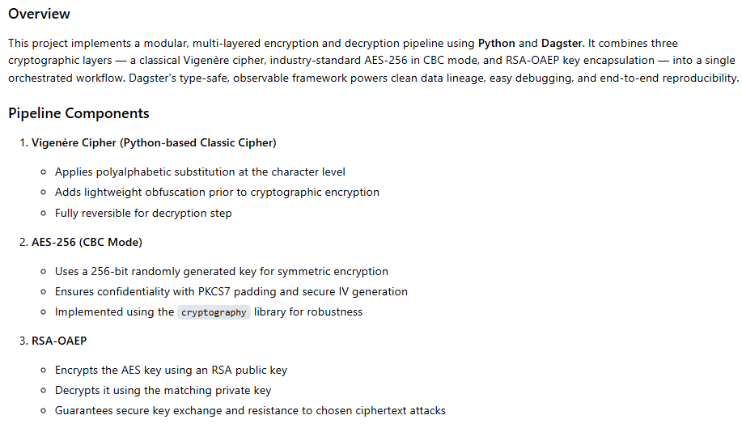
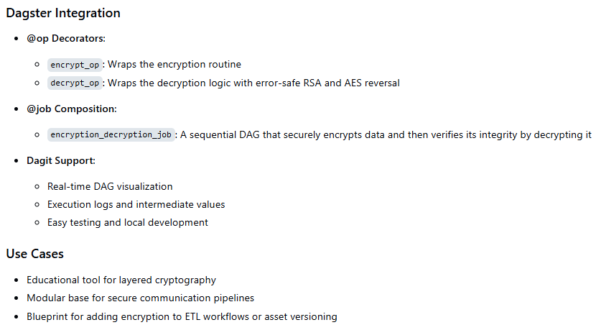

7. References
1. C. Paar, J. Pelzl: "Understanding Cryptography", Springer (2010); H. Delfs, H. Knebl: "Introduction to Cryptography", 3rd Ed. Springer (2015); J. Katz, Y. lindell: "Introduction to Modern Cryptography", 2nd Ed, CRC Press (2015); O. Goldreich: "Foundations of Cryptography", Cambridge University Press (2008); J. P. Aumasson: "Serious Cryptography", no starch press (2018).
2. A. Meister , T. Sonar: "Numerik", 1st Ed. Springer-Spektrum (2019); S. Chapra, R. Canale: "Numerical Methods for Engineers", Mcgraw-Hill, 6th Edition (2010).
3. J. Kilty, A. M. McAllister: "Mathematical Modeling and Applied Calculus", 1st Ed. Oxford University Press (2018).
4. U. Kockelkorn: "Statistik für Anwender", 1st Ed. Springer (2012), s. chapters 7 - 8.
5. Robert H. Shumway, David S. Stoffer: "Time Series Analysis and Its Applications with R Examples", Springer (2011).
6. Gareth James, Daniela Witten, Trevor Hastie, Robert Tibshirani, Jonathan Taylor: "An Introduction to Statistical Learning with Applications in Python", Springer (2023).
7. Cornelis W. Oosterlee, Lech A. Grzelak: "Mathematical Modeling and Computation in Finance with Exercises and Python and MATLAB Computer Codes", World Scientific (2020).
8. Richard Szeliski: "Computer Vision - Algorithms and Applications", Springer (2022).
9. Anthony Scopatz, Kathryn D. Huff: "Effective Computation in Physics - Field Guide to Research with Python", O'Reilly Media (2015).
10. Alex Gezerlis: "Numerical Methods in Physics with Python", Cambridge University Press (2020).
11. Gary Hutson, Matt Jackson: "Graph Data Modeling in Python. A practical guide", Packt-Publishing (2023).
12. Hagen Kleinert: "Path Integrals in Quantum Mechanics, Statistics, Polymer Physics, and Financial Markets", 5th Edition, World Scientific Publishing Company (2009).
13. Peter Richmond, Jurgen Mimkes, Stefan Hutzler: "Econophysics and Physical Economics", Oxford University Press (2013).
14. A. Coryn , L. Bailer Jones: "Practical Bayesian Inference A Primer for Physical Scientists", Cambridge University Press (2017).
15. Avram Sidi: "Practical Extrapolation Methods - Theory and Applications", Cambridge university Press (2003).
16. Volker Ziemann: "Physics and Finance", Springer (2021).
17. Zhi-Hua Zhou: "Ensemble methods, foundations and algorithms", CRC Press (2012).
18. B. S. Everitt, et al.: "Cluster analysis", Wiley (2011).
19. Lior Rokach, Oded Maimon: "Data Mining With Decision Trees - Theory and Applications", World Scientific (2015).
20. Bernhard Schölkopf, Alexander J. Smola: "Learning with kernels - support vector machines, regularization, optimization and beyond", MIT Press (2009).
21. Johan A. K. Suykens: "Regularization, Optimization, Kernels, and Support Vector Machines", CRC Press (2014).
22. Sarah Depaoli: "Bayesian Structural Equation Modeling", Guilford Press (2021).
23. Rex B. Kline: "Principles and Practice of Structural Equation Modeling", Guilford Press (2023).
24. Ekaterina Kochmar: "Getting Started with Natural Language Processing", Manning (2022).
25. Rex B. Kline: "Principles and Practice of Structural Equation Modeling", Guilford Press (2023).
26. Ekaterina Kochmar: "Getting Started with Natural Language Processing", Manning (2022).
27. Jakub Langr, Vladimir Bok: "GANs in Action", Computer Vision Lead at Founders Factory (2019).
28. David Foster: "Generative Deep Learning", O'Reilly(2023).
29. Rowel Atienza: "Advanced Deep Learning with Keras: Applying GANs and other new deep learning algorithms to the real world", Packt Publishing (2018).
30. Josh Kalin: "Generative Adversarial Networks Cookbook", Packt Publishing (2018).
31. Thomas Haslwanter: „Hands-on Signal Analysis with Python: An Introduction“, Springer (2021).
32. Jose Unpingco: „Python for Signal Processing“, Springer (2023).
33. R. K. Burdick, C. M. Borror, D. C. Montgomery: "Design and Analysis of Gauge R&R Studies", 1st Ed. SIAM (2005); S. H. Derakhshan , C. V. Deutsch: "Numerical Integration of Bivariate Gaussian Distribution", Paper 405, CCG Anual Report 13 (2011).

