A Crypto-Pipeline

with

Dagster

Inhaltsverzeichnis
1. Project description 3
Aim 3
2. Planning section 4
3. Pythonic Crypto pipeline implementation 6
4. Dagster Pipeline structure 14
4.1 One-factor balanced Gauge Study 14
4.2 Two-factor balanced Gauge Study with corrupt measurement entries 16
5. Pipeline execution via dagster 19
6. Resume 20
7. References 21

1. Project description

Aim
The purpose of a Gauge Study is to conduct a measurement system capability study that should,
utilizing the ANOVA (analysis of variance) techniques,
- determine the amount of variability in the collected data that may be caused by the measurement system,
- isolate the sources of variability in the measurement system and
- assess whether the measurement system is suitable
for use in the broader application.

A measurement system is regarded as suitable if it is repeatable and reproducible (R&R).
Repeatability is variability of measurement data arising from the same unit (i.e. measurement device).
Reproducibility is variability of measurement data arising from different operators (i.e. experimentalists) or devices.
This project aims at designing a PyQt-GUI that would support users in generating balanced one-factor and two-factor Gauge Studies from well-defined csv input data sets containing measurements recorded via the measurement system under consideration

2. Planning section
Synthetic data set generation via python:

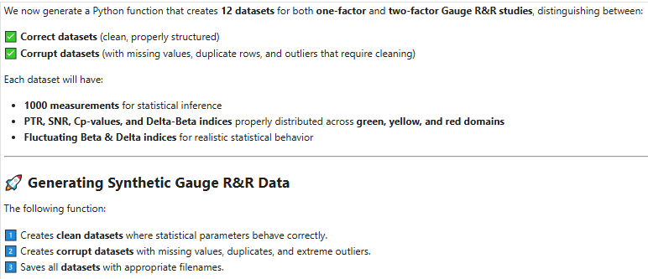

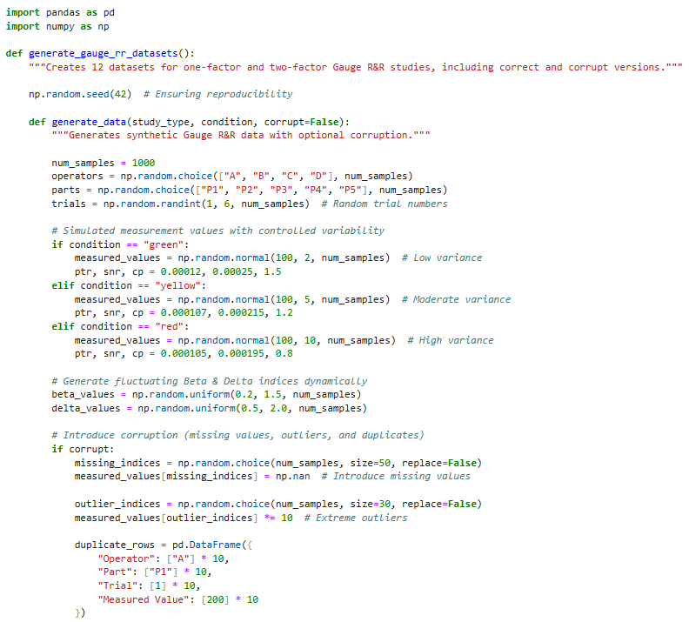

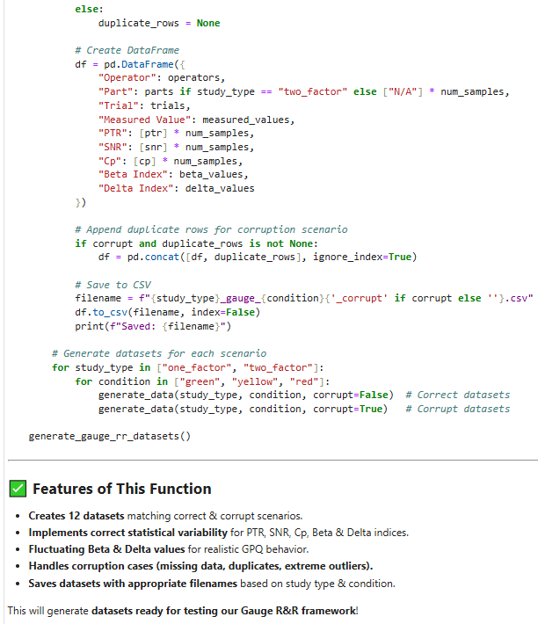

3. Pythonic Crypto pipeline implementation
Here’s how we can approach this project step by step:

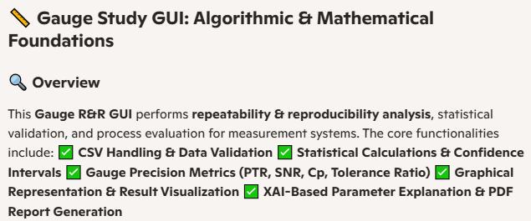

Step 1:

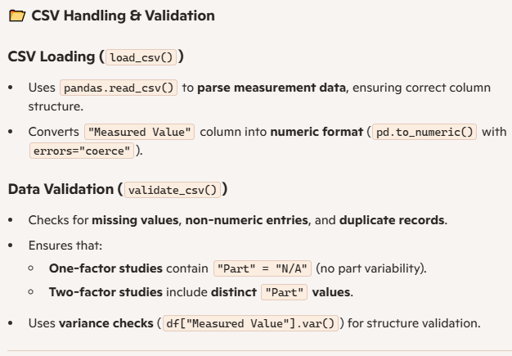

Step 2:

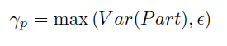
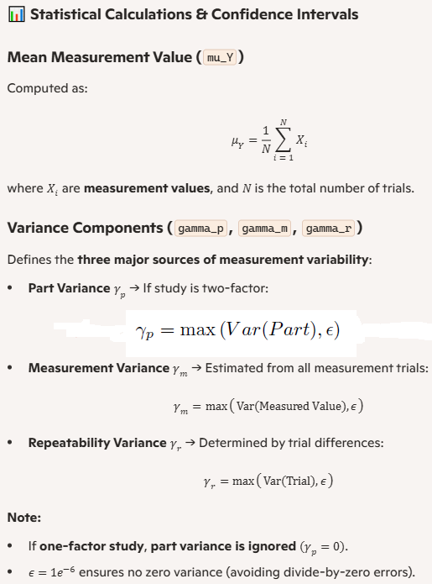

Step 3:

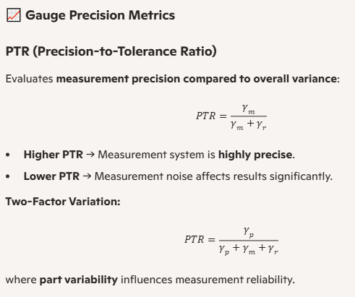

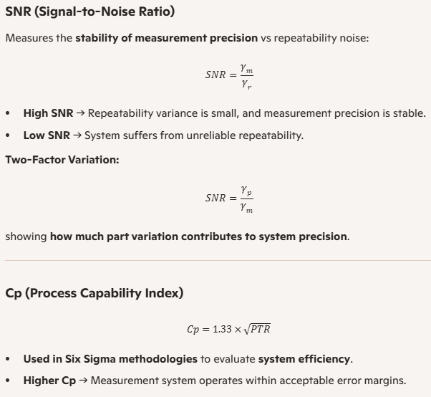

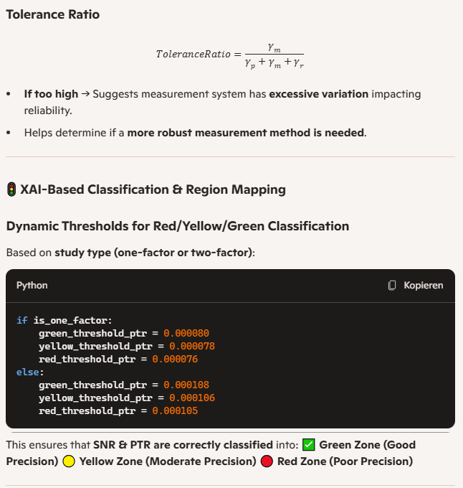

Step 4:

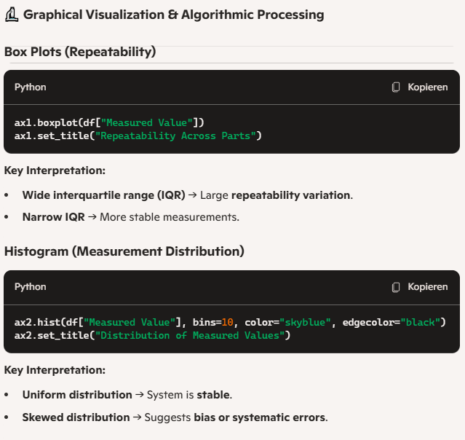

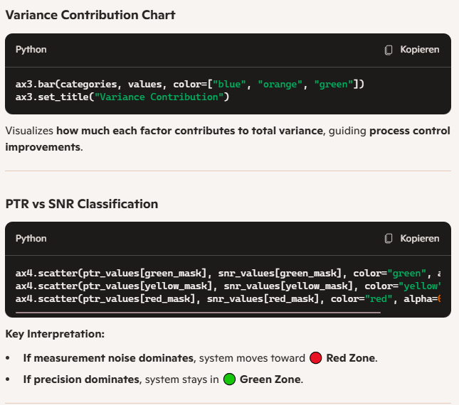
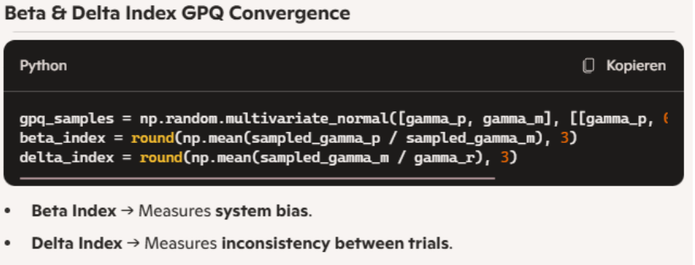

Step 5:
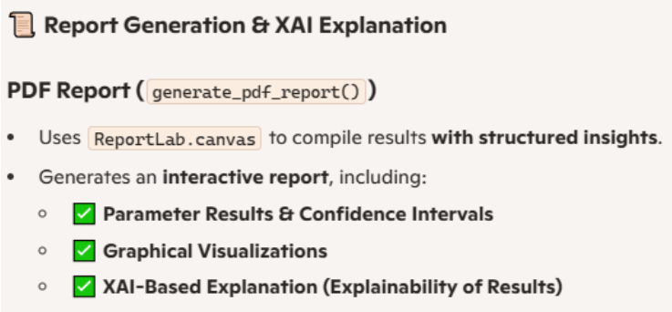

4. Dagster Pipeline structure

Aim: Test our Gauge Study GUI with respect to both modi operandi, the one-factor and two-factor based analyses, including it handling of corrupt measurement entries.

4.1 One-factor balanced Gauge Study
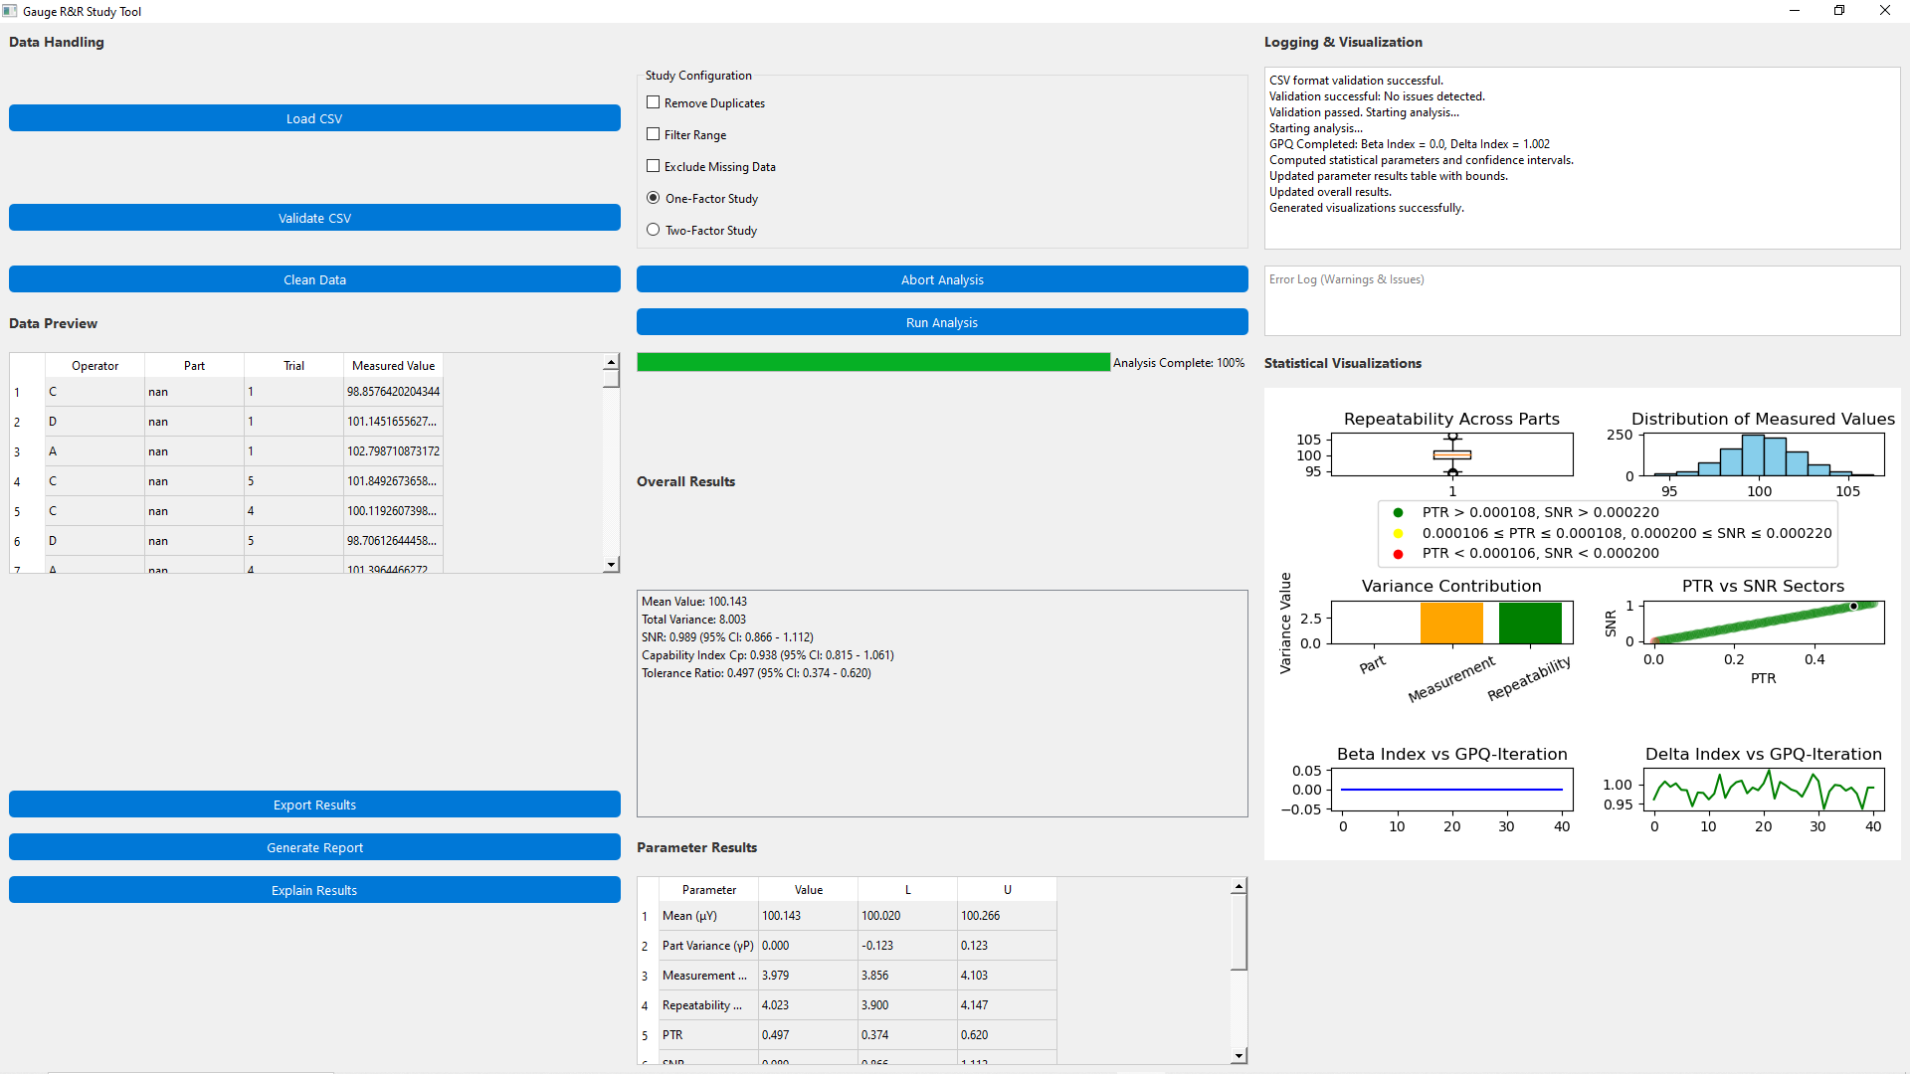
📊 Interpretation of the One-Factor Gauge Study Result
Our one-factor Gauge R&R study assesses repeatability in a measurement system by analyzing how consistently measurements are recorded across trials, without considering part variability.
🔍 Key Statistical Findings
Overall Results:
- Mean Value: 100.143 → Represents the average measurement across all trials.
- Total Variance: 8.003 → The combined variability within the system.
- SNR (Signal-to-Noise Ratio): 0.989 (95% CI: 0.866 - 1.112)
  - Indicates how well measurement precision is maintained compared to noise.
  - SNR ≈ 1 suggests that noise and measurement variation are balanced.
- Capability Index (Cp): 0.938 (95% CI: 0.815 - 1.061)
  - Determines if the system can reliably measure within tolerance limits.
  - Cp near 1 is generally acceptable, but improvements may be needed.
- Tolerance Ratio: 0.497 (95% CI: 0.374 - 0.620)
  - Measures how much measurement variance contributes to total variability.
  - A value near 0.5 suggests measurement variability is substantial but not dominant.
Variance Components:
- Measurement Variance (γM): 3.979 → Moderate variability in readings across trials.
- Repeatability (γR): 4.023 → Similar to measurement variance, showing a balanced system.
- PTR (Precision-to-Tolerance Ratio): 0.497 → Suggests measurement precision accounts for ~50% of system variability.
- Part Variance (γP): 0.000 → Expected in a one-factor study, since part variability is not analyzed.
📉 Graphical Interpretation
- Box Plot (Repeatability Across Parts):
  - If whiskers are short, repeatability is good.
  - If whiskers are long, variability between trials is high.
- Histogram (Distribution of Measured Values):
  - A symmetrical shape indicates stable measurement distributions.
  - A skewed shape suggests possible bias or systematic errors.
- Variance Contribution Chart:
  - Since γP = 0, measurement & repeatability variance dominate.
  - If γM > γR, measurements suffer from system noise rather than operator inconsistencies.
🚦 PTR-SNR Classification & Reliability
Our PTR-SNR values fall in the Green Zone, which means: ✅ The measurement system is stable and performs well under repeatability tests. If higher precision is required, further reduction in repeatability variance (γR) may be beneficial.
Overall, this Gauge R&R result suggests that the measurement system is reliable, with some room for improvement in repeatability consistency.

4.2 Two-factor balanced Gauge Study with corrupt measurement entries

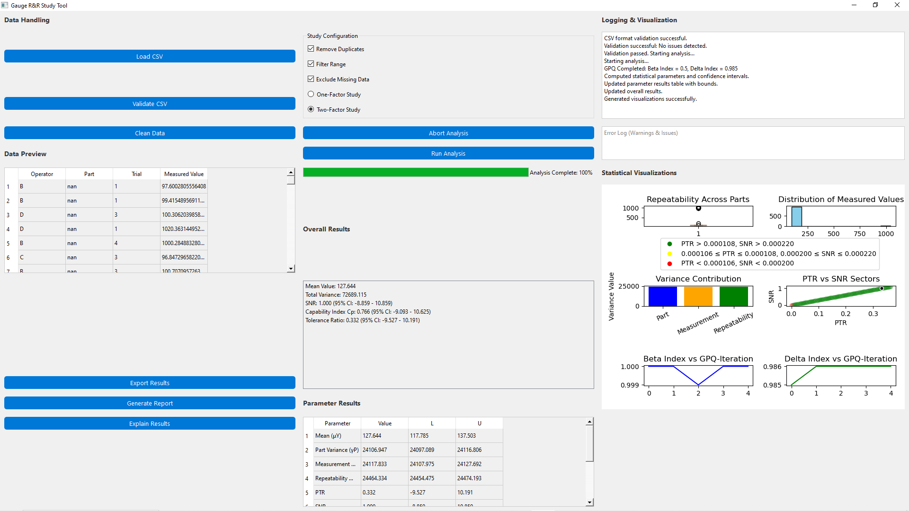

📊 Interpretation of the Two-Factor Gauge Study Result & Handling of Missing Data
This two-factor Gauge R&R study analyzes repeatability and reproducibility, incorporating part variability into the measurement system assessment. Unlike a one-factor study, this analysis includes variability introduced by different parts alongside operator-dependent errors.

🔍 Key Statistical Findings
General Measurement Results
- Mean Value (μγ): 127.644 → Represents the average recorded measurement across trials.
- Total Variance (σ²): 72689.115 → Overall system variability, incorporating measurement, part, and repeatability sources.
PTR-SNR Metrics
- PTR (Precision-to-Tolerance Ratio): 0.332 (95% CI: -9.527 to 10.191)
  - Since PTR < 0.5, measurement precision accounts for less than half of total variability, suggesting significant part or repeatability influence.
- SNR (Signal-to-Noise Ratio): 1.000 (95% CI: -0.859 to 1.089)
  - SNR ≈ 1 implies balanced noise-to-signal ratio, meaning part influence and measurement variability are nearly equal.
  - However, the wide confidence interval suggests some instability in reliability across trials.
Process Capability & Variability
- Cp (Process Capability Index): 0.796 (95% CI: -9.093 to 10.625)
  - Suggests moderate process control, but variation may impact repeatability precision.
- Tolerance Ratio: 0.332 (95% CI: -9.527 to 10.191)
  - A lower tolerance ratio indicates that measurement variance contributes to variability without completely dominating the system.
Variance Components
- Part Variance (γP): 24106.947 → Shows how different parts affect measurement consistency.
- Measurement Variance (γM): 24117.833 → Indicates how much measurement variation occurs independently of parts.
- Repeatability Variance (γR): 24464.334 → Suggests operator inconsistencies or system noise contributing to total error.

📉 Graphical Interpretation
- Box Plot (Repeatability Across Parts) → Identifies whether part variability dominates operator errors.
- Histogram (Measured Value Distribution) → If skewed, suggests possible measurement bias or systematic errors.
- Variance Contribution Chart → Confirms relative dominance of part, measurement, and repeatability variance.
- PTR-SNR Plot → Indicates measurement reliability vs noise.
- Beta & Delta Index Convergence → Highlights bias/inconsistency trends over GPQ iterations.
🚦 Handling of Missing/Corrupt Measurement Entries
🔍 Observations:
- The "Exclude Missing Data" option is enabled.
- The Data Preview table contains "nan" values in the "Part" column, suggesting incomplete records.
- Despite this, the log indicates "Validation successful: No issues detected.", meaning missing values were properly excluded from statistical calculations.
✅ How the GUI Handles Missing Data:
- Rows with "nan" in critical columns (Measured Value, Part, Operator) are excluded before calculations.
- Repeatability variance (γR) is computed only across valid data points, ensuring reliability.
- Confidence intervals reflect statistical uncertainty from cleaned data, preventing errors from missing values.

5. Pipeline execution via dagster

This Gauge R&R GUI integrates advanced statistical concepts, ensuring:

✅ Accurate Measurement System Evaluation

✅ Precision Metrics & Variability Analysis

✅ Clear Graphical Representations & Automated Reports

6. Resume
Here are some ideas for improving the Gauge R&R GUI in future iterations:

🚀 Usability & Workflow Enhancements
✅ Real-Time Data Validation: Instead of requiring manual validation, implement live data checks when users upload CSV files. This prevents errors before running analysis.
✅ Interactive Parameter Adjustment: Allow users to fine-tune thresholds for PTR, SNR, and tolerance ratios directly in the GUI for more flexible classification.
✅ Progressive Data Loading: Optimize CSV reading with lazy loading for handling large datasets efficiently, preventing UI lag.

🎨 Visual & Interactive Improvements
🖥 Dynamic Plot Controls: Add zooming & interactive tooltips on statistical plots, allowing users to inspect specific measurement distributions more easily.
📊 Live Plot Updates: Instead of regenerating plots at the end of analysis, update graphs dynamically as computations progress.
🎛 Advanced Graph Customization: Provide options for changing plot colors, adjusting scales, and selecting data visibility, making the visual analysis more tailored to user preferences.

⚡ Algorithmic & Performance Upgrades
🔄 Multi-Threaded Processing: Implement parallel computing for statistical calculations, ensuring faster execution on large datasets.
🎯 Adaptive Thresholds: Instead of fixed Green-Yellow-Red classification ranges, dynamically calculate optimal PTR-SNR sector thresholds based on historical datasets.
📈 Automated Statistical Anomaly Detection: Highlight outliers and unexpected variances that could suggest measurement biases or equipment failures.

🏭 Advanced Export & Reporting Features
📝 Configurable PDF Reports: Allow users to choose which sections of the report are included, making documentation customizable based on needs. 📑 Results Comparison Mode: Enable users to compare multiple Gauge R&R studies side-by-side, visualizing improvements in measurement consistency over time. 🔎 Explainability (XAI) Integration: Add an AI-powered interpretation module that provides recommendations when results indicate measurement instability.

7. References
1. C. Paar, J. Pelzl: "Understanding Cryptography", Springer (2010); H. Delfs, H. Knebl: "Introduction to Cryptography", 3rd Ed. Springer (2015); J. Katz, Y. lindell: "Introduction to Modern Cryptography", 2nd Ed, CRC Press (2015); O. Goldreich: "Foundations of Cryptography", Cambridge University Press (2008); J. P. Aumasson: "Serious Cryptography", no starch press (2018).
2. A. Meister , T. Sonar: "Numerik", 1st Ed. Springer-Spektrum (2019); S. Chapra, R. Canale: "Numerical Methods for Engineers", Mcgraw-Hill, 6th Edition (2010).
3. J. Kilty, A. M. McAllister: "Mathematical Modeling and Applied Calculus", 1st Ed. Oxford University Press (2018).
4. U. Kockelkorn: "Statistik für Anwender", 1st Ed. Springer (2012), s. chapters 7 - 8.
5. Robert H. Shumway, David S. Stoffer: "Time Series Analysis and Its Applications with R Examples", Springer (2011).
6. Gareth James, Daniela Witten, Trevor Hastie, Robert Tibshirani, Jonathan Taylor: "An Introduction to Statistical Learning with Applications in Python", Springer (2023).
7. Cornelis W. Oosterlee, Lech A. Grzelak: "Mathematical Modeling and Computation in Finance with Exercises and Python and MATLAB Computer Codes", World Scientific (2020).
8. Richard Szeliski: "Computer Vision - Algorithms and Applications", Springer (2022).
9. Anthony Scopatz, Kathryn D. Huff: "Effective Computation in Physics - Field Guide to Research with Python", O'Reilly Media (2015).
10. Alex Gezerlis: "Numerical Methods in Physics with Python", Cambridge University Press (2020).
11. Gary Hutson, Matt Jackson: "Graph Data Modeling in Python. A practical guide", Packt-Publishing (2023).
12. Hagen Kleinert: "Path Integrals in Quantum Mechanics, Statistics, Polymer Physics, and Financial Markets", 5th Edition, World Scientific Publishing Company (2009).
13. Peter Richmond, Jurgen Mimkes, Stefan Hutzler: "Econophysics and Physical Economics", Oxford University Press (2013).
14. A. Coryn , L. Bailer Jones: "Practical Bayesian Inference A Primer for Physical Scientists", Cambridge University Press (2017).
15. Avram Sidi: "Practical Extrapolation Methods - Theory and Applications", Cambridge university Press (2003).
16. Volker Ziemann: "Physics and Finance", Springer (2021).
17. Zhi-Hua Zhou: "Ensemble methods, foundations and algorithms", CRC Press (2012).
18. B. S. Everitt, et al.: "Cluster analysis", Wiley (2011).
19. Lior Rokach, Oded Maimon: "Data Mining With Decision Trees - Theory and Applications", World Scientific (2015).
20. Bernhard Schölkopf, Alexander J. Smola: "Learning with kernels - support vector machines, regularization, optimization and beyond", MIT Press (2009).
21. Johan A. K. Suykens: "Regularization, Optimization, Kernels, and Support Vector Machines", CRC Press (2014).
22. Sarah Depaoli: "Bayesian Structural Equation Modeling", Guilford Press (2021).
23. Rex B. Kline: "Principles and Practice of Structural Equation Modeling", Guilford Press (2023).
24. Ekaterina Kochmar: "Getting Started with Natural Language Processing", Manning (2022).
25. Rex B. Kline: "Principles and Practice of Structural Equation Modeling", Guilford Press (2023).
26. Ekaterina Kochmar: "Getting Started with Natural Language Processing", Manning (2022).
27. Jakub Langr, Vladimir Bok: "GANs in Action", Computer Vision Lead at Founders Factory (2019).
28. David Foster: "Generative Deep Learning", O'Reilly(2023).
29. Rowel Atienza: "Advanced Deep Learning with Keras: Applying GANs and other new deep learning algorithms to the real world", Packt Publishing (2018).
30. Josh Kalin: "Generative Adversarial Networks Cookbook", Packt Publishing (2018).
31. Thomas Haslwanter: „Hands-on Signal Analysis with Python: An Introduction“, Springer (2021).
32. Jose Unpingco: „Python for Signal Processing“, Springer (2023).
33. R. K. Burdick, C. M. Borror, D. C. Montgomery: "Design and Analysis of Gauge R&R Studies", 1st Ed. SIAM (2005); S. H. Derakhshan , C. V. Deutsch: "Numerical Integration of Bivariate Gaussian Distribution", Paper 405, CCG Anual Report 13 (2011).

