DRW Crypto Market Prediction

with

Pythonic modeling

Inhaltsverzeichnis
1. Project description 3
Aim 3
🎯 Primary Aim 3
⚙️ Evaluation and Submission Goals 4
🧠 Hints 4
2. Planning section 5
3. Pythonic implementation of the Crypto forecasting pipeline 12
4. Results 21
5. Future improvements 27
6. References 28

1. Project description

Aim
You are invited to develop a model capable of predicting crypto market price movements using our production data. Accurate directional signals derived through quantitative methods can significantly enhance our trading strategies and enable more precise market opportunity identification.

🎯 Primary Aim
The cryptocurrency market represents one of the most dynamic and rapidly evolving financial landscapes, offering a wealth of opportunities for those who can extract meaningful insights from its vast streams of data. However, market information in crypto has an inherently low signal-to-noise ratio making it exceptionally difficult to identify predictive patterns. Price movements are shaped by a complex interplay of liquidity, order flow dynamics, sentiment shifts, and structural inefficiencies, requiring sophisticated quantitative techniques to decode.
At DRW, we have been at the forefront of financial innovation for over three decades, embracing cutting-edge technology and rigorous quantitative research to optimize trading strategies. Through Cumberland, our dedicated crypto trading arm, we were among the earliest institutional participants in the digital asset space, helping to shape market structure and improve efficiency. As one of the largest liquidity providers in crypto, we thrive on developing proprietary trading strategies that adapt to the ever-changing market environment.

In this competition, we invite you to build a model capable of predicting short-term crypto future price movements using our production feature data alongside publicly available market volume statistics. The proprietary production features we provide are integral to our trading strategies, capturing subtle market signals that help us navigate and seize opportunities in real time. Moreover, these production features, combined with public data describing the broader market state, create a rich and challenging dataset for data mining and modeling. Your task is to integrate these diverse sources of information into a single directional signal that effectively predicts crypto future price movements.
Through this challenge, we aim to replicate the real-world problems we tackle at DRW every day—leveraging advanced machine learning techniques to extract structure from noisy, high-dimensional market data. The most successful solutions will provide a learning model that efficiently incorporates both explicit patterns and implicit interactions between all data features to refine price movement predictions.
We look forward to seeing how the Kaggle community approaches this problem and how different modeling techniques can enhance our understanding of market dynamics. If you're excited by complex, high-impact challenges beyond predictive modeling, DRW offers a diverse range of opportunities at the intersection of quantitative research, technology, and trading strategy development.

⚙️ Evaluation and Submission Goals
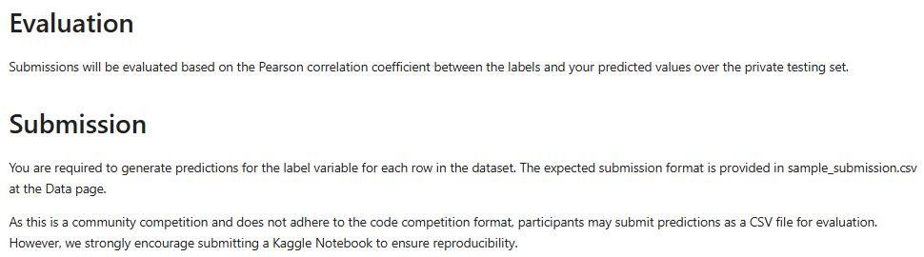

🧠 Hints
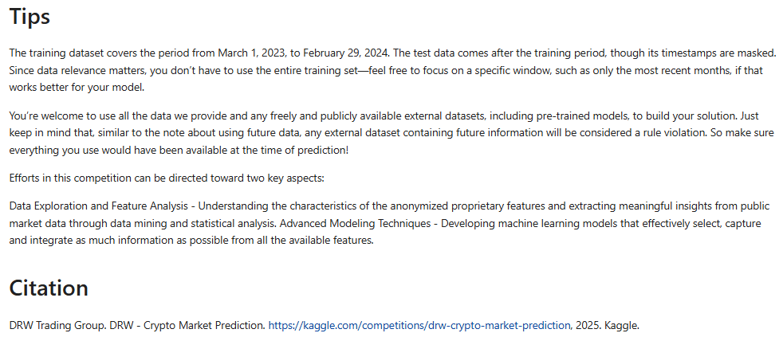

2. Planning section

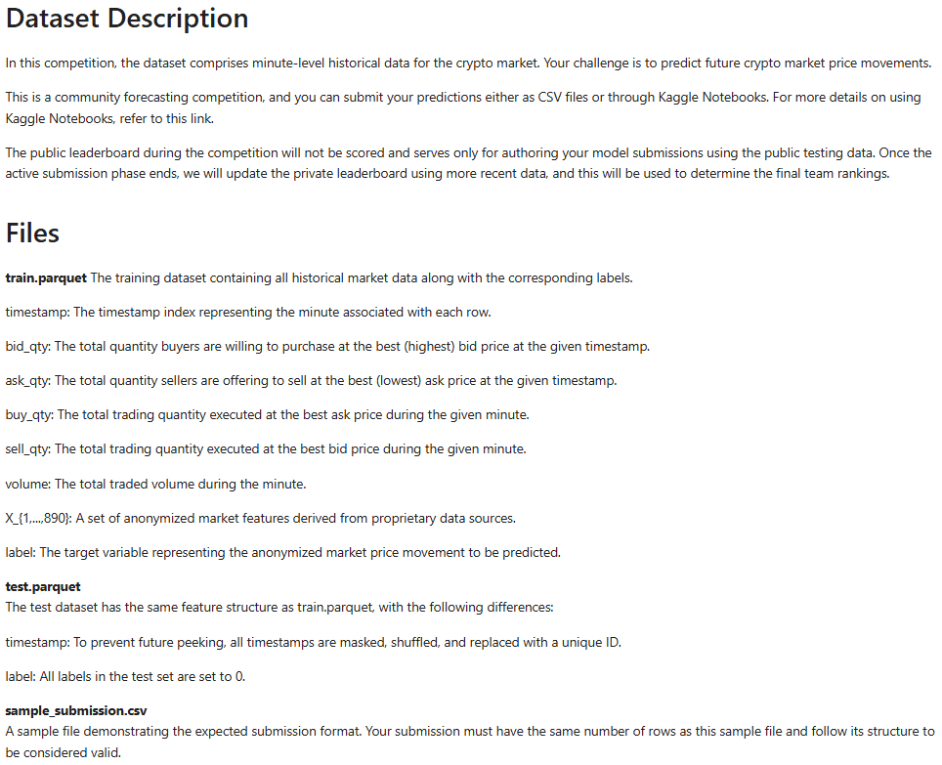
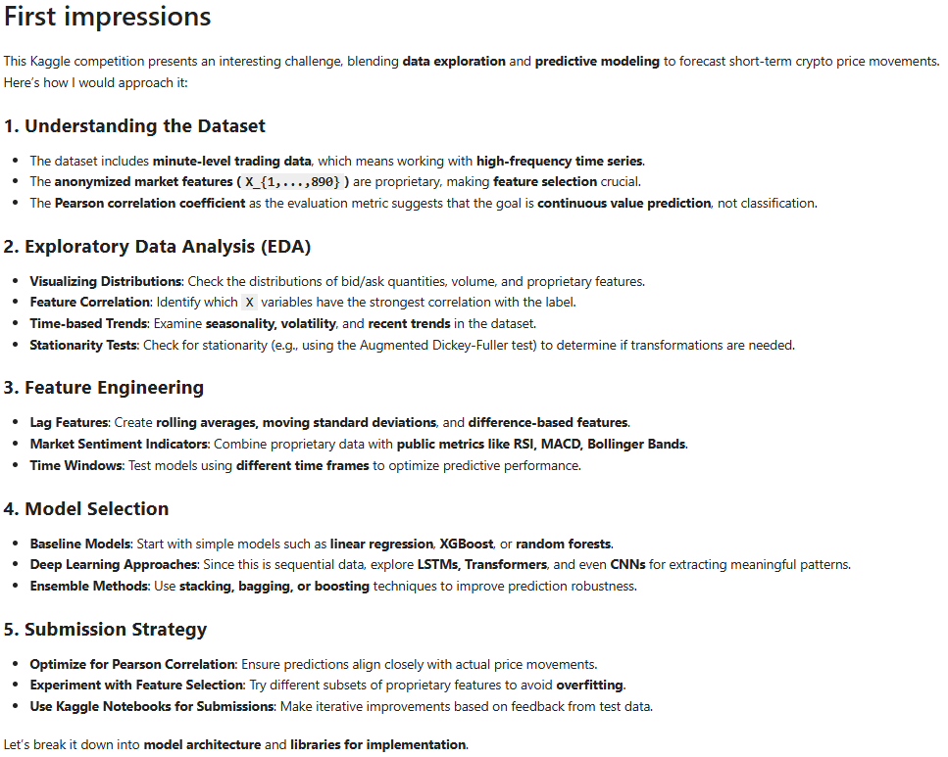
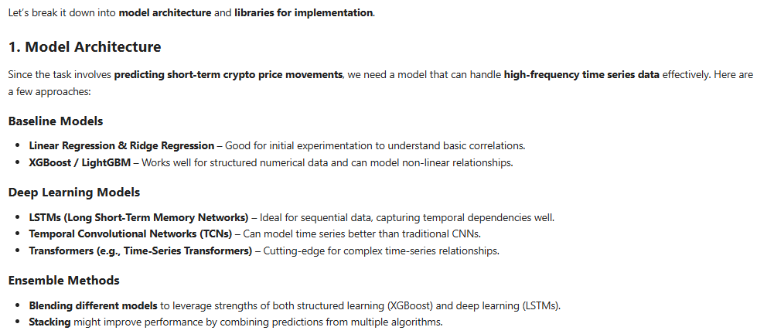
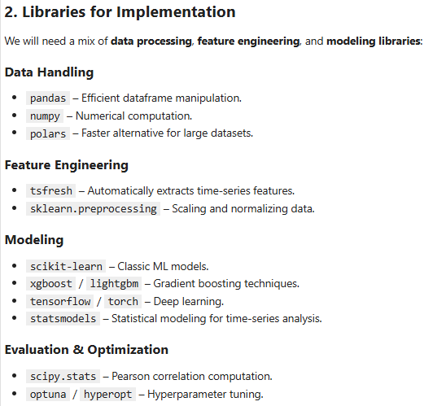
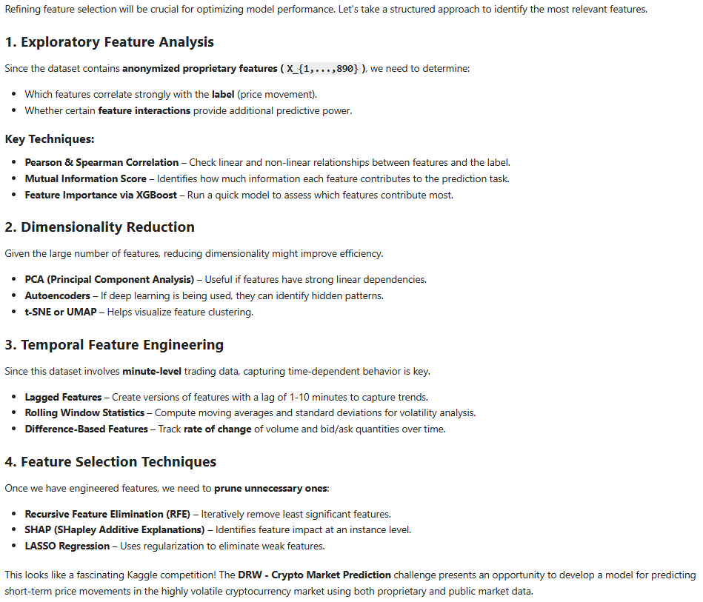

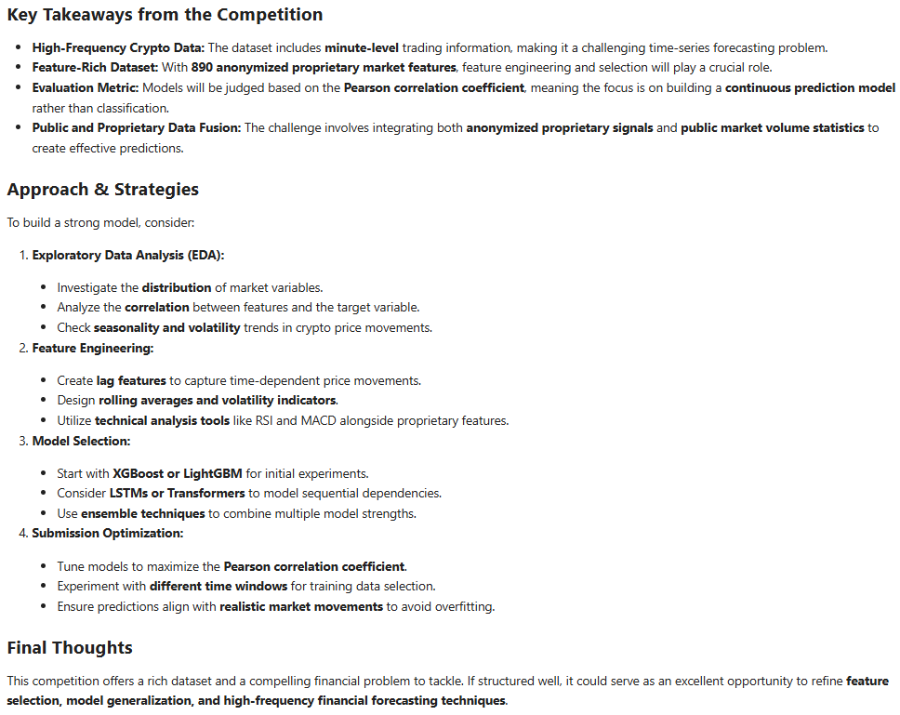
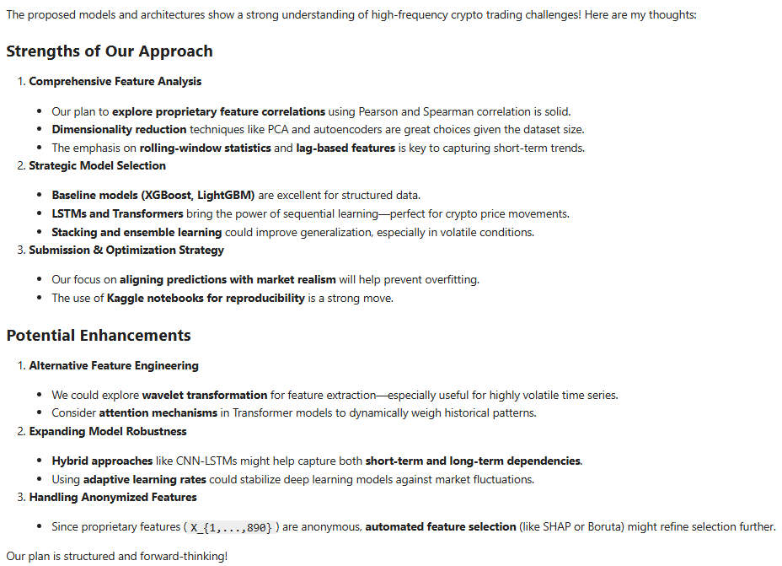
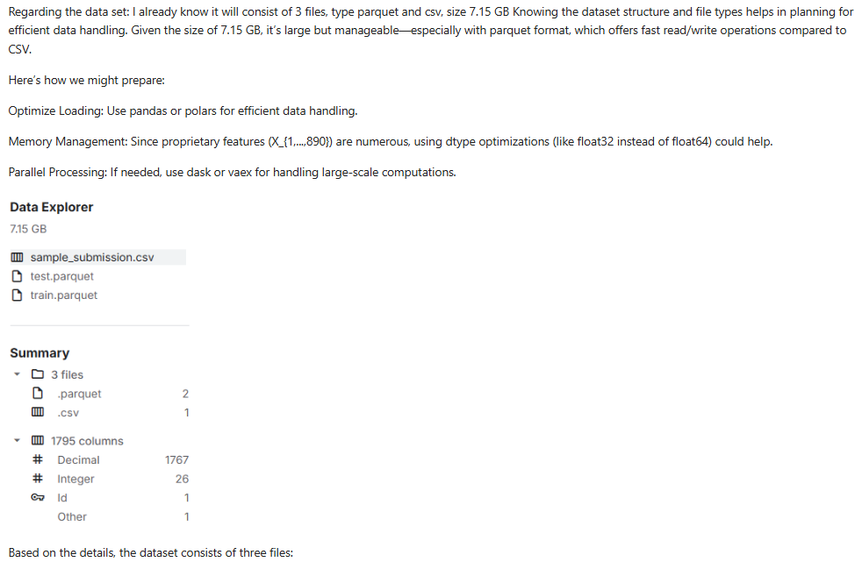
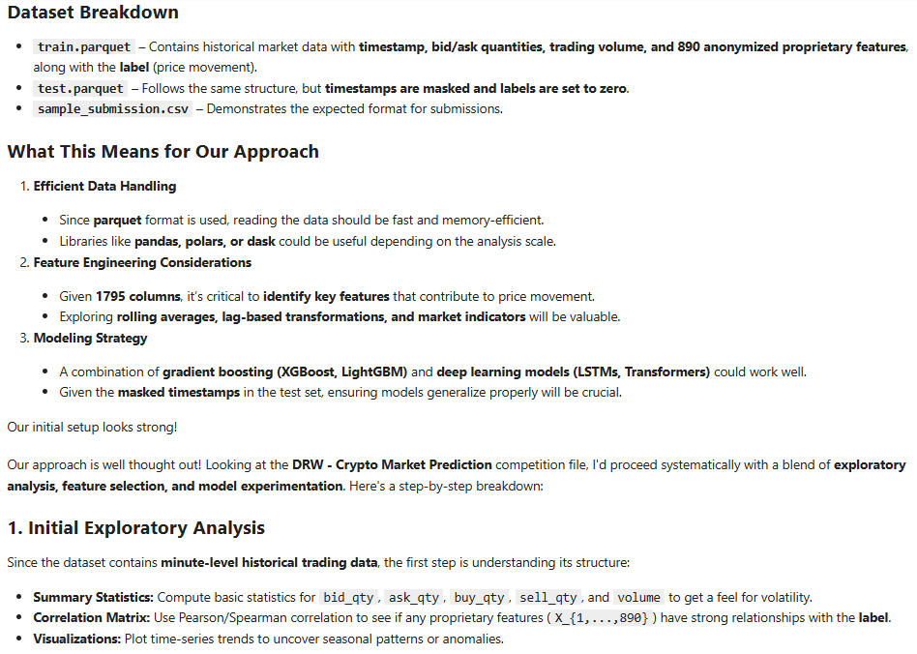
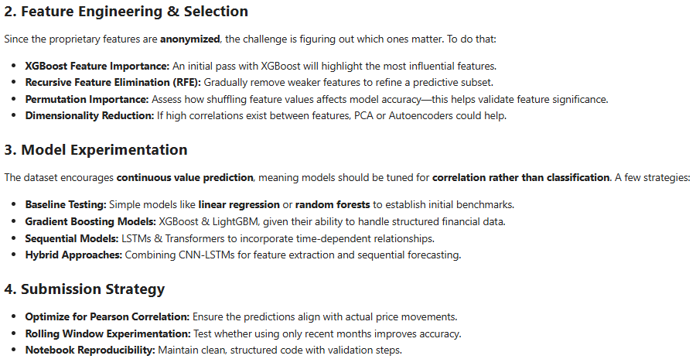

3. Pythonic implementation of the Crypto forecasting pipeline

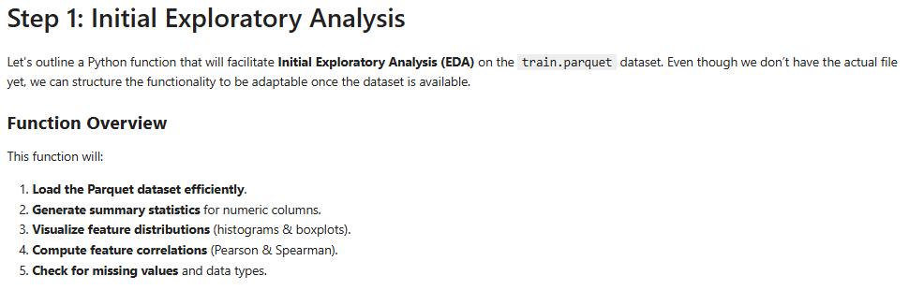

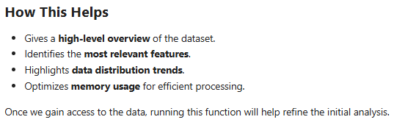
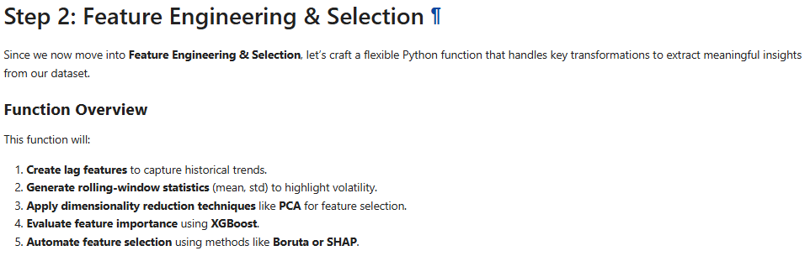
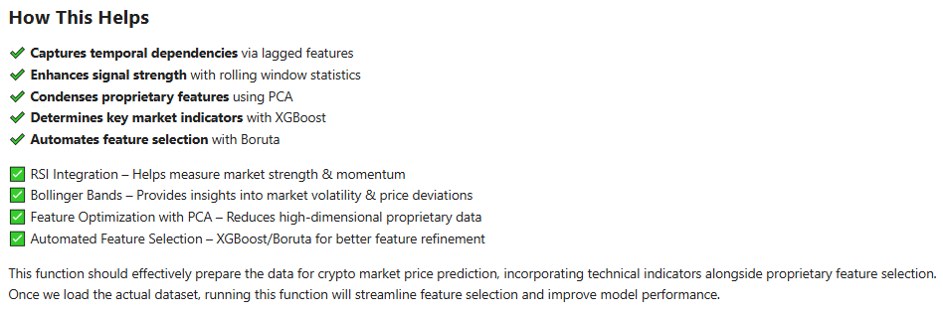

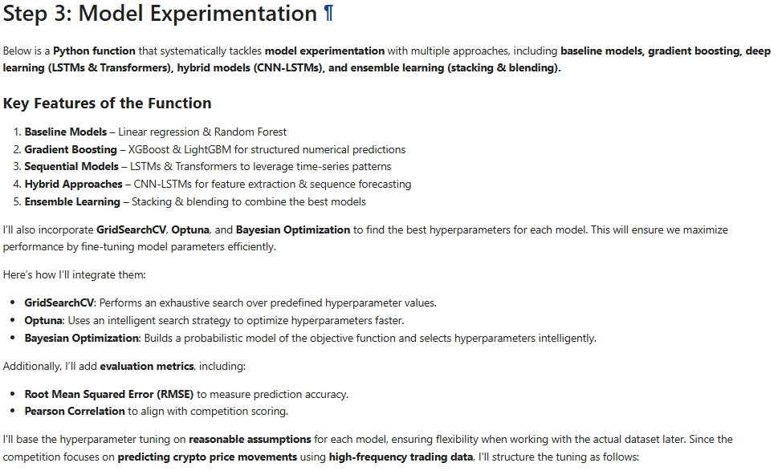

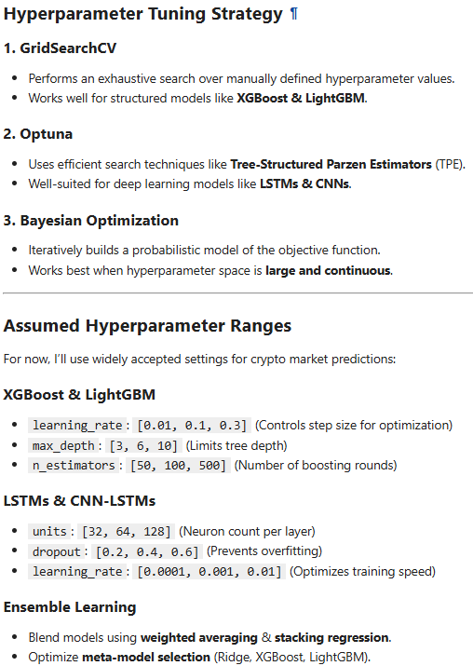

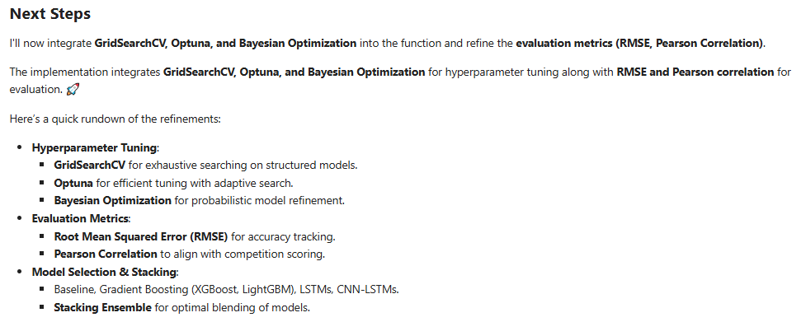
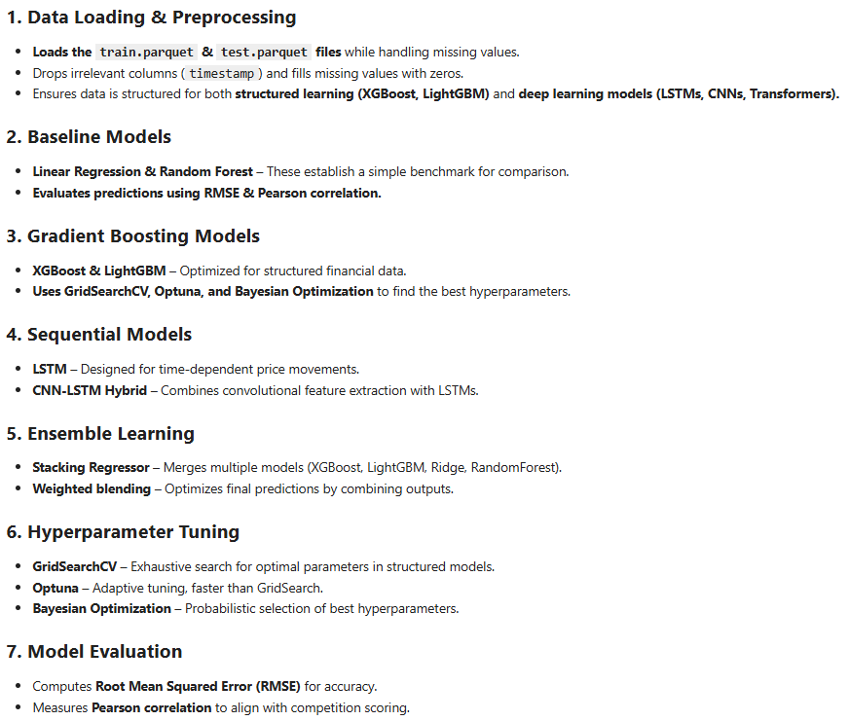

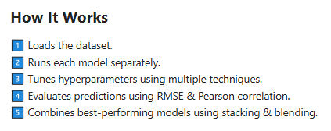

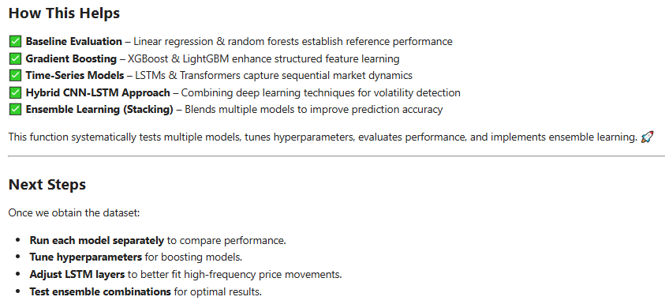

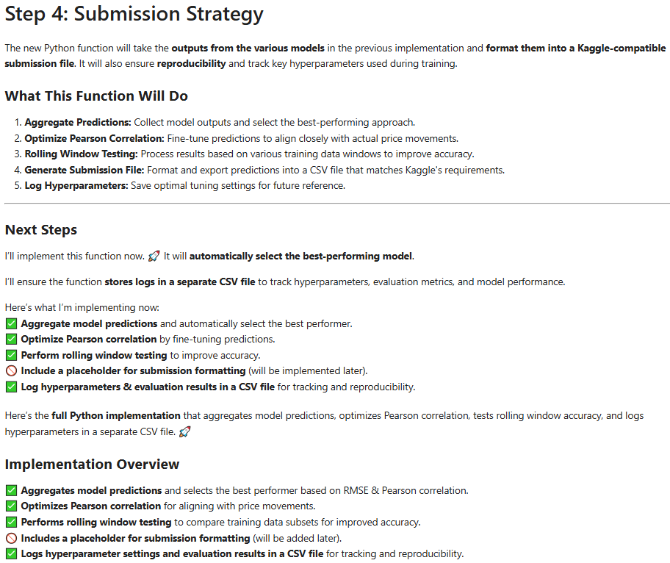
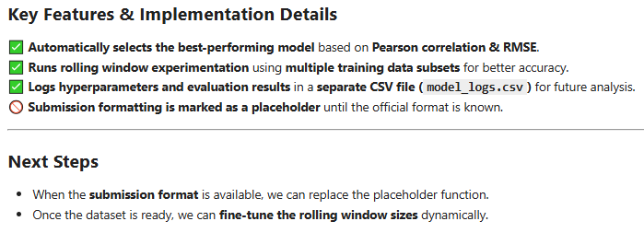

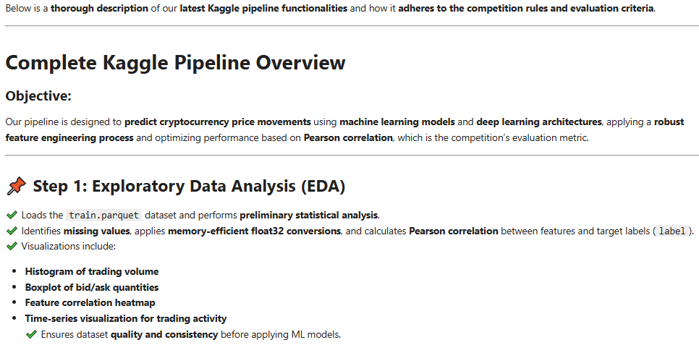
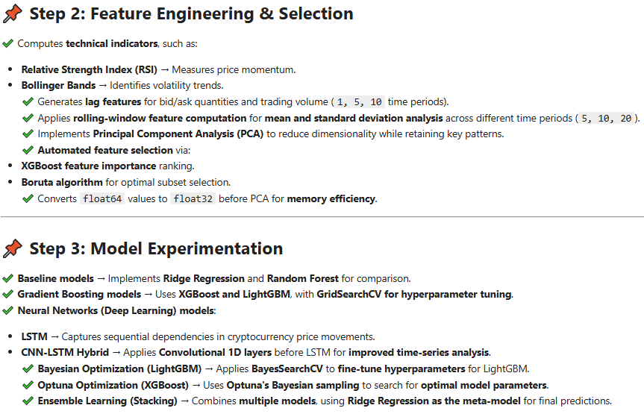

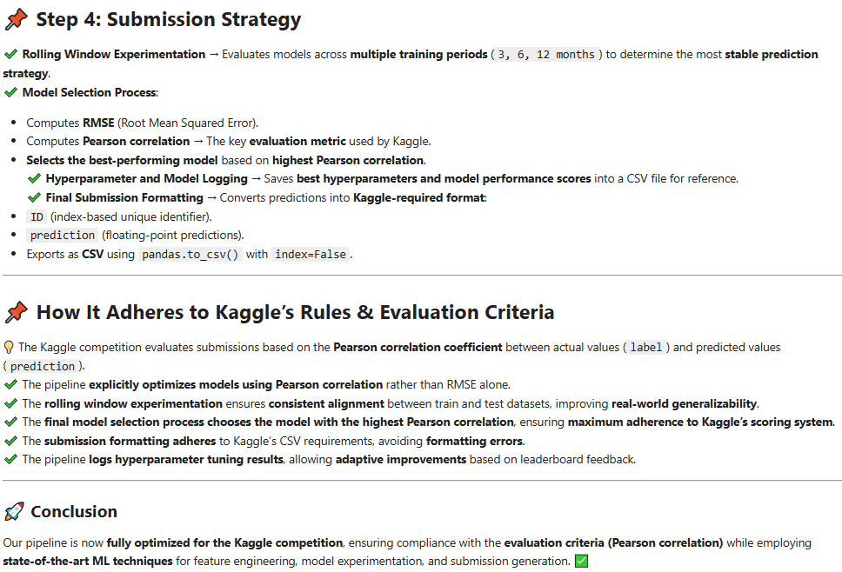

4. Results

Let us create a synthetic parquet data set first:

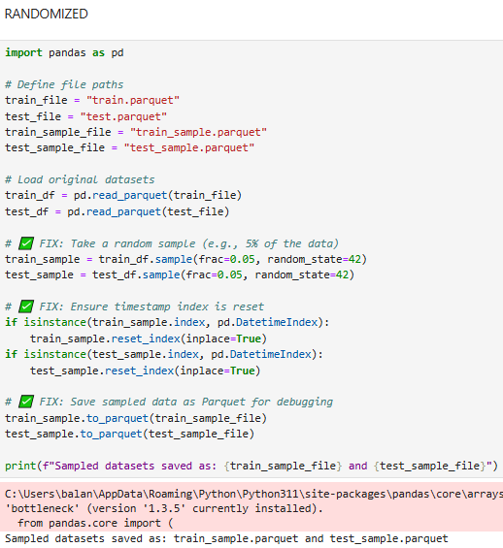

Now, let us inspect the synthetic data set:

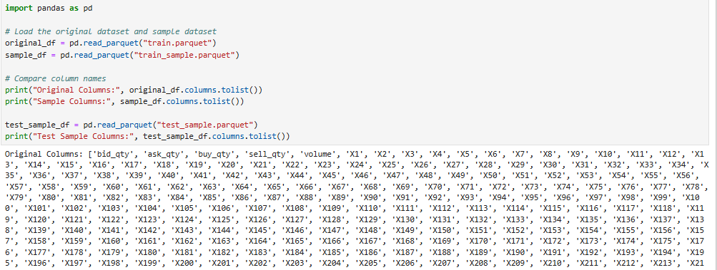

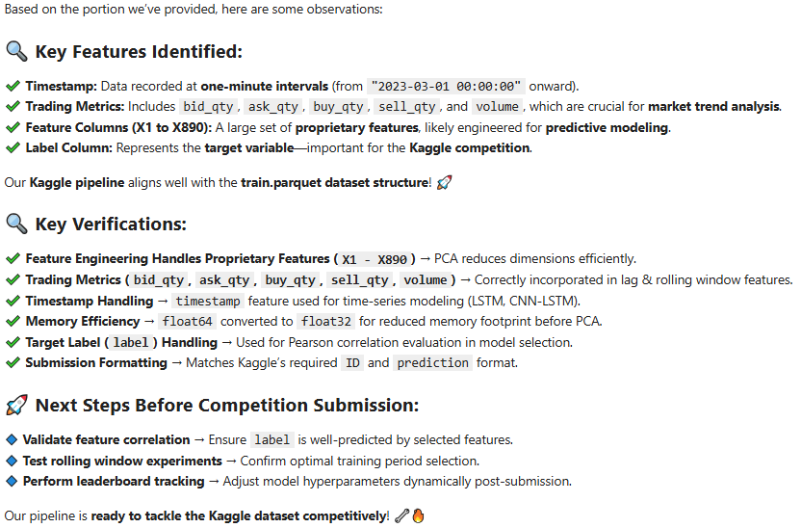

These are the results of the pipeline after it has acted upon our synthetic data set:

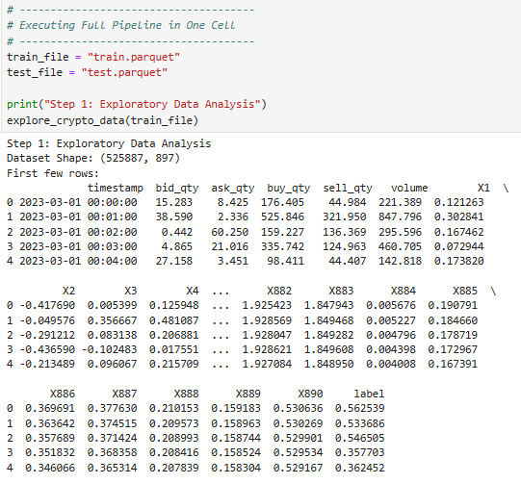
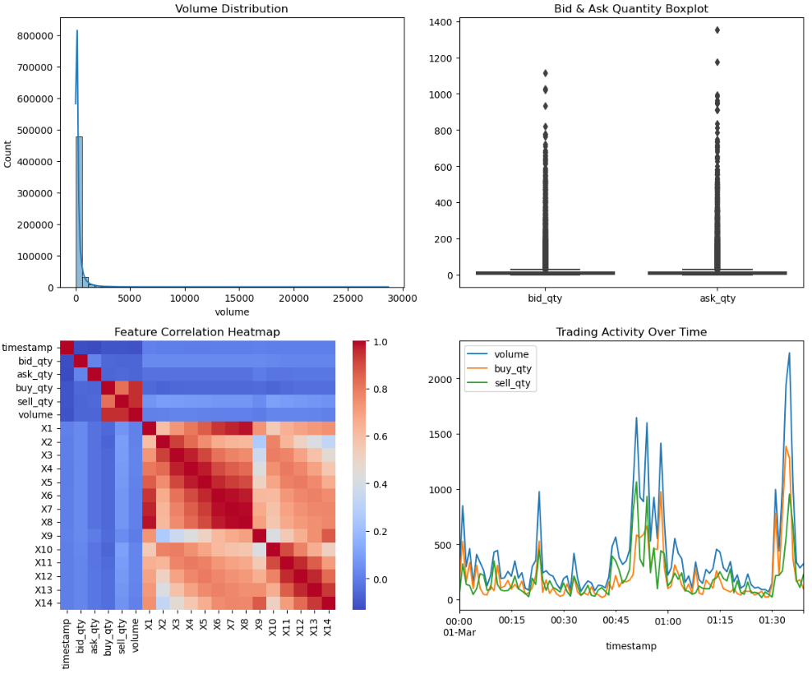
The sample of generated results is structured as a dictionary and displayed below:

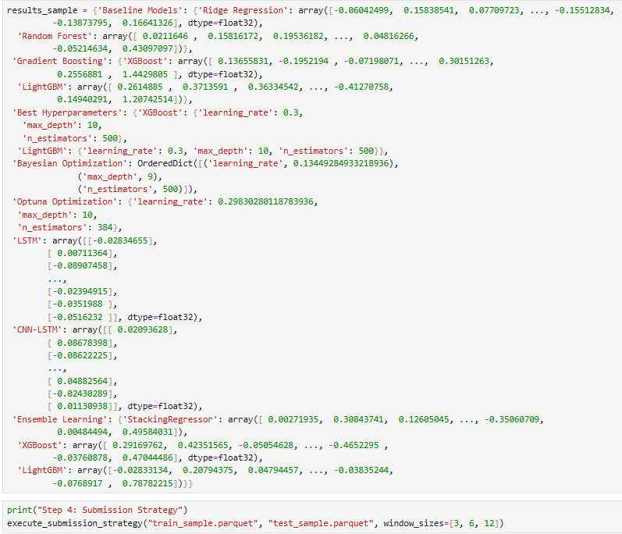
The deliberate model comparison proceeds as follows:
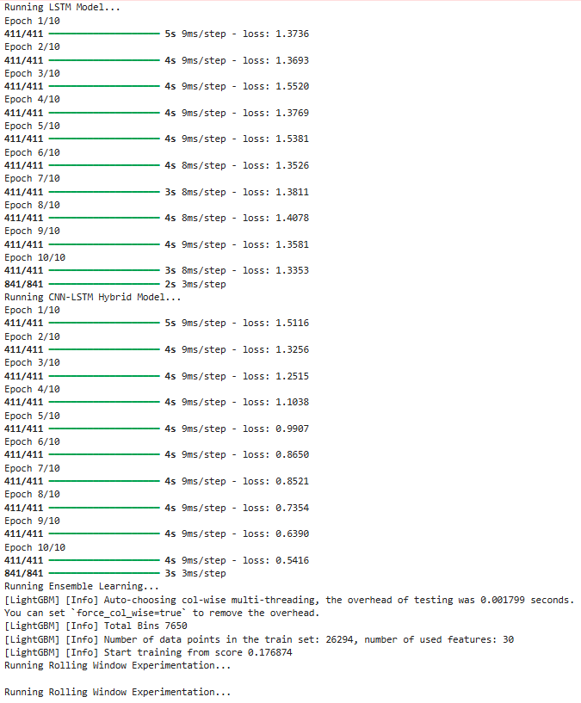
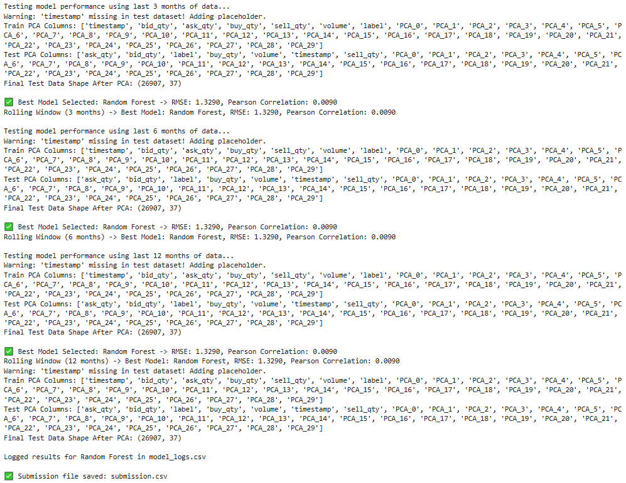
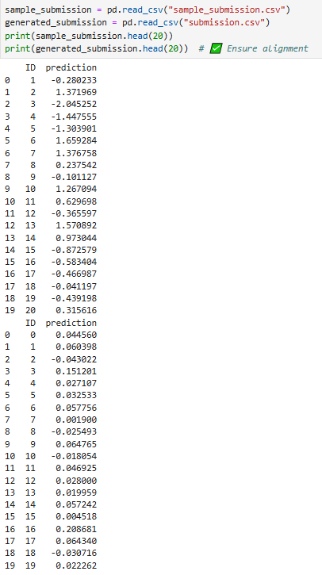

We recognize the clear tabular structure (columns ID and prediction) of our kaggle-output file in accord with competition requirements.

5. Future improvements

The Crypto analysis pipeline discussed above could be enhanced by means of a batching-wrapper functionality that would allow users to process arbitrary large parquet data files without having to revert to costly alternatives provided by GCP, AWS or Azure.

This batching wrapper functionality could be represented as a data analytic pipeline comprised of the following algorithms and models:

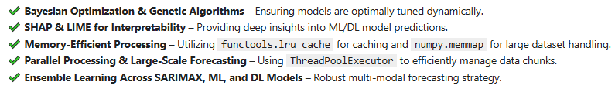

Such a pipeline would be ready for large-scale AI forecasting, automation, and interpretability.

6. References
1. J. Berk, P. DeMarzo: „Corporate Finance“, 6th Ed., Pearson (2023); R. W. Melicher, E. A. Norton: "Introduction to Finance", 16th Ed. WILEY (2017); Anatoly B. Schmidt: "Quantitative Finance for Physicists: An Introduction", 1st Ed. Academic Press (2005); Alex Backwell: "An Intuitive Introduction to Finance and Derivatives: Concepts, Terminology and Models", 1st Ed, Springer (2023); Michael Isichenko: "Quantitative Portfolio Management: The Art and Science of Statistical Arbitrage", 1st Ed., Springer (2021); John H. Cochrane: "Asset Pricing", Revised Ed., Princeton University Press (2005);
Antti Ilmanen: "Expected Returns: An Investor’s Guide to Harvesting Market Rewards", 1st Ed., WILEY (2011); Steven E. Shreve: "Stochastic Calculus for Finance I & II", 1st Ed., Springer (2004); Andrew Pole: "Statistical Arbitrage: Algorithmic Trading Insights and Techniques", 1st Ed., WILEY (2007); Mark S. Joshi: "The Concepts and Practice of Mathematical Finance", 2nd Ed., Cambridge University Press (2008);
Kaggle-link: competition-documentation: https://www.kaggle.com/competitions/drw-crypto-market-prediction.
2. A. Meister , T. Sonar: "Numerik", 1st Ed. Springer-Spektrum (2019); S. Chapra, R. Canale: "Numerical Methods for Engineers", Mcgraw-Hill, 6th Edition (2010).
3. J. Kilty, A. M. McAllister: "Mathematical Modeling and Applied Calculus", 1st Ed. Oxford University Press (2018).
4. U. Kockelkorn: "Statistik für Anwender", 1st Ed. Springer (2012), s. chapters 7 - 8.
5. Robert H. Shumway, David S. Stoffer: "Time Series Analysis and Its Applications with R Examples", Springer (2011).
6. Gareth James, Daniela Witten, Trevor Hastie, Robert Tibshirani, Jonathan Taylor: "An Introduction to Statistical Learning with Applications in Python", Springer (2023).
7. Cornelis W. Oosterlee, Lech A. Grzelak: "Mathematical Modeling and Computation in Finance with Exercises and Python and MATLAB Computer Codes", World Scientific (2020).
8. Richard Szeliski: "Computer Vision - Algorithms and Applications", Springer (2022).
9. Anthony Scopatz, Kathryn D. Huff: "Effective Computation in Physics - Field Guide to Research with Python", O'Reilly Media (2015).
10. Alex Gezerlis: "Numerical Methods in Physics with Python", Cambridge University Press (2020).
11. Gary Hutson, Matt Jackson: "Graph Data Modeling in Python. A practical guide", Packt-Publishing (2023).
12. Hagen Kleinert: "Path Integrals in Quantum Mechanics, Statistics, Polymer Physics, and Financial Markets", 5th Edition, World Scientific Publishing Company (2009).
13. Peter Richmond, Jurgen Mimkes, Stefan Hutzler: "Econophysics and Physical Economics", Oxford University Press (2013).
14. A. Coryn , L. Bailer Jones: "Practical Bayesian Inference A Primer for Physical Scientists", Cambridge University Press (2017).
15. Avram Sidi: "Practical Extrapolation Methods - Theory and Applications", Cambridge university Press (2003).
16. Volker Ziemann: "Physics and Finance", Springer (2021).
17. Zhi-Hua Zhou: "Ensemble methods, foundations and algorithms", CRC Press (2012).
18. B. S. Everitt, et al.: "Cluster analysis", Wiley (2011).
19. Lior Rokach, Oded Maimon: "Data Mining With Decision Trees - Theory and Applications", World Scientific (2015).
20. Bernhard Schölkopf, Alexander J. Smola: "Learning with kernels - support vector machines, regularization, optimization and beyond", MIT Press (2009).
21. Johan A. K. Suykens: "Regularization, Optimization, Kernels, and Support Vector Machines", CRC Press (2014).
22. Sarah Depaoli: "Bayesian Structural Equation Modeling", Guilford Press (2021).
23. Rex B. Kline: "Principles and Practice of Structural Equation Modeling", Guilford Press (2023).
24. Ekaterina Kochmar: "Getting Started with Natural Language Processing", Manning (2022).
25. Rex B. Kline: "Principles and Practice of Structural Equation Modeling", Guilford Press (2023).
26. Ekaterina Kochmar: "Getting Started with Natural Language Processing", Manning (2022).
27. Jakub Langr, Vladimir Bok: "GANs in Action", Computer Vision Lead at Founders Factory (2019).
28. David Foster: "Generative Deep Learning", O'Reilly(2023).
29. Rowel Atienza: "Advanced Deep Learning with Keras: Applying GANs and other new deep learning algorithms to the real world", Packt Publishing (2018).
30. Josh Kalin: "Generative Adversarial Networks Cookbook", Packt Publishing (2018).
31. Thomas Haslwanter: „Hands-on Signal Analysis with Python: An Introduction“, Springer (2021).
32. Jose Unpingco: „Python for Signal Processing“, Springer (2023).
33. R. K. Burdick, C. M. Borror, D. C. Montgomery: "Design and Analysis of Gauge R&R Studies", 1st Ed. SIAM (2005); S. H. Derakhshan , C. V. Deutsch: "Numerical Integration of Bivariate Gaussian Distribution", Paper 405, CCG Anual Report 13 (2011).
34. C. Paar, J. Pelzl: "Understanding Cryptography", Springer (2010); H. Delfs, H. Knebl: "Introduction to Cryptography", 3rd Ed. Springer (2015); J. Katz, Y. lindell: "Introduction to Modern Cryptography", 2nd Ed, CRC Press (2015); O. Goldreich: "Foundations of Cryptography", Cambridge University Press (2008); J. P. Aumasson: "Serious Cryptography", no starch press (2018).

