Practical – 6

Rendering External JSON Data using Fetch API, Search and Filter
Problem Definition : Display event lists, student profiles, notices, or FAQs from external JSON files using Fetch API. Implement dynamic rendering, search, filter, sorting, and pagination.
A. THEORY
1. How is JSON fetched, parsed, and rendered?
JSON data is fetched using the Fetch API. The response is converted into JSON using response.json(). The received data is then processed and displayed dynamically on the webpage using JavaScript.
2. Which array methods are used for search, filter, sort, and pagination?
Common JavaScript array methods are used:
- Search: find() or includes()
- Filter: filter()
- Sort: sort()
- Pagination: slice()
These methods make it easier to manage and display JSON data.
3. How are loading and error states handled?
A loading message is displayed while the JSON data is being fetched. If the request fails, an error message is shown using try...catch or error handling with fetch().
4. How is modularity maintained in JavaScript files?
Modularity is maintained by dividing JavaScript code into separate files or functions based on their purpose. ES6 import and export can also be used to share functions between files. This makes the code easier to understand, reuse, and maintain.

References
- MDN Web Docs – Fetch API
- MDN Web Docs – JSON.parse()
- MDN Web Docs – Array Methods
- MDN Web Docs – JavaScript Modules

B. Implementation/ Output/Result
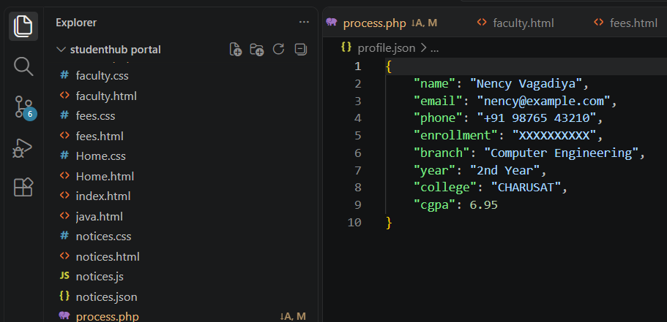

C. Evidence of Work (Screenshots)

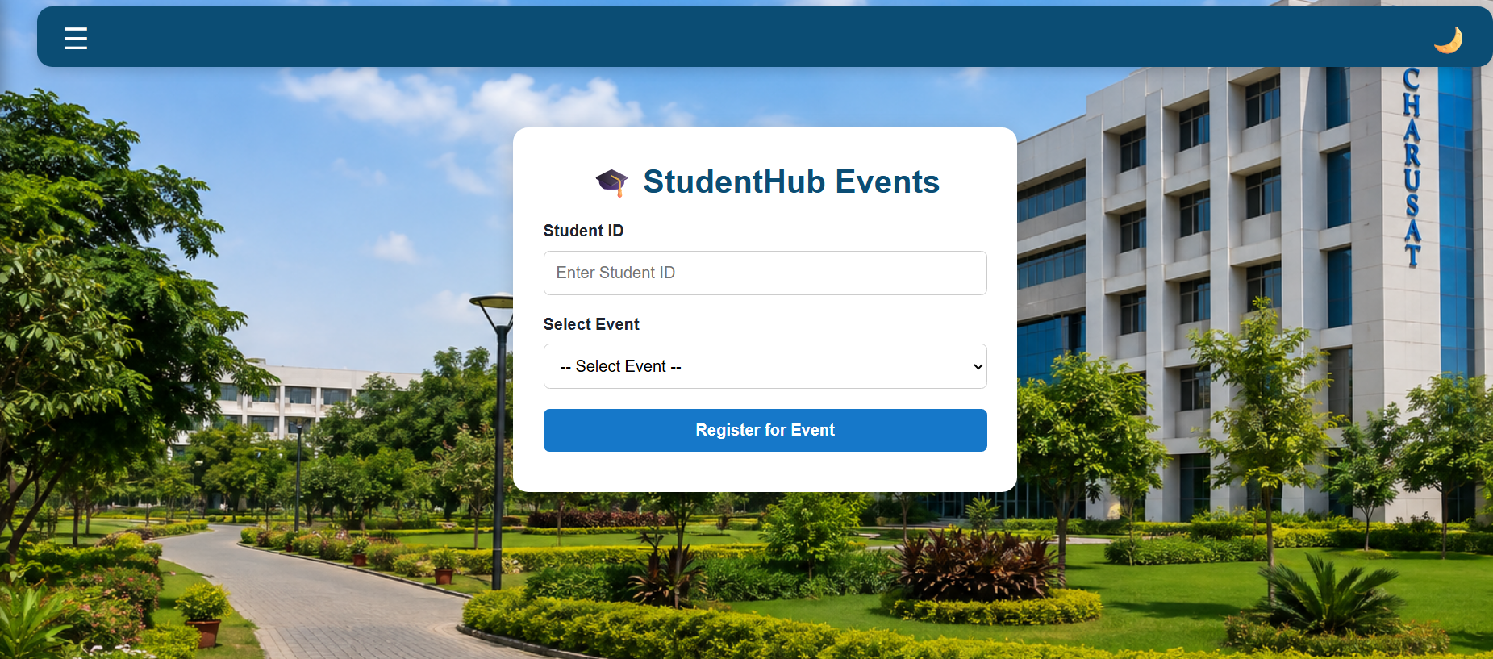

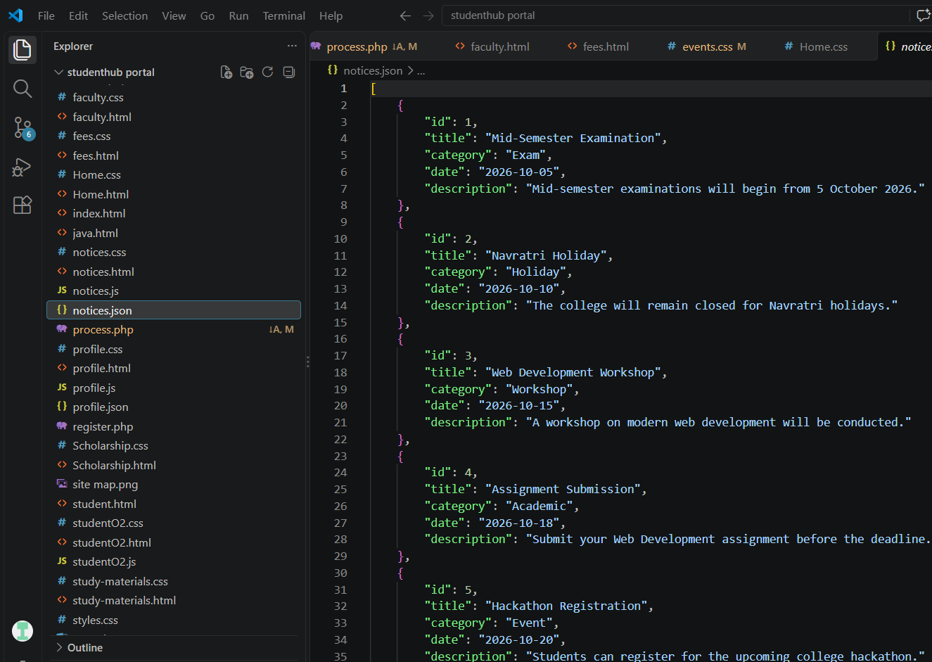
D. GitHub Repository Link
https://github.com/NencyNVagadiya/Student-Hub-portal/blob/main/notices.json

E. Challenges Faced:
“I faced difficulty in fetching JSON data using the Fetch API and dynamically displaying it while implementing search, filter, sorting, and pagination.”
F. Learning Outcomes:
Students will consume external JSON data and render reusable frontend views.

G. Faculty Remarks:

