Practical – 10

Secure Login/Logout with Sessions, Role-Based Access, Timeout, and Remember-Me Token
Problem Definition :Develop secure login and logout functionality using PHP sessions. Verify password using password_verify(), regenerate session ID after login,restrict dashboard access, implement role-based redirection, session timeout, and optional secure remember-me token.
A. THEORY
1. Are sessions started and destroyed securely?
Yes, session_start() is used, and sessions are securely destroyed during logout using session_destroy().
2. Is password_verify() used correctly?
Yes, password_verify() checks the entered password against the hashed password stored in the database.
3. Is unauthorized dashboard access blocked?
Yes, session checks prevent users who are not logged in from accessing the dashboard.
4. Is session timeout implemented?
Yes, the session expires after a specified period of inactivity.
5. Are admin and student users redirected appropriately?
Yes, admins are redirected to the admin dashboard, and students are redirected to the student dashboard based on their roles.
References
- PHP Sessions: https://www.php.net/manual/en/book.session.php
- password_verify(): https://www.php.net/manual/en/function.password-verify.php
- session_destroy(): https://www.php.net/manual/en/function.session-destroy.php

B. Implementation/ Output/Result
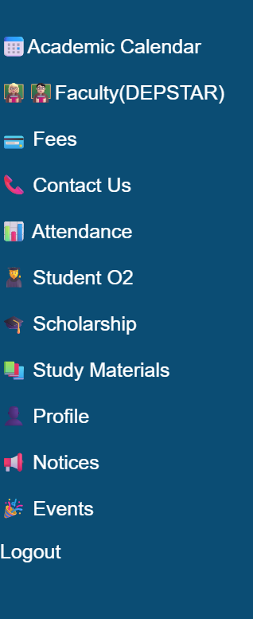

C. Evidence of Work (Screenshots)
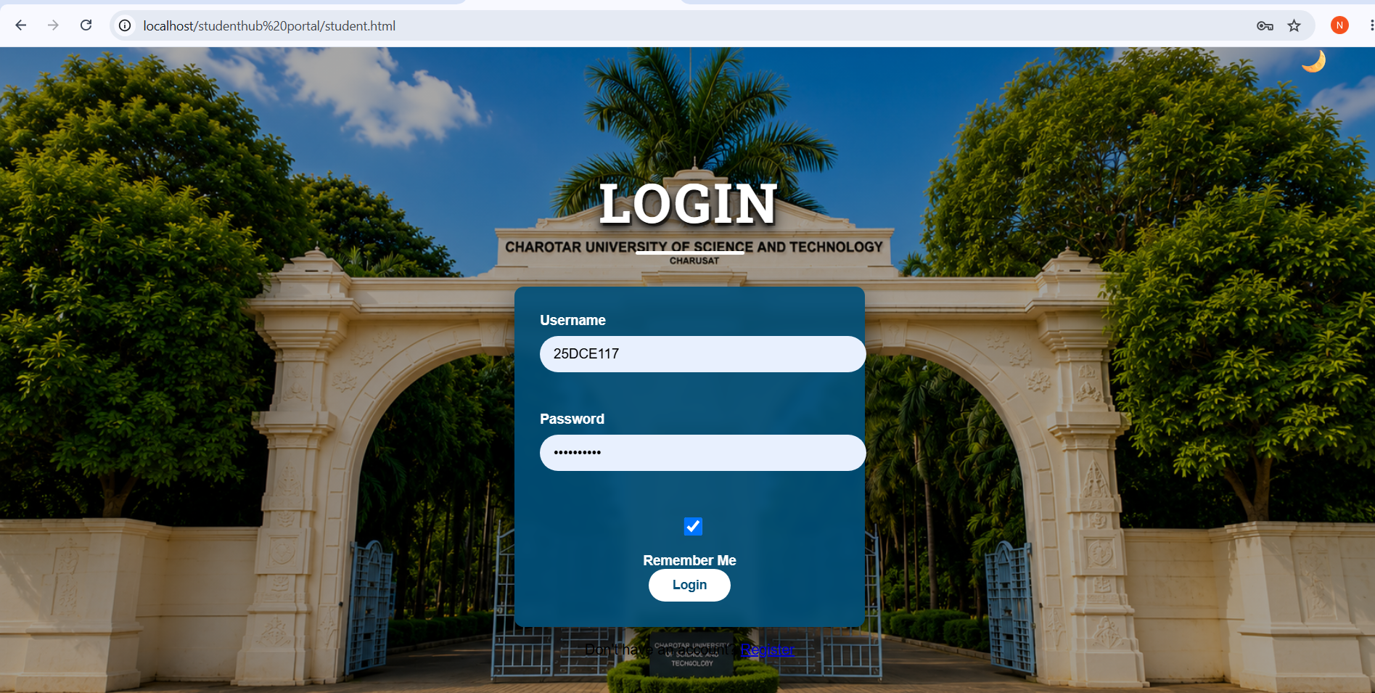

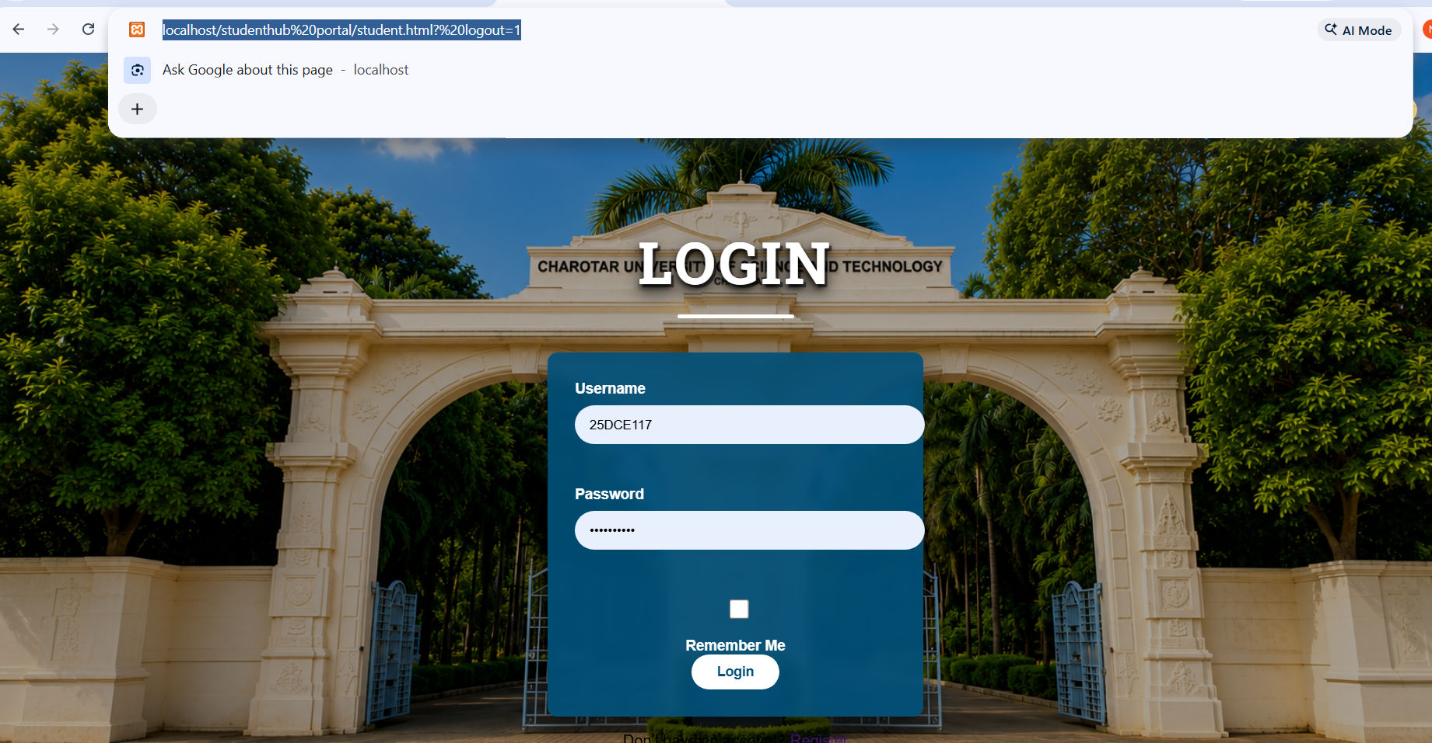

D. GitHub Repository Link
https://github.com/NencyNVagadiya/Student-Hub-portal/commit/8bcdfa508d57d915b2b4dcf40648f53ebed1fdf4

E. Challenges Faced:
I faced some problems while implementing the login and logout system using PHP. I had difficulty managing sessions, verifying passwords, and preventing unauthorized access to the dashboard. I also faced challenges in implementing session timeout and redirecting admin and student users to their correct dashboards.

F. Learning Outcomes:
Students will implement login/logout with secure session management.

G. Faculty Remarks:

