Practical – 11

Student Management CRUD with Search and Filter
Problem Definition : Create a student management module to add, view, edit, delete, search and filter student records. All database operations must use MYSQLi statements and clear success/failure messages.
A. THEORY
1. Are SELECT, INSERT, UPDATE, and DELETE operations working? Yes, these operations are working properly. We can view, add, update, and delete student records in the database.
2. Is search by name/email/course implemented?
Yes, the search feature helps us find student records using their name, email, or course.
3. Are delete operations confirmed before execution?
Yes, a confirmation message is displayed before deleting a record to avoid accidental deletion.
References:
- W3Schools – SQL Tutorial
- PHP Official Documentation – MySQLi

B. Implementation/ Output/Result
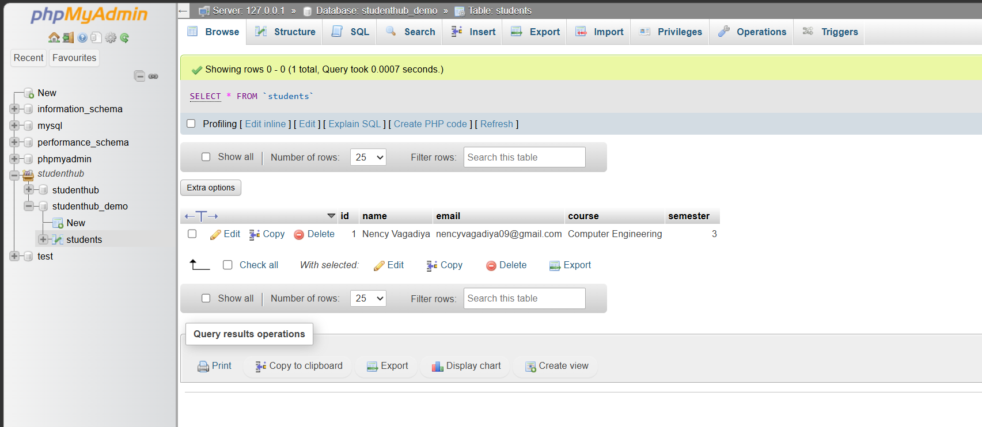

C. Evidence of Work (Screenshots)
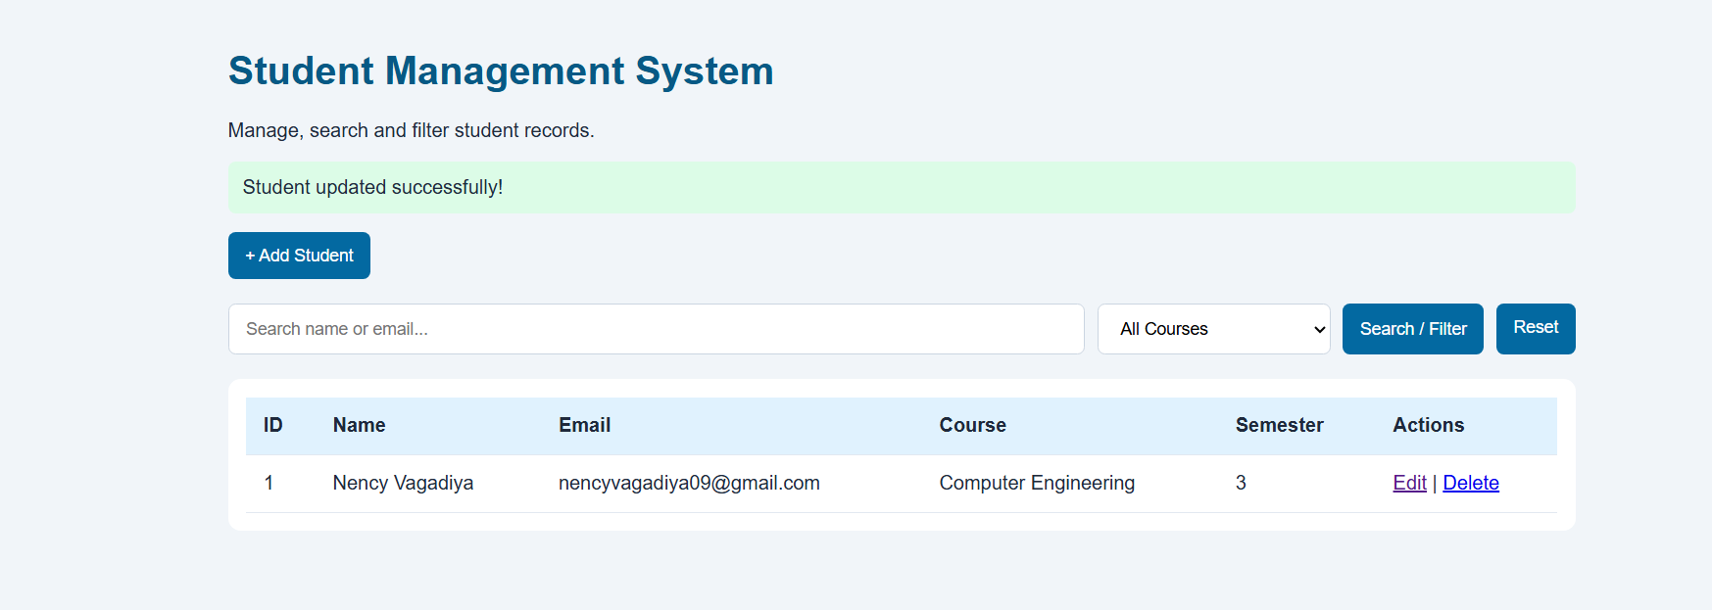

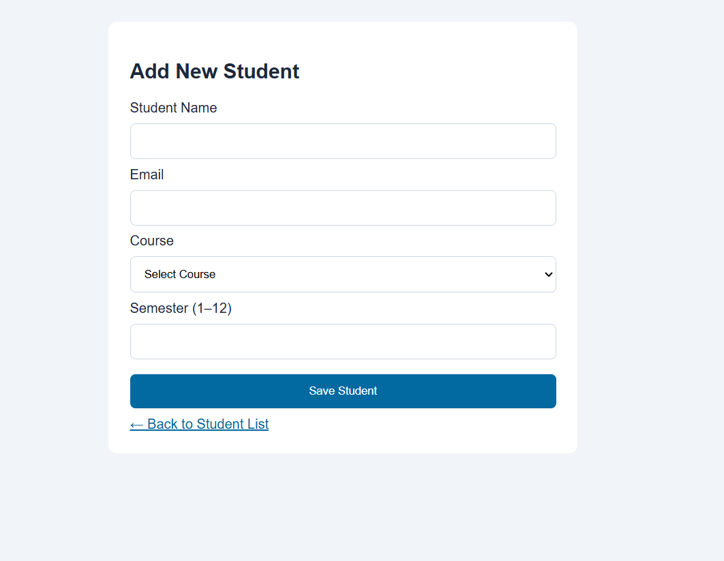

D. GitHub Repository Link
https://github.com/NencyNVagadiya/Student-Hub-portal/commit/3536903761d98071d2c12182f08bd0defef41d93

E. Challenges Faced:
Database Connection: Initially, connecting PHP to MySQL using MySQLi was challenging.
CRUD Operations: Implementing Add, View, Edit, and Delete operations required proper SQL queries.
Search and Filter: Searching students by name or email and filtering by course required conditional queries.
Error Handling: Displaying clear success and failure messages for database operations was challenging.
Debugging: Resolving connection errors and blank pages required checking the PHP code and XAMPP settings.

F. Learning Outcomes:
Students will develop a complete and secure data-management page.

G. Faculty Remarks:

