Practical – 12

Event Management CRUD with Poster Upload and File Validation
Problem Definition : Develop event management functionality for admin users. Admin can add, view, update, delete, and upload event posters with file type and file size validation.
A. THEORY
1. Are add, update, and delete functionalities implemented correctly?
Yes, add, update, and delete functionalities are implemented to manage records properly.
2. Is the UI linked with the database correctly?
Yes, the user interface is connected to the database to insert, display, update, and delete records.
3. Are poster uploads validated for type and size?
Yes, poster uploads are validated for file type and size to prevent invalid or oversized files.
4. Are success and failure messages displayed?
Yes, success messages are displayed when an operation is completed, and error messages are shown if an operation fails.
References:
- PHP Official Documentation – MySQLi
- PHP Official Documentation – File Uploads
- MDN Web Docs – Form Validation

B. Implementation/ Output/Result
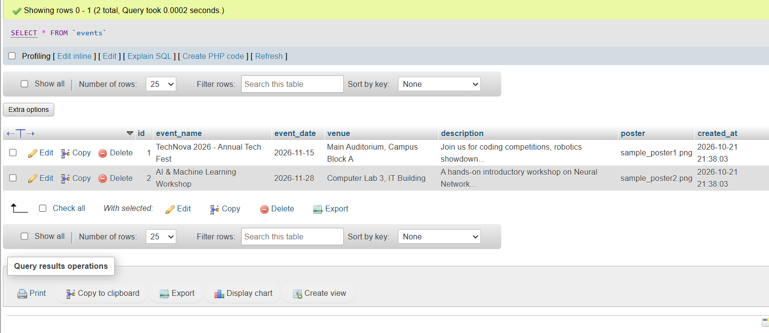

C. Evidence of Work (Screenshots)


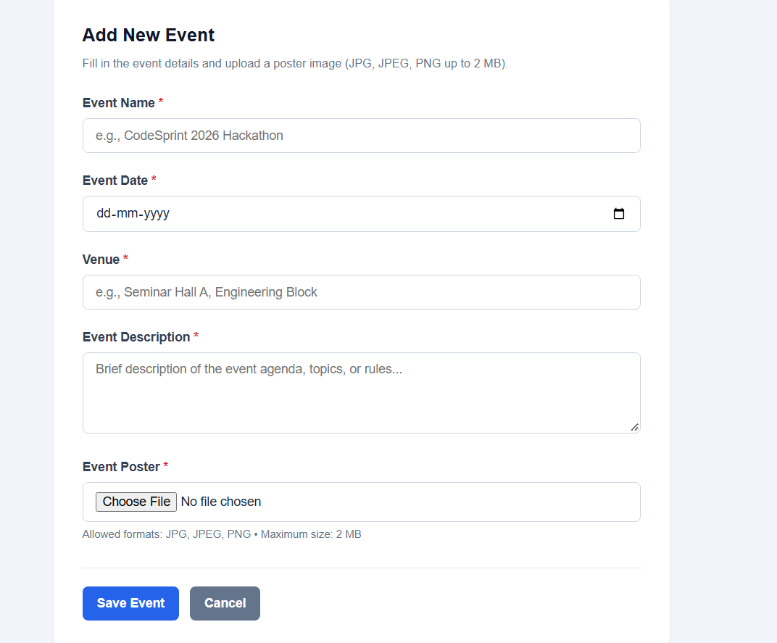

D. GitHub Repository Link
https://github.com/NencyNVagadiya/Student-Hub-portal/commit/0e22d2a4913b5b754b144a654e919d24a0a36f81

E. Challenges Faced:
The main challenges were validating poster file type and size, uploading files correctly, connecting PHP with MySQL, and managing posters during update and delete operations.
F. Learning Outcomes:
Students will implement a secure CRUD module with validated file upload.

G. Faculty Remarks:

