Practical – 13

PHP JSON API and AJAX/Fetch-Based CRUD without Page Reload
Problem Definition : Create simple PHP JSON API endpoints for events or students and consume them using Fetch API. Perform list, add, update, and delete operations asynchronously without full page reload.
A. THEORY
1. Do PHP endpoints return valid JSON responses?
Yes, PHP endpoints return valid JSON responses that can be easily understood and processed by JavaScript.
2. Are GET and POST requests handled properly?
Yes, GET requests are used to fetch data, while POST requests are used to send data to the server.
3. Are loading, success, and error states shown on the frontend?
Yes, the frontend displays loading messages while fetching data, success messages after completing an operation, and error messages if something goes wrong.
4. Is input validation performed before database operations?
Yes, input validation is performed before database operations to prevent invalid data and reduce errors.
References:
- PHP Official Documentation – JSON
- MDN Web Docs – HTTP Request Methods
- PHP Official Documentation – MySQLi

B. Implementation/ Output/Result
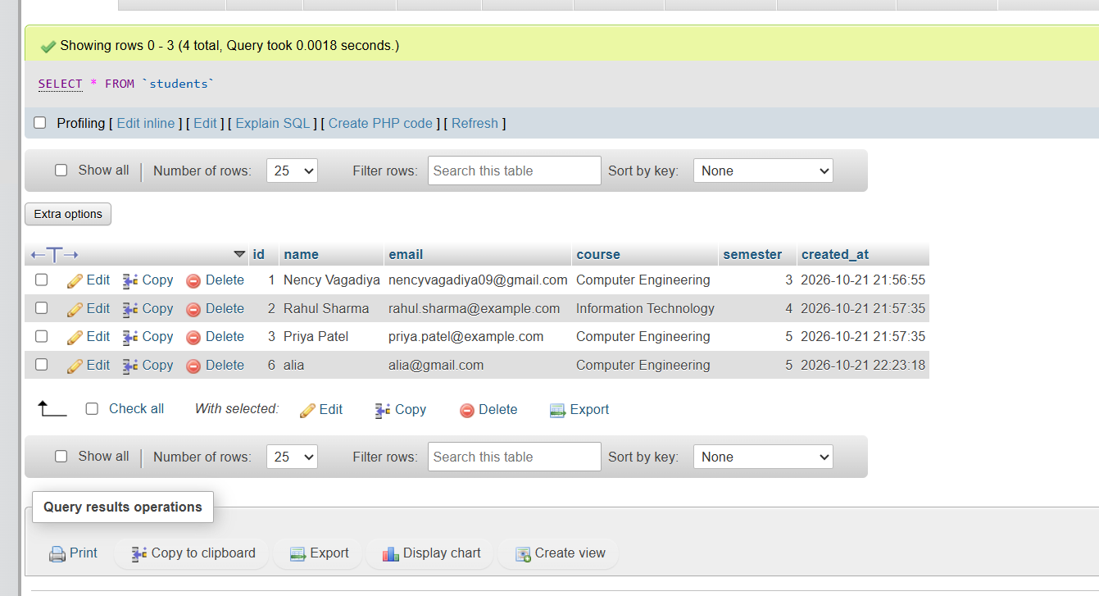

C. Evidence of Work (Screenshots)

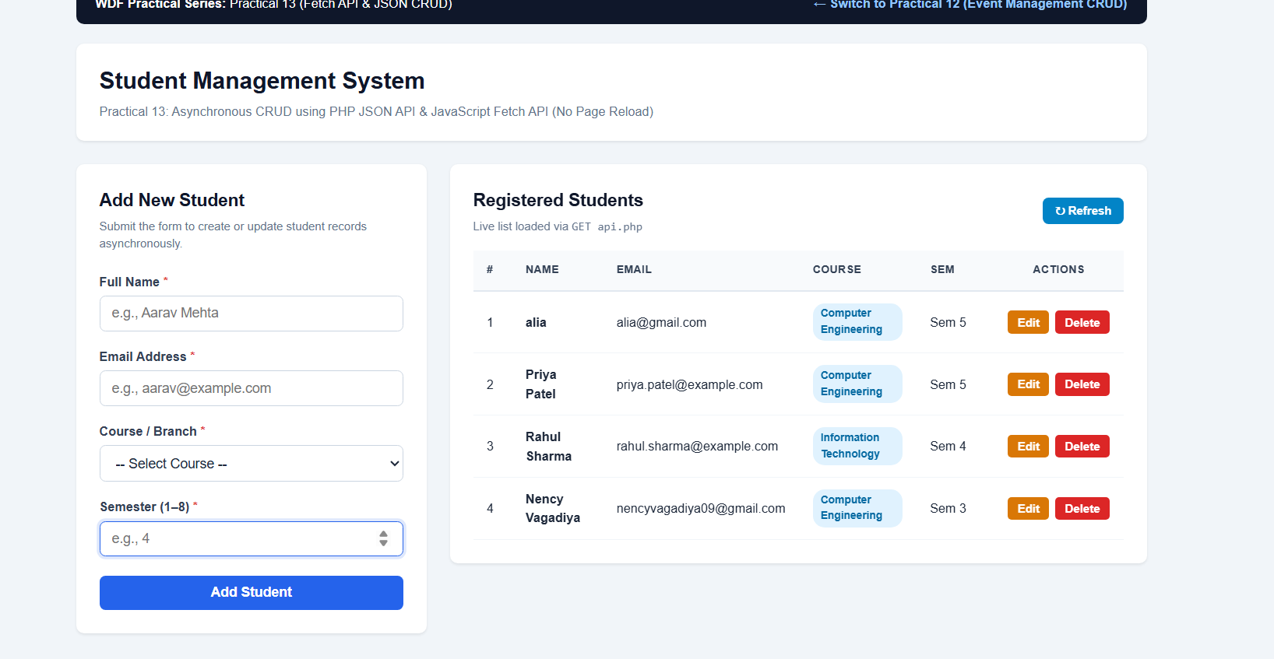
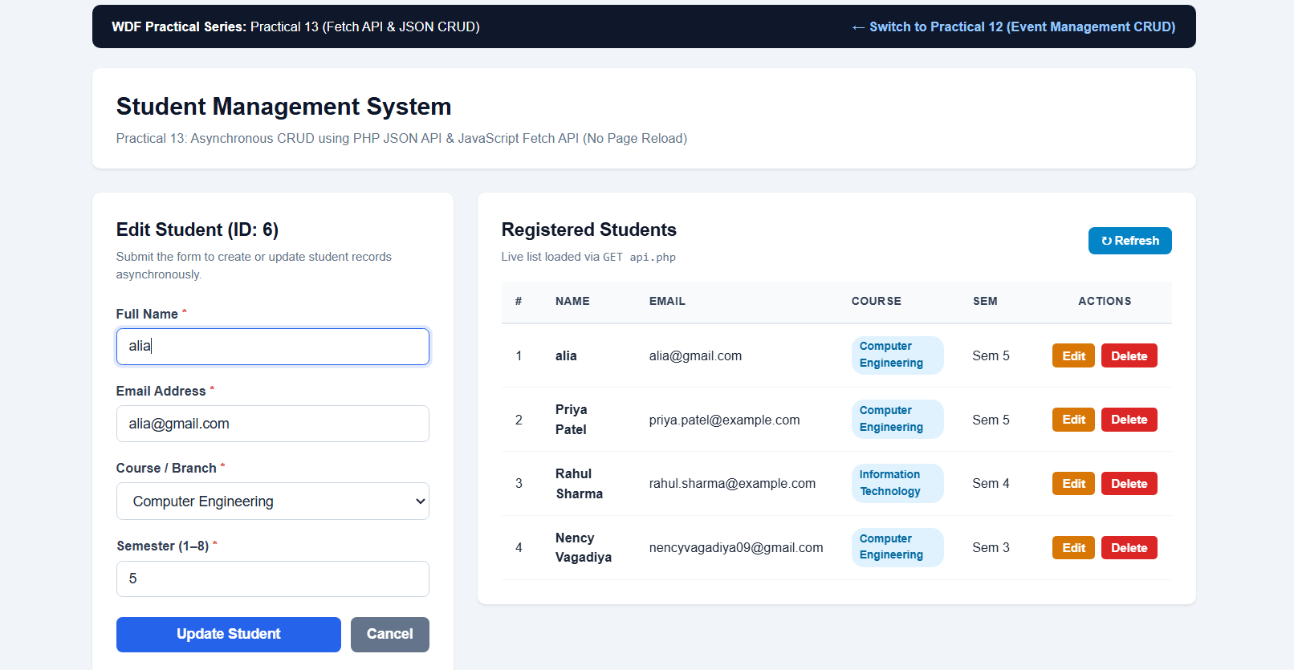

D. GitHub Repository Link:
https://github.com/NencyNVagadiya/Student-Hub-portal/commit/2e82ed7bae6c583de977b14550721a165694d34a

E. Challenges Faced:
The main challenges were handling JSON data, using the Fetch API, connecting PHP APIs with MySQL, managing CRUD operations without page reload, and handling API errors.
F. Learning Outcomes:
Students will integrate frontend JavaScript with PHP backend using JSON APIs.

G. Faculty Remarks:

