Practical – 14

Admin Dashboard with Role-Based Access Control, Dynamic Menu, and Audit Log
Problem Definition : Develop an admin dashboard that displays user statistics, student count, event count and latest registrations. Restrict access to admin users only and show dynamic menu options based on role.
A. THEORY
1. Are dashboard values loaded dynamically from the database?
Yes, dashboard values are fetched dynamically from the database and updated according to the available records.
2. Is access restricted to admin users?
Yes, only authenticated admin users can access the admin dashboard and its restricted features.
3. Are role-based menus working?
Yes, role-based menus display options according to the user's role, such as admin or student.
4. Are important admin actions recorded in audit_logs?
Yes, important admin actions are recorded in the audit_logs table to maintain a record of activities and improve security.
References:
- PHP Official Documentation – Sessions
- PHP Official Documentation – MySQLi
- OWASP – Logging Cheat Sheet

B. Implementation/ Output/Result :
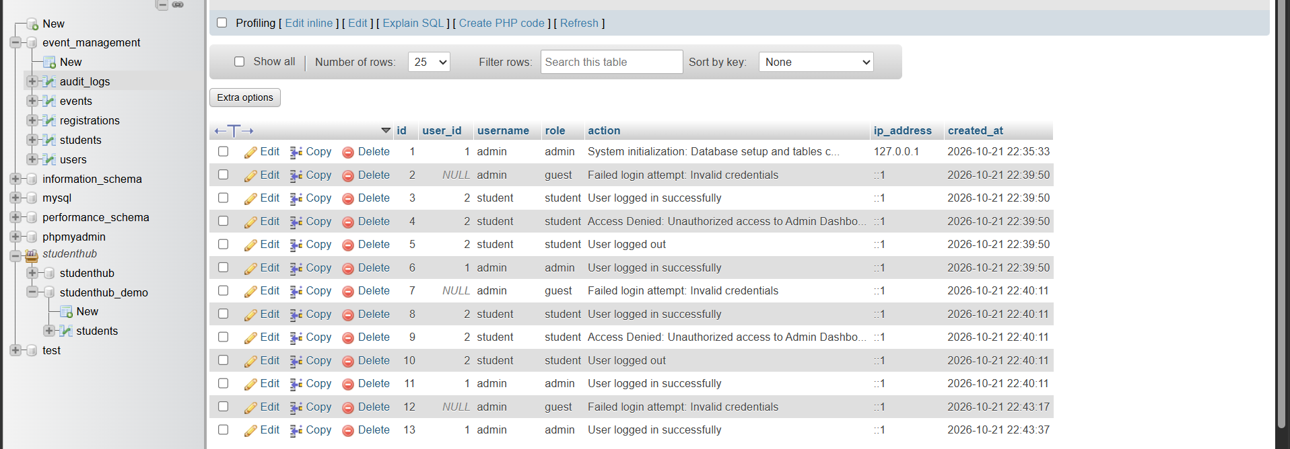

C. Evidence of Work (Screenshots):
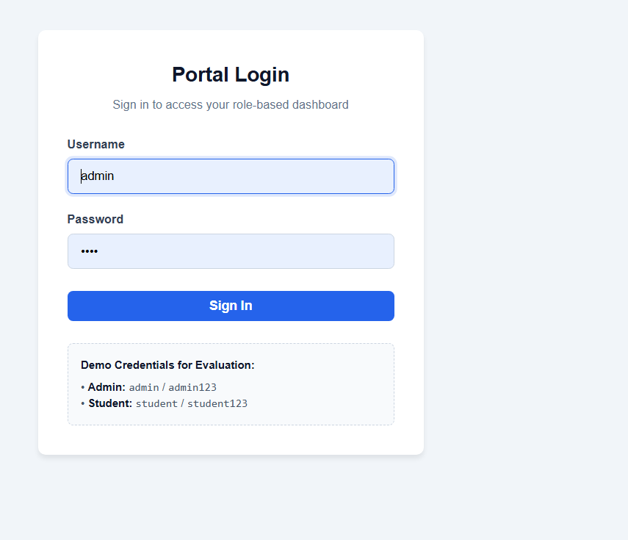
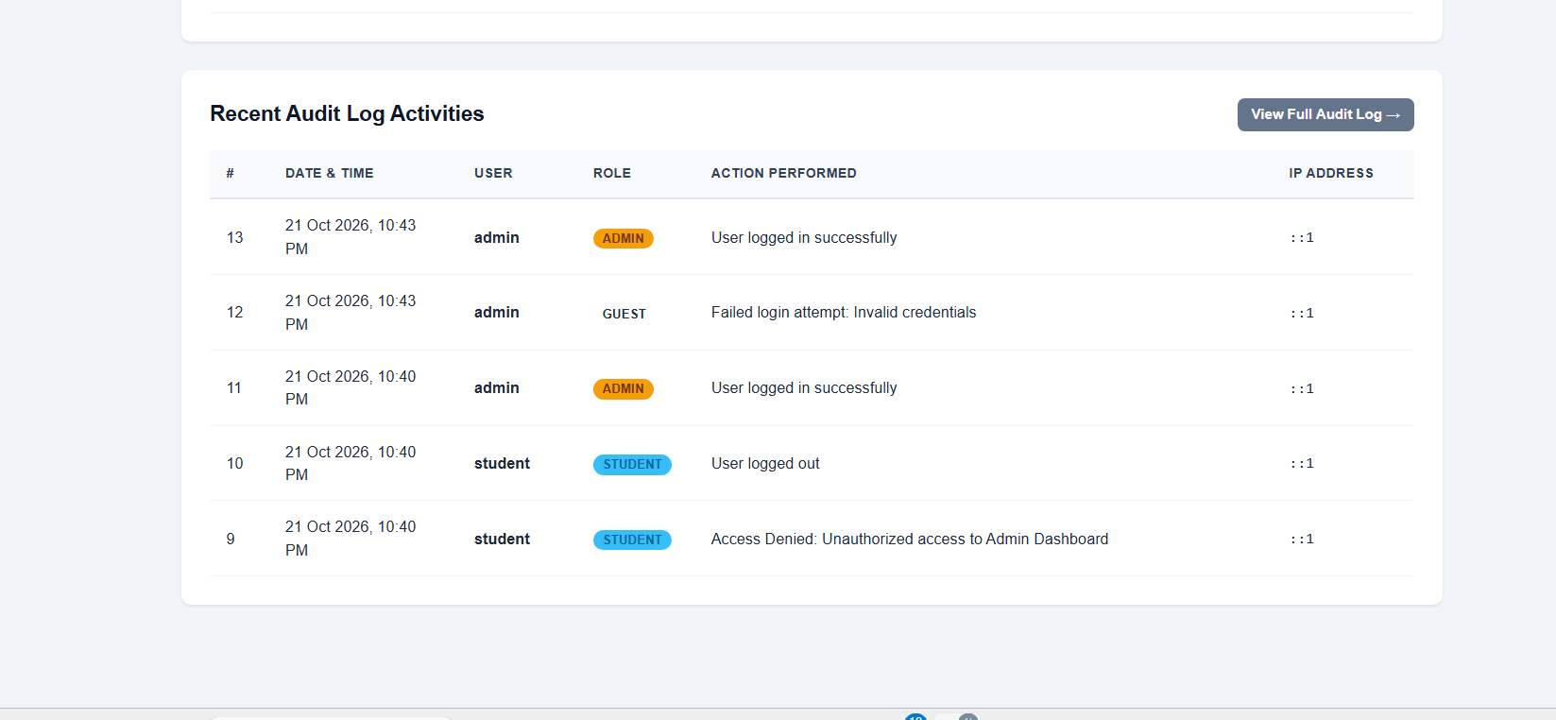

D. GitHub Repository Link:
https://github.com/NencyNVagadiya/Student-Hub-portal/commit/deee7a697ea0645546f91115497f9c4078093721

E. Challenges Faced:
The main challenges were implementing role-based access control, restricting the dashboard to admin users, displaying dynamic statistics from MySQL, creating role-based menu options, managing PHP sessions, and recording user activities in the audit log.

F. Learning Outcomes:
Students will build a role-based admin dashboard with basic monitoring and traceability.

G. Faculty Remarks:

