This snap shot for showing all validation

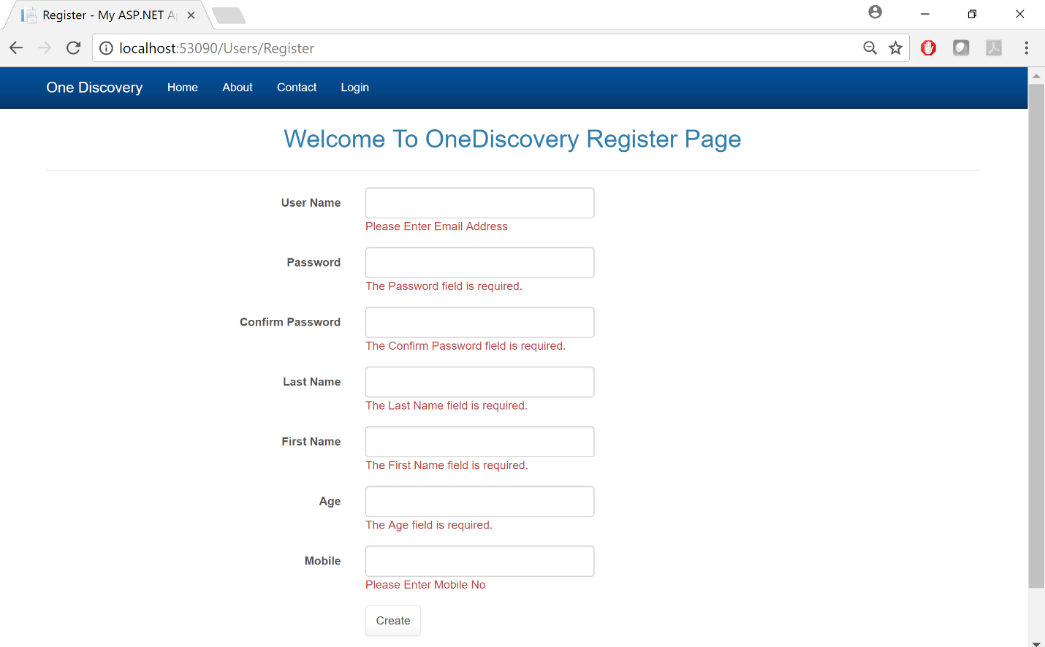

I hash and salt the password to make it more stronger as shown blow

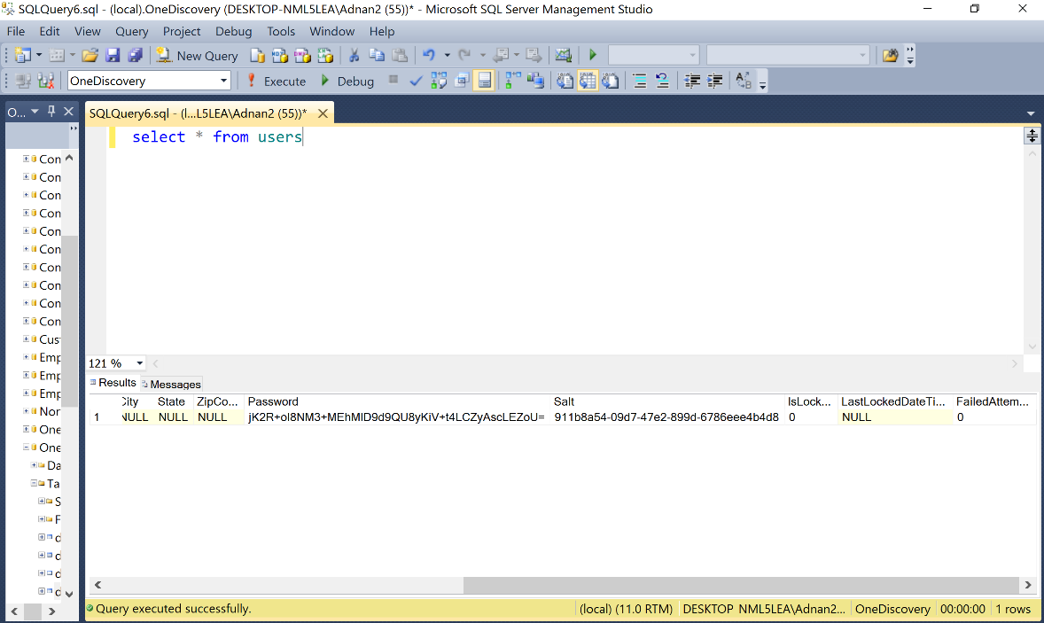

If the user try to register using exist user name it will get this error message

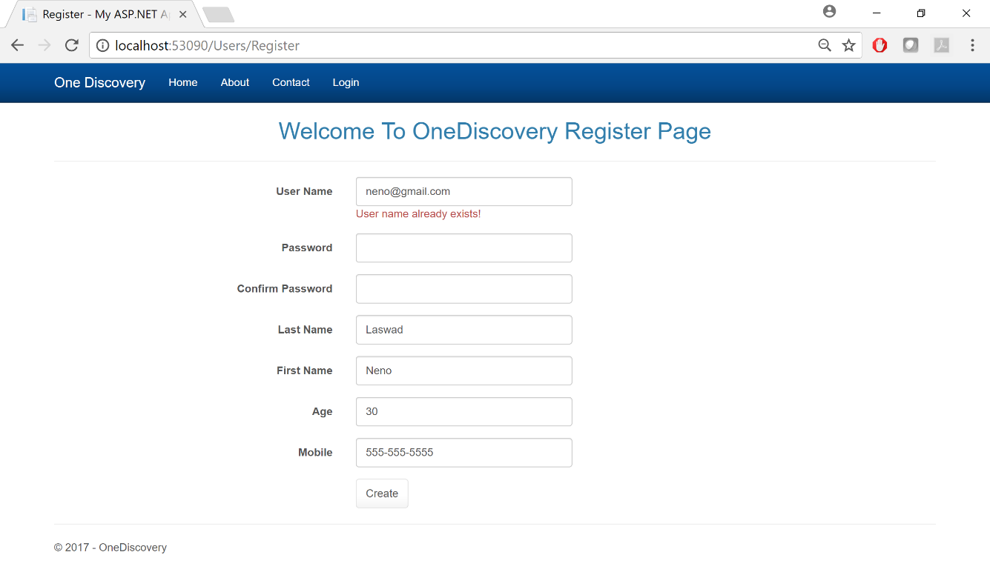

When the user click the check box, he can access next time with out login, I store the information in the cookies, by using Form Authentication

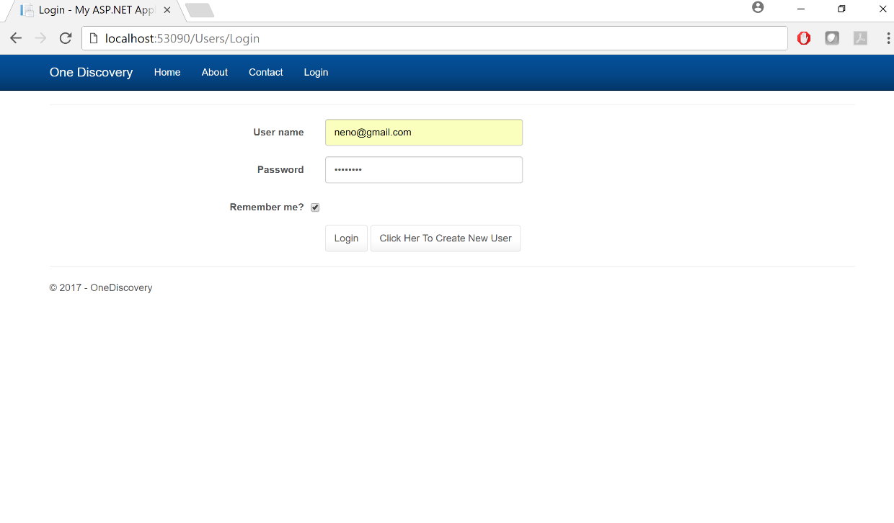

When the user try to log in by using wrong password, it will lock him for some time (I make it just for 60 sec in real case scenario we make it 24 hours and send an temporary password to let him login and change his password )

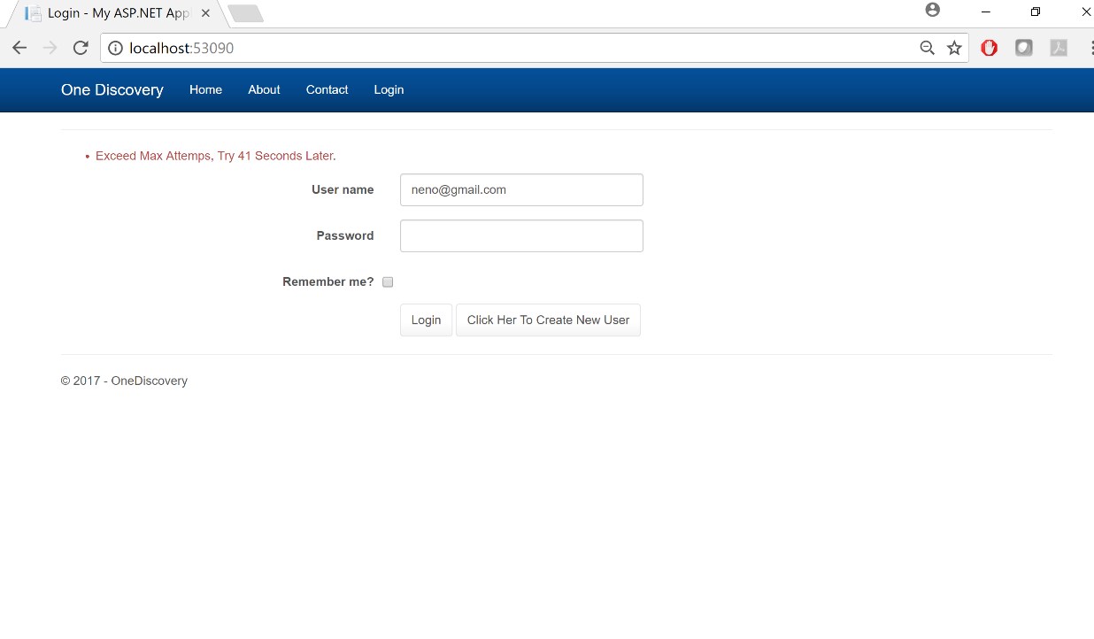

When the user is authenticated to log in , he can access the home page

