DISTRIBUTION MANAGEMENT SYSTEM

**Requirements Specification**

**Version 1.0**

**March 19, 2019**

**Table of Contents**

**1.** **EXECUTIVE SUMMARY 3**

1.1 Project Overview 3

1.2 Purpose and Scope of this Specification 3

**2.** **PRODUCT/SERVICE DESCRIPTION 3**

2.1 Product Context 3

2.2 User Characteristics 3

2.3 Assumptions 3

2.4 Constraints 3

2.5 Dependencies 4

**3.** **REQUIREMENTS 4**

3.1 Functional Requirements 5

3.2 Non-Functional Requirements 5

*3.2.1* *User Interface Requirements 5*

*3.2.2* *Usability 5*

*3.2.3* *Performance 6*

*3.2.4* *Manageability/Maintainability 6*

*3.2.5* *System Interface/Integration 7*

*3.2.6* *Security 8*

*3.2.7* *Data Management 8*

*3.2.8* *Standards Compliance 8*

*3.2.9* *Portability 8*

*3.2.10* *Other Non-Functional Requirements 9*

3.3 Domain Requirements 9

**4.** **USER SCENARIOS/USE CASES 9**

**APPENDIX 10**

Appendix A. Definitions, Acronyms, and Abbreviations 10

Appendix B. References 10

Appendix C. Requirements Traceability Matrix 10

Appendix D. Organizing the Requirements 12

# Executive Summary

## ***Project Overview***

There is a constant need in the Albanian market to improve the way companies organize their inner work process, especially those having to deal with employees working in terrain and in our case: a medium-sizes distribution company.

We aim to propose a solution to this problem by providing a web application which remodels and creates an easier way to assign tasks, keep track of the whole process from the order to the delivery, hence making analysis and keeping everything documented. The implementation of this application will work closely with an already-established company in Tirana of such kind called DS Albania.

The administrator of the web application will assign a manager, who will be mainly in charge of Employees Performance. The manager will have the opportunity to register employees. They will assign an Inventory Supervisor and an order dispatcher for an easy and real-time inventory/order management. For the sales agents, he will create their schedule consisting in the address the sales agent must attend daily. The sales agent must attend those schedules and write a report on the respective situation. This report is later on checked by the manager. This process will include scoring and daily documentation of the performance, which is thought to organically raise employees’ competitiveness and efficiency. Additionally, this web application emphasizes the relationship between the client and the sales agent. As expressed by our contact, a representative of the company:

“It is sometimes hard to be consistent in meeting the clients, as the process gets mixed up with other daily tasks such as creating new clients, inventory management, and often our employees end up with too much idle time.”

The client consist in gyms, bars/restaurants and supermarkets. The latter mostly waits for sales agents themselves to check upon their respective products in their stores as they have lots of products. This is why sales agents are required to attend them at least once a week using the system aforementioned. For the former two: gyms, bars/restaurants with very few offered products in their place, the web application provides with a ‘online shopping’ kind of platform tailor-made for DS Albania’s products. Not only will the clients not have to consistently call the warehouse for their demands, but they will be dynamically be informed on in stock products and special offers.

## ***Purpose and Scope of this Specification***

The purpose of this specification is to currently define the state of the application design and documentation of the processes.

In this scope:

● Documentation of the features

● Technical overview of application processes (discussed in Part 2.1)

● Components & Functional/non-functional requirements( discussed in Part 3)

● Use cases/scenarios (discussed in Part 4)

● Constraints (discussed in Part 2.4/5) of the Document

● *Legislative requirements for the product*

● Auditing and financial considerations of the product

# Product/Service Description

DS Albania is a distribution company in Albania whose aim is to distribute mainly isotonic energy drinks and other healthy products in gyms, supermarkets and some bar & restaurants. As an existing medium-sized business it was seen that it had some flaws on its distribution process that need improvement by providing new technological solutions to every step of the process.

So our idea consists in creating a web application to help in the process from ordering the products to the delivery for the customers. This involves the creation of a dynamic platform, useful and friendly to every user.This tool aims to help the company improve the distribution system and professionalise organization and management of the company processes.

## ***Product Context***

Our service consists in a Distribution Service for a line of some isotonic drinks called **OSHEE**.They operate mainly in gyms, bars, restaurants and supermarkets.

We can say it is an independent system as it operates on its own, that will make the connection between three main entities: Warehouse, Transportation and Client.

## ***User Characteristics***

In our system there will be 7 different type of users that have different access and priorities.

* + Admin

**Client**

* + Client

**Transportation**

* + Sales Agent
  + Manager
  + Delivery Employee

**Warehouse**

* + Order Dispatcher
  + Inventory Supervisor

**Admin**

Admin is responsible mostly to create managers in the software.The Administrator has all the privileges, and has visibility over all modules.He will have the highest priority as he is the one who hires managers and employees if necessary.

**Manager**

The manager has most of the responsibilities in the system. He has to create clients, employees, schedules, reports.

He also has to check the performances at all times, check inventory.

The general manager will have to assign tasks to almost all of the employees, Distribution Employees,Sales Agents and Order Dispatcher.

**Sales Agent**

Sales Agent will also have an account of its own. He will be responsible for contacting existing clients and also new clients. He can take orders from the client. Also he has to achieve a high performance and find as many clients on the terrein as possible.Then he will get bonuses depending on that performance.

**Inventory Supervisor**

This system will also have an inventory supervisor. He will manage all inventory in the warehouse and will notify the general manager whenever a new order should be made.

He will record initial order taking by the client which helps to have a real time information about the inventory.

Inventory supervisor will be responsible for calculating holding costs(rent,depreciation,labor cost for storage, maintenance cost etc) versus ordering costs(shipping cost, insurance etc).He can add or delete products and also record spoiled or expired products.

**Delivery Employee**

The delivering employee will be responsible for taking orders from the warehouse facility and deliver them to the corresponding addresses. Their tasks will be assigned from the general manager and the Order Dispatcher will have previously prepared the order for him to deliver it during the working hours.

Also same as the Sales Agent he will be provided with a small bonus based on his performance.

**Order Dispatcher**

The order dispatcher is one employee who will be working at the warehouse facility only.His duties will be to see new orders from the clients in the system and prepare them for the Delivery Employee to pick them up.

**Client**

The client will be the last user of the system. He will be able to view all the products and also make new orders as they desire.He will have access and information about the products and their stock situation. The client can make an order online or by contacting its corresponding Sales Agent.Of course the client will have its own account with username and password..

## ***Assumptions***

* It is assumed the client has been verified before being registered by the Manager, using the NIPT : <http://www.qkr.gov.al/kerko/kerko-ne-regjistrin-tregtar/kerko-per-statusin-e-aplikimit-te-subjektit/> . If the NIPT is active it is eligible to be part of the database.
* The software will have a functionality of providing the delivery agent with the proper billing/receipt format according to the business law (e.g vat must be included) It is assumed the company has printer. And that the delivery agent gets the signature from the client.
* It is assumed that the manager sets the schedule properly to the employees.
* It is assumed the sales agent fill out the report for better performance tracking results.
* It is assumed the employees and the Manager are able to use the application.

## ***Constraints***

This system will be potentially constrained by:

* The project is constrained by Internet connection
* Sales Agent, Inventory Supervisor and Order Dispatcher have to be equipped at all times with mobile smartphones or computers.
* The need of a fast internet connection and strong mobile data signals.
* Constrained by external government audit
* The application for the clients will be accessed for login only by the accounts pre-registered by the manager.
* Only the manager can have access to the creation of schedules, and the checking of employees’ score-tracking
* Laravel-based application deployment is better suggested in Cloud Hosting than in Shared Hosting/

## ***Dependencies***

* As a Web-based Application, Internet access will be essential for our software to work. It would be convenient that the Internet provider to be a good one with high speed, preferably 10-20 Mpbs or higher .
* As the system works on web, all employees should be provided with devices that support the application, otherwise there will be o job to work on.
* The manager account can only be created by Administrator(owner of the business).
* The client account can only be created by the general manager not by other employees.
* It will be dependent on QKB, when the Client will have to be verified through their NIPT if they are existing in the market.

## ***Functional Requirements***

The following table shows all function requirements for our Software:

|  |  |  |  |  |  |
| --- | --- | --- | --- | --- | --- |
| **Req#** | **Requirement** | **Comments** | **Priority** | **Date Reviewed** | **SME Reviewed/ Approved** |
| BR_01 | Handling multiple account roles and types | Different views according to the type and/or role of user:   * Administrator * Manager * Inventory Supervisor * Delivery employee * Order dispatcher * Sales Agent * Client | 1 | 3/28/2019 | Nensi Ahmetbeja |
| BR_02 | Every user has a unique account secured by a password. | Account will be stored in a database using hashing techniques. | 1 | 3/28/2019 | Ina Panavija |
| BR_03 | Each user and product is uniquely identifiable | Each user is identified by an id, each product by a barcode, no ambiguity | 1 | 3/28/2019 | Nensi Ahmetbeja |
| BR_04 | The Administrator can create the Manager. | The Administrator has the higher priority in organization's structure | 2 | 3/28/2019 | Erika Balliu |
| BR_05 | The administrator has all the privileges in the system. | The Administrator can access every module and functionality. | 2 | 3/29/2019 | Nensi Ahmetbeja |
| BR_06 | The Manager keeps track of all Sales Agents performance at all time. | This way the manager will define the best employee and their bonuses | 2 | 3/29/2019 | Erika Balliu |
| BR_07 | The manager has access at the employees/clients database | There is a list with the respective details | 1 | 3/29/2019 | Nensi Ahmetbeja |
| BR_08 | When creating employees, the manager will need different fields where they will input employee/client information. | The field include required info and validation after filled in. | 1 | 3/29/2019 | Erika Balliu |
| BR_09 | The web application provides opportunity to update account information. | This functionality is provided for each user type | 3 | 3/29/2019 | Erika Balliu |
| BR_10 | The web application provides opportunity to reset the password by email confirmation | This functionality is provided for each user type | 2 | 3/29/2019 | Nensi Ahmetbeja |
| BR_11 | Inventory Supervisor is able to input information of supplier and Manager for products | Inventory Supervisor and Manager are able to create products and supplier in the database | 1 | 3/29/2019 | Erika Balliu/Nensi Ahmetbeja |
| BR_12 | The manager should be able to delete employees that are no longer part of the company. | This functionality is provided in the  Employees List | 2 | 3/29/2019 | Erika Balliu |
| BR_13 | The manager is in charge of updating accounts for each of the employees | This is represented in the Employees List view. | 1 | 3/29/2019 | Erika Balliu/Nensi Ahmetbeja |
| BR_14 | The manager is in charge of creating daily tasks for the Sales Agent | The manager sets objectives to motivate employees | 2 | 3/29/2019 | Nensi Ahmetbeja |
| BR_15 | The manager is able to check the task history of the Sales Agent. | List of Sales Agents will be displayed and the tasks they have completed. | 2 | 3/29/2019 | Nensi Ahmetbeja |
| BR_16 | The Sales Agent is responsible to check these tasks in order to accomplish them. | Tasks will be displayed in home page of Sales Agent modules. | 2 | 3/29/2019 | Ina Panavija |
| BR_17 | Sales Agent is able to see the products when creating an order. | A list of products will display when an order is created. | 2 | 3/29/2019 | Nensi Ahmetbeja |
| BR_18 | Sales Agent is able to create a new client. | A form will be required to be filled in. | 2 | 3/29/2019 | Ina Panavija |
| BR_19 | Sales Agent is able to create a new order. | Sales Agent will choose the preferred products and create the order | 2 | 3/29/2019 | Nensi Ahmetbeja |
| BR_20 | Sales Agent has to mark the task if it is completed. | Sales Agent will have to mark the task as done or not | 2 | 3/29/2019 | Ina Panavija |
| BR_21 | The Sales Agent can manually navigate throughout the map in order to arrive in the job location. | Sales agent will have access to a map to help him find existing or new clients | 3 | 3/29/2019 | Erika Balliu |
| BR_22 | The Sales Agent will be provided with a bonus for two cases. | A bonus of 1.5% of the Revenue of the orders taken by him, and a bonus of 500*number of new clients created by him will be given to the the Employee at the end of the month | 2 | 3/29/2019 | Nensi Ahmetbeja |
| BR_23 | The Sales Agent will be provided with a score for one case. | Each time the Sales Agent creates a new client, the score gets increase by one | 2 | 3/29/2019 | Nensi Ahmetbeja |
| BR_24 | Inventory should reflect the current stock. | This will be accessed and controlled by the Inventory supervisor. | 2 | 3/29/2019 | Nensi Ahmetbeja |
| BR_25 | There will be an Order Dispatcher that will be working in the warehouse. | Order Dispatcher will be responsible for viewing orders and preparing them for the Delivery Employee. | 1 | 3/29/2019 | Ina Panavija |
| BR_26 | Inventory supervisor and the manager are able to check the bills after an order is created | Bills will be stored and displayed. | 2 | 3/29/2019 | Nensi Ahmetbeja |
| BR_27 | Clients or Sales Agents will receive bill after an order is created. | Bills will be stored and displayed. | 2 | 3/29/2019 | Nensi Ahmetbeja |
| BR_28 | The Inventory Supervisor will report each account according to the cost, demand and supply | These accounts will consists in the Holding and Ordering Costs, Demand by the Clients, Initial Inventory Stock. | 1 | 3/29/2019 | Erika Balliu/Nensi Ahmetbeja |
| BR_29 | There will be an analysis approach on the Economic Order Quantity checked by the Inventory Supervisor. | This will be calculated by these variables:  Holding and Ordering Costs, Order Demand. | 2 | 3/29/2019 | Nensi Ahmetbeja |
| BR_30 | The manager is in charge of creating an account for each of the clients | The Client should be uniquely identified by a NIPT | 1 | 3/29/2019 | Erika Balliu/Nensi Ahmetbeja |
| BR_31 | The manager is in charge of updating accounts for each of the clients | This is represented in the Client List view. | 1 | 3/29/2019 | Erika Balliu/Nensi Ahmetbeja |
| BR_32 | The manager should be able to delete outdated clients that are no longer part of the company. | This functionality is provided in the Client List | 2 | 3/29/2019 | Erika Balliu |
| BR_33 | The Manager should attach the respective area that corresponds to the address when creating Client’s Account. | This will create the possibility to group the Clients according to the Area. | 3 | 3/29/2019 | Nensi Ahmetbeja |
| BR_34 | The Manager creates weekly schedule and assigns to the Sales Agent a different group of Client filtered by the Area each day. | The Sales Agent can check the scheduled tasks | 2 | 3/29/2019 | Nensi Ahmetbeja |
| BR_35 | The client will be able to log in to the software with a specific username and password. | The account for the client will be created by the manager and the client can change the password anytime. | 2 | 3/29/2019 | Ina Panavija |
| BR_36 | The password resetting will be provided by a reset link through smtp driver. | When one of the Modules registers a new Employee, the password is firstly randomly generated (encrypted). | 1 | 4/2/2019 | Nensi Ahmetbeja |
| BR_37 | The client will be able to see all the products and their stock status. | All product will be listed.If a specific product is out of stock it will be disabled. | 2 | 3/29/2019 | Ina Panavija |
| BR_38 | The client can make an order online or by communicating with the Sales Agent. | The client can use its account created to make an order or can make it through the Sales Agent. | 1 | 3/29/2019 | Ina Panavija |
| BR_39 | The client will have all record history for their orders in the past into their account.. | This way the client can see how well the product is doing for their business. | 2 | 3/29/2019 | Ina Panavija |
| BR_40 | Order Dispatcher will be responsible to see the orders in the warehouse. | Orders will be displayed including client’s name,products and quantity. | 2 | 3/29/2019 | Nensi Ahmetbeja |
| BR_41 | Order Dispatcher will be responsible to mark the orders. | Order Dispatcher will have to mark the order Ready or not. | 2 | 3/29/2019 | Ina Panavija |
| BR_42 | Clients or Sales Agent will add the needed products in the basket. | Products,also with the required quantity,will be added in the basket. | 1 | 3/29/2019 | Nensi Ahmetbeja |
| BR_43 | Clients or Sales Agent can remove products from the basket if chosen wrong. | Clients are able to remove from the basket products. | 1 | 3/29/2019 | Ina Panavija |
| BR_44 | Delivery employee has to mark the order after delivery. | Delivery employee will have to mark the order Delivered or not. | 2 | 3/29/2019 | Nensi Ahmetbeja |
| BR_45 | The delivering employee will be responsible for taking orders from the warehouse facility and deliver them to the corresponding addresses. | The main task of this employee will be delivering. | 2 | 3/29/2019 | Ina Panavija |
| BR_46 | The manager is able to check the stock in the warehouse. | This functionality will be provided in Manager’s view. | 2 | 3/29/2019 | Nensi Ahmetbeja |

## ***Non-Functional Requirements***

### **User Interface Requirements**

* Simple layout
* Dynamic screen size
* Real time notifications
* Sliding navigation drawer for app
* Static navigation drawer for the web page
* Easy-to-use and user-friendly structure
* Commands with specific functions

### **Usability**

* Since the application is web based it is easy to access it in real time from different browsers online.
* It shall be easy to update to meet the user requirements.
* The application should allow users to practically and reliably manage their data.
* The application provides fast and efficient communication between users across the platform.

### **Performance**

* Firstly our system will be a web-application that will be stored in a web server
* It will be designed to support multiple users at the same time, by multiple interfaces.
* It will require a good Internet Service Provider with strong internet, to make the application perform properly.

#### **Capacity**

Since our application is web-based, there is no need for capacity occupation in our mobile phones, computers or other devices.For sure internet connection is a key component when performance is considered but we will make sure that the application works even if there is low internet strength provided.

Multiple users will be able to use the application at anytime, but as a medium-size organisation, it is not expected to be accessed by a very large number of users. Being said that, the database that is going to be used will not be very complex, but also it will be capable enough to store everything that is needed.

To do all this we will be working on phpMyAdmin platform.

#### **Availability**

Include specific and measurable requirements for :

* The application will be available to use anytime of the day or night, 24/7
* You can use the application in any geographic location in Albania, as long as the user has Internet access
* It will be designed in English language only
* The performance of the system, will not depend on the hours or number of users spend on the application
* Different type of users have different availability and access

#### **Latency**

Acceptance script during the time that the website will not be loaded will be completed within less 3.21 seconds and less than 4 seconds when the website is loaded.In order to be efficient and productive,DMS is expected to fulfil some time limitations such as (also depending on internet speed and database size) :

* Max 300 ms for the Log-in page to be loaded
* Max 300 ms to perform and execute any other loading page

### **Manageability/Maintainability**

#### **Monitoring**

The application’s user interfaces will be simple and easy to be used which will minimize the possibility for any error or crash of the system.Firstly it will need two inputs, a username and a password that will redirect the user by its type to its corresponding page,in the log in page.In the case that inputs are not valid or not matched in the database an Error message will be displayed.

Every user’s page will include all the functionalities mentioned before and it will consist on simple manageable modules.Of course admin will have an access privilege among all other users who is followed by the manage , and so on with all the employees, depending on their specific duties.

#### **Maintenance**

PhpMyAdmin will provide an ease of maintenance of the database.Still the construction of the application will consist on simple and well organized modules, not complex and user-friendly interface designs in order to create a useful tool to the users.In case of any error it is recommended simply a refresh or a re-initialization of the system.If the application faces a failure again outside help is required.

#### **Operations**

A user will be able and responsible to these operations:

* Log-in
* Create/remove new users (admin,manager)
* Assign tasks and schedule (manager)
* Modify personal information
* Create and check reports
* Make orders (client)
* Complete orders (dispatcher and delivery employees)
* Check real-time stock in inventory(supervisor)

### **System Interface/Integration**

The system is going to operate as long as it is supported by a database in phpMyAdmin platform.Once the construction and the design of the application is finished and its system interface is accordingly connected with the database it is its duty to manage the avoidance of any possible error occurrence.Also the administrator and the manager of the company who have the most system access can make any changes in the database,if needed.

#### **Network and Hardware Interfaces**

As we have acknowledged before our software will be a web based application, that will be stored in a web server, which will be a HTTP server.

This way a TCP connection will be created between the user and the server using HTTP protocol.

We will be working with phpMyAdmin which will be properly supported by the server.

The web page will be accessible by every device that supports internet connection since the screen size will be dynamic.

#### **Systems Interfaces**

There will be 4 main view interfaces:

1. Admin view
2. Manager view
3. Employee view (Sales Agent, Order Dispatcher, Delivery)
4. Client view

Surely the admin will be the most privileged one, having more access and usability upon the system.

The administrator,manager,employees and the clients will be able to authenticate using the following methods:

* email
* password

The required fields to fill in for the client to sign up will be:

* NIPT number
* Name
* Address (physical)
* Category (gym, bar/restaurant, supermarket)
* Area
* Password

The employee in addition to client’s fields will need a surname, an email, phone number, a passport ID and a username. While fields as NIPT, Address, Area and Category will not be needed.Also inventory which is the other module will consist on products that will be displayed in the stock reports and in the client’s page too.As attributes it is needed a product name,an unique identifiable ID and quantity.

**Security**

Predefined fields which are the required information that every user needs to fill in at the moment of registration help to almost create a non-existing error system and secure user’s credentials.

#### **Protection**

When dealing with credentials creation/change there will be checkings:

* The Employee’s password that is generated randomly will be encrypted
* This password shall be reset only through the link sent to his/her email.
* Authentication will provide users to their respective access to the database and views.
* Database abusements forms will all be taken in consideration
* Login/registration process will go through validation

#### **Authorization and Authentication**

Authentication is made through Middleware layers such as auth(‘guest) and auth(‘login) to distinct all registered/logged-in in accounts. Admin will have preset login credentials, and has full authorization on all views, also can assign a Manager. The Manager has access on all Transport Module Entities/Functionalities such as employees CRUDs, Schedules-making, Raport-Checking, on the Warehouse Module he has access on the availability of current stock and on the Client Module he has access on the list of current clients, as it was required for the Manager to have a general knowledge for better performance. The Employee Entities on the other hand are authorized only for their specific department duties.

### **Data Management**

* We will primarily be using MySql
* Its model is relational, it is open source
* It supports various languages (JavaScript, C, C++ etc)
* We will be using PhpmyAdmin which supports a wide range of operations and tasks, has a helpful documentation and its data can be exported in various formats (JSON)
* There will be these main data entities: Manager, Employee, Categories and Client. Categories will have these default/initial entries: Inventory Supervisor, Delivery, Order Dispatcher. The relations amongst these entities and others such as Tasks/Schedule/ Demanded_Orders will be defined properly.
* Depending in the user’s level of accessibility/category different privileges will be set.

### **Standards Compliance**

Regarding the Client relationship, the billing format of each of the clients’ orders will be made according to the Law:Nr.92/14 “**Për Tatimin** mbi **Vlerën e Shtuar**” which states that value with VAT must be included and represented according to a specific standard.

Regarding the Employees relationship, everything will be done according to the law standards of “Inspektoriati i Punes”.

### **Portability**

Since it is a web application it can be accessed by multiple devices such as mobile phone, computer, iPad ect,and multiple platforms such as Android, IOS, Java, Python etc, if internet connection is provided.

This web application is worked on Laravel, PHP-based. PHP is available for UNIX, MICROSOFT WINDOWS, MAC OS, and OS/2 and it is portable amongst platforms.

In the future, the experience is thought to be improved with Android and iOS for client and/or employee, with the basis of the current backend and not many changes made to the main infrastructure.

## ***Domain Requirements***

The system manages and covers everything related to the distribution process for an existing medium-size business. It should be able to add and update employees and clients and store tabs of information on the database. It should operate in a way that most tasks should be able to be completed without the need to make endless calls or texts between a small number of people, but instead they can do this online by using their web browser.

# User Scenarios/Use Cases

1. User updates its account

1. User is logged in the system
2. Presses “My Account” button from the nav menu item
3. A table with each row containing user’s details shows.
4. Updates data
5. Clicks Update, and the user has updated information in the database.

2. User Successful Login (Not for the first time)

1. Enter email and password
2. Press “Sign In” button
3. If matched in the database, authenticated and redirected in the home page

3. User Failed Login

1. Enter email and password
2. The user presses “Sign In” button
3. If not matched in the database, it is displayed an error message

4. First time User Logins Wrong Email

1. Enter email
2. The user presses “Reset Password”
3. Email entered is not matched in the database, it is displayed an error message

5. First time User Login - Successful

1. Enter email
2. The user presses “Reset Password”
3. Email address matched in the database
4. Email arrives within seconds to this address with the reset link
5. User resets Password in the respective field
6. User can Login Successfully in the main page using the password he/she just created

6. Manager creates Employee

1. Manager is logged and authenticated in the system
2. Presses the “Register Employee” from the nav menu item
3. Fills in information in the form, and presses Register
4. New Employee Information is stored in the database, together with a encrypted randomly generated password

7. Manager updates Employee

1. Manager is logged in the system
2. Presses the “List Employees” button from the nav menu item
3. A table with each row containing employee’s details shows.
4. Presses “Show” where a new view shows with only the respective employee’s details that are editable and a “Update” and “Delete” button.
5. Manager clicks Update, and the employee has updated information in the database.

8.Manager reads Employees

1. Manager is logged in the system
2. Presses the “List Employees” button from the nav menu item
3. A table with each row containing employee’s details shows.
4. A button “Show” is displayed attached to each Employee.
5. Presses “Show” to display personal information of that Employee.

9. Manager deletes Employee

1. Admin is logged in the system
2. Presses the “List Employees” button from the nav menu item
3. A table with each row containing employee’s details shows.
4. Presses “Show” where a new view shows with only the respective employee’s details that are editable and a “Update” and “Delete” button.
5. Admin clicks Delete, and the employee gets deleted from the database.

10. Manager creates Client

1. Manager is logged and authenticated in the system
2. Presses the “Register Client” from the nav menu item
3. Fills in information in the form, and presses Register
4. New Client Information is stored in the database, together with a encrypted randomly generated password.

11. Manager updates Client

1. Manager is logged in the system
2. Presses the “List Clients” button from the nav menu item
3. A table with each row containing client’s details shows.
4. Presses “Show” where a new view shows with only the respective client’s details that are editable and a “Update” and “Delete” button.
5. Manager clicks Update, and the client has updated information in the database.

12.Manager reads Clients

1. Manager is logged in the system
2. Presses the “List Clients” button from the nav menu item
3. A table with each row containing client’s details shows.
4. A button “Show” is displayed attached to each Client.
5. Presses “Show” to display personal information of that Client.

13. Manager deletes Client

1. Manager is logged in the system
2. Presses the “List Clients” button from the nav menu item
3. A table with each row containing client’s details shows.
4. Presses “Show” where a new view shows with only the respective client’s details that are editable and a “Update” and “Delete” button.
5. Manager clicks Delete, and the client gets deleted from the database.

14. Manager creates Scheduled Tasks for Employee

1. Manager is logged in the system
2. Presses the “Schedule” button from the nav menu item
3. Task assignment form and Assigned Tasks of the day Table is shown
4. Fills in the information for Task assignment: Area, Employee’s name, Area, Category, Day of the Week and presses Add Task
5. A new Task is added to the database table: tasks
6. Manager redirects to the same page, with the table of Assigned Tasks of the Day is updated.

15. Manager Checks Assigned Tasks History for Each Employee

1. Manager is logged in the system
2. Presses the “Check Task History” button from the nav menu item
3. A table with each row containing employee’s details shows, where columns refers to the “Tasks History”
4. Table shows all the assigned tasks history of that employee: with the client information, visited checkbox, comment textarea, date.

16. Manager checks Sales Agent Performance

1. Manager is logged in the system.
2. Manager presses “Sales Agents Performance”.
3. A table gets displayed with Month, Employee of the Month, Score number to keep track of the history

17. Manager checks Stock

1. Manager is logged in the system.
2. Manager presses “Check Stock”.
3. A table gets displayed with Product details (Name, Description, Category, Buy Price, Profit Margin, Sell Price, Image, Quantity)

18. Manager checks Bills

1. Manager is logged in the system.
2. Manager presses “List Bills”.
3. A table gets displayed with Bill History, with each bill details.

19. Client Successful Login (Not for the first time)

1. Enter email and password
2. Press “Sign In” button
3. If matched in the database, authenticated and redirected in the home page

20. Client Failed Login

1. Enter email and password
2. The user presses “Sign In” button
3. If not matched in the database, it is displayed an error message

21. First time Client Logins Wrong Email

1. Enter email
2. The user presses “Reset Password”
3. Email entered is not matched in the database, it is displayed an error message

22. First time Client Login - Successful

1. Enter email
2. The user presses “Reset Password”
3. Email address matched in the database
4. Email arrives within seconds to this address with the reset link
5. User resets Password in the respective field
6. User can Login Successfully in the main page using the password he/she just created

23. Client orders products

1. Client is successfully logged in
2. Clicks “Check Products” button
3. A list of products with the respective categories: “Isotonic Drinks, Energy Drinks, Muesli/Protein Bars” is displayed. Each product holds its price, quantity textarea and “Add to Basket” if it is in stock, otherwise it is disabled for the client to order.
4. Client chooses products, enters desired quantity, presses submit. This goes in the basket.
5. When client finishes with the order, the basket offers the submit button, that creates a new demanded order in the database, and a new bill for the client (to be paid in cash).
6. The Order History is updated with this order.
7. Bill is displayed to client’s page.

24. Client removes products from basket if not preferred

1. Client is successfully logged in
2. Clicks “Check Products” button
3. A list of products with the respective categories: “Isotonic Drinks, Energy Drinks, Muesli/Protein Bars” is displayed. Each product holds its price, quantity textarea and “Add to Basket” if it is in stock, otherwise it is disabled for the client to order.
4. Client chooses products, enters desired quantity, presses submit. This goes in the basket.
5. A “Remove” button is shown attached to each product in the basket.
6. Presses the button and that product is removed from the basket and the page is still displaying the basket.
7. When client finishes with the order, the basket offers the submit button, that creates a new demanded order in the database, and a new bill for the client (to be paid in cash).
8. The Order History is updated with this order.
9. Bill is displayed to the client’s page.

25. Client checks order history

1. Client is successfully logged in.
2. Clicks “Order history” button.
3. A list of all previous orders is displayed with the respective products,quantities and date for each order.

26. Client updates its account

1. Client is logged in the system
2. Presses “My Account” button from the nav menu item
3. A table with each row containing client’s details shows.
4. Updates data
5. Clicks Update, and the client has updated information in the database.

27. Sales Agent checks Daily Tasks Assigned

1. Sales Agent is logged in successfully in the system
2. Clicks “Daily Task” button
3. Checks a table with Area, Clients Information, Visited Checkbox and Comment Textarea

28. Sales Agent marks Task

1. Sales Agent is logged in successfully in the system
2. Clicks “Daily Task” button
3. Marks Task as Done

29. Sales Agent checks All Tasks Assigned History

1. Sales Agent is logged in successfully in the system
2. Clicks “Task History” button
3. Checks a table with Area, Clients Information, Visited Checkbox and Comment Textarea, date.

30. Sales Agent takes new order

1. Sales Agent is successfully logged in
2. Clicks “Check Products” button
3. A list of products with the respective categories: “Isotonic Drinks, Energy Drinks, Muesli/Protein Bars” is displayed. Each product holds its price, quantity textarea and “Add to Basket” if it is in stock, otherwise it is disabled to order.
4. Sales Agent chooses products, enters desired quantity, presses submit. This goes in the basket.
5. When Sales Agent finishes with the order, the basket offers the submit button, that creates a new demanded order in the database, and a new bill for the client (to be paid in cash).
6. The Order History is updated with this order.
7. Bill is displayed to the page.
8. Total of the bill is added to the “Bonus” table database. At the end of the month 1.5% of this total is added to the Sales Agent’s wage.

31. Sales Agent removes products from basket if not preferred

1. Sales Agent is successfully logged in
2. Clicks “Check Products” button
3. A list of products with the respective categories: “Isotonic Drinks, Energy Drinks, Muesli/Protein Bars” is displayed. Each product holds its price, quantity textarea and “Add to Basket” if it is in stock, otherwise it is disabled to order.
4. Sales Agent chooses products, enters desired quantity, presses submit. This goes in the basket.
5. A “Remove” button is shown attached to each product in the basket.
6. Presses the button and that product is removed from the basket and the page is still displaying the basket.
7. When Sales Agent finishes with the order, the basket offers the submit button, that creates a new demanded order in the database, and a new bill for the client (to be paid in cash).
8. The Order History is updated with this order.
9. Bill is displayed to the page.
10. Total of the bill is added to the “Bonus” table database. At the end of the month 1.5% of this total is added to the Sales Agent’s wage.

32. Sales Agent generates New Client

1. Sales Agent is logged and authenticated in the system
2. Presses the “Register Client” from the nav menu item
3. Fills in information in the form, and presses Register
4. New Client Information is stored in the database, together with a encrypted randomly generated password.
5. Score Quantity is increased by 1 in the Score table. At the end of the month the sales agent with the highest score gets 500 lek * the number of new clients the sales agent has found added to the wage.

33. Delivery Employee delivers order

1. Delivery employee is logged in successfully in the system.
2. Checks outgoing orders of the day and their locations
3. Marks order delivery as completed
4. Adds optional comment in a textbox.

34. Order Dispatcher prepares order

1. Delivery employee is logged in successfully in the system.
2. Checks incoming orders of the day.
3. Marks order preparation as ready to be delivered.
4. Adds optional comment in a textbox.

35. Inventory Supervisor records initial stock

1. Supervisor is logged in
2. “Record Initial stock” button is displayed
3. Presses button and enters current stock from supplier

36. Inventory Supervisor checks bills

1. Supervisor is logged in
2. “Check Bills” button is displayed
3. Supervisor presses the button and it is shown a list on bills history

37. Inventory Supervisor reports costs

1. Supervisor is logged in
2. “Report Costs” button is shown.
3. Presses the button and it opens a table where he enters holding cost of rent in the warehouse
4. Enters in the table carrying costs such as rent insurance, amortization, expiration and damaged products
5. Enters in the table ordering costs, these two help in forecasting economic order quantity, the order the company should be making to the supplier that minimizes total costs.

38. Admin creates Manager

1. Admin is logged and authenticated in the system
2. Presses the “Register Manager” from the nav menu item
3. Fills in information in the form, and presses Register
4. New Manager Information is stored in the database, together with a encrypted randomly generated password

39. Admin updates Manager

1. Admin is logged in the system
2. Presses the “List Managers ” button from the nav menu item
3. A table with each row containing manager’s details shows.
4. Presses “Show” where a new view shows with only the respective manager’s details that are editable and a “Update” and “Delete” button.
5. Admin clicks Update, and the manager has updated information in the database.

40. Admin reads Manager

1. Admin is logged in the system
2. Presses the “List Managers” button from the nav menu item
3. A table with each row containing manager’s details shows.

41. Admin deletes Manager

1. Admin is logged in the system
2. Presses the “List Managers ” button from the nav menu item
3. A table with each row containing manager’s details shows.
4. Presses “Show” where a new view shows with only the respective manager’s details that are editable and a “Update” and “Delete” button.
5. Admin clicks Delete, and the manager gets deleted from the database.

42. Admin creates Employee

1. Admin is logged and authenticated in the system
2. Presses the “Register Employee” from the nav menu item
3. Fills in information in the form, and presses Register
4. New Employee Information is stored in the database, together with a encrypted randomly generated password

43. Admin updates Employee

1. Admin is logged in the system
2. Presses the “List Employees” button from the nav menu item
3. A table with each row containing employee’s details shows.
4. Presses “Show” where a new view shows with only the respective employee’s details that are editable and a “Update” and “Delete” button.
5. Admin clicks Update, and the employee has updated information in the database.

44. Admin reads Employees

1. Admin is logged in the system
2. Presses the “List Employees” button from the nav menu item
3. A table with each row containing employee’s details shows.

45. Admin deletes Employee

1. Admin is logged in the system
2. Presses the “List Employees” button from the nav menu item
3. A table with each row containing employee’s details shows.
4. Presses “Show” where a new view shows with only the respective employee’s details that are editable and a “Update” and “Delete” button.
5. Admin clicks Delete, and the employee gets deleted from the database.

46. Admin creates Client

1. Admin is logged and authenticated in the system
2. Presses the “Register Client” from the nav menu item
3. Fills in information in the form, and presses Register
4. New Client Information is stored in the database, together with a encrypted randomly generated password.

47. Admin updates Client

1. Admin is logged in the system
2. Presses the “List Clients” button from the nav menu item
3. A table with each row containing client’s details shows.
4. Presses “Show” where a new view shows with only the respective client’s details that are editable and a “Update” and “Delete” button.
5. Admin clicks Update, and the client has updated information in the database.

48. Admin deletes Client

1. Admin is logged in the system
2. Presses the “List Clients” button from the nav menu item
3. A table with each row containing client’s details shows.
4. Presses “Show” where a new view shows with only the respective client’s details that are editable and a “Update” and “Delete” button.
5. Admin clicks Delete, and the client gets deleted from the database.

49.Admin reads Clients

1. Admin is logged in the system
2. Presses the “List Clients” button from the nav menu item
3. A table with each row containing employee’s details shows.
4. A button “Show” is displayed attached to each Client.
5. Presses “Show” to display personal information of that Client.

50. Admin creates Scheduled Tasks for Employee

1. Admin is logged in the system
2. Presses the “Schedule” button from the nav menu item
3. Task assignment form and Assigned Tasks of the day Table is shown
4. Fills in the information for Task assignment: Area, Employee’s name, Area, Category, Day of the Week and presses Add Task
5. A new Task is added to the database table: tasks
6. Admin redirects to the same page, with the table of Assigned Tasks of the Day is updated.

51. Admin Checks Assigned Tasks History for Each Employee

1. Admin is logged in the system
2. Presses the “List Employees” button from the nav menu item
3. A table with each row containing employee’s details shows, where a column refers to the “Tasks History”
4. Presses “Show” where a new view shows with all the assigned tasks history of that employee: with the client information, visited checkbox, comment textarea, date.

52. Admin checks Sales Agent Performance

1. Admin is logged in the system.
2. Admin presses “Sales Agents Performance”.
3. A table gets displayed with Month, Employee of the Month, Score number to keep track of the history

53. Admin checks Stock

1. Admin is logged in the system.
2. Admin presses “Check Stock”.
3. A table gets displayed with Product details (Name, Description, Category, Buy Price, Profit Margin, Sell Price, Image, Quantity)

54. Admin checks Bills

1. Admin is logged in the system.
2. Admin presses “Check Bills”.
3. A table gets displayed with Bill History, with each bill details.

55. Admin takes new order

1. Admin is successfully logged in
2. Clicks “Check Products” button
3. A list of products with the respective categories: “Isotonic Drinks, Energy Drinks, Muesli/Protein Bars” is displayed. Each product holds its price, quantity textarea and “Add to Basket” if it is in stock, otherwise it is disabled to order.
4. Admin chooses products, enters desired quantity, presses submit. This goes in the basket.
5. When Admin finishes with the order, the basket offers the submit button, that creates a new demanded order in the database, and a new bill for the client (to be paid in cash).
6. The Order History is updated with this order.
7. Bill is displayed to the page.

56. Admin removes products from basket if not preferred

1. Admin is successfully logged in
2. Clicks “Check Products” button
3. A list of products with the respective categories: “Isotonic Drinks, Energy Drinks, Muesli/Protein Bars” is displayed. Each product holds its price, quantity textarea and “Add to Basket” if it is in stock, otherwise it is disabled to order.
4. Admin chooses products, enters desired quantity, presses submit. This goes in the basket.
5. A “Remove” button is shown attached to each product in the basket.
6. Presses the button and that product is removed from the basket and the page is still displaying the basket.
7. When Admin finishes with the order, the basket offers the submit button, that creates a new demanded order in the database, and a new bill for the client (to be paid in cash).
8. The Order History is updated with this order.
9. Bill is displayed to the page.

57. Admin records initial stock

1. Admin is logged in
2. “Record Initial stock” button is displayed
3. Presses button and enters current stock from supplier

58. Admin reports costs

1. Admin is logged in
2. “Report Costs” button is shown.
3. Presses the button and it opens a table where he enters holding cost of rent in the warehouse
4. Enters in the table carrying costs such as rent insurance, amortization, expiration and damaged products
5. Enters in the table ordering costs, these two help in forecasting economic order quantity, the order the company should be making to the supplier that minimizes total costs.

59. Admin checks outgoing orders

1. Admin is logged in successfully in the system.
2. Checks outgoing orders of the day and their locations

60. Admin checks incoming orders

1. Admin is logged in successfully in the system.
2. Checks incoming orders of the day.

61.Inventory Supervisor checks Stock

1. Inventory Supervisor is logged in the system.
2. Inventory Supervisor presses “Check Stock”.
3. A table gets displayed with Product details (Name, Description, Category, Buy Price, Profit Margin, Sell Price, Image, Quantity)

**USE CASES**

|  |  |
| --- | --- |
| Name | User updates account |
| Summary | Users updates account in own modules |
| Actor | Admin, Manager,Employees |
| Description | The actors are able to update their by My Account button in their own account. |
| Precondition | The actors must be logged in first. |
| Alternative | Admin and Manager can update for other employees,Admin can update for manager too. |
| Post Condition | Information updated. |

|  |  |
| --- | --- |
| Name | Client updates account |
| Summary | Client updates account in own module. |
| Actor | Clients |
| Description | The clients are able to update their by My Account button in their own account. |
| Precondition | The actors must be logged in first. |
| Alternative | Admin and Manager can update for clients.. |
| Post Condition | Information updated. |

|  |  |
| --- | --- |
| Name | User resets password |
| Summary | User resets password in the beginning or if wants to reset it. |
| Actor | Admin,Manager and Employees. |
| Description | The actors must enter email address and will get a confirmation and then put in the new one. |
| Precondition | The actors must have a valid email address to get the confirmation. |
| Alternative | No alternatives. |
| Post Condition | Password is changed. |

|  |  |
| --- | --- |
| Name | Client resets password |
| Summary | Client resets password in the beginning or if wants to reset it. |
| Actor | Clients |
| Description | The actors must enter email address and will get a confirmation and then put in the new one. |
| Precondition | The actors must have a valid email address to get the confirmation. |
| Alternative | No alternatives. |
| Post Condition | Password is changed. |

|  |  |
| --- | --- |
| Name | Create Employees |
| Summary | Actors can create employees by properly filling in the required information. |
| Actor | Admin,Manager |
| Description | The actors are able to create employees by firstly clicking in the button responsible to this functionality and filling in the information in the form. |
| Precondition | The actors must be logged in first. |
| Alternative | No alternatives. |
| Post Condition | Employee is created and It is stored in the database. |

|  |  |
| --- | --- |
| Name | Read Employees |
| Summary | Actors can list employees and check their information. |
| Actor | Admin,Manager |
| Description | The actors are able to list employees by firstly clicking in the button responsible to this functionality and all information is displayed. |
| Precondition | The actors must be logged in first. |
| Alternative | No alternatives. |
| Post Condition | Employee information is read from the database. |

|  |  |
| --- | --- |
| Name | Update Employees |
| Summary | Actors can update employees by properly filling in the required information that they need to change. |
| Actor | Admin,Manager |
| Description | The actors are able to update employees by firstly clicking in the button responsible to list the employees and then clicking to the button which shows specifically information about the employee. |
| Precondition | The actors must be logged in first. |
| Alternative | Employees can update their account information by Employee module. |
| Post Condition | Employee’s information is stored in the database. |

|  |  |
| --- | --- |
| Name | Delete Employees |
| Summary | Actors can delete employees from the company’s database. |
| Actor | Admin,Manager |
| Description | The actors are able to delete employees by firstly clicking in the button to list the employees and then the button that shows specific employee. |
| Precondition | The actors must be logged in first. |
| Alternative | No alternatives. |
| Post Condition | Employee is deleted from the database. |

|  |  |
| --- | --- |
| Name | Create Clients |
| Summary | Actors can create clients by properly filling in the required information. |
| Actor | Admin,Manager,Sales Agent |
| Description | The actors are able to create clients by firstly clicking in the button responsible to this functionality and filling in the information in the form. |
| Precondition | The actors must be logged in first. |
| Alternative | No alternatives. |
| Post Condition | Client is created and It is stored in the database.Sales Agent increases its score by 1 and gets 500 lek bonus on its wage. |

|  |  |
| --- | --- |
| Name | Read Clients |
| Summary | Actors can list clients and check their information. |
| Actor | Admin,Manager |
| Description | The actors are able to list clients by firstly clicking in the button responsible to this functionality and all information is displayed. |
| Precondition | The actors must be logged in first. |
| Alternative | No alternatives. |
| Post Condition | Client information is read from the database. |

|  |  |
| --- | --- |
| Name | Update Clients |
| Summary | Actors can update clients by properly filling in the required information that they need to change. |
| Actor | Admin,Manager |
| Description | The actors are able to update client by firstly clicking in the button responsible to list the clients and then clicking to the button which shows specifically information about the client. |
| Precondition | The actors must be logged in first. |
| Alternative | The client can update its account information by client module. |
| Post Condition | Client’s information is stored in the database. |

|  |  |
| --- | --- |
| Name | Delete Client |
| Summary | Actors can delete clients from the company’s database. |
| Actor | Admin,Manager |
| Description | The actors are able to delete clients by firstly clicking in the button to list the clients and then the button that shows specific client. |
| Precondition | The actors must be logged in first. |
| Alternative | No alternatives. |
| Post Condition | Client is deleted from the database. |

|  |  |
| --- | --- |
| Name | Create Task |
| Summary | Actors can create tasks by properly filling in the required information. |
| Actor | Admin,Manager |
| Description | The actors are able to create task by firstly clicking in the button responsible to this functionality and filling in the information in the form. |
| Precondition | The actors must be logged in first. |
| Alternative | No alternatives. |
| Post Condition | Task is created and It is stored in the database. |

|  |  |
| --- | --- |
| Name | Mark Task |
| Summary | Actors can mark the tasks as done if completed. |
| Actor | Sales Agent |
| Description | The actors are able to mark the tasks completed by clicking in the button responsible to this functionality. |
| Precondition | The actors must be logged in first. |
| Alternative | No alternatives. |
| Post Condition | Task is marked and It is stored in the database. |

|  |  |
| --- | --- |
| Name | Check Daily Tasks |
| Summary | Actors can check the tasks created and assigned to them. |
| Actor | Sales Agent |
| Description | The actors are able to check the tasks assigned to them by clicking in the button responsible to this functionality. |
| Precondition | The actors must be logged in first. |
| Alternative | No alternatives. |
| Post Condition | No Post Condition. |

|  |  |
| --- | --- |
| Name | Check Task History |
| Summary | Actors can check the task history of Sales Agent. |
| Actor | Sales Agent,Admin,Manager. |
| Description | The actors are able to check the tasks completed by clicking in the button responsible to this functionality. |
| Precondition | The actors must be logged in first. |
| Alternative | No alternatives. |
| Post Condition | No Post Condition.. |

|  |  |
| --- | --- |
| Name | Check Performance |
| Summary | Actors can check the performance of the Sales Agents. |
| Actor | Admin,Manager |
| Description | The actors are able to check the performance of the Sales Agents by checking at the score of each of them displayed in a table by clicking in the button responsible to this functionality. |
| Precondition | The actors must be logged in first. |
| Alternative | No alternatives. |
| Post Condition | No Post Condition. |

|  |  |
| --- | --- |
| Name | Check Basket |
| Summary | Actors can check the products before finishing an order. |
| Actor | Sales Agent,Admin,Client |
| Description | The actors are able to check the list of products which is displayed after choosing the products and by clicking in the button responsible to this functionality that opens this page. |
| Precondition | The actors must be logged in firstly and choosing the products from the list displayed in the page. |
| Alternative | No alternatives. |
| Post Condition | Order is stored in the database. |

|  |  |
| --- | --- |
| Name | Add/Remove from Basket |
| Summary | Actors can add and remove products from the basket before finishing an order. |
| Actor | Sales Agent,Admin,Client |
| Description | The actors are able to add products in the basket if needed after choosing the products from the list displayed and by clicking in the button responsible to this functionality.They can remove if not needed after the basket is displayed. |
| Precondition | The actors must be logged in firstly and choosing the products from the list displayed in the page. |
| Alternative | No alternatives. |
| Post Condition | Order is stored in the database. |

|  |  |
| --- | --- |
| Name | Check Products |
| Summary | Actors can check the products before finishing an order. |
| Actor | Sales Agent,Admin,Client |
| Description | The actors are able to check the list of products which is displayed by clicking in the button responsible to this functionality that opens this page. |
| Precondition | The actors must be logged in first. |
| Alternative | No alternatives. |
| Post Condition | No Post Condition. |

|  |  |
| --- | --- |
| Name | Create Order |
| Summary | Actors can create an order after choosing the products. |
| Actor | Sales Agent,Admin,Client |
| Description | The actors are able to create an order after choosing the products and by clicking in the button responsible to this functionality. |
| Precondition | The actors must be logged in firstly and choosing the products from the list displayed in the page. |
| Alternative | No alternatives. |
| Post Condition | Order is stored in the database and bill received.  Sales Agent gets 1.5% of the total of the bill from orders generated from him in a month. |

|  |  |
| --- | --- |
| Name | Check Order History |
| Summary | Actors can check the order history of their purchases. |
| Actor | Client |
| Description | The actors are able to check the list of orders purchased in the past which is displayed by clicking in the button responsible to this functionality. |
| Precondition | The actors must be logged in firstly. |
| Alternative | No alternatives. |
| Post Condition | No Post Condition. |

|  |  |
| --- | --- |
| Name | Check Bills |
| Summary | Actors can check the bill history. |
| Actor | Sales Agent,Admin,Inventory Supervisor. |
| Description | The actors are able to check the list of bills which is displayed by clicking in the button responsible to this functionality.. |
| Precondition | The actors must be logged in first. |
| Alternative | No alternatives. |
| Post Condition | No Post Condition. |

|  |  |
| --- | --- |
| Name | Receive Bill |
| Summary | Actors receive the bill after generating an order. |
| Actor | Sales Agent,Admin,Client |
| Description | The actors receive the bill which is displayed after creating and clicking the “order” button which submits the order. |
| Precondition | The actors must be logged in firstly and choosing the products from the list displayed in the page. |
| Alternative | No alternatives. |
| Post Condition | Bill is stored in the database. |

|  |  |
| --- | --- |
| Name | Check Stock |
| Summary | Actors can check the products currently in the warehouse. |
| Actor | Manager,Admin,Inventory Supervisor . |
| Description | The actors are able to check the list of products which is displayed by clicking in the button responsible to this functionality that opens this page. |
| Precondition | The actors must be logged in firstly. |
| Alternative | No alternatives. |
| Post Condition | No Post Condition. |

|  |  |
| --- | --- |
| Name | Record Initial Stock |
| Summary | Actors can record The initial stock after the order from the suppliers. |
| Actor | Inventory Supervisor,Admin. |
| Description | The actors are able to record the initial stock from the suppliers by clicking in the button responsible to this functionality that opens this page. |
| Precondition | The actors must be logged in firstly. |
| Alternative | No alternatives. |
| Post Condition | Initial stock is stored in the database. |

|  |  |
| --- | --- |
| Name | Report Costs |
| Summary | Actors can report Holding,Carrying and total costs. |
| Actor | Inventory Supervisor,Admin. |
| Description | The actors are able to report all the costs in a form which is displayed by clicking in the button responsible to this functionality that opens this page. |
| Precondition | The actors must be logged in first. |
| Alternative | No alternatives. |
| Post Condition | Costs are stored in the database. |

|  |  |
| --- | --- |
| Name | Check Incoming Order |
| Summary | Actors can check the incoming orders from the clients. |
| Actor | Admin,Order Dispatcher. |
| Description | The actors are able to check the list of products which is displayed after by clicking in the button responsible to this functionality that opens this page. |
| Precondition | The actors must be logged in first. |
| Alternative | No alternatives. |
| Post Condition | No Post Condition. |

|  |  |
| --- | --- |
| Name | Check Outgoing Order |
| Summary | Actors can check the outgoing orders to the clients. |
| Actor | Admin,Delivery Employee. |
| Description | The actors are able to check the list of products which is displayed after by clicking in the button responsible to this functionality that opens this page. |
| Precondition | The actors must be logged in first. |
| Alternative | No alternatives. |
| Post Condition | No Post Condition. |

|  |  |
| --- | --- |
| Name | Mark Order |
| Summary | Actors can mark the orders if they are completed. |
| Actor | Order Dispatcher,Delivery Employee. |
| Description | The actors are able to mark the orders as Ready or Delivered respectively by clicking in the button responsible to display the order. |
| Precondition | The actors must be logged in firstly and check the order. |
| Alternative | No alternatives. |
| Post Condition | No Post Condition. |

**4. Diagrams**

**4.1** USE CASE Diagrams

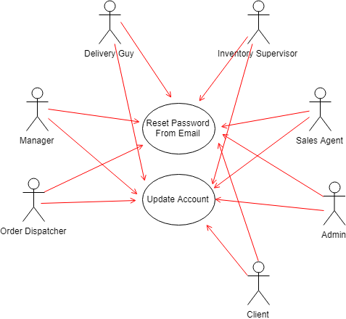

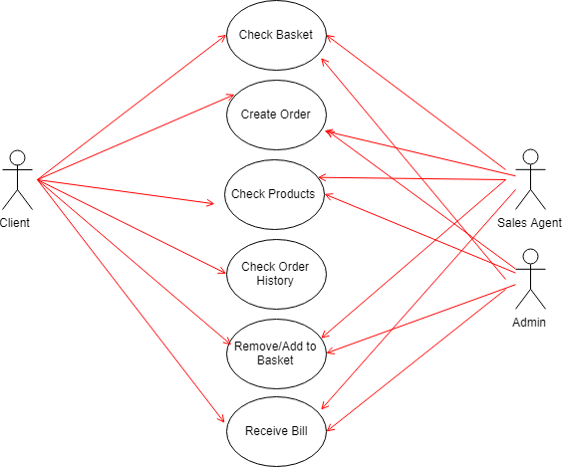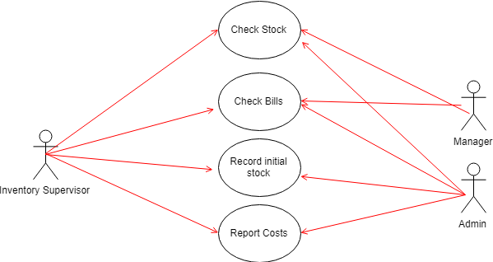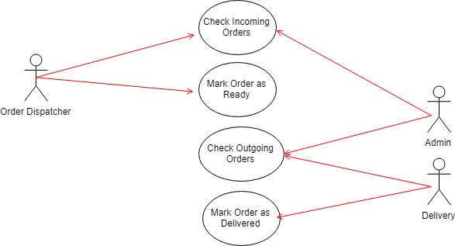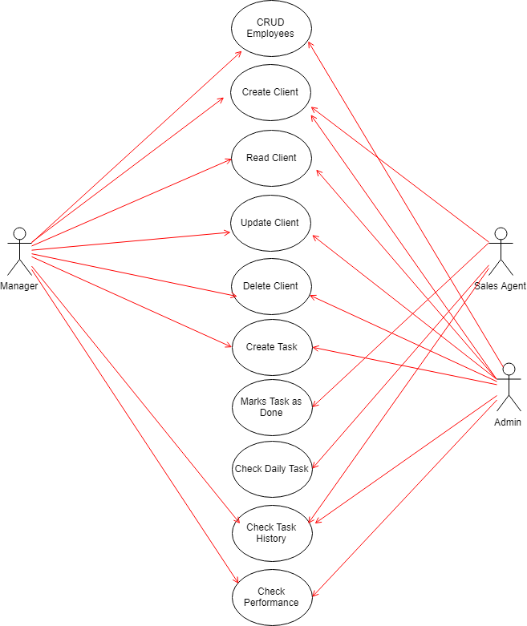

**4.2 Activity Diagrams**

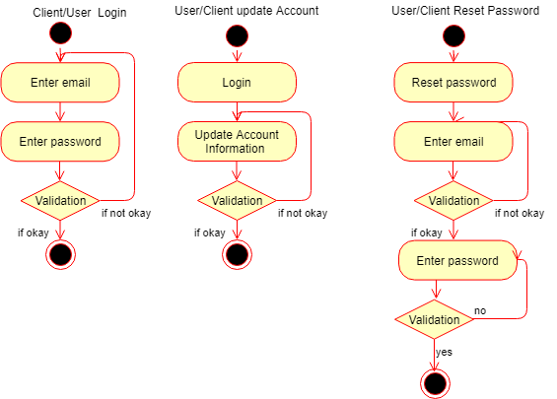

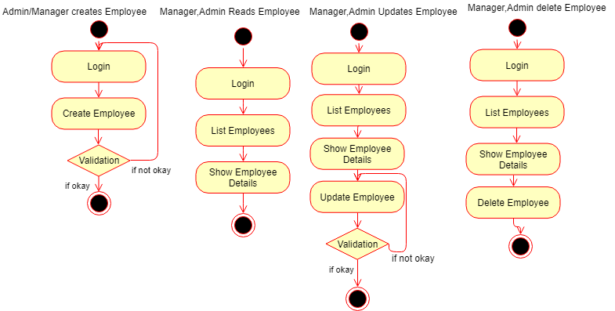

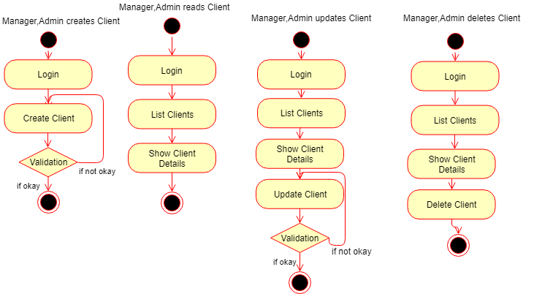

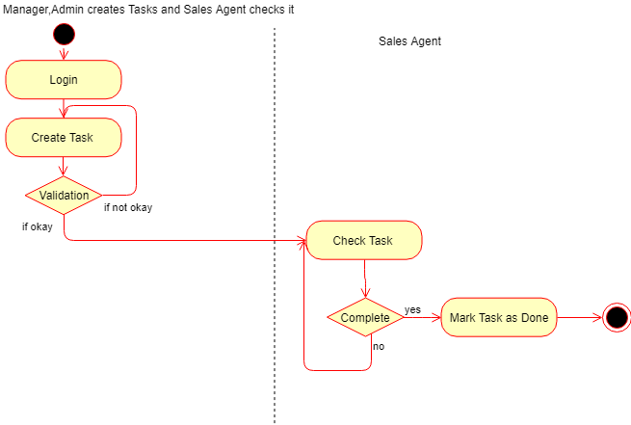

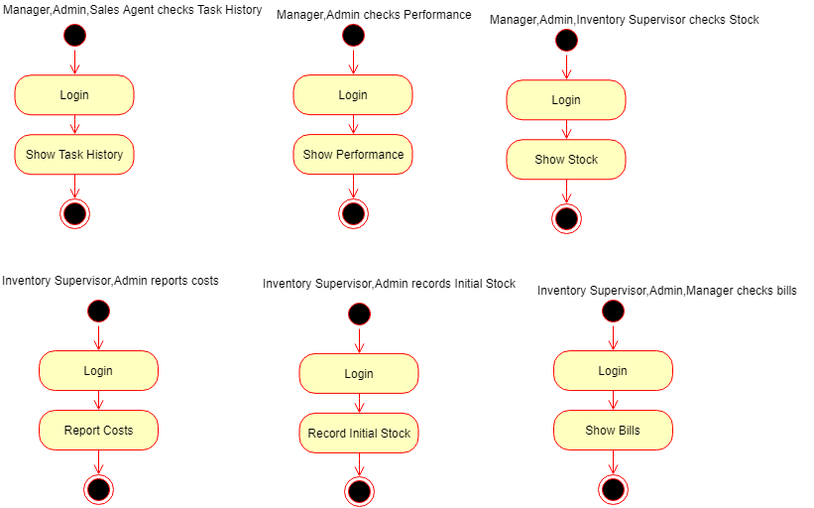

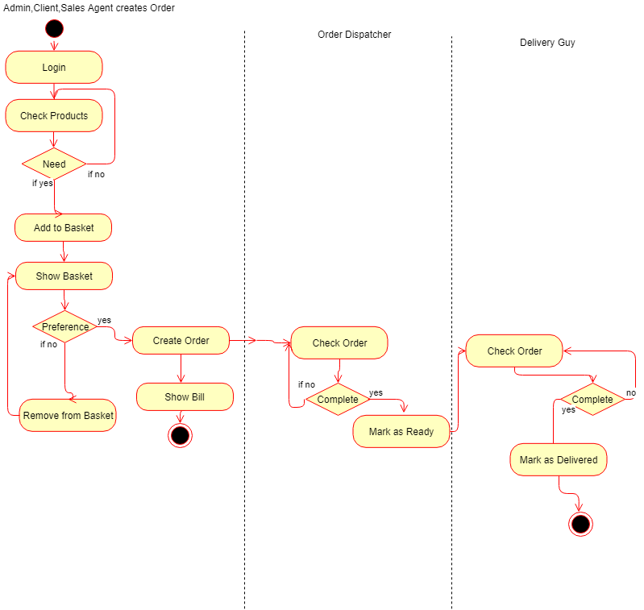

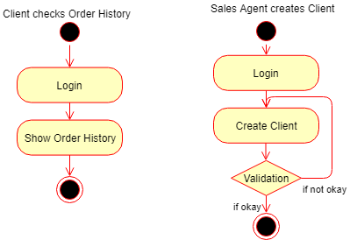

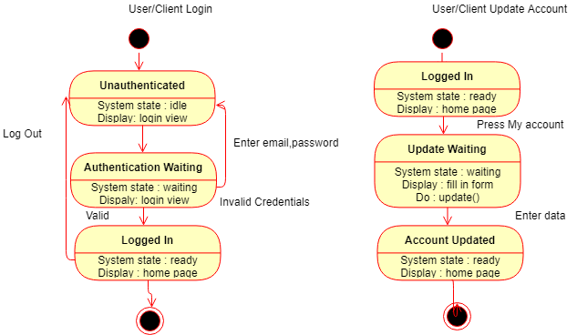

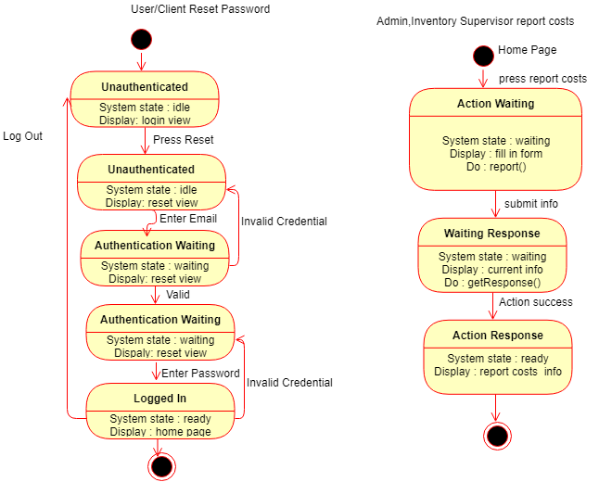

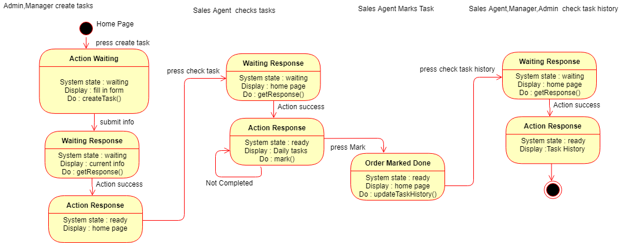

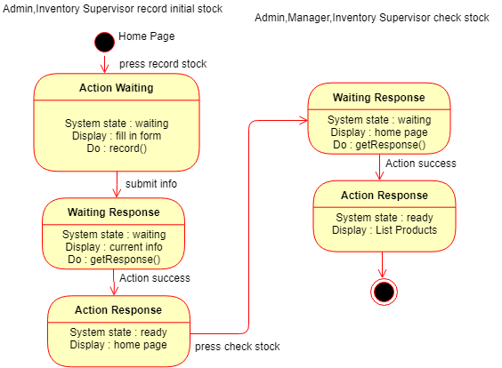

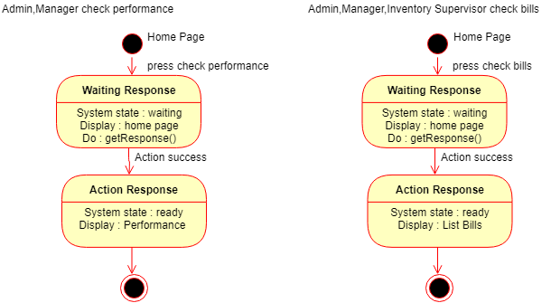

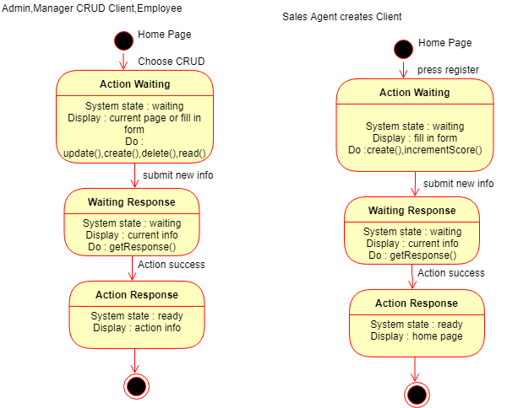

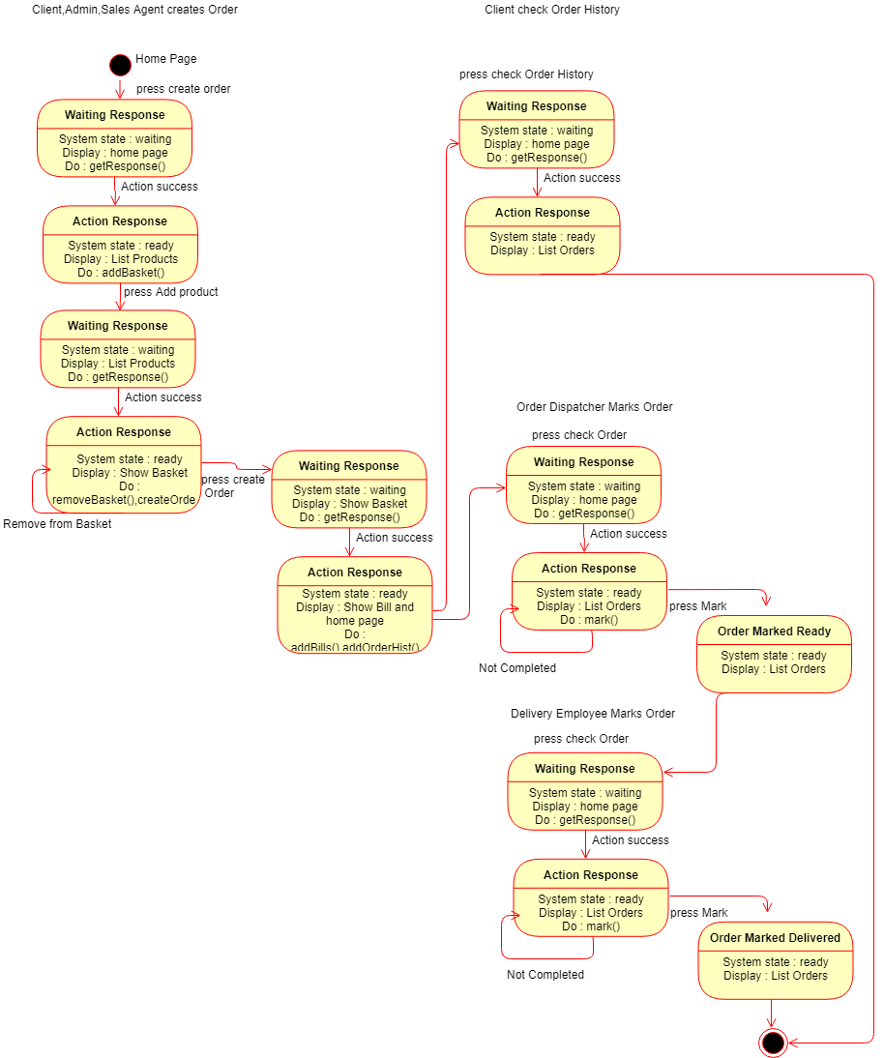

**4.3 Sequence Diagrams**

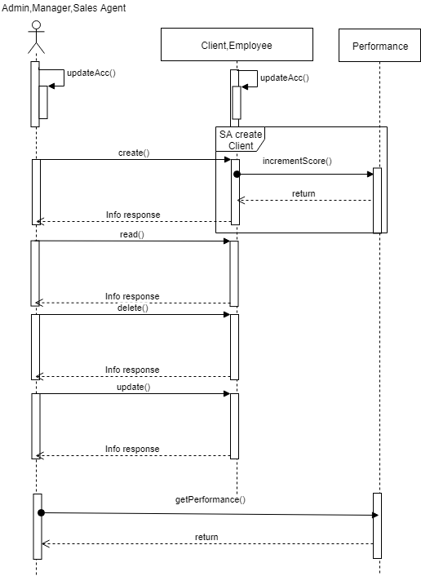

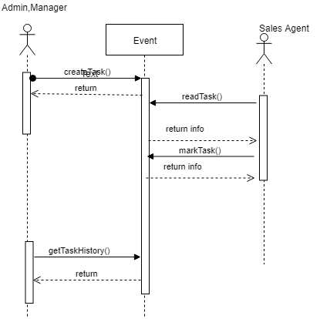

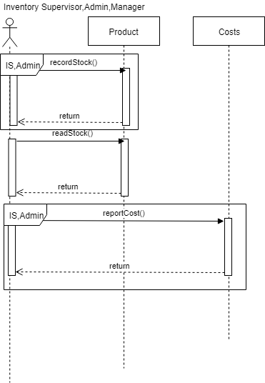

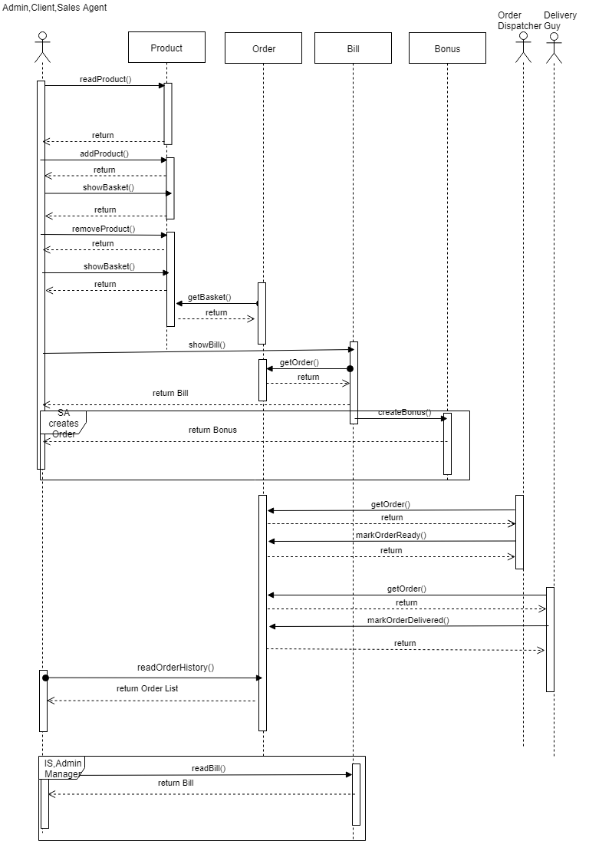

**4.4 Collaborations Diagram**

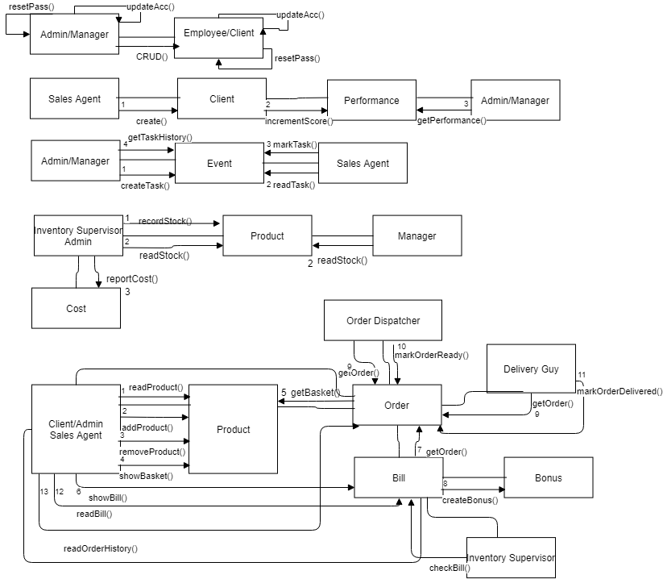

**4.5 Data Flow Diagram**

***Level 0***

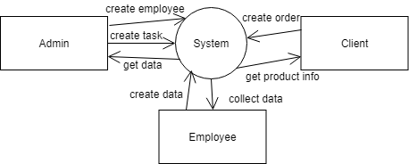

***Level 1***

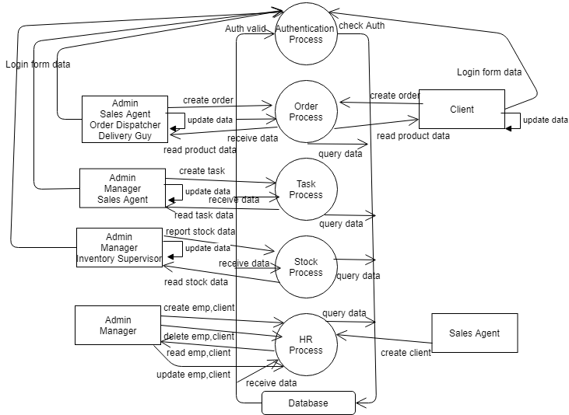

***Level 2***

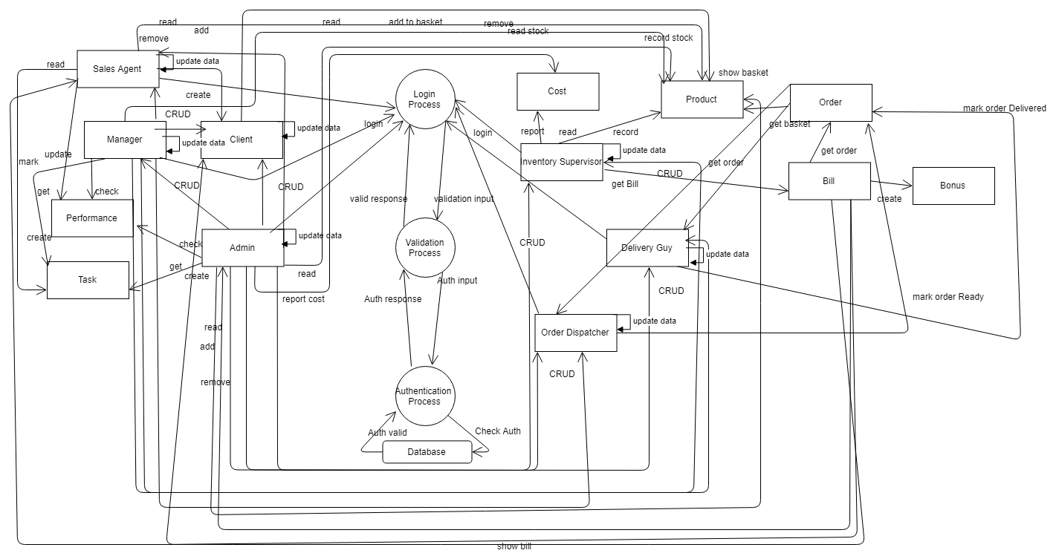

**4.6 ER Diagram**

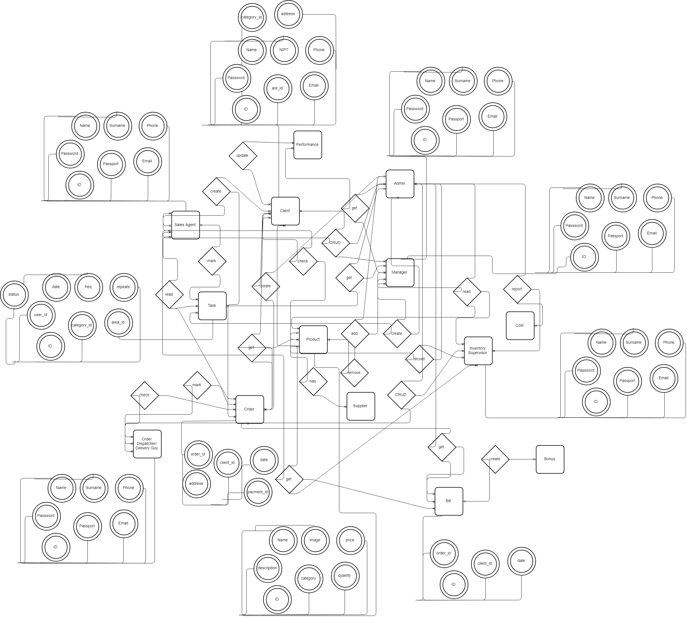

**4.7 Class Diagram** 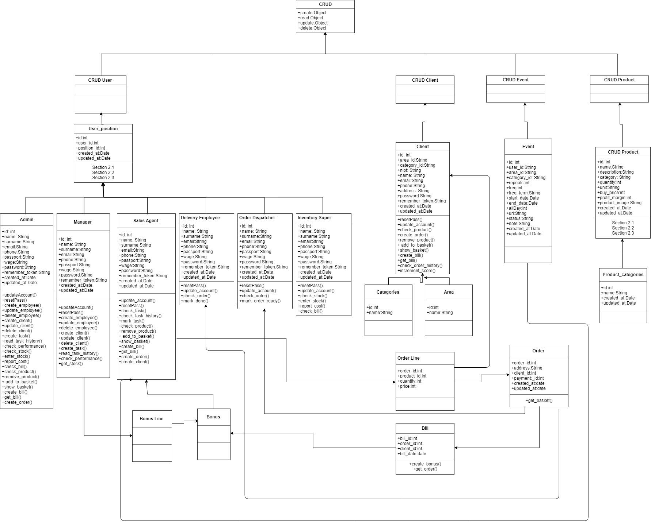

**4.9 Object Diagram**

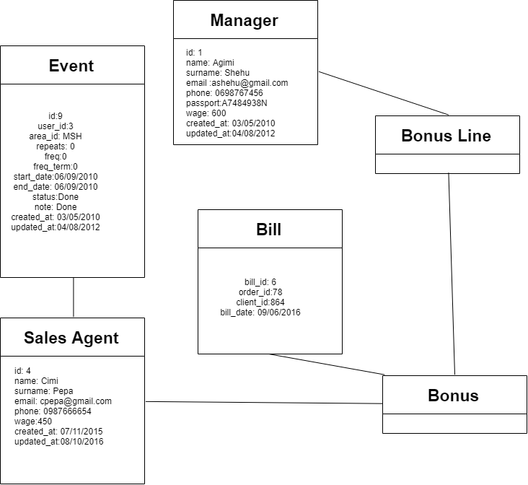

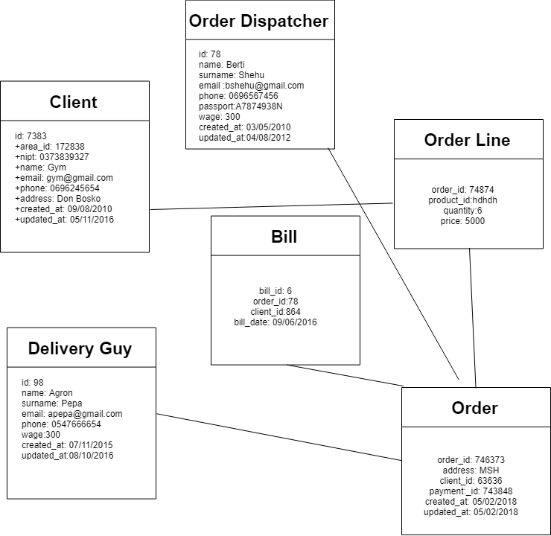

**4.10 Component Diagram**

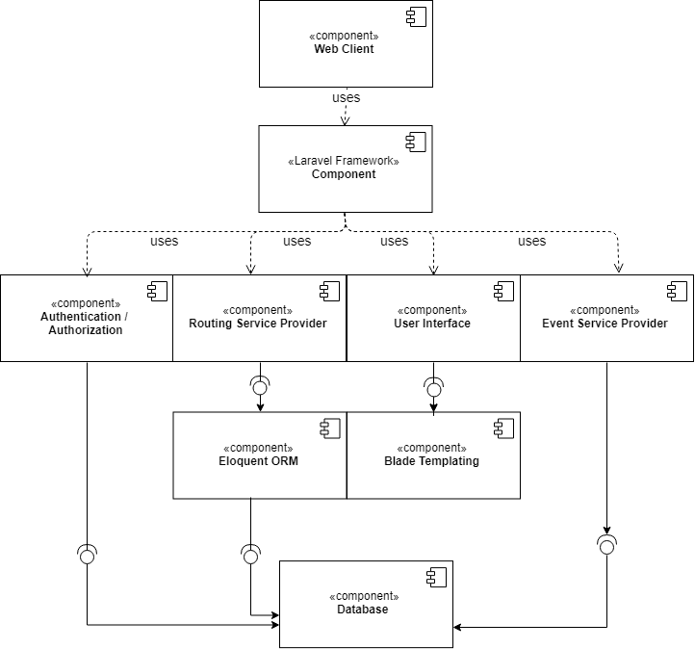

**4.11 Deployment Diagram**

