Live Health Monitoring System

In propose work we are utilizing latest technologies such as sensor data and ML algorithm to monitor live patient health. This application will be very helpful for elderly or accident patients whose health continuous monitoring help in recovering faster. Application will utilize sensors to sense patient vitals such as Heart Rate, BP, spo2, temperature and many other important features and then feed to ML algorithms to predict patient health as High or Low risk.

To predict health accurately we have experimented with various ML algorithms such as Random Forest, XGBOOST, MLP Neural Network and SVM. Each algorithm performance is evaluated in terms of accuracy, precision, recall and FSCORE. Among all algorithms Random Forest and XGBOOST getting high accuracy and we deployed highest performing algorithm for real time health monitoring.

To train and test above algorithms we have used human vitals dataset which can be downloaded from below URL

<https://www.kaggle.com/datasets/nasirayub2/human-vital-sign-dataset>

Above dataset contains all vitals describe by you in your experiments and this dataset values showing in below screen

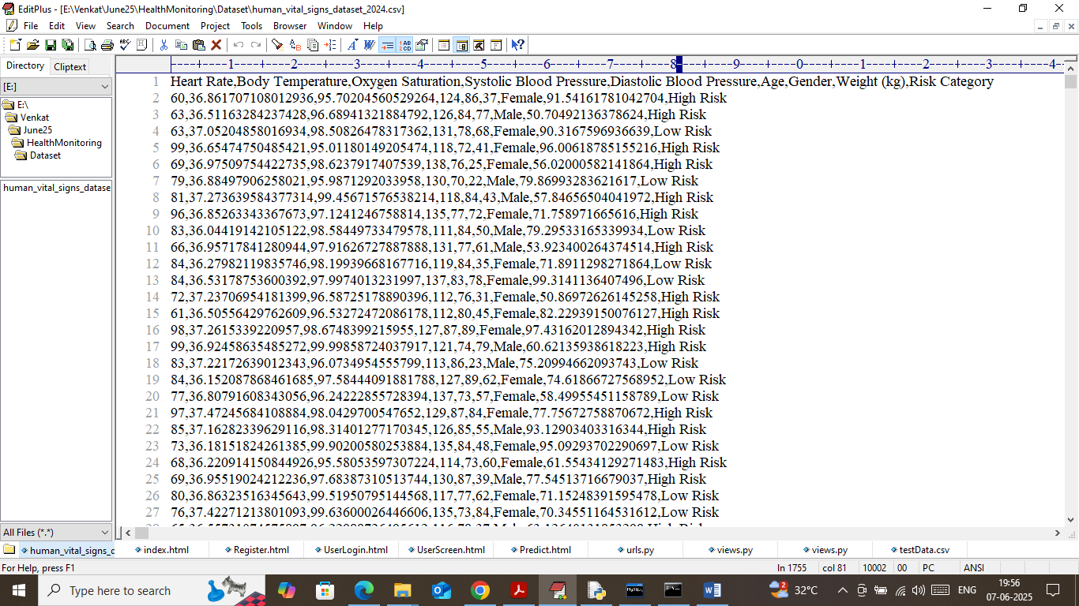

In above dataset first row represents dataset column names and remaining rows contains dataset values and in last column we have class labels as ‘High or Low Risk’.

Algorithms trained on above dataset can be applied on Live sensor data to predict patient health.

Note: we don’t have any sensors so for predicting health we are using TEST data which you can replace with sensors if you can manage to arrange otherwise you can perform prediction on given test data. In below screen showing sample test data values

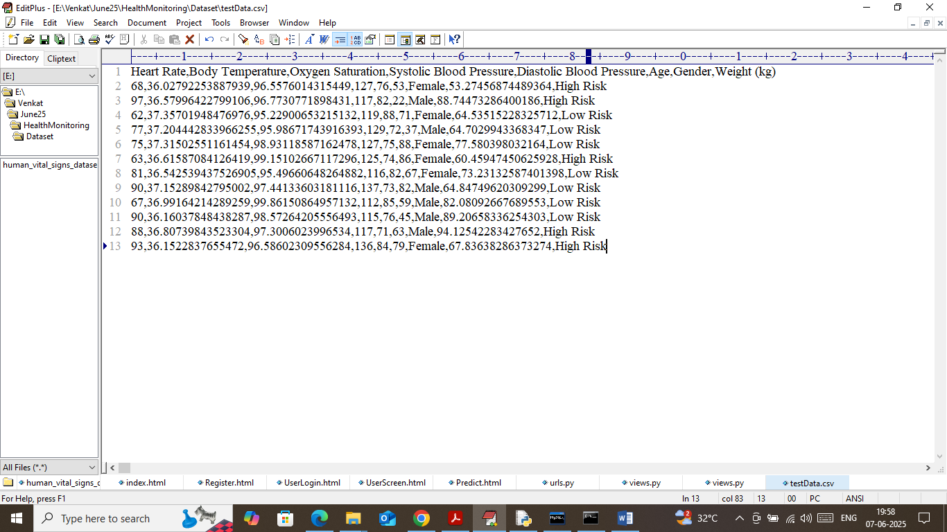

In above test data we have all patients’ values except class labels and ML algorithm will analyse above test data and predict health risk.

Modules Information

To implement this project we have designed following modules

1. Registration Here: user can sign up with the application
2. User Login: user can login to system
3. Load & Process Health Dataset: using this model will load and normalize all human vitals dataset and then split into train and test where application using 80% records for training and 20% for testing
4. Train ML Algorithms: 80% training records will be input to all ML algorithms to trained a model and this model will be applied on 20% test data to calculate risk prediction accuracy
5. Live Health Prediction: using this module user can upload test data along and then algorithm will process test data and then predict patient health risk.

SCREEN SHOTS

Install python 3.7.2 and then install all packages given in requirements.txt file and then install MYSQL and then copy content from ‘database.txt’ file and paste in MYSQL console to create database

To run project double click on ‘runWebServer.bat’ file to start python server and then will get below page

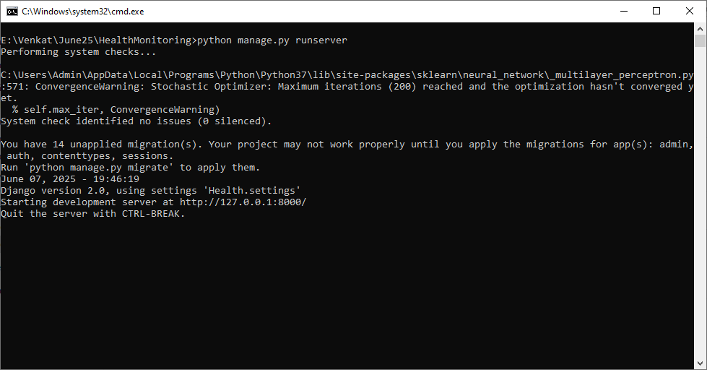

In above screen python server started and now open browser and enter URL as <http://127.0.0.1:8000/index.html> and then press enter key to get below page

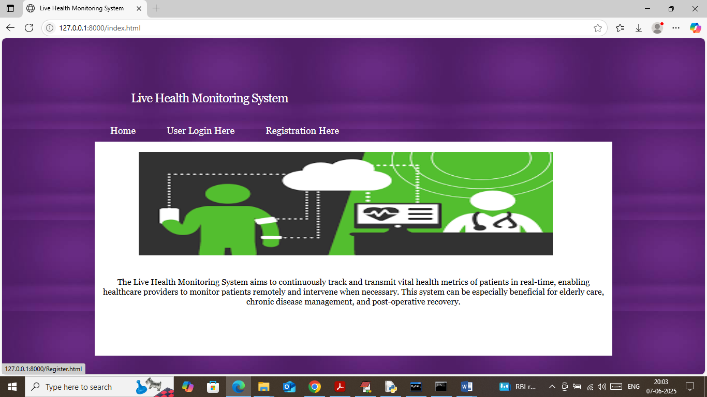

In above screen click on ‘Registration Here’ link to get below page

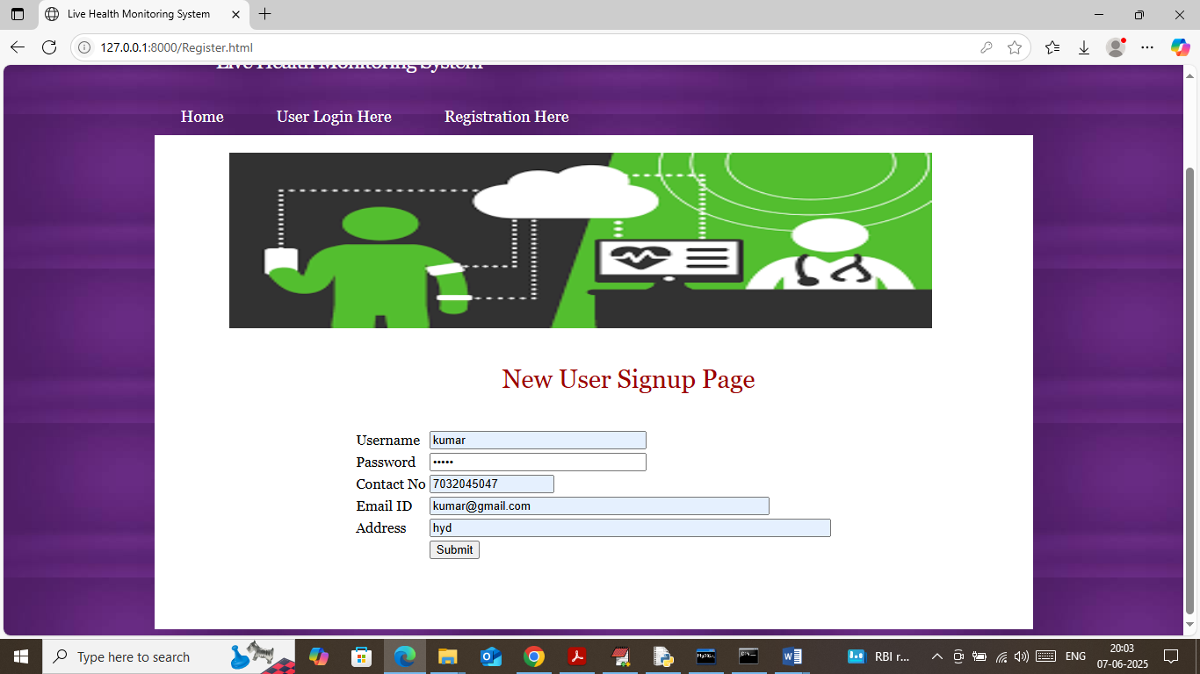

In above screen user is entering sign up details and then press button to get below page

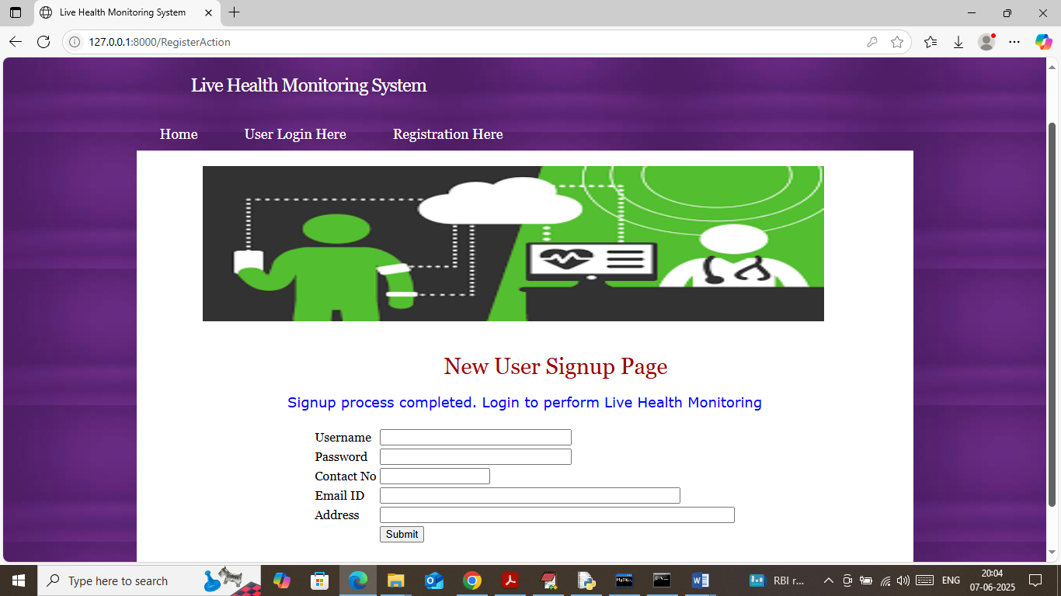

In above screen user sign up process completed and now click on ‘User Login Here’ link to get below page

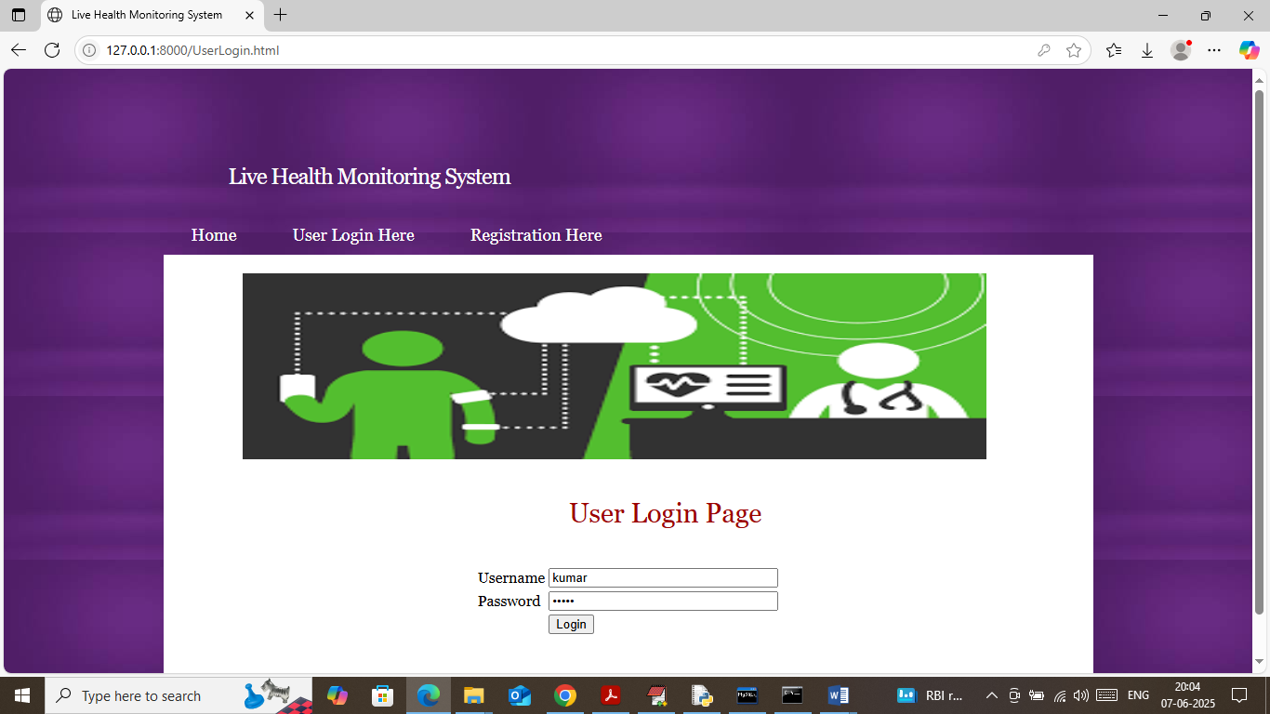

In above screen user is login and after login will get below page

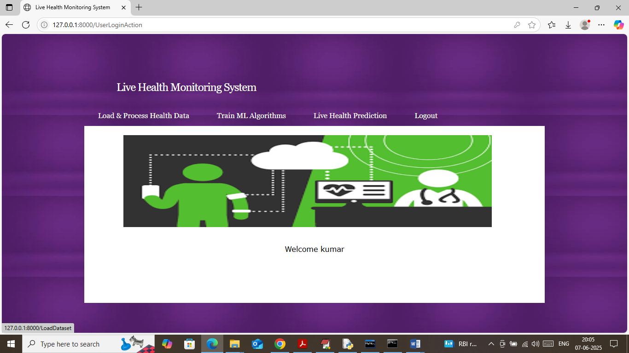

In above screen user can click on ‘Load & Process Health Dataset’ link to load dataset and then will get below page

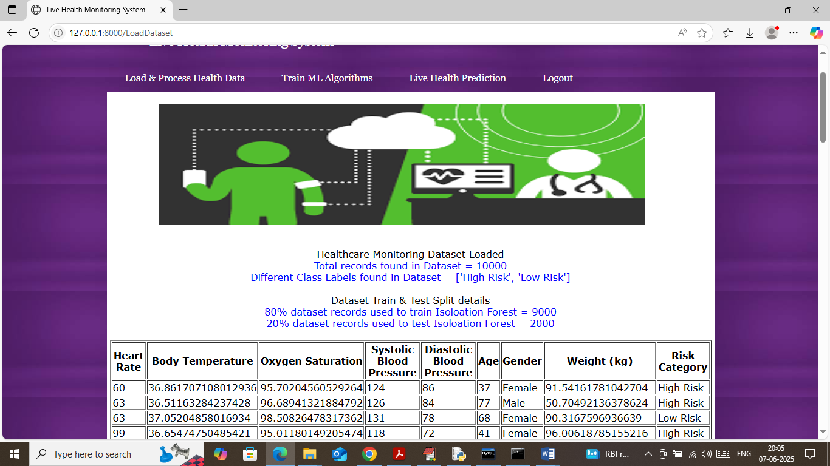

In above screen can see dataset loaded and in first 3 lines can see dataset loaded along with dataset rows size and different class labels found in dataset. In next two lines can see train and test size and then in table format can see loaded dataset values and now click on ‘Train ML Algorithms’ link to get below page

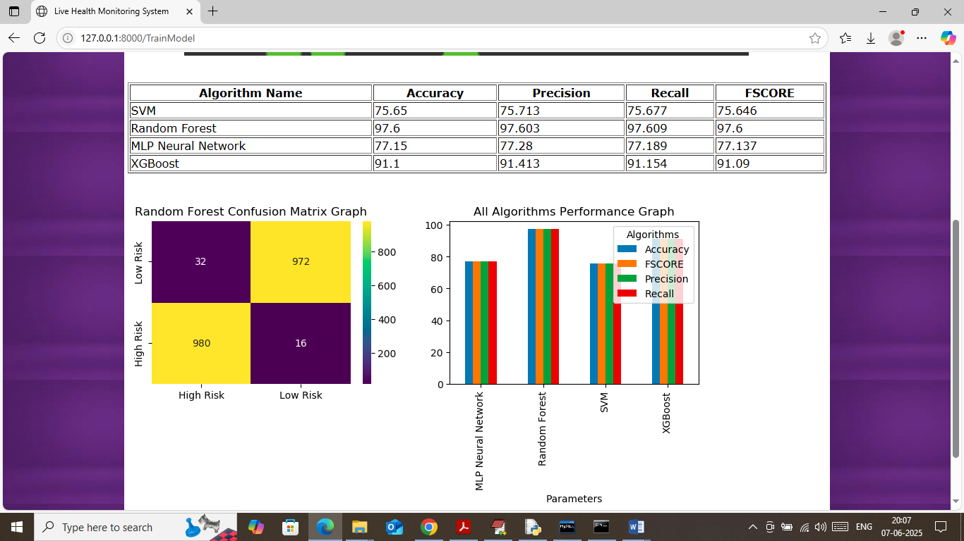

In above screen in table format can see accuracy, precision, recall and FSCORE of each algorithm and in all algorithms Random Forest and XGBOOST got high accuracy. In confusion matrix graph x-axis represents ‘Predicted Labels’ and y-axis represents ‘True Labels’ and then yellow boxes in diagonal represents correct prediction count and blue boxes represents incorrect prediction count which are very few. In bar graph can see comparison graph between all algorithms where x-axis represents algorithm names and y-axis represents accuracy and other metrics in different colour bars. Now click on ‘Live Health Prediction’ link to get below page

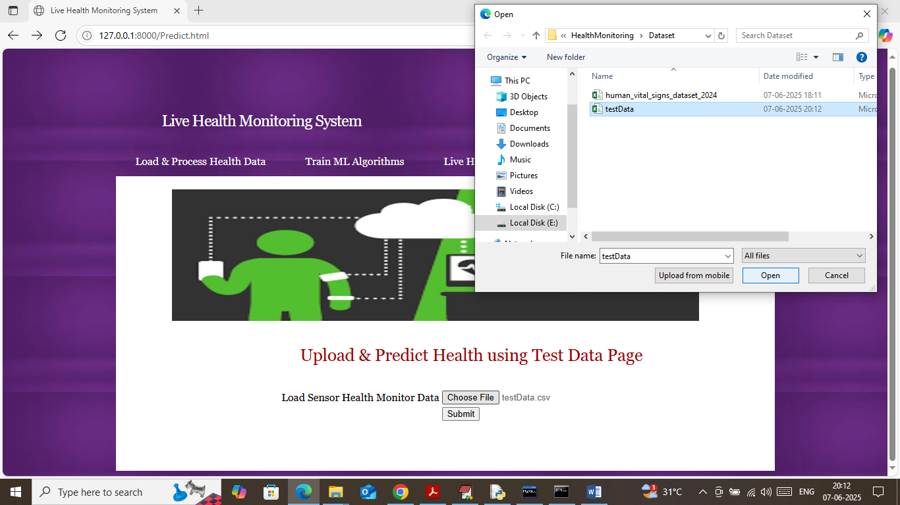

In above screen selecting and uploading ‘testData.csv’ file and then click on buttons to get below page

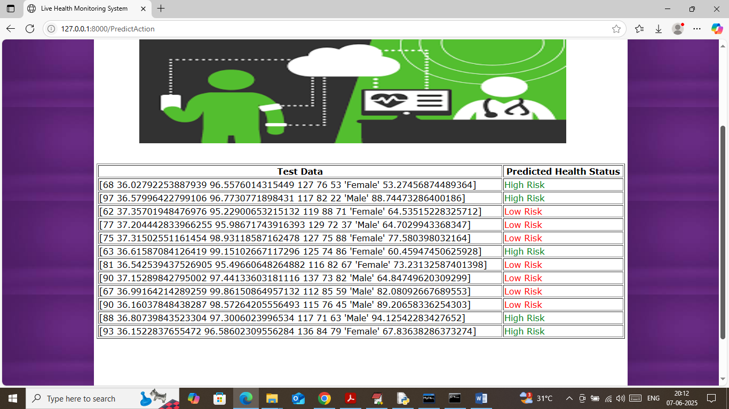

In above screen in first column can see Test Data patient vitals and in second column can see predicted Health status as ‘High or low risk’. Based on detected health risk doctors can take necessary medications steps.

Note: we don’t have any real cloud account like AWS so we designed dummy python server and this application deployed on that dummy server

Android Execution: connect your laptop on which server is running to same mobile hotspot or connect both to same WIFY and then open browser in your mobile and type URL as <http://wify> or mobile hot spot ip address:8000/index.html and then press enter key to begin execution in mobile.